**TIRVANDOR**

Dungeon Master's Guide

# Table of Contents

**PART I: THE WORLD**

Introduction: Complete History ............................ **4**

The Seven Primordials ..................................... **25**

**PART II: RUNNING THE GAME**

Chapter 1: Running the Game ............................... **35**

Chapter 2: Adventure Creation ............................. **55**

Chapter 3: Campaign Creation .............................. **75**

Chapter 4: Secret Locations ............................... **90**

Chapter 5: Magic Mechanics ................................ **105**

**PART III: TREASURE**

Chapter 6: Treasure (43 items) ............................ **120**

**PART IV: NPCs**

Chapter 7: NPCs (133 complete) ............................ **165**

Chapter 8: NPC Creation Guide ............................. **340**

**PART V: DM TOOLS**

Chapter 9: DM Toolbox ..................................... **355**

Chapter 10: Faction Strongholds ........................... **370**

Chapter 11: Encounter Building ............................ **385**

Chapter 12: Wilderness Exploration ........................ **400**

**PART VI: APPENDICES & MAPS**

Appendix A: Tables & Charts ............................... **415**

Appendix B: Adventure Hooks by City ....................... **440**

Appendix C: Street-Level Details .......................... **465**

Appendix D: Battle Maps (20 maps) ......................... **485**

Appendix E: Region Maps (6 maps) .......................... **495**

**Legal**

Copyright Notice .......................................... **505**

Attribution ............................................... **506**

Open Game License ......................................... **507**

# Dungeon Master's Guide to Tirvandor

## The Secrets Behind the World

## Using This Guide

This guide contains information only for Dungeon Masters. It reveals secrets players should not know.

## Complete Timeline of Tirvandor

### Age of Myth (??-15,000 BS)

The earliest age, shrouded in legend and oral tradition.

The First Creation:

* Primordials and First Gods walked the world
* Magic flowed without restraint
* Dragons born from the blood of the earth
* Giants created to tend world-trees
* First mortal races emerged

The Dragon Hegemony (12,000-8,000 BS):

* Great dragons rose to dominance
* Chromatic Conclave divided the world
* Dragon Libraries created (repositories of ancient knowledge)
* First Dragon War between chromatic and metallic dragons

The Giant Kingdoms (8,000-6,000 BS):

* Giant-kin built massive cities of stone
* Ordning System established
* Sky Fortresses constructed
* Giant-Dragon Pact ended Dragon Wars

### Age of Dawn (6,000-3,000 BS)

The rise of mortal civilizations.

First Elven Kingdom (6,000-4,500 BS):

* Elves discovered ley line nexuses
* Kingdom of Lothlindor established
* Singing Groves planted
* First contact with Feywild
* Elven high magic flourished

Dwarven Delving (5,500-4,000 BS):

* Dwarves discovered Ironspine Mountains
* Foundation of Khaz-Durath (First Deep Kingdom)
* Discovery of mithril and adamantine
* Runic forging techniques developed
* Conflicts with underground aberrations

Human Emergence (5,000-3,500 BS):

* Nomadic tribes settled into agricultural communities
* Development of divine magic through worship
* First human kingdoms in central Thaldros
* Cultural exchange between races

Age of Accord (3,500-3,000 BS):

* Relative peace and cooperation
* Accords of Unity treaties signed
* Mixed-race cities founded
* Great Library of Silverpine established
* Magical research advances

### Age of Strife (3,000-1,000 BS)

Wars, plagues, and catastrophes.

First Planar Incursions (3,000-2,800 BS):

* Portals to other planes opened spontaneously
* Demon Wars against extraplanar invaders
* First paladin orders formed
* Permanent planar scars created

Wizard Wars (2,700-2,400 BS):

* Mage-lords vied for power
* Wild magic twisted landscapes
* Spellplague killed thousands of practitioners
* First Warforged created as soldiers

Divine Silence (2,400-2,200 BS):

* Gods stopped answering prayers
* Divine magic waned
* Theocratic governments collapsed
* Social upheaval and loss of faith

Age of Tyrants (2,200-1,500 BS):

* Lich-kings and vampire lords seized control
* Zalthar the Undying ruled Sundaran region (300 years)
* Crimson Court controlled central Thaldros
* aberration Colony of K'thrax enslaved eastern Aethoria
* Underground resistance movements

Rise of Empires (1,500-1,000 BS):

* Heroes overthrew the tyrants
* First unified human empire in Thaldros
* Elven kingdoms consolidated in Aethoria
* Period of rebuilding and recovery

### Pre-Worldrend Era (1,000-2,400 BS)

Leading to the catastrophe.

1,000-800 BS - Golden Age Returns:

* Peace and prosperity across both continents
* Population reaches 30 million
* Magic integrated into daily life
* Trade flourishes
* Art and culture golden age

800-500 BS - Growing Tensions:

* Minor conflicts between kingdoms
* Competition over magical resources
* Ley line instability first reported
* Some mages report disturbing dreams

500-400 BS - The Warnings:

* Major ley line surge destroys city
* Circle of Seven discovers Primordial prisons weakening
* Empire mobilizes to reinforce seals
* Public panic begins

400-350 BS - Failed Containment:

* Attempts to strengthen seals backfire
* Two cities destroyed by magical backlash
* Crime increases as fear spreads
* Religious cults form

350-300 BS - Social Breakdown:

* Trade networks fail
* Food shortages in cities
* Mass migration begins
* Civil unrest and riots

300-250 BS - Economic Collapse:

* Government authority weakens
* Regional warlords seize power
* Empire fragments
* Assassination of key officials

250-200 BS - Divine Silence Begins:

* Gods stop responding to prayers
* Clerics lose spellcasting ability
* Religious institutions collapse
* Mass despair

200-100 BS - Desperate Measures:

* Circle of Seven proposes radical solution
* Plan to redirect ley line energy
* Debate over which Primordial prison to reinforce
* Population ordered to evacuate

100-1 BS - Final Preparations:

* Circle chooses to reinforce Devourer's prison
* All other prisons will be critically weakened
* Massive ritual prepared at Observatory Citadel
* Last attempts to save civilization

### The Worldrend (Year 0 / 2,400 BS)

Day 1 - Dawn:

* Circle of Seven begins ritual
* Ley lines glow visible to naked eye
* Animals flee the region
* Ground begins shaking

Day 1 - Midday:

* Ritual reaches critical point
* Ocean starts receding
* Gods manifest physically, try to stop ritual
* Too late to prevent catastrophe

Day 1 - Sunset:

* Catastrophic magical explosion
* Observatory Citadel vaporized
* Shockwave kills 10 million instantly
* Primordial prisons breach simultaneously

Day 2 - The Split:

* Continent literally splits in two
* Eastern third separates and drifts
* Massive tsunami destroys coastal cities
* 20 million more die in floods

Day 3-7 - Chaos:

* Earthquakes continue for week
* Volcanic eruptions across continent
* Ash clouds block sun
* Temperature drops 20 degrees

Year of Darkness:

* Volcanic winter
* Crops fail globally
* Starvation begins
* Survivors flee underground

Final Toll:

* 35 million dead from direct impact (70% of population)
* 10 million more in first year (starvation, disease)
* Population stabilized at 5 million (10% of original)
* Civilization nearly destroyed

### Recovery Era (1-1000 CR)

1-200 CR - Emergence:

* Survivors emerge from shelters
* Small communities form
* Technology and magic knowledge largely lost
* Oral tradition preserves some history

200-400 CR - Rebuilding:

* Villages near ruins established
* Agriculture resumes
* Written language re-established
* Population: 6-8 million

400-600 CR - Rediscovery:

* Explorers find magical artifacts
* Spells rediscovered
* Divine Return: Gods begin responding again
* Hope returns
* Population: 10-12 million

600-800 CR - Separate Development:

* Western land becomes Thaldros
* Eastern land becomes Aethoria
* Different cultures develop independently
* Limited contact across Sundering Sea

800-1000 CR - Age of Kingdoms:

* Multiple kingdoms rise on both continents
* Trade resumes
* Magic schools re-established
* Population: 15-20 million

### Current Era (1000-1247 CR)

1000-1100 CR - Consolidation:

* Thaldros kingdoms unite under Thandris Dynasty
* Aethoria remains allied city-states
* Border region contested
* Discovery of spreading Primordial corruption

1100-1200 CR - Growing Conflict:

* Thaldros expands aggressively
* Aethoria resists
* Skirmishes increase
* Iron Guild founded as neutral faction

1220 CR - Current Emperor:

* Aldric IV takes throne
* Continues war but seeks solution
* Secretly investigates Primordial threat
* Realizes war distracts from real danger

1240-1247 CR - Present Day:

* War continues but both sides weakening
* Primordial prisons critically compromised
* Corruption spreading
* Window to prevent second Worldrend closing

## The Seven Primordials (DM Secret)

### 1. The Devourer (Under Ironvault)

* Domain: Hunger, Consumption, Void
* Prison Status: Weakening (20-30 years until breach)
* Seal reinforced in Worldrend (only one reinforced)
* Corruption: Insatiable hunger, victims consume themselves

### 2. The Dreamer (Under Cloudspire)

* Domain: Madness, Sleep, Unreality
* Prison Status: Critical (10-15 years)
* Corruption: Loss of reality, can't distinguish dreams

### 3. The Weaver (Under Silverpeak Mountains)

* Domain: Fate, Threads, Control
* Prison Status: Severe (15-20 years)
* Corruption: Loss of free will, become puppets

### 4. The Tyrant (Under Highcrown Ruins)

* Domain: Domination, Hierarchy, Subjugation
* Prison Status: Severe (15-20 years)
* Corruption: Megalomania, enslave others

### 5. The Corruptor (Under Border Wastes)

* Domain: Disease, Decay, Transformation
* Prison Status: Advanced (5-10 years)
* Corruption: Mutation into monstrosities

### 6. The Hunter (Deep Wilderness, Unknown)

* Domain: Pursuit, Prey, Terror
* Prison Status: Unknown (hidden)
* Corruption: Become bestial, hunt former friends

### 7. The Oracle (Lost Temple, Unknown)

* Domain: Time, Knowledge, Future
* Prison Status: Unknown
* Corruption: See all futures simultaneously, madness

## Campaign Use

The Primordial threat is the ultimate story backbone. Everything connects to the approaching crisis and the need to prevent a second Worldrend.

# Chapter 2: Running the Game

## Core Mechanics and Adjudication

## Ability Checks

### When to Call for Checks

Call for ability checks when:

* The outcome is uncertain
* Both success and failure have interesting consequences
* The action takes significant effort or skill

Don't call for checks when:

* The outcome is certain (routine tasks for skilled characters)
* Failure would just stop the story with no interesting outcome
* Success is impossible regardless of roll

### Setting Difficulty Classes

|  |  |  |
| --- | --- | --- |
| **Difficulty** | **DC** | **Example** |
| Very Easy | 5 | Notice something obvious, climb a knotted rope |
| Easy | 10 | Hear an approaching guard, climb a surface with ledges |
| Medium | 15 | Eavesdrop through a door, scale a brick wall |
| Hard | 20 | Hear a whisper through a door, climb a slippery sheer surface |
| Very Hard | 25 | Hear breathing through a door, climb an oiled wall |
| Nearly Impossible | 30 | Read lips from across a plaza, climb a perfectly smooth surface |

Most checks should be DC 15 (Medium). Reserve DC 25+ for legendary feats.

### Multiple Ability Options

When a task could use multiple abilities, let players describe their approach:

Example: Getting Past a Guard

* Strength (Athletics): Overpower and restrain
* Dexterity (Stealth): Sneak past without being seen
* Charisma (Deception): Convince guard you belong there
* Charisma (Intimidation): Threaten guard into letting you pass
* Intelligence (Investigation): Find alternate route by studying patrol patterns
* Wisdom (Insight): Determine when guard is distracted

The player's description determines which ability applies. Reward creative thinking.

### Group Checks

When the whole party attempts something together (crossing a rope bridge, sneaking past guards, rowing a boat in storm):

Method 1: Simple Majority

Everyone rolls. If more than half succeed, the group succeeds.

Method 2: Leader + Help

One character leads (rolls), others who succeed on DC 10 checks give advantage through the Help action.

Method 3: Best Applies

When one character's success helps everyone (ranger navigating, rogue scouting ahead), use the best result.

### Contests

When two creatures oppose each other (arm wrestling, chase, hiding vs seeking):

* Both roll appropriate ability checks
* Highest total wins
* Ties go to the creature with higher ability modifier
* If still tied, reroll

## Advantage and Disadvantage

### When to Grant Advantage

Favorable Circumstances:

* High ground in combat
* Target is restrained, prone, or unconscious
* Ally provides Help action
* Environmental factor aids the task (bright light for Perception, etc.)
* Creative player solution that makes sense

Don't Stack: Multiple sources of advantage don't stack. You either have it or you don't.

### When to Impose Disadvantage

Unfavorable Circumstances:

* Attacking while prone
* Attacker is blinded or can't see target
* Target has cover (for attacks)
* Environmental hindrance (darkness for Perception, noise for Stealth)
* Exhaustion levels 1-2
* Task is being rushed

Don't Stack: Multiple sources don't stack.

### Advantage/Disadvantage Cancel

If you have both advantage and disadvantage from any sources, they cancel completely. Roll one d20 normally, regardless of how many sources of each you have.

## Combat

### Initiative

Rolling Initiative:

|  |  |
| --- | --- |
| **Roll** | **Result** |
| 1 | Situation becomes combat (violence is inevitable, trap springs, ambush happens) |
| 2 | Everyone rolls d20 + Dexterity modifier |
| 3 | DM ranks all combatants from highest to lowest |
| 4 | Ties: PCs win ties with monsters. Tied PCs/monsters choose their order. |

Tracking Initiative:

Write on paper or use tracker. Call out current turn and who's next: "Thea, you're up. Marcus, you're on deck."

Changing Initiative: Some DMs reroll each round. Others keep same order entire combat. Choose consistency.

### Actions in Combat

On Your Turn (in any order):

* Move: Up to your speed
* Action: One of the options below
* Bonus Action: If you have ability that grants one
* Object Interaction: One free (draw weapon, open door, etc.)
* Communication: Brief phrases, a few words

Standard Actions:

* Attack: Make one melee or ranged attack (more if Extra Attack)
* Cast a Spell: Cast one spell with casting time of 1 action
* Dash: Move again (up to your speed)
* Disengage: Move without provoking opportunity attacks
* Dodge: Attacks against you have disadvantage, you have advantage on Dex saves
* Help: Give ally advantage on ability check or next attack against creature you can see
* Hide: Make Dexterity (Stealth) check
* Ready: Prepare action to trigger on condition ("I attack if it comes through door")
* Search: Make Wisdom (Perception) or Intelligence (Investigation) check
* Use an Object: Interact with second object (first is free)

Reactions (Triggered, Not on Your Turn):

* Opportunity Attack: Enemy leaves your reach without Disengaging
* Spells: Some spells cast as reactions (Shield, Counterspell, etc.)
* Readied Action: Triggering condition occurs

### Movement

Speed: Move up to your speed in feet. Can split movement (move 10 ft, attack, move 20 ft more).

Difficult Terrain: Every foot costs 2 feet of movement (rubble, shallow water, undergrowth, steep stairs).

Prone: Standing from prone costs half your speed.

Climbing/Swimming: Usually costs 2 feet per foot moved (unless creature has climb/swim speed).

### Attacking

Melee Attack:

|  |  |
| --- | --- |
| **Roll** | **Result** |
| 1 | Declare target within reach |
| 2 | Roll d20 + Strength modifier + proficiency bonus (if proficient) |
| 3 | Compare to target's AC |
| 4 | If equal or higher: Hit! Roll damage. |
| 5 | If lower: Miss. |

Ranged Attack:

Same as melee but uses Dexterity and has range limitations.

Range: Weapon has normal range and long range (e.g., 80/320 for longbow)

* Normal range: Attack normally
* Long range: Attack at disadvantage
* Beyond long range: Can't attack

Cover: Target behind cover gets AC bonus

* Half cover (+2 AC): Behind furniture, narrow tree, another creature
* Three-quarters cover (+5 AC): Arrow slit, thick tree trunk
* Total cover (can't target): Completely concealed

Critical Hits: Natural 20 on attack roll

* Automatic hit regardless of AC
* Roll all damage dice twice, then add modifiers once

Critical Fails: Some DMs use special effects for natural 1s. Official rules: just automatic miss. If using critical fails, keep them minor (drop weapon, fall prone) not campaign-ending.

### Damage and Healing

Taking Damage:

Subtract from current hit points. Track carefully.

Dropping to 0 HP:

Fall unconscious. Start making death saving throws.

Death Saving Throws:

* At start of your turn if at 0 HP, roll d20 (no modifiers)
* 10 or higher: Success (mark one)
* 9 or lower: Failure (mark one)
* Natural 20: Regain 1 HP, wake up
* Natural 1: Counts as two failures
* Three successes: Stabilized (unconscious but not dying)
* Three failures: Dead

Damage at 0 HP:

* Any damage while at 0 HP: One death save failure
* Critical hit while at 0 HP: Two death save failures
* Damage equals or exceeds max HP: Instant death

Healing:

Regain HP (from spells, potions, etc.). If at 0 HP, regain consciousness.

Stabilizing:

* Action: DC 10 Wisdom (Medicine) check stabilizes dying creature
* Spare the Dying cantrip: Stabilizes automatically
* Healing magic: Restores HP and stabilizes

### Conditions Reference

Blinded:

* Can't see, automatically fails checks requiring sight
* Attack rolls have disadvantage
* Attacks against you have advantage

Charmed:

* Can't attack charmer or target them with harmful effects
* Charmer has advantage on social checks against you

Deafened:

* Can't hear, automatically fails checks requiring hearing

Exhaustion: (Cumulative)

* Level 1: Disadvantage on ability checks
* Level 2: Speed halved
* Level 3: Disadvantage on attacks and saves
* Level 4: HP maximum halved
* Level 5: Speed reduced to 0
* Level 6: Death

Frightened:

* Disadvantage on ability checks and attacks while source is visible
* Can't willingly move closer to source

Grappled:

* Speed becomes 0
* Can't benefit from bonuses to speed

Incapacitated:

* Can't take actions or reactions

Invisible:

* Impossible to see without special sense
* Considered heavily obscured for hiding
* Attack rolls have advantage
* Attacks against you have disadvantage

Paralyzed:

* Incapacitated, can't move or speak
* Automatically fails Strength and Dexterity saves
* Attacks against you have advantage
* Attacks within 5 feet are automatic crits if they hit

Petrified:

* Transformed to stone along with nonmagical objects worn/carried
* Weight increases by factor of 10, stops aging
* Incapacitated, can't move or speak
* Unaware of surroundings
* Automatically fails Strength and Dexterity saves
* Attacks against you have advantage
* Resistance to all damage
* Immune to poison and disease

Poisoned:

* Disadvantage on attack rolls and ability checks

Prone:

* Can only crawl (every foot costs 1 extra foot) or stand up (costs half speed)
* Disadvantage on attack rolls
* Attacks within 5 feet have advantage
* Attacks from more than 5 feet have disadvantage

Restrained:

* Speed becomes 0
* Attack rolls have disadvantage
* Attacks against you have advantage
* Disadvantage on Dexterity saves

Stunned:

* Incapacitated, can't move, can speak falteringly
* Automatically fails Strength and Dexterity saves
* Attacks against you have advantage

Unconscious:

* Incapacitated, can't move or speak, unaware of surroundings
* Drops whatever it's holding, falls prone
* Automatically fails Strength and Dexterity saves
* Attacks against you have advantage
* Attacks within 5 feet are automatic crits if they hit

## Exploration

### Tracking Time

Combat: Rounds (6 seconds) and turns

Exploration: Minutes, hours, days

Downtime: Days, weeks, months

Campaign Time: Months, years

Use calendar to track dates. Note seasonal changes, festivals, and important events.

### Travel Pace

|  |  |  |  |  |
| --- | --- | --- | --- | --- |
| **Pace** | **Per Minute** | **Per Hour** | **Per Day** | **Effect** |
| Fast | 400 ft | 4 miles | 30 miles | -5 to passive Perception |
| Normal | 300 ft | 3 miles | 24 miles | Normal |
| Slow | 200 ft | 2 miles | 18 miles | Can use Stealth |

Terrain Modifiers:

* Roads: Normal pace
* Grasslands, open plains: Normal pace
* Forests, hills: 2/3 speed
* Mountains, swamps, jungle: 1/2 speed
* Desert: Normal but requires water

### Foraging and Hunting

Foraging (While Traveling):

* DC 15 Wisdom (Survival) check
* Success: Find 1d6 pounds food + 1d6 gallons water per point over DC
* Abundant area (forest, jungle): Advantage
* Barren area (desert, dead lands): Disadvantage
* Takes no extra time if traveling at slow pace

Hunting (Dedicated Activity):

* Takes 4 hours
* DC 15 Wisdom (Survival) to track prey
* Then combat encounter or contested check vs prey
* Success: 2d6 pounds meat

### Getting Lost

When to Check: Traveling through wilderness without clear path

* Normal terrain: DC 15 Wisdom (Survival)
* Poor visibility (fog, rain): DC 20
* Storm: DC 25

Frequency: Check once per day of travel

Lost: Group deviates from intended direction. They don't realize it until they make successful check.

### Resting

Short Rest:

* At least 1 hour
* Can spend Hit Dice: Roll + Con modifier, regain that many HP
* Some abilities recharge
* Can do light activity (eat, read, tend wounds)

Long Rest:

* At least 8 hours
* At most 2 hours light activity (watch, cook), rest must be sleep
* Regain all HP
* Regain spent Hit Dice (up to half maximum)
* Regain all expended spell slots and abilities
* Can only benefit from one long rest per 24 hours

Interrupting Rest:

* Short rest interrupted: No benefit, must start over
* Long rest interrupted by combat <1 hour: Can resume for full benefit
* Long rest interrupted by combat >1 hour: Must start over

## Social Interaction

### NPC Attitudes

|  |  |  |
| --- | --- | --- |
| **Attitude** | **Description** | **Effect** |
| Hostile | Will actively oppose party | Attacks, sabotages, spreads rumors |
| Unfriendly | Dislikes party | Won't help, might hinder, needs convincing |
| Indifferent | Doesn't care either way | Professional, transactional, fair price |
| Friendly | Likes party | Helps if convenient, gives honest advice, fair deals |
| Helpful | Strongly likes party | Goes out of their way, takes risks, offers discounts |

### Changing Attitudes

Charisma Checks:

* Success shifts attitude one step in your favor
* Failure by 5+ shifts one step against you
* Can attempt once per day per NPC

DCs:

* Hostile to Unfriendly: DC 20
* Unfriendly to Indifferent: DC 15
* Indifferent to Friendly: DC 15
* Friendly to Helpful: DC 20

Factors:

* Align with NPC's interests: Advantage
* Oppose NPC's interests: Disadvantage
* NPC has reason to distrust you: +5 DC
* You've helped them before: -5 DC

### Persuasion, Deception, Intimidation

Persuasion: Convince through logic, emotion, or appeal to interests

* "The Resistance can offer you protection from Thaldros retaliation"
* Must present actual argument or benefit
* Won't make NPC do things completely against their nature

Deception: Convince through lies or misdirection

* "We're Thaldros agents sent to inspect your papers"
* Requires believable cover story
* Insight checks may detect lies (contested)

Intimidation: Convince through threats or fear

* "Tell us or we burn your shop down"
* Works best when you can follow through
* May create enemies for later

### Information Gathering

Gather Information:

* Takes 1d4 hours in settlement
* Charisma (Investigation) or Charisma (Persuasion) check
* DC depends on how secret the information is

|  |  |
| --- | --- |
| **DC** | **Information Type** |
| 5 | Common knowledge (inn location, major roads) |
| 10 | Generally known (local noble's name, recent news) |
| 15 | Hidden but findable (crime boss identity, secret meeting place) |
| 20 | Well-kept secret (spy network contact, hidden treasure) |
| 25+ | Closely guarded (conspiracy details, hidden vault location) |

## Improvisation

### When Players Surprise You

Stay Calm: Players going unexpected directions is normal and good. It means they're engaged.

Ask Clarifying Questions:

* "What's your goal here?"
* "How do you imagine this working?"
* "What are you hoping to find?"

Use "Yes, And...":

Instead of shutting down ideas, build on them:

* Player: "Can I swing from the chandelier?"
* Bad: "No, that's not in the rules."
* Good: "Yes! Make an Athletics check. If you fail, it breaks and you fall."

### Quick NPC Creation

When you need an NPC right now:

Name: Use name list or combine syllables

Distinctive Feature: One physical trait (scar, accent, nervous tic)

Goal: What do they want?

Secret: What are they hiding?

Example:

* Name: Kerra
* Feature: Missing left ear
* Goal: Get enough money to leave town
* Secret: Secretly works for Iron Guild

### Quick Room Description

When party enters unexpected room:

Size and Shape: Small/medium/large, square/rectangular/circular

Purpose: What was this room for? (Bedroom, storage, shrine, guard post)

Condition: Pristine/dusty/damaged/destroyed

Notable Feature: One interesting thing (murals, weapons rack, altar, fireplace)

Exists: Obvious doors/windows

Example:

"You enter a medium-sized rectangular room. Looks like a guard barracks - three cots along the wall, weapons rack (empty now). Everything's covered in dust. The interesting part: someone has scratched a map into the wooden table in the center. You see three doors - one ahead, two on the sides."

### Saying "No" Gracefully

Sometimes you must refuse player ideas:

Bad: "No, you can't do that."

Better: "That won't work because [reason], but what if you [alternative]?"

Example:

* Player: "I want to convince the king to abdicate."
* DM: "The king won't abandon his kingdom based on one conversation, but you could plant seeds of doubt about his advisors. Maybe he'd take action against corrupt officials?"

## Pacing

### Recognizing Pacing Problems

Too Slow:

* Players checking phones
* Side conversations
* "What's happening?"
* Yawning
* Combat dragging

Too Fast:

* Players look confused
* Asking to repeat information
* Not engaging with scenes
* Feeling rushed

### Speeding Things Up

In Combat:

* Set turn timer (30-60 seconds)
* Roll multiple attacks together
* Describe outcomes cinematically
* Skip to interesting parts ("You fight through minions...")

In Exploration:

* Montage: "You spend three days traveling through forest. Anything specific you want to do?"
* Jump to next interesting scene
* Resolve routine tasks quickly

In Social Interaction:

* Get to the point: "What do you want from them?"
* Skip pleasantries unless character moment
* Resolve straightforward conversations in one roll

### Slowing Things Down

In Combat:

* Add description between turns
* Let players strategize briefly
* Ask what character is thinking/feeling

In Important Moments:

* Describe in detail
* Ask each player for their reaction
* Let scene breathe
* Allow roleplay

In Exploration:

* Add sensory details
* Ask "What are you looking for?"
* Zoom in on interesting features

### Scene Transitions

Cut Efficiently:

* "Three hours later..."
* "Meanwhile, at the castle..."
* "The next morning..."
* "After a week of travel..."

Don't play out every moment. Jump to interesting parts.

## Rulings Over Rules

### Making Fair Rulings

When situation isn't covered by rules:

1. Listen to player's intent

2. Determine appropriate ability + skill

3. Set DC based on difficulty

4. Consider advantage/disadvantage

5. Describe outcome based on roll

Note the ruling and apply it consistently afterward.

### When to Look Up Rules

Look it up:

* First time using complex rule
* Player challenges ruling
* Affects major outcome (death, TPK)

Don't look it up:

* Middle of intense moment
* Would break pacing
* You're reasonably sure of rule

Make ruling, note it, look it up after session.

### Admitting Mistakes

If you realize you ruled wrong:

* Acknowledge it: "I got that rule wrong."
* Correct it going forward: "From now on we'll do it this way."
* Don't retcon unless truly game-breaking
* Don't beat yourself up

## Using This Chapter

Reference these mechanics during play. Most important points:

|  |  |
| --- | --- |
| **Roll** | **Result** |
| 1 | Most checks are DC 15 |
| 2 | Grant advantage/disadvantage liberally |
| 3 | Say "yes, and..." to player ideas |
| 4 | Keep combat moving |
| 5 | Cut boring parts, zoom into interesting parts |
| 6 | Make rulings, look up rules later |

The goal is fun and flow, not perfect rules mastery.

# Chapter 3: Creating Adventures

## Step-by-Step Adventure Design

## What Makes a Good Adventure

A good D&D adventure has:

|  |  |
| --- | --- |
| **Roll** | **Result** |
| 1 | Clear Initial Hook: Players know why they're doing this |
| 2 | Meaningful Choices: Players decisions matter |
| 3 | Multiple Approaches: Combat isn't the only solution |
| 4 | Rising Tension: Stakes increase as adventure progresses |
| 5 | Satisfying Resolution: Clear ending with consequences |
| 6 | Player Agency: Players drive the story through their choices |

Bad adventure: Linear railroad with one solution

Good adventure: Situation with multiple possible outcomes based on player choices

## Step-by-Step Process

### Step 1: Establish the Premise (One Sentence)

What is this adventure about in one sentence?

Examples:

* "Rebels steal military supplies from Thaldros convoy"
* "Missing children lead to corrupt noble's secret"
* "Primordial corruption spreads from ancient ruin"
* "Rival factions compete for powerful artifact"

Good premises:

* Specific and actionable
* Have clear stakes
* Can be completed in 3-6 sessions

### Step 2: Identify the Villain or Threat

Who or what opposes the players?

Villain Checklist:

* Goal: What do they want?
* Method: How are they trying to achieve it?
* Weakness: How can they be stopped?
* Backup Plan: What if first plan fails?

Example: Captain Vex (Thaldros Officer)

* Goal: Capture Resistance leaders
* Method: Infiltrate with spies, set trap
* Weakness: Too confident, underestimates party
* Backup: Has reinforcements 1 hour away

Threat Checklist (Non-Villain):

* Source: Where does threat come from?
* Effect: What happens if not stopped?
* Solution: How can players stop it?
* Escalation: What if players fail or delay?

Example: Primordial Corruption

* Source: Weakened prison seal beneath city
* Effect: Citizens transform into spawns
* Solution: Reseal prison or evacuate city
* Escalation: More corrupted daily, eventually awakens Primordial

### Step 3: Design Key Locations

Identify 3-5 important locations for this adventure.

For Each Location:

* Purpose: What happens here?
* Description: What does it look/sound/smell like?
* Inhabitants: Who or what is here?
* Secrets: What's hidden here?
* Connections: How does this tie to other locations?

Example Locations:

|  |  |
| --- | --- |
| **Roll** | **Result** |
| 1 | Resistance Safehouse - Party's base, information source |
| 2 | Thaldros Supply Depot - Target for heist |
| 3 | Border Crossing - Escape route, checkpoint encounter |
| 4 | Iron Guild Tavern - Neutral ground, negotiation possible |
| 5 | Primordial Ruin - Optional discovery, raises stakes |

### Step 4: Create Major NPCs

Design 3-5 important NPCs players will interact with.

For Each NPC:

* Name and Appearance: Distinctive feature
* Role: Ally? Enemy? Neutral?
* Goal: What do they want?
* Secret: What are they hiding?
* Offer: What can they give players?
* Ask: What do they want from players?

Example: Kerra the Smuggler

* Appearance: Missing left ear, nervous energy
* Role: Uneasy ally
* Goal: Make enough money to flee to Aethoria
* Secret: Secretly reports to Iron Guild
* Offer: Safe passage through checkpoint
* Ask: Cut of stolen supplies

### Step 5: Build Encounters

Design 4-8 encounters mixing combat, social, and exploration.

Encounter Types:

Combat Encounters:

* Planned fights (guards, monsters)
* Dynamic battlefields (fire, falling, cover)
* Objectives beyond "kill everything" (protect NPC, hold position, escape)

Social Encounters:

* Negotiations with opposing factions
* Gathering information from NPCs
* Convincing someone to help

Exploration Encounters:

* Searching ruins for clues
* Navigating dangerous terrain
* Solving puzzles or riddles

Aim for Mix:

* 40% combat
* 30% social
* 30% exploration

### Step 6: Plan Rewards

What do players gain?

Types of Rewards:

* Gold and Treasure: Standard, use CR-based tables
* Magic Items: 1-2 per adventure (based on level)
* Information: Maps, letters, intelligence
* Contacts: New NPCs who owe them favors
* Reputation: Faction influence points
* Story Progress: Answers to mysteries, plot advancement

Balance: Don't over-reward or under-reward. Match party level.

### Step 7: Prepare for Player Choices

Anticipate 3-4 likely player approaches:

Example: Stealing Supplies

Approach 1: Stealth

* Sneak in at night
* Disable guards quietly
* Load supplies and escape

Approach 2: Social

* Forge documents
* Bribe or convince guards
* Walk out with "authorized" supplies

Approach 3: Combat

* Attack during escort
* Fight through guards
* Take supplies by force

Approach 4: Alternative

* Discover supplies going elsewhere
* Hijack alternate route
* Avoid main depot entirely

Don't force one approach. Reward creativity.

## Adventure Structures

### Location-Based Adventures

Adventure centers on exploring a place (dungeon, city, wilderness).

Structure:

|  |  |
| --- | --- |
| **Roll** | **Result** |
| 1 | Entrance: How players get in |
| 2 | Zones: Different areas with different threats/themes |
| 3 | Factions: Groups within location (may ally, fight, or ignore players) |
| 4 | Goal: What players seek (rescue, artifact, information) |
| 5 | Exit: How players get out (may be different from entrance) |

Good For: Dungeons, ruins, fortresses, cities

Example: Ancient Primordial Prison

* Entrance: Through collapsed temple
* Zones: Outer wards, prison cells, seal chamber
* Factions: Cultists trying to break seal, corrupted prisoners, constructs still guarding
* Goal: Reseal prison before Primordial breaks free
* Exit: Teleportation circle in seal chamber (risky) or climb back out

### Event-Based Adventures

Adventure follows sequence of events. Location changes as events unfold.

Structure:

|  |  |
| --- | --- |
| **Roll** | **Result** |
| 1 | Inciting Incident: Event that kicks everything off |
| 2 | Rising Action: Series of encounters/scenes building tension |
| 3 | Complication: Unexpected twist raises stakes |
| 4 | Climax: Final confrontation or decision |
| 5 | Resolution: Immediate consequences of player actions |

Good For: Heists, chases, time-sensitive missions

Example: Supply Convoy Heist

* Inciting Incident: Learn convoy leaving tomorrow
* Rising Action: Gather information, plan attack, prepare ambush
* Complication: Convoy has unexpected magical defense
* Climax: Battle for the supplies
* Resolution: Escape with supplies, deal with pursuit

### Mystery Adventures

Adventure about uncovering truth. Players follow clues.

Structure:

|  |  |
| --- | --- |
| **Roll** | **Result** |
| 1 | Crime/Mystery: Something happened, players investigate |
| 2 | Clues: Information pointing to suspects/locations |
| 3 | Red Herrings: False leads that seem promising |
| 4 | Revelation: Key discovery that clarifies situation |
| 5 | Confrontation: Confront culprit or reveal truth |
| 6 | Resolution: Justice, consequences, lingering questions |

Good For: Murders, conspiracies, missing persons

Example: Missing Children

* Crime: Five children vanished from Border village
* Clues: Footprints lead to noble's estate, children wore iron collars, witnessed strange lights
* Red Herrings: Local hermit seems suspicious, rumors of monsters
* Revelation: Noble conducting experiments on children for Primordial cult
* Confrontation: Infiltrate estate, rescue children, stop ritual
* Resolution: Noble arrested or escapes, cult exposed or stays hidden

Three-Clue Rule: For any key information players need, provide at least three different ways to find it. If they miss two, they'll still get it.

## Pacing and Tension

### Five-Act Structure

Act 1: Introduction (Session 1)

* Present hook
* Introduce key NPCs
* Establish stakes
* Give players clear short-term goal

Act 2: Rising Action (Session 1-2)

* Players pursue goal
* Encounters increase in difficulty
* New information complicates situation
* Players make meaningful choices

Act 3: Midpoint Twist (Session 2-3)

* Major revelation changes everything
* Stakes increase dramatically
* New threat or ally emerges
* Players must adapt plan

Act 4: Approaching Climax (Session 3-4)

* Final preparations
* Point of no return
* All pieces come together
* Building to showdown

Act 5: Climax and Resolution (Session 4)

* Major encounter/decision
* All previous choices matter
* Clear victory or defeat conditions
* Immediate consequences
* Seeds for next adventure

### Building Tension

Early Adventure (Sessions 1-2):

* Easier encounters
* Success comes easier
* Players feel capable
* Information flows

Middle Adventure (Sessions 2-3):

* Harder encounters
* Complications arise
* Resources depleting
* Time pressure introduced

Late Adventure (Sessions 3-4):

* Hardest encounters
* Multiple threats at once
* Resources scarce
* High stakes, real danger

### Using Time Pressure

Introduce countdown or deadline:

* "Ritual completes in 3 days"
* "Convoy leaves at dawn"
* "Corruption spreading, infects 1d6 more citizens daily"

Each session: Advance the countdown. Make consequences clear.

If players delay: Bad things happen. Don't pull punches, but don't make it impossible either.

## Encounters by Party Level

### Levels 1-4: Local Threats

Appropriate Challenges:

* Local bandits, wild animals
* Minor undead, goblins
* Corrupt town officials
* Haunted buildings
* Small cults

Stakes:

* Save village
* Rescue individuals
* Retrieve stolen items
* Investigate local mystery

Rewards:

* 50-500 gp
* Common or uncommon magic items
* Local reputation

### Levels 5-10: Regional Problems

Appropriate Challenges:

* Organized crime, mercenary companies
* Young dragons, ettins, trolls
* Rogue mages, evil priests
* Faction agents, spies
* Corrupted nobles
* Primordial-touched creatures

Stakes:

* Affect multiple settlements
* Faction conflicts
* Regional disasters
* Political intrigue

Rewards:

* 500-5,000 gp
* Uncommon to rare magic items
* Faction rank
* Land or titles

### Levels 11-16: Continental Crises

Appropriate Challenges:

* Adult dragons, giants
* Powerful mages, high priests
* Demon/devil incursions
* Major faction warfare
* Primordial prison weakening
* Ancient artifacts

Stakes:

* Entire region at risk
* Continental war
* Planar breaches
* Mass corruption

Rewards:

* 5,000-50,000 gp
* Rare to very rare magic items
* Command positions
* Political power

### Levels 17-20: World-Ending Threats

Appropriate Challenges:

* Ancient dragons, liches
* Demigods, avatars
* Primordial awakening
* Apocalyptic rituals
* Divine intervention needed

Stakes:

* Civilization's survival
* Reality itself
* Prevent cataclysm

Rewards:

* 50,000+ gp
* Very rare to legendary items
* Save the world
* Legend status

## Common Mistakes

### Railroad Adventures

Problem: Players have no real choices. One path only.

Fix: Always provide 2-3 ways to approach situations. Accept unexpected solutions.

### Killer DM

Problem: Adventure designed to kill players or "beat" them.

Fix: Challenge players, but give them tools to succeed. Death should result from bad choices, not unfair design.

### No Stakes

Problem: Nothing bad happens if players fail or delay.

Fix: Establish clear consequences. If players ignore quest, things get worse.

### Too Many NPCs

Problem: Players can't remember who's who.

Fix: Limit to 5-6 major NPCs per adventure. Give each distinctive feature.

### Info Dump

Problem: Pages of backstory dumped on players.

Fix: Reveal information through play. Show, don't tell. Let players discover it.

### Ignoring Player Choices

Problem: Players' decisions don't matter, everything leads to same outcome.

Fix: Make player choices have real consequences. Branch the adventure.

## Adventure Templates

### Template 1: The Heist

Hook: Steal valuable item from well-guarded location

Investigation Phase: Scout location, gather information

Planning Phase: Players devise approach

Execution Phase: Pull off the heist

Escape Phase: Get away with loot

Resolution: Deal with consequences

Key NPCs:

* Quest giver (patron)
* Inside contact (information)
* Rival thief (complication)
* Guard captain (opposition)

### Template 2: The Rescue

Hook: Someone important captured

Investigation Phase: Learn where they're held

Infiltration Phase: Sneak into enemy territory

Rescue Phase: Free the captive

Escape Phase: Get out alive

Resolution: Return safely, learn why they were taken

Key NPCs:

* Captive (rescue target)
* Captor (villain)
* Betrayer (sold them out)
* Insider (helps escape)

### Template 3: The Mystery

Hook: Crime or strange occurrence

Investigation Phase: Gather clues

Suspect Phase: Identify potential culprits

Revelation Phase: Discover truth

Confrontation Phase: Face real culprit

Resolution: Justice and consequences

Key NPCs:

* Victim (murdered or wronged)
* Suspects (3-4 with motives)
* Witness (helpful or unreliable)
* Culprit (true villain)

### Template 4: The Hunt

Hook: Dangerous creature/person threatens area

Tracking Phase: Follow trail

Encounter Phase: First confrontation (escapes)

Ambush Phase: Set trap or be ambushed

Final Battle: Climactic showdown

Resolution: Safety restored, but at what cost?

Key NPCs:

* Hunter (rival or ally)
* Victim (survived attack, has information)
* Bait (used to lure target)
* Witness (saw creature)

## Using This Chapter

Before Adventure:

|  |  |
| --- | --- |
| **Roll** | **Result** |
| 1 | Write one-sentence premise |
| 2 | Design 3-5 locations |
| 3 | Create 3-5 major NPCs |
| 4 | Plan 4-8 encounters |
| 5 | Prepare for 3-4 player approaches |

During Adventure:

* Accept player solutions you didn't plan for
* Adjust difficulty based on how players are doing
* Cut boring parts, zoom into interesting parts
* Let player choices have consequences

After Adventure:

* Note what worked and what didn't
* Plant seeds for next adventure in resolution
* Award appropriate rewards
* Give players sense of accomplishment

# Chapter 4: Creating Campaigns

## Long-Term Play and Story Arcs

## Campaign vs Adventure

Adventure: Self-contained story (3-6 sessions)

Campaign: Series of interconnected adventures (months or years of play)

A campaign has:

* Overarching plot or threat
* Recurring NPCs and factions
* Character development arcs
* Escalating stakes
* Long-term consequences
* Satisfying conclusion

## Tirvandor Campaign Themes

### The War

Central Conflict: Thaldros Empire vs Aethoria Resistance

Campaign Hooks:

* Resistance cell fighting occupation
* Thaldros soldiers questioning orders
* Border smugglers caught between sides
* Iron Guild exploiting both factions
* Civilians trying to survive

Escalation: Skirmishes → Battles → Full-scale war → Peace treaty or victory

Levels 1-20 Arc:

* 1-4: Local Resistance operations
* 5-10: Regional faction conflicts
* 11-16: Continental warfare
* 17-20: Prevent apocalyptic weapons

### The Primordial Threat

Central Conflict: Ancient entities breaking free from prisons

Campaign Hooks:

* Investigate corruption spreading from ruins
* Cult trying to free Primordials
* Prison seals failing worldwide
* Race to strengthen seals before too late
* Corrupted by Primordial power

Escalation: Rumors → Local corruption → Multiple breaches → Primordial awakening

Levels 1-20 Arc:

* 1-4: Encounter minor corruption
* 5-10: Discover weakened prison
* 11-16: Fight cults, reseal prisons
* 17-20: Prevent Primordial from fully awakening

### Faction Intrigue

Central Conflict: Secret agendas, political maneuvering, espionage

Campaign Hooks:

* Spies in faction hierarchy
* Noble houses vying for power
* Iron Guild playing both sides
* Church hiding dangerous secrets
* Assassinations and betrayals

Escalation: Local politics → Regional scheming → Continental conspiracy → World-changing revelation

Levels 1-20 Arc:

* 1-4: Caught in local power struggle
* 5-10: Faction agents, missions
* 11-16: High-level politics, Continental intrigue
* 17-20: Reshape political landscape

### Personal Quests

Central Conflict: Character backstories drive campaign

Campaign Hooks:

* Revenge against those who wronged them
* Seeking lost family member
* Reclaiming stolen heritage
* Breaking family curse
* Proving themselves worthy

Escalation: Personal discovery → Local consequences → Regional impact → World-changing destiny

Levels 1-20 Arc:

* 1-4: Learn about past
* 5-10: Confront personal villains
* 11-16: Past has bigger implications
* 17-20: Personal arc affects world

## Campaign Structure

### Episodic Campaigns

Structure: Self-contained adventures with recurring cast and setting

Pros:

* Easy for players to miss sessions
* Low commitment
* Clear endings
* Easy to run

Cons:

* Less epic feeling
* Character development slower
* Lower stakes

Good For:

* New players
* Inconsistent schedules
* Shorter campaigns

Example: Iron Guild Mercenaries

Each adventure is a contract. Client hires party for job. Complete job, get paid, next job. Recurring clients, growing reputation, but each mission stands alone.

### Serialized Campaigns

Structure: Interconnected adventures building toward major conclusion

Pros:

* Epic scope
* Satisfying payoffs
* Character arcs
* High stakes

Cons:

* Harder if players miss sessions
* Requires long-term commitment
* More planning required

Good For:

* Experienced players
* Consistent group
* Long campaigns

Example: Stopping Primordial Awakening

Each adventure reveals more about Primordial threat. Party strengthens seals, fights cults, uncovers conspiracy, all building toward final confrontation with awakening entity.

### Hybrid Structure (Recommended)

Structure: Episodic adventures with serialized backbone

How It Works:

* Main story progresses in background
* Most sessions are self-contained adventures
* Every 3-4 adventures, major plot advancement
* Players can miss sessions without losing thread

Example: Resistance Campaign

Session 1-3: Rescue prisoners (self-contained)

Session 4: Discover Thaldros attack plans (plot advancement)

Sessions 5-7: Steal supplies (self-contained)

Session 8: Betrayed by ally working for enemy (plot advancement)

Sessions 9-11: Infiltrate enemy fortress (self-contained)

Session 12: Thaldros invasion begins (major plot event)

## Campaign Phases

### Levels 1-4: Local Heroes

Scope: Single settlement or small region

Threats: Local problems (bandits, monsters, corrupt officials)

Stakes: Save village, stop local cult, expose corruption

Power Level: Ordinary people with extraordinary potential

Session Structure:

* Adventure 1: Meet, first mission, establish dynamic
* Adventures 2-3: Build local reputation
* Adventure 4: Local crisis requiring their intervention
* Level up to 5 at end

Rewards: 50-500 gp per adventure, common/uncommon items, local fame

Focus: Learning to work together, establishing character personalities

### Levels 5-10: Regional Agents

Scope: Multiple settlements, entire region

Threats: Organized factions, significant monsters, political intrigue

Stakes: Regional stability, faction conflicts, prevent disasters

Power Level: Recognized heroes, faction agents

Session Structure:

* Adventures with regional consequences
* Faction missions
* Discover bigger threats
* Political entanglements

Rewards: 500-5,000 gp per adventure, uncommon/rare items, faction rank

Focus: Faction relationships, moral complexity, meaningful choices

### Levels 11-16: Continental Players

Scope: Entire continent, multiple factions, major cities

Threats: Dragons, liches, demon incursions, weakening Primordial prisons

Stakes: Continental war, planar breaches, civilization's future

Power Level: Famous heroes, faction leaders, political players

Session Structure:

* High-stakes missions affecting thousands
* Command armies or cells
* Face ancient evils
* Make decisions affecting nations

Rewards: 5,000-50,000 gp per adventure, rare/very rare items, titles and lands

Focus: Leadership, tough moral choices, dealing with fame and power

### Levels 17-20: World-Shapers

Scope: Entire world, multiple planes

Threats: Gods, Primordials, apocalyptic events

Stakes: Survival of civilization, reality itself

Power Level: Legendary heroes, can reshape world

Session Structure:

* World-ending threats
* Battles against divine/primordial entities
* Decisions affecting future of world
* Epic conclusion to campaign

Rewards: 50,000+ gp, legendary items/artifacts, eternal fame, reshape world

Focus: Legacy, final choices, satisfying conclusion

## Campaign Planning

### Before Session Zero

1. Choose Core Theme:

Pick primary focus (War, Primordials, Intrigue, Personal)

2. Decide Campaign Length:

* Short: 10-20 sessions (Levels 1-10)
* Medium: 20-40 sessions (Levels 1-15)
* Long: 40+ sessions (Levels 1-20)

3. Outline Major Arcs:

Break campaign into 3-5 major story arcs

Example - War Campaign (30 sessions):

* Arc 1 (Levels 1-5, 8 sessions): Join Resistance, local operations
* Arc 2 (Levels 6-10, 10 sessions): Faction intrigue, spy network
* Arc 3 (Levels 11-15, 10 sessions): Major battles, political upheaval
* Conclusion (Level 15-16, 2 sessions): Peace treaty or final victory

4. Identify Key NPCs:

Create 5-10 major NPCs who will recur throughout campaign:

* Allies (quest givers, mentors)
* Rivals (competing heroes or factions)
* Villains (antagonists, growing threat)
* Neutrals (Iron Guild, merchants, informants)

5. Establish Factions:

Identify which factions matter and their agendas

### Session Zero

Goals:

* Set table expectations
* Create characters together
* Establish connections
* Explain campaign themes
* Set tone and boundaries

Agenda:

1. Pitch the Campaign (15 minutes):

Describe setting, themes, and tone. Be honest about content.

"This campaign focuses on the Resistance against Thaldros occupation. Themes include:

* Moral ambiguity (no clear good/evil)
* Difficult choices with consequences
* Guerrilla warfare and espionage
* Personal sacrifice for greater good

Tone: Serious but with moments of levity. Gritty realism mixed with heroic fantasy."

2. Safety Tools (10 minutes):

Establish X-card, lines and veils, consent checklist.

* What content should we avoid?
* What should we fade to black?
* How do we communicate discomfort?

3. Character Creation Together (60-90 minutes):

Create characters as group, not in isolation.

Connections: Each character must have:

* Connection to one other PC (established together)
* Reason to care about campaign theme
* Personal goal that can drive adventures

4. Establish Party Dynamic (15 minutes):

* How did you meet?
* Why do you trust each other?
* What's your group's dynamic?
* Do you have a name?

5. Set Logistics (10 minutes):

* Session length and frequency
* What happens if someone misses
* How to handle disagreements
* House rules

### Campaign Journal

Keep Notes On:

Sessions:

* What happened
* Player choices
* Consequences
* Unresolved threads
* Quotes

NPCs:

* Who they met
* Reactions to party
* Goals and secrets
* Status (alive, dead, allied, enemy)

Factions:

* Current relationship with party
* Recent actions
* Goals and setbacks

Plot Threads:

* Open questions
* Mysteries
* Future hooks
* Payoff timing

Review Before Each Session: Read last 2-3 sessions of notes.

## Tying Player Backstories

### Incorporating Backstories

During Campaign Planning:

Identify 2-3 elements from each character's backstory that can become adventures or plot threads.

Example - Character: Marcus, Ex-Thaldros Soldier

Backstory: Deserted when ordered to kill civilians. Mentor (Commander Vale) helped him escape.

Incorporated:

* Session 8: Commander Vale sends coded message asking for help
* Session 15: Vale captured, faces execution for treason
* Session 22: Vale reveals why he helped Marcus - bigger conspiracy

Distribution:

Each character should have:

* 2-3 backstory adventures (focused on them)
* Regular moments to shine using their skills
* Character development opportunities

### When to Focus on Each Character

Don't:

* Do every character's backstory at once
* Ignore certain characters
* Make backstory adventures feel disconnected from main plot

Do:

* Weave backstory into main campaign
* Give each character spotlight time every 3-4 sessions
* Connect character backstories to campaign themes

## Pacing the Campaign

### Session Pacing

Good Variety:

* Combat: 40%
* Social: 30%
* Exploration: 30%

Adjust Based on Table:

If players love combat, increase to 60%. If they prefer roleplay, decrease combat to 20%.

### Arc Pacing

Three-Act Structure for Each Arc:

Act 1 - Setup (2-3 sessions):

* Introduce arc's threat
* Establish stakes
* Give players goal

Act 2 - Development (3-5 sessions):

* Players pursue goal
* Complications arise
* Midpoint twist
* Stakes increase

Act 3 - Resolution (1-2 sessions):

* Final confrontation
* Consequences
* Transition to next arc

### Campaign Pacing

Early Campaign (Levels 1-5):

* Faster leveling (every 2-3 sessions)
* Smaller stakes
* Establish world and NPCs
* Build party dynamic

Mid Campaign (Levels 6-15):

* Moderate leveling (every 3-4 sessions)
* Escalating stakes
* Major plot developments
* Tough choices

Late Campaign (Levels 16-20):

* Slower leveling (every 4-5 sessions)
* World-ending stakes
* Epic encounters
* Building to conclusion

## Ending the Campaign

### Planning the Ending

Start with the End:

When planning campaign, know generally how it could end.

Example - Primordial Campaign:

Possible Endings:

|  |  |
| --- | --- |
| **Roll** | **Result** |
| 1 | Reseal all Primordials, save world |
| 2 | Negotiate with Primordials, new world order |
| 3 | Primordials escape, survive apocalypse |
| 4 | Sacrifice to seal prisons permanently |

Don't force one ending. Prepare for 2-3 possibilities based on player choices.

### The Final Arc (Last 5-8 Sessions)

Structure:

Sessions 1-2: Gathering Allies

Call in favors, unite factions, prepare for final battle

Sessions 3-4: Final Preparations

Gather intelligence, craft weapons, final character moments

Session 5: Point of No Return

Launch final offensive, no going back

Sessions 6-7: Climax

Epic confrontation with primary threat, all choices matter

Session 8: Epilogue

Wrap up character arcs, show consequences, establish new normal

### Satisfying Endings

Good endings have:

* Direct result of player choices throughout campaign
* Every character gets moment to shine
* Clear victory or defeat conditions
* Consequences shown
* Emotional payoff
* Hints at characters' futures

Don't:

* Pull victory out of nowhere
* Ignore player choices in final moments
* Kill everyone for shock value
* Leave major threads unresolved
* Rush the ending

### Epilogue Session

After main campaign ends, dedicate one session to:

1. Immediate Aftermath (1 hour):

What happens right after final battle? Celebration? Mourning? Political shifts?

2. Character Fates (1-2 hours):

Go around table. Each player describes what their character does next:

* Do they retire? Continue adventuring?
* What relationships did they form?
* What's their legacy?

3. World State (30 minutes):

Describe how world changed because of party's actions:

* Political landscape
* Faction status
* Major NPCs
* Lasting impacts

4. Campaign Retrospective (30 minutes):

Out of character discussion:

* Favorite moments
* Lessons learned
* Thank yous
* Future plans

## Common Campaign Problems

### Problem: Players Not Engaged with Plot

Symptoms:

* Players ignore hooks
* Focus on side activities
* Don't care about NPCs or factions

Solutions:

* Tie plot to player backstories
* Make stakes personal
* Let players drive story
* Ask them what they want

### Problem: Pacing Issues

Symptoms:

* Campaign dragging
* Players losing interest
* Too many unresolved threads

Solutions:

* Cut or combine adventures
* Resolve minor threads
* Fast-forward through downtime
* Escalate stakes

### Problem: Power Imbalance

Symptoms:

* One player dominates
* Some characters feel useless
* Unequal spotlight time

Solutions:

* Design encounters targeting different skills
* Call on quiet players directly
* Private conversation with dominant player
* Ensure everyone shines

### Problem: Party Conflict

Symptoms:

* Players fighting in or out of character
* Disruptive behavior
* Some players not having fun

Solutions:

* Session zero revisit
* Private conversations
* Establish boundaries
* Sometimes: ask disruptive player to leave

### Problem: Lost the Thread

Symptoms:

* Players don't remember what's happening
* Too many plot threads
* Confusion about goals

Solutions:

* Session recaps
* Written summaries
* Focus on 1-2 main threads
* Simplify complexity

## Using This Chapter

Campaign Planning:

|  |  |
| --- | --- |
| **Roll** | **Result** |
| 1 | Choose theme |
| 2 | Outline 3-5 major arcs |
| 3 | Create 5-10 recurring NPCs |
| 4 | Establish faction agendas |
| 5 | Run Session Zero |

During Campaign:

* Keep campaign journal
* Review notes before sessions
* Weave in backstories
* Adjust pacing as needed
* Build toward satisfying ending

Remember:

* Players drive the story
* Flexible plans are better than rigid ones
* Not every campaign reaches level 20
* Better to end satisfyingly early than drag on too long

# Secret Locations

## Hidden Places of Power

Locations players won't find in the World Guide.

## The Black Archive

Location: Beneath Silverpine University

Secret Level: Tier 3 (Faculty only)

Description: A forbidden library containing pre-Worldrend texts. Access requires 3 faculty keys.

Contents:

* True history of the Primordials
* Sealed tome: *The Binding Rituals*
* Map to 4 remaining Primordial prisons
* Research notes from Circle of Seven

Guardians: Constructs keyed to faculty bloodlines. 2 Shield Guardians, 4 Animated Armors.

Hook: PCs find 1 faculty key, must acquire others or break in.

## The Forgotten Monastery

Location: Ironspine Mountains, unmarked

Secret Level: Tier 2 (Rumored)

Description: Monks who worship The Forgotten One (missing Primordial). Believe it will return and bring enlightenment.

Features:

* 20 monks (CR 2 each, leader is CR 8)
* Library of erased histories
* Ritual chamber with time distortion effects
* Portal to a demiplane (locked)

Plot: Monks aren't evil—they genuinely seek knowledge. But their patron may be corrupted.

Treasure: *Staff of Forgotten Moments* (legendary), historical texts worth 5,000 gp.

## Nexus of Seven Sorrows

Location: Sundering Sea floor, exact coordinates lost

Secret Level: Tier 4 (Mythical)

Description: Where the first seal was broken. Now a corrupted ley nexus radiating void energy.

Hazards:

* Water breathing required
* Pressure: DC 15 Con save/hour or 1 exhaustion
* Void corruption: DC 18 Wis save when casting or spell warps unpredictably
* Haunted by drowned empire ghosts (10d10 specters)

Reward: Access to *The Seal Chamber*—can repair seal or drain power (dangerous).

Campaign Use: Final arc location for preventing second Worldrend.

## The Wandering Tower

Location: Appears randomly near ley nexuses

Secret Level: Tier 3 (Known only to Circle survivors)

Description: Tower of the last surviving Circle of Seven member. Teleports to escape pursuit.

Occupant: Archmagus Valdren (archmage, 150 years old, guilt-ridden)

Interior:

* 7 floors, extradimensional spaces
* Library with Primordial research
* Scrying chamber tracking seal integrity
* Valdren's quarters (lonely, paranoid)

Encounter: Valdren attacks intruders initially, but can be convinced to share knowledge (DC 20 Persuasion, or prove you're trying to fix his mistakes).

Information: Complete history, ritual to reinforce seals (requires legendary quest), locations of all nexuses.

## Ashgate Undercity

Location: Beneath Ashgate

Secret Level: Tier 1 (Local rumor)

Description: Pre-Worldrend ruins beneath the city. Government denies existence.

Levels:

* Basement Level: Smuggler tunnels, black market
* Ancient Sewers: Abandoned 200 years ago, now monster lair
* Imperial Ruins: Original city, partially flooded
* The Deep Vault: Where city's portion of imperial treasury was stored

Inhabitants:

* Smugglers (levels 1-2)
* Otyughs, ropers (levels 3-5)
* Undead imperial guards (levels 6-8)
* The Vault Guardian: Modified iron golem (CR 16)

Treasure: 50,000 gp in old imperial currency (collectors pay 3× face value), magic items, historical artifacts.

Hook: City council will pay 5,000 gp to clear undercity and recover treasury.

## The Singing Stones

Location: Northern Thaldros, remote valley

Secret Level: Tier 2 (Druid secret)

Description: Circle of standing stones that hum with ley line energy. Druids use for rituals.

Powers:

* Scrying across ley line network (requires attunement)
* Speak with ancient spirits (once per week)
* Portal to Feywild (new moon only)
* Ritual site (+5 to spellcasting checks here)

Guardians: Circle of druids (12 members, levels 5-9). Not hostile but protective.

Bargain: PCs can use stones if they complete quest for druids (usually ecological: stop loggers, cleanse corrupted nexus, etc.).

## The Obsidian Spire

Location: Contested frontier territories

Secret Level: Tier 4 (Legend)

Description: Tower of pure obsidian that appeared after the Worldrend. No entrance visible.

Truth: Prison for The Devourer (Primordial of entropy). The spire IS the prison.

Approach: Requires flying or climbing DC 25. Touching spire: DC 20 Wis save or gain temporary madness.

Entry: Invisible door at apex, opens only to those carrying a Primordial artifact.

Interior:

* Single massive chamber
* The Devourer in center (size: gargantuan, appears as living void)
* Seal mechanisms in cardinal directions
* Each mechanism requires legendary artifact to operate

Encounter: The Devourer will bargain—offers incredible power in exchange for weakening just one seal mechanism. Lying. Will consume whoever accepts.

Outcome:

* Reinforce seal: Prevents catastrophe for 1,000 years
* Weaken seal: Devourer escapes in 1d10 years
* Drain power: Gain artifact but weaken seal by 50 years

## Goldreach Vault 13

Location: Beneath Goldreach central bank

Secret Level: Tier 1 (Known to thieves)

Description: Goldreach Bank has 12 public vaults. Vault 13 is unacknowledged.

Contents:

* Embezzled funds: 100,000 gp
* Blackmail material on 20 nobles
* Stolen art worth 50,000 gp
* Ledger proving bank owner funds Thornwood Syndicate

Security:

* Bank guards (20, levels 1-3)
* Magical locks (DC 25 to pick)
* Glyph of warding (fireball)
* Alarm spell (silent, alerts owner)

Heist Challenge: Getting in isn't hard—getting out with proof before guards arrive is.

Consequence: Exposing vault brings down bank owner, destabilizes Goldreach economy, but weakens Thornwood Syndicate.

## Temple of the Void Saints

Location: Contested Lands, moving camp

Secret Level: Tier 2 (Active threat)

Description: Cult worshipping The Devourer. Believe void will bring transcendence.

Leader: High Voidcaller Malthus (CR 11 warlock)

Activities:

* Raiding settlements for sacrifices
* Seeking Primordial artifacts
* Attempting to weaken seals
* Recruiting desperate refugees

Camp: 40 cultists (CR 1/2 each), 6 void-touched (CR 3), Malthus, portable altar (desecrated ground effect).

Plot: Malthus genuinely believes void will save people from suffering. Debate him (DC 22 Persuasion) or fight.

Loot: *Void Crystal* (arcane focus, +2 to spell attacks, deals 1d6 necrotic to wielder on critical fails), 8,000 gp stolen goods.

## The Riftmaw

Location: Exact position unknown, Sundering Sea

Secret Level: Tier 4 (Sailor legend)

Description: Massive wound in reality where two Primordials escaped. Raw planar chaos.

Hazards:

* Ships pulled toward it (DC 20 group check to escape)
* Planar effects: Roll on Wild Magic table every round
* Elementals pour through (endless spawn)
* Reality unstable: Gravity may reverse, time may slow

Opportunity: Portal to Elemental Planes, access to primordial essence (material component for epic magic).

Survival: DC 25 Arcana check to stabilize personal reality bubble. Lasts 10 minutes.

Treasure: Primordial essence (worth 10,000 gp per vial, 1d4 vials available), planar gems (5d10 × 100 gp).

## Using Secret Locations

Tier 1 (Levels 1-4): Ashgate Undercity, Goldreach Vault 13

Tier 2 (Levels 5-10): Forgotten Monastery, Singing Stones, Void Saints Temple

Tier 3 (Levels 11-16): Black Archive, Wandering Tower

Tier 4 (Levels 17-20): Nexus of Seven Sorrows, Obsidian Spire, Riftmaw

Integration: Drop hints in early game. Map fragments, NPC rumors, historical texts. Build toward high-level locations.

# Magic Mechanics Deep Dive

## How Magic Really Works in Tirvandor

## Ley Line System

### Basic Mechanics

Proximity Bonus:

* Within 1 mile of ley line: +1 spell attack, +1 spell save DC
* At ley nexus (intersection): +2 bonus
* At corrupted nexus: +3 bonus, but Wild Magic risk

Detecting Ley Lines:

* *Detect magic* shows faint aura in direction of nearest ley line
* Arcana DC 15: Feel ley line within 1 mile
* Arcana DC 20: Determine direction and strength
* Druid/Ranger: Automatic awareness within 1 mile (part of natural world)

### Ley Line Map (DM Reference)

Major Nexuses:

|  |  |
| --- | --- |
| **Roll** | **Result** |
| 1 | Silverpine Nexus: Beneath university, stable, heavily monitored |
| 2 | Ironhold Deep Forge: Dwarven-controlled, powers magical forges |
| 3 | Kaer Thandros Vault: Secret royal vault, emergency power source |
| 4 | Goldreach Harbor: Underwater, powers lighthouse and wards |
| 5 | The Singing Stones: Druid circle, portal to Feywild |
| 6 | Ashgate Catacombs: Unstable, partially corrupted |
| 7 | Nexus of Seven Sorrows: Fully corrupted, underwater |

Minor Ley Lines: Connect major nexuses. GMs can place 2d4 minor nodes per region as needed for plot.

## Spell Creation Rules

### Requirements

* Caster level ≥ spell level ×2
* Access to spell slot of desired level
* Arcana proficiency
* Downtime: 1 week per spell level
* Cost: 50 gp × spell level
* Workspace: Library or laboratory

### Process

1. Research Phase (3 days): Arcana check DC 10 + (spell level × 2)

* Failure: Lose 1 day, retry

2. Creation Phase (Remaining days): Arcana check DC 12 + (spell level × 2)

* Failure by <5: Spell flawed—works but with drawback
* Failure by 5+: Total failure, lose half materials

### Flawed Spells

Roll 1d6 if spell creation failed by <5:

|  |  |
| --- | --- |
| **d20** | **Result** |
| 1 | Unstable: Roll d20 when cast. On 1-2, wild magic surge. |
| 2 | Exhausting: Caster gains 1 level exhaustion after casting. |
| 3 | Obvious: Spell creates loud noise or bright flash. |
| 4 | Slow: Requires 1 round longer to cast. |
| 5 | Painful: Deals 1d6 damage per spell level to caster. |
| 6 | Unreliable: 10% chance spell simply fails when cast. |

Flawed spells can be fixed with another week of work and DC 15 Arcana check.

### Example Spells PCs Might Create

Tirvandor's Temporal Refuge (4th level, transmutation)

* Casting Time: 1 action
* Range: Self
* Duration: Special
* Effect: You step into a pocket dimension for up to 1 hour (your time). To outside observers, you disappear and reappear instantly. You age normally during this time.

Ley Line Sight (2nd level, divination)

* Casting Time: 1 action
* Range: Self
* Duration: Concentration, up to 10 minutes
* Effect: You see ley lines as glowing threads of energy. You can determine their direction, strength, and whether corrupted.

Primordial Warding (5th level, abjuration)

* Casting Time: 1 minute
* Range: Touch
* Duration: 8 hours
* Effect: Target gains resistance to force, necrotic, and psychic damage. If target is at a ley nexus, they also gain advantage on saves against Wild Magic effects.

## Magic Item Creation

### Minor Items (Uncommon/Rare)

Requirements:

* Caster level 5+ (uncommon), 9+ (rare)
* Appropriate spell or class feature
* Materials: 500 gp (uncommon), 5,000 gp (rare)
* Time: 1 week per 1,000 gp value
* Workspace: Forge, lab, or enchanting chamber

Process:

* Arcana check DC 15 (uncommon), DC 18 (rare)
* Success: Item functions as designed
* Failure: Lose half materials, can retry

Example: Creating a *+1 Weapon* requires caster level 5+, *magic weapon* spell or Extra Attack feature, 1,000 gp, 1 week, DC 15 Arcana.

### Major Items (Very Rare/Legendary)

Requirements:

* Caster level 13+ (very rare), 17+ (legendary)
* Access to ley nexus
* Materials: 50,000 gp (very rare), 500,000 gp (legendary)
* Time: 30 days per item
* Sacrifice: −2 to one ability score (minimum 8), permanent

Process:

* 30-day ritual at nexus
* Arcana check DC 22 (very rare), DC 25 (legendary)
* Success: Item created, crafter suffers ability score loss
* Failure: Lose all materials, suffer ability score loss anyway, wild magic backlash (roll on table)

Limitation: Can only create 1 legendary item per lifetime. Very rare: 1 per 5 years.

## Ritual Casting

### Standard Rituals

Any ritual spell can be cast by anyone who:

* Has spell in spellbook/knows it
* Has 10 minutes per spell level
* Uses materials (not consumed)

### Tirvandor Ritual Sites

Consecrated Ground:

* Temple of aligned deity: +2 to ritual spell checks
* Ancient shrine: +1, may have side effects
* Desecrated ground: −2, attracts hostile entities

Ley Nexus Rituals:

* Double ritual spell duration
* Increase spell save DC by +2
* Can affect area 2× normal size

### Custom Rituals (DM Tool)

For plot-important rituals not in spell list:

Requirements:

* Multiple casters (1d4+2 recommended)
* Ritual time: 1 hour per desired spell level equivalent
* Materials: 100 gp × spell level
* Skill check DC 10 + (spell level × 3)

Example: Ritual to seal a Primordial prison

* Equivalent: 9th level spell
* Casters: 6 (at least 1 must be level 15+)
* Time: 9 hours
* Materials: 900 gp (incense, chalk, gems)
* Check: DC 37 Arcana (or Religion if divine)
* Each additional caster: +2 to check

## Wild Magic

### Trigger Conditions

Roll d20 when:

* Casting at corrupted nexus (1-3 triggers)
* Casting with flawed spell (1-2 triggers)
* Surge from previous Wild Magic result

On trigger: Roll on Wild Magic Surge table (PHB p.104) or Tirvandor table below.

### Tirvandor Wild Magic Effects (d12)

|  |  |
| --- | --- |
| **d10** | **Result** |
| 1 | Ley Feedback: All creatures within 30 ft take 2d10 force damage. DC 15 Dex save for half. |
| 2 | Temporal Hiccup: Time reverses 6 seconds. Everyone except caster remembers. Caster can act differently. |
| 3 | Primordial Whisper: Caster hears ancient language. DC 16 Wis save or gain short-term madness. |
| 4 | Reality Thin: Portal opens to random plane for 1 minute. 1d4 creatures emerge (DM choice). |
| 5 | Magic Amplified: Spell succeeds at 2× power. Caster gains 1 exhaustion. |
| 6 | Magic Null: 30 ft radius antimagic field, 1 minute. Centered on caster. |
| 7 | Ley Surge: Spell targets 1d4 additional random creatures within range. |
| 8 | Elemental Storm: Random element (fire/ice/lightning/acid) fills 20 ft radius. 3d10 damage, Dex DC 15. |
| 9 | Memory Loss: Caster forgets why they cast spell. Confused (as spell) for 1 round. |
| 10 | Power Drain: Caster loses spell slot 1 level higher than spell cast (if available). |
| 11 | Blessing: Spell succeeds, caster gains inspiration. |
| 12 | Stable Flux: No additional effect. Wild Magic suppressed for 1 hour. |

## Artifact Rules

### Attunement

Artifacts require 1d4 days of attunement instead of 1 hour. During this time:

* Caster must spend 4 hours/day meditating with artifact
* Arcana DC 20 to successfully attune
* Failure: Take 4d10 psychic damage, can retry after long rest

### Sentient Artifacts

Tirvandor artifacts are often sentient. When attuning:

Conflict Check:

* If character alignment/goals oppose artifact: DC 18 Cha save
* Failure: Artifact refuses attunement, deals 8d10 psychic damage
* Success: Attunement works, but artifact is uncooperative (DM decides)

Cooperation:

* Aligned character: Artifact grants +2 to all DCs and attack rolls from its powers
* Neutral: Normal functionality
* Opposed: −2 penalty, artifact may betray wielder at dramatic moment

### Example Artifacts

The Worldrend Blade (Legendary longsword)

* +3 weapon, 3d8 extra force damage
* Once per day: Cast *disintegrate* (DC 19)
* Sentience: Int 16, Wis 14, Cha 18, LN alignment
* Goal: Prevent second Worldrend
* Personality: Stoic, values order and sacrifice

The Forgotten Crown (Legendary artifact)

* Wearer immune to divination
* 3 charges: Erase 1 minute of memory from all who witness an event (DC 20 Wis negates)
* Sentience: Int 20, Wis 8, Cha 12, CN alignment
* Goal: Catalog all forgotten lore
* Flaw: Occasionally erases wielder's memories (DM choice)

## Planar Travel

### Permanent Portals

* Singing Stones → Feywild: New moon only, druid key required
* Riftmaw → Elemental Chaos: Always open, extremely dangerous
* Black Archive → Demiplane: Faculty key required, one-way

### Creating Portals

Permanent Portal:

* Requires: 9th level spell slot, ritual at ley nexus, 100,000 gp materials
* Time: 10 days
* Check: Arcana DC 25
* Result: Two-way portal between nexuses

Temporary Portal:

* Use *gate* spell normally
* At ley nexus: Duration doubles, save DC +2

## Using Magic Mechanics

For Plot:

* PCs discover corrupted nexus, must cleanse it
* Villain creating artifact, PCs must interrupt ritual
* Ley lines failing, world's magic weakening

For Player Agency:

* Let wizards research spells
* Allow downtime crafting
* Reward creative ritual use

Balance:

* Spell creation is expensive and time-consuming
* Artifact creation is heroic sacrifice
* Wild Magic keeps ley nexuses risky

# Treasure & Magic Items

## Comprehensive Catalog with Images

## Using Treasure in Tirvandor

Magic items are rare and significant. Each item has history and often ties to specific NPCs or factions.

**Rarity Levels:**

* **Common:** 50-100 gp
* **Uncommon:** 101-500 gp
* **Rare:** 501-5,000 gp
* **Very Rare:** 5,001-50,000 gp
* **Legendary:** 50,001+ gp
* **Artifact:** Priceless, plot-significant

## Complete Magic Item Catalog

All 43 Tirvandor magic items with artwork, complete descriptions, and mechanics.

### 1: BORDER CAPTAIN'S BADGE

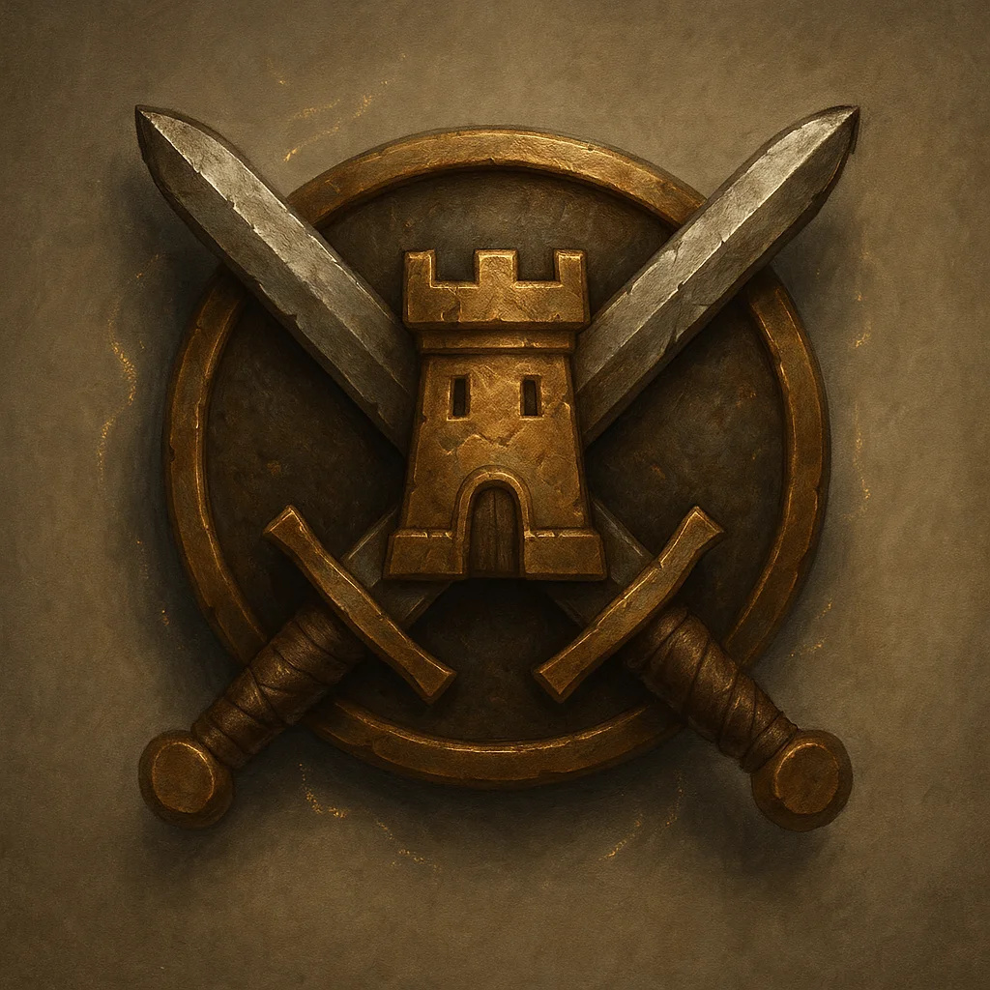

**Type:** Wondrous Item

**Rarity:** Uncommon

**Attunement:** No Attunement

**Properties:**

* +2 to Persuasion checks
* Free passage at borders
* Command respect
* Identifies wearer as

**Campaign:** Universal

**Signature NPC:** Border patrol officers

### 2: CLOAK OF ELVENKIND - SILVERPINE VARIANT

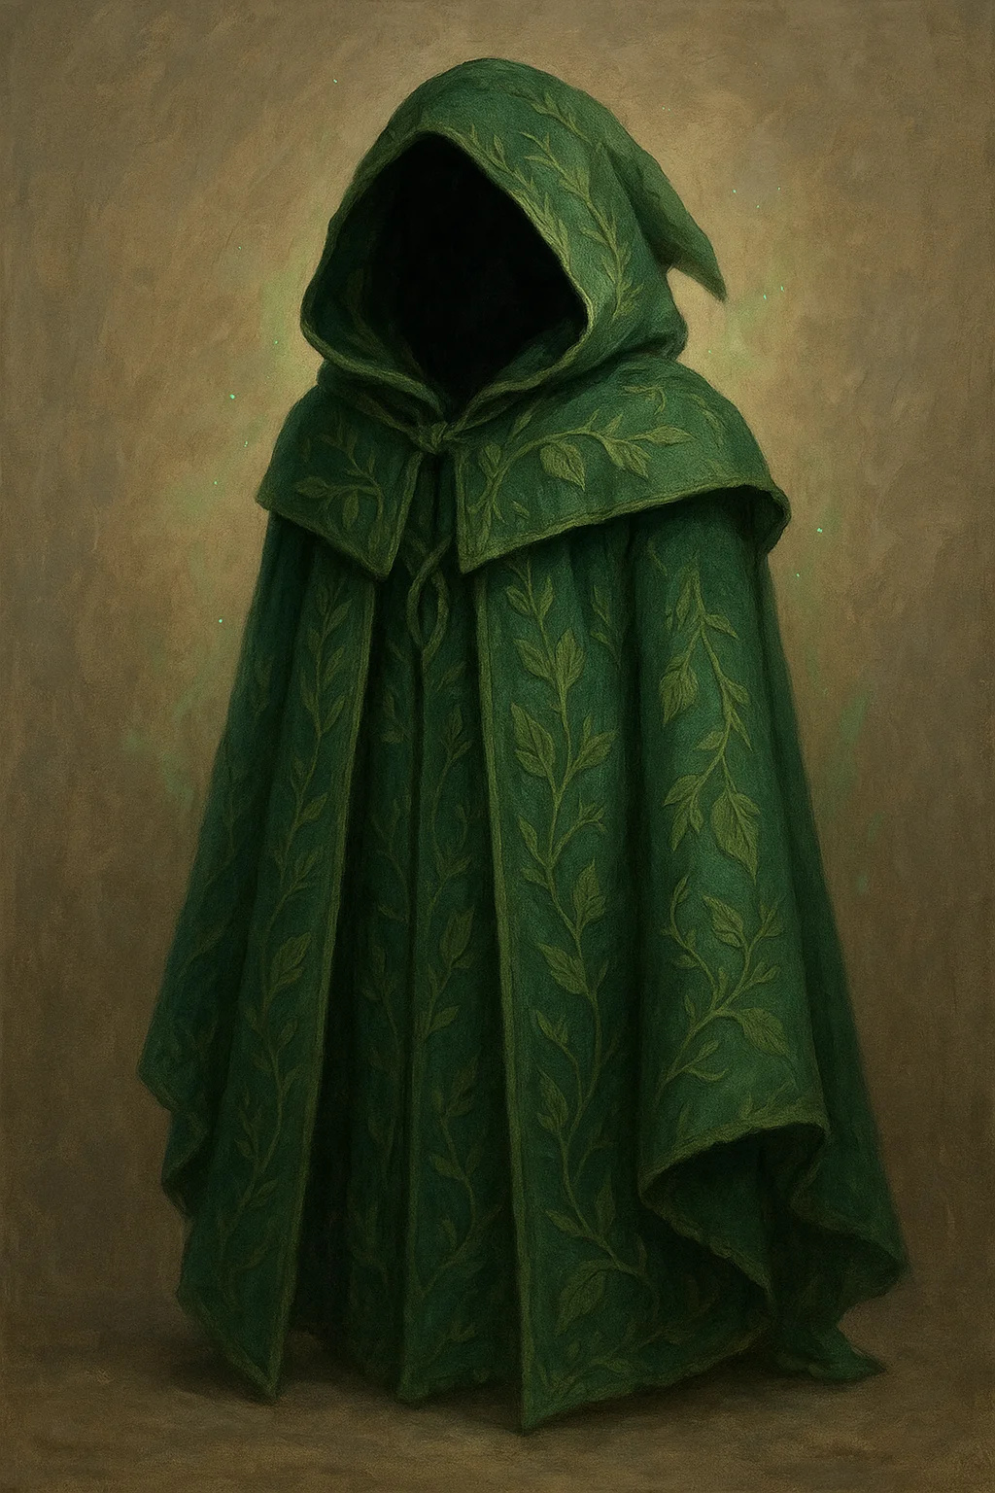

**Type:** Wondrous Item

**Rarity:** Uncommon

**Attunement:** No Attunement

**Properties:**

* Advantage on Stealth
* Pull hood to obscure face
* Forest green with leaf
* Silverpine craftsmanship
* Blends into nature

**Campaign:** Shattered Oaths

### 3: NECKLACE OF ADAPTATION

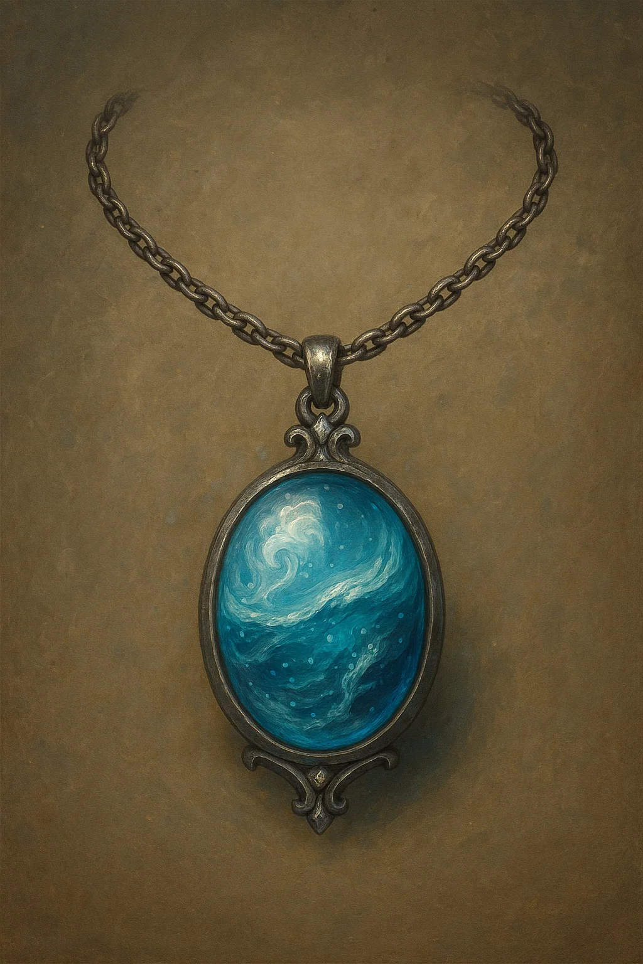

**Type:** Wondrous Item

**Rarity:** Uncommon

**Attunement:** No Attunement

**Properties:**

* Breathe in any environment
* Underwater, poison gas,
* Does NOT grant swim speed
* Ocean-themed design
* Perfect for Goldshore

**Campaign:** Shattered Oaths

**Signature NPC:** House Goldshore

### 4: POTION OF FIRE RESISTANCE

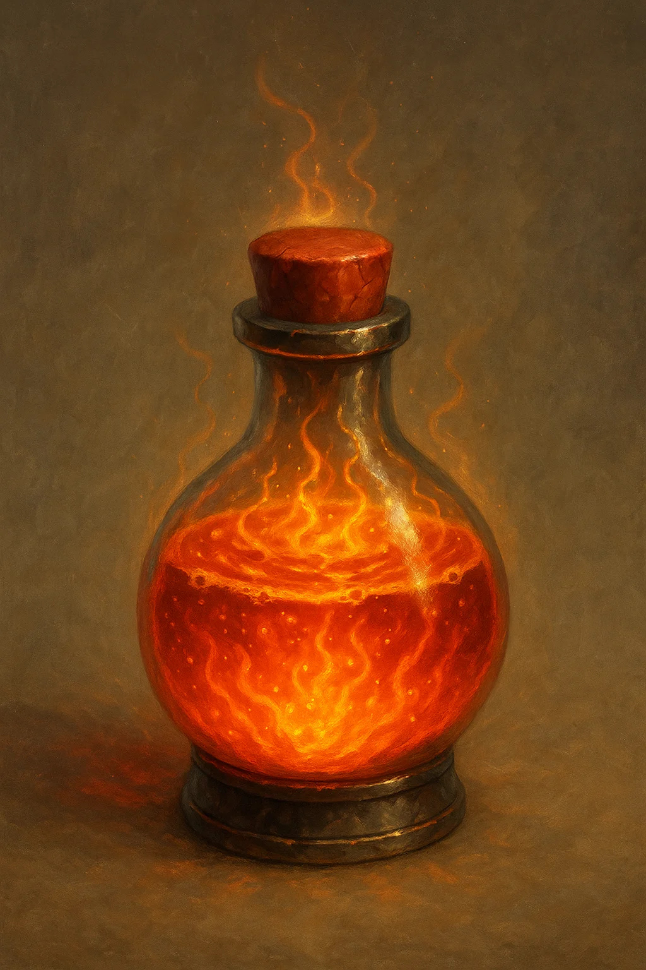

**Type:** Wondrous Item

**Rarity:** Uncommon

**Attunement:** No Attunement

**Properties:**

* Drink as action
* Grants fire resistance
* Orange flames swirl inside
* Heat smoke rises from cork
* Single use

**Campaign:** Universal

### 5: POTION OF GREATER HEALING

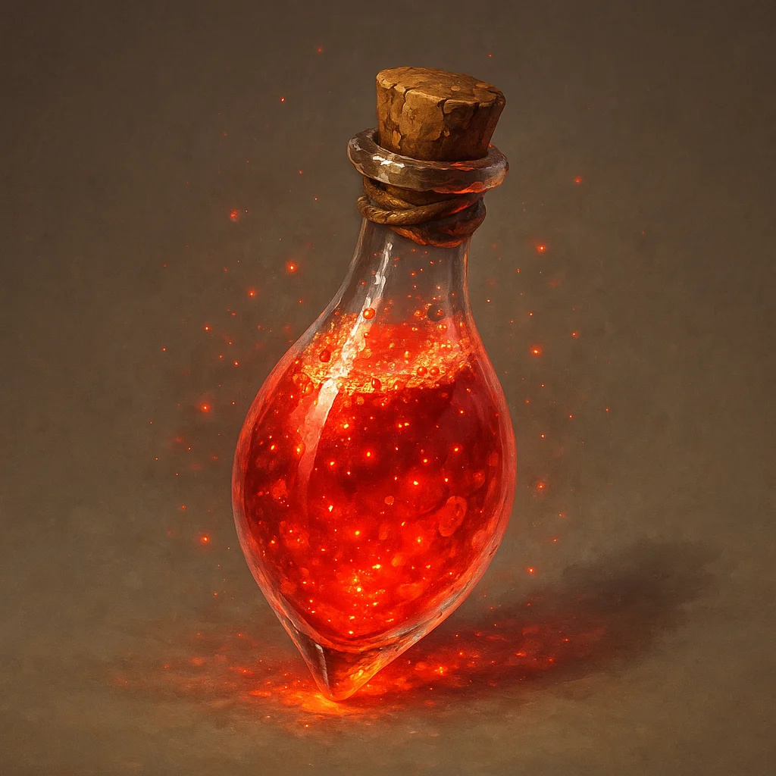

**Type:** Wondrous Item

**Rarity:** Uncommon

**Attunement:** No Attunement

**Properties:**

* Drink as action
* Heals 4d4+4 hit points
* Red liquid with sparkles
* Most common healing potion
* Single use

**Campaign:** Universal

### 6: RING OF MIND SHIELDING

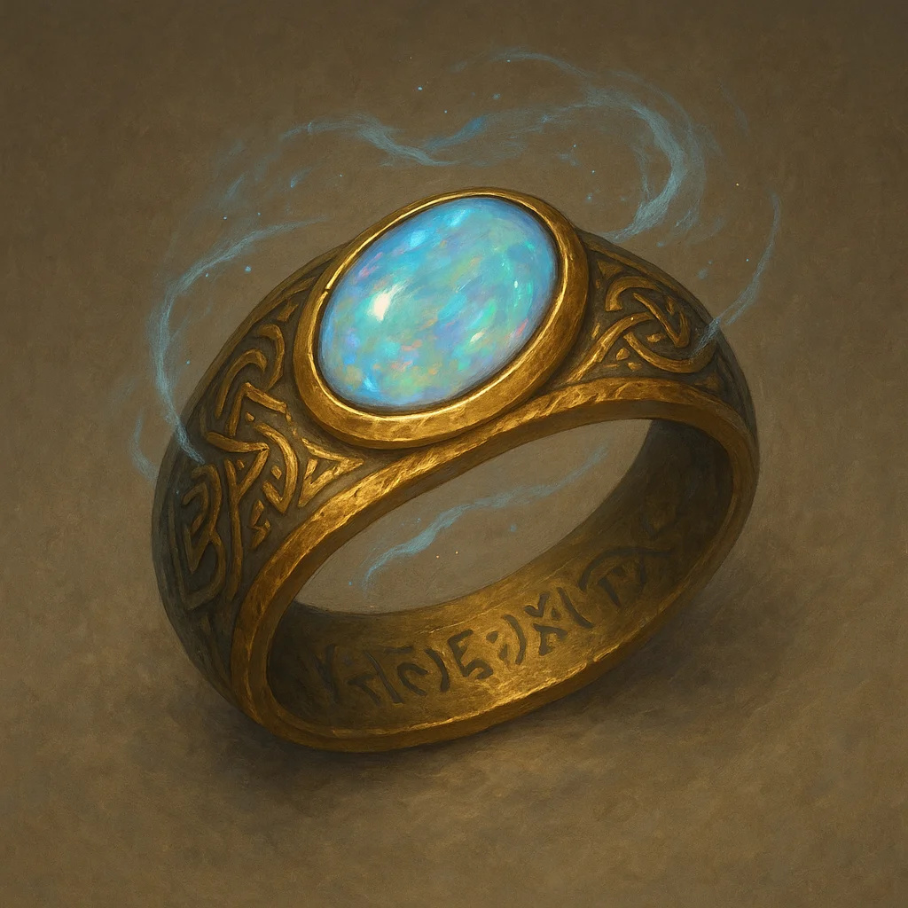

**Type:** Wondrous Item

**Rarity:** Uncommon

**Attunement:** No Attunement

**Properties:**

* Immune to magic reading
* Can't be detected by
* Soul trapped on death
* Communicate with soul

**Campaign:** Blood & Coin

### 7: WAND OF MAGIC MISSILES

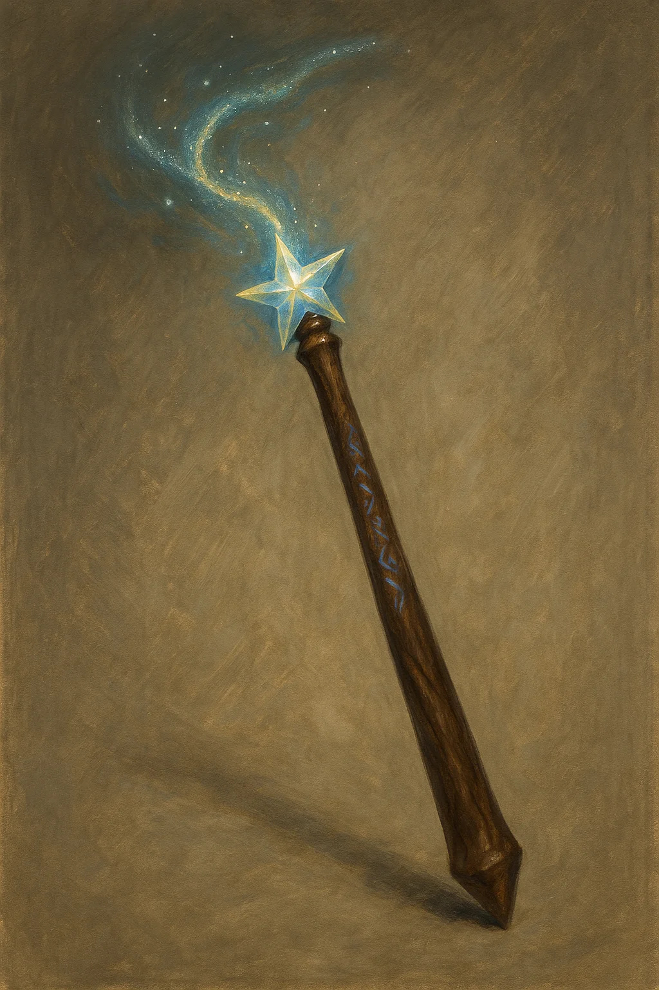

**Type:** Wondrous Item

**Rarity:** Uncommon

**Attunement:** No Attunement

**Properties:**

* 7 charges
* Cast Magic Missile:
* Regain 1d6+1 at dawn

**Campaign:** Universal

### 8: ADMIRAL'S TELESCOPE

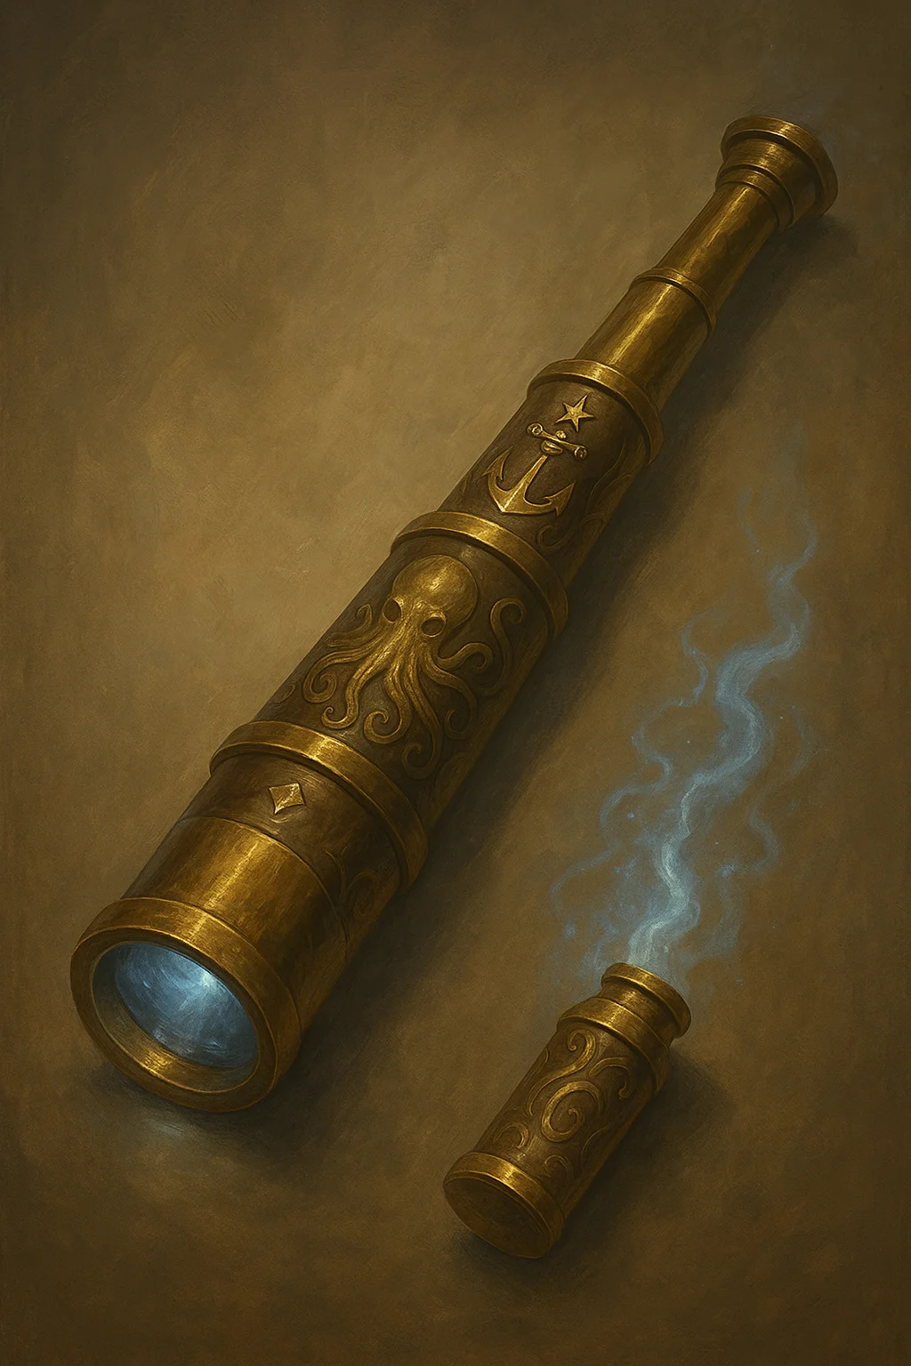

**Type:** Wondrous Item

**Rarity:** Rare

**Attunement:** No Attunement

**Properties:**

* See 10× normal distance
* Advantage on Perception
* Identify ships 5 miles out
* Brass nautical design
* House Goldshore heirloom

**Campaign:** Shattered Oaths

**Signature NPC:** House Goldshore

### 9: AMULET OF HEALTH

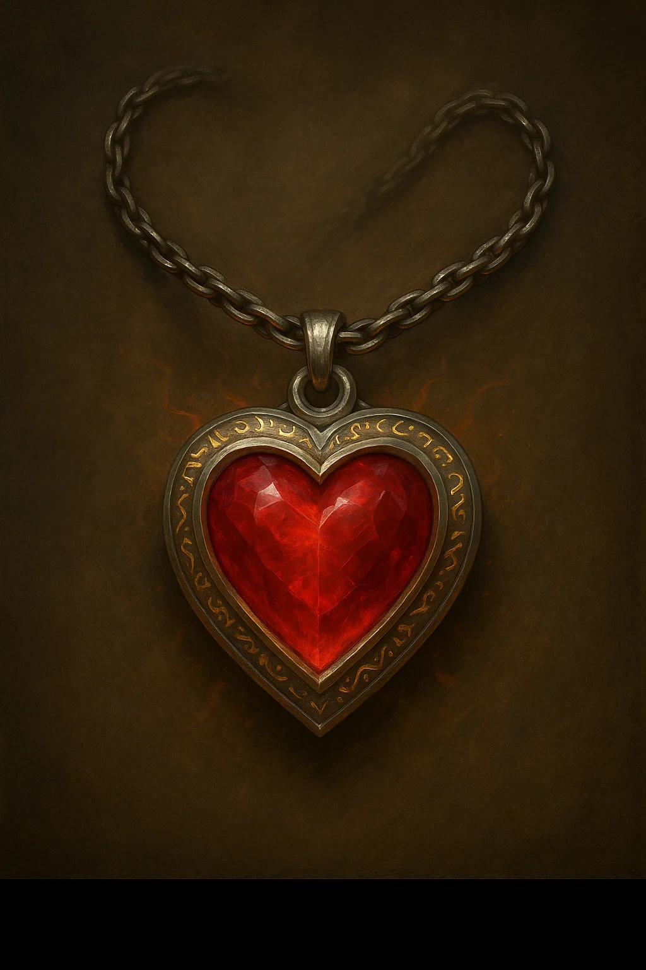

**Type:** Wondrous Item

**Rarity:** Uncommon

**Attunement:** No Attunement

**Properties:**

* Constitution becomes 19
* Does not stack with items
* Perfect for frail wizards
* Classic D&D item
* Red gemstone design

**Campaign:** Universal

### 10: CHAINS OF BINDING

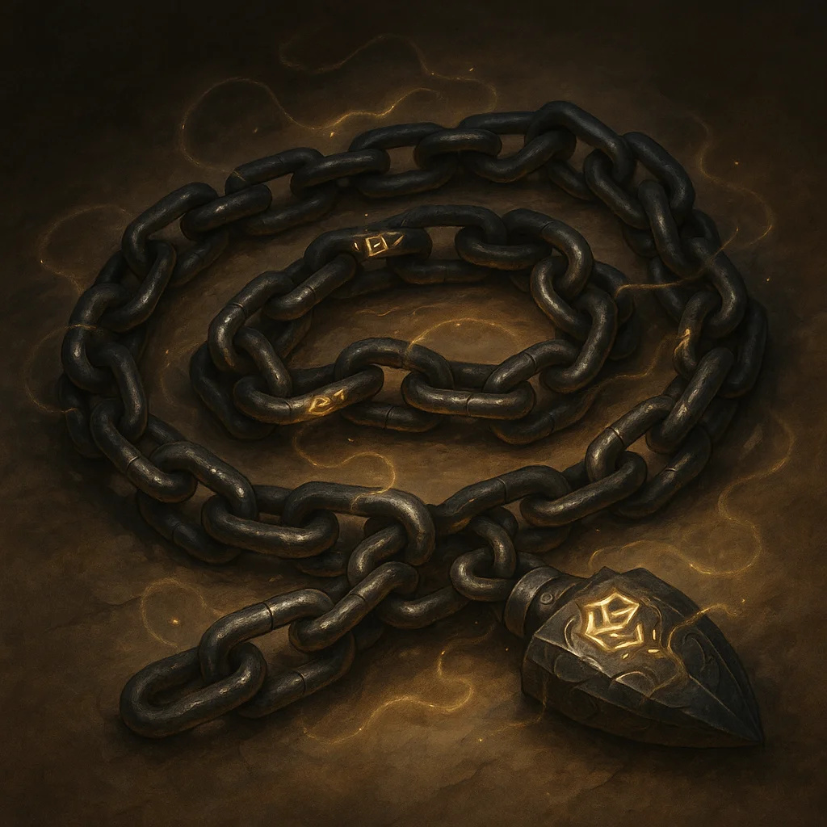

**Type:** Wondrous Item

**Rarity:** Rare

**Attunement:** No Attunement

**Properties:**

* DC 25 to break (STR)
* DC 25 to pick (Thieves')
* Suppresses abilities
* Extends up to 30 feet
* Cannot be broken by magic

**Campaign:** Shattered Oaths

### 11: DRAGON SLAYING ARROWS (SET OF 3)

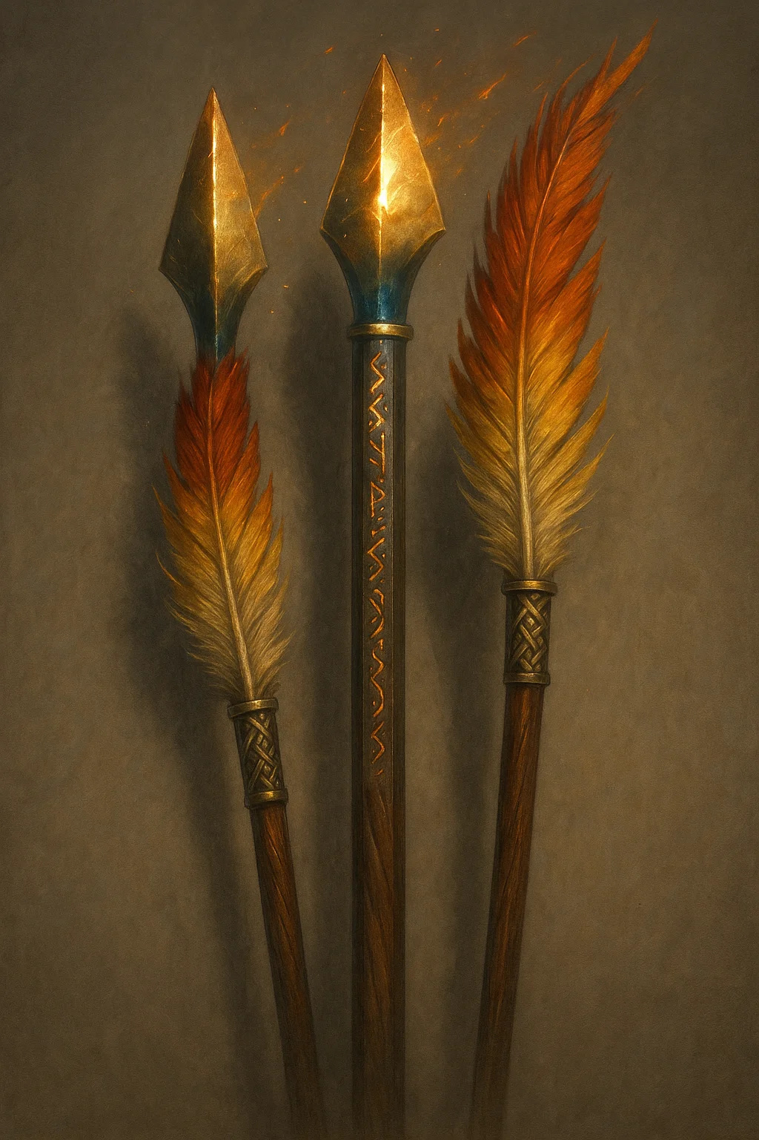

**Type:** Wondrous Item

**Rarity:** Uncommon

**Attunement:** No Attunement

**Properties:**

* +1 ammunition
* +6d10 damage vs dragons
* Phoenix feather fletching
* Golden glowing arrowheads
* Runic engravings on shaft

**Campaign:** Universal

### 12: DRAGON WARDING AMULETS (SET OF 4)

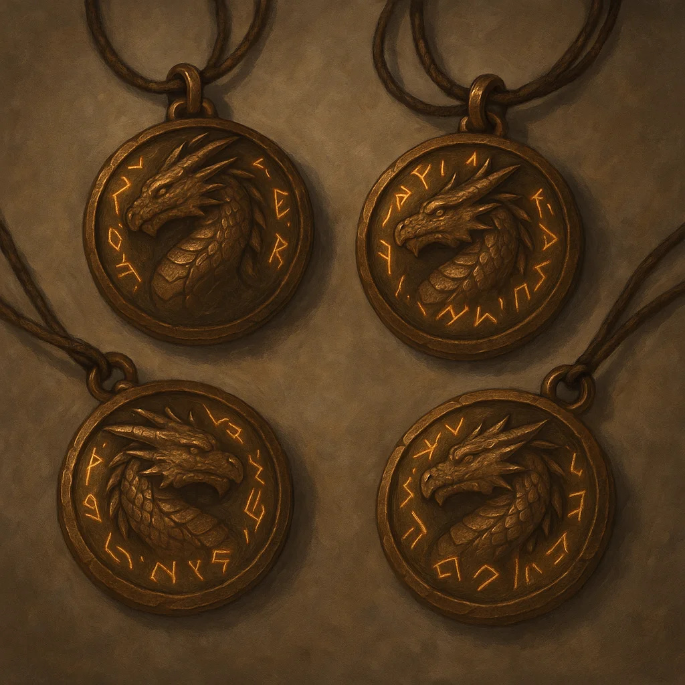

**Type:** Wondrous Item

**Rarity:** Uncommon

**Attunement:** No Attunement

**Properties:**

* 4 amulets, each different:
* Advantage vs Frightful
* Protection Energy 1/day

**Campaign:** Universal

### 13: FLAMING LONGSWORD - PHOENIX VARIANT

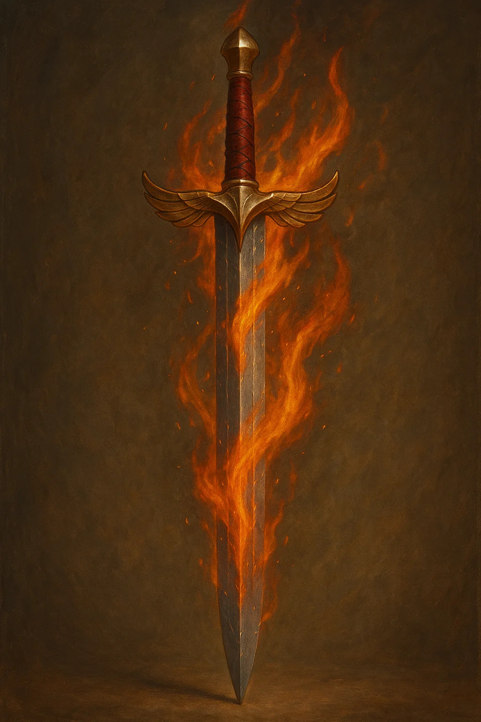

**Type:** Wondrous Item

**Rarity:** Uncommon

**Attunement:** No Attunement

**Properties:**

* +1 longsword
* Command word: ignite blade
* While lit: +2d6 fire dmg
* Bright light 40ft, dim 40'
* Phoenix wing crossguard

**Campaign:** Universal

### 14: MORNINGSTAR - HOLY RADIANT

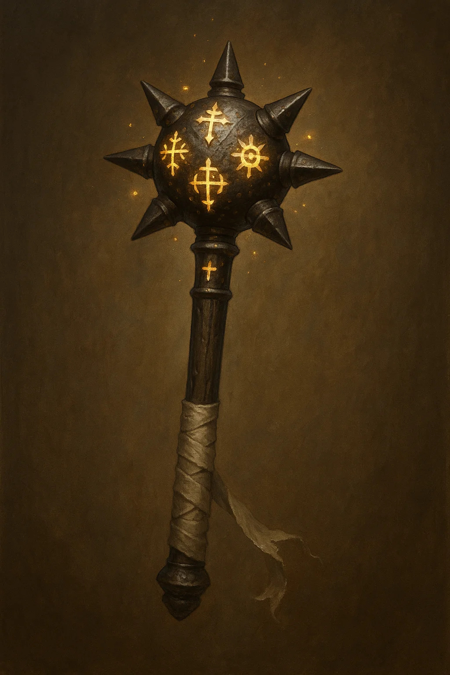

**Type:** Wondrous Item

**Rarity:** Uncommon

**Attunement:** No Attunement

**Properties:**

* +1 morningstar
* 1d8+1 bludgeoning +
* Advantage vs undead
* Sheds light 10/20ft
* Cast Daylight 1/day

**Campaign:** Universal

### 15: PROPHECY FRAGMENT

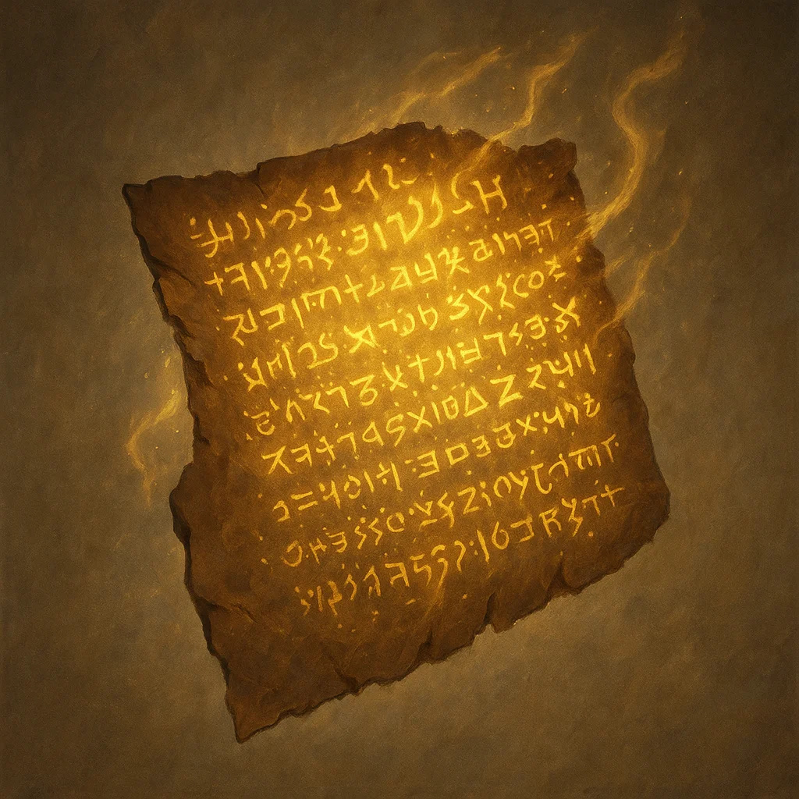

**Type:** Wondrous Item

**Rarity:** Rare

**Attunement:** No Attunement

**Properties:**

* Part 1 of 3 fragments
* Reveals portion of
* Glowing golden runes
* Weathered stone tablet
* Collect all 3 for truth

**Campaign:** Shattered Oaths

### 16: RED WOLF'S LONGBOW

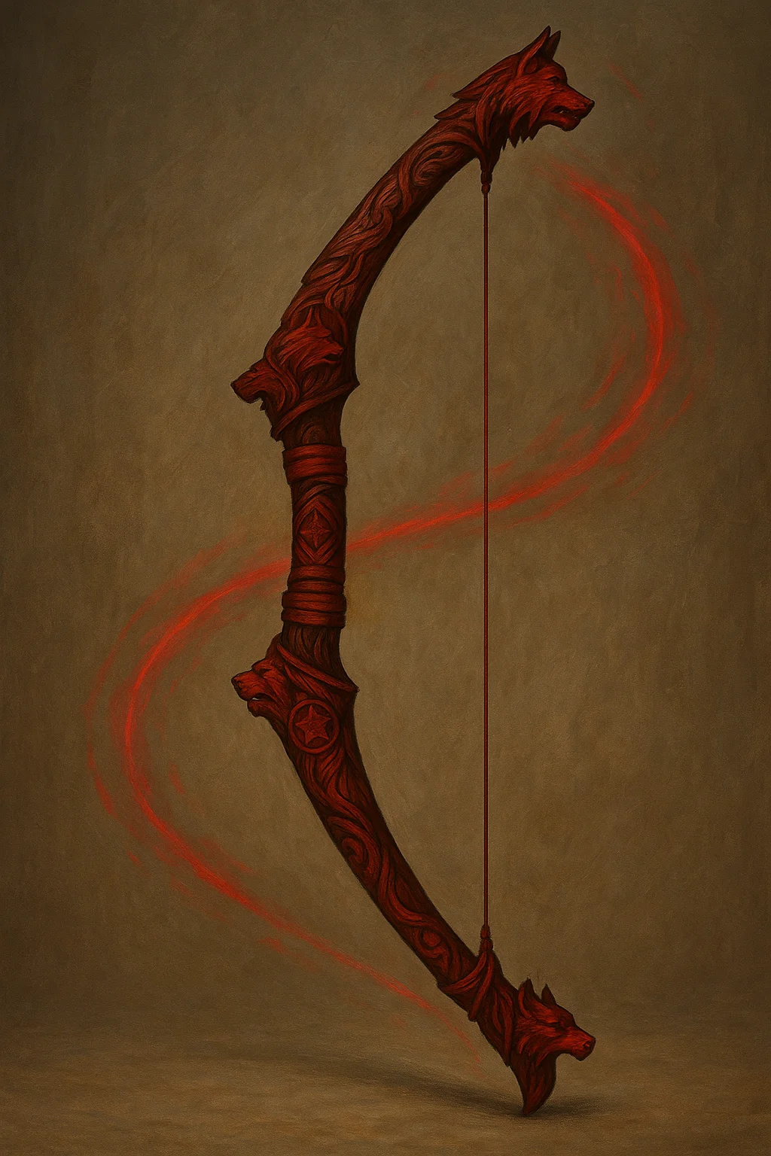

**Type:** Wondrous Item

**Rarity:** Uncommon

**Attunement:** No Attunement

**Properties:**

* +1 longbow
* 1d8+1 piercing damage
* Range 150/600 feet
* Dark wood with red accents
* Wolf motif carvings

**Campaign:** Blood & Coin

**Signature NPC:** Red Wolf rangers

### 17: RING OF PROTECTION - SEVEN GODS VARIANT

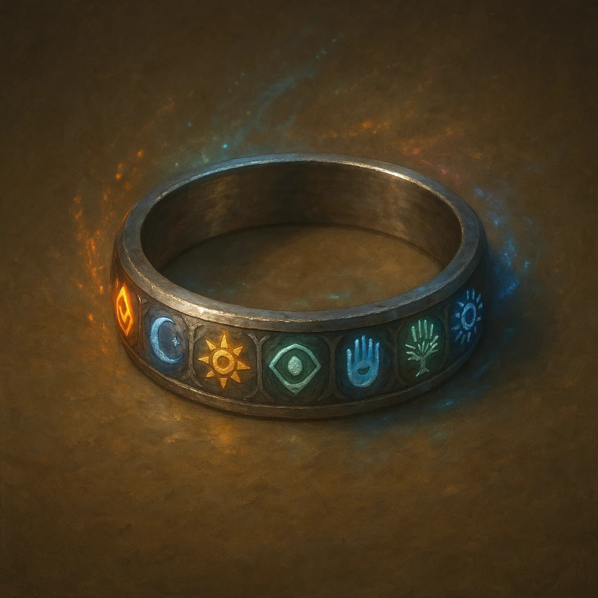

**Type:** Wondrous Item

**Rarity:** Uncommon

**Attunement:** No Attunement

**Properties:**

* +1 to AC and saving throws
* Seven colored gemstones
* Each = one of Seven Gods:
* UNIQUE TIRVANDOR DESIGN

**Campaign:** Shattered Oaths

### 18: RING OF SHADOWS

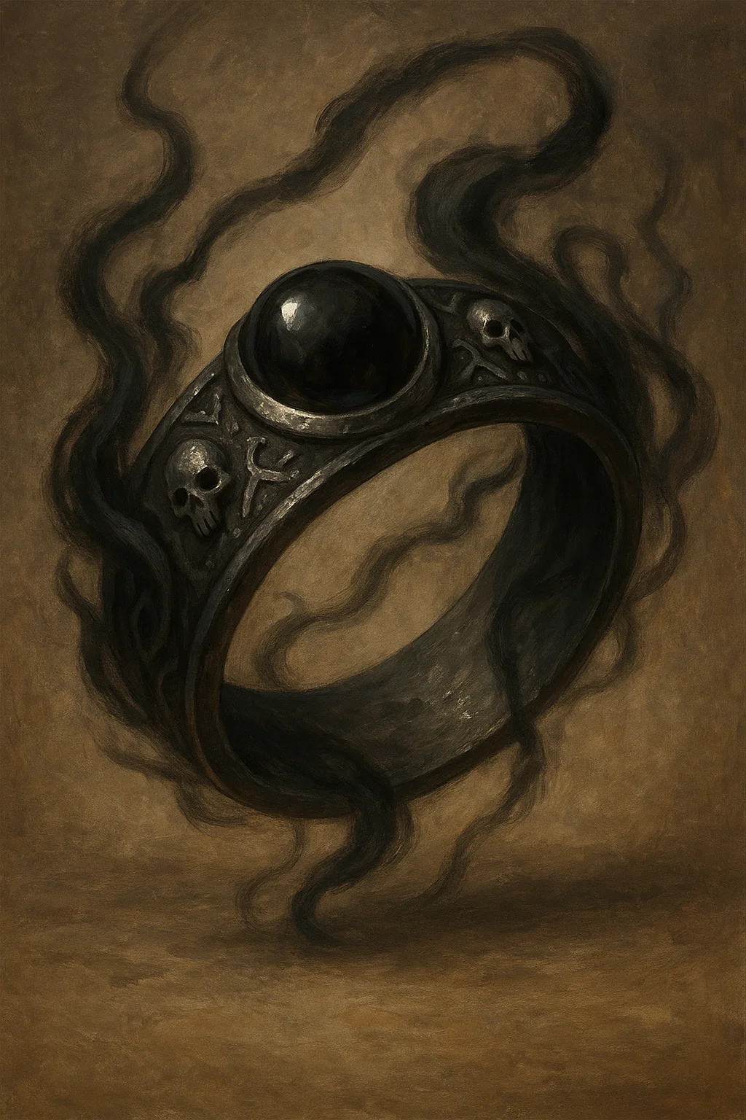

**Type:** Wondrous Item

**Rarity:** Uncommon

**Attunement:** No Attunement

**Properties:**

* Cast Invisibility 1/day
* Advantage on Stealth in
* Shadow tendrils when used
* Dark aesthetic
* Perfect for rogues

**Campaign:** Shattered Oaths

### 19: RING OF SPELL STORING



**Type:** Wondrous Item

**Rarity:** Uncommon

**Attunement:** No Attunement

**Properties:**

* Store up to 5 spell levels
* Anyone can cast stored
* Cosmic nebula stone
* Swirling colors inside
* Classic D&D utility item

**Campaign:** Universal

### 20: SCALES OF JUSTICE



**Type:** Wondrous Item

**Rarity:** Rare

**Attunement:** No Attunement

**Properties:**

* Cast Zone of Truth 1/day
* Advantage on Insight vs
* Symbol of law and order
* Used in official trials
* Glows when lie detected

**Campaign:** Shattered Oaths

### 21: BELT OF GIANT STRENGTH (FROST GIANT)

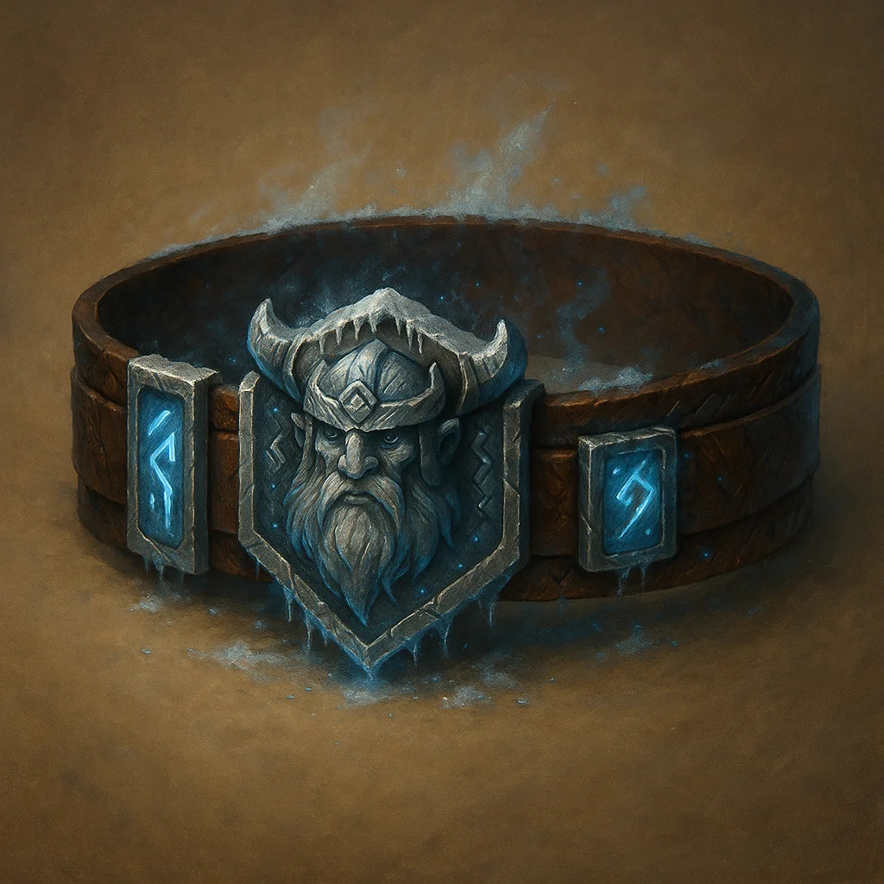

**Type:** Wondrous Item

**Rarity:** Very Rare

**Attunement:** No Attunement

**Properties:**

* Strength becomes 23
* Does not stack with items
* Classic D&D item
* Transforms weakling into

**Campaign:** Universal

### 22: CROWN OF THE DEPTHS

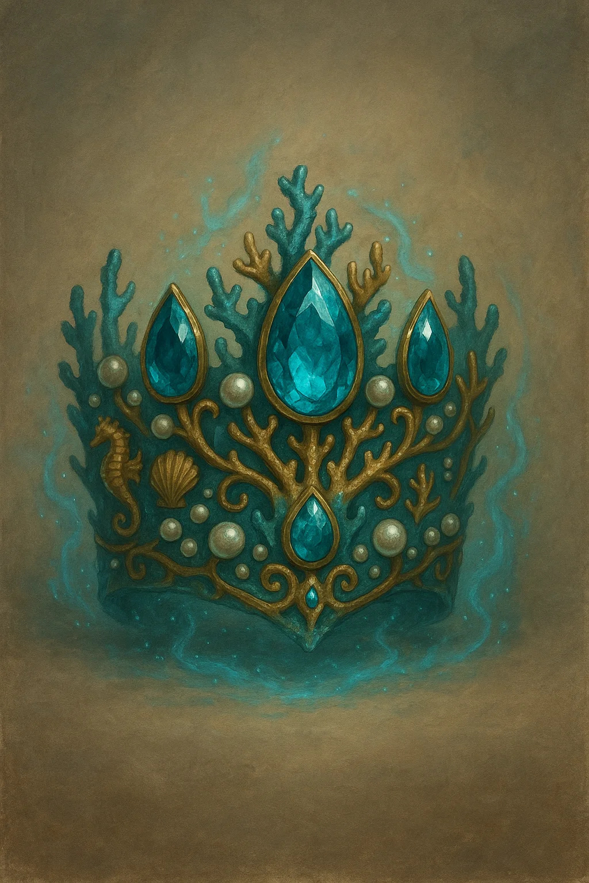

**Type:** Wondrous Item

**Rarity:** Legendary

**Attunement:** No Attunement

**Properties:**

* Water breathing
* Swim speed 60 feet
* Cast Control Water 1/day
* Freedom of Movement
* Summon Water Ele 1/week

**Campaign:** Shattered Oaths

**Signature NPC:** House Goldshore

### 23: ETERNAL WINTER SHARD

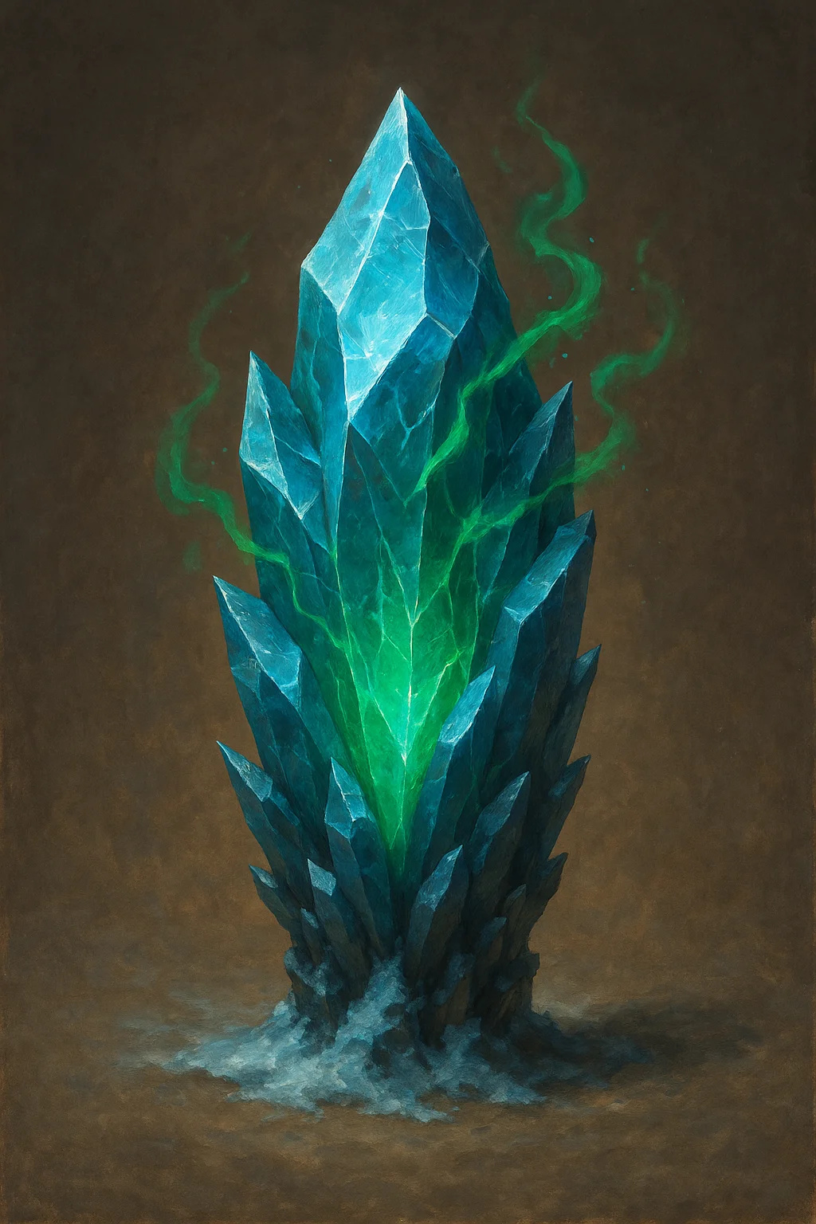

**Type:** Wondrous Item

**Rarity:** Very Rare

**Attunement:** No Attunement

**Properties:**

* Material component
* Resistance to cold damage
* Cast Ice Storm 1/day
* Cold spells +1d6 damage
* Freeze water permanently

**Campaign:** Universal

### 24: GOLDSHORE ANCESTRAL BLADE

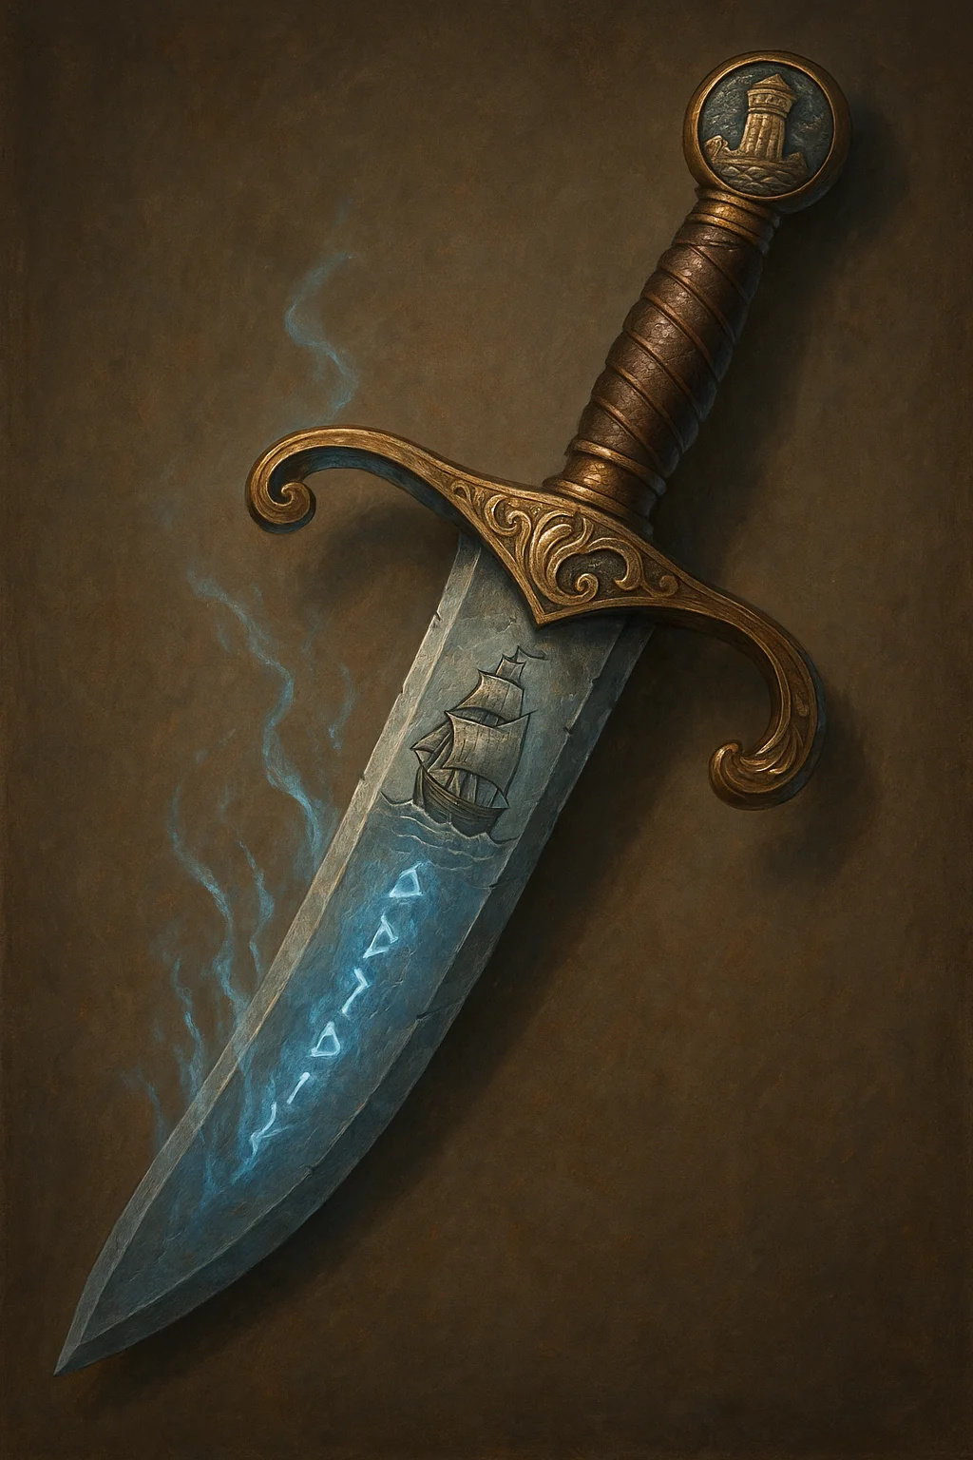

**Type:** Wondrous Item

**Rarity:** Uncommon

**Attunement:** No Attunement

**Properties:**

* +2 shortsword
* 1d6+2 slashing +
* Ship engraved on blade
* Lighthouse on pommel
* Grant swim = walk speed

**Campaign:** Shattered Oaths

**Signature NPC:** House Goldshore heir

### 25: ORB OF PROPHECY



**Type:** Wondrous Item

**Rarity:** Very Rare

**Attunement:** No Attunement

**Properties:**

* Cast Scrying 3/day
* Cast Divination 1/day
* Cast Commune 1/week
* Visions in swirling mists
* DC 15 Arcana to interpret

**Campaign:** Shattered Oaths

### 26: SHADOW RAPIER +2

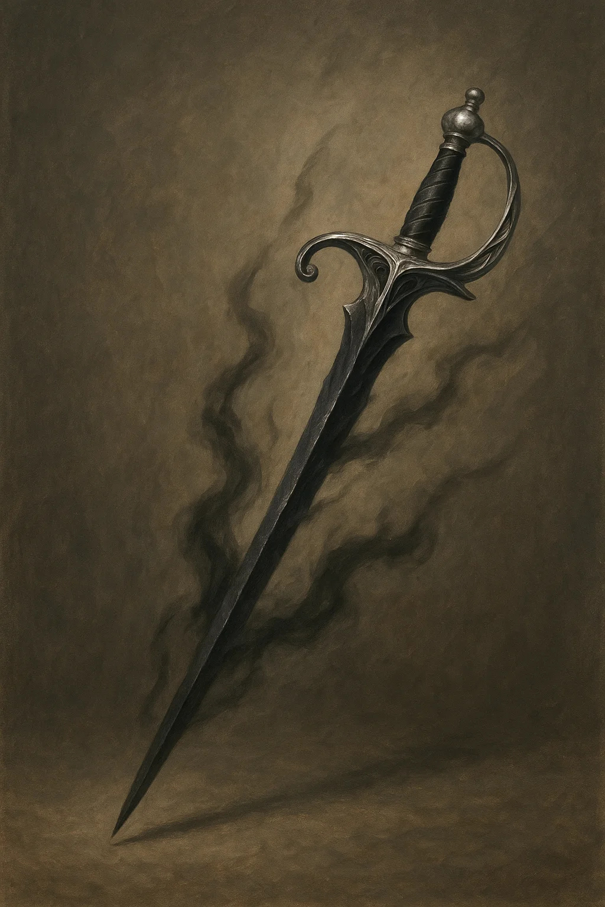

**Type:** Wondrous Item

**Rarity:** Uncommon

**Attunement:** No Attunement

**Properties:**

* +2 rapier
* 1d8+2 piercing +
* Advantage on Stealth
* Shadow Teleport bonus
* Lord Shadows' signature

**Campaign:** Shattered Oaths

**Signature NPC:** Lord Corvus Blackwood

### 27: STAFF OF CORVUS

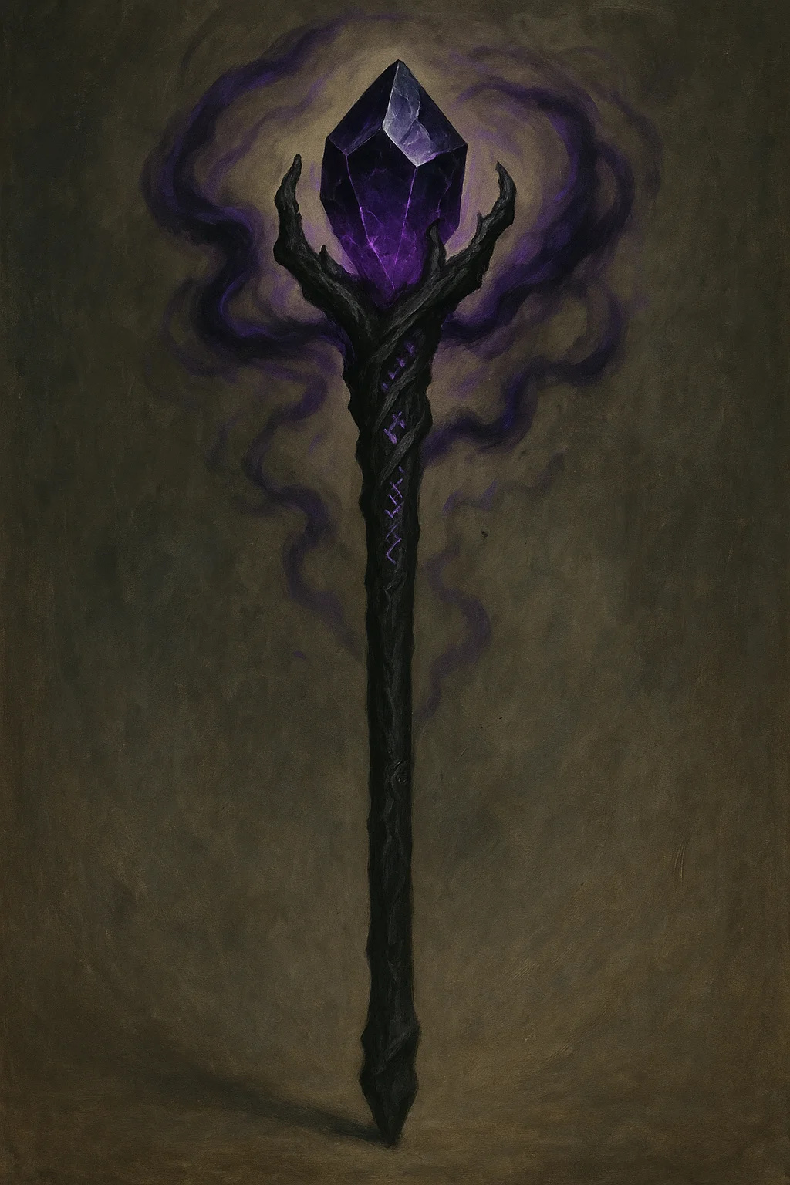

**Type:** Wondrous Item

**Rarity:** Uncommon

**Attunement:** No Attunement

**Properties:**

* +2 quarterstaff/focus
* Store 3 levels necromancy
* Advantage on necromancy
* Cast Animate Dead 1/day
* Purple crystal top

**Campaign:** Shattered Oaths

**Signature NPC:** Lord Corvus Blackwood

### 28: STAFF OF DYNASTIES

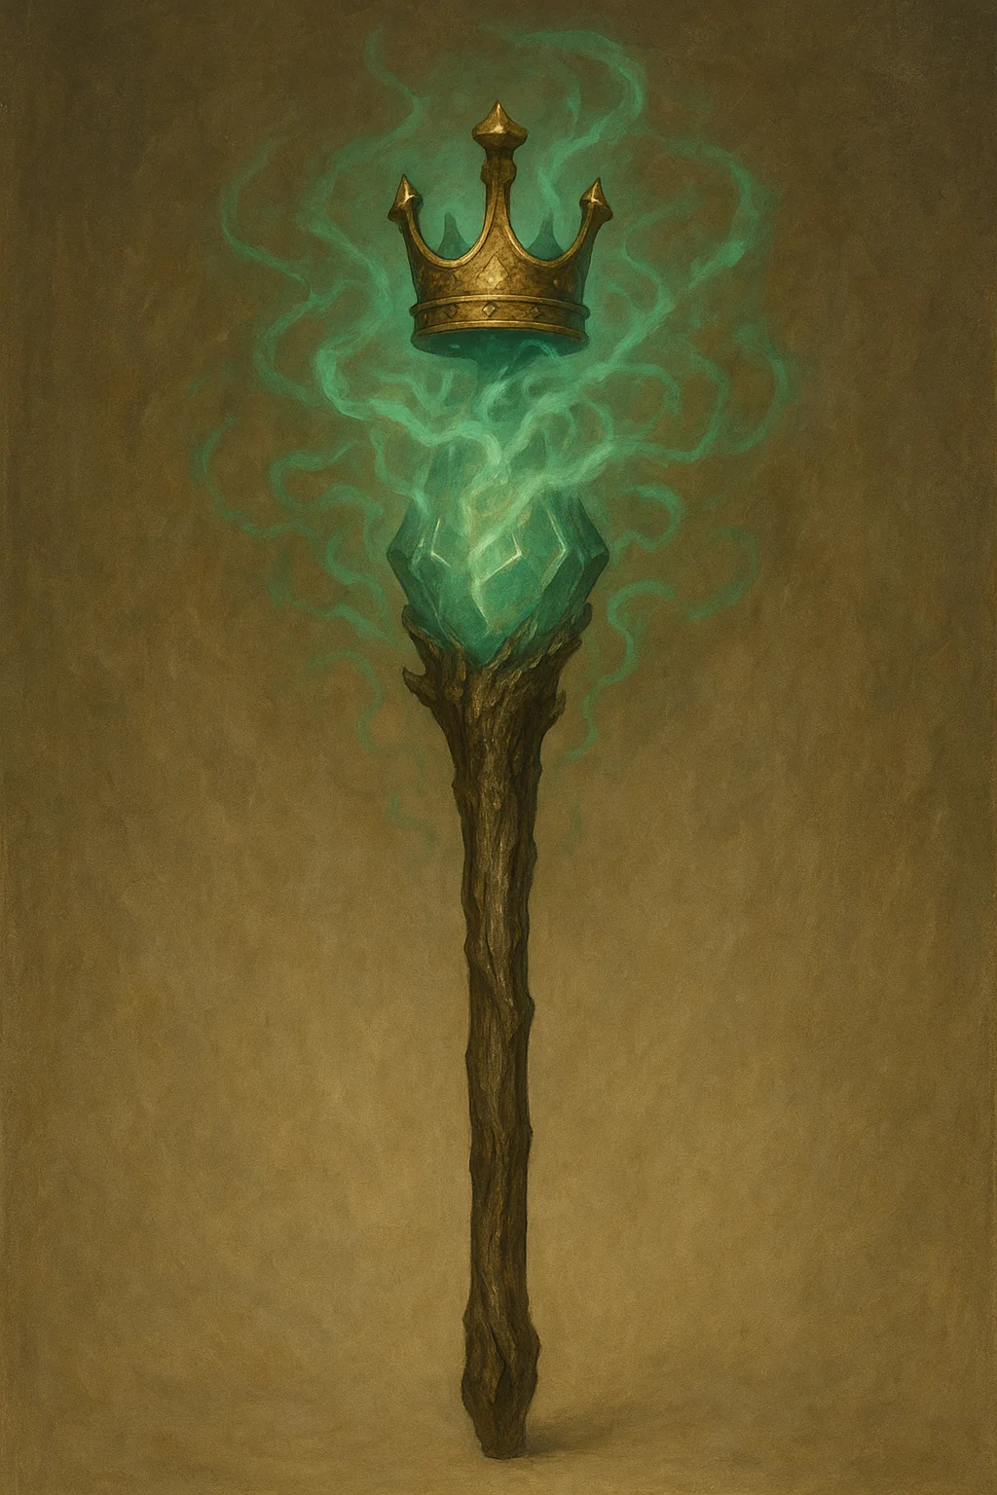

**Type:** Wondrous Item

**Rarity:** Uncommon

**Attunement:** No Attunement

**Properties:**

* +2 quarterstaff/focus
* Advantage Persuasion with
* Cast Legend Lore 1/day
* Reveals true bloodlines
* Crown and emerald design

**Campaign:** Universal

### 29: STAFF OF POWER

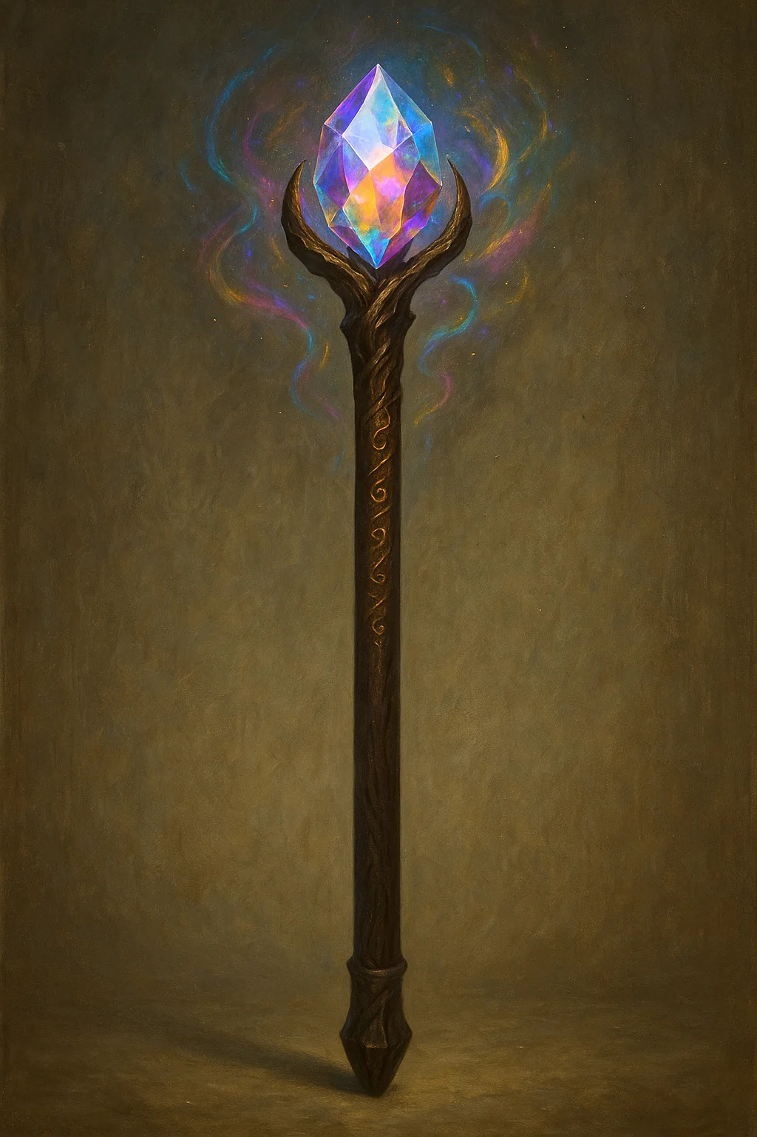

**Type:** Wondrous Item

**Rarity:** Uncommon

**Attunement:** No Attunement

**Properties:**

* +2 quarterstaff, +2 AC,
* 20 charges for spells
* Fireball, Lightning Bolt,
* Classic D&D legendary

**Campaign:** Universal

### 30: VOIDBLADE LONGSWORD

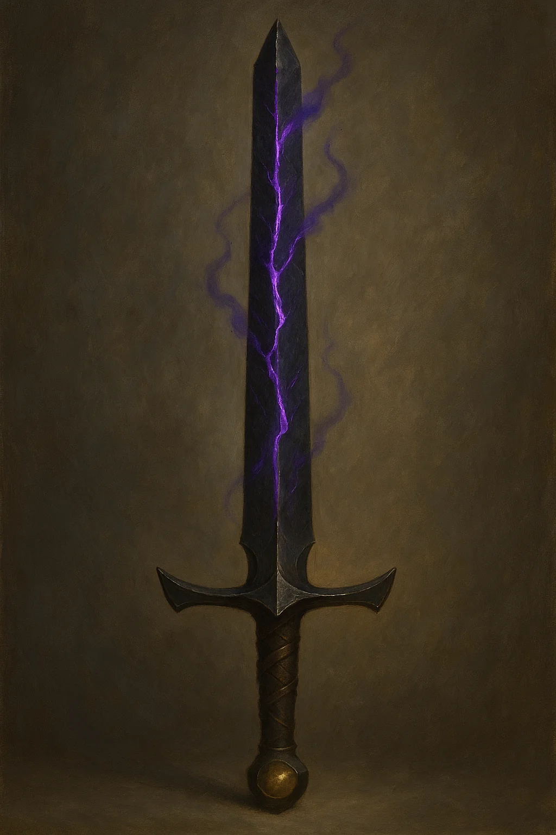

**Type:** Wondrous Item

**Rarity:** Uncommon

**Attunement:** No Attunement

**Properties:**

* +2 longsword
* 1d8+2 slashing +
* Ignores resistance to
* Dimension Door 1/day
* Crits: +2d8 force damage

**Campaign:** Universal

### 31: AMULET OF THE BLACK RAVEN

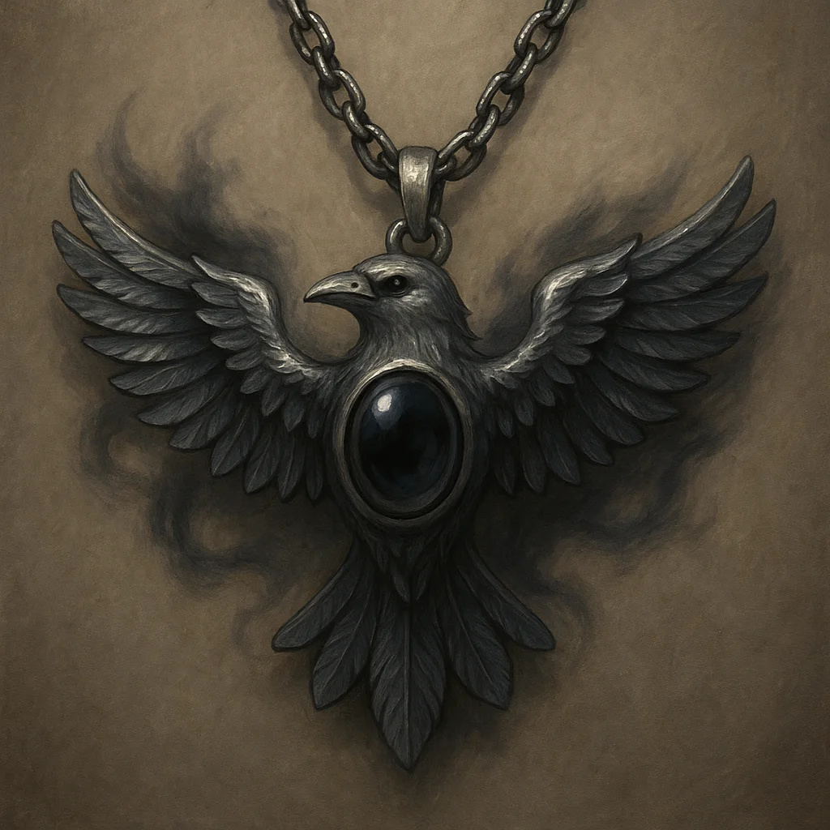

**Type:** Wondrous Item

**Rarity:** Uncommon

**Attunement:** No Attunement

**Properties:**

* +2 to all saving throws
* Immunity to divination
* Dimension Door 3/day
* Shadow Step ability
* Lord Shadows' phylactery

**Campaign:** Shattered Oaths

**Signature NPC:** Lord Corvus Blackwood

### 32: ARMOR OF THE UNBREAKABLE

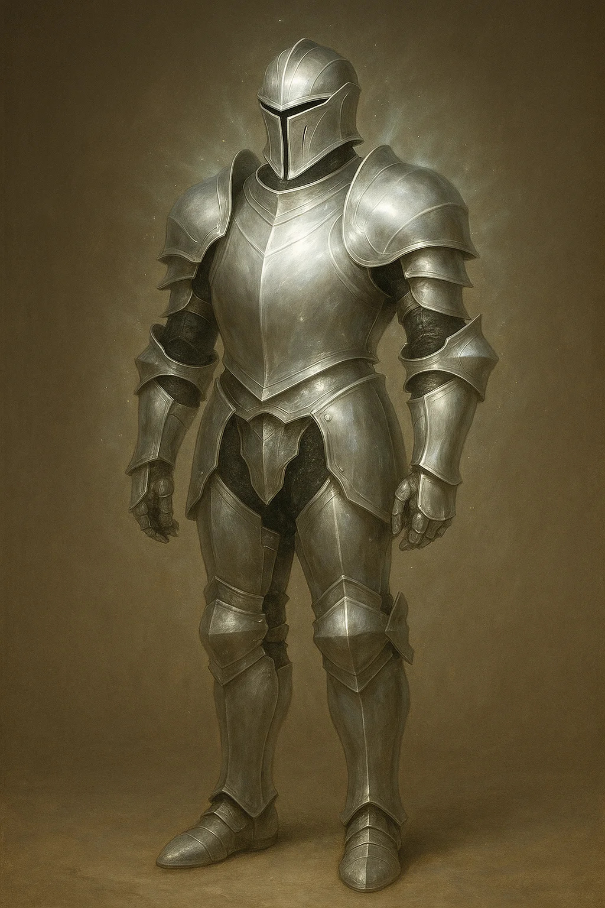

**Type:** Wondrous Item

**Rarity:** Uncommon

**Attunement:** No Attunement

**Properties:**

* +3 plate armor (AC 21)
* Resistance nonmagical dmg
* Immunity to critical hits
* Advantage vs being prone
* Cannot be broken/damaged
* Cannot be moved vs will

**Campaign:** Universal

### 33: BOOK OF FORGOTTEN NAMES

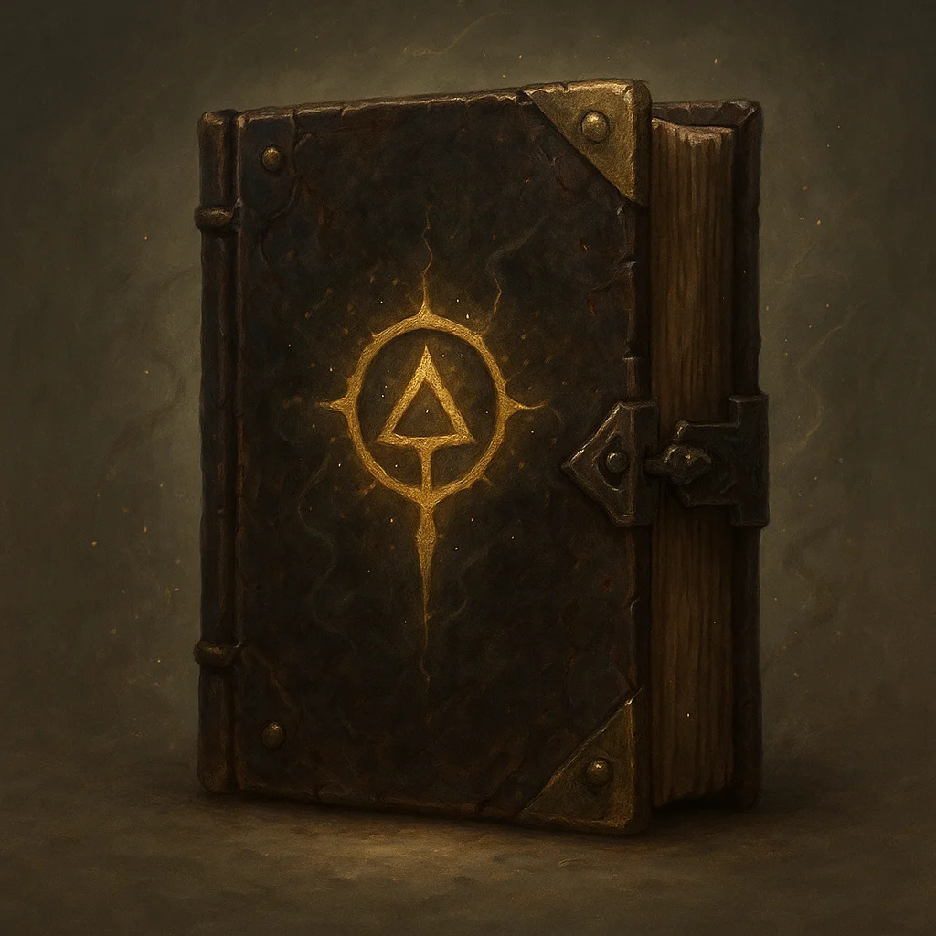

**Type:** Wondrous Item

**Rarity:** Legendary

**Attunement:** No Attunement

**Properties:**

* Contains 20 spells (1-9)
* Learn: DC 15 Arcana check
* Each spell: DC 12 Wis save
* Reveals true names
* Cast Legend Lore 3/day

**Campaign:** Shattered Oaths

### 34: CLOAK OF INVISIBILITY

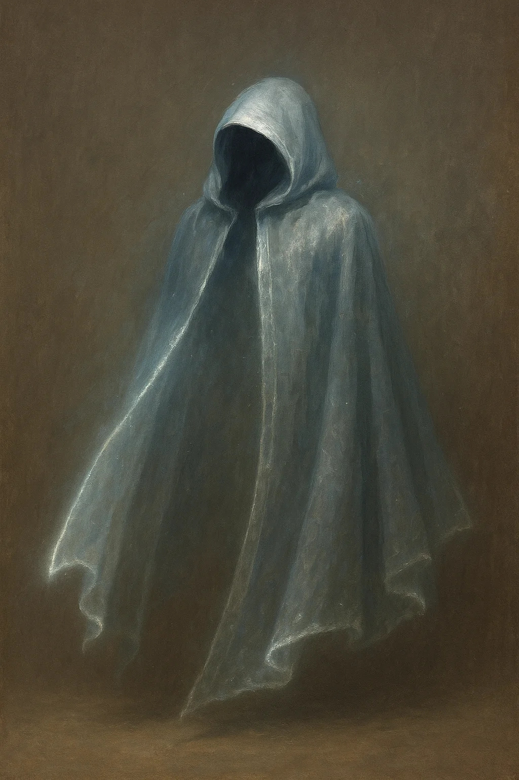

**Type:** Wondrous Item

**Rarity:** Legendary

**Attunement:** No Attunement

**Properties:**

* Pull hood: become
* No duration limit
* Attacks/spells end effect
* Classic D&D legendary item
* Ultimate stealth tool

**Campaign:** Universal

### 35: CROWN JEWELS OF THALDROS

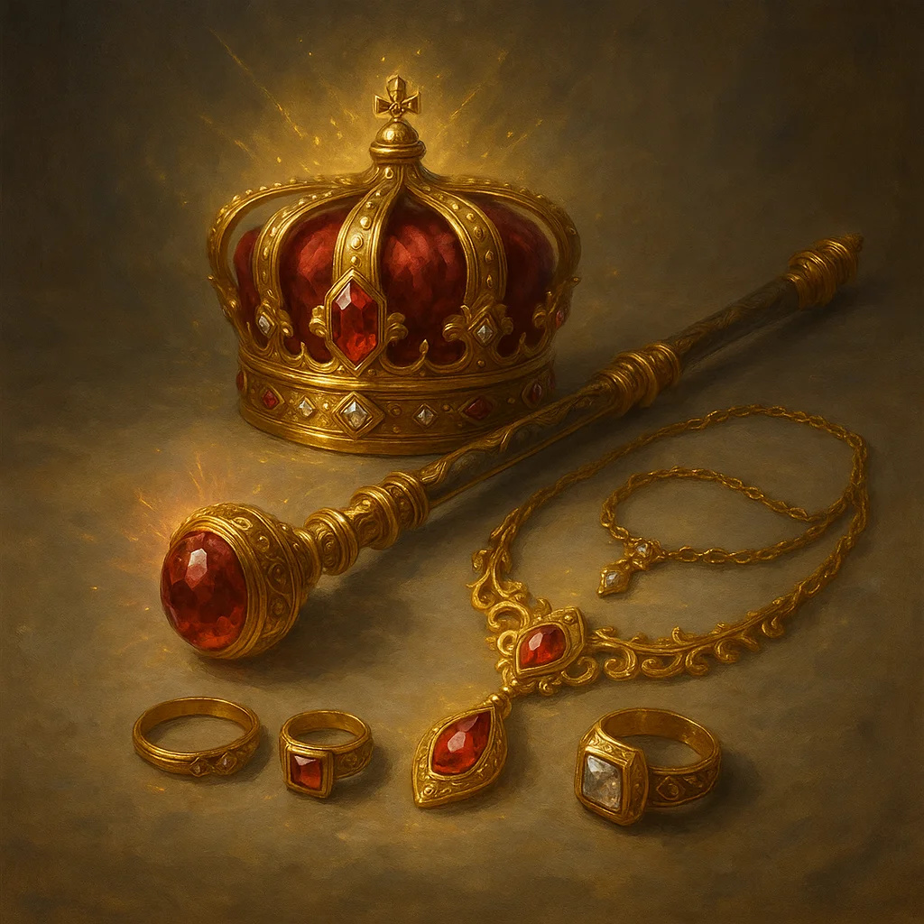

**Type:** Wondrous Item

**Rarity:** Legendary

**Attunement:** No Attunement

**Properties:**

* Symbol of royal authority
* +3 to Persuasion/Intimid
* Cast Command at will
* Cast Geas 1/week
* Only lawful can attune

**Campaign:** Shattered Oaths

**Signature NPC:** King of Thaldros

### 36: DREAD KING'S CROWN

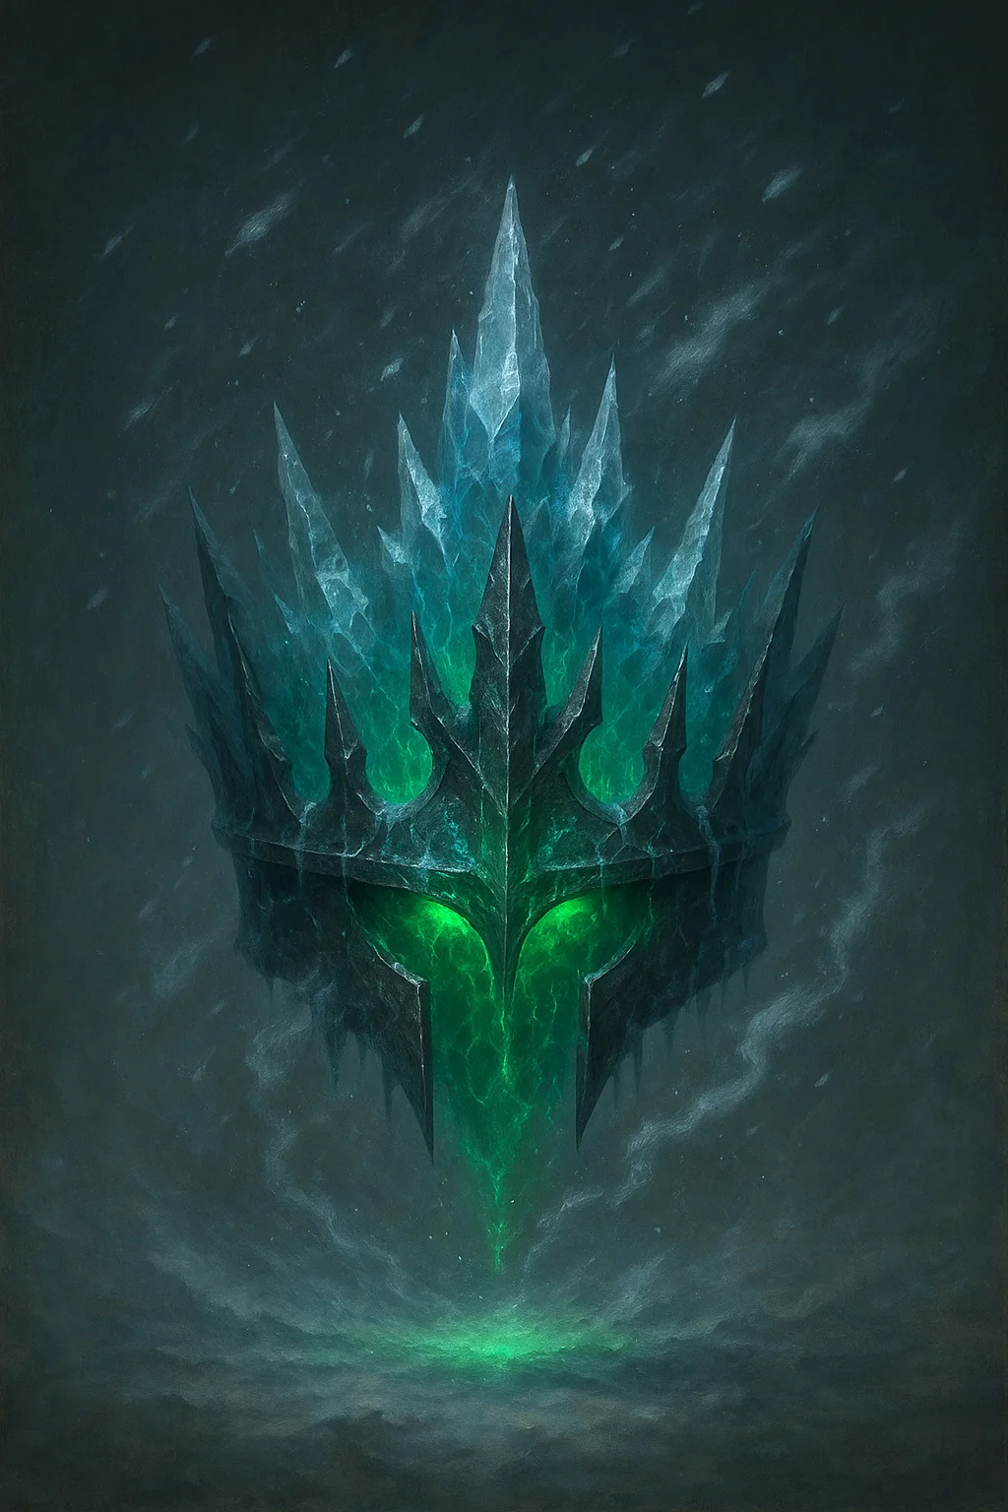

**Type:** Wondrous Item

**Rarity:** Legendary

**Attunement:** No Attunement

**Properties:**

* +3 to cold/necrotic DC
* Immunity to cold damage
* Aura: 30ft Sleet Storm
* Command undead 60ft
* Cast Cone of Cold at will
* ICE LICH ARTIFACT

**Campaign:** Villain Artifact

### 37: LORD SHADOWS' VOID STAFF

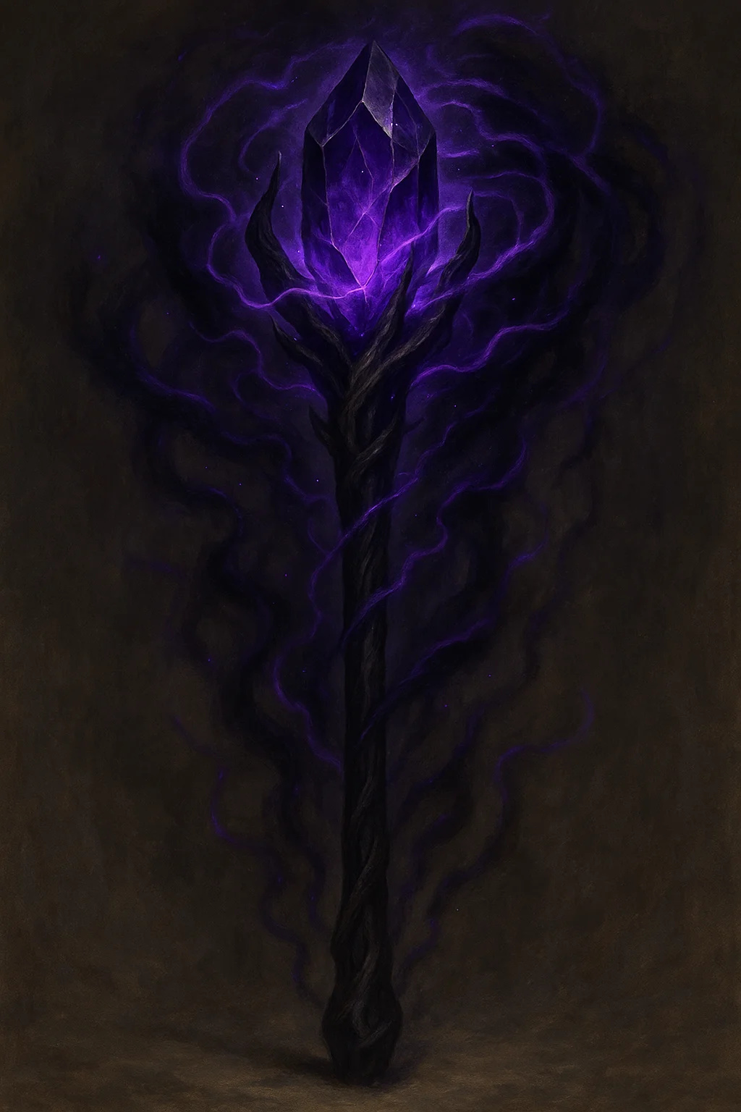

**Type:** Wondrous Item

**Rarity:** Uncommon

**Attunement:** No Attunement

**Properties:**

* +3 quarterstaff/focus
* Void spells cast at +2 lvl
* Hunger of Hadar at will
* Finger of Death 1/day
* Crits: banish to void
* CORRUPTS: Daily Wis save

**Campaign:** Shattered Oaths

**Signature NPC:** Lord Shadows (boss form)

### 38: MERCY'S EDGE

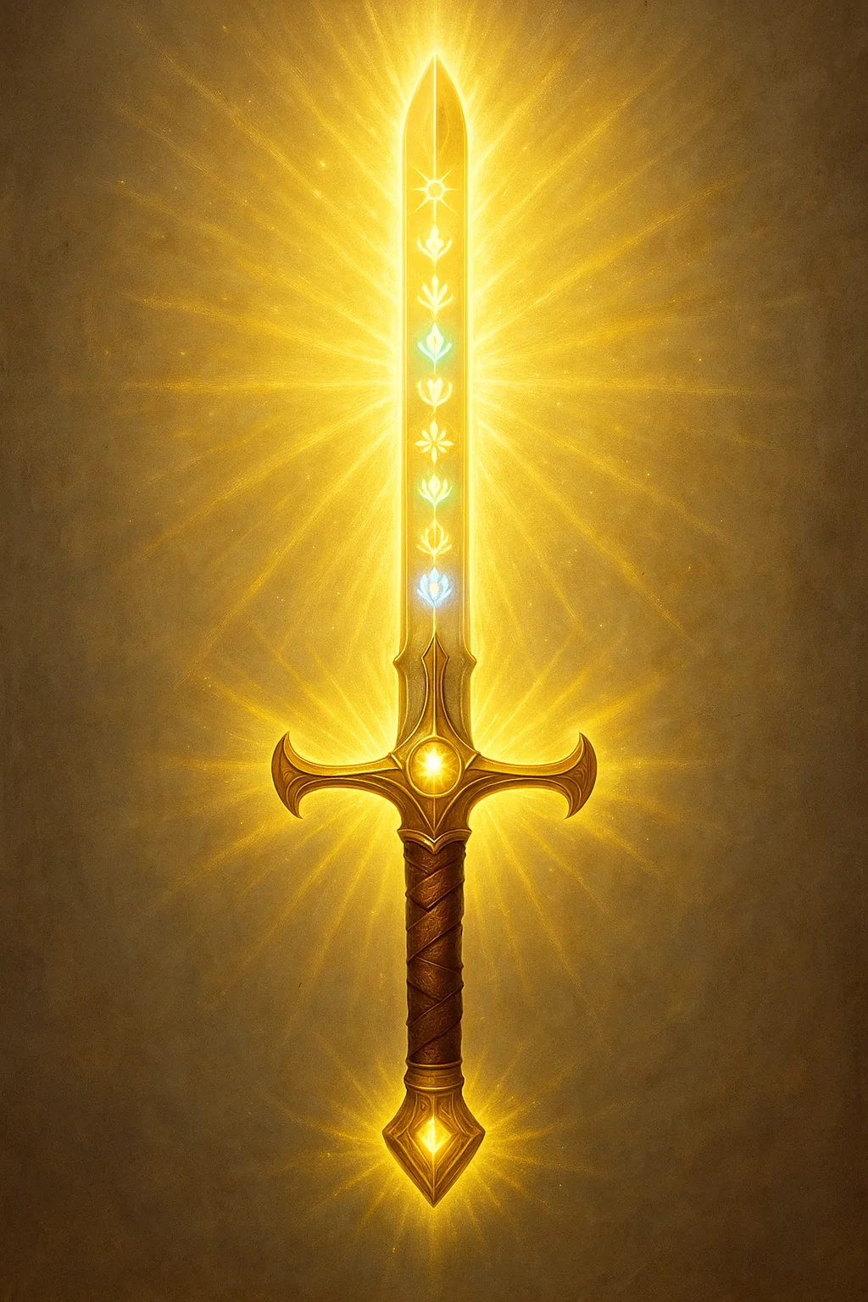

**Type:** Wondrous Item

**Rarity:** Uncommon

**Attunement:** No Attunement

**Properties:**

* +3 longsword
* 1d8+3 slashing +
* Advantage vs undead/fiends
* Immunity to fear
* Dispel Evil/Good 1/day
* SEVEN GODS BLESSING

**Campaign:** Shattered Oaths

### 39: NECROMANCER LORD'S PHYLACTERY

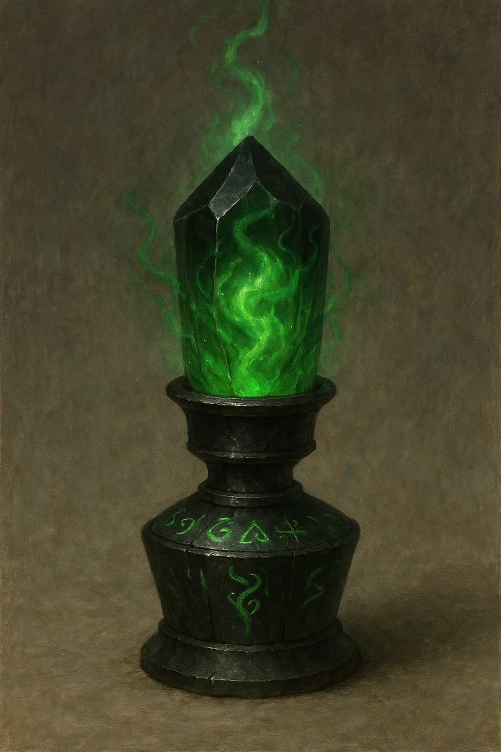

**Type:** Wondrous Item

**Rarity:** Legendary

**Attunement:** No Attunement

**Properties:**

* Soul container for lich
* Cannot be destroyed by
* Lich reforms if this
* QUEST OBJECTIVE
* Multiple protections

**Campaign:** Universal

### 40: SCEPTER OF RULERSHIP

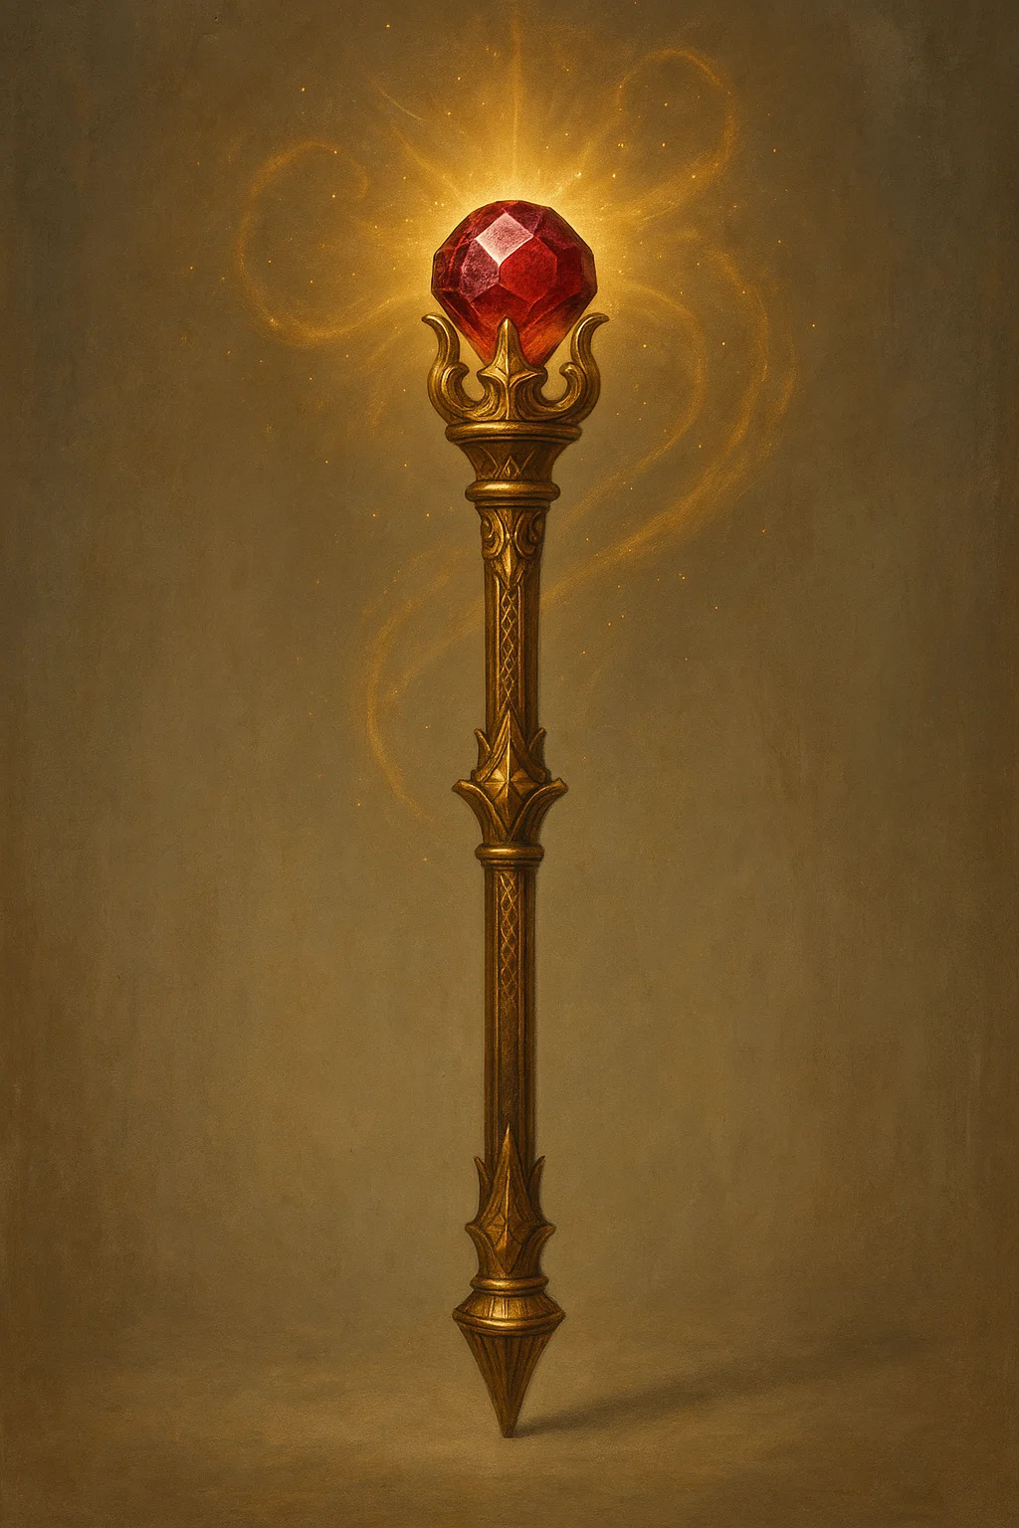

**Type:** Wondrous Item

**Rarity:** Legendary

**Attunement:** No Attunement

**Properties:**

* +3 Persuasion/Intimidation
* Command 500 people at once
* Cast Command at will
* Mass Suggestion 1/day
* Cast Geas 1/week
* Ruby gemstone top

**Campaign:** Blood & Coin

**Signature NPC:** Kings, nobles

### 41: UNBOUND DARK BLADE

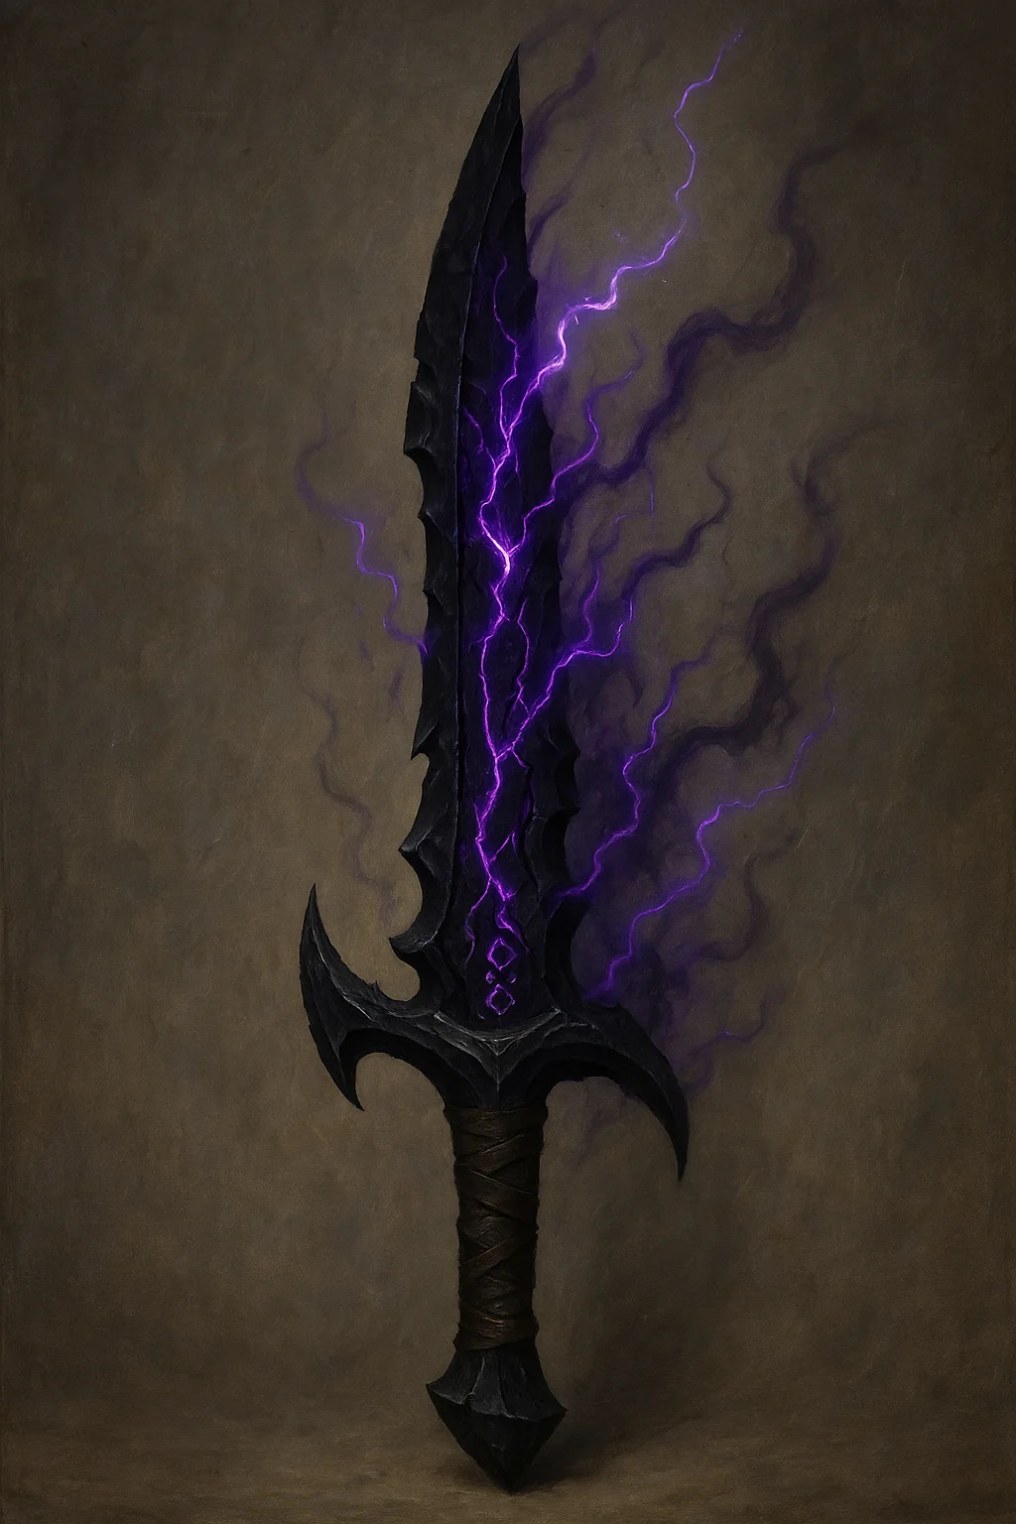

**Type:** Wondrous Item

**Rarity:** Uncommon

**Attunement:** No Attunement

**Properties:**

* +3 longsword (CURSED)
* 1d8+3 slash + 2d8 lightning
* Cannot remove w/o Remove
* Whispers: DC 15 Wis daily
* Chain Lightning 1/day

**Campaign:** Villain Artifact

### 42: THE WORLD SPLITTER (COMPLETE)

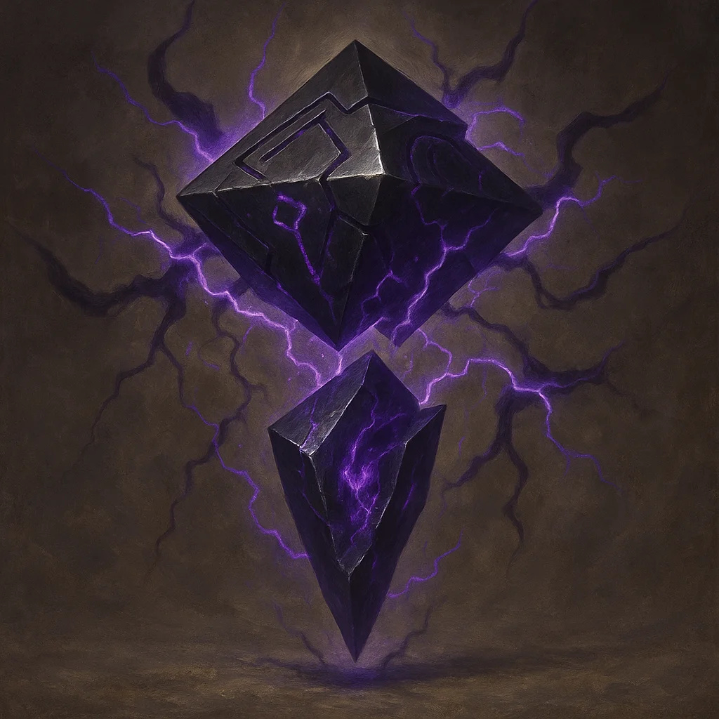

**Type:** Wondrous Item

**Rarity:** Uncommon

**Attunement:** No Attunement

**Properties:**

* Two pyramids floating
* Purple lightning between
* Split Thaldros/Aethoria
* Cannot be destroyed
* Activation = world ends
* CAMPAIGN MACGUFFIN

**Campaign:** Shattered Oaths

### LAYOUT



**Type:** Wondrous Item

**Rarity:** Uncommon

**Attunement:** No Attunement

**Campaign:** Universal

## Treasure Tables by CR

Use these tables to generate appropriate treasure for encounters.

|  |  |  |  |
| --- | --- | --- | --- |
| **CR** | **Coins (gp)** | **Magic Items** | **Avg Total Value** |
| 0-4 | 50-200 | Common (1d4) | 300-500 gp |
| 5-7 | 500-1,000 | Uncommon (1d3) | 1,500-2,500 gp |
| 8-10 | 1,000-2,500 | Uncommon (1d4), Rare (1d2) | 5,000-8,000 gp |
| 11-13 | 2,500-7,500 | Rare (1d3) | 12,000-20,000 gp |
| 14-16 | 7,500-15,000 | Rare (1d4), Very Rare (1) | 35,000-55,000 gp |
| 17-19 | 15,000-50,000 | Very Rare (1d3) | 80,000-120,000 gp |
| 20+ | 50,000+ | Very Rare (1d4), Legendary (1) | 200,000+ gp |

## Item Distribution Guidelines

**Common Items:** Villages, minor NPCs, basic shops

**Uncommon Items:** Towns, mid-level NPCs, specialized shops

**Rare Items:** Cities, important NPCs, guild headquarters

**Very Rare Items:** Capitals, major NPCs, ancient vaults

**Legendary Items:** Campaign climax, major BBEGs, hidden locations

**Artifacts:** World-changing plot items, endgame rewards

# Chapter 7: NPCs of Tirvandor

Complete stat blocks for 133 NPCs

## Basic Information

*Medium humanoid*

|  |  |
| --- | --- |
| **Armor Class** | 12 |
| **Hit Points** | 27 (6d8) |
| **Speed** | 30 ft. |
| **STR** | 10 |
| **DEX** | 10 |
| **CON** | 10 |
| **INT** | 10 |
| **WIS** | 10 |
| **CHA** | 10 |
| **Challenge** | 1 (PB +2) |

**ACTIONS**

* Unarmed Strike. Melee Weapon Attack: +2 to hit, reach 5 ft. Hit: 2 (1+1) bludgeoning.

**ROLEPLAYING NOTES**

## Physical Description

*Medium humanoid*

|  |  |
| --- | --- |
| **Armor Class** | 12 |
| **Hit Points** | 27 (6d8) |
| **Speed** | 30 ft. |
| **STR** | 10 |
| **DEX** | 10 |
| **CON** | 10 |
| **INT** | 10 |
| **WIS** | 10 |
| **CHA** | 10 |
| **Challenge** | 1 (PB +2) |

**ACTIONS**

* Unarmed Strike. Melee Weapon Attack: +2 to hit, reach 5 ft. Hit: 2 (1+1) bludgeoning.

**ROLEPLAYING NOTES**

## Stat Block

*Medium Humanoid (Human), Lawful Neutral*

|  |  |
| --- | --- |
| **Armor Class** | : 20 (plate armor +2, shield +2, defense fighting style) |
| **Hit Points** | : 165 (15d10 + 75) |
| **Speed** | : 30 ft. |
| **STR** | 10 |
| **DEX** | 10 |
| **CON** | 10 |
| **INT** | 10 |
| **WIS** | 10 |
| **CHA** | 10 |
| **Challenge** | Rating: 15 (13,000 XP) (PB +2) |

**Saving Throws** : Strength +9, Constitution +10, Wisdom +8

**Skills** : Athletics +9, History +7, Insight +8, Intimidation +8, Perception +8, Persuasion +8

**Senses** : Passive Perception 18

**Languages** : Common, Dwarvish, Draconic, Elvish

**ACTIONS**

* Unarmed Strike. Melee Weapon Attack: +2 to hit, reach 5 ft. Hit: 2 (1+1) bludgeoning.

**ROLEPLAYING NOTES**

## Equipment

*Medium humanoid*

|  |  |
| --- | --- |
| **Armor Class** | 12 |
| **Hit Points** | 27 (6d8) |
| **Speed** | 30 ft. |
| **STR** | 10 |
| **DEX** | 10 |
| **CON** | 10 |
| **INT** | 10 |
| **WIS** | 10 |
| **CHA** | 10 |
| **Challenge** | 1 (PB +2) |

**ACTIONS**

* Unarmed Strike. Melee Weapon Attack: +2 to hit, reach 5 ft. Hit: 2 (1+1) bludgeoning.

**ROLEPLAYING NOTES**

## Personality

*Medium humanoid*

|  |  |
| --- | --- |
| **Armor Class** | 12 |
| **Hit Points** | 27 (6d8) |
| **Speed** | 30 ft. |
| **STR** | 10 |
| **DEX** | 10 |
| **CON** | 10 |
| **INT** | 10 |
| **WIS** | 10 |
| **CHA** | 10 |
| **Challenge** | 1 (PB +2) |

**ACTIONS**

* Unarmed Strike. Melee Weapon Attack: +2 to hit, reach 5 ft. Hit: 2 (1+1) bludgeoning.

**ROLEPLAYING NOTES**

## Background & History

*Born in 1200 CR, third in line for the throne. Never expected to rule—his older brothers were the heirs. Changed when his eldest brother died in the Dragon Wars (1215), and his second brother died of plague (1222). At age 28, he became heir apparent.*

|  |  |
| --- | --- |
| **Armor Class** | 12 |
| **Hit Points** | 27 (6d8) |
| **Speed** | 30 ft. |
| **STR** | 10 |
| **DEX** | 10 |
| **CON** | 10 |
| **INT** | 10 |
| **WIS** | 10 |
| **CHA** | 10 |
| **Challenge** | 1 (PB +2) |

**ACTIONS**

* Unarmed Strike. Melee Weapon Attack: +2 to hit, reach 5 ft. Hit: 2 (1+1) bludgeoning.

**ROLEPLAYING NOTES**

## Connections

*Medium humanoid*

|  |  |
| --- | --- |
| **Armor Class** | 12 |
| **Hit Points** | 27 (6d8) |
| **Speed** | 30 ft. |
| **STR** | 10 |
| **DEX** | 10 |
| **CON** | 10 |
| **INT** | 10 |
| **WIS** | 10 |
| **CHA** | 10 |
| **Challenge** | 1 (PB +2) |

**ACTIONS**

* Unarmed Strike. Melee Weapon Attack: +2 to hit, reach 5 ft. Hit: 2 (1+1) bludgeoning.

**ROLEPLAYING NOTES**

## Secrets

*Medium humanoid*

|  |  |
| --- | --- |
| **Armor Class** | 12 |
| **Hit Points** | 27 (6d8) |
| **Speed** | 30 ft. |
| **STR** | 10 |
| **DEX** | 10 |
| **CON** | 10 |
| **INT** | 10 |
| **WIS** | 10 |
| **CHA** | 10 |
| **Challenge** | 1 (PB +2) |

**ACTIONS**

* Unarmed Strike. Melee Weapon Attack: +2 to hit, reach 5 ft. Hit: 2 (1+1) bludgeoning.

**ROLEPLAYING NOTES**

## Plot Hooks

*5. Dragon's Return: A dragon attacks the border. King needs heroes to deal with it—but secretly, it might be tied to his family's past.*

|  |  |
| --- | --- |
| **Armor Class** | 12 |
| **Hit Points** | 27 (6d8) |
| **Speed** | 30 ft. |
| **STR** | 10 |
| **DEX** | 10 |
| **CON** | 10 |
| **INT** | 10 |
| **WIS** | 10 |
| **CHA** | 10 |
| **Challenge** | 1 (PB +2) |

**ACTIONS**

* Unarmed Strike. Melee Weapon Attack: +2 to hit, reach 5 ft. Hit: 2 (1+1) bludgeoning.

**ROLEPLAYING NOTES**

## Roleplaying Notes

*Medium humanoid*

|  |  |
| --- | --- |
| **Armor Class** | 12 |
| **Hit Points** | 27 (6d8) |
| **Speed** | 30 ft. |
| **STR** | 10 |
| **DEX** | 10 |
| **CON** | 10 |
| **INT** | 10 |
| **WIS** | 10 |
| **CHA** | 10 |
| **Challenge** | 1 (PB +2) |

**ACTIONS**

* Unarmed Strike. Melee Weapon Attack: +2 to hit, reach 5 ft. Hit: 2 (1+1) bludgeoning.

**ROLEPLAYING NOTES**

## Notes for DMs

*Medium humanoid*

|  |  |
| --- | --- |
| **Armor Class** | 12 |
| **Hit Points** | 27 (6d8) |
| **Speed** | 30 ft. |
| **STR** | 10 |
| **DEX** | 10 |
| **CON** | 10 |
| **INT** | 10 |
| **WIS** | 10 |
| **CHA** | 10 |
| **Challenge** | 1 (PB +2) |

**ACTIONS**

* Unarmed Strike. Melee Weapon Attack: +2 to hit, reach 5 ft. Hit: 2 (1+1) bludgeoning.

**ROLEPLAYING NOTES**

## Basic Information

*Medium humanoid*

|  |  |
| --- | --- |
| **Armor Class** | 12 |
| **Hit Points** | 27 (6d8) |
| **Speed** | 30 ft. |
| **STR** | 10 |
| **DEX** | 10 |
| **CON** | 10 |
| **INT** | 10 |
| **WIS** | 10 |
| **CHA** | 10 |
| **Challenge** | 1 (PB +2) |

**ACTIONS**

* Unarmed Strike. Melee Weapon Attack: +2 to hit, reach 5 ft. Hit: 2 (1+1) bludgeoning.

**ROLEPLAYING NOTES**

## Physical Description

*Medium humanoid*

|  |  |
| --- | --- |
| **Armor Class** | 12 |
| **Hit Points** | 27 (6d8) |
| **Speed** | 30 ft. |
| **STR** | 10 |
| **DEX** | 10 |
| **CON** | 10 |
| **INT** | 10 |
| **WIS** | 10 |
| **CHA** | 10 |
| **Challenge** | 1 (PB +2) |

**ACTIONS**

* Unarmed Strike. Melee Weapon Attack: +2 to hit, reach 5 ft. Hit: 2 (1+1) bludgeoning.

**ROLEPLAYING NOTES**

## Stat Block

*Medium Humanoid (High Elf), Lawful Good*

|  |  |
| --- | --- |
| **Armor Class** | : 17 (Robes of the Archmagi, ring of protection) |
| **Hit Points** | : 105 (16d6 + 48) |
| **Speed** | : 30 ft. |
| **STR** | 10 |
| **DEX** | 10 |
| **CON** | 10 |
| **INT** | 10 |
| **WIS** | 10 |
| **CHA** | 10 |
| **Challenge** | Rating: 16 (15,000 XP) (PB +2) |

**Saving Throws** : Intelligence +12, Wisdom +10

**Skills** : Arcana +12, History +12, Insight +10, Perception +10, Persuasion +11

**Senses** : Darkvision 60 ft., Passive Perception 20

**Languages** : Common, Elvish, Celestial, Draconic, Sylvan, Deep Speech, Primordial

**ACTIONS**

* Unarmed Strike. Melee Weapon Attack: +2 to hit, reach 5 ft. Hit: 2 (1+1) bludgeoning.

**ROLEPLAYING NOTES**

## Equipment

*Medium humanoid*

|  |  |
| --- | --- |
| **Armor Class** | 12 |
| **Hit Points** | 27 (6d8) |
| **Speed** | 30 ft. |
| **STR** | 10 |
| **DEX** | 10 |
| **CON** | 10 |
| **INT** | 10 |
| **WIS** | 10 |
| **CHA** | 10 |
| **Challenge** | 1 (PB +2) |

**ACTIONS**

* Unarmed Strike. Melee Weapon Attack: +2 to hit, reach 5 ft. Hit: 2 (1+1) bludgeoning.

**ROLEPLAYING NOTES**

## Personality

*Medium humanoid*

|  |  |
| --- | --- |
| **Armor Class** | 12 |
| **Hit Points** | 27 (6d8) |
| **Speed** | 30 ft. |
| **STR** | 10 |
| **DEX** | 10 |
| **CON** | 10 |
| **INT** | 10 |
| **WIS** | 10 |
| **CHA** | 10 |
| **Challenge** | 1 (PB +2) |

**ACTIONS**

* Unarmed Strike. Melee Weapon Attack: +2 to hit, reach 5 ft. Hit: 2 (1+1) bludgeoning.

**ROLEPLAYING NOTES**

## Background & History

*Medium humanoid*

|  |  |
| --- | --- |
| **Armor Class** | 12 |
| **Hit Points** | 27 (6d8) |
| **Speed** | 30 ft. |
| **STR** | 10 |
| **DEX** | 10 |
| **CON** | 10 |
| **INT** | 10 |
| **WIS** | 10 |
| **CHA** | 10 |
| **Challenge** | 1 (PB +2) |

**ACTIONS**

* Unarmed Strike. Melee Weapon Attack: +2 to hit, reach 5 ft. Hit: 2 (1+1) bludgeoning.

**ROLEPLAYING NOTES**

## Connections

*Medium humanoid*

|  |  |
| --- | --- |
| **Armor Class** | 12 |
| **Hit Points** | 27 (6d8) |
| **Speed** | 30 ft. |
| **STR** | 10 |
| **DEX** | 10 |
| **CON** | 10 |
| **INT** | 10 |
| **WIS** | 10 |
| **CHA** | 10 |
| **Challenge** | 1 (PB +2) |

**ACTIONS**

* Unarmed Strike. Melee Weapon Attack: +2 to hit, reach 5 ft. Hit: 2 (1+1) bludgeoning.

**ROLEPLAYING NOTES**

## Secrets

*Medium humanoid*

|  |  |
| --- | --- |
| **Armor Class** | 12 |
| **Hit Points** | 27 (6d8) |
| **Speed** | 30 ft. |
| **STR** | 10 |
| **DEX** | 10 |
| **CON** | 10 |
| **INT** | 10 |
| **WIS** | 10 |
| **CHA** | 10 |
| **Challenge** | 1 (PB +2) |

**ACTIONS**

* Unarmed Strike. Melee Weapon Attack: +2 to hit, reach 5 ft. Hit: 2 (1+1) bludgeoning.

**ROLEPLAYING NOTES**

## Plot Hooks

*Medium humanoid*

|  |  |
| --- | --- |
| **Armor Class** | 12 |
| **Hit Points** | 27 (6d8) |
| **Speed** | 30 ft. |
| **STR** | 10 |
| **DEX** | 10 |
| **CON** | 10 |
| **INT** | 10 |
| **WIS** | 10 |
| **CHA** | 10 |
| **Challenge** | 1 (PB +2) |

**ACTIONS**

* Unarmed Strike. Melee Weapon Attack: +2 to hit, reach 5 ft. Hit: 2 (1+1) bludgeoning.

**ROLEPLAYING NOTES**

## Roleplaying Notes

*Medium humanoid*

|  |  |
| --- | --- |
| **Armor Class** | 12 |
| **Hit Points** | 27 (6d8) |
| **Speed** | 30 ft. |
| **STR** | 10 |
| **DEX** | 10 |
| **CON** | 10 |
| **INT** | 10 |
| **WIS** | 10 |
| **CHA** | 10 |
| **Challenge** | 1 (PB +2) |

**ACTIONS**

* Unarmed Strike. Melee Weapon Attack: +2 to hit, reach 5 ft. Hit: 2 (1+1) bludgeoning.

**ROLEPLAYING NOTES**

## Notes for DMs

*Medium humanoid*

|  |  |
| --- | --- |
| **Armor Class** | 12 |
| **Hit Points** | 27 (6d8) |
| **Speed** | 30 ft. |
| **STR** | 10 |
| **DEX** | 10 |
| **CON** | 10 |
| **INT** | 10 |
| **WIS** | 10 |
| **CHA** | 10 |
| **Challenge** | 1 (PB +2) |

**ACTIONS**

* Unarmed Strike. Melee Weapon Attack: +2 to hit, reach 5 ft. Hit: 2 (1+1) bludgeoning.

**ROLEPLAYING NOTES**

## Basic Information

*Medium humanoid*

|  |  |
| --- | --- |
| **Armor Class** | 12 |
| **Hit Points** | 27 (6d8) |
| **Speed** | 30 ft. |
| **STR** | 10 |
| **DEX** | 10 |
| **CON** | 10 |
| **INT** | 10 |
| **WIS** | 10 |
| **CHA** | 10 |
| **Challenge** | 1 (PB +2) |

**ACTIONS**

* Unarmed Strike. Melee Weapon Attack: +2 to hit, reach 5 ft. Hit: 2 (1+1) bludgeoning.

**ROLEPLAYING NOTES**

## Physical Description

*Medium humanoid*

|  |  |
| --- | --- |
| **Armor Class** | 12 |
| **Hit Points** | 27 (6d8) |
| **Speed** | 30 ft. |
| **STR** | 10 |
| **DEX** | 10 |
| **CON** | 10 |
| **INT** | 10 |
| **WIS** | 10 |
| **CHA** | 10 |
| **Challenge** | 1 (PB +2) |

**ACTIONS**

* Unarmed Strike. Melee Weapon Attack: +2 to hit, reach 5 ft. Hit: 2 (1+1) bludgeoning.

**ROLEPLAYING NOTES**

## Stat Block

*Medium Humanoid (Half-Elf), Lawful Neutral*

|  |  |
| --- | --- |
| **Armor Class** | : 17 (studded leather +2, ring of protection, defensive style) |
| **Hit Points** | : 120 (12d8 + 4d8 + 48) |
| **Speed** | : 30 ft. |
| **STR** | 10 |
| **DEX** | 10 |
| **CON** | 10 |
| **INT** | 10 |
| **WIS** | 10 |
| **CHA** | 10 |
| **Challenge** | Rating: 13 (10,000 XP) (PB +2) |

**Saving Throws** : Dexterity +9, Intelligence +8, Wisdom +7, Charisma +10

**Skills** : Deception +15, Insight +12, Intimidation +10, Investigation +8, Perception +7, Persuasion +15, Sleight of Hand +9, Stealth +9

**Senses** : Darkvision 60 ft., Passive Perception 17

**Languages** : Common, Elvish, Dwarvish, Halfling, Thieves' Cant, Draconic

**ACTIONS**

* Unarmed Strike. Melee Weapon Attack: +2 to hit, reach 5 ft. Hit: 2 (1+1) bludgeoning.

**ROLEPLAYING NOTES**

## Equipment

*Medium humanoid*

|  |  |
| --- | --- |
| **Armor Class** | 12 |
| **Hit Points** | 27 (6d8) |
| **Speed** | 30 ft. |
| **STR** | 10 |
| **DEX** | 10 |
| **CON** | 10 |
| **INT** | 10 |
| **WIS** | 10 |
| **CHA** | 10 |
| **Challenge** | 1 (PB +2) |

**ACTIONS**

* Unarmed Strike. Melee Weapon Attack: +2 to hit, reach 5 ft. Hit: 2 (1+1) bludgeoning.

**ROLEPLAYING NOTES**

## Personality

*Medium humanoid*

|  |  |
| --- | --- |
| **Armor Class** | 12 |
| **Hit Points** | 27 (6d8) |
| **Speed** | 30 ft. |
| **STR** | 10 |
| **DEX** | 10 |
| **CON** | 10 |
| **INT** | 10 |
| **WIS** | 10 |
| **CHA** | 10 |
| **Challenge** | 1 (PB +2) |

**ACTIONS**

* Unarmed Strike. Melee Weapon Attack: +2 to hit, reach 5 ft. Hit: 2 (1+1) bludgeoning.

**ROLEPLAYING NOTES**

## Background & History

*Currently the richest individual in Tirvandor (excepting maybe dragons). Worth estimated 8-10 million gold pieces. Controls approximately 40% of maritime trade between continents.*

|  |  |
| --- | --- |
| **Armor Class** | 12 |
| **Hit Points** | 27 (6d8) |
| **Speed** | 30 ft. |
| **STR** | 10 |
| **DEX** | 10 |
| **CON** | 10 |
| **INT** | 10 |
| **WIS** | 10 |
| **CHA** | 10 |
| **Challenge** | 1 (PB +2) |

**ACTIONS**

* Unarmed Strike. Melee Weapon Attack: +2 to hit, reach 5 ft. Hit: 2 (1+1) bludgeoning.

**ROLEPLAYING NOTES**

## Connections

*Medium humanoid*

|  |  |
| --- | --- |
| **Armor Class** | 12 |
| **Hit Points** | 27 (6d8) |
| **Speed** | 30 ft. |
| **STR** | 10 |
| **DEX** | 10 |
| **CON** | 10 |
| **INT** | 10 |
| **WIS** | 10 |
| **CHA** | 10 |
| **Challenge** | 1 (PB +2) |

**ACTIONS**

* Unarmed Strike. Melee Weapon Attack: +2 to hit, reach 5 ft. Hit: 2 (1+1) bludgeoning.

**ROLEPLAYING NOTES**

## Secrets

*Medium humanoid*

|  |  |
| --- | --- |
| **Armor Class** | 12 |
| **Hit Points** | 27 (6d8) |
| **Speed** | 30 ft. |
| **STR** | 10 |
| **DEX** | 10 |
| **CON** | 10 |
| **INT** | 10 |
| **WIS** | 10 |
| **CHA** | 10 |
| **Challenge** | 1 (PB +2) |

**ACTIONS**

* Unarmed Strike. Melee Weapon Attack: +2 to hit, reach 5 ft. Hit: 2 (1+1) bludgeoning.

**ROLEPLAYING NOTES**

## Plot Hooks

*Medium humanoid*

|  |  |
| --- | --- |
| **Armor Class** | 12 |
| **Hit Points** | 27 (6d8) |
| **Speed** | 30 ft. |
| **STR** | 10 |
| **DEX** | 10 |
| **CON** | 10 |
| **INT** | 10 |
| **WIS** | 10 |
| **CHA** | 10 |
| **Challenge** | 1 (PB +2) |

**ACTIONS**

* Unarmed Strike. Melee Weapon Attack: +2 to hit, reach 5 ft. Hit: 2 (1+1) bludgeoning.

**ROLEPLAYING NOTES**

## Roleplaying Notes

*Medium humanoid*

|  |  |
| --- | --- |
| **Armor Class** | 12 |
| **Hit Points** | 27 (6d8) |
| **Speed** | 30 ft. |
| **STR** | 10 |
| **DEX** | 10 |
| **CON** | 10 |
| **INT** | 10 |
| **WIS** | 10 |
| **CHA** | 10 |
| **Challenge** | 1 (PB +2) |

**ACTIONS**

* Unarmed Strike. Melee Weapon Attack: +2 to hit, reach 5 ft. Hit: 2 (1+1) bludgeoning.

**ROLEPLAYING NOTES**

## Notes for DMs

*Medium humanoid*

|  |  |
| --- | --- |
| **Armor Class** | 12 |
| **Hit Points** | 27 (6d8) |
| **Speed** | 30 ft. |
| **STR** | 10 |
| **DEX** | 10 |
| **CON** | 10 |
| **INT** | 10 |
| **WIS** | 10 |
| **CHA** | 10 |
| **Challenge** | 1 (PB +2) |

**ACTIONS**

* Unarmed Strike. Melee Weapon Attack: +2 to hit, reach 5 ft. Hit: 2 (1+1) bludgeoning.

**ROLEPLAYING NOTES**

## Basic Information

*Medium humanoid*

|  |  |
| --- | --- |
| **Armor Class** | 12 |
| **Hit Points** | 27 (6d8) |
| **Speed** | 30 ft. |
| **STR** | 10 |
| **DEX** | 10 |
| **CON** | 10 |
| **INT** | 10 |
| **WIS** | 10 |
| **CHA** | 10 |
| **Challenge** | 1 (PB +2) |

**ACTIONS**

* Unarmed Strike. Melee Weapon Attack: +2 to hit, reach 5 ft. Hit: 2 (1+1) bludgeoning.

**ROLEPLAYING NOTES**

## Physical Description

*Medium humanoid*

|  |  |
| --- | --- |
| **Armor Class** | 12 |
| **Hit Points** | 27 (6d8) |
| **Speed** | 30 ft. |
| **STR** | 10 |
| **DEX** | 10 |
| **CON** | 10 |
| **INT** | 10 |
| **WIS** | 10 |
| **CHA** | 10 |
| **Challenge** | 1 (PB +2) |

**ACTIONS**

* Unarmed Strike. Melee Weapon Attack: +2 to hit, reach 5 ft. Hit: 2 (1+1) bludgeoning.

**ROLEPLAYING NOTES**

## Stat Block

*Medium Humanoid (Human), Lawful Good*

|  |  |
| --- | --- |
| **Armor Class** | : 18 (Bracers of Defense, Wisdom modifier, no armor) |
| **Hit Points** | : 126 (14d8 + 2d8 + 48) |
| **Speed** | : 40 ft. |
| **STR** | 10 |
| **DEX** | 10 |
| **CON** | 10 |
| **INT** | 10 |
| **WIS** | 10 |
| **CHA** | 10 |
| **Challenge** | Rating: 14 (11,500 XP) (PB +2) |

**Saving Throws** : Wisdom +11, Charisma +9

**Skills** : History +8, Insight +11, Medicine +11, Perception +11, Religion +8

**Senses** : Passive Perception 21

**Languages** : Common, Celestial, Primordial, Draconic

**ACTIONS**

* Unarmed Strike. Melee Weapon Attack: +2 to hit, reach 5 ft. Hit: 2 (1+1) bludgeoning.

**ROLEPLAYING NOTES**

## Equipment

*Medium humanoid*

|  |  |
| --- | --- |
| **Armor Class** | 12 |
| **Hit Points** | 27 (6d8) |
| **Speed** | 30 ft. |
| **STR** | 10 |
| **DEX** | 10 |
| **CON** | 10 |
| **INT** | 10 |
| **WIS** | 10 |
| **CHA** | 10 |
| **Challenge** | 1 (PB +2) |

**ACTIONS**

* Unarmed Strike. Melee Weapon Attack: +2 to hit, reach 5 ft. Hit: 2 (1+1) bludgeoning.

**ROLEPLAYING NOTES**

## Personality

*Medium humanoid*

|  |  |
| --- | --- |
| **Armor Class** | 12 |
| **Hit Points** | 27 (6d8) |
| **Speed** | 30 ft. |
| **STR** | 10 |
| **DEX** | 10 |
| **CON** | 10 |
| **INT** | 10 |
| **WIS** | 10 |
| **CHA** | 10 |
| **Challenge** | 1 (PB +2) |

**ACTIONS**

* Unarmed Strike. Melee Weapon Attack: +2 to hit, reach 5 ft. Hit: 2 (1+1) bludgeoning.

**ROLEPLAYING NOTES**

## Background & History

*Medium humanoid*

|  |  |
| --- | --- |
| **Armor Class** | 12 |
| **Hit Points** | 27 (6d8) |
| **Speed** | 30 ft. |
| **STR** | 10 |
| **DEX** | 10 |
| **CON** | 10 |
| **INT** | 10 |
| **WIS** | 10 |
| **CHA** | 10 |
| **Challenge** | 1 (PB +2) |

**ACTIONS**

* Unarmed Strike. Melee Weapon Attack: +2 to hit, reach 5 ft. Hit: 2 (1+1) bludgeoning.

**ROLEPLAYING NOTES**

## Connections

*Medium humanoid*

|  |  |
| --- | --- |
| **Armor Class** | 12 |
| **Hit Points** | 27 (6d8) |
| **Speed** | 30 ft. |
| **STR** | 10 |
| **DEX** | 10 |
| **CON** | 10 |
| **INT** | 10 |
| **WIS** | 10 |
| **CHA** | 10 |
| **Challenge** | 1 (PB +2) |

**ACTIONS**

* Unarmed Strike. Melee Weapon Attack: +2 to hit, reach 5 ft. Hit: 2 (1+1) bludgeoning.

**ROLEPLAYING NOTES**

## Secrets

*Medium humanoid*

|  |  |
| --- | --- |
| **Armor Class** | 12 |
| **Hit Points** | 27 (6d8) |
| **Speed** | 30 ft. |
| **STR** | 10 |
| **DEX** | 10 |
| **CON** | 10 |
| **INT** | 10 |
| **WIS** | 10 |
| **CHA** | 10 |
| **Challenge** | 1 (PB +2) |

**ACTIONS**

* Unarmed Strike. Melee Weapon Attack: +2 to hit, reach 5 ft. Hit: 2 (1+1) bludgeoning.

**ROLEPLAYING NOTES**

## Plot Hooks

*Medium humanoid*

|  |  |
| --- | --- |
| **Armor Class** | 12 |
| **Hit Points** | 27 (6d8) |
| **Speed** | 30 ft. |
| **STR** | 10 |
| **DEX** | 10 |
| **CON** | 10 |
| **INT** | 10 |
| **WIS** | 10 |
| **CHA** | 10 |
| **Challenge** | 1 (PB +2) |

**ACTIONS**

* Unarmed Strike. Melee Weapon Attack: +2 to hit, reach 5 ft. Hit: 2 (1+1) bludgeoning.

**ROLEPLAYING NOTES**

## Roleplaying Notes

*Medium humanoid*

|  |  |
| --- | --- |
| **Armor Class** | 12 |
| **Hit Points** | 27 (6d8) |
| **Speed** | 30 ft. |
| **STR** | 10 |
| **DEX** | 10 |
| **CON** | 10 |
| **INT** | 10 |
| **WIS** | 10 |
| **CHA** | 10 |
| **Challenge** | 1 (PB +2) |

**ACTIONS**

* Unarmed Strike. Melee Weapon Attack: +2 to hit, reach 5 ft. Hit: 2 (1+1) bludgeoning.

**ROLEPLAYING NOTES**

## Notes for DMs

*Medium humanoid*

|  |  |
| --- | --- |
| **Armor Class** | 12 |
| **Hit Points** | 27 (6d8) |
| **Speed** | 30 ft. |
| **STR** | 10 |
| **DEX** | 10 |
| **CON** | 10 |
| **INT** | 10 |
| **WIS** | 10 |
| **CHA** | 10 |
| **Challenge** | 1 (PB +2) |

**ACTIONS**

* Unarmed Strike. Melee Weapon Attack: +2 to hit, reach 5 ft. Hit: 2 (1+1) bludgeoning.

**ROLEPLAYING NOTES**

## Basic Information

*Medium humanoid*

|  |  |
| --- | --- |
| **Armor Class** | 12 |
| **Hit Points** | 27 (6d8) |
| **Speed** | 30 ft. |
| **STR** | 10 |
| **DEX** | 10 |
| **CON** | 10 |
| **INT** | 10 |
| **WIS** | 10 |
| **CHA** | 10 |
| **Challenge** | 1 (PB +2) |

**ACTIONS**

* Unarmed Strike. Melee Weapon Attack: +2 to hit, reach 5 ft. Hit: 2 (1+1) bludgeoning.

**ROLEPLAYING NOTES**

## Physical Description

*Medium humanoid*

|  |  |
| --- | --- |
| **Armor Class** | 12 |
| **Hit Points** | 27 (6d8) |
| **Speed** | 30 ft. |
| **STR** | 10 |
| **DEX** | 10 |
| **CON** | 10 |
| **INT** | 10 |
| **WIS** | 10 |
| **CHA** | 10 |
| **Challenge** | 1 (PB +2) |

**ACTIONS**

* Unarmed Strike. Melee Weapon Attack: +2 to hit, reach 5 ft. Hit: 2 (1+1) bludgeoning.

**ROLEPLAYING NOTES**

## Stat Block

*Medium Humanoid (High Elf), Neutral Good*

|  |  |
| --- | --- |
| **Armor Class** | : 19 (Robe of the Archmagi, shield spell, ring of protection) |
| **Hit Points** | : 112 (15d6 + 60) |
| **Speed** | : 30 ft. |
| **STR** | 10 |
| **DEX** | 10 |
| **CON** | 10 |
| **INT** | 10 |
| **WIS** | 10 |
| **CHA** | 10 |
| **Challenge** | Rating: 15 (13,000 XP) (PB +2) |

**Saving Throws** : Intelligence +11, Wisdom +9

**Skills** : Arcana +17 (expertise), History +11, Investigation +11, Insight +9, Perception +9

**Senses** : Darkvision 60 ft., Passive Perception 19

**Languages** : Common, Elvish, Draconic, Dwarvish, Celestial, Abyssal, Infernal, Sylvan

**ACTIONS**

* Unarmed Strike. Melee Weapon Attack: +2 to hit, reach 5 ft. Hit: 2 (1+1) bludgeoning.

**ROLEPLAYING NOTES**

## Equipment

*Medium humanoid*

|  |  |
| --- | --- |
| **Armor Class** | 12 |
| **Hit Points** | 27 (6d8) |
| **Speed** | 30 ft. |
| **STR** | 10 |
| **DEX** | 10 |
| **CON** | 10 |
| **INT** | 10 |
| **WIS** | 10 |
| **CHA** | 10 |
| **Challenge** | 1 (PB +2) |

**ACTIONS**

* Unarmed Strike. Melee Weapon Attack: +2 to hit, reach 5 ft. Hit: 2 (1+1) bludgeoning.

**ROLEPLAYING NOTES**

## Personality

*Medium humanoid*

|  |  |
| --- | --- |
| **Armor Class** | 12 |
| **Hit Points** | 27 (6d8) |
| **Speed** | 30 ft. |
| **STR** | 10 |
| **DEX** | 10 |
| **CON** | 10 |
| **INT** | 10 |
| **WIS** | 10 |
| **CHA** | 10 |
| **Challenge** | 1 (PB +2) |

**ACTIONS**

* Unarmed Strike. Melee Weapon Attack: +2 to hit, reach 5 ft. Hit: 2 (1+1) bludgeoning.

**ROLEPLAYING NOTES**

## Background & History

*Medium humanoid*

|  |  |
| --- | --- |
| **Armor Class** | 12 |
| **Hit Points** | 27 (6d8) |
| **Speed** | 30 ft. |
| **STR** | 10 |
| **DEX** | 10 |
| **CON** | 10 |
| **INT** | 10 |
| **WIS** | 10 |
| **CHA** | 10 |
| **Challenge** | 1 (PB +2) |

**ACTIONS**

* Unarmed Strike. Melee Weapon Attack: +2 to hit, reach 5 ft. Hit: 2 (1+1) bludgeoning.

**ROLEPLAYING NOTES**

## Connections

*Medium humanoid*

|  |  |
| --- | --- |
| **Armor Class** | 12 |
| **Hit Points** | 27 (6d8) |
| **Speed** | 30 ft. |
| **STR** | 10 |
| **DEX** | 10 |
| **CON** | 10 |
| **INT** | 10 |
| **WIS** | 10 |
| **CHA** | 10 |
| **Challenge** | 1 (PB +2) |

**ACTIONS**

* Unarmed Strike. Melee Weapon Attack: +2 to hit, reach 5 ft. Hit: 2 (1+1) bludgeoning.

**ROLEPLAYING NOTES**

## Secrets

*Medium humanoid*

|  |  |
| --- | --- |
| **Armor Class** | 12 |
| **Hit Points** | 27 (6d8) |
| **Speed** | 30 ft. |
| **STR** | 10 |
| **DEX** | 10 |
| **CON** | 10 |
| **INT** | 10 |
| **WIS** | 10 |
| **CHA** | 10 |
| **Challenge** | 1 (PB +2) |

**ACTIONS**

* Unarmed Strike. Melee Weapon Attack: +2 to hit, reach 5 ft. Hit: 2 (1+1) bludgeoning.

**ROLEPLAYING NOTES**

## Plot Hooks

*Medium humanoid*

|  |  |
| --- | --- |
| **Armor Class** | 12 |
| **Hit Points** | 27 (6d8) |
| **Speed** | 30 ft. |
| **STR** | 10 |
| **DEX** | 10 |
| **CON** | 10 |
| **INT** | 10 |
| **WIS** | 10 |
| **CHA** | 10 |
| **Challenge** | 1 (PB +2) |

**ACTIONS**

* Unarmed Strike. Melee Weapon Attack: +2 to hit, reach 5 ft. Hit: 2 (1+1) bludgeoning.

**ROLEPLAYING NOTES**

## Roleplaying Notes

*Medium humanoid*

|  |  |
| --- | --- |
| **Armor Class** | 12 |
| **Hit Points** | 27 (6d8) |
| **Speed** | 30 ft. |
| **STR** | 10 |
| **DEX** | 10 |
| **CON** | 10 |
| **INT** | 10 |
| **WIS** | 10 |
| **CHA** | 10 |
| **Challenge** | 1 (PB +2) |

**ACTIONS**

* Unarmed Strike. Melee Weapon Attack: +2 to hit, reach 5 ft. Hit: 2 (1+1) bludgeoning.

**ROLEPLAYING NOTES**

## Notes for DMs

*Medium humanoid*

|  |  |
| --- | --- |
| **Armor Class** | 12 |
| **Hit Points** | 27 (6d8) |
| **Speed** | 30 ft. |
| **STR** | 10 |
| **DEX** | 10 |
| **CON** | 10 |
| **INT** | 10 |
| **WIS** | 10 |
| **CHA** | 10 |
| **Challenge** | 1 (PB +2) |

**ACTIONS**

* Unarmed Strike. Melee Weapon Attack: +2 to hit, reach 5 ft. Hit: 2 (1+1) bludgeoning.

**ROLEPLAYING NOTES**

## Stat Block

*Medium Humanoid (Dwarf), Lawful Good*

|  |  |
| --- | --- |
| **Armor Class** | : 21 (plate +2, shield, defense) |
| **Hit Points** | : 156 (13d10 + 78) |
| **Speed** | : 25 ft. |
| **STR** | 10 |
| **DEX** | 10 |
| **CON** | 10 |
| **INT** | 10 |
| **WIS** | 10 |
| **CHA** | 10 |
| **Challenge** | : 13 (10,000 XP) (PB +2) |

**Saving Throws** : Strength +10, Constitution +11

**Skills** : Athletics +10, Intimidation +6, Perception +7

**Senses** : darkvision 60 ft., passive Perception 12

**Languages** : Common, Dwarvish

**ACTIONS**

* Unarmed Strike. Melee Weapon Attack: +2 to hit, reach 5 ft. Hit: 2 (1+1) bludgeoning.

**ROLEPLAYING NOTES**

## Personality & Background

*Gruff, honorable, old soldier. Commands with respect, not fear. Has served under three kings. Trusted advisor to King Aldric IV. Lost an eye in the Dragon Wars but refused magical healing ("Good dwarves earn their scars"). Values loyalty, hates cowardice.*

|  |  |
| --- | --- |
| **Armor Class** | 12 |
| **Hit Points** | 27 (6d8) |
| **Speed** | 30 ft. |
| **STR** | 10 |
| **DEX** | 10 |
| **CON** | 10 |
| **INT** | 10 |
| **WIS** | 10 |
| **CHA** | 10 |
| **Challenge** | 1 (PB +2) |

**ACTIONS**

* Unarmed Strike. Melee Weapon Attack: +2 to hit, reach 5 ft. Hit: 2 (1+1) bludgeoning.

**ROLEPLAYING NOTES**

## Background & History

*Born in the deep halls of Kaer Thandros to the Ironoak clan, one of the oldest dwarven families in the Ironspine Holds. Joined the mountain guard at age 45, served in the Border Wars against orc incursions (1180s CR). Rose through ranks during the Post-Dragon Reconstruction, when his tactical brilliance defending supply caravans caught King Aldric III's attention.*

|  |  |
| --- | --- |
| **Armor Class** | 12 |
| **Hit Points** | 27 (6d8) |
| **Speed** | 30 ft. |
| **STR** | 10 |
| **DEX** | 10 |
| **CON** | 10 |
| **INT** | 10 |
| **WIS** | 10 |
| **CHA** | 10 |
| **Challenge** | 1 (PB +2) |

**ACTIONS**

* Unarmed Strike. Melee Weapon Attack: +2 to hit, reach 5 ft. Hit: 2 (1+1) bludgeoning.

**ROLEPLAYING NOTES**

## Connections

*Medium humanoid*

|  |  |
| --- | --- |
| **Armor Class** | 12 |
| **Hit Points** | 27 (6d8) |
| **Speed** | 30 ft. |
| **STR** | 10 |
| **DEX** | 10 |
| **CON** | 10 |
| **INT** | 10 |
| **WIS** | 10 |
| **CHA** | 10 |
| **Challenge** | 1 (PB +2) |

**ACTIONS**

* Unarmed Strike. Melee Weapon Attack: +2 to hit, reach 5 ft. Hit: 2 (1+1) bludgeoning.

**ROLEPLAYING NOTES**

## Secrets

*3. The Dragon Deal: Witnessed the moment the red dragon Infernalix departed in 1156 CR. Saw someone speaking to it from the walls. Has never told anyone, not even the king.*

|  |  |
| --- | --- |
| **Armor Class** | 12 |
| **Hit Points** | 27 (6d8) |
| **Speed** | 30 ft. |
| **STR** | 10 |
| **DEX** | 10 |
| **CON** | 10 |
| **INT** | 10 |
| **WIS** | 10 |
| **CHA** | 10 |
| **Challenge** | 1 (PB +2) |

**ACTIONS**

* Unarmed Strike. Melee Weapon Attack: +2 to hit, reach 5 ft. Hit: 2 (1+1) bludgeoning.

**ROLEPLAYING NOTES**

## Plot Hooks

*5. Dragon Witness: After decades of silence, he's ready to tell someone what he saw during the Dragon Crisis—but only adventurers who've proven themselves trustworthy.*

|  |  |
| --- | --- |
| **Armor Class** | 12 |
| **Hit Points** | 27 (6d8) |
| **Speed** | 30 ft. |
| **STR** | 10 |
| **DEX** | 10 |
| **CON** | 10 |
| **INT** | 10 |
| **WIS** | 10 |
| **CHA** | 10 |
| **Challenge** | 1 (PB +2) |

**ACTIONS**

* Unarmed Strike. Melee Weapon Attack: +2 to hit, reach 5 ft. Hit: 2 (1+1) bludgeoning.

**ROLEPLAYING NOTES**

## Equipment

*Medium humanoid*

|  |  |
| --- | --- |
| **Armor Class** | 12 |
| **Hit Points** | 27 (6d8) |
| **Speed** | 30 ft. |
| **STR** | 10 |
| **DEX** | 10 |
| **CON** | 10 |
| **INT** | 10 |
| **WIS** | 10 |
| **CHA** | 10 |
| **Challenge** | 1 (PB +2) |

**ACTIONS**

* Unarmed Strike. Melee Weapon Attack: +2 to hit, reach 5 ft. Hit: 2 (1+1) bludgeoning.

**ROLEPLAYING NOTES**

## Plot Hooks

*- Seeks heroes to recover lost company standard from dragon's hoard*

|  |  |
| --- | --- |
| **Armor Class** | 12 |
| **Hit Points** | 27 (6d8) |
| **Speed** | 30 ft. |
| **STR** | 10 |
| **DEX** | 10 |
| **CON** | 10 |
| **INT** | 10 |
| **WIS** | 10 |
| **CHA** | 10 |
| **Challenge** | 1 (PB +2) |

**ACTIONS**

* Unarmed Strike. Melee Weapon Attack: +2 to hit, reach 5 ft. Hit: 2 (1+1) bludgeoning.

**ROLEPLAYING NOTES**

## Stat Block

*Medium Humanoid (Dwarf), Lawful Neutral*

|  |  |
| --- | --- |
| **Armor Class** | : 16 (breastplate, shield) |
| **Hit Points** | : 90 (11d8 + 33) |
| **Speed** | : 25 ft. |
| **STR** | 10 |
| **DEX** | 10 |
| **CON** | 10 |
| **INT** | 10 |
| **WIS** | 10 |
| **CHA** | 10 |
| **Challenge** | : 11 (7,200 XP) (PB +2) |

**Saving Throws** : Constitution +7, Intelligence +9

**Skills** : Arcana +9, Investigation +9, Smith's Tools +13 (expertise)

**Senses** : darkvision 60 ft., passive Perception 12

**Languages** : Common, Dwarvish, Elvish

**ACTIONS**

* Unarmed Strike. Melee Weapon Attack: +2 to hit, reach 5 ft. Hit: 2 (1+1) bludgeoning.

**ROLEPLAYING NOTES**

## Personality & Background

*Medium humanoid*

|  |  |
| --- | --- |
| **Armor Class** | 12 |
| **Hit Points** | 27 (6d8) |
| **Speed** | 30 ft. |
| **STR** | 10 |
| **DEX** | 10 |
| **CON** | 10 |
| **INT** | 10 |
| **WIS** | 10 |
| **CHA** | 10 |
| **Challenge** | 1 (PB +2) |

**ACTIONS**

* Unarmed Strike. Melee Weapon Attack: +2 to hit, reach 5 ft. Hit: 2 (1+1) bludgeoning.

**ROLEPLAYING NOTES**

## Background & History

*Returned to Kaer Thandros in 1120 CR and assumed his father's position after his death during the Dragon Crisis. The dragon Infernalix specifically targeted the Forge District—Durgan believes it was seeking something. He's spent 90 years trying to understand what.*

|  |  |
| --- | --- |
| **Armor Class** | 12 |
| **Hit Points** | 27 (6d8) |
| **Speed** | 30 ft. |
| **STR** | 10 |
| **DEX** | 10 |
| **CON** | 10 |
| **INT** | 10 |
| **WIS** | 10 |
| **CHA** | 10 |
| **Challenge** | 1 (PB +2) |

**ACTIONS**

* Unarmed Strike. Melee Weapon Attack: +2 to hit, reach 5 ft. Hit: 2 (1+1) bludgeoning.

**ROLEPLAYING NOTES**

## Connections

*Medium humanoid*

|  |  |
| --- | --- |
| **Armor Class** | 12 |
| **Hit Points** | 27 (6d8) |
| **Speed** | 30 ft. |
| **STR** | 10 |
| **DEX** | 10 |
| **CON** | 10 |
| **INT** | 10 |
| **WIS** | 10 |
| **CHA** | 10 |
| **Challenge** | 1 (PB +2) |

**ACTIONS**

* Unarmed Strike. Melee Weapon Attack: +2 to hit, reach 5 ft. Hit: 2 (1+1) bludgeoning.

**ROLEPLAYING NOTES**

## Secrets

*5. The Royal Request: King Aldric IV has asked him to forge something unprecedented—a weapon that could kill an ancient dragon. He's not sure it's possible. Or ethical.*

|  |  |
| --- | --- |
| **Armor Class** | 12 |
| **Hit Points** | 27 (6d8) |
| **Speed** | 30 ft. |
| **STR** | 10 |
| **DEX** | 10 |
| **CON** | 10 |
| **INT** | 10 |
| **WIS** | 10 |
| **CHA** | 10 |
| **Challenge** | 1 (PB +2) |

**ACTIONS**

* Unarmed Strike. Melee Weapon Attack: +2 to hit, reach 5 ft. Hit: 2 (1+1) bludgeoning.

**ROLEPLAYING NOTES**

## Plot Hooks

*4. The Dragon Scale Commission: A wealthy patron wants dragon-scale armor. Durgan needs fresh scales from a living dragon—and someone to get them.*

|  |  |
| --- | --- |
| **Armor Class** | 12 |
| **Hit Points** | 27 (6d8) |
| **Speed** | 30 ft. |
| **STR** | 10 |
| **DEX** | 10 |
| **CON** | 10 |
| **INT** | 10 |
| **WIS** | 10 |
| **CHA** | 10 |
| **Challenge** | 1 (PB +2) |

**ACTIONS**

* Unarmed Strike. Melee Weapon Attack: +2 to hit, reach 5 ft. Hit: 2 (1+1) bludgeoning.

**ROLEPLAYING NOTES**

## Equipment

*Medium humanoid*

|  |  |
| --- | --- |
| **Armor Class** | 12 |
| **Hit Points** | 27 (6d8) |
| **Speed** | 30 ft. |
| **STR** | 10 |
| **DEX** | 10 |
| **CON** | 10 |
| **INT** | 10 |
| **WIS** | 10 |
| **CHA** | 10 |
| **Challenge** | 1 (PB +2) |

**ACTIONS**

* Unarmed Strike. Melee Weapon Attack: +2 to hit, reach 5 ft. Hit: 2 (1+1) bludgeoning.

**ROLEPLAYING NOTES**

## Plot Hooks

*- Dragon destroyed his brother's forge, wants revenge/scales for armor*

|  |  |
| --- | --- |
| **Armor Class** | 12 |
| **Hit Points** | 27 (6d8) |
| **Speed** | 30 ft. |
| **STR** | 10 |
| **DEX** | 10 |
| **CON** | 10 |
| **INT** | 10 |
| **WIS** | 10 |
| **CHA** | 10 |
| **Challenge** | 1 (PB +2) |

**ACTIONS**

* Unarmed Strike. Melee Weapon Attack: +2 to hit, reach 5 ft. Hit: 2 (1+1) bludgeoning.

**ROLEPLAYING NOTES**

## Stat Block

*Medium Humanoid (Dwarf), Lawful Neutral*

|  |  |
| --- | --- |
| **Armor Class** | : 20 (plate, shield, defense) |
| **Hit Points** | : 130 (9d10 + 3d10 + 48) |
| **Speed** | : 25 ft. |
| **STR** | 10 |
| **DEX** | 10 |
| **CON** | 10 |
| **INT** | 10 |
| **WIS** | 10 |
| **CHA** | 10 |
| **Challenge** | : 10 (5,900 XP) (PB +2) |

**Saving Throws** : Strength +8, Constitution +8, Wisdom +6, Charisma +6

**Skills** : None

**Senses** : darkvision 60 ft., passive Perception 12

**Languages** : Common, Dwarvish

**ACTIONS**

* Unarmed Strike. Melee Weapon Attack: +2 to hit, reach 5 ft. Hit: 2 (1+1) bludgeoning.

**ROLEPLAYING NOTES**

## Personality & Background

*Medium humanoid*

|  |  |
| --- | --- |
| **Armor Class** | 12 |
| **Hit Points** | 27 (6d8) |
| **Speed** | 30 ft. |
| **STR** | 10 |
| **DEX** | 10 |
| **CON** | 10 |
| **INT** | 10 |
| **WIS** | 10 |
| **CHA** | 10 |
| **Challenge** | 1 (PB +2) |

**ACTIONS**

* Unarmed Strike. Melee Weapon Attack: +2 to hit, reach 5 ft. Hit: 2 (1+1) bludgeoning.

**ROLEPLAYING NOTES**

## Background & History

*Born in a minor clan in the Ironspine Holds, not the prestigious halls of Kaer Thandros. Came to the capital as a young dwarf seeking opportunity. Joined the City Watch at age 50, worked the Outer City beat during the worst post-Dragon reconstruction years.*

|  |  |
| --- | --- |
| **Armor Class** | 12 |
| **Hit Points** | 27 (6d8) |
| **Speed** | 30 ft. |
| **STR** | 10 |
| **DEX** | 10 |
| **CON** | 10 |
| **INT** | 10 |
| **WIS** | 10 |
| **CHA** | 10 |
| **Challenge** | 1 (PB +2) |

**ACTIONS**

* Unarmed Strike. Melee Weapon Attack: +2 to hit, reach 5 ft. Hit: 2 (1+1) bludgeoning.

**ROLEPLAYING NOTES**

## Connections

*Medium humanoid*

|  |  |
| --- | --- |
| **Armor Class** | 12 |
| **Hit Points** | 27 (6d8) |
| **Speed** | 30 ft. |
| **STR** | 10 |
| **DEX** | 10 |
| **CON** | 10 |
| **INT** | 10 |
| **WIS** | 10 |
| **CHA** | 10 |
| **Challenge** | 1 (PB +2) |

**ACTIONS**

* Unarmed Strike. Melee Weapon Attack: +2 to hit, reach 5 ft. Hit: 2 (1+1) bludgeoning.

**ROLEPLAYING NOTES**

## Secrets

*Medium humanoid*

|  |  |
| --- | --- |
| **Armor Class** | 12 |
| **Hit Points** | 27 (6d8) |
| **Speed** | 30 ft. |
| **STR** | 10 |
| **DEX** | 10 |
| **CON** | 10 |
| **INT** | 10 |
| **WIS** | 10 |
| **CHA** | 10 |
| **Challenge** | 1 (PB +2) |

**ACTIONS**

* Unarmed Strike. Melee Weapon Attack: +2 to hit, reach 5 ft. Hit: 2 (1+1) bludgeoning.

**ROLEPLAYING NOTES**

## Plot Hooks

*Medium humanoid*

|  |  |
| --- | --- |
| **Armor Class** | 12 |
| **Hit Points** | 27 (6d8) |
| **Speed** | 30 ft. |
| **STR** | 10 |
| **DEX** | 10 |
| **CON** | 10 |
| **INT** | 10 |
| **WIS** | 10 |
| **CHA** | 10 |
| **Challenge** | 1 (PB +2) |

**ACTIONS**

* Unarmed Strike. Melee Weapon Attack: +2 to hit, reach 5 ft. Hit: 2 (1+1) bludgeoning.

**ROLEPLAYING NOTES**

## Plot Hooks

*Medium humanoid*

|  |  |
| --- | --- |
| **Armor Class** | 12 |
| **Hit Points** | 27 (6d8) |
| **Speed** | 30 ft. |
| **STR** | 10 |
| **DEX** | 10 |
| **CON** | 10 |
| **INT** | 10 |
| **WIS** | 10 |
| **CHA** | 10 |
| **Challenge** | 1 (PB +2) |

**ACTIONS**

* Unarmed Strike. Melee Weapon Attack: +2 to hit, reach 5 ft. Hit: 2 (1+1) bludgeoning.

**ROLEPLAYING NOTES**

## Stat Block

*Medium Humanoid (Human), Neutral Good*

|  |  |
| --- | --- |
| **Armor Class** | : 15 (mage armor, ring) |
| **Hit Points** | : 66 (12d6 + 24) |
| **Speed** | : 30 ft. |
| **STR** | 10 |
| **DEX** | 10 |
| **CON** | 10 |
| **INT** | 10 |
| **WIS** | 10 |
| **CHA** | 10 |
| **Challenge** | : 11 (7,200 XP) (PB +2) |

**Saving Throws** : Intelligence +9, Wisdom +7

**Skills** : Arcana +13, History +13, Insight +7

**Senses** : passive Perception 13

**Languages** : Common, Elvish

**ACTIONS**

* Unarmed Strike. Melee Weapon Attack: +2 to hit, reach 5 ft. Hit: 2 (1+1) bludgeoning.

**ROLEPLAYING NOTES**

## Personality & Background

*Medium humanoid*

|  |  |
| --- | --- |
| **Armor Class** | 12 |
| **Hit Points** | 27 (6d8) |
| **Speed** | 30 ft. |
| **STR** | 10 |
| **DEX** | 10 |
| **CON** | 10 |
| **INT** | 10 |
| **WIS** | 10 |
| **CHA** | 10 |
| **Challenge** | 1 (PB +2) |

**ACTIONS**

* Unarmed Strike. Melee Weapon Attack: +2 to hit, reach 5 ft. Hit: 2 (1+1) bludgeoning.

**ROLEPLAYING NOTES**

## Background & History

*Survived the Dragon Crisis of 1156 CR as a young apprentice in Silverpine, but the experience haunted him. Has spent decades researching why the dragon departed. His divinations suggest something negotiated with it—but his visions of that moment are always obscured.*

|  |  |
| --- | --- |
| **Armor Class** | 12 |
| **Hit Points** | 27 (6d8) |
| **Speed** | 30 ft. |
| **STR** | 10 |
| **DEX** | 10 |
| **CON** | 10 |
| **INT** | 10 |
| **WIS** | 10 |
| **CHA** | 10 |
| **Challenge** | 1 (PB +2) |

**ACTIONS**

* Unarmed Strike. Melee Weapon Attack: +2 to hit, reach 5 ft. Hit: 2 (1+1) bludgeoning.

**ROLEPLAYING NOTES**

## Connections

*Medium humanoid*

|  |  |
| --- | --- |
| **Armor Class** | 12 |
| **Hit Points** | 27 (6d8) |
| **Speed** | 30 ft. |
| **STR** | 10 |
| **DEX** | 10 |
| **CON** | 10 |
| **INT** | 10 |
| **WIS** | 10 |
| **CHA** | 10 |
| **Challenge** | 1 (PB +2) |

**ACTIONS**

* Unarmed Strike. Melee Weapon Attack: +2 to hit, reach 5 ft. Hit: 2 (1+1) bludgeoning.

**ROLEPLAYING NOTES**

## Secrets

*2. The Dragon's Deal: His divinations show King Aldric III's father made some kind of bargain with Infernalix. He can't see the terms, but the dragon's departure wasn't random.*

|  |  |
| --- | --- |
| **Armor Class** | 12 |
| **Hit Points** | 27 (6d8) |
| **Speed** | 30 ft. |
| **STR** | 10 |
| **DEX** | 10 |
| **CON** | 10 |
| **INT** | 10 |
| **WIS** | 10 |
| **CHA** | 10 |
| **Challenge** | 1 (PB +2) |

**ACTIONS**

* Unarmed Strike. Melee Weapon Attack: +2 to hit, reach 5 ft. Hit: 2 (1+1) bludgeoning.

**ROLEPLAYING NOTES**

## Plot Hooks

*6. The Dragon Research: Needs someone to investigate the Ashfall Barrens where Infernalix was last seen—to understand what the dragon wanted.*

|  |  |
| --- | --- |
| **Armor Class** | 12 |
| **Hit Points** | 27 (6d8) |
| **Speed** | 30 ft. |
| **STR** | 10 |
| **DEX** | 10 |
| **CON** | 10 |
| **INT** | 10 |
| **WIS** | 10 |
| **CHA** | 10 |
| **Challenge** | 1 (PB +2) |

**ACTIONS**

* Unarmed Strike. Melee Weapon Attack: +2 to hit, reach 5 ft. Hit: 2 (1+1) bludgeoning.

**ROLEPLAYING NOTES**

## Plot Hooks

*Medium humanoid*

|  |  |
| --- | --- |
| **Armor Class** | 12 |
| **Hit Points** | 27 (6d8) |
| **Speed** | 30 ft. |
| **STR** | 10 |
| **DEX** | 10 |
| **CON** | 10 |
| **INT** | 10 |
| **WIS** | 10 |
| **CHA** | 10 |
| **Challenge** | 1 (PB +2) |

**ACTIONS**

* Unarmed Strike. Melee Weapon Attack: +2 to hit, reach 5 ft. Hit: 2 (1+1) bludgeoning.

**ROLEPLAYING NOTES**

## Stat Block

*Medium Humanoid (Human), Lawful Good*

|  |  |
| --- | --- |
| **Armor Class** | : 19 (plate, shield) |
| **Hit Points** | : 85 (10d8 + 30) |
| **Speed** | : 30 ft. |
| **STR** | 10 |
| **DEX** | 10 |
| **CON** | 10 |
| **INT** | 10 |
| **WIS** | 10 |
| **CHA** | 10 |
| **Challenge** | : 9 (5,000 XP) (PB +2) |

**Saving Throws** : Wisdom +8, Charisma +6

**Skills** : None

**Senses** : passive Perception 14

**Languages** : Common

**ACTIONS**

* Unarmed Strike. Melee Weapon Attack: +2 to hit, reach 5 ft. Hit: 2 (1+1) bludgeoning.

**ROLEPLAYING NOTES**

## Personality & Background

*Medium humanoid*

|  |  |
| --- | --- |
| **Armor Class** | 12 |
| **Hit Points** | 27 (6d8) |
| **Speed** | 30 ft. |
| **STR** | 10 |
| **DEX** | 10 |
| **CON** | 10 |
| **INT** | 10 |
| **WIS** | 10 |
| **CHA** | 10 |
| **Challenge** | 1 (PB +2) |

**ACTIONS**

* Unarmed Strike. Melee Weapon Attack: +2 to hit, reach 5 ft. Hit: 2 (1+1) bludgeoning.

**ROLEPLAYING NOTES**

## Background & History

*Medium humanoid*

|  |  |
| --- | --- |
| **Armor Class** | 12 |
| **Hit Points** | 27 (6d8) |
| **Speed** | 30 ft. |
| **STR** | 10 |
| **DEX** | 10 |
| **CON** | 10 |
| **INT** | 10 |
| **WIS** | 10 |
| **CHA** | 10 |
| **Challenge** | 1 (PB +2) |

**ACTIONS**

* Unarmed Strike. Melee Weapon Attack: +2 to hit, reach 5 ft. Hit: 2 (1+1) bludgeoning.

**ROLEPLAYING NOTES**

## Connections

*Medium humanoid*

|  |  |
| --- | --- |
| **Armor Class** | 12 |
| **Hit Points** | 27 (6d8) |
| **Speed** | 30 ft. |
| **STR** | 10 |
| **DEX** | 10 |
| **CON** | 10 |
| **INT** | 10 |
| **WIS** | 10 |
| **CHA** | 10 |
| **Challenge** | 1 (PB +2) |

**ACTIONS**

* Unarmed Strike. Melee Weapon Attack: +2 to hit, reach 5 ft. Hit: 2 (1+1) bludgeoning.

**ROLEPLAYING NOTES**

## Secrets

*1. The Vision: Saw a massive battle coming to Kaer Thandros—worse than the Dragon Crisis. Siege weapons, dark magic, armies beyond counting. He's quietly stockpiling supplies and training healers.*

|  |  |
| --- | --- |
| **Armor Class** | 12 |
| **Hit Points** | 27 (6d8) |
| **Speed** | 30 ft. |
| **STR** | 10 |
| **DEX** | 10 |
| **CON** | 10 |
| **INT** | 10 |
| **WIS** | 10 |
| **CHA** | 10 |
| **Challenge** | 1 (PB +2) |

**ACTIONS**

* Unarmed Strike. Melee Weapon Attack: +2 to hit, reach 5 ft. Hit: 2 (1+1) bludgeoning.

**ROLEPLAYING NOTES**

## Plot Hooks

*Medium humanoid*

|  |  |
| --- | --- |
| **Armor Class** | 12 |
| **Hit Points** | 27 (6d8) |
| **Speed** | 30 ft. |
| **STR** | 10 |
| **DEX** | 10 |
| **CON** | 10 |
| **INT** | 10 |
| **WIS** | 10 |
| **CHA** | 10 |
| **Challenge** | 1 (PB +2) |

**ACTIONS**

* Unarmed Strike. Melee Weapon Attack: +2 to hit, reach 5 ft. Hit: 2 (1+1) bludgeoning.

**ROLEPLAYING NOTES**

## Stat Block

*Medium Humanoid (Elf), Neutral Good*

|  |  |
| --- | --- |
| **Armor Class** | : 15 (mage armor, shield) |
| **Hit Points** | : 70 (11d6 + 3d8 + 28) |
| **Speed** | : 35 ft. |
| **STR** | 10 |
| **DEX** | 10 |
| **CON** | 10 |
| **INT** | 10 |
| **WIS** | 10 |
| **CHA** | 10 |
| **Challenge** | : 11 (7,200 XP) (PB +2) |

**Saving Throws** : None

**Skills** : None

**Senses** : darkvision 60 ft., passive Perception 14

**Languages** : Common, Elvish

**ACTIONS**

* Unarmed Strike. Melee Weapon Attack: +2 to hit, reach 5 ft. Hit: 2 (1+1) bludgeoning.

**ROLEPLAYING NOTES**

## Personality & Background

*Medium humanoid*

|  |  |
| --- | --- |
| **Armor Class** | 12 |
| **Hit Points** | 27 (6d8) |
| **Speed** | 30 ft. |
| **STR** | 10 |
| **DEX** | 10 |
| **CON** | 10 |
| **INT** | 10 |
| **WIS** | 10 |
| **CHA** | 10 |
| **Challenge** | 1 (PB +2) |

**ACTIONS**

* Unarmed Strike. Melee Weapon Attack: +2 to hit, reach 5 ft. Hit: 2 (1+1) bludgeoning.

**ROLEPLAYING NOTES**

## Background & History

*Medium humanoid*

|  |  |
| --- | --- |
| **Armor Class** | 12 |
| **Hit Points** | 27 (6d8) |
| **Speed** | 30 ft. |
| **STR** | 10 |
| **DEX** | 10 |
| **CON** | 10 |
| **INT** | 10 |
| **WIS** | 10 |
| **CHA** | 10 |
| **Challenge** | 1 (PB +2) |

**ACTIONS**

* Unarmed Strike. Melee Weapon Attack: +2 to hit, reach 5 ft. Hit: 2 (1+1) bludgeoning.

**ROLEPLAYING NOTES**

## Connections

*Medium humanoid*

|  |  |
| --- | --- |
| **Armor Class** | 12 |
| **Hit Points** | 27 (6d8) |
| **Speed** | 30 ft. |
| **STR** | 10 |
| **DEX** | 10 |
| **CON** | 10 |
| **INT** | 10 |
| **WIS** | 10 |
| **CHA** | 10 |
| **Challenge** | 1 (PB +2) |

**ACTIONS**

* Unarmed Strike. Melee Weapon Attack: +2 to hit, reach 5 ft. Hit: 2 (1+1) bludgeoning.

**ROLEPLAYING NOTES**

## Secrets

*Medium humanoid*

|  |  |
| --- | --- |
| **Armor Class** | 12 |
| **Hit Points** | 27 (6d8) |
| **Speed** | 30 ft. |
| **STR** | 10 |
| **DEX** | 10 |
| **CON** | 10 |
| **INT** | 10 |
| **WIS** | 10 |
| **CHA** | 10 |
| **Challenge** | 1 (PB +2) |

**ACTIONS**

* Unarmed Strike. Melee Weapon Attack: +2 to hit, reach 5 ft. Hit: 2 (1+1) bludgeoning.

**ROLEPLAYING NOTES**

## Plot Hooks

*Medium humanoid*

|  |  |
| --- | --- |
| **Armor Class** | 12 |
| **Hit Points** | 27 (6d8) |
| **Speed** | 30 ft. |
| **STR** | 10 |
| **DEX** | 10 |
| **CON** | 10 |
| **INT** | 10 |
| **WIS** | 10 |
| **CHA** | 10 |
| **Challenge** | 1 (PB +2) |

**ACTIONS**

* Unarmed Strike. Melee Weapon Attack: +2 to hit, reach 5 ft. Hit: 2 (1+1) bludgeoning.

**ROLEPLAYING NOTES**

## Stat Block

*Medium Humanoid (Elf), Neutral Good*

|  |  |
| --- | --- |
| **Armor Class** | : 17 (breastplate, shield) |
| **Hit Points** | : 91 (13d8 + 26) |
| **Speed** | : 30 ft. |
| **STR** | 10 |
| **DEX** | 10 |
| **CON** | 10 |
| **INT** | 10 |
| **WIS** | 10 |
| **CHA** | 10 |
| **Challenge** | : 12 (8,400 XP) (PB +2) |

**Saving Throws** : None

**Skills** : None

**Senses** : darkvision 60 ft., passive Perception 11

**Languages** : Common, Elvish

**ACTIONS**

* Unarmed Strike. Melee Weapon Attack: +2 to hit, reach 5 ft. Hit: 2 (1+1) bludgeoning.

**ROLEPLAYING NOTES**

## Personality & Background

*Medium humanoid*

|  |  |
| --- | --- |
| **Armor Class** | 12 |
| **Hit Points** | 27 (6d8) |
| **Speed** | 30 ft. |
| **STR** | 10 |
| **DEX** | 10 |
| **CON** | 10 |
| **INT** | 10 |
| **WIS** | 10 |
| **CHA** | 10 |
| **Challenge** | 1 (PB +2) |

**ACTIONS**

* Unarmed Strike. Melee Weapon Attack: +2 to hit, reach 5 ft. Hit: 2 (1+1) bludgeoning.

**ROLEPLAYING NOTES**

## Background & History

*Medium humanoid*

|  |  |
| --- | --- |
| **Armor Class** | 12 |
| **Hit Points** | 27 (6d8) |
| **Speed** | 30 ft. |
| **STR** | 10 |
| **DEX** | 10 |
| **CON** | 10 |
| **INT** | 10 |
| **WIS** | 10 |
| **CHA** | 10 |
| **Challenge** | 1 (PB +2) |

**ACTIONS**

* Unarmed Strike. Melee Weapon Attack: +2 to hit, reach 5 ft. Hit: 2 (1+1) bludgeoning.

**ROLEPLAYING NOTES**

## Connections

*Medium humanoid*

|  |  |
| --- | --- |
| **Armor Class** | 12 |
| **Hit Points** | 27 (6d8) |
| **Speed** | 30 ft. |
| **STR** | 10 |
| **DEX** | 10 |
| **CON** | 10 |
| **INT** | 10 |
| **WIS** | 10 |
| **CHA** | 10 |
| **Challenge** | 1 (PB +2) |

**ACTIONS**

* Unarmed Strike. Melee Weapon Attack: +2 to hit, reach 5 ft. Hit: 2 (1+1) bludgeoning.

**ROLEPLAYING NOTES**

## Secrets

*Medium humanoid*

|  |  |
| --- | --- |
| **Armor Class** | 12 |
| **Hit Points** | 27 (6d8) |
| **Speed** | 30 ft. |
| **STR** | 10 |
| **DEX** | 10 |
| **CON** | 10 |
| **INT** | 10 |
| **WIS** | 10 |
| **CHA** | 10 |
| **Challenge** | 1 (PB +2) |

**ACTIONS**

* Unarmed Strike. Melee Weapon Attack: +2 to hit, reach 5 ft. Hit: 2 (1+1) bludgeoning.

**ROLEPLAYING NOTES**

## Plot Hooks

*Medium humanoid*

|  |  |
| --- | --- |
| **Armor Class** | 12 |
| **Hit Points** | 27 (6d8) |
| **Speed** | 30 ft. |
| **STR** | 10 |
| **DEX** | 10 |
| **CON** | 10 |
| **INT** | 10 |
| **WIS** | 10 |
| **CHA** | 10 |
| **Challenge** | 1 (PB +2) |

**ACTIONS**

* Unarmed Strike. Melee Weapon Attack: +2 to hit, reach 5 ft. Hit: 2 (1+1) bludgeoning.

**ROLEPLAYING NOTES**

## Stat Block

*Medium Humanoid (Half-Elf), Lawful Good*

|  |  |
| --- | --- |
| **Armor Class** | : 19 (studded leather +2, shield, defensive) |
| **Hit Points** | : 110 (10d10 + 3d8 + 39) |
| **Speed** | : 35 ft. |
| **STR** | 10 |
| **DEX** | 10 |
| **CON** | 10 |
| **INT** | 10 |
| **WIS** | 10 |
| **CHA** | 10 |
| **Challenge** | : 11 (7,200 XP) (PB +2) |

**Saving Throws** : None

**Skills** : None

**Senses** : darkvision 60 ft., passive Perception 12

**Languages** : Common, Elvish

**ACTIONS**

* Unarmed Strike. Melee Weapon Attack: +2 to hit, reach 5 ft. Hit: 2 (1+1) bludgeoning.

**ROLEPLAYING NOTES**

## Personality & Background

*Medium humanoid*

|  |  |
| --- | --- |
| **Armor Class** | 12 |
| **Hit Points** | 27 (6d8) |
| **Speed** | 30 ft. |
| **STR** | 10 |
| **DEX** | 10 |
| **CON** | 10 |
| **INT** | 10 |
| **WIS** | 10 |
| **CHA** | 10 |
| **Challenge** | 1 (PB +2) |

**ACTIONS**

* Unarmed Strike. Melee Weapon Attack: +2 to hit, reach 5 ft. Hit: 2 (1+1) bludgeoning.

**ROLEPLAYING NOTES**

## Background & History

*Medium humanoid*

|  |  |
| --- | --- |
| **Armor Class** | 12 |
| **Hit Points** | 27 (6d8) |
| **Speed** | 30 ft. |
| **STR** | 10 |
| **DEX** | 10 |
| **CON** | 10 |
| **INT** | 10 |
| **WIS** | 10 |
| **CHA** | 10 |
| **Challenge** | 1 (PB +2) |

**ACTIONS**

* Unarmed Strike. Melee Weapon Attack: +2 to hit, reach 5 ft. Hit: 2 (1+1) bludgeoning.

**ROLEPLAYING NOTES**

## Connections

*Medium humanoid*

|  |  |
| --- | --- |
| **Armor Class** | 12 |
| **Hit Points** | 27 (6d8) |
| **Speed** | 30 ft. |
| **STR** | 10 |
| **DEX** | 10 |
| **CON** | 10 |
| **INT** | 10 |
| **WIS** | 10 |
| **CHA** | 10 |
| **Challenge** | 1 (PB +2) |

**ACTIONS**

* Unarmed Strike. Melee Weapon Attack: +2 to hit, reach 5 ft. Hit: 2 (1+1) bludgeoning.

**ROLEPLAYING NOTES**

## Secrets

*Medium humanoid*

|  |  |
| --- | --- |
| **Armor Class** | 12 |
| **Hit Points** | 27 (6d8) |
| **Speed** | 30 ft. |
| **STR** | 10 |
| **DEX** | 10 |
| **CON** | 10 |
| **INT** | 10 |
| **WIS** | 10 |
| **CHA** | 10 |
| **Challenge** | 1 (PB +2) |

**ACTIONS**

* Unarmed Strike. Melee Weapon Attack: +2 to hit, reach 5 ft. Hit: 2 (1+1) bludgeoning.

**ROLEPLAYING NOTES**

## Plot Hooks

*Medium humanoid*

|  |  |
| --- | --- |
| **Armor Class** | 12 |
| **Hit Points** | 27 (6d8) |
| **Speed** | 30 ft. |
| **STR** | 10 |
| **DEX** | 10 |
| **CON** | 10 |
| **INT** | 10 |
| **WIS** | 10 |
| **CHA** | 10 |
| **Challenge** | 1 (PB +2) |

**ACTIONS**

* Unarmed Strike. Melee Weapon Attack: +2 to hit, reach 5 ft. Hit: 2 (1+1) bludgeoning.

**ROLEPLAYING NOTES**

## Stat Block

*Medium Humanoid (Tiefling), True Neutral*

|  |  |
| --- | --- |
| **Armor Class** | : 17 (studded leather +2, ring) |
| **Hit Points** | : 105 (12d8 + 4d8 + 32) |
| **Speed** | : 30 ft. |
| **STR** | 10 |
| **DEX** | 10 |
| **CON** | 10 |
| **INT** | 10 |
| **WIS** | 10 |
| **CHA** | 10 |
| **Challenge** | : 13 (10,000 XP) (PB +2) |

**Saving Throws** : None

**Skills** : None

**Senses** : darkvision 60 ft., passive Perception 13

**Languages** : Common, Infernal, Elvish

**ACTIONS**

* Unarmed Strike. Melee Weapon Attack: +2 to hit, reach 5 ft. Hit: 2 (1+1) bludgeoning.

**ROLEPLAYING NOTES**

## Personality & Background

*Medium humanoid*

|  |  |
| --- | --- |
| **Armor Class** | 12 |
| **Hit Points** | 27 (6d8) |
| **Speed** | 30 ft. |
| **STR** | 10 |
| **DEX** | 10 |
| **CON** | 10 |
| **INT** | 10 |
| **WIS** | 10 |
| **CHA** | 10 |
| **Challenge** | 1 (PB +2) |

**ACTIONS**

* Unarmed Strike. Melee Weapon Attack: +2 to hit, reach 5 ft. Hit: 2 (1+1) bludgeoning.

**ROLEPLAYING NOTES**

## Background & History

*Medium humanoid*

|  |  |
| --- | --- |
| **Armor Class** | 12 |
| **Hit Points** | 27 (6d8) |
| **Speed** | 30 ft. |
| **STR** | 10 |
| **DEX** | 10 |
| **CON** | 10 |
| **INT** | 10 |
| **WIS** | 10 |
| **CHA** | 10 |
| **Challenge** | 1 (PB +2) |

**ACTIONS**

* Unarmed Strike. Melee Weapon Attack: +2 to hit, reach 5 ft. Hit: 2 (1+1) bludgeoning.

**ROLEPLAYING NOTES**

## Connections

*Medium humanoid*

|  |  |
| --- | --- |
| **Armor Class** | 12 |
| **Hit Points** | 27 (6d8) |
| **Speed** | 30 ft. |
| **STR** | 10 |
| **DEX** | 10 |
| **CON** | 10 |
| **INT** | 10 |
| **WIS** | 10 |
| **CHA** | 10 |
| **Challenge** | 1 (PB +2) |

**ACTIONS**

* Unarmed Strike. Melee Weapon Attack: +2 to hit, reach 5 ft. Hit: 2 (1+1) bludgeoning.

**ROLEPLAYING NOTES**

## Secrets

*Medium humanoid*

|  |  |
| --- | --- |
| **Armor Class** | 12 |
| **Hit Points** | 27 (6d8) |
| **Speed** | 30 ft. |
| **STR** | 10 |
| **DEX** | 10 |
| **CON** | 10 |
| **INT** | 10 |
| **WIS** | 10 |
| **CHA** | 10 |
| **Challenge** | 1 (PB +2) |

**ACTIONS**

* Unarmed Strike. Melee Weapon Attack: +2 to hit, reach 5 ft. Hit: 2 (1+1) bludgeoning.

**ROLEPLAYING NOTES**

## Plot Hooks

*Medium humanoid*

|  |  |
| --- | --- |
| **Armor Class** | 12 |
| **Hit Points** | 27 (6d8) |
| **Speed** | 30 ft. |
| **STR** | 10 |
| **DEX** | 10 |
| **CON** | 10 |
| **INT** | 10 |
| **WIS** | 10 |
| **CHA** | 10 |
| **Challenge** | 1 (PB +2) |

**ACTIONS**

* Unarmed Strike. Melee Weapon Attack: +2 to hit, reach 5 ft. Hit: 2 (1+1) bludgeoning.

**ROLEPLAYING NOTES**

## Stat Block

*Medium Humanoid (Human), Neutral Good*

|  |  |
| --- | --- |
| **Armor Class** | : 17 (studded leather +1, dex) |
| **Hit Points** | : 88 (8d10 + 24) |
| **Speed** | : 30 ft. |
| **STR** | 10 |
| **DEX** | 10 |
| **CON** | 10 |
| **INT** | 10 |
| **WIS** | 10 |
| **CHA** | 10 |
| **Challenge** | : 8 (3,900 XP) (PB +2) |

**Saving Throws** : None

**Skills** : Athletics +7, Perception +6, Navigator's Tools +10, Water Vehicles +10

**Senses** : passive Perception 12

**Languages** : Common

**ACTIONS**

* Unarmed Strike. Melee Weapon Attack: +2 to hit, reach 5 ft. Hit: 2 (1+1) bludgeoning.

**ROLEPLAYING NOTES**

## Background & History

*Medium humanoid*

|  |  |
| --- | --- |
| **Armor Class** | 12 |
| **Hit Points** | 27 (6d8) |
| **Speed** | 30 ft. |
| **STR** | 10 |
| **DEX** | 10 |
| **CON** | 10 |
| **INT** | 10 |
| **WIS** | 10 |
| **CHA** | 10 |
| **Challenge** | 1 (PB +2) |

**ACTIONS**

* Unarmed Strike. Melee Weapon Attack: +2 to hit, reach 5 ft. Hit: 2 (1+1) bludgeoning.

**ROLEPLAYING NOTES**

## Connections

*Medium humanoid*

|  |  |
| --- | --- |
| **Armor Class** | 12 |
| **Hit Points** | 27 (6d8) |
| **Speed** | 30 ft. |
| **STR** | 10 |
| **DEX** | 10 |
| **CON** | 10 |
| **INT** | 10 |
| **WIS** | 10 |
| **CHA** | 10 |
| **Challenge** | 1 (PB +2) |

**ACTIONS**

* Unarmed Strike. Melee Weapon Attack: +2 to hit, reach 5 ft. Hit: 2 (1+1) bludgeoning.

**ROLEPLAYING NOTES**

## Secrets

*Medium humanoid*

|  |  |
| --- | --- |
| **Armor Class** | 12 |
| **Hit Points** | 27 (6d8) |
| **Speed** | 30 ft. |
| **STR** | 10 |
| **DEX** | 10 |
| **CON** | 10 |
| **INT** | 10 |
| **WIS** | 10 |
| **CHA** | 10 |
| **Challenge** | 1 (PB +2) |

**ACTIONS**

* Unarmed Strike. Melee Weapon Attack: +2 to hit, reach 5 ft. Hit: 2 (1+1) bludgeoning.

**ROLEPLAYING NOTES**

## Plot Hooks

*Medium humanoid*

|  |  |
| --- | --- |
| **Armor Class** | 12 |
| **Hit Points** | 27 (6d8) |
| **Speed** | 30 ft. |
| **STR** | 10 |
| **DEX** | 10 |
| **CON** | 10 |
| **INT** | 10 |
| **WIS** | 10 |
| **CHA** | 10 |
| **Challenge** | 1 (PB +2) |

**ACTIONS**

* Unarmed Strike. Melee Weapon Attack: +2 to hit, reach 5 ft. Hit: 2 (1+1) bludgeoning.

**ROLEPLAYING NOTES**

## Stat Block

*Medium Humanoid (Half-Elf), Lawful Neutral*

|  |  |
| --- | --- |
| **Armor Class** | : 18 (breastplate +1, shield) |
| **Hit Points** | : 115 (11d10 + 44) |
| **Speed** | : 30 ft., swim 30 ft. |
| **STR** | 10 |
| **DEX** | 10 |
| **CON** | 10 |
| **INT** | 10 |
| **WIS** | 10 |
| **CHA** | 10 |
| **Challenge** | : 10 (5,900 XP) (PB +2) |

**Saving Throws** : None

**Skills** : None

**Senses** : darkvision 60 ft., passive Perception 12

**Languages** : Common, Elvish

**ACTIONS**

* Unarmed Strike. Melee Weapon Attack: +2 to hit, reach 5 ft. Hit: 2 (1+1) bludgeoning.

**ROLEPLAYING NOTES**

## Background & History

*Medium humanoid*

|  |  |
| --- | --- |
| **Armor Class** | 12 |
| **Hit Points** | 27 (6d8) |
| **Speed** | 30 ft. |
| **STR** | 10 |
| **DEX** | 10 |
| **CON** | 10 |
| **INT** | 10 |
| **WIS** | 10 |
| **CHA** | 10 |
| **Challenge** | 1 (PB +2) |

**ACTIONS**

* Unarmed Strike. Melee Weapon Attack: +2 to hit, reach 5 ft. Hit: 2 (1+1) bludgeoning.

**ROLEPLAYING NOTES**

## Connections

*Medium humanoid*

|  |  |
| --- | --- |
| **Armor Class** | 12 |
| **Hit Points** | 27 (6d8) |
| **Speed** | 30 ft. |
| **STR** | 10 |
| **DEX** | 10 |
| **CON** | 10 |
| **INT** | 10 |
| **WIS** | 10 |
| **CHA** | 10 |
| **Challenge** | 1 (PB +2) |

**ACTIONS**

* Unarmed Strike. Melee Weapon Attack: +2 to hit, reach 5 ft. Hit: 2 (1+1) bludgeoning.

**ROLEPLAYING NOTES**

## Secrets

*Medium humanoid*

|  |  |
| --- | --- |
| **Armor Class** | 12 |
| **Hit Points** | 27 (6d8) |
| **Speed** | 30 ft. |
| **STR** | 10 |
| **DEX** | 10 |
| **CON** | 10 |
| **INT** | 10 |
| **WIS** | 10 |
| **CHA** | 10 |
| **Challenge** | 1 (PB +2) |

**ACTIONS**

* Unarmed Strike. Melee Weapon Attack: +2 to hit, reach 5 ft. Hit: 2 (1+1) bludgeoning.

**ROLEPLAYING NOTES**

## Plot Hooks

*Medium humanoid*

|  |  |
| --- | --- |
| **Armor Class** | 12 |
| **Hit Points** | 27 (6d8) |
| **Speed** | 30 ft. |
| **STR** | 10 |
| **DEX** | 10 |
| **CON** | 10 |
| **INT** | 10 |
| **WIS** | 10 |
| **CHA** | 10 |
| **Challenge** | 1 (PB +2) |

**ACTIONS**

* Unarmed Strike. Melee Weapon Attack: +2 to hit, reach 5 ft. Hit: 2 (1+1) bludgeoning.

**ROLEPLAYING NOTES**

## Stat Block

*Small Humanoid (Halfling), Lawful Evil*

|  |  |
| --- | --- |
| **Armor Class** | : 16 (studded leather +1, dex) |
| **Hit Points** | : 75 (10d8 + 20) |
| **Speed** | : 25 ft. |
| **STR** | 10 |
| **DEX** | 10 |
| **CON** | 10 |
| **INT** | 10 |
| **WIS** | 10 |
| **CHA** | 10 |
| **Challenge** | : 9 (5,000 XP) (PB +2) |

**Saving Throws** : None

**Skills** : None

**Senses** : passive Perception 11

**Languages** : Common, Halfling, Elvish

**ACTIONS**

* Unarmed Strike. Melee Weapon Attack: +2 to hit, reach 5 ft. Hit: 2 (1+1) bludgeoning.

**ROLEPLAYING NOTES**

## Background & History

*Medium humanoid*

|  |  |
| --- | --- |
| **Armor Class** | 12 |
| **Hit Points** | 27 (6d8) |
| **Speed** | 30 ft. |
| **STR** | 10 |
| **DEX** | 10 |
| **CON** | 10 |
| **INT** | 10 |
| **WIS** | 10 |
| **CHA** | 10 |
| **Challenge** | 1 (PB +2) |

**ACTIONS**

* Unarmed Strike. Melee Weapon Attack: +2 to hit, reach 5 ft. Hit: 2 (1+1) bludgeoning.

**ROLEPLAYING NOTES**

## Connections

*Medium humanoid*

|  |  |
| --- | --- |
| **Armor Class** | 12 |
| **Hit Points** | 27 (6d8) |
| **Speed** | 30 ft. |
| **STR** | 10 |
| **DEX** | 10 |
| **CON** | 10 |
| **INT** | 10 |
| **WIS** | 10 |
| **CHA** | 10 |
| **Challenge** | 1 (PB +2) |

**ACTIONS**

* Unarmed Strike. Melee Weapon Attack: +2 to hit, reach 5 ft. Hit: 2 (1+1) bludgeoning.

**ROLEPLAYING NOTES**

## Secrets

*Medium humanoid*

|  |  |
| --- | --- |
| **Armor Class** | 12 |
| **Hit Points** | 27 (6d8) |
| **Speed** | 30 ft. |
| **STR** | 10 |
| **DEX** | 10 |
| **CON** | 10 |
| **INT** | 10 |
| **WIS** | 10 |
| **CHA** | 10 |
| **Challenge** | 1 (PB +2) |

**ACTIONS**

* Unarmed Strike. Melee Weapon Attack: +2 to hit, reach 5 ft. Hit: 2 (1+1) bludgeoning.

**ROLEPLAYING NOTES**

## Plot Hooks

*Medium humanoid*

|  |  |
| --- | --- |
| **Armor Class** | 12 |
| **Hit Points** | 27 (6d8) |
| **Speed** | 30 ft. |
| **STR** | 10 |
| **DEX** | 10 |
| **CON** | 10 |
| **INT** | 10 |
| **WIS** | 10 |
| **CHA** | 10 |
| **Challenge** | 1 (PB +2) |

**ACTIONS**

* Unarmed Strike. Melee Weapon Attack: +2 to hit, reach 5 ft. Hit: 2 (1+1) bludgeoning.

**ROLEPLAYING NOTES**

## Stat Block

*Medium Humanoid (Human), Neutral Good*

|  |  |
| --- | --- |
| **Armor Class** | : 18 (scale mail, shield, ring) |
| **Hit Points** | : 95 (12d8 + 36) |
| **Speed** | : 30 ft. |
| **STR** | 10 |
| **DEX** | 10 |
| **CON** | 10 |
| **INT** | 10 |
| **WIS** | 10 |
| **CHA** | 10 |
| **Challenge** | : 11 (7,200 XP) (PB +2) |

**Saving Throws** : None

**Skills** : None

**Senses** : passive Perception 14

**Languages** : Common

**ACTIONS**

* Unarmed Strike. Melee Weapon Attack: +2 to hit, reach 5 ft. Hit: 2 (1+1) bludgeoning.

**ROLEPLAYING NOTES**

## Background & History

*Medium humanoid*

|  |  |
| --- | --- |
| **Armor Class** | 12 |
| **Hit Points** | 27 (6d8) |
| **Speed** | 30 ft. |
| **STR** | 10 |
| **DEX** | 10 |
| **CON** | 10 |
| **INT** | 10 |
| **WIS** | 10 |
| **CHA** | 10 |
| **Challenge** | 1 (PB +2) |

**ACTIONS**

* Unarmed Strike. Melee Weapon Attack: +2 to hit, reach 5 ft. Hit: 2 (1+1) bludgeoning.

**ROLEPLAYING NOTES**

## Connections

*Medium humanoid*

|  |  |
| --- | --- |
| **Armor Class** | 12 |
| **Hit Points** | 27 (6d8) |
| **Speed** | 30 ft. |
| **STR** | 10 |
| **DEX** | 10 |
| **CON** | 10 |
| **INT** | 10 |
| **WIS** | 10 |
| **CHA** | 10 |
| **Challenge** | 1 (PB +2) |

**ACTIONS**

* Unarmed Strike. Melee Weapon Attack: +2 to hit, reach 5 ft. Hit: 2 (1+1) bludgeoning.

**ROLEPLAYING NOTES**

## Secrets

*Medium humanoid*

|  |  |
| --- | --- |
| **Armor Class** | 12 |
| **Hit Points** | 27 (6d8) |
| **Speed** | 30 ft. |
| **STR** | 10 |
| **DEX** | 10 |
| **CON** | 10 |
| **INT** | 10 |
| **WIS** | 10 |
| **CHA** | 10 |
| **Challenge** | 1 (PB +2) |

**ACTIONS**

* Unarmed Strike. Melee Weapon Attack: +2 to hit, reach 5 ft. Hit: 2 (1+1) bludgeoning.

**ROLEPLAYING NOTES**

## Plot Hooks

*Medium humanoid*

|  |  |
| --- | --- |
| **Armor Class** | 12 |
| **Hit Points** | 27 (6d8) |
| **Speed** | 30 ft. |
| **STR** | 10 |
| **DEX** | 10 |
| **CON** | 10 |
| **INT** | 10 |
| **WIS** | 10 |
| **CHA** | 10 |
| **Challenge** | 1 (PB +2) |

**ACTIONS**

* Unarmed Strike. Melee Weapon Attack: +2 to hit, reach 5 ft. Hit: 2 (1+1) bludgeoning.

**ROLEPLAYING NOTES**

## Stat Block

*Medium Humanoid (Half-Elf), Lawful Evil*

|  |  |
| --- | --- |
| **Armor Class** | : 18 (studded leather +2, dex, defensive) |
| **Hit Points** | : 105 (14d8 + 42) |
| **Speed** | : 30 ft. |
| **STR** | 10 |
| **DEX** | 10 |
| **CON** | 10 |
| **INT** | 10 |
| **WIS** | 10 |
| **CHA** | 10 |
| **Challenge** | : 13 (10,000 XP) (PB +2) |

**Saving Throws** : None

**Skills** : None

**Senses** : darkvision 60 ft., passive Perception 11

**Languages** : Common, Elvish

**ACTIONS**

* Unarmed Strike. Melee Weapon Attack: +2 to hit, reach 5 ft. Hit: 2 (1+1) bludgeoning.

**ROLEPLAYING NOTES**

## Background & History

*Medium humanoid*

|  |  |
| --- | --- |
| **Armor Class** | 12 |
| **Hit Points** | 27 (6d8) |
| **Speed** | 30 ft. |
| **STR** | 10 |
| **DEX** | 10 |
| **CON** | 10 |
| **INT** | 10 |
| **WIS** | 10 |
| **CHA** | 10 |
| **Challenge** | 1 (PB +2) |

**ACTIONS**

* Unarmed Strike. Melee Weapon Attack: +2 to hit, reach 5 ft. Hit: 2 (1+1) bludgeoning.

**ROLEPLAYING NOTES**

## Connections

*Medium humanoid*

|  |  |
| --- | --- |
| **Armor Class** | 12 |
| **Hit Points** | 27 (6d8) |
| **Speed** | 30 ft. |
| **STR** | 10 |
| **DEX** | 10 |
| **CON** | 10 |
| **INT** | 10 |
| **WIS** | 10 |
| **CHA** | 10 |
| **Challenge** | 1 (PB +2) |

**ACTIONS**

* Unarmed Strike. Melee Weapon Attack: +2 to hit, reach 5 ft. Hit: 2 (1+1) bludgeoning.

**ROLEPLAYING NOTES**

## Secrets

*Medium humanoid*

|  |  |
| --- | --- |
| **Armor Class** | 12 |
| **Hit Points** | 27 (6d8) |
| **Speed** | 30 ft. |
| **STR** | 10 |
| **DEX** | 10 |
| **CON** | 10 |
| **INT** | 10 |
| **WIS** | 10 |
| **CHA** | 10 |
| **Challenge** | 1 (PB +2) |

**ACTIONS**

* Unarmed Strike. Melee Weapon Attack: +2 to hit, reach 5 ft. Hit: 2 (1+1) bludgeoning.

**ROLEPLAYING NOTES**

## Plot Hooks

*Medium humanoid*

|  |  |
| --- | --- |
| **Armor Class** | 12 |
| **Hit Points** | 27 (6d8) |
| **Speed** | 30 ft. |
| **STR** | 10 |
| **DEX** | 10 |
| **CON** | 10 |
| **INT** | 10 |
| **WIS** | 10 |
| **CHA** | 10 |
| **Challenge** | 1 (PB +2) |

**ACTIONS**

* Unarmed Strike. Melee Weapon Attack: +2 to hit, reach 5 ft. Hit: 2 (1+1) bludgeoning.

**ROLEPLAYING NOTES**

## Stat Block

*Medium Humanoid (Human), Lawful Neutral*

|  |  |
| --- | --- |
| **Armor Class** | : 14 (studded leather, dex) |
| **Hit Points** | : 52 (5d8 + 15) |
| **Speed** | : 30 ft. |
| **STR** | 10 |
| **DEX** | 10 |
| **CON** | 10 |
| **INT** | 10 |
| **WIS** | 10 |
| **CHA** | 10 |
| **Challenge** | : 5 (1,800 XP) (PB +2) |

**Saving Throws** : None

**Skills** : None

**Senses** : passive Perception 12

**Languages** : Common, Elvish

**ACTIONS**

* Unarmed Strike. Melee Weapon Attack: +2 to hit, reach 5 ft. Hit: 2 (1+1) bludgeoning.

**ROLEPLAYING NOTES**

## Background & History

*Medium humanoid*

|  |  |
| --- | --- |
| **Armor Class** | 12 |
| **Hit Points** | 27 (6d8) |
| **Speed** | 30 ft. |
| **STR** | 10 |
| **DEX** | 10 |
| **CON** | 10 |
| **INT** | 10 |
| **WIS** | 10 |
| **CHA** | 10 |
| **Challenge** | 1 (PB +2) |

**ACTIONS**

* Unarmed Strike. Melee Weapon Attack: +2 to hit, reach 5 ft. Hit: 2 (1+1) bludgeoning.

**ROLEPLAYING NOTES**

## Connections

*Medium humanoid*

|  |  |
| --- | --- |
| **Armor Class** | 12 |
| **Hit Points** | 27 (6d8) |
| **Speed** | 30 ft. |
| **STR** | 10 |
| **DEX** | 10 |
| **CON** | 10 |
| **INT** | 10 |
| **WIS** | 10 |
| **CHA** | 10 |
| **Challenge** | 1 (PB +2) |

**ACTIONS**

* Unarmed Strike. Melee Weapon Attack: +2 to hit, reach 5 ft. Hit: 2 (1+1) bludgeoning.

**ROLEPLAYING NOTES**

## Secrets

*Medium humanoid*

|  |  |
| --- | --- |
| **Armor Class** | 12 |
| **Hit Points** | 27 (6d8) |
| **Speed** | 30 ft. |
| **STR** | 10 |
| **DEX** | 10 |
| **CON** | 10 |
| **INT** | 10 |
| **WIS** | 10 |
| **CHA** | 10 |
| **Challenge** | 1 (PB +2) |

**ACTIONS**

* Unarmed Strike. Melee Weapon Attack: +2 to hit, reach 5 ft. Hit: 2 (1+1) bludgeoning.

**ROLEPLAYING NOTES**

## Plot Hooks

*Medium humanoid*

|  |  |
| --- | --- |
| **Armor Class** | 12 |
| **Hit Points** | 27 (6d8) |
| **Speed** | 30 ft. |
| **STR** | 10 |
| **DEX** | 10 |
| **CON** | 10 |
| **INT** | 10 |
| **WIS** | 10 |
| **CHA** | 10 |
| **Challenge** | 1 (PB +2) |

**ACTIONS**

* Unarmed Strike. Melee Weapon Attack: +2 to hit, reach 5 ft. Hit: 2 (1+1) bludgeoning.

**ROLEPLAYING NOTES**

## Stat Block

*Medium Humanoid (Dwarf), True Neutral*

|  |  |
| --- | --- |
| **Armor Class** | : 16 (breastplate, shield) |
| **Hit Points** | : 70 (7d8 + 28) |
| **Speed** | : 25 ft. |
| **STR** | 10 |
| **DEX** | 10 |
| **CON** | 10 |
| **INT** | 10 |
| **WIS** | 10 |
| **CHA** | 10 |
| **Challenge** | : 7 (2,900 XP) (PB +2) |

**Saving Throws** : Constitution +7, Intelligence +7

**Skills** : Insight +5, Investigation +7, Perception +5, Persuasion +4

**Senses** : darkvision 60 ft., passive Perception 15

**Languages** : Common, Dwarvish, Elvish, Halfling

**ACTIONS**

* Unarmed Strike. Melee Weapon Attack: +2 to hit, reach 5 ft. Hit: 2 (1+1) bludgeoning.

**ROLEPLAYING NOTES**

## Background & History

*Medium humanoid*

|  |  |
| --- | --- |
| **Armor Class** | 12 |
| **Hit Points** | 27 (6d8) |
| **Speed** | 30 ft. |
| **STR** | 10 |
| **DEX** | 10 |
| **CON** | 10 |
| **INT** | 10 |
| **WIS** | 10 |
| **CHA** | 10 |
| **Challenge** | 1 (PB +2) |

**ACTIONS**

* Unarmed Strike. Melee Weapon Attack: +2 to hit, reach 5 ft. Hit: 2 (1+1) bludgeoning.

**ROLEPLAYING NOTES**

## Connections

*Medium humanoid*

|  |  |
| --- | --- |
| **Armor Class** | 12 |
| **Hit Points** | 27 (6d8) |
| **Speed** | 30 ft. |
| **STR** | 10 |
| **DEX** | 10 |
| **CON** | 10 |
| **INT** | 10 |
| **WIS** | 10 |
| **CHA** | 10 |
| **Challenge** | 1 (PB +2) |

**ACTIONS**

* Unarmed Strike. Melee Weapon Attack: +2 to hit, reach 5 ft. Hit: 2 (1+1) bludgeoning.

**ROLEPLAYING NOTES**

## Secrets

*Medium humanoid*

|  |  |
| --- | --- |
| **Armor Class** | 12 |
| **Hit Points** | 27 (6d8) |
| **Speed** | 30 ft. |
| **STR** | 10 |
| **DEX** | 10 |
| **CON** | 10 |
| **INT** | 10 |
| **WIS** | 10 |
| **CHA** | 10 |
| **Challenge** | 1 (PB +2) |

**ACTIONS**

* Unarmed Strike. Melee Weapon Attack: +2 to hit, reach 5 ft. Hit: 2 (1+1) bludgeoning.

**ROLEPLAYING NOTES**

## Plot Hooks

*Medium humanoid*

|  |  |
| --- | --- |
| **Armor Class** | 12 |
| **Hit Points** | 27 (6d8) |
| **Speed** | 30 ft. |
| **STR** | 10 |
| **DEX** | 10 |
| **CON** | 10 |
| **INT** | 10 |
| **WIS** | 10 |
| **CHA** | 10 |
| **Challenge** | 1 (PB +2) |

**ACTIONS**

* Unarmed Strike. Melee Weapon Attack: +2 to hit, reach 5 ft. Hit: 2 (1+1) bludgeoning.

**ROLEPLAYING NOTES**

## Stat Block

*Medium Humanoid (Human), Chaotic Neutral*

|  |  |
| --- | --- |
| **Armor Class** | : 17 (studded leather +1, shield) |
| **Hit Points** | : 85 (8d10 + 24) |
| **Speed** | : 30 ft. |
| **STR** | 10 |
| **DEX** | 10 |
| **CON** | 10 |
| **INT** | 10 |
| **WIS** | 10 |
| **CHA** | 10 |
| **Challenge** | : 8 (3,900 XP) (PB +2) |

**Saving Throws** : None

**Skills** : None

**Senses** : passive Perception 13

**Languages** : Common

**ACTIONS**

* Unarmed Strike. Melee Weapon Attack: +2 to hit, reach 5 ft. Hit: 2 (1+1) bludgeoning.

**ROLEPLAYING NOTES**

## Background & History

*Medium humanoid*

|  |  |
| --- | --- |
| **Armor Class** | 12 |
| **Hit Points** | 27 (6d8) |
| **Speed** | 30 ft. |
| **STR** | 10 |
| **DEX** | 10 |
| **CON** | 10 |
| **INT** | 10 |
| **WIS** | 10 |
| **CHA** | 10 |
| **Challenge** | 1 (PB +2) |

**ACTIONS**

* Unarmed Strike. Melee Weapon Attack: +2 to hit, reach 5 ft. Hit: 2 (1+1) bludgeoning.

**ROLEPLAYING NOTES**

## Connections

*Medium humanoid*

|  |  |
| --- | --- |
| **Armor Class** | 12 |
| **Hit Points** | 27 (6d8) |
| **Speed** | 30 ft. |
| **STR** | 10 |
| **DEX** | 10 |
| **CON** | 10 |
| **INT** | 10 |
| **WIS** | 10 |
| **CHA** | 10 |
| **Challenge** | 1 (PB +2) |

**ACTIONS**

* Unarmed Strike. Melee Weapon Attack: +2 to hit, reach 5 ft. Hit: 2 (1+1) bludgeoning.

**ROLEPLAYING NOTES**

## Secrets

*Medium humanoid*

|  |  |
| --- | --- |
| **Armor Class** | 12 |
| **Hit Points** | 27 (6d8) |
| **Speed** | 30 ft. |
| **STR** | 10 |
| **DEX** | 10 |
| **CON** | 10 |
| **INT** | 10 |
| **WIS** | 10 |
| **CHA** | 10 |
| **Challenge** | 1 (PB +2) |

**ACTIONS**

* Unarmed Strike. Melee Weapon Attack: +2 to hit, reach 5 ft. Hit: 2 (1+1) bludgeoning.

**ROLEPLAYING NOTES**

## Plot Hooks

*Medium humanoid*

|  |  |
| --- | --- |
| **Armor Class** | 12 |
| **Hit Points** | 27 (6d8) |
| **Speed** | 30 ft. |
| **STR** | 10 |
| **DEX** | 10 |
| **CON** | 10 |
| **INT** | 10 |
| **WIS** | 10 |
| **CHA** | 10 |
| **Challenge** | 1 (PB +2) |

**ACTIONS**

* Unarmed Strike. Melee Weapon Attack: +2 to hit, reach 5 ft. Hit: 2 (1+1) bludgeoning.

**ROLEPLAYING NOTES**

## Stat Block

*Medium Humanoid (Human), Lawful Good*

|  |  |
| --- | --- |
| **Armor Class** | : 19 (plate, shield) |
| **Hit Points** | : 115 (10d10 + 40) |
| **Speed** | : 30 ft. |
| **STR** | 10 |
| **DEX** | 10 |
| **CON** | 10 |
| **INT** | 10 |
| **WIS** | 10 |
| **CHA** | 10 |
| **Challenge** | : 9 (5,000 XP) (PB +2) |

**Saving Throws** : None

**Skills** : None

**Senses** : passive Perception 12

**Languages** : Common

**ACTIONS**

* Unarmed Strike. Melee Weapon Attack: +2 to hit, reach 5 ft. Hit: 2 (1+1) bludgeoning.

**ROLEPLAYING NOTES**

## Background & History

*Medium humanoid*

|  |  |
| --- | --- |
| **Armor Class** | 12 |
| **Hit Points** | 27 (6d8) |
| **Speed** | 30 ft. |
| **STR** | 10 |
| **DEX** | 10 |
| **CON** | 10 |
| **INT** | 10 |
| **WIS** | 10 |
| **CHA** | 10 |
| **Challenge** | 1 (PB +2) |

**ACTIONS**

* Unarmed Strike. Melee Weapon Attack: +2 to hit, reach 5 ft. Hit: 2 (1+1) bludgeoning.

**ROLEPLAYING NOTES**

## Connections

*Medium humanoid*

|  |  |
| --- | --- |
| **Armor Class** | 12 |
| **Hit Points** | 27 (6d8) |
| **Speed** | 30 ft. |
| **STR** | 10 |
| **DEX** | 10 |
| **CON** | 10 |
| **INT** | 10 |
| **WIS** | 10 |
| **CHA** | 10 |
| **Challenge** | 1 (PB +2) |

**ACTIONS**

* Unarmed Strike. Melee Weapon Attack: +2 to hit, reach 5 ft. Hit: 2 (1+1) bludgeoning.

**ROLEPLAYING NOTES**

## Secrets

*Medium humanoid*

|  |  |
| --- | --- |
| **Armor Class** | 12 |
| **Hit Points** | 27 (6d8) |
| **Speed** | 30 ft. |
| **STR** | 10 |
| **DEX** | 10 |
| **CON** | 10 |
| **INT** | 10 |
| **WIS** | 10 |
| **CHA** | 10 |
| **Challenge** | 1 (PB +2) |

**ACTIONS**

* Unarmed Strike. Melee Weapon Attack: +2 to hit, reach 5 ft. Hit: 2 (1+1) bludgeoning.

**ROLEPLAYING NOTES**

## Plot Hooks

*Medium humanoid*

|  |  |
| --- | --- |
| **Armor Class** | 12 |
| **Hit Points** | 27 (6d8) |
| **Speed** | 30 ft. |
| **STR** | 10 |
| **DEX** | 10 |
| **CON** | 10 |
| **INT** | 10 |
| **WIS** | 10 |
| **CHA** | 10 |
| **Challenge** | 1 (PB +2) |

**ACTIONS**

* Unarmed Strike. Melee Weapon Attack: +2 to hit, reach 5 ft. Hit: 2 (1+1) bludgeoning.

**ROLEPLAYING NOTES**

## Stat Block

*Small Humanoid (Halfling), Neutral Evil*

|  |  |
| --- | --- |
| **Armor Class** | : 17 (studded leather +2, dex) |
| **Hit Points** | : 85 (11d8 + 22) |
| **Speed** | : 25 ft. |
| **STR** | 10 |
| **DEX** | 10 |
| **CON** | 10 |
| **INT** | 10 |
| **WIS** | 10 |
| **CHA** | 10 |
| **Challenge** | : 10 (5,900 XP) (PB +2) |

**Saving Throws** : None

**Skills** : None

**Senses** : passive Perception 12

**Languages** : Common, Halfling, Elvish

**ACTIONS**

* Unarmed Strike. Melee Weapon Attack: +2 to hit, reach 5 ft. Hit: 2 (1+1) bludgeoning.

**ROLEPLAYING NOTES**

## Background & History

*Medium humanoid*

|  |  |
| --- | --- |
| **Armor Class** | 12 |
| **Hit Points** | 27 (6d8) |
| **Speed** | 30 ft. |
| **STR** | 10 |
| **DEX** | 10 |
| **CON** | 10 |
| **INT** | 10 |
| **WIS** | 10 |
| **CHA** | 10 |
| **Challenge** | 1 (PB +2) |

**ACTIONS**

* Unarmed Strike. Melee Weapon Attack: +2 to hit, reach 5 ft. Hit: 2 (1+1) bludgeoning.

**ROLEPLAYING NOTES**

## Connections

*Medium humanoid*

|  |  |
| --- | --- |
| **Armor Class** | 12 |
| **Hit Points** | 27 (6d8) |
| **Speed** | 30 ft. |
| **STR** | 10 |
| **DEX** | 10 |
| **CON** | 10 |
| **INT** | 10 |
| **WIS** | 10 |
| **CHA** | 10 |
| **Challenge** | 1 (PB +2) |

**ACTIONS**

* Unarmed Strike. Melee Weapon Attack: +2 to hit, reach 5 ft. Hit: 2 (1+1) bludgeoning.

**ROLEPLAYING NOTES**

## Secrets

*Medium humanoid*

|  |  |
| --- | --- |
| **Armor Class** | 12 |
| **Hit Points** | 27 (6d8) |
| **Speed** | 30 ft. |
| **STR** | 10 |
| **DEX** | 10 |
| **CON** | 10 |
| **INT** | 10 |
| **WIS** | 10 |
| **CHA** | 10 |
| **Challenge** | 1 (PB +2) |

**ACTIONS**

* Unarmed Strike. Melee Weapon Attack: +2 to hit, reach 5 ft. Hit: 2 (1+1) bludgeoning.

**ROLEPLAYING NOTES**

## Plot Hooks

*Medium humanoid*

|  |  |
| --- | --- |
| **Armor Class** | 12 |
| **Hit Points** | 27 (6d8) |
| **Speed** | 30 ft. |
| **STR** | 10 |
| **DEX** | 10 |
| **CON** | 10 |
| **INT** | 10 |
| **WIS** | 10 |
| **CHA** | 10 |
| **Challenge** | 1 (PB +2) |

**ACTIONS**

* Unarmed Strike. Melee Weapon Attack: +2 to hit, reach 5 ft. Hit: 2 (1+1) bludgeoning.

**ROLEPLAYING NOTES**

## Stat Block

*Medium Humanoid (Human), Lawful Neutral*

|  |  |
| --- | --- |
| **Armor Class** | : 18 (studded leather +2, shield) |
| **Hit Points** | : 120 (12d10 + 48) |
| **Speed** | : 30 ft. |
| **STR** | 10 |
| **DEX** | 10 |
| **CON** | 10 |
| **INT** | 10 |
| **WIS** | 10 |
| **CHA** | 10 |
| **Challenge** | : 11 (7,200 XP) (PB +2) |

**Saving Throws** : None

**Skills** : None

**Senses** : passive Perception 13

**Languages** : Common

**ACTIONS**

* Unarmed Strike. Melee Weapon Attack: +2 to hit, reach 5 ft. Hit: 2 (1+1) bludgeoning.

**ROLEPLAYING NOTES**

## Background & History

*Medium humanoid*

|  |  |
| --- | --- |
| **Armor Class** | 12 |
| **Hit Points** | 27 (6d8) |
| **Speed** | 30 ft. |
| **STR** | 10 |
| **DEX** | 10 |
| **CON** | 10 |
| **INT** | 10 |
| **WIS** | 10 |
| **CHA** | 10 |
| **Challenge** | 1 (PB +2) |

**ACTIONS**

* Unarmed Strike. Melee Weapon Attack: +2 to hit, reach 5 ft. Hit: 2 (1+1) bludgeoning.

**ROLEPLAYING NOTES**

## Connections

*Medium humanoid*

|  |  |
| --- | --- |
| **Armor Class** | 12 |
| **Hit Points** | 27 (6d8) |
| **Speed** | 30 ft. |
| **STR** | 10 |
| **DEX** | 10 |
| **CON** | 10 |
| **INT** | 10 |
| **WIS** | 10 |
| **CHA** | 10 |
| **Challenge** | 1 (PB +2) |

**ACTIONS**

* Unarmed Strike. Melee Weapon Attack: +2 to hit, reach 5 ft. Hit: 2 (1+1) bludgeoning.

**ROLEPLAYING NOTES**

## Secrets

*Medium humanoid*

|  |  |
| --- | --- |
| **Armor Class** | 12 |
| **Hit Points** | 27 (6d8) |
| **Speed** | 30 ft. |
| **STR** | 10 |
| **DEX** | 10 |
| **CON** | 10 |
| **INT** | 10 |
| **WIS** | 10 |
| **CHA** | 10 |
| **Challenge** | 1 (PB +2) |

**ACTIONS**

* Unarmed Strike. Melee Weapon Attack: +2 to hit, reach 5 ft. Hit: 2 (1+1) bludgeoning.

**ROLEPLAYING NOTES**

## Plot Hooks

*Medium humanoid*

|  |  |
| --- | --- |
| **Armor Class** | 12 |
| **Hit Points** | 27 (6d8) |
| **Speed** | 30 ft. |
| **STR** | 10 |
| **DEX** | 10 |
| **CON** | 10 |
| **INT** | 10 |
| **WIS** | 10 |
| **CHA** | 10 |
| **Challenge** | 1 (PB +2) |

**ACTIONS**

* Unarmed Strike. Melee Weapon Attack: +2 to hit, reach 5 ft. Hit: 2 (1+1) bludgeoning.

**ROLEPLAYING NOTES**

## Stat Block

*Medium Humanoid (Human), Lawful Neutral*

|  |  |
| --- | --- |
| **Armor Class** | : 18 (chain mail, shield, defensive) |
| **Hit Points** | : 115 (11d10 + 44) |
| **Speed** | : 30 ft. |
| **STR** | 10 |
| **DEX** | 10 |
| **CON** | 10 |
| **INT** | 10 |
| **WIS** | 10 |
| **CHA** | 10 |
| **Challenge** | : 10 (5,900 XP) (PB +2) |

**Saving Throws** : None

**Skills** : None

**Senses** : passive Perception 12

**Languages** : Common

**ACTIONS**

* Unarmed Strike. Melee Weapon Attack: +2 to hit, reach 5 ft. Hit: 2 (1+1) bludgeoning.

**ROLEPLAYING NOTES**

## Background & History

*Medium humanoid*

|  |  |
| --- | --- |
| **Armor Class** | 12 |
| **Hit Points** | 27 (6d8) |
| **Speed** | 30 ft. |
| **STR** | 10 |
| **DEX** | 10 |
| **CON** | 10 |
| **INT** | 10 |
| **WIS** | 10 |
| **CHA** | 10 |
| **Challenge** | 1 (PB +2) |

**ACTIONS**

* Unarmed Strike. Melee Weapon Attack: +2 to hit, reach 5 ft. Hit: 2 (1+1) bludgeoning.

**ROLEPLAYING NOTES**

## Connections

*Medium humanoid*

|  |  |
| --- | --- |
| **Armor Class** | 12 |
| **Hit Points** | 27 (6d8) |
| **Speed** | 30 ft. |
| **STR** | 10 |
| **DEX** | 10 |
| **CON** | 10 |
| **INT** | 10 |
| **WIS** | 10 |
| **CHA** | 10 |
| **Challenge** | 1 (PB +2) |

**ACTIONS**

* Unarmed Strike. Melee Weapon Attack: +2 to hit, reach 5 ft. Hit: 2 (1+1) bludgeoning.

**ROLEPLAYING NOTES**

## Secrets

*Medium humanoid*

|  |  |
| --- | --- |
| **Armor Class** | 12 |
| **Hit Points** | 27 (6d8) |
| **Speed** | 30 ft. |
| **STR** | 10 |
| **DEX** | 10 |
| **CON** | 10 |
| **INT** | 10 |
| **WIS** | 10 |
| **CHA** | 10 |
| **Challenge** | 1 (PB +2) |

**ACTIONS**

* Unarmed Strike. Melee Weapon Attack: +2 to hit, reach 5 ft. Hit: 2 (1+1) bludgeoning.

**ROLEPLAYING NOTES**

## Plot Hooks

*Medium humanoid*

|  |  |
| --- | --- |
| **Armor Class** | 12 |
| **Hit Points** | 27 (6d8) |
| **Speed** | 30 ft. |
| **STR** | 10 |
| **DEX** | 10 |
| **CON** | 10 |
| **INT** | 10 |
| **WIS** | 10 |
| **CHA** | 10 |
| **Challenge** | 1 (PB +2) |

**ACTIONS**

* Unarmed Strike. Melee Weapon Attack: +2 to hit, reach 5 ft. Hit: 2 (1+1) bludgeoning.

**ROLEPLAYING NOTES**

## Stat Block

*Small Humanoid (Halfling), Chaotic Good*

|  |  |
| --- | --- |
| **Armor Class** | : 18 (studded leather +2, dex, defensive) |
| **Hit Points** | : 95 (13d8 + 26) |
| **Speed** | : 25 ft. |
| **STR** | 10 |
| **DEX** | 10 |
| **CON** | 10 |
| **INT** | 10 |
| **WIS** | 10 |
| **CHA** | 10 |
| **Challenge** | : 12 (8,400 XP) (PB +2) |

**Saving Throws** : None

**Skills** : None

**Senses** : passive Perception 13

**Languages** : Common, Halfling

**ACTIONS**

* Unarmed Strike. Melee Weapon Attack: +2 to hit, reach 5 ft. Hit: 2 (1+1) bludgeoning.

**ROLEPLAYING NOTES**

## Background & History

*Medium humanoid*

|  |  |
| --- | --- |
| **Armor Class** | 12 |
| **Hit Points** | 27 (6d8) |
| **Speed** | 30 ft. |
| **STR** | 10 |
| **DEX** | 10 |
| **CON** | 10 |
| **INT** | 10 |
| **WIS** | 10 |
| **CHA** | 10 |
| **Challenge** | 1 (PB +2) |

**ACTIONS**

* Unarmed Strike. Melee Weapon Attack: +2 to hit, reach 5 ft. Hit: 2 (1+1) bludgeoning.

**ROLEPLAYING NOTES**

## Connections

*Medium humanoid*

|  |  |
| --- | --- |
| **Armor Class** | 12 |
| **Hit Points** | 27 (6d8) |
| **Speed** | 30 ft. |
| **STR** | 10 |
| **DEX** | 10 |
| **CON** | 10 |
| **INT** | 10 |
| **WIS** | 10 |
| **CHA** | 10 |
| **Challenge** | 1 (PB +2) |

**ACTIONS**

* Unarmed Strike. Melee Weapon Attack: +2 to hit, reach 5 ft. Hit: 2 (1+1) bludgeoning.

**ROLEPLAYING NOTES**

## Secrets

*1. The Ancient Tracks: He's tracking what he believes is an ancient dragon—not Infernalix, but something older. The tracks suggest it's been dormant for centuries and recently awakened.*

|  |  |
| --- | --- |
| **Armor Class** | 12 |
| **Hit Points** | 27 (6d8) |
| **Speed** | 30 ft. |
| **STR** | 10 |
| **DEX** | 10 |
| **CON** | 10 |
| **INT** | 10 |
| **WIS** | 10 |
| **CHA** | 10 |
| **Challenge** | 1 (PB +2) |

**ACTIONS**

* Unarmed Strike. Melee Weapon Attack: +2 to hit, reach 5 ft. Hit: 2 (1+1) bludgeoning.

**ROLEPLAYING NOTES**

## Plot Hooks

*1. The Dragon Hunt: Finally ready to share what he knows—but needs help for the final approach.*

|  |  |
| --- | --- |
| **Armor Class** | 12 |
| **Hit Points** | 27 (6d8) |
| **Speed** | 30 ft. |
| **STR** | 10 |
| **DEX** | 10 |
| **CON** | 10 |
| **INT** | 10 |
| **WIS** | 10 |
| **CHA** | 10 |
| **Challenge** | 1 (PB +2) |

**ACTIONS**

* Unarmed Strike. Melee Weapon Attack: +2 to hit, reach 5 ft. Hit: 2 (1+1) bludgeoning.

**ROLEPLAYING NOTES**

## Stat Block

*Medium Humanoid (Human), Lawful Good*

|  |  |
| --- | --- |
| **Armor Class** | : 18 (chain mail, shield) |
| **Hit Points** | : 75 (9d8 + 27) |
| **Speed** | : 30 ft. |
| **STR** | 10 |
| **DEX** | 10 |
| **CON** | 10 |
| **INT** | 10 |
| **WIS** | 10 |
| **CHA** | 10 |
| **Challenge** | : 8 (3,900 XP) (PB +2) |

**Saving Throws** : None

**Skills** : None

**Senses** : passive Perception 14

**Languages** : Common

**ACTIONS**

* Unarmed Strike. Melee Weapon Attack: +2 to hit, reach 5 ft. Hit: 2 (1+1) bludgeoning.

**ROLEPLAYING NOTES**

## Background & History

*Medium humanoid*

|  |  |
| --- | --- |
| **Armor Class** | 12 |
| **Hit Points** | 27 (6d8) |
| **Speed** | 30 ft. |
| **STR** | 10 |
| **DEX** | 10 |
| **CON** | 10 |
| **INT** | 10 |
| **WIS** | 10 |
| **CHA** | 10 |
| **Challenge** | 1 (PB +2) |

**ACTIONS**

* Unarmed Strike. Melee Weapon Attack: +2 to hit, reach 5 ft. Hit: 2 (1+1) bludgeoning.

**ROLEPLAYING NOTES**

## Connections

*Medium humanoid*

|  |  |
| --- | --- |
| **Armor Class** | 12 |
| **Hit Points** | 27 (6d8) |
| **Speed** | 30 ft. |
| **STR** | 10 |
| **DEX** | 10 |
| **CON** | 10 |
| **INT** | 10 |
| **WIS** | 10 |
| **CHA** | 10 |
| **Challenge** | 1 (PB +2) |

**ACTIONS**

* Unarmed Strike. Melee Weapon Attack: +2 to hit, reach 5 ft. Hit: 2 (1+1) bludgeoning.

**ROLEPLAYING NOTES**

## Secrets

*Medium humanoid*

|  |  |
| --- | --- |
| **Armor Class** | 12 |
| **Hit Points** | 27 (6d8) |
| **Speed** | 30 ft. |
| **STR** | 10 |
| **DEX** | 10 |
| **CON** | 10 |
| **INT** | 10 |
| **WIS** | 10 |
| **CHA** | 10 |
| **Challenge** | 1 (PB +2) |

**ACTIONS**

* Unarmed Strike. Melee Weapon Attack: +2 to hit, reach 5 ft. Hit: 2 (1+1) bludgeoning.

**ROLEPLAYING NOTES**

## Plot Hooks

*Class: Sorcerer 15 (Draconic—White Dragon) or Warlock (Archfey - Winter Court) | Location: Remote tower near Ironhold*

|  |  |
| --- | --- |
| **Armor Class** | 12 |
| **Hit Points** | 27 (6d8) |
| **Speed** | 30 ft. |
| **STR** | 10 |
| **DEX** | 10 |
| **CON** | 10 |
| **INT** | 10 |
| **WIS** | 10 |
| **CHA** | 10 |
| **Challenge** | 1 (PB +2) |

**ACTIONS**

* Unarmed Strike. Melee Weapon Attack: +2 to hit, reach 5 ft. Hit: 2 (1+1) bludgeoning.

**ROLEPLAYING NOTES**

## Stat Block

*Medium Humanoid (Human), Chaotic Neutral*

|  |  |
| --- | --- |
| **Armor Class** | : 16 (draconic resilience, dex) |
| **Hit Points** | : 105 (15d6 + 60) |
| **Speed** | : 30 ft., fly 30 ft. (levitate) |
| **STR** | 10 |
| **DEX** | 10 |
| **CON** | 10 |
| **INT** | 10 |
| **WIS** | 10 |
| **CHA** | 10 |
| **Challenge** | : 14 (11,500 XP) (PB +2) |

**Saving Throws** : None

**Skills** : None

**Senses** : passive Perception 12

**Languages** : Common, Elvish

**ACTIONS**

* Unarmed Strike. Melee Weapon Attack: +2 to hit, reach 5 ft. Hit: 2 (1+1) bludgeoning.

**ROLEPLAYING NOTES**

## Background & History

*Medium humanoid*

|  |  |
| --- | --- |
| **Armor Class** | 12 |
| **Hit Points** | 27 (6d8) |
| **Speed** | 30 ft. |
| **STR** | 10 |
| **DEX** | 10 |
| **CON** | 10 |
| **INT** | 10 |
| **WIS** | 10 |
| **CHA** | 10 |
| **Challenge** | 1 (PB +2) |

**ACTIONS**

* Unarmed Strike. Melee Weapon Attack: +2 to hit, reach 5 ft. Hit: 2 (1+1) bludgeoning.

**ROLEPLAYING NOTES**

## Connections

*Medium humanoid*

|  |  |
| --- | --- |
| **Armor Class** | 12 |
| **Hit Points** | 27 (6d8) |
| **Speed** | 30 ft. |
| **STR** | 10 |
| **DEX** | 10 |
| **CON** | 10 |
| **INT** | 10 |
| **WIS** | 10 |
| **CHA** | 10 |
| **Challenge** | 1 (PB +2) |

**ACTIONS**

* Unarmed Strike. Melee Weapon Attack: +2 to hit, reach 5 ft. Hit: 2 (1+1) bludgeoning.

**ROLEPLAYING NOTES**

## Secrets

*Medium humanoid*

|  |  |
| --- | --- |
| **Armor Class** | 12 |
| **Hit Points** | 27 (6d8) |
| **Speed** | 30 ft. |
| **STR** | 10 |
| **DEX** | 10 |
| **CON** | 10 |
| **INT** | 10 |
| **WIS** | 10 |
| **CHA** | 10 |
| **Challenge** | 1 (PB +2) |

**ACTIONS**

* Unarmed Strike. Melee Weapon Attack: +2 to hit, reach 5 ft. Hit: 2 (1+1) bludgeoning.

**ROLEPLAYING NOTES**

## Plot Hooks

*Medium humanoid*

|  |  |
| --- | --- |
| **Armor Class** | 12 |
| **Hit Points** | 27 (6d8) |
| **Speed** | 30 ft. |
| **STR** | 10 |
| **DEX** | 10 |
| **CON** | 10 |
| **INT** | 10 |
| **WIS** | 10 |
| **CHA** | 10 |
| **Challenge** | 1 (PB +2) |

**ACTIONS**

* Unarmed Strike. Melee Weapon Attack: +2 to hit, reach 5 ft. Hit: 2 (1+1) bludgeoning.

**ROLEPLAYING NOTES**

## Stat Block

*Medium Humanoid (Human), Neutral Good*

|  |  |
| --- | --- |
| **Armor Class** | : 16 (leather armor, dex, shield) |
| **Hit Points** | : 90 (12d8 + 36) |
| **Speed** | : 30 ft. |
| **STR** | 10 |
| **DEX** | 10 |
| **CON** | 10 |
| **INT** | 10 |
| **WIS** | 10 |
| **CHA** | 10 |
| **Challenge** | : 11 (7,200 XP) (PB +2) |

**Saving Throws** : None

**Skills** : None

**Senses** : passive Perception 12

**Languages** : Common, Elvish

**ACTIONS**

* Unarmed Strike. Melee Weapon Attack: +2 to hit, reach 5 ft. Hit: 2 (1+1) bludgeoning.

**ROLEPLAYING NOTES**

## Background & History

*Medium humanoid*

|  |  |
| --- | --- |
| **Armor Class** | 12 |
| **Hit Points** | 27 (6d8) |
| **Speed** | 30 ft. |
| **STR** | 10 |
| **DEX** | 10 |
| **CON** | 10 |
| **INT** | 10 |
| **WIS** | 10 |
| **CHA** | 10 |
| **Challenge** | 1 (PB +2) |

**ACTIONS**

* Unarmed Strike. Melee Weapon Attack: +2 to hit, reach 5 ft. Hit: 2 (1+1) bludgeoning.

**ROLEPLAYING NOTES**

## Connections

*Medium humanoid*

|  |  |
| --- | --- |
| **Armor Class** | 12 |
| **Hit Points** | 27 (6d8) |
| **Speed** | 30 ft. |
| **STR** | 10 |
| **DEX** | 10 |
| **CON** | 10 |
| **INT** | 10 |
| **WIS** | 10 |
| **CHA** | 10 |
| **Challenge** | 1 (PB +2) |

**ACTIONS**

* Unarmed Strike. Melee Weapon Attack: +2 to hit, reach 5 ft. Hit: 2 (1+1) bludgeoning.

**ROLEPLAYING NOTES**

## Secrets

*Medium humanoid*

|  |  |
| --- | --- |
| **Armor Class** | 12 |
| **Hit Points** | 27 (6d8) |
| **Speed** | 30 ft. |
| **STR** | 10 |
| **DEX** | 10 |
| **CON** | 10 |
| **INT** | 10 |
| **WIS** | 10 |
| **CHA** | 10 |
| **Challenge** | 1 (PB +2) |

**ACTIONS**

* Unarmed Strike. Melee Weapon Attack: +2 to hit, reach 5 ft. Hit: 2 (1+1) bludgeoning.

**ROLEPLAYING NOTES**

## Plot Hooks

*Medium humanoid*

|  |  |
| --- | --- |
| **Armor Class** | 12 |
| **Hit Points** | 27 (6d8) |
| **Speed** | 30 ft. |
| **STR** | 10 |
| **DEX** | 10 |
| **CON** | 10 |
| **INT** | 10 |
| **WIS** | 10 |
| **CHA** | 10 |
| **Challenge** | 1 (PB +2) |

**ACTIONS**

* Unarmed Strike. Melee Weapon Attack: +2 to hit, reach 5 ft. Hit: 2 (1+1) bludgeoning.

**ROLEPLAYING NOTES**

## Stat Block

*Medium Humanoid (Human), Lawful Neutral*

|  |  |
| --- | --- |
| **Armor Class** | : 17 (studded leather +1, shield) |
| **Hit Points** | : 100 (11d10 + 33) |
| **Speed** | : 30 ft. |
| **STR** | 10 |
| **DEX** | 10 |
| **CON** | 10 |
| **INT** | 10 |
| **WIS** | 10 |
| **CHA** | 10 |
| **Challenge** | : 10 (5,900 XP) (PB +2) |

**Saving Throws** : None

**Skills** : None

**Senses** : passive Perception 13

**Languages** : Common

**ACTIONS**

* Unarmed Strike. Melee Weapon Attack: +2 to hit, reach 5 ft. Hit: 2 (1+1) bludgeoning.

**ROLEPLAYING NOTES**

## Background & History

*Medium humanoid*

|  |  |
| --- | --- |
| **Armor Class** | 12 |
| **Hit Points** | 27 (6d8) |
| **Speed** | 30 ft. |
| **STR** | 10 |
| **DEX** | 10 |
| **CON** | 10 |
| **INT** | 10 |
| **WIS** | 10 |
| **CHA** | 10 |
| **Challenge** | 1 (PB +2) |

**ACTIONS**

* Unarmed Strike. Melee Weapon Attack: +2 to hit, reach 5 ft. Hit: 2 (1+1) bludgeoning.

**ROLEPLAYING NOTES**

## Connections

*Medium humanoid*

|  |  |
| --- | --- |
| **Armor Class** | 12 |
| **Hit Points** | 27 (6d8) |
| **Speed** | 30 ft. |
| **STR** | 10 |
| **DEX** | 10 |
| **CON** | 10 |
| **INT** | 10 |
| **WIS** | 10 |
| **CHA** | 10 |
| **Challenge** | 1 (PB +2) |

**ACTIONS**

* Unarmed Strike. Melee Weapon Attack: +2 to hit, reach 5 ft. Hit: 2 (1+1) bludgeoning.

**ROLEPLAYING NOTES**

## Secrets

*Medium humanoid*

|  |  |
| --- | --- |
| **Armor Class** | 12 |
| **Hit Points** | 27 (6d8) |
| **Speed** | 30 ft. |
| **STR** | 10 |
| **DEX** | 10 |
| **CON** | 10 |
| **INT** | 10 |
| **WIS** | 10 |
| **CHA** | 10 |
| **Challenge** | 1 (PB +2) |

**ACTIONS**

* Unarmed Strike. Melee Weapon Attack: +2 to hit, reach 5 ft. Hit: 2 (1+1) bludgeoning.

**ROLEPLAYING NOTES**

## Plot Hooks

*Medium humanoid*

|  |  |
| --- | --- |
| **Armor Class** | 12 |
| **Hit Points** | 27 (6d8) |
| **Speed** | 30 ft. |
| **STR** | 10 |
| **DEX** | 10 |
| **CON** | 10 |
| **INT** | 10 |
| **WIS** | 10 |
| **CHA** | 10 |
| **Challenge** | 1 (PB +2) |

**ACTIONS**

* Unarmed Strike. Melee Weapon Attack: +2 to hit, reach 5 ft. Hit: 2 (1+1) bludgeoning.

**ROLEPLAYING NOTES**

## Stat Block

*Medium Humanoid (Human), Lawful Neutral*

|  |  |
| --- | --- |
| **Armor Class** | : 15 (studded leather, dex, ring) |
| **Hit Points** | : 56 (8d8 + 16) |
| **Speed** | : 30 ft. |
| **STR** | 10 |
| **DEX** | 10 |
| **CON** | 10 |
| **INT** | 10 |
| **WIS** | 10 |
| **CHA** | 10 |
| **Challenge** | : 7 (2,900 XP) (PB +2) |

**Saving Throws** : None

**Skills** : None

**Senses** : passive Perception 12

**Languages** : Common, Elvish

**ACTIONS**

* Unarmed Strike. Melee Weapon Attack: +2 to hit, reach 5 ft. Hit: 2 (1+1) bludgeoning.

**ROLEPLAYING NOTES**

## Background & History

*Medium humanoid*

|  |  |
| --- | --- |
| **Armor Class** | 12 |
| **Hit Points** | 27 (6d8) |
| **Speed** | 30 ft. |
| **STR** | 10 |
| **DEX** | 10 |
| **CON** | 10 |
| **INT** | 10 |
| **WIS** | 10 |
| **CHA** | 10 |
| **Challenge** | 1 (PB +2) |

**ACTIONS**

* Unarmed Strike. Melee Weapon Attack: +2 to hit, reach 5 ft. Hit: 2 (1+1) bludgeoning.

**ROLEPLAYING NOTES**

## Connections

*Medium humanoid*

|  |  |
| --- | --- |
| **Armor Class** | 12 |
| **Hit Points** | 27 (6d8) |
| **Speed** | 30 ft. |
| **STR** | 10 |
| **DEX** | 10 |
| **CON** | 10 |
| **INT** | 10 |
| **WIS** | 10 |
| **CHA** | 10 |
| **Challenge** | 1 (PB +2) |

**ACTIONS**

* Unarmed Strike. Melee Weapon Attack: +2 to hit, reach 5 ft. Hit: 2 (1+1) bludgeoning.

**ROLEPLAYING NOTES**

## Secrets

*Medium humanoid*

|  |  |
| --- | --- |
| **Armor Class** | 12 |
| **Hit Points** | 27 (6d8) |
| **Speed** | 30 ft. |
| **STR** | 10 |
| **DEX** | 10 |
| **CON** | 10 |
| **INT** | 10 |
| **WIS** | 10 |
| **CHA** | 10 |
| **Challenge** | 1 (PB +2) |

**ACTIONS**

* Unarmed Strike. Melee Weapon Attack: +2 to hit, reach 5 ft. Hit: 2 (1+1) bludgeoning.

**ROLEPLAYING NOTES**

## Plot Hooks

*Medium humanoid*

|  |  |
| --- | --- |
| **Armor Class** | 12 |
| **Hit Points** | 27 (6d8) |
| **Speed** | 30 ft. |
| **STR** | 10 |
| **DEX** | 10 |
| **CON** | 10 |
| **INT** | 10 |
| **WIS** | 10 |
| **CHA** | 10 |
| **Challenge** | 1 (PB +2) |

**ACTIONS**

* Unarmed Strike. Melee Weapon Attack: +2 to hit, reach 5 ft. Hit: 2 (1+1) bludgeoning.

**ROLEPLAYING NOTES**

## Stat Block

*Medium Humanoid (Human), True Neutral*

|  |  |
| --- | --- |
| **Armor Class** | : 15 (barkskin, wisdom) |
| **Hit Points** | : 91 (13d8 + 26) |
| **Speed** | : 30 ft. |
| **STR** | 10 |
| **DEX** | 10 |
| **CON** | 10 |
| **INT** | 10 |
| **WIS** | 10 |
| **CHA** | 10 |
| **Challenge** | : 12 (8,400 XP) (PB +2) |

**Saving Throws** : None

**Skills** : None

**Senses** : passive Perception 15

**Languages** : Common, Elvish

**ACTIONS**

* Unarmed Strike. Melee Weapon Attack: +2 to hit, reach 5 ft. Hit: 2 (1+1) bludgeoning.

**ROLEPLAYING NOTES**

## Background & History

*Medium humanoid*

|  |  |
| --- | --- |
| **Armor Class** | 12 |
| **Hit Points** | 27 (6d8) |
| **Speed** | 30 ft. |
| **STR** | 10 |
| **DEX** | 10 |
| **CON** | 10 |
| **INT** | 10 |
| **WIS** | 10 |
| **CHA** | 10 |
| **Challenge** | 1 (PB +2) |

**ACTIONS**

* Unarmed Strike. Melee Weapon Attack: +2 to hit, reach 5 ft. Hit: 2 (1+1) bludgeoning.

**ROLEPLAYING NOTES**

## Connections

*Medium humanoid*

|  |  |
| --- | --- |
| **Armor Class** | 12 |
| **Hit Points** | 27 (6d8) |
| **Speed** | 30 ft. |
| **STR** | 10 |
| **DEX** | 10 |
| **CON** | 10 |
| **INT** | 10 |
| **WIS** | 10 |
| **CHA** | 10 |
| **Challenge** | 1 (PB +2) |

**ACTIONS**

* Unarmed Strike. Melee Weapon Attack: +2 to hit, reach 5 ft. Hit: 2 (1+1) bludgeoning.

**ROLEPLAYING NOTES**

## Secrets

*Medium humanoid*

|  |  |
| --- | --- |
| **Armor Class** | 12 |
| **Hit Points** | 27 (6d8) |
| **Speed** | 30 ft. |
| **STR** | 10 |
| **DEX** | 10 |
| **CON** | 10 |
| **INT** | 10 |
| **WIS** | 10 |
| **CHA** | 10 |
| **Challenge** | 1 (PB +2) |

**ACTIONS**

* Unarmed Strike. Melee Weapon Attack: +2 to hit, reach 5 ft. Hit: 2 (1+1) bludgeoning.

**ROLEPLAYING NOTES**

## Plot Hooks

*Medium humanoid*

|  |  |
| --- | --- |
| **Armor Class** | 12 |
| **Hit Points** | 27 (6d8) |
| **Speed** | 30 ft. |
| **STR** | 10 |
| **DEX** | 10 |
| **CON** | 10 |
| **INT** | 10 |
| **WIS** | 10 |
| **CHA** | 10 |
| **Challenge** | 1 (PB +2) |

**ACTIONS**

* Unarmed Strike. Melee Weapon Attack: +2 to hit, reach 5 ft. Hit: 2 (1+1) bludgeoning.

**ROLEPLAYING NOTES**

## Stat Block

*Medium Humanoid (Human), Lawful Neutral*

|  |  |
| --- | --- |
| **Armor Class** | : 19 (plate, shield, defensive) |
| **Hit Points** | : 135 (12d10 + 60) |
| **Speed** | : 30 ft. |
| **STR** | 10 |
| **DEX** | 10 |
| **CON** | 10 |
| **INT** | 10 |
| **WIS** | 10 |
| **CHA** | 10 |
| **Challenge** | : 11 (7,200 XP) (PB +2) |

**Saving Throws** : None

**Skills** : None

**Senses** : passive Perception 12

**Languages** : Common, Elvish

**ACTIONS**

* Unarmed Strike. Melee Weapon Attack: +2 to hit, reach 5 ft. Hit: 2 (1+1) bludgeoning.

**ROLEPLAYING NOTES**

## Background & History

*Medium humanoid*

|  |  |
| --- | --- |
| **Armor Class** | 12 |
| **Hit Points** | 27 (6d8) |
| **Speed** | 30 ft. |
| **STR** | 10 |
| **DEX** | 10 |
| **CON** | 10 |
| **INT** | 10 |
| **WIS** | 10 |
| **CHA** | 10 |
| **Challenge** | 1 (PB +2) |

**ACTIONS**

* Unarmed Strike. Melee Weapon Attack: +2 to hit, reach 5 ft. Hit: 2 (1+1) bludgeoning.

**ROLEPLAYING NOTES**

## Connections

*Medium humanoid*

|  |  |
| --- | --- |
| **Armor Class** | 12 |
| **Hit Points** | 27 (6d8) |
| **Speed** | 30 ft. |
| **STR** | 10 |
| **DEX** | 10 |
| **CON** | 10 |
| **INT** | 10 |
| **WIS** | 10 |
| **CHA** | 10 |
| **Challenge** | 1 (PB +2) |

**ACTIONS**

* Unarmed Strike. Melee Weapon Attack: +2 to hit, reach 5 ft. Hit: 2 (1+1) bludgeoning.

**ROLEPLAYING NOTES**

## Secrets

*Medium humanoid*

|  |  |
| --- | --- |
| **Armor Class** | 12 |
| **Hit Points** | 27 (6d8) |
| **Speed** | 30 ft. |
| **STR** | 10 |
| **DEX** | 10 |
| **CON** | 10 |
| **INT** | 10 |
| **WIS** | 10 |
| **CHA** | 10 |
| **Challenge** | 1 (PB +2) |

**ACTIONS**

* Unarmed Strike. Melee Weapon Attack: +2 to hit, reach 5 ft. Hit: 2 (1+1) bludgeoning.

**ROLEPLAYING NOTES**

## Plot Hooks

*Medium humanoid*

|  |  |
| --- | --- |
| **Armor Class** | 12 |
| **Hit Points** | 27 (6d8) |
| **Speed** | 30 ft. |
| **STR** | 10 |
| **DEX** | 10 |
| **CON** | 10 |
| **INT** | 10 |
| **WIS** | 10 |
| **CHA** | 10 |
| **Challenge** | 1 (PB +2) |

**ACTIONS**

* Unarmed Strike. Melee Weapon Attack: +2 to hit, reach 5 ft. Hit: 2 (1+1) bludgeoning.

**ROLEPLAYING NOTES**

## Stat Block

*Undying Servitude. When Morgana slays a humanoid with a spell of 1st level or higher, she can raise it as a zombie at the start of her next turn.*

|  |  |
| --- | --- |
| **Armor Class** | : 16 (mage armor, shield, ring) |
| **Hit Points** | : 85 (13d6 + 39) |
| **Speed** | : 30 ft. |
| **STR** | 10 |
| **DEX** | 10 |
| **CON** | 10 |
| **INT** | 10 |
| **WIS** | 10 |
| **CHA** | 10 |
| **Challenge** | : 12 (8,400 XP) (PB +2) |

**Saving Throws** : None

**Skills** : None

**Senses** : passive Perception 12

**Languages** : Common, Elvish

**ACTIONS**

* Unarmed Strike. Melee Weapon Attack: +2 to hit, reach 5 ft. Hit: 2 (1+1) bludgeoning.

**ROLEPLAYING NOTES**

## Background & History

*Medium humanoid*

|  |  |
| --- | --- |
| **Armor Class** | 12 |
| **Hit Points** | 27 (6d8) |
| **Speed** | 30 ft. |
| **STR** | 10 |
| **DEX** | 10 |
| **CON** | 10 |
| **INT** | 10 |
| **WIS** | 10 |
| **CHA** | 10 |
| **Challenge** | 1 (PB +2) |

**ACTIONS**

* Unarmed Strike. Melee Weapon Attack: +2 to hit, reach 5 ft. Hit: 2 (1+1) bludgeoning.

**ROLEPLAYING NOTES**

## Connections

*Medium humanoid*

|  |  |
| --- | --- |
| **Armor Class** | 12 |
| **Hit Points** | 27 (6d8) |
| **Speed** | 30 ft. |
| **STR** | 10 |
| **DEX** | 10 |
| **CON** | 10 |
| **INT** | 10 |
| **WIS** | 10 |
| **CHA** | 10 |
| **Challenge** | 1 (PB +2) |

**ACTIONS**

* Unarmed Strike. Melee Weapon Attack: +2 to hit, reach 5 ft. Hit: 2 (1+1) bludgeoning.

**ROLEPLAYING NOTES**

## Secrets

*Medium humanoid*

|  |  |
| --- | --- |
| **Armor Class** | 12 |
| **Hit Points** | 27 (6d8) |
| **Speed** | 30 ft. |
| **STR** | 10 |
| **DEX** | 10 |
| **CON** | 10 |
| **INT** | 10 |
| **WIS** | 10 |
| **CHA** | 10 |
| **Challenge** | 1 (PB +2) |

**ACTIONS**

* Unarmed Strike. Melee Weapon Attack: +2 to hit, reach 5 ft. Hit: 2 (1+1) bludgeoning.

**ROLEPLAYING NOTES**

## Plot Hooks

*Medium humanoid*

|  |  |
| --- | --- |
| **Armor Class** | 12 |
| **Hit Points** | 27 (6d8) |
| **Speed** | 30 ft. |
| **STR** | 10 |
| **DEX** | 10 |
| **CON** | 10 |
| **INT** | 10 |
| **WIS** | 10 |
| **CHA** | 10 |
| **Challenge** | 1 (PB +2) |

**ACTIONS**

* Unarmed Strike. Melee Weapon Attack: +2 to hit, reach 5 ft. Hit: 2 (1+1) bludgeoning.

**ROLEPLAYING NOTES**

## Stat Block

*Medium Humanoid (Half-Orc), Neutral Evil*

|  |  |
| --- | --- |
| **Armor Class** | : 17 (studded leather +2, dex, shield) |
| **Hit Points** | : 112 (14d8 + 42) |
| **Speed** | : 30 ft. |
| **STR** | 10 |
| **DEX** | 10 |
| **CON** | 10 |
| **INT** | 10 |
| **WIS** | 10 |
| **CHA** | 10 |
| **Challenge** | : 13 (10,000 XP) (PB +2) |

**Saving Throws** : None

**Skills** : None

**Senses** : passive Perception 11

**Languages** : Common, Orc, Elvish

**ACTIONS**

* Unarmed Strike. Melee Weapon Attack: +2 to hit, reach 5 ft. Hit: 2 (1+1) bludgeoning.

**ROLEPLAYING NOTES**

## Background & History

*Medium humanoid*

|  |  |
| --- | --- |
| **Armor Class** | 12 |
| **Hit Points** | 27 (6d8) |
| **Speed** | 30 ft. |
| **STR** | 10 |
| **DEX** | 10 |
| **CON** | 10 |
| **INT** | 10 |
| **WIS** | 10 |
| **CHA** | 10 |
| **Challenge** | 1 (PB +2) |

**ACTIONS**

* Unarmed Strike. Melee Weapon Attack: +2 to hit, reach 5 ft. Hit: 2 (1+1) bludgeoning.

**ROLEPLAYING NOTES**

## Connections

*Medium humanoid*

|  |  |
| --- | --- |
| **Armor Class** | 12 |
| **Hit Points** | 27 (6d8) |
| **Speed** | 30 ft. |
| **STR** | 10 |
| **DEX** | 10 |
| **CON** | 10 |
| **INT** | 10 |
| **WIS** | 10 |
| **CHA** | 10 |
| **Challenge** | 1 (PB +2) |

**ACTIONS**

* Unarmed Strike. Melee Weapon Attack: +2 to hit, reach 5 ft. Hit: 2 (1+1) bludgeoning.

**ROLEPLAYING NOTES**

## Secrets

*Medium humanoid*

|  |  |
| --- | --- |
| **Armor Class** | 12 |
| **Hit Points** | 27 (6d8) |
| **Speed** | 30 ft. |
| **STR** | 10 |
| **DEX** | 10 |
| **CON** | 10 |
| **INT** | 10 |
| **WIS** | 10 |
| **CHA** | 10 |
| **Challenge** | 1 (PB +2) |

**ACTIONS**

* Unarmed Strike. Melee Weapon Attack: +2 to hit, reach 5 ft. Hit: 2 (1+1) bludgeoning.

**ROLEPLAYING NOTES**

## Plot Hooks

*Medium humanoid*

|  |  |
| --- | --- |
| **Armor Class** | 12 |
| **Hit Points** | 27 (6d8) |
| **Speed** | 30 ft. |
| **STR** | 10 |
| **DEX** | 10 |
| **CON** | 10 |
| **INT** | 10 |
| **WIS** | 10 |
| **CHA** | 10 |
| **Challenge** | 1 (PB +2) |

**ACTIONS**

* Unarmed Strike. Melee Weapon Attack: +2 to hit, reach 5 ft. Hit: 2 (1+1) bludgeoning.

**ROLEPLAYING NOTES**

## Stat Block

*Medium humanoid*

|  |  |
| --- | --- |
| **Armor Class** | 12 |
| **Hit Points** | 27 (6d8) |
| **Speed** | 30 ft. |
| **STR** | 10 |
| **DEX** | 10 |
| **CON** | 10 |
| **INT** | 10 |
| **WIS** | 10 |
| **CHA** | 10 |
| **Challenge** | 1 (PB +2) |

**ACTIONS**

* Unarmed Strike. Melee Weapon Attack: +2 to hit, reach 5 ft. Hit: 2 (1+1) bludgeoning.

**ROLEPLAYING NOTES**

## Background & History

*Medium humanoid*

|  |  |
| --- | --- |
| **Armor Class** | 12 |
| **Hit Points** | 27 (6d8) |
| **Speed** | 30 ft. |
| **STR** | 10 |
| **DEX** | 10 |
| **CON** | 10 |
| **INT** | 10 |
| **WIS** | 10 |
| **CHA** | 10 |
| **Challenge** | 1 (PB +2) |

**ACTIONS**

* Unarmed Strike. Melee Weapon Attack: +2 to hit, reach 5 ft. Hit: 2 (1+1) bludgeoning.

**ROLEPLAYING NOTES**

## Connections

*Medium humanoid*

|  |  |
| --- | --- |
| **Armor Class** | 12 |
| **Hit Points** | 27 (6d8) |
| **Speed** | 30 ft. |
| **STR** | 10 |
| **DEX** | 10 |
| **CON** | 10 |
| **INT** | 10 |
| **WIS** | 10 |
| **CHA** | 10 |
| **Challenge** | 1 (PB +2) |

**ACTIONS**

* Unarmed Strike. Melee Weapon Attack: +2 to hit, reach 5 ft. Hit: 2 (1+1) bludgeoning.

**ROLEPLAYING NOTES**

## Secrets

*Medium humanoid*

|  |  |
| --- | --- |
| **Armor Class** | 12 |
| **Hit Points** | 27 (6d8) |
| **Speed** | 30 ft. |
| **STR** | 10 |
| **DEX** | 10 |
| **CON** | 10 |
| **INT** | 10 |
| **WIS** | 10 |
| **CHA** | 10 |
| **Challenge** | 1 (PB +2) |

**ACTIONS**

* Unarmed Strike. Melee Weapon Attack: +2 to hit, reach 5 ft. Hit: 2 (1+1) bludgeoning.

**ROLEPLAYING NOTES**

## Plot Hooks

*Medium Humanoid (Human), True Neutral*

|  |  |
| --- | --- |
| **Armor Class** | : 17 (studded leather +1, shield) |
| **Hit Points** | : 105 (12d10 + 36) |
| **Speed** | : 30 ft., swim 30 ft. |
| **STR** | 10 |
| **DEX** | 10 |
| **CON** | 10 |
| **INT** | 10 |
| **WIS** | 10 |
| **CHA** | 10 |
| **Challenge** | : 11 (7,200 XP) (PB +2) |

**Saving Throws** : —

**Skills** : Perception +6

**Senses** : passive Perception 13

**Languages** : Common

**ACTIONS**

* Unarmed Strike. Melee Weapon Attack: +2 to hit, reach 5 ft. Hit: 2 (1+1) bludgeoning.

**ROLEPLAYING NOTES**

## Stat Block

*Medium humanoid*

|  |  |
| --- | --- |
| **Armor Class** | 12 |
| **Hit Points** | 27 (6d8) |
| **Speed** | 30 ft. |
| **STR** | 10 |
| **DEX** | 10 |
| **CON** | 10 |
| **INT** | 10 |
| **WIS** | 10 |
| **CHA** | 10 |
| **Challenge** | 1 (PB +2) |

**ACTIONS**

* Unarmed Strike. Melee Weapon Attack: +2 to hit, reach 5 ft. Hit: 2 (1+1) bludgeoning.

**ROLEPLAYING NOTES**

## Background & History

*Medium humanoid*

|  |  |
| --- | --- |
| **Armor Class** | 12 |
| **Hit Points** | 27 (6d8) |
| **Speed** | 30 ft. |
| **STR** | 10 |
| **DEX** | 10 |
| **CON** | 10 |
| **INT** | 10 |
| **WIS** | 10 |
| **CHA** | 10 |
| **Challenge** | 1 (PB +2) |

**ACTIONS**

* Unarmed Strike. Melee Weapon Attack: +2 to hit, reach 5 ft. Hit: 2 (1+1) bludgeoning.

**ROLEPLAYING NOTES**

## Connections

*Medium humanoid*

|  |  |
| --- | --- |
| **Armor Class** | 12 |
| **Hit Points** | 27 (6d8) |
| **Speed** | 30 ft. |
| **STR** | 10 |
| **DEX** | 10 |
| **CON** | 10 |
| **INT** | 10 |
| **WIS** | 10 |
| **CHA** | 10 |
| **Challenge** | 1 (PB +2) |

**ACTIONS**

* Unarmed Strike. Melee Weapon Attack: +2 to hit, reach 5 ft. Hit: 2 (1+1) bludgeoning.

**ROLEPLAYING NOTES**

## Secrets

*Medium humanoid*

|  |  |
| --- | --- |
| **Armor Class** | 12 |
| **Hit Points** | 27 (6d8) |
| **Speed** | 30 ft. |
| **STR** | 10 |
| **DEX** | 10 |
| **CON** | 10 |
| **INT** | 10 |
| **WIS** | 10 |
| **CHA** | 10 |
| **Challenge** | 1 (PB +2) |

**ACTIONS**

* Unarmed Strike. Melee Weapon Attack: +2 to hit, reach 5 ft. Hit: 2 (1+1) bludgeoning.

**ROLEPLAYING NOTES**

## Plot Hooks

*Medium Humanoid (Half-Elf), Chaotic Evil*

|  |  |
| --- | --- |
| **Armor Class** | : 18 (studded leather +2, dex, defensive) |
| **Hit Points** | : 105 (13d8 + 39) |
| **Speed** | : 30 ft., swim 40 ft. |
| **STR** | 10 |
| **DEX** | 10 |
| **CON** | 10 |
| **INT** | 10 |
| **WIS** | 10 |
| **CHA** | 10 |
| **Challenge** | : 12 (8,400 XP) (PB +2) |

**Saving Throws** : —

**Skills** : Perception +4

**Senses** : darkvision 60 ft., passive Perception 11

**Languages** : Common, Elvish

**ACTIONS**

* Unarmed Strike. Melee Weapon Attack: +2 to hit, reach 5 ft. Hit: 2 (1+1) bludgeoning.

**ROLEPLAYING NOTES**

## Stat Block

*Medium humanoid*

|  |  |
| --- | --- |
| **Armor Class** | 12 |
| **Hit Points** | 27 (6d8) |
| **Speed** | 30 ft. |
| **STR** | 10 |
| **DEX** | 10 |
| **CON** | 10 |
| **INT** | 10 |
| **WIS** | 10 |
| **CHA** | 10 |
| **Challenge** | 1 (PB +2) |

**ACTIONS**

* Unarmed Strike. Melee Weapon Attack: +2 to hit, reach 5 ft. Hit: 2 (1+1) bludgeoning.

**ROLEPLAYING NOTES**

## Background & History

*Medium humanoid*

|  |  |
| --- | --- |
| **Armor Class** | 12 |
| **Hit Points** | 27 (6d8) |
| **Speed** | 30 ft. |
| **STR** | 10 |
| **DEX** | 10 |
| **CON** | 10 |
| **INT** | 10 |
| **WIS** | 10 |
| **CHA** | 10 |
| **Challenge** | 1 (PB +2) |

**ACTIONS**

* Unarmed Strike. Melee Weapon Attack: +2 to hit, reach 5 ft. Hit: 2 (1+1) bludgeoning.

**ROLEPLAYING NOTES**

## Connections

*Medium humanoid*

|  |  |
| --- | --- |
| **Armor Class** | 12 |
| **Hit Points** | 27 (6d8) |
| **Speed** | 30 ft. |
| **STR** | 10 |
| **DEX** | 10 |
| **CON** | 10 |
| **INT** | 10 |
| **WIS** | 10 |
| **CHA** | 10 |
| **Challenge** | 1 (PB +2) |

**ACTIONS**

* Unarmed Strike. Melee Weapon Attack: +2 to hit, reach 5 ft. Hit: 2 (1+1) bludgeoning.

**ROLEPLAYING NOTES**

## Secrets

*Medium humanoid*

|  |  |
| --- | --- |
| **Armor Class** | 12 |
| **Hit Points** | 27 (6d8) |
| **Speed** | 30 ft. |
| **STR** | 10 |
| **DEX** | 10 |
| **CON** | 10 |
| **INT** | 10 |
| **WIS** | 10 |
| **CHA** | 10 |
| **Challenge** | 1 (PB +2) |

**ACTIONS**

* Unarmed Strike. Melee Weapon Attack: +2 to hit, reach 5 ft. Hit: 2 (1+1) bludgeoning.

**ROLEPLAYING NOTES**

## Plot Hooks

*Medium Humanoid (Human), Chaotic Neutral*

|  |  |
| --- | --- |
| **Armor Class** | : 16 (mage armor, dex, ring) |
| **Hit Points** | : 91 (13d8 + 26) |
| **Speed** | : 30 ft. |
| **STR** | 10 |
| **DEX** | 10 |
| **CON** | 10 |
| **INT** | 10 |
| **WIS** | 10 |
| **CHA** | 10 |
| **Challenge** | : 12 (8,400 XP) (PB +2) |

**Saving Throws** : —

**Skills** : Perception +6

**Senses** : passive Perception 13

**Languages** : Common, Elvish

**ACTIONS**

* Unarmed Strike. Melee Weapon Attack: +2 to hit, reach 5 ft. Hit: 2 (1+1) bludgeoning.

**ROLEPLAYING NOTES**

## Stat Block

*Medium humanoid*

|  |  |
| --- | --- |
| **Armor Class** | 12 |
| **Hit Points** | 27 (6d8) |
| **Speed** | 30 ft. |
| **STR** | 10 |
| **DEX** | 10 |
| **CON** | 10 |
| **INT** | 10 |
| **WIS** | 10 |
| **CHA** | 10 |
| **Challenge** | 1 (PB +2) |

**ACTIONS**

* Unarmed Strike. Melee Weapon Attack: +2 to hit, reach 5 ft. Hit: 2 (1+1) bludgeoning.

**ROLEPLAYING NOTES**

## Background & History

*Medium humanoid*

|  |  |
| --- | --- |
| **Armor Class** | 12 |
| **Hit Points** | 27 (6d8) |
| **Speed** | 30 ft. |
| **STR** | 10 |
| **DEX** | 10 |
| **CON** | 10 |
| **INT** | 10 |
| **WIS** | 10 |
| **CHA** | 10 |
| **Challenge** | 1 (PB +2) |

**ACTIONS**

* Unarmed Strike. Melee Weapon Attack: +2 to hit, reach 5 ft. Hit: 2 (1+1) bludgeoning.

**ROLEPLAYING NOTES**

## Connections

*Medium humanoid*

|  |  |
| --- | --- |
| **Armor Class** | 12 |
| **Hit Points** | 27 (6d8) |
| **Speed** | 30 ft. |
| **STR** | 10 |
| **DEX** | 10 |
| **CON** | 10 |
| **INT** | 10 |
| **WIS** | 10 |
| **CHA** | 10 |
| **Challenge** | 1 (PB +2) |

**ACTIONS**

* Unarmed Strike. Melee Weapon Attack: +2 to hit, reach 5 ft. Hit: 2 (1+1) bludgeoning.

**ROLEPLAYING NOTES**

## Secrets

*Medium humanoid*

|  |  |
| --- | --- |
| **Armor Class** | 12 |
| **Hit Points** | 27 (6d8) |
| **Speed** | 30 ft. |
| **STR** | 10 |
| **DEX** | 10 |
| **CON** | 10 |
| **INT** | 10 |
| **WIS** | 10 |
| **CHA** | 10 |
| **Challenge** | 1 (PB +2) |

**ACTIONS**

* Unarmed Strike. Melee Weapon Attack: +2 to hit, reach 5 ft. Hit: 2 (1+1) bludgeoning.

**ROLEPLAYING NOTES**

## Plot Hooks

*Medium Humanoid (Elf), Lawful Good*

|  |  |
| --- | --- |
| **Armor Class** | : 16 (robes, shield, ring) |
| **Hit Points** | : 85 (14d6 + 2d8 + 32) |
| **Speed** | : 30 ft. |
| **STR** | 10 |
| **DEX** | 10 |
| **CON** | 10 |
| **INT** | 10 |
| **WIS** | 10 |
| **CHA** | 10 |
| **Challenge** | : 13 (10,000 XP) (PB +2) |

**Saving Throws** : —

**Skills** : Perception +7

**Senses** : darkvision 60 ft., passive Perception 14

**Languages** : Common, Elvish

**ACTIONS**

* Unarmed Strike. Melee Weapon Attack: +2 to hit, reach 5 ft. Hit: 2 (1+1) bludgeoning.

**ROLEPLAYING NOTES**

## Stat Block

*Medium humanoid*

|  |  |
| --- | --- |
| **Armor Class** | 12 |
| **Hit Points** | 27 (6d8) |
| **Speed** | 30 ft. |
| **STR** | 10 |
| **DEX** | 10 |
| **CON** | 10 |
| **INT** | 10 |
| **WIS** | 10 |
| **CHA** | 10 |
| **Challenge** | 1 (PB +2) |

**ACTIONS**

* Unarmed Strike. Melee Weapon Attack: +2 to hit, reach 5 ft. Hit: 2 (1+1) bludgeoning.

**ROLEPLAYING NOTES**

## Background & History

*Medium humanoid*

|  |  |
| --- | --- |
| **Armor Class** | 12 |
| **Hit Points** | 27 (6d8) |
| **Speed** | 30 ft. |
| **STR** | 10 |
| **DEX** | 10 |
| **CON** | 10 |
| **INT** | 10 |
| **WIS** | 10 |
| **CHA** | 10 |
| **Challenge** | 1 (PB +2) |

**ACTIONS**

* Unarmed Strike. Melee Weapon Attack: +2 to hit, reach 5 ft. Hit: 2 (1+1) bludgeoning.

**ROLEPLAYING NOTES**

## Connections

*Medium humanoid*

|  |  |
| --- | --- |
| **Armor Class** | 12 |
| **Hit Points** | 27 (6d8) |
| **Speed** | 30 ft. |
| **STR** | 10 |
| **DEX** | 10 |
| **CON** | 10 |
| **INT** | 10 |
| **WIS** | 10 |
| **CHA** | 10 |
| **Challenge** | 1 (PB +2) |

**ACTIONS**

* Unarmed Strike. Melee Weapon Attack: +2 to hit, reach 5 ft. Hit: 2 (1+1) bludgeoning.

**ROLEPLAYING NOTES**

## Secrets

*Medium humanoid*

|  |  |
| --- | --- |
| **Armor Class** | 12 |
| **Hit Points** | 27 (6d8) |
| **Speed** | 30 ft. |
| **STR** | 10 |
| **DEX** | 10 |
| **CON** | 10 |
| **INT** | 10 |
| **WIS** | 10 |
| **CHA** | 10 |
| **Challenge** | 1 (PB +2) |

**ACTIONS**

* Unarmed Strike. Melee Weapon Attack: +2 to hit, reach 5 ft. Hit: 2 (1+1) bludgeoning.

**ROLEPLAYING NOTES**

## Plot Hooks

*Medium Humanoid (Elf), Neutral Good*

|  |  |
| --- | --- |
| **Armor Class** | : 16 (barkskin, wisdom) |
| **Hit Points** | : 112 (15d8 + 45) |
| **Speed** | : 30 ft. |
| **STR** | 10 |
| **DEX** | 10 |
| **CON** | 10 |
| **INT** | 10 |
| **WIS** | 10 |
| **CHA** | 10 |
| **Challenge** | : 14 (11,500 XP) (PB +2) |

**Saving Throws** : —

**Skills** : Perception +8

**Senses** : darkvision 60 ft., passive Perception 15

**Languages** : Common, Elvish

**ACTIONS**

* Unarmed Strike. Melee Weapon Attack: +2 to hit, reach 5 ft. Hit: 2 (1+1) bludgeoning.

**ROLEPLAYING NOTES**

## Stat Block

*Medium humanoid*

|  |  |
| --- | --- |
| **Armor Class** | 12 |
| **Hit Points** | 27 (6d8) |
| **Speed** | 30 ft. |
| **STR** | 10 |
| **DEX** | 10 |
| **CON** | 10 |
| **INT** | 10 |
| **WIS** | 10 |
| **CHA** | 10 |
| **Challenge** | 1 (PB +2) |

**ACTIONS**

* Unarmed Strike. Melee Weapon Attack: +2 to hit, reach 5 ft. Hit: 2 (1+1) bludgeoning.

**ROLEPLAYING NOTES**

## Background & History

*Medium humanoid*

|  |  |
| --- | --- |
| **Armor Class** | 12 |
| **Hit Points** | 27 (6d8) |
| **Speed** | 30 ft. |
| **STR** | 10 |
| **DEX** | 10 |
| **CON** | 10 |
| **INT** | 10 |
| **WIS** | 10 |
| **CHA** | 10 |
| **Challenge** | 1 (PB +2) |

**ACTIONS**

* Unarmed Strike. Melee Weapon Attack: +2 to hit, reach 5 ft. Hit: 2 (1+1) bludgeoning.

**ROLEPLAYING NOTES**

## Connections

*Medium humanoid*

|  |  |
| --- | --- |
| **Armor Class** | 12 |
| **Hit Points** | 27 (6d8) |
| **Speed** | 30 ft. |
| **STR** | 10 |
| **DEX** | 10 |
| **CON** | 10 |
| **INT** | 10 |
| **WIS** | 10 |
| **CHA** | 10 |
| **Challenge** | 1 (PB +2) |

**ACTIONS**

* Unarmed Strike. Melee Weapon Attack: +2 to hit, reach 5 ft. Hit: 2 (1+1) bludgeoning.

**ROLEPLAYING NOTES**

## Secrets

*Medium humanoid*

|  |  |
| --- | --- |
| **Armor Class** | 12 |
| **Hit Points** | 27 (6d8) |
| **Speed** | 30 ft. |
| **STR** | 10 |
| **DEX** | 10 |
| **CON** | 10 |
| **INT** | 10 |
| **WIS** | 10 |
| **CHA** | 10 |
| **Challenge** | 1 (PB +2) |

**ACTIONS**

* Unarmed Strike. Melee Weapon Attack: +2 to hit, reach 5 ft. Hit: 2 (1+1) bludgeoning.

**ROLEPLAYING NOTES**

## Plot Hooks

*Secret: Silver dragon ancestor visits him in dreams. Gives advice. Is real dragon, not hallucination. Dragon watching over family.*

|  |  |
| --- | --- |
| **Armor Class** | : 17 (draconic resilience, dex, shield) |
| **Hit Points** | : 105 (14d6 + 56) |
| **Speed** | : 30 ft., fly 30 ft. |
| **STR** | 10 |
| **DEX** | 10 |
| **CON** | 10 |
| **INT** | 10 |
| **WIS** | 10 |
| **CHA** | 10 |
| **Challenge** | : 13 (10,000 XP) (PB +2) |

**Saving Throws** : —

**Skills** : Perception +4

**Senses** : darkvision 60 ft., passive Perception 11

**Languages** : Common, Elvish

**ACTIONS**

* Unarmed Strike. Melee Weapon Attack: +2 to hit, reach 5 ft. Hit: 2 (1+1) bludgeoning.

**ROLEPLAYING NOTES**

## Stat Block

*Medium humanoid*

|  |  |
| --- | --- |
| **Armor Class** | 12 |
| **Hit Points** | 27 (6d8) |
| **Speed** | 30 ft. |
| **STR** | 10 |
| **DEX** | 10 |
| **CON** | 10 |
| **INT** | 10 |
| **WIS** | 10 |
| **CHA** | 10 |
| **Challenge** | 1 (PB +2) |

**ACTIONS**

* Unarmed Strike. Melee Weapon Attack: +2 to hit, reach 5 ft. Hit: 2 (1+1) bludgeoning.

**ROLEPLAYING NOTES**

## Background & History

*Medium humanoid*

|  |  |
| --- | --- |
| **Armor Class** | 12 |
| **Hit Points** | 27 (6d8) |
| **Speed** | 30 ft. |
| **STR** | 10 |
| **DEX** | 10 |
| **CON** | 10 |
| **INT** | 10 |
| **WIS** | 10 |
| **CHA** | 10 |
| **Challenge** | 1 (PB +2) |

**ACTIONS**

* Unarmed Strike. Melee Weapon Attack: +2 to hit, reach 5 ft. Hit: 2 (1+1) bludgeoning.

**ROLEPLAYING NOTES**

## Connections

*Medium humanoid*

|  |  |
| --- | --- |
| **Armor Class** | 12 |
| **Hit Points** | 27 (6d8) |
| **Speed** | 30 ft. |
| **STR** | 10 |
| **DEX** | 10 |
| **CON** | 10 |
| **INT** | 10 |
| **WIS** | 10 |
| **CHA** | 10 |
| **Challenge** | 1 (PB +2) |

**ACTIONS**

* Unarmed Strike. Melee Weapon Attack: +2 to hit, reach 5 ft. Hit: 2 (1+1) bludgeoning.

**ROLEPLAYING NOTES**

## Secrets

*Medium humanoid*

|  |  |
| --- | --- |
| **Armor Class** | 12 |
| **Hit Points** | 27 (6d8) |
| **Speed** | 30 ft. |
| **STR** | 10 |
| **DEX** | 10 |
| **CON** | 10 |
| **INT** | 10 |
| **WIS** | 10 |
| **CHA** | 10 |
| **Challenge** | 1 (PB +2) |

**ACTIONS**

* Unarmed Strike. Melee Weapon Attack: +2 to hit, reach 5 ft. Hit: 2 (1+1) bludgeoning.

**ROLEPLAYING NOTES**

## Plot Hooks

*Medium Humanoid (Elf), Lawful Neutral*

|  |  |
| --- | --- |
| **Armor Class** | : 19 (studded leather +3, dex, defensive) |
| **Hit Points** | : 125 (15d8 + 3d10 + 54) |
| **Speed** | : 40 ft. |
| **STR** | 10 |
| **DEX** | 10 |
| **CON** | 10 |
| **INT** | 10 |
| **WIS** | 10 |
| **CHA** | 10 |
| **Challenge** | : 15 (13,000 XP) (PB +2) |

**Saving Throws** : —

**Skills** : Perception +6

**Senses** : darkvision 60 ft., passive Perception 13

**Languages** : Common, Elvish

**ACTIONS**

* Unarmed Strike. Melee Weapon Attack: +2 to hit, reach 5 ft. Hit: 2 (1+1) bludgeoning.

**ROLEPLAYING NOTES**

## Stat Block

*Medium humanoid*

|  |  |
| --- | --- |
| **Armor Class** | 12 |
| **Hit Points** | 27 (6d8) |
| **Speed** | 30 ft. |
| **STR** | 10 |
| **DEX** | 10 |
| **CON** | 10 |
| **INT** | 10 |
| **WIS** | 10 |
| **CHA** | 10 |
| **Challenge** | 1 (PB +2) |

**ACTIONS**

* Unarmed Strike. Melee Weapon Attack: +2 to hit, reach 5 ft. Hit: 2 (1+1) bludgeoning.

**ROLEPLAYING NOTES**

## Background & History

*Medium humanoid*

|  |  |
| --- | --- |
| **Armor Class** | 12 |
| **Hit Points** | 27 (6d8) |
| **Speed** | 30 ft. |
| **STR** | 10 |
| **DEX** | 10 |
| **CON** | 10 |
| **INT** | 10 |
| **WIS** | 10 |
| **CHA** | 10 |
| **Challenge** | 1 (PB +2) |

**ACTIONS**

* Unarmed Strike. Melee Weapon Attack: +2 to hit, reach 5 ft. Hit: 2 (1+1) bludgeoning.

**ROLEPLAYING NOTES**

## Connections

*Medium humanoid*

|  |  |
| --- | --- |
| **Armor Class** | 12 |
| **Hit Points** | 27 (6d8) |
| **Speed** | 30 ft. |
| **STR** | 10 |
| **DEX** | 10 |
| **CON** | 10 |
| **INT** | 10 |
| **WIS** | 10 |
| **CHA** | 10 |
| **Challenge** | 1 (PB +2) |

**ACTIONS**

* Unarmed Strike. Melee Weapon Attack: +2 to hit, reach 5 ft. Hit: 2 (1+1) bludgeoning.

**ROLEPLAYING NOTES**

## Secrets

*Medium humanoid*

|  |  |
| --- | --- |
| **Armor Class** | 12 |
| **Hit Points** | 27 (6d8) |
| **Speed** | 30 ft. |
| **STR** | 10 |
| **DEX** | 10 |
| **CON** | 10 |
| **INT** | 10 |
| **WIS** | 10 |
| **CHA** | 10 |
| **Challenge** | 1 (PB +2) |

**ACTIONS**

* Unarmed Strike. Melee Weapon Attack: +2 to hit, reach 5 ft. Hit: 2 (1+1) bludgeoning.

**ROLEPLAYING NOTES**

## Plot Hooks

*Medium Humanoid (Elf), Lawful Neutral*

|  |  |
| --- | --- |
| **Armor Class** | : 17 (mage armor, shield, ring) |
| **Hit Points** | : 100 (16d6 + 48) |
| **Speed** | : 30 ft. |
| **STR** | 10 |
| **DEX** | 10 |
| **CON** | 10 |
| **INT** | 10 |
| **WIS** | 10 |
| **CHA** | 10 |
| **Challenge** | : 15 (13,000 XP) (PB +2) |

**Saving Throws** : —

**Skills** : Perception +7

**Senses** : darkvision 60 ft., passive Perception 14

**Languages** : Common, Elvish

**ACTIONS**

* Unarmed Strike. Melee Weapon Attack: +2 to hit, reach 5 ft. Hit: 2 (1+1) bludgeoning.

**ROLEPLAYING NOTES**

## Stat Block

*Medium humanoid*

|  |  |
| --- | --- |
| **Armor Class** | 12 |
| **Hit Points** | 27 (6d8) |
| **Speed** | 30 ft. |
| **STR** | 10 |
| **DEX** | 10 |
| **CON** | 10 |
| **INT** | 10 |
| **WIS** | 10 |
| **CHA** | 10 |
| **Challenge** | 1 (PB +2) |

**ACTIONS**

* Unarmed Strike. Melee Weapon Attack: +2 to hit, reach 5 ft. Hit: 2 (1+1) bludgeoning.

**ROLEPLAYING NOTES**

## Background & History

*Medium humanoid*

|  |  |
| --- | --- |
| **Armor Class** | 12 |
| **Hit Points** | 27 (6d8) |
| **Speed** | 30 ft. |
| **STR** | 10 |
| **DEX** | 10 |
| **CON** | 10 |
| **INT** | 10 |
| **WIS** | 10 |
| **CHA** | 10 |
| **Challenge** | 1 (PB +2) |

**ACTIONS**

* Unarmed Strike. Melee Weapon Attack: +2 to hit, reach 5 ft. Hit: 2 (1+1) bludgeoning.

**ROLEPLAYING NOTES**

## Connections

*Medium humanoid*

|  |  |
| --- | --- |
| **Armor Class** | 12 |
| **Hit Points** | 27 (6d8) |
| **Speed** | 30 ft. |
| **STR** | 10 |
| **DEX** | 10 |
| **CON** | 10 |
| **INT** | 10 |
| **WIS** | 10 |
| **CHA** | 10 |
| **Challenge** | 1 (PB +2) |

**ACTIONS**

* Unarmed Strike. Melee Weapon Attack: +2 to hit, reach 5 ft. Hit: 2 (1+1) bludgeoning.

**ROLEPLAYING NOTES**

## Secrets

*Medium humanoid*

|  |  |
| --- | --- |
| **Armor Class** | 12 |
| **Hit Points** | 27 (6d8) |
| **Speed** | 30 ft. |
| **STR** | 10 |
| **DEX** | 10 |
| **CON** | 10 |
| **INT** | 10 |
| **WIS** | 10 |
| **CHA** | 10 |
| **Challenge** | 1 (PB +2) |

**ACTIONS**

* Unarmed Strike. Melee Weapon Attack: +2 to hit, reach 5 ft. Hit: 2 (1+1) bludgeoning.

**ROLEPLAYING NOTES**

## Plot Hooks

*Medium Humanoid (Human), Lawful Good*

|  |  |
| --- | --- |
| **Armor Class** | : 15 (studded leather, dex) |
| **Hit Points** | : 63 (9d8 + 18) |
| **Speed** | : 30 ft., swim 40 ft. |
| **STR** | 10 |
| **DEX** | 10 |
| **CON** | 10 |
| **INT** | 10 |
| **WIS** | 10 |
| **CHA** | 10 |
| **Challenge** | : 8 (3,900 XP) (PB +2) |

**Saving Throws** : —

**Skills** : Perception +6

**Senses** : passive Perception 13

**Languages** : Common, Elvish

**ACTIONS**

* Unarmed Strike. Melee Weapon Attack: +2 to hit, reach 5 ft. Hit: 2 (1+1) bludgeoning.

**ROLEPLAYING NOTES**

## Stat Block

*Medium humanoid*

|  |  |
| --- | --- |
| **Armor Class** | 12 |
| **Hit Points** | 27 (6d8) |
| **Speed** | 30 ft. |
| **STR** | 10 |
| **DEX** | 10 |
| **CON** | 10 |
| **INT** | 10 |
| **WIS** | 10 |
| **CHA** | 10 |
| **Challenge** | 1 (PB +2) |

**ACTIONS**

* Unarmed Strike. Melee Weapon Attack: +2 to hit, reach 5 ft. Hit: 2 (1+1) bludgeoning.

**ROLEPLAYING NOTES**

## Background & History

*Talia came to Aethoria as a refugee from Thaldros, one of the half-elf children displaced by the conflicts following the Dragon Wars. The elves took her in reluctantly—half-breeds often struggled to find acceptance—but she won them over with determination and wisdom beyond her years.*

|  |  |
| --- | --- |
| **Armor Class** | 12 |
| **Hit Points** | 27 (6d8) |
| **Speed** | 30 ft. |
| **STR** | 10 |
| **DEX** | 10 |
| **CON** | 10 |
| **INT** | 10 |
| **WIS** | 10 |
| **CHA** | 10 |
| **Challenge** | 1 (PB +2) |

**ACTIONS**

* Unarmed Strike. Melee Weapon Attack: +2 to hit, reach 5 ft. Hit: 2 (1+1) bludgeoning.

**ROLEPLAYING NOTES**

## Connections

*Medium humanoid*

|  |  |
| --- | --- |
| **Armor Class** | 12 |
| **Hit Points** | 27 (6d8) |
| **Speed** | 30 ft. |
| **STR** | 10 |
| **DEX** | 10 |
| **CON** | 10 |
| **INT** | 10 |
| **WIS** | 10 |
| **CHA** | 10 |
| **Challenge** | 1 (PB +2) |

**ACTIONS**

* Unarmed Strike. Melee Weapon Attack: +2 to hit, reach 5 ft. Hit: 2 (1+1) bludgeoning.

**ROLEPLAYING NOTES**

## Secrets

*Medium humanoid*

|  |  |
| --- | --- |
| **Armor Class** | 12 |
| **Hit Points** | 27 (6d8) |
| **Speed** | 30 ft. |
| **STR** | 10 |
| **DEX** | 10 |
| **CON** | 10 |
| **INT** | 10 |
| **WIS** | 10 |
| **CHA** | 10 |
| **Challenge** | 1 (PB +2) |

**ACTIONS**

* Unarmed Strike. Melee Weapon Attack: +2 to hit, reach 5 ft. Hit: 2 (1+1) bludgeoning.

**ROLEPLAYING NOTES**

## Plot Hooks

*Medium Humanoid (Elf), Neutral Good*

|  |  |
| --- | --- |
| **Armor Class** | : 16 (barkskin, wisdom) |
| **Hit Points** | : 105 (14d8 + 42) |
| **Speed** | : 35 ft., climb 35 ft. |
| **STR** | 10 |
| **DEX** | 10 |
| **CON** | 10 |
| **INT** | 10 |
| **WIS** | 10 |
| **CHA** | 10 |
| **Challenge** | : 13 (10,000 XP) (PB +2) |

**Saving Throws** : —

**Skills** : Perception +8

**Senses** : darkvision 60 ft., passive Perception 15

**Languages** : Common, Elvish

**ACTIONS**

* Unarmed Strike. Melee Weapon Attack: +2 to hit, reach 5 ft. Hit: 2 (1+1) bludgeoning.

**ROLEPLAYING NOTES**

## Stat Block

*Medium humanoid*

|  |  |
| --- | --- |
| **Armor Class** | 12 |
| **Hit Points** | 27 (6d8) |
| **Speed** | 30 ft. |
| **STR** | 10 |
| **DEX** | 10 |
| **CON** | 10 |
| **INT** | 10 |
| **WIS** | 10 |
| **CHA** | 10 |
| **Challenge** | 1 (PB +2) |

**ACTIONS**

* Unarmed Strike. Melee Weapon Attack: +2 to hit, reach 5 ft. Hit: 2 (1+1) bludgeoning.

**ROLEPLAYING NOTES**

## Background & History

*Medium humanoid*

|  |  |
| --- | --- |
| **Armor Class** | 12 |
| **Hit Points** | 27 (6d8) |
| **Speed** | 30 ft. |
| **STR** | 10 |
| **DEX** | 10 |
| **CON** | 10 |
| **INT** | 10 |
| **WIS** | 10 |
| **CHA** | 10 |
| **Challenge** | 1 (PB +2) |

**ACTIONS**

* Unarmed Strike. Melee Weapon Attack: +2 to hit, reach 5 ft. Hit: 2 (1+1) bludgeoning.

**ROLEPLAYING NOTES**

## Connections

*Medium humanoid*

|  |  |
| --- | --- |
| **Armor Class** | 12 |
| **Hit Points** | 27 (6d8) |
| **Speed** | 30 ft. |
| **STR** | 10 |
| **DEX** | 10 |
| **CON** | 10 |
| **INT** | 10 |
| **WIS** | 10 |
| **CHA** | 10 |
| **Challenge** | 1 (PB +2) |

**ACTIONS**

* Unarmed Strike. Melee Weapon Attack: +2 to hit, reach 5 ft. Hit: 2 (1+1) bludgeoning.

**ROLEPLAYING NOTES**

## Secrets

*Medium humanoid*

|  |  |
| --- | --- |
| **Armor Class** | 12 |
| **Hit Points** | 27 (6d8) |
| **Speed** | 30 ft. |
| **STR** | 10 |
| **DEX** | 10 |
| **CON** | 10 |
| **INT** | 10 |
| **WIS** | 10 |
| **CHA** | 10 |
| **Challenge** | 1 (PB +2) |

**ACTIONS**

* Unarmed Strike. Melee Weapon Attack: +2 to hit, reach 5 ft. Hit: 2 (1+1) bludgeoning.

**ROLEPLAYING NOTES**

## Plot Hooks

*Medium Humanoid (Human), Lawful Good*

|  |  |
| --- | --- |
| **Armor Class** | : 21 (plate +1, shield +1, defense) |
| **Hit Points** | : 165 (15d10 + 75) |
| **Speed** | : 30 ft. |
| **STR** | 10 |
| **DEX** | 10 |
| **CON** | 10 |
| **INT** | 10 |
| **WIS** | 10 |
| **CHA** | 10 |
| **Challenge** | : 15 (13,000 XP) (PB +2) |

**Saving Throws** : —

**Skills** : Perception +5

**Senses** : passive Perception 12

**Languages** : Common

**ACTIONS**

* Unarmed Strike. Melee Weapon Attack: +2 to hit, reach 5 ft. Hit: 2 (1+1) bludgeoning.

**ROLEPLAYING NOTES**

## Stat Block

*Medium humanoid*

|  |  |
| --- | --- |
| **Armor Class** | 12 |
| **Hit Points** | 27 (6d8) |
| **Speed** | 30 ft. |
| **STR** | 10 |
| **DEX** | 10 |
| **CON** | 10 |
| **INT** | 10 |
| **WIS** | 10 |
| **CHA** | 10 |
| **Challenge** | 1 (PB +2) |

**ACTIONS**

* Unarmed Strike. Melee Weapon Attack: +2 to hit, reach 5 ft. Hit: 2 (1+1) bludgeoning.

**ROLEPLAYING NOTES**

## Background & History

*Medium humanoid*

|  |  |
| --- | --- |
| **Armor Class** | 12 |
| **Hit Points** | 27 (6d8) |
| **Speed** | 30 ft. |
| **STR** | 10 |
| **DEX** | 10 |
| **CON** | 10 |
| **INT** | 10 |
| **WIS** | 10 |
| **CHA** | 10 |
| **Challenge** | 1 (PB +2) |

**ACTIONS**

* Unarmed Strike. Melee Weapon Attack: +2 to hit, reach 5 ft. Hit: 2 (1+1) bludgeoning.

**ROLEPLAYING NOTES**

## Connections

*Medium humanoid*

|  |  |
| --- | --- |
| **Armor Class** | 12 |
| **Hit Points** | 27 (6d8) |
| **Speed** | 30 ft. |
| **STR** | 10 |
| **DEX** | 10 |
| **CON** | 10 |
| **INT** | 10 |
| **WIS** | 10 |
| **CHA** | 10 |
| **Challenge** | 1 (PB +2) |

**ACTIONS**

* Unarmed Strike. Melee Weapon Attack: +2 to hit, reach 5 ft. Hit: 2 (1+1) bludgeoning.

**ROLEPLAYING NOTES**

## Secrets

*Medium humanoid*

|  |  |
| --- | --- |
| **Armor Class** | 12 |
| **Hit Points** | 27 (6d8) |
| **Speed** | 30 ft. |
| **STR** | 10 |
| **DEX** | 10 |
| **CON** | 10 |
| **INT** | 10 |
| **WIS** | 10 |
| **CHA** | 10 |
| **Challenge** | 1 (PB +2) |

**ACTIONS**

* Unarmed Strike. Melee Weapon Attack: +2 to hit, reach 5 ft. Hit: 2 (1+1) bludgeoning.

**ROLEPLAYING NOTES**

## Plot Hooks

*Medium Humanoid (Human), Lawful Evil*

|  |  |
| --- | --- |
| **Armor Class** | : 17 (studded leather +2, dex, ring) |
| **Hit Points** | : 88 (11d8 + 33) |
| **Speed** | : 30 ft. |
| **STR** | 10 |
| **DEX** | 10 |
| **CON** | 10 |
| **INT** | 10 |
| **WIS** | 10 |
| **CHA** | 10 |
| **Challenge** | : 11 (7,200 XP) (PB +2) |

**Saving Throws** : —

**Skills** : Perception +5

**Senses** : passive Perception 12

**Languages** : Common, Elvish

**ACTIONS**

* Unarmed Strike. Melee Weapon Attack: +2 to hit, reach 5 ft. Hit: 2 (1+1) bludgeoning.

**ROLEPLAYING NOTES**

## Known Information

*Medium humanoid*

|  |  |
| --- | --- |
| **Armor Class** | 12 |
| **Hit Points** | 27 (6d8) |
| **Speed** | 30 ft. |
| **STR** | 10 |
| **DEX** | 10 |
| **CON** | 10 |
| **INT** | 10 |
| **WIS** | 10 |
| **CHA** | 10 |
| **Challenge** | 1 (PB +2) |

**ACTIONS**

* Unarmed Strike. Melee Weapon Attack: +2 to hit, reach 5 ft. Hit: 2 (1+1) bludgeoning.

**ROLEPLAYING NOTES**

## Background & History

*Medium humanoid*

|  |  |
| --- | --- |
| **Armor Class** | 12 |
| **Hit Points** | 27 (6d8) |
| **Speed** | 30 ft. |
| **STR** | 10 |
| **DEX** | 10 |
| **CON** | 10 |
| **INT** | 10 |
| **WIS** | 10 |
| **CHA** | 10 |
| **Challenge** | 1 (PB +2) |

**ACTIONS**

* Unarmed Strike. Melee Weapon Attack: +2 to hit, reach 5 ft. Hit: 2 (1+1) bludgeoning.

**ROLEPLAYING NOTES**

## Connections

*Medium humanoid*

|  |  |
| --- | --- |
| **Armor Class** | 12 |
| **Hit Points** | 27 (6d8) |
| **Speed** | 30 ft. |
| **STR** | 10 |
| **DEX** | 10 |
| **CON** | 10 |
| **INT** | 10 |
| **WIS** | 10 |
| **CHA** | 10 |
| **Challenge** | 1 (PB +2) |

**ACTIONS**

* Unarmed Strike. Melee Weapon Attack: +2 to hit, reach 5 ft. Hit: 2 (1+1) bludgeoning.

**ROLEPLAYING NOTES**

## Secrets

*Medium humanoid*

|  |  |
| --- | --- |
| **Armor Class** | 12 |
| **Hit Points** | 27 (6d8) |
| **Speed** | 30 ft. |
| **STR** | 10 |
| **DEX** | 10 |
| **CON** | 10 |
| **INT** | 10 |
| **WIS** | 10 |
| **CHA** | 10 |
| **Challenge** | 1 (PB +2) |

**ACTIONS**

* Unarmed Strike. Melee Weapon Attack: +2 to hit, reach 5 ft. Hit: 2 (1+1) bludgeoning.

**ROLEPLAYING NOTES**

## Plot Hooks

*Medium humanoid*

|  |  |
| --- | --- |
| **Armor Class** | 12 |
| **Hit Points** | 27 (6d8) |
| **Speed** | 30 ft. |
| **STR** | 10 |
| **DEX** | 10 |
| **CON** | 10 |
| **INT** | 10 |
| **WIS** | 10 |
| **CHA** | 10 |
| **Challenge** | 1 (PB +2) |

**ACTIONS**

* Unarmed Strike. Melee Weapon Attack: +2 to hit, reach 5 ft. Hit: 2 (1+1) bludgeoning.

**ROLEPLAYING NOTES**

## Stat Block

*Medium humanoid*

|  |  |
| --- | --- |
| **Armor Class** | 12 |
| **Hit Points** | 27 (6d8) |
| **Speed** | 30 ft. |
| **STR** | 10 |
| **DEX** | 10 |
| **CON** | 10 |
| **INT** | 10 |
| **WIS** | 10 |
| **CHA** | 10 |
| **Challenge** | 1 (PB +2) |

**ACTIONS**

* Unarmed Strike. Melee Weapon Attack: +2 to hit, reach 5 ft. Hit: 2 (1+1) bludgeoning.

**ROLEPLAYING NOTES**

## Background & History

*Medium humanoid*

|  |  |
| --- | --- |
| **Armor Class** | 12 |
| **Hit Points** | 27 (6d8) |
| **Speed** | 30 ft. |
| **STR** | 10 |
| **DEX** | 10 |
| **CON** | 10 |
| **INT** | 10 |
| **WIS** | 10 |
| **CHA** | 10 |
| **Challenge** | 1 (PB +2) |

**ACTIONS**

* Unarmed Strike. Melee Weapon Attack: +2 to hit, reach 5 ft. Hit: 2 (1+1) bludgeoning.

**ROLEPLAYING NOTES**

## Connections

*Medium humanoid*

|  |  |
| --- | --- |
| **Armor Class** | 12 |
| **Hit Points** | 27 (6d8) |
| **Speed** | 30 ft. |
| **STR** | 10 |
| **DEX** | 10 |
| **CON** | 10 |
| **INT** | 10 |
| **WIS** | 10 |
| **CHA** | 10 |
| **Challenge** | 1 (PB +2) |

**ACTIONS**

* Unarmed Strike. Melee Weapon Attack: +2 to hit, reach 5 ft. Hit: 2 (1+1) bludgeoning.

**ROLEPLAYING NOTES**

## Secrets

*Medium humanoid*

|  |  |
| --- | --- |
| **Armor Class** | 12 |
| **Hit Points** | 27 (6d8) |
| **Speed** | 30 ft. |
| **STR** | 10 |
| **DEX** | 10 |
| **CON** | 10 |
| **INT** | 10 |
| **WIS** | 10 |
| **CHA** | 10 |
| **Challenge** | 1 (PB +2) |

**ACTIONS**

* Unarmed Strike. Melee Weapon Attack: +2 to hit, reach 5 ft. Hit: 2 (1+1) bludgeoning.

**ROLEPLAYING NOTES**

## Plot Hooks

*Medium Humanoid (Human), Lawful Neutral*

|  |  |
| --- | --- |
| **Armor Class** | : 21 (plate +1, shield +1, Forge blessing) |
| **Hit Points** | : 160 (14d8 + 4d10 + 72) |
| **Speed** | : 30 ft. |
| **STR** | 10 |
| **DEX** | 10 |
| **CON** | 10 |
| **INT** | 10 |
| **WIS** | 10 |
| **CHA** | 10 |
| **Challenge** | : 14 (11,500 XP) (PB +2) |

**Saving Throws** : —

**Skills** : Perception +7

**Senses** : passive Perception 14

**Languages** : Common

**ACTIONS**

* Unarmed Strike. Melee Weapon Attack: +2 to hit, reach 5 ft. Hit: 2 (1+1) bludgeoning.

**ROLEPLAYING NOTES**

## Stat Block

*Medium humanoid*

|  |  |
| --- | --- |
| **Armor Class** | 12 |
| **Hit Points** | 27 (6d8) |
| **Speed** | 30 ft. |
| **STR** | 10 |
| **DEX** | 10 |
| **CON** | 10 |
| **INT** | 10 |
| **WIS** | 10 |
| **CHA** | 10 |
| **Challenge** | 1 (PB +2) |

**ACTIONS**

* Unarmed Strike. Melee Weapon Attack: +2 to hit, reach 5 ft. Hit: 2 (1+1) bludgeoning.

**ROLEPLAYING NOTES**

## Background & History

*Medium humanoid*

|  |  |
| --- | --- |
| **Armor Class** | 12 |
| **Hit Points** | 27 (6d8) |
| **Speed** | 30 ft. |
| **STR** | 10 |
| **DEX** | 10 |
| **CON** | 10 |
| **INT** | 10 |
| **WIS** | 10 |
| **CHA** | 10 |
| **Challenge** | 1 (PB +2) |

**ACTIONS**

* Unarmed Strike. Melee Weapon Attack: +2 to hit, reach 5 ft. Hit: 2 (1+1) bludgeoning.

**ROLEPLAYING NOTES**

## Connections

*Medium humanoid*

|  |  |
| --- | --- |
| **Armor Class** | 12 |
| **Hit Points** | 27 (6d8) |
| **Speed** | 30 ft. |
| **STR** | 10 |
| **DEX** | 10 |
| **CON** | 10 |
| **INT** | 10 |
| **WIS** | 10 |
| **CHA** | 10 |
| **Challenge** | 1 (PB +2) |

**ACTIONS**

* Unarmed Strike. Melee Weapon Attack: +2 to hit, reach 5 ft. Hit: 2 (1+1) bludgeoning.

**ROLEPLAYING NOTES**

## Secrets

*Medium humanoid*

|  |  |
| --- | --- |
| **Armor Class** | 12 |
| **Hit Points** | 27 (6d8) |
| **Speed** | 30 ft. |
| **STR** | 10 |
| **DEX** | 10 |
| **CON** | 10 |
| **INT** | 10 |
| **WIS** | 10 |
| **CHA** | 10 |
| **Challenge** | 1 (PB +2) |

**ACTIONS**

* Unarmed Strike. Melee Weapon Attack: +2 to hit, reach 5 ft. Hit: 2 (1+1) bludgeoning.

**ROLEPLAYING NOTES**

## Plot Hooks

*Secret: Has befriended silver dragon living in high peaks. It provides intelligence. Official reports omit this detail.*

|  |  |
| --- | --- |
| **Armor Class** | : 19 (studded leather +3, dex, ring) |
| **Hit Points** | : 155 (16d10 + 64) |
| **Speed** | : 40 ft., climb 40 ft. |
| **STR** | 10 |
| **DEX** | 10 |
| **CON** | 10 |
| **INT** | 10 |
| **WIS** | 10 |
| **CHA** | 10 |
| **Challenge** | : 15 (13,000 XP) (PB +2) |

**Saving Throws** : —

**Skills** : Perception +7

**Senses** : darkvision 60 ft., passive Perception 14

**Languages** : Common, Elvish

**ACTIONS**

* Unarmed Strike. Melee Weapon Attack: +2 to hit, reach 5 ft. Hit: 2 (1+1) bludgeoning.

**ROLEPLAYING NOTES**

## Stat Block

*Medium humanoid*

|  |  |
| --- | --- |
| **Armor Class** | 12 |
| **Hit Points** | 27 (6d8) |
| **Speed** | 30 ft. |
| **STR** | 10 |
| **DEX** | 10 |
| **CON** | 10 |
| **INT** | 10 |
| **WIS** | 10 |
| **CHA** | 10 |
| **Challenge** | 1 (PB +2) |

**ACTIONS**

* Unarmed Strike. Melee Weapon Attack: +2 to hit, reach 5 ft. Hit: 2 (1+1) bludgeoning.

**ROLEPLAYING NOTES**

## Background & History

*Medium humanoid*

|  |  |
| --- | --- |
| **Armor Class** | 12 |
| **Hit Points** | 27 (6d8) |
| **Speed** | 30 ft. |
| **STR** | 10 |
| **DEX** | 10 |
| **CON** | 10 |
| **INT** | 10 |
| **WIS** | 10 |
| **CHA** | 10 |
| **Challenge** | 1 (PB +2) |

**ACTIONS**

* Unarmed Strike. Melee Weapon Attack: +2 to hit, reach 5 ft. Hit: 2 (1+1) bludgeoning.

**ROLEPLAYING NOTES**

## Connections

*Medium humanoid*

|  |  |
| --- | --- |
| **Armor Class** | 12 |
| **Hit Points** | 27 (6d8) |
| **Speed** | 30 ft. |
| **STR** | 10 |
| **DEX** | 10 |
| **CON** | 10 |
| **INT** | 10 |
| **WIS** | 10 |
| **CHA** | 10 |
| **Challenge** | 1 (PB +2) |

**ACTIONS**

* Unarmed Strike. Melee Weapon Attack: +2 to hit, reach 5 ft. Hit: 2 (1+1) bludgeoning.

**ROLEPLAYING NOTES**

## Secrets

*2. The Forbidden Technique: Knows how to forge using dragon fire. It's dangerous and possibly illegal.*

|  |  |
| --- | --- |
| **Armor Class** | 12 |
| **Hit Points** | 27 (6d8) |
| **Speed** | 30 ft. |
| **STR** | 10 |
| **DEX** | 10 |
| **CON** | 10 |
| **INT** | 10 |
| **WIS** | 10 |
| **CHA** | 10 |
| **Challenge** | 1 (PB +2) |

**ACTIONS**

* Unarmed Strike. Melee Weapon Attack: +2 to hit, reach 5 ft. Hit: 2 (1+1) bludgeoning.

**ROLEPLAYING NOTES**

## Plot Hooks

*Medium Humanoid (Dwarf), Lawful Good*

|  |  |
| --- | --- |
| **Armor Class** | : 21 (artificer armor, defensive infusions) |
| **Hit Points** | : 135 (15d8 + 75) |
| **Speed** | : 25 ft. |
| **STR** | 10 |
| **DEX** | 10 |
| **CON** | 10 |
| **INT** | 10 |
| **WIS** | 10 |
| **CHA** | 10 |
| **Challenge** | : 14 (11,500 XP) (PB +2) |

**Saving Throws** : —

**Skills** : Perception +5

**Senses** : darkvision 60 ft., passive Perception 12

**Languages** : Common, Dwarvish, Elvish

**ACTIONS**

* Unarmed Strike. Melee Weapon Attack: +2 to hit, reach 5 ft. Hit: 2 (1+1) bludgeoning.

**ROLEPLAYING NOTES**

## Basic Information

*Medium humanoid*

|  |  |
| --- | --- |
| **Armor Class** | 12 |
| **Hit Points** | 27 (6d8) |
| **Speed** | 30 ft. |
| **STR** | 10 |
| **DEX** | 10 |
| **CON** | 10 |
| **INT** | 10 |
| **WIS** | 10 |
| **CHA** | 10 |
| **Challenge** | 1 (PB +2) |

**ACTIONS**

* Unarmed Strike. Melee Weapon Attack: +2 to hit, reach 5 ft. Hit: 2 (1+1) bludgeoning.

**ROLEPLAYING NOTES**

## Physical Description

*Medium humanoid*

|  |  |
| --- | --- |
| **Armor Class** | 12 |
| **Hit Points** | 27 (6d8) |
| **Speed** | 30 ft. |
| **STR** | 10 |
| **DEX** | 10 |
| **CON** | 10 |
| **INT** | 10 |
| **WIS** | 10 |
| **CHA** | 10 |
| **Challenge** | 1 (PB +2) |

**ACTIONS**

* Unarmed Strike. Melee Weapon Attack: +2 to hit, reach 5 ft. Hit: 2 (1+1) bludgeoning.

**ROLEPLAYING NOTES**

## Stat Block

*Medium Humanoid (Human), Lawful Good*

|  |  |
| --- | --- |
| **Armor Class** | : 20 (plate armor +1, shield, defense fighting style) |
| **Hit Points** | : 126 (12d10 + 48) |
| **Speed** | : 30 ft. |
| **STR** | 10 |
| **DEX** | 10 |
| **CON** | 10 |
| **INT** | 10 |
| **WIS** | 10 |
| **CHA** | 10 |
| **Challenge** | Rating: 12 (8,400 XP) (PB +2) |

**Saving Throws** : Strength +9, Constitution +9, Wisdom +7, Charisma +8

**Skills** : Athletics +9, History +6, Insight +7, Intimidation +8, Perception +7, Persuasion +8

**Senses** : Passive Perception 17

**Languages** : Common, Dwarvish, Elvish

**ACTIONS**

* Unarmed Strike. Melee Weapon Attack: +2 to hit, reach 5 ft. Hit: 2 (1+1) bludgeoning.

**ROLEPLAYING NOTES**

## Equipment

*Medium humanoid*

|  |  |
| --- | --- |
| **Armor Class** | 12 |
| **Hit Points** | 27 (6d8) |
| **Speed** | 30 ft. |
| **STR** | 10 |
| **DEX** | 10 |
| **CON** | 10 |
| **INT** | 10 |
| **WIS** | 10 |
| **CHA** | 10 |
| **Challenge** | 1 (PB +2) |

**ACTIONS**

* Unarmed Strike. Melee Weapon Attack: +2 to hit, reach 5 ft. Hit: 2 (1+1) bludgeoning.

**ROLEPLAYING NOTES**

## Personality

*Medium humanoid*

|  |  |
| --- | --- |
| **Armor Class** | 12 |
| **Hit Points** | 27 (6d8) |
| **Speed** | 30 ft. |
| **STR** | 10 |
| **DEX** | 10 |
| **CON** | 10 |
| **INT** | 10 |
| **WIS** | 10 |
| **CHA** | 10 |
| **Challenge** | 1 (PB +2) |

**ACTIONS**

* Unarmed Strike. Melee Weapon Attack: +2 to hit, reach 5 ft. Hit: 2 (1+1) bludgeoning.

**ROLEPLAYING NOTES**

## Background & History

*Medium humanoid*

|  |  |
| --- | --- |
| **Armor Class** | 12 |
| **Hit Points** | 27 (6d8) |
| **Speed** | 30 ft. |
| **STR** | 10 |
| **DEX** | 10 |
| **CON** | 10 |
| **INT** | 10 |
| **WIS** | 10 |
| **CHA** | 10 |
| **Challenge** | 1 (PB +2) |

**ACTIONS**

* Unarmed Strike. Melee Weapon Attack: +2 to hit, reach 5 ft. Hit: 2 (1+1) bludgeoning.

**ROLEPLAYING NOTES**

## Connections

*Medium humanoid*

|  |  |
| --- | --- |
| **Armor Class** | 12 |
| **Hit Points** | 27 (6d8) |
| **Speed** | 30 ft. |
| **STR** | 10 |
| **DEX** | 10 |
| **CON** | 10 |
| **INT** | 10 |
| **WIS** | 10 |
| **CHA** | 10 |
| **Challenge** | 1 (PB +2) |

**ACTIONS**

* Unarmed Strike. Melee Weapon Attack: +2 to hit, reach 5 ft. Hit: 2 (1+1) bludgeoning.

**ROLEPLAYING NOTES**

## Secrets

*3. The Dragon Pact: Aldric secretly met with a bronze dragon named Aerthis who lives in the northern peaks. They've formed a tentative alliance - the dragon provides intelligence on giant movements, Aldric keeps miners away from the dragon's territory. His father doesn't know.*

|  |  |
| --- | --- |
| **Armor Class** | 12 |
| **Hit Points** | 27 (6d8) |
| **Speed** | 30 ft. |
| **STR** | 10 |
| **DEX** | 10 |
| **CON** | 10 |
| **INT** | 10 |
| **WIS** | 10 |
| **CHA** | 10 |
| **Challenge** | 1 (PB +2) |

**ACTIONS**

* Unarmed Strike. Melee Weapon Attack: +2 to hit, reach 5 ft. Hit: 2 (1+1) bludgeoning.

**ROLEPLAYING NOTES**

## Plot Hooks

*4. The Dragon Alliance: Giants are mobilizing in the north. Aldric needs the party to carry a message to the bronze dragon Aerthis and convince her to honor their alliance. But the dragon demands a price.*

|  |  |
| --- | --- |
| **Armor Class** | 12 |
| **Hit Points** | 27 (6d8) |
| **Speed** | 30 ft. |
| **STR** | 10 |
| **DEX** | 10 |
| **CON** | 10 |
| **INT** | 10 |
| **WIS** | 10 |
| **CHA** | 10 |
| **Challenge** | 1 (PB +2) |

**ACTIONS**

* Unarmed Strike. Melee Weapon Attack: +2 to hit, reach 5 ft. Hit: 2 (1+1) bludgeoning.

**ROLEPLAYING NOTES**

## Roleplaying Notes

*Medium humanoid*

|  |  |
| --- | --- |
| **Armor Class** | 12 |
| **Hit Points** | 27 (6d8) |
| **Speed** | 30 ft. |
| **STR** | 10 |
| **DEX** | 10 |
| **CON** | 10 |
| **INT** | 10 |
| **WIS** | 10 |
| **CHA** | 10 |
| **Challenge** | 1 (PB +2) |

**ACTIONS**

* Unarmed Strike. Melee Weapon Attack: +2 to hit, reach 5 ft. Hit: 2 (1+1) bludgeoning.

**ROLEPLAYING NOTES**

## Notable Dialogue

*Medium humanoid*

|  |  |
| --- | --- |
| **Armor Class** | 12 |
| **Hit Points** | 27 (6d8) |
| **Speed** | 30 ft. |
| **STR** | 10 |
| **DEX** | 10 |
| **CON** | 10 |
| **INT** | 10 |
| **WIS** | 10 |
| **CHA** | 10 |
| **Challenge** | 1 (PB +2) |

**ACTIONS**

* Unarmed Strike. Melee Weapon Attack: +2 to hit, reach 5 ft. Hit: 2 (1+1) bludgeoning.

**ROLEPLAYING NOTES**

## Notes for DMs

*Medium humanoid*

|  |  |
| --- | --- |
| **Armor Class** | 12 |
| **Hit Points** | 27 (6d8) |
| **Speed** | 30 ft. |
| **STR** | 10 |
| **DEX** | 10 |
| **CON** | 10 |
| **INT** | 10 |
| **WIS** | 10 |
| **CHA** | 10 |
| **Challenge** | 1 (PB +2) |

**ACTIONS**

* Unarmed Strike. Melee Weapon Attack: +2 to hit, reach 5 ft. Hit: 2 (1+1) bludgeoning.

**ROLEPLAYING NOTES**

## Basic Information

*Medium humanoid*

|  |  |
| --- | --- |
| **Armor Class** | 12 |
| **Hit Points** | 27 (6d8) |
| **Speed** | 30 ft. |
| **STR** | 10 |
| **DEX** | 10 |
| **CON** | 10 |
| **INT** | 10 |
| **WIS** | 10 |
| **CHA** | 10 |
| **Challenge** | 1 (PB +2) |

**ACTIONS**

* Unarmed Strike. Melee Weapon Attack: +2 to hit, reach 5 ft. Hit: 2 (1+1) bludgeoning.

**ROLEPLAYING NOTES**

## Physical Description

*Medium humanoid*

|  |  |
| --- | --- |
| **Armor Class** | 12 |
| **Hit Points** | 27 (6d8) |
| **Speed** | 30 ft. |
| **STR** | 10 |
| **DEX** | 10 |
| **CON** | 10 |
| **INT** | 10 |
| **WIS** | 10 |
| **CHA** | 10 |
| **Challenge** | 1 (PB +2) |

**ACTIONS**

* Unarmed Strike. Melee Weapon Attack: +2 to hit, reach 5 ft. Hit: 2 (1+1) bludgeoning.

**ROLEPLAYING NOTES**

## Stat Block

*Medium Humanoid (Human), Lawful Neutral*

|  |  |
| --- | --- |
| **Armor Class** | : 20 (plate armor +2, defense fighting style) |
| **Hit Points** | : 154 (14d10 + 70) |
| **Speed** | : 30 ft. |
| **STR** | 10 |
| **DEX** | 10 |
| **CON** | 10 |
| **INT** | 10 |
| **WIS** | 10 |
| **CHA** | 10 |
| **Challenge** | Rating: 14 (11,500 XP) (PB +2) |

**Saving Throws** : Strength +11, Constitution +11

**Skills** : Athletics +11, History +9, Insight +8, Intimidation +8, Perception +8, Survival +8

**Senses** : Passive Perception 18

**Languages** : Common, Dwarvish, Giant, Orc

**ACTIONS**

* Unarmed Strike. Melee Weapon Attack: +2 to hit, reach 5 ft. Hit: 2 (1+1) bludgeoning.

**ROLEPLAYING NOTES**

## Equipment

*Medium humanoid*

|  |  |
| --- | --- |
| **Armor Class** | 12 |
| **Hit Points** | 27 (6d8) |
| **Speed** | 30 ft. |
| **STR** | 10 |
| **DEX** | 10 |
| **CON** | 10 |
| **INT** | 10 |
| **WIS** | 10 |
| **CHA** | 10 |
| **Challenge** | 1 (PB +2) |

**ACTIONS**

* Unarmed Strike. Melee Weapon Attack: +2 to hit, reach 5 ft. Hit: 2 (1+1) bludgeoning.

**ROLEPLAYING NOTES**

## Personality

*Medium humanoid*

|  |  |
| --- | --- |
| **Armor Class** | 12 |
| **Hit Points** | 27 (6d8) |
| **Speed** | 30 ft. |
| **STR** | 10 |
| **DEX** | 10 |
| **CON** | 10 |
| **INT** | 10 |
| **WIS** | 10 |
| **CHA** | 10 |
| **Challenge** | 1 (PB +2) |

**ACTIONS**

* Unarmed Strike. Melee Weapon Attack: +2 to hit, reach 5 ft. Hit: 2 (1+1) bludgeoning.

**ROLEPLAYING NOTES**

## Background & History

*Medium humanoid*

|  |  |
| --- | --- |
| **Armor Class** | 12 |
| **Hit Points** | 27 (6d8) |
| **Speed** | 30 ft. |
| **STR** | 10 |
| **DEX** | 10 |
| **CON** | 10 |
| **INT** | 10 |
| **WIS** | 10 |
| **CHA** | 10 |
| **Challenge** | 1 (PB +2) |

**ACTIONS**

* Unarmed Strike. Melee Weapon Attack: +2 to hit, reach 5 ft. Hit: 2 (1+1) bludgeoning.

**ROLEPLAYING NOTES**

## Connections

*Medium humanoid*

|  |  |
| --- | --- |
| **Armor Class** | 12 |
| **Hit Points** | 27 (6d8) |
| **Speed** | 30 ft. |
| **STR** | 10 |
| **DEX** | 10 |
| **CON** | 10 |
| **INT** | 10 |
| **WIS** | 10 |
| **CHA** | 10 |
| **Challenge** | 1 (PB +2) |

**ACTIONS**

* Unarmed Strike. Melee Weapon Attack: +2 to hit, reach 5 ft. Hit: 2 (1+1) bludgeoning.

**ROLEPLAYING NOTES**

## Secrets

*Medium humanoid*

|  |  |
| --- | --- |
| **Armor Class** | 12 |
| **Hit Points** | 27 (6d8) |
| **Speed** | 30 ft. |
| **STR** | 10 |
| **DEX** | 10 |
| **CON** | 10 |
| **INT** | 10 |
| **WIS** | 10 |
| **CHA** | 10 |
| **Challenge** | 1 (PB +2) |

**ACTIONS**

* Unarmed Strike. Melee Weapon Attack: +2 to hit, reach 5 ft. Hit: 2 (1+1) bludgeoning.

**ROLEPLAYING NOTES**

## Plot Hooks

*Medium humanoid*

|  |  |
| --- | --- |
| **Armor Class** | 12 |
| **Hit Points** | 27 (6d8) |
| **Speed** | 30 ft. |
| **STR** | 10 |
| **DEX** | 10 |
| **CON** | 10 |
| **INT** | 10 |
| **WIS** | 10 |
| **CHA** | 10 |
| **Challenge** | 1 (PB +2) |

**ACTIONS**

* Unarmed Strike. Melee Weapon Attack: +2 to hit, reach 5 ft. Hit: 2 (1+1) bludgeoning.

**ROLEPLAYING NOTES**

## Roleplaying Notes

*Medium humanoid*

|  |  |
| --- | --- |
| **Armor Class** | 12 |
| **Hit Points** | 27 (6d8) |
| **Speed** | 30 ft. |
| **STR** | 10 |
| **DEX** | 10 |
| **CON** | 10 |
| **INT** | 10 |
| **WIS** | 10 |
| **CHA** | 10 |
| **Challenge** | 1 (PB +2) |

**ACTIONS**

* Unarmed Strike. Melee Weapon Attack: +2 to hit, reach 5 ft. Hit: 2 (1+1) bludgeoning.

**ROLEPLAYING NOTES**

## Notable Dialogue

*Medium humanoid*

|  |  |
| --- | --- |
| **Armor Class** | 12 |
| **Hit Points** | 27 (6d8) |
| **Speed** | 30 ft. |
| **STR** | 10 |
| **DEX** | 10 |
| **CON** | 10 |
| **INT** | 10 |
| **WIS** | 10 |
| **CHA** | 10 |
| **Challenge** | 1 (PB +2) |

**ACTIONS**

* Unarmed Strike. Melee Weapon Attack: +2 to hit, reach 5 ft. Hit: 2 (1+1) bludgeoning.

**ROLEPLAYING NOTES**

## Notes for DMs

*Medium humanoid*

|  |  |
| --- | --- |
| **Armor Class** | 12 |
| **Hit Points** | 27 (6d8) |
| **Speed** | 30 ft. |
| **STR** | 10 |
| **DEX** | 10 |
| **CON** | 10 |
| **INT** | 10 |
| **WIS** | 10 |
| **CHA** | 10 |
| **Challenge** | 1 (PB +2) |

**ACTIONS**

* Unarmed Strike. Melee Weapon Attack: +2 to hit, reach 5 ft. Hit: 2 (1+1) bludgeoning.

**ROLEPLAYING NOTES**

## Basic Information

*Medium humanoid*

|  |  |
| --- | --- |
| **Armor Class** | 12 |
| **Hit Points** | 27 (6d8) |
| **Speed** | 30 ft. |
| **STR** | 10 |
| **DEX** | 10 |
| **CON** | 10 |
| **INT** | 10 |
| **WIS** | 10 |
| **CHA** | 10 |
| **Challenge** | 1 (PB +2) |

**ACTIONS**

* Unarmed Strike. Melee Weapon Attack: +2 to hit, reach 5 ft. Hit: 2 (1+1) bludgeoning.

**ROLEPLAYING NOTES**

## Physical Description

*Medium humanoid*

|  |  |
| --- | --- |
| **Armor Class** | 12 |
| **Hit Points** | 27 (6d8) |
| **Speed** | 30 ft. |
| **STR** | 10 |
| **DEX** | 10 |
| **CON** | 10 |
| **INT** | 10 |
| **WIS** | 10 |
| **CHA** | 10 |
| **Challenge** | 1 (PB +2) |

**ACTIONS**

* Unarmed Strike. Melee Weapon Attack: +2 to hit, reach 5 ft. Hit: 2 (1+1) bludgeoning.

**ROLEPLAYING NOTES**

## Stat Block

*Medium Humanoid (Elf), Neutral Good*

|  |  |
| --- | --- |
| **Armor Class** | : 15 (13 + Dex + Ring of Protection) |
| **Hit Points** | : 94 (14d8 + 28) |
| **Speed** | : 30 ft. |
| **STR** | 10 |
| **DEX** | 10 |
| **CON** | 10 |
| **INT** | 10 |
| **WIS** | 10 |
| **CHA** | 10 |
| **Challenge** | Rating: 11 (7,200 XP) (PB +2) |

**Saving Throws** : Intelligence +10, Wisdom +8, Charisma +9

**Skills** : Arcana +10, Deception +9, Diplomacy +14 (expertise), History +10, Insight +8, Perception +8, Persuasion +14 (expertise), Performance +9

**Senses** : Darkvision 60 ft., Passive Perception 18

**Languages** : Common, Elvish, Sylvan, Draconic, Dwarvish, Celestial

**ACTIONS**

* Unarmed Strike. Melee Weapon Attack: +2 to hit, reach 5 ft. Hit: 2 (1+1) bludgeoning.

**ROLEPLAYING NOTES**

## Equipment

*Medium humanoid*

|  |  |
| --- | --- |
| **Armor Class** | 12 |
| **Hit Points** | 27 (6d8) |
| **Speed** | 30 ft. |
| **STR** | 10 |
| **DEX** | 10 |
| **CON** | 10 |
| **INT** | 10 |
| **WIS** | 10 |
| **CHA** | 10 |
| **Challenge** | 1 (PB +2) |

**ACTIONS**

* Unarmed Strike. Melee Weapon Attack: +2 to hit, reach 5 ft. Hit: 2 (1+1) bludgeoning.

**ROLEPLAYING NOTES**

## Personality

*Medium humanoid*

|  |  |
| --- | --- |
| **Armor Class** | 12 |
| **Hit Points** | 27 (6d8) |
| **Speed** | 30 ft. |
| **STR** | 10 |
| **DEX** | 10 |
| **CON** | 10 |
| **INT** | 10 |
| **WIS** | 10 |
| **CHA** | 10 |
| **Challenge** | 1 (PB +2) |

**ACTIONS**

* Unarmed Strike. Melee Weapon Attack: +2 to hit, reach 5 ft. Hit: 2 (1+1) bludgeoning.

**ROLEPLAYING NOTES**

## Background & History

*Medium humanoid*

|  |  |
| --- | --- |
| **Armor Class** | 12 |
| **Hit Points** | 27 (6d8) |
| **Speed** | 30 ft. |
| **STR** | 10 |
| **DEX** | 10 |
| **CON** | 10 |
| **INT** | 10 |
| **WIS** | 10 |
| **CHA** | 10 |
| **Challenge** | 1 (PB +2) |

**ACTIONS**

* Unarmed Strike. Melee Weapon Attack: +2 to hit, reach 5 ft. Hit: 2 (1+1) bludgeoning.

**ROLEPLAYING NOTES**

## Connections

*Medium humanoid*

|  |  |
| --- | --- |
| **Armor Class** | 12 |
| **Hit Points** | 27 (6d8) |
| **Speed** | 30 ft. |
| **STR** | 10 |
| **DEX** | 10 |
| **CON** | 10 |
| **INT** | 10 |
| **WIS** | 10 |
| **CHA** | 10 |
| **Challenge** | 1 (PB +2) |

**ACTIONS**

* Unarmed Strike. Melee Weapon Attack: +2 to hit, reach 5 ft. Hit: 2 (1+1) bludgeoning.

**ROLEPLAYING NOTES**

## Secrets

*Medium humanoid*

|  |  |
| --- | --- |
| **Armor Class** | 12 |
| **Hit Points** | 27 (6d8) |
| **Speed** | 30 ft. |
| **STR** | 10 |
| **DEX** | 10 |
| **CON** | 10 |
| **INT** | 10 |
| **WIS** | 10 |
| **CHA** | 10 |
| **Challenge** | 1 (PB +2) |

**ACTIONS**

* Unarmed Strike. Melee Weapon Attack: +2 to hit, reach 5 ft. Hit: 2 (1+1) bludgeoning.

**ROLEPLAYING NOTES**

## Plot Hooks

*Medium humanoid*

|  |  |
| --- | --- |
| **Armor Class** | 12 |
| **Hit Points** | 27 (6d8) |
| **Speed** | 30 ft. |
| **STR** | 10 |
| **DEX** | 10 |
| **CON** | 10 |
| **INT** | 10 |
| **WIS** | 10 |
| **CHA** | 10 |
| **Challenge** | 1 (PB +2) |

**ACTIONS**

* Unarmed Strike. Melee Weapon Attack: +2 to hit, reach 5 ft. Hit: 2 (1+1) bludgeoning.

**ROLEPLAYING NOTES**

## Roleplaying Notes

*Medium humanoid*

|  |  |
| --- | --- |
| **Armor Class** | 12 |
| **Hit Points** | 27 (6d8) |
| **Speed** | 30 ft. |
| **STR** | 10 |
| **DEX** | 10 |
| **CON** | 10 |
| **INT** | 10 |
| **WIS** | 10 |
| **CHA** | 10 |
| **Challenge** | 1 (PB +2) |

**ACTIONS**

* Unarmed Strike. Melee Weapon Attack: +2 to hit, reach 5 ft. Hit: 2 (1+1) bludgeoning.

**ROLEPLAYING NOTES**

## Notable Dialogue

*Medium humanoid*

|  |  |
| --- | --- |
| **Armor Class** | 12 |
| **Hit Points** | 27 (6d8) |
| **Speed** | 30 ft. |
| **STR** | 10 |
| **DEX** | 10 |
| **CON** | 10 |
| **INT** | 10 |
| **WIS** | 10 |
| **CHA** | 10 |
| **Challenge** | 1 (PB +2) |

**ACTIONS**

* Unarmed Strike. Melee Weapon Attack: +2 to hit, reach 5 ft. Hit: 2 (1+1) bludgeoning.

**ROLEPLAYING NOTES**

## Notes for DMs

*Medium humanoid*

|  |  |
| --- | --- |
| **Armor Class** | 12 |
| **Hit Points** | 27 (6d8) |
| **Speed** | 30 ft. |
| **STR** | 10 |
| **DEX** | 10 |
| **CON** | 10 |
| **INT** | 10 |
| **WIS** | 10 |
| **CHA** | 10 |
| **Challenge** | 1 (PB +2) |

**ACTIONS**

* Unarmed Strike. Melee Weapon Attack: +2 to hit, reach 5 ft. Hit: 2 (1+1) bludgeoning.

**ROLEPLAYING NOTES**

## Basic Information

*Medium humanoid*

|  |  |
| --- | --- |
| **Armor Class** | 12 |
| **Hit Points** | 27 (6d8) |
| **Speed** | 30 ft. |
| **STR** | 10 |
| **DEX** | 10 |
| **CON** | 10 |
| **INT** | 10 |
| **WIS** | 10 |
| **CHA** | 10 |
| **Challenge** | 1 (PB +2) |

**ACTIONS**

* Unarmed Strike. Melee Weapon Attack: +2 to hit, reach 5 ft. Hit: 2 (1+1) bludgeoning.

**ROLEPLAYING NOTES**

## Physical Description

*Medium humanoid*

|  |  |
| --- | --- |
| **Armor Class** | 12 |
| **Hit Points** | 27 (6d8) |
| **Speed** | 30 ft. |
| **STR** | 10 |
| **DEX** | 10 |
| **CON** | 10 |
| **INT** | 10 |
| **WIS** | 10 |
| **CHA** | 10 |
| **Challenge** | 1 (PB +2) |

**ACTIONS**

* Unarmed Strike. Melee Weapon Attack: +2 to hit, reach 5 ft. Hit: 2 (1+1) bludgeoning.

**ROLEPLAYING NOTES**

## Stat Block

*Medium Humanoid (Elf), Lawful Neutral*

|  |  |
| --- | --- |
| **Armor Class** | : 17 (Robe of the Archmagi, Dex, Shield spell) |
| **Hit Points** | : 128 (17d6 + 51) |
| **Speed** | : 30 ft. |
| **STR** | 10 |
| **DEX** | 10 |
| **CON** | 10 |
| **INT** | 10 |
| **WIS** | 10 |
| **CHA** | 10 |
| **Challenge** | Rating: 17 (18,000 XP) (PB +2) |

**Saving Throws** : Intelligence +13, Wisdom +11

**Skills** : Arcana +20 (expertise), History +13, Insight +11, Investigation +13, Perception +11

**Senses** : Darkvision 60 ft., Passive Perception 21

**Languages** : Common, Elvish, Draconic, Celestial, Infernal, Abyssal, Sylvan, Primordial

**ACTIONS**

* Unarmed Strike. Melee Weapon Attack: +2 to hit, reach 5 ft. Hit: 2 (1+1) bludgeoning.

**ROLEPLAYING NOTES**

## Equipment

*Medium humanoid*

|  |  |
| --- | --- |
| **Armor Class** | 12 |
| **Hit Points** | 27 (6d8) |
| **Speed** | 30 ft. |
| **STR** | 10 |
| **DEX** | 10 |
| **CON** | 10 |
| **INT** | 10 |
| **WIS** | 10 |
| **CHA** | 10 |
| **Challenge** | 1 (PB +2) |

**ACTIONS**

* Unarmed Strike. Melee Weapon Attack: +2 to hit, reach 5 ft. Hit: 2 (1+1) bludgeoning.

**ROLEPLAYING NOTES**

## Personality

*Medium humanoid*

|  |  |
| --- | --- |
| **Armor Class** | 12 |
| **Hit Points** | 27 (6d8) |
| **Speed** | 30 ft. |
| **STR** | 10 |
| **DEX** | 10 |
| **CON** | 10 |
| **INT** | 10 |
| **WIS** | 10 |
| **CHA** | 10 |
| **Challenge** | 1 (PB +2) |

**ACTIONS**

* Unarmed Strike. Melee Weapon Attack: +2 to hit, reach 5 ft. Hit: 2 (1+1) bludgeoning.

**ROLEPLAYING NOTES**

## Background & History

*Medium humanoid*

|  |  |
| --- | --- |
| **Armor Class** | 12 |
| **Hit Points** | 27 (6d8) |
| **Speed** | 30 ft. |
| **STR** | 10 |
| **DEX** | 10 |
| **CON** | 10 |
| **INT** | 10 |
| **WIS** | 10 |
| **CHA** | 10 |
| **Challenge** | 1 (PB +2) |

**ACTIONS**

* Unarmed Strike. Melee Weapon Attack: +2 to hit, reach 5 ft. Hit: 2 (1+1) bludgeoning.

**ROLEPLAYING NOTES**

## Connections

*Medium humanoid*

|  |  |
| --- | --- |
| **Armor Class** | 12 |
| **Hit Points** | 27 (6d8) |
| **Speed** | 30 ft. |
| **STR** | 10 |
| **DEX** | 10 |
| **CON** | 10 |
| **INT** | 10 |
| **WIS** | 10 |
| **CHA** | 10 |
| **Challenge** | 1 (PB +2) |

**ACTIONS**

* Unarmed Strike. Melee Weapon Attack: +2 to hit, reach 5 ft. Hit: 2 (1+1) bludgeoning.

**ROLEPLAYING NOTES**

## Secrets

*Medium humanoid*

|  |  |
| --- | --- |
| **Armor Class** | 12 |
| **Hit Points** | 27 (6d8) |
| **Speed** | 30 ft. |
| **STR** | 10 |
| **DEX** | 10 |
| **CON** | 10 |
| **INT** | 10 |
| **WIS** | 10 |
| **CHA** | 10 |
| **Challenge** | 1 (PB +2) |

**ACTIONS**

* Unarmed Strike. Melee Weapon Attack: +2 to hit, reach 5 ft. Hit: 2 (1+1) bludgeoning.

**ROLEPLAYING NOTES**

## Plot Hooks

*Medium humanoid*

|  |  |
| --- | --- |
| **Armor Class** | 12 |
| **Hit Points** | 27 (6d8) |
| **Speed** | 30 ft. |
| **STR** | 10 |
| **DEX** | 10 |
| **CON** | 10 |
| **INT** | 10 |
| **WIS** | 10 |
| **CHA** | 10 |
| **Challenge** | 1 (PB +2) |

**ACTIONS**

* Unarmed Strike. Melee Weapon Attack: +2 to hit, reach 5 ft. Hit: 2 (1+1) bludgeoning.

**ROLEPLAYING NOTES**

## Roleplaying Notes

*Medium humanoid*

|  |  |
| --- | --- |
| **Armor Class** | 12 |
| **Hit Points** | 27 (6d8) |
| **Speed** | 30 ft. |
| **STR** | 10 |
| **DEX** | 10 |
| **CON** | 10 |
| **INT** | 10 |
| **WIS** | 10 |
| **CHA** | 10 |
| **Challenge** | 1 (PB +2) |

**ACTIONS**

* Unarmed Strike. Melee Weapon Attack: +2 to hit, reach 5 ft. Hit: 2 (1+1) bludgeoning.

**ROLEPLAYING NOTES**

## Notable Dialogue

*Medium humanoid*

|  |  |
| --- | --- |
| **Armor Class** | 12 |
| **Hit Points** | 27 (6d8) |
| **Speed** | 30 ft. |
| **STR** | 10 |
| **DEX** | 10 |
| **CON** | 10 |
| **INT** | 10 |
| **WIS** | 10 |
| **CHA** | 10 |
| **Challenge** | 1 (PB +2) |

**ACTIONS**

* Unarmed Strike. Melee Weapon Attack: +2 to hit, reach 5 ft. Hit: 2 (1+1) bludgeoning.

**ROLEPLAYING NOTES**

## Notes for DMs

*Medium humanoid*

|  |  |
| --- | --- |
| **Armor Class** | 12 |
| **Hit Points** | 27 (6d8) |
| **Speed** | 30 ft. |
| **STR** | 10 |
| **DEX** | 10 |
| **CON** | 10 |
| **INT** | 10 |
| **WIS** | 10 |
| **CHA** | 10 |
| **Challenge** | 1 (PB +2) |

**ACTIONS**

* Unarmed Strike. Melee Weapon Attack: +2 to hit, reach 5 ft. Hit: 2 (1+1) bludgeoning.

**ROLEPLAYING NOTES**

## Basic Information

*Medium humanoid*

|  |  |
| --- | --- |
| **Armor Class** | 12 |
| **Hit Points** | 27 (6d8) |
| **Speed** | 30 ft. |
| **STR** | 10 |
| **DEX** | 10 |
| **CON** | 10 |
| **INT** | 10 |
| **WIS** | 10 |
| **CHA** | 10 |
| **Challenge** | 1 (PB +2) |

**ACTIONS**

* Unarmed Strike. Melee Weapon Attack: +2 to hit, reach 5 ft. Hit: 2 (1+1) bludgeoning.

**ROLEPLAYING NOTES**

## Physical Description

*Medium humanoid*

|  |  |
| --- | --- |
| **Armor Class** | 12 |
| **Hit Points** | 27 (6d8) |
| **Speed** | 30 ft. |
| **STR** | 10 |
| **DEX** | 10 |
| **CON** | 10 |
| **INT** | 10 |
| **WIS** | 10 |
| **CHA** | 10 |
| **Challenge** | 1 (PB +2) |

**ACTIONS**

* Unarmed Strike. Melee Weapon Attack: +2 to hit, reach 5 ft. Hit: 2 (1+1) bludgeoning.

**ROLEPLAYING NOTES**

## Stat Block

*Medium Humanoid (Human), Neutral*

|  |  |
| --- | --- |
| **Armor Class** | : 17 (studded leather +2, Dex) |
| **Hit Points** | : 105 (15d8 + 30) |
| **Speed** | : 30 ft. |
| **STR** | 10 |
| **DEX** | 10 |
| **CON** | 10 |
| **INT** | 10 |
| **WIS** | 10 |
| **CHA** | 10 |
| **Challenge** | Rating: 13 (10,000 XP) (PB +2) |

**Saving Throws** : Dexterity +9, Intelligence +9, Charisma +10

**Skills** : Deception +15 (expertise), Insight +13 (expertise), Intimidation +10, Investigation +9, Perception +8, Persuasion +15 (expertise), Sleight of Hand +9

**Senses** : Passive Perception 18

**Languages** : Common, Elvish, Dwarvish, Halfling, Thieves' Cant, Draconic

**ACTIONS**

* Unarmed Strike. Melee Weapon Attack: +2 to hit, reach 5 ft. Hit: 2 (1+1) bludgeoning.

**ROLEPLAYING NOTES**

## Equipment

*Medium humanoid*

|  |  |
| --- | --- |
| **Armor Class** | 12 |
| **Hit Points** | 27 (6d8) |
| **Speed** | 30 ft. |
| **STR** | 10 |
| **DEX** | 10 |
| **CON** | 10 |
| **INT** | 10 |
| **WIS** | 10 |
| **CHA** | 10 |
| **Challenge** | 1 (PB +2) |

**ACTIONS**

* Unarmed Strike. Melee Weapon Attack: +2 to hit, reach 5 ft. Hit: 2 (1+1) bludgeoning.

**ROLEPLAYING NOTES**

## Personality

*Medium humanoid*

|  |  |
| --- | --- |
| **Armor Class** | 12 |
| **Hit Points** | 27 (6d8) |
| **Speed** | 30 ft. |
| **STR** | 10 |
| **DEX** | 10 |
| **CON** | 10 |
| **INT** | 10 |
| **WIS** | 10 |
| **CHA** | 10 |
| **Challenge** | 1 (PB +2) |

**ACTIONS**

* Unarmed Strike. Melee Weapon Attack: +2 to hit, reach 5 ft. Hit: 2 (1+1) bludgeoning.

**ROLEPLAYING NOTES**

## Background & History

*Medium humanoid*

|  |  |
| --- | --- |
| **Armor Class** | 12 |
| **Hit Points** | 27 (6d8) |
| **Speed** | 30 ft. |
| **STR** | 10 |
| **DEX** | 10 |
| **CON** | 10 |
| **INT** | 10 |
| **WIS** | 10 |
| **CHA** | 10 |
| **Challenge** | 1 (PB +2) |

**ACTIONS**

* Unarmed Strike. Melee Weapon Attack: +2 to hit, reach 5 ft. Hit: 2 (1+1) bludgeoning.

**ROLEPLAYING NOTES**

## Connections

*Medium humanoid*

|  |  |
| --- | --- |
| **Armor Class** | 12 |
| **Hit Points** | 27 (6d8) |
| **Speed** | 30 ft. |
| **STR** | 10 |
| **DEX** | 10 |
| **CON** | 10 |
| **INT** | 10 |
| **WIS** | 10 |
| **CHA** | 10 |
| **Challenge** | 1 (PB +2) |

**ACTIONS**

* Unarmed Strike. Melee Weapon Attack: +2 to hit, reach 5 ft. Hit: 2 (1+1) bludgeoning.

**ROLEPLAYING NOTES**

## Secrets

*Medium humanoid*

|  |  |
| --- | --- |
| **Armor Class** | 12 |
| **Hit Points** | 27 (6d8) |
| **Speed** | 30 ft. |
| **STR** | 10 |
| **DEX** | 10 |
| **CON** | 10 |
| **INT** | 10 |
| **WIS** | 10 |
| **CHA** | 10 |
| **Challenge** | 1 (PB +2) |

**ACTIONS**

* Unarmed Strike. Melee Weapon Attack: +2 to hit, reach 5 ft. Hit: 2 (1+1) bludgeoning.

**ROLEPLAYING NOTES**

## Plot Hooks

*Medium humanoid*

|  |  |
| --- | --- |
| **Armor Class** | 12 |
| **Hit Points** | 27 (6d8) |
| **Speed** | 30 ft. |
| **STR** | 10 |
| **DEX** | 10 |
| **CON** | 10 |
| **INT** | 10 |
| **WIS** | 10 |
| **CHA** | 10 |
| **Challenge** | 1 (PB +2) |

**ACTIONS**

* Unarmed Strike. Melee Weapon Attack: +2 to hit, reach 5 ft. Hit: 2 (1+1) bludgeoning.

**ROLEPLAYING NOTES**

## Roleplaying Notes

*Medium humanoid*

|  |  |
| --- | --- |
| **Armor Class** | 12 |
| **Hit Points** | 27 (6d8) |
| **Speed** | 30 ft. |
| **STR** | 10 |
| **DEX** | 10 |
| **CON** | 10 |
| **INT** | 10 |
| **WIS** | 10 |
| **CHA** | 10 |
| **Challenge** | 1 (PB +2) |

**ACTIONS**

* Unarmed Strike. Melee Weapon Attack: +2 to hit, reach 5 ft. Hit: 2 (1+1) bludgeoning.

**ROLEPLAYING NOTES**

## Stat Block

*Small Humanoid (Dwarf), Neutral*

|  |  |
| --- | --- |
| **Armor Class** | : 16 (breastplate, dex) |
| **Hit Points** | : 70 (7d8 + 28) |
| **Speed** | : 25 ft. |
| **STR** | 10 |
| **DEX** | 10 |
| **CON** | 10 |
| **INT** | 10 |
| **WIS** | 10 |
| **CHA** | 10 |
| **Challenge** | : 7 (2,900 XP) (PB +2) |

**Saving Throws** : —

**Skills** : Perception +5

**Senses** : darkvision 60 ft., passive Perception 12

**Languages** : Common, Dwarvish, Halfling, Elvish

**ACTIONS**

* Unarmed Strike. Melee Weapon Attack: +2 to hit, reach 5 ft. Hit: 2 (1+1) bludgeoning.

**ROLEPLAYING NOTES**

## Basic Information

*Medium humanoid*

|  |  |
| --- | --- |
| **Armor Class** | 12 |
| **Hit Points** | 27 (6d8) |
| **Speed** | 30 ft. |
| **STR** | 10 |
| **DEX** | 10 |
| **CON** | 10 |
| **INT** | 10 |
| **WIS** | 10 |
| **CHA** | 10 |
| **Challenge** | 1 (PB +2) |

**ACTIONS**

* Unarmed Strike. Melee Weapon Attack: +2 to hit, reach 5 ft. Hit: 2 (1+1) bludgeoning.

**ROLEPLAYING NOTES**

## Physical Description

*Medium humanoid*

|  |  |
| --- | --- |
| **Armor Class** | 12 |
| **Hit Points** | 27 (6d8) |
| **Speed** | 30 ft. |
| **STR** | 10 |
| **DEX** | 10 |
| **CON** | 10 |
| **INT** | 10 |
| **WIS** | 10 |
| **CHA** | 10 |
| **Challenge** | 1 (PB +2) |

**ACTIONS**

* Unarmed Strike. Melee Weapon Attack: +2 to hit, reach 5 ft. Hit: 2 (1+1) bludgeoning.

**ROLEPLAYING NOTES**

## Stat Block

*Medium Humanoid (Human), Neutral Good*

|  |  |
| --- | --- |
| **Armor Class** | : 16 (studded leather +1, Dex) |
| **Hit Points** | : 75 (12d8 + 12) |
| **Speed** | : 30 ft. |
| **STR** | 10 |
| **DEX** | 10 |
| **CON** | 10 |
| **INT** | 10 |
| **WIS** | 10 |
| **CHA** | 10 |
| **Challenge** | Rating: 9 (5,000 XP) (PB +2) |

**Saving Throws** : Dexterity +7, Charisma +9

**Skills** : Acrobatics +7, Deception +9, Insight +10 (expertise), Investigation +7, Perception +6, Performance +13 (expertise), Persuasion +13 (expertise), Sleight of Hand +7

**Senses** : Passive Perception 16

**Languages** : Common, Elvish, Dwarvish, Halfling, Sylvan, Aquan

**ACTIONS**

* Unarmed Strike. Melee Weapon Attack: +2 to hit, reach 5 ft. Hit: 2 (1+1) bludgeoning.

**ROLEPLAYING NOTES**

## Equipment

*Medium humanoid*

|  |  |
| --- | --- |
| **Armor Class** | 12 |
| **Hit Points** | 27 (6d8) |
| **Speed** | 30 ft. |
| **STR** | 10 |
| **DEX** | 10 |
| **CON** | 10 |
| **INT** | 10 |
| **WIS** | 10 |
| **CHA** | 10 |
| **Challenge** | 1 (PB +2) |

**ACTIONS**

* Unarmed Strike. Melee Weapon Attack: +2 to hit, reach 5 ft. Hit: 2 (1+1) bludgeoning.

**ROLEPLAYING NOTES**

## Personality

*Medium humanoid*

|  |  |
| --- | --- |
| **Armor Class** | 12 |
| **Hit Points** | 27 (6d8) |
| **Speed** | 30 ft. |
| **STR** | 10 |
| **DEX** | 10 |
| **CON** | 10 |
| **INT** | 10 |
| **WIS** | 10 |
| **CHA** | 10 |
| **Challenge** | 1 (PB +2) |

**ACTIONS**

* Unarmed Strike. Melee Weapon Attack: +2 to hit, reach 5 ft. Hit: 2 (1+1) bludgeoning.

**ROLEPLAYING NOTES**

## Background & History

*Medium humanoid*

|  |  |
| --- | --- |
| **Armor Class** | 12 |
| **Hit Points** | 27 (6d8) |
| **Speed** | 30 ft. |
| **STR** | 10 |
| **DEX** | 10 |
| **CON** | 10 |
| **INT** | 10 |
| **WIS** | 10 |
| **CHA** | 10 |
| **Challenge** | 1 (PB +2) |

**ACTIONS**

* Unarmed Strike. Melee Weapon Attack: +2 to hit, reach 5 ft. Hit: 2 (1+1) bludgeoning.

**ROLEPLAYING NOTES**

## Connections

*Medium humanoid*

|  |  |
| --- | --- |
| **Armor Class** | 12 |
| **Hit Points** | 27 (6d8) |
| **Speed** | 30 ft. |
| **STR** | 10 |
| **DEX** | 10 |
| **CON** | 10 |
| **INT** | 10 |
| **WIS** | 10 |
| **CHA** | 10 |
| **Challenge** | 1 (PB +2) |

**ACTIONS**

* Unarmed Strike. Melee Weapon Attack: +2 to hit, reach 5 ft. Hit: 2 (1+1) bludgeoning.

**ROLEPLAYING NOTES**

## Secrets

*Medium humanoid*

|  |  |
| --- | --- |
| **Armor Class** | 12 |
| **Hit Points** | 27 (6d8) |
| **Speed** | 30 ft. |
| **STR** | 10 |
| **DEX** | 10 |
| **CON** | 10 |
| **INT** | 10 |
| **WIS** | 10 |
| **CHA** | 10 |
| **Challenge** | 1 (PB +2) |

**ACTIONS**

* Unarmed Strike. Melee Weapon Attack: +2 to hit, reach 5 ft. Hit: 2 (1+1) bludgeoning.

**ROLEPLAYING NOTES**

## Plot Hooks

*Medium humanoid*

|  |  |
| --- | --- |
| **Armor Class** | 12 |
| **Hit Points** | 27 (6d8) |
| **Speed** | 30 ft. |
| **STR** | 10 |
| **DEX** | 10 |
| **CON** | 10 |
| **INT** | 10 |
| **WIS** | 10 |
| **CHA** | 10 |
| **Challenge** | 1 (PB +2) |

**ACTIONS**

* Unarmed Strike. Melee Weapon Attack: +2 to hit, reach 5 ft. Hit: 2 (1+1) bludgeoning.

**ROLEPLAYING NOTES**

## Roleplaying Notes

*Medium humanoid*

|  |  |
| --- | --- |
| **Armor Class** | 12 |
| **Hit Points** | 27 (6d8) |
| **Speed** | 30 ft. |
| **STR** | 10 |
| **DEX** | 10 |
| **CON** | 10 |
| **INT** | 10 |
| **WIS** | 10 |
| **CHA** | 10 |
| **Challenge** | 1 (PB +2) |

**ACTIONS**

* Unarmed Strike. Melee Weapon Attack: +2 to hit, reach 5 ft. Hit: 2 (1+1) bludgeoning.

**ROLEPLAYING NOTES**

## Notable Dialogue

*Medium humanoid*

|  |  |
| --- | --- |
| **Armor Class** | 12 |
| **Hit Points** | 27 (6d8) |
| **Speed** | 30 ft. |
| **STR** | 10 |
| **DEX** | 10 |
| **CON** | 10 |
| **INT** | 10 |
| **WIS** | 10 |
| **CHA** | 10 |
| **Challenge** | 1 (PB +2) |

**ACTIONS**

* Unarmed Strike. Melee Weapon Attack: +2 to hit, reach 5 ft. Hit: 2 (1+1) bludgeoning.

**ROLEPLAYING NOTES**

## Notes for DMs

*Medium humanoid*

|  |  |
| --- | --- |
| **Armor Class** | 12 |
| **Hit Points** | 27 (6d8) |
| **Speed** | 30 ft. |
| **STR** | 10 |
| **DEX** | 10 |
| **CON** | 10 |
| **INT** | 10 |
| **WIS** | 10 |
| **CHA** | 10 |
| **Challenge** | 1 (PB +2) |

**ACTIONS**

* Unarmed Strike. Melee Weapon Attack: +2 to hit, reach 5 ft. Hit: 2 (1+1) bludgeoning.

**ROLEPLAYING NOTES**

## Basic Information

*Medium humanoid*

|  |  |
| --- | --- |
| **Armor Class** | 12 |
| **Hit Points** | 27 (6d8) |
| **Speed** | 30 ft. |
| **STR** | 10 |
| **DEX** | 10 |
| **CON** | 10 |
| **INT** | 10 |
| **WIS** | 10 |
| **CHA** | 10 |
| **Challenge** | 1 (PB +2) |

**ACTIONS**

* Unarmed Strike. Melee Weapon Attack: +2 to hit, reach 5 ft. Hit: 2 (1+1) bludgeoning.

**ROLEPLAYING NOTES**

## Physical Description

*Medium humanoid*

|  |  |
| --- | --- |
| **Armor Class** | 12 |
| **Hit Points** | 27 (6d8) |
| **Speed** | 30 ft. |
| **STR** | 10 |
| **DEX** | 10 |
| **CON** | 10 |
| **INT** | 10 |
| **WIS** | 10 |
| **CHA** | 10 |
| **Challenge** | 1 (PB +2) |

**ACTIONS**

* Unarmed Strike. Melee Weapon Attack: +2 to hit, reach 5 ft. Hit: 2 (1+1) bludgeoning.

**ROLEPLAYING NOTES**

## Stat Block

*Medium Humanoid (Dwarf), Lawful Neutral*

|  |  |
| --- | --- |
| **Armor Class** | : 20 (plate armor +1, shield, defense) |
| **Hit Points** | : 180 (16d10 + 80) |
| **Speed** | : 25 ft. |
| **STR** | 10 |
| **DEX** | 10 |
| **CON** | 10 |
| **INT** | 10 |
| **WIS** | 10 |
| **CHA** | 10 |
| **Challenge** | Rating: 13 (10,000 XP) (PB +2) |

**Saving Throws** : Strength +10, Constitution +10, Wisdom +9

**Skills** : Athletics +10, Insight +9, Perception +9, Religion +7, Smith's Tools +12 (expertise), Mason's Tools +7

**Senses** : Darkvision 60 ft., Passive Perception 19

**Languages** : Common, Dwarvish, Undercommon, Terran

**ACTIONS**

* Unarmed Strike. Melee Weapon Attack: +2 to hit, reach 5 ft. Hit: 2 (1+1) bludgeoning.

**ROLEPLAYING NOTES**

## Equipment

*Medium humanoid*

|  |  |
| --- | --- |
| **Armor Class** | 12 |
| **Hit Points** | 27 (6d8) |
| **Speed** | 30 ft. |
| **STR** | 10 |
| **DEX** | 10 |
| **CON** | 10 |
| **INT** | 10 |
| **WIS** | 10 |
| **CHA** | 10 |
| **Challenge** | 1 (PB +2) |

**ACTIONS**

* Unarmed Strike. Melee Weapon Attack: +2 to hit, reach 5 ft. Hit: 2 (1+1) bludgeoning.

**ROLEPLAYING NOTES**

## Personality

*Medium humanoid*

|  |  |
| --- | --- |
| **Armor Class** | 12 |
| **Hit Points** | 27 (6d8) |
| **Speed** | 30 ft. |
| **STR** | 10 |
| **DEX** | 10 |
| **CON** | 10 |
| **INT** | 10 |
| **WIS** | 10 |
| **CHA** | 10 |
| **Challenge** | 1 (PB +2) |

**ACTIONS**

* Unarmed Strike. Melee Weapon Attack: +2 to hit, reach 5 ft. Hit: 2 (1+1) bludgeoning.

**ROLEPLAYING NOTES**

## Background & History

*Medium humanoid*

|  |  |
| --- | --- |
| **Armor Class** | 12 |
| **Hit Points** | 27 (6d8) |
| **Speed** | 30 ft. |
| **STR** | 10 |
| **DEX** | 10 |
| **CON** | 10 |
| **INT** | 10 |
| **WIS** | 10 |
| **CHA** | 10 |
| **Challenge** | 1 (PB +2) |

**ACTIONS**

* Unarmed Strike. Melee Weapon Attack: +2 to hit, reach 5 ft. Hit: 2 (1+1) bludgeoning.

**ROLEPLAYING NOTES**

## Connections

*Medium humanoid*

|  |  |
| --- | --- |
| **Armor Class** | 12 |
| **Hit Points** | 27 (6d8) |
| **Speed** | 30 ft. |
| **STR** | 10 |
| **DEX** | 10 |
| **CON** | 10 |
| **INT** | 10 |
| **WIS** | 10 |
| **CHA** | 10 |
| **Challenge** | 1 (PB +2) |

**ACTIONS**

* Unarmed Strike. Melee Weapon Attack: +2 to hit, reach 5 ft. Hit: 2 (1+1) bludgeoning.

**ROLEPLAYING NOTES**

## Secrets

*5. The Dragon Pact: Durin discovered a red dragon lair near one mythril vein. He made a deal - Ironforge doesn't mine that vein, the dragon doesn't attack the mines. The dragon occasionally provides Durin with information about deep threats. If this became known, it would be scandal.*

|  |  |
| --- | --- |
| **Armor Class** | 12 |
| **Hit Points** | 27 (6d8) |
| **Speed** | 30 ft. |
| **STR** | 10 |
| **DEX** | 10 |
| **CON** | 10 |
| **INT** | 10 |
| **WIS** | 10 |
| **CHA** | 10 |
| **Challenge** | 1 (PB +2) |

**ACTIONS**

* Unarmed Strike. Melee Weapon Attack: +2 to hit, reach 5 ft. Hit: 2 (1+1) bludgeoning.

**ROLEPLAYING NOTES**

## Plot Hooks

*5. The Dragon Negotiation: The dragon wants renegotiation of the pact - more territory or she starts raiding. Durin sends the party as intermediaries. Can they satisfy an ancient red dragon?*

|  |  |
| --- | --- |
| **Armor Class** | 12 |
| **Hit Points** | 27 (6d8) |
| **Speed** | 30 ft. |
| **STR** | 10 |
| **DEX** | 10 |
| **CON** | 10 |
| **INT** | 10 |
| **WIS** | 10 |
| **CHA** | 10 |
| **Challenge** | 1 (PB +2) |

**ACTIONS**

* Unarmed Strike. Melee Weapon Attack: +2 to hit, reach 5 ft. Hit: 2 (1+1) bludgeoning.

**ROLEPLAYING NOTES**

## Roleplaying Notes

*Medium humanoid*

|  |  |
| --- | --- |
| **Armor Class** | 12 |
| **Hit Points** | 27 (6d8) |
| **Speed** | 30 ft. |
| **STR** | 10 |
| **DEX** | 10 |
| **CON** | 10 |
| **INT** | 10 |
| **WIS** | 10 |
| **CHA** | 10 |
| **Challenge** | 1 (PB +2) |

**ACTIONS**

* Unarmed Strike. Melee Weapon Attack: +2 to hit, reach 5 ft. Hit: 2 (1+1) bludgeoning.

**ROLEPLAYING NOTES**

## Notable Dialogue

*Medium humanoid*

|  |  |
| --- | --- |
| **Armor Class** | 12 |
| **Hit Points** | 27 (6d8) |
| **Speed** | 30 ft. |
| **STR** | 10 |
| **DEX** | 10 |
| **CON** | 10 |
| **INT** | 10 |
| **WIS** | 10 |
| **CHA** | 10 |
| **Challenge** | 1 (PB +2) |

**ACTIONS**

* Unarmed Strike. Melee Weapon Attack: +2 to hit, reach 5 ft. Hit: 2 (1+1) bludgeoning.

**ROLEPLAYING NOTES**

## Notes for DMs

*- The dragon pact adds complexity*

|  |  |
| --- | --- |
| **Armor Class** | 12 |
| **Hit Points** | 27 (6d8) |
| **Speed** | 30 ft. |
| **STR** | 10 |
| **DEX** | 10 |
| **CON** | 10 |
| **INT** | 10 |
| **WIS** | 10 |
| **CHA** | 10 |
| **Challenge** | 1 (PB +2) |

**ACTIONS**

* Unarmed Strike. Melee Weapon Attack: +2 to hit, reach 5 ft. Hit: 2 (1+1) bludgeoning.

**ROLEPLAYING NOTES**

## Basic Information

*Medium humanoid*

|  |  |
| --- | --- |
| **Armor Class** | 12 |
| **Hit Points** | 27 (6d8) |
| **Speed** | 30 ft. |
| **STR** | 10 |
| **DEX** | 10 |
| **CON** | 10 |
| **INT** | 10 |
| **WIS** | 10 |
| **CHA** | 10 |
| **Challenge** | 1 (PB +2) |

**ACTIONS**

* Unarmed Strike. Melee Weapon Attack: +2 to hit, reach 5 ft. Hit: 2 (1+1) bludgeoning.

**ROLEPLAYING NOTES**

## Physical Description

*Medium humanoid*

|  |  |
| --- | --- |
| **Armor Class** | 12 |
| **Hit Points** | 27 (6d8) |
| **Speed** | 30 ft. |
| **STR** | 10 |
| **DEX** | 10 |
| **CON** | 10 |
| **INT** | 10 |
| **WIS** | 10 |
| **CHA** | 10 |
| **Challenge** | 1 (PB +2) |

**ACTIONS**

* Unarmed Strike. Melee Weapon Attack: +2 to hit, reach 5 ft. Hit: 2 (1+1) bludgeoning.

**ROLEPLAYING NOTES**

## Stat Block

*Medium Humanoid (Dwarf), Neutral Good*

|  |  |
| --- | --- |
| **Armor Class** | : 19 (Arcane Armor - heavy) |
| **Hit Points** | : 135 (15d8 + 60) |
| **Speed** | : 25 ft. |
| **STR** | 10 |
| **DEX** | 10 |
| **CON** | 10 |
| **INT** | 10 |
| **WIS** | 10 |
| **CHA** | 10 |
| **Challenge** | Rating: 12 (8,400 XP) (PB +2) |

**Saving Throws** : Constitution +9, Intelligence +10

**Skills** : Arcana +10, Investigation +10, Perception +7, Smith's Tools +15 (expertise), Tinker's Tools +10

**Senses** : Darkvision 60 ft., Passive Perception 17

**Languages** : Common, Dwarvish, Draconic, Primordial

**ACTIONS**

* Unarmed Strike. Melee Weapon Attack: +2 to hit, reach 5 ft. Hit: 2 (1+1) bludgeoning.

**ROLEPLAYING NOTES**

## Equipment

*Medium humanoid*

|  |  |
| --- | --- |
| **Armor Class** | 12 |
| **Hit Points** | 27 (6d8) |
| **Speed** | 30 ft. |
| **STR** | 10 |
| **DEX** | 10 |
| **CON** | 10 |
| **INT** | 10 |
| **WIS** | 10 |
| **CHA** | 10 |
| **Challenge** | 1 (PB +2) |

**ACTIONS**

* Unarmed Strike. Melee Weapon Attack: +2 to hit, reach 5 ft. Hit: 2 (1+1) bludgeoning.

**ROLEPLAYING NOTES**

## Personality

*Medium humanoid*

|  |  |
| --- | --- |
| **Armor Class** | 12 |
| **Hit Points** | 27 (6d8) |
| **Speed** | 30 ft. |
| **STR** | 10 |
| **DEX** | 10 |
| **CON** | 10 |
| **INT** | 10 |
| **WIS** | 10 |
| **CHA** | 10 |
| **Challenge** | 1 (PB +2) |

**ACTIONS**

* Unarmed Strike. Melee Weapon Attack: +2 to hit, reach 5 ft. Hit: 2 (1+1) bludgeoning.

**ROLEPLAYING NOTES**

## Background & History

*Medium humanoid*

|  |  |
| --- | --- |
| **Armor Class** | 12 |
| **Hit Points** | 27 (6d8) |
| **Speed** | 30 ft. |
| **STR** | 10 |
| **DEX** | 10 |
| **CON** | 10 |
| **INT** | 10 |
| **WIS** | 10 |
| **CHA** | 10 |
| **Challenge** | 1 (PB +2) |

**ACTIONS**

* Unarmed Strike. Melee Weapon Attack: +2 to hit, reach 5 ft. Hit: 2 (1+1) bludgeoning.

**ROLEPLAYING NOTES**

## Connections

*Medium humanoid*

|  |  |
| --- | --- |
| **Armor Class** | 12 |
| **Hit Points** | 27 (6d8) |
| **Speed** | 30 ft. |
| **STR** | 10 |
| **DEX** | 10 |
| **CON** | 10 |
| **INT** | 10 |
| **WIS** | 10 |
| **CHA** | 10 |
| **Challenge** | 1 (PB +2) |

**ACTIONS**

* Unarmed Strike. Melee Weapon Attack: +2 to hit, reach 5 ft. Hit: 2 (1+1) bludgeoning.

**ROLEPLAYING NOTES**

## Secrets

*Medium humanoid*

|  |  |
| --- | --- |
| **Armor Class** | 12 |
| **Hit Points** | 27 (6d8) |
| **Speed** | 30 ft. |
| **STR** | 10 |
| **DEX** | 10 |
| **CON** | 10 |
| **INT** | 10 |
| **WIS** | 10 |
| **CHA** | 10 |
| **Challenge** | 1 (PB +2) |

**ACTIONS**

* Unarmed Strike. Melee Weapon Attack: +2 to hit, reach 5 ft. Hit: 2 (1+1) bludgeoning.

**ROLEPLAYING NOTES**

## Plot Hooks

*3. The Masterpiece: Gundren reveals the Worldforge Hammer project and needs help. Gathering the knowledge requires delving into ancient ruins, negotiating with dragons, and possibly time travel.*

|  |  |
| --- | --- |
| **Armor Class** | 12 |
| **Hit Points** | 27 (6d8) |
| **Speed** | 30 ft. |
| **STR** | 10 |
| **DEX** | 10 |
| **CON** | 10 |
| **INT** | 10 |
| **WIS** | 10 |
| **CHA** | 10 |
| **Challenge** | 1 (PB +2) |

**ACTIONS**

* Unarmed Strike. Melee Weapon Attack: +2 to hit, reach 5 ft. Hit: 2 (1+1) bludgeoning.

**ROLEPLAYING NOTES**

## Roleplaying Notes

*Medium humanoid*

|  |  |
| --- | --- |
| **Armor Class** | 12 |
| **Hit Points** | 27 (6d8) |
| **Speed** | 30 ft. |
| **STR** | 10 |
| **DEX** | 10 |
| **CON** | 10 |
| **INT** | 10 |
| **WIS** | 10 |
| **CHA** | 10 |
| **Challenge** | 1 (PB +2) |

**ACTIONS**

* Unarmed Strike. Melee Weapon Attack: +2 to hit, reach 5 ft. Hit: 2 (1+1) bludgeoning.

**ROLEPLAYING NOTES**

## Notable Dialogue

*Medium humanoid*

|  |  |
| --- | --- |
| **Armor Class** | 12 |
| **Hit Points** | 27 (6d8) |
| **Speed** | 30 ft. |
| **STR** | 10 |
| **DEX** | 10 |
| **CON** | 10 |
| **INT** | 10 |
| **WIS** | 10 |
| **CHA** | 10 |
| **Challenge** | 1 (PB +2) |

**ACTIONS**

* Unarmed Strike. Melee Weapon Attack: +2 to hit, reach 5 ft. Hit: 2 (1+1) bludgeoning.

**ROLEPLAYING NOTES**

## Notes for DMs

*Medium humanoid*

|  |  |
| --- | --- |
| **Armor Class** | 12 |
| **Hit Points** | 27 (6d8) |
| **Speed** | 30 ft. |
| **STR** | 10 |
| **DEX** | 10 |
| **CON** | 10 |
| **INT** | 10 |
| **WIS** | 10 |
| **CHA** | 10 |
| **Challenge** | 1 (PB +2) |

**ACTIONS**

* Unarmed Strike. Melee Weapon Attack: +2 to hit, reach 5 ft. Hit: 2 (1+1) bludgeoning.

**ROLEPLAYING NOTES**

## Basic Information

*Medium humanoid*

|  |  |
| --- | --- |
| **Armor Class** | 12 |
| **Hit Points** | 27 (6d8) |
| **Speed** | 30 ft. |
| **STR** | 10 |
| **DEX** | 10 |
| **CON** | 10 |
| **INT** | 10 |
| **WIS** | 10 |
| **CHA** | 10 |
| **Challenge** | 1 (PB +2) |

**ACTIONS**

* Unarmed Strike. Melee Weapon Attack: +2 to hit, reach 5 ft. Hit: 2 (1+1) bludgeoning.

**ROLEPLAYING NOTES**

## Physical Description

*Medium humanoid*

|  |  |
| --- | --- |
| **Armor Class** | 12 |
| **Hit Points** | 27 (6d8) |
| **Speed** | 30 ft. |
| **STR** | 10 |
| **DEX** | 10 |
| **CON** | 10 |
| **INT** | 10 |
| **WIS** | 10 |
| **CHA** | 10 |
| **Challenge** | 1 (PB +2) |

**ACTIONS**

* Unarmed Strike. Melee Weapon Attack: +2 to hit, reach 5 ft. Hit: 2 (1+1) bludgeoning.

**ROLEPLAYING NOTES**

## Stat Block

*Medium Humanoid (Elf), Neutral Good*

|  |  |
| --- | --- |
| **Armor Class** | : 18 (barkskin spell, Dex, natural armor) |
| **Hit Points** | : 156 (18d8 + 72) |
| **Speed** | : 35 ft., climb 35 ft. (through trees) |
| **STR** | 10 |
| **DEX** | 10 |
| **CON** | 10 |
| **INT** | 10 |
| **WIS** | 10 |
| **CHA** | 10 |
| **Challenge** | Rating: 15 (13,000 XP) (PB +2) |

**Saving Throws** : Intelligence +8, Wisdom +11

**Skills** : Animal Handling +11, Arcana +8, Insight +11, Medicine +11, Nature +13 (expertise), Perception +11, Stealth +9, Survival +11

**Senses** : Darkvision 60 ft., Passive Perception 21

**Languages** : Common, Elvish, Sylvan, Druidic, can speak with plants and animals

**ACTIONS**

* Unarmed Strike. Melee Weapon Attack: +2 to hit, reach 5 ft. Hit: 2 (1+1) bludgeoning.

**ROLEPLAYING NOTES**

## Equipment

*Medium humanoid*

|  |  |
| --- | --- |
| **Armor Class** | 12 |
| **Hit Points** | 27 (6d8) |
| **Speed** | 30 ft. |
| **STR** | 10 |
| **DEX** | 10 |
| **CON** | 10 |
| **INT** | 10 |
| **WIS** | 10 |
| **CHA** | 10 |
| **Challenge** | 1 (PB +2) |

**ACTIONS**

* Unarmed Strike. Melee Weapon Attack: +2 to hit, reach 5 ft. Hit: 2 (1+1) bludgeoning.

**ROLEPLAYING NOTES**

## Personality

*Medium humanoid*

|  |  |
| --- | --- |
| **Armor Class** | 12 |
| **Hit Points** | 27 (6d8) |
| **Speed** | 30 ft. |
| **STR** | 10 |
| **DEX** | 10 |
| **CON** | 10 |
| **INT** | 10 |
| **WIS** | 10 |
| **CHA** | 10 |
| **Challenge** | 1 (PB +2) |

**ACTIONS**

* Unarmed Strike. Melee Weapon Attack: +2 to hit, reach 5 ft. Hit: 2 (1+1) bludgeoning.

**ROLEPLAYING NOTES**

## Background & History

*Medium humanoid*

|  |  |
| --- | --- |
| **Armor Class** | 12 |
| **Hit Points** | 27 (6d8) |
| **Speed** | 30 ft. |
| **STR** | 10 |
| **DEX** | 10 |
| **CON** | 10 |
| **INT** | 10 |
| **WIS** | 10 |
| **CHA** | 10 |
| **Challenge** | 1 (PB +2) |

**ACTIONS**

* Unarmed Strike. Melee Weapon Attack: +2 to hit, reach 5 ft. Hit: 2 (1+1) bludgeoning.

**ROLEPLAYING NOTES**

## Connections

*Medium humanoid*

|  |  |
| --- | --- |
| **Armor Class** | 12 |
| **Hit Points** | 27 (6d8) |
| **Speed** | 30 ft. |
| **STR** | 10 |
| **DEX** | 10 |
| **CON** | 10 |
| **INT** | 10 |
| **WIS** | 10 |
| **CHA** | 10 |
| **Challenge** | 1 (PB +2) |

**ACTIONS**

* Unarmed Strike. Melee Weapon Attack: +2 to hit, reach 5 ft. Hit: 2 (1+1) bludgeoning.

**ROLEPLAYING NOTES**

## Secrets

*Medium humanoid*

|  |  |
| --- | --- |
| **Armor Class** | 12 |
| **Hit Points** | 27 (6d8) |
| **Speed** | 30 ft. |
| **STR** | 10 |
| **DEX** | 10 |
| **CON** | 10 |
| **INT** | 10 |
| **WIS** | 10 |
| **CHA** | 10 |
| **Challenge** | 1 (PB +2) |

**ACTIONS**

* Unarmed Strike. Melee Weapon Attack: +2 to hit, reach 5 ft. Hit: 2 (1+1) bludgeoning.

**ROLEPLAYING NOTES**

## Plot Hooks

*Medium humanoid*

|  |  |
| --- | --- |
| **Armor Class** | 12 |
| **Hit Points** | 27 (6d8) |
| **Speed** | 30 ft. |
| **STR** | 10 |
| **DEX** | 10 |
| **CON** | 10 |
| **INT** | 10 |
| **WIS** | 10 |
| **CHA** | 10 |
| **Challenge** | 1 (PB +2) |

**ACTIONS**

* Unarmed Strike. Melee Weapon Attack: +2 to hit, reach 5 ft. Hit: 2 (1+1) bludgeoning.

**ROLEPLAYING NOTES**

## Roleplaying Notes

*Medium humanoid*

|  |  |
| --- | --- |
| **Armor Class** | 12 |
| **Hit Points** | 27 (6d8) |
| **Speed** | 30 ft. |
| **STR** | 10 |
| **DEX** | 10 |
| **CON** | 10 |
| **INT** | 10 |
| **WIS** | 10 |
| **CHA** | 10 |
| **Challenge** | 1 (PB +2) |

**ACTIONS**

* Unarmed Strike. Melee Weapon Attack: +2 to hit, reach 5 ft. Hit: 2 (1+1) bludgeoning.

**ROLEPLAYING NOTES**

## Notable Dialogue

*Medium humanoid*

|  |  |
| --- | --- |
| **Armor Class** | 12 |
| **Hit Points** | 27 (6d8) |
| **Speed** | 30 ft. |
| **STR** | 10 |
| **DEX** | 10 |
| **CON** | 10 |
| **INT** | 10 |
| **WIS** | 10 |
| **CHA** | 10 |
| **Challenge** | 1 (PB +2) |

**ACTIONS**

* Unarmed Strike. Melee Weapon Attack: +2 to hit, reach 5 ft. Hit: 2 (1+1) bludgeoning.

**ROLEPLAYING NOTES**

## Notes for DMs

*Medium humanoid*

|  |  |
| --- | --- |
| **Armor Class** | 12 |
| **Hit Points** | 27 (6d8) |
| **Speed** | 30 ft. |
| **STR** | 10 |
| **DEX** | 10 |
| **CON** | 10 |
| **INT** | 10 |
| **WIS** | 10 |
| **CHA** | 10 |
| **Challenge** | 1 (PB +2) |

**ACTIONS**

* Unarmed Strike. Melee Weapon Attack: +2 to hit, reach 5 ft. Hit: 2 (1+1) bludgeoning.

**ROLEPLAYING NOTES**

## Basic Information

*Medium humanoid*

|  |  |
| --- | --- |
| **Armor Class** | 12 |
| **Hit Points** | 27 (6d8) |
| **Speed** | 30 ft. |
| **STR** | 10 |
| **DEX** | 10 |
| **CON** | 10 |
| **INT** | 10 |
| **WIS** | 10 |
| **CHA** | 10 |
| **Challenge** | 1 (PB +2) |

**ACTIONS**

* Unarmed Strike. Melee Weapon Attack: +2 to hit, reach 5 ft. Hit: 2 (1+1) bludgeoning.

**ROLEPLAYING NOTES**

## Physical Description

*Medium humanoid*

|  |  |
| --- | --- |
| **Armor Class** | 12 |
| **Hit Points** | 27 (6d8) |
| **Speed** | 30 ft. |
| **STR** | 10 |
| **DEX** | 10 |
| **CON** | 10 |
| **INT** | 10 |
| **WIS** | 10 |
| **CHA** | 10 |
| **Challenge** | 1 (PB +2) |

**ACTIONS**

* Unarmed Strike. Melee Weapon Attack: +2 to hit, reach 5 ft. Hit: 2 (1+1) bludgeoning.

**ROLEPLAYING NOTES**

## Stat Block

*Medium Humanoid (Elf), Neutral*

|  |  |
| --- | --- |
| **Armor Class** | : 20 (studded leather +2, Dex, defensive training) |
| **Hit Points** | : 168 (16d10 + 80) |
| **Speed** | : 40 ft., climb 40 ft. |
| **STR** | 10 |
| **DEX** | 10 |
| **CON** | 10 |
| **INT** | 10 |
| **WIS** | 10 |
| **CHA** | 10 |
| **Challenge** | Rating: 16 (15,000 XP) (PB +2) |

**Saving Throws** : Strength +8, Dexterity +11, Wisdom +10

**Skills** : Animal Handling +10, Athletics +8, Investigation +7, Nature +7, Perception +15 (expertise), Stealth +16 (expertise), Survival +15 (expertise)

**Senses** : Darkvision 60 ft., Passive Perception 25

**Languages** : Common, Elvish, Sylvan, Druidic, Goblin, Orc

**ACTIONS**

* Unarmed Strike. Melee Weapon Attack: +2 to hit, reach 5 ft. Hit: 2 (1+1) bludgeoning.

**ROLEPLAYING NOTES**

## Equipment

*Medium humanoid*

|  |  |
| --- | --- |
| **Armor Class** | 12 |
| **Hit Points** | 27 (6d8) |
| **Speed** | 30 ft. |
| **STR** | 10 |
| **DEX** | 10 |
| **CON** | 10 |
| **INT** | 10 |
| **WIS** | 10 |
| **CHA** | 10 |
| **Challenge** | 1 (PB +2) |

**ACTIONS**

* Unarmed Strike. Melee Weapon Attack: +2 to hit, reach 5 ft. Hit: 2 (1+1) bludgeoning.

**ROLEPLAYING NOTES**

## Personality

*Medium humanoid*

|  |  |
| --- | --- |
| **Armor Class** | 12 |
| **Hit Points** | 27 (6d8) |
| **Speed** | 30 ft. |
| **STR** | 10 |
| **DEX** | 10 |
| **CON** | 10 |
| **INT** | 10 |
| **WIS** | 10 |
| **CHA** | 10 |
| **Challenge** | 1 (PB +2) |

**ACTIONS**

* Unarmed Strike. Melee Weapon Attack: +2 to hit, reach 5 ft. Hit: 2 (1+1) bludgeoning.

**ROLEPLAYING NOTES**

## Background & History

*Medium humanoid*

|  |  |
| --- | --- |
| **Armor Class** | 12 |
| **Hit Points** | 27 (6d8) |
| **Speed** | 30 ft. |
| **STR** | 10 |
| **DEX** | 10 |
| **CON** | 10 |
| **INT** | 10 |
| **WIS** | 10 |
| **CHA** | 10 |
| **Challenge** | 1 (PB +2) |

**ACTIONS**

* Unarmed Strike. Melee Weapon Attack: +2 to hit, reach 5 ft. Hit: 2 (1+1) bludgeoning.

**ROLEPLAYING NOTES**

## Connections

*Medium humanoid*

|  |  |
| --- | --- |
| **Armor Class** | 12 |
| **Hit Points** | 27 (6d8) |
| **Speed** | 30 ft. |
| **STR** | 10 |
| **DEX** | 10 |
| **CON** | 10 |
| **INT** | 10 |
| **WIS** | 10 |
| **CHA** | 10 |
| **Challenge** | 1 (PB +2) |

**ACTIONS**

* Unarmed Strike. Melee Weapon Attack: +2 to hit, reach 5 ft. Hit: 2 (1+1) bludgeoning.

**ROLEPLAYING NOTES**

## Secrets

*2. The Forbidden Alliance: He's made a deal with a green dragon named Veridianscale who lives in the forest. They share intelligence and coordinate against common threats. If his mother knew, she'd be furious - dragons are dangerous allies.*

|  |  |
| --- | --- |
| **Armor Class** | 12 |
| **Hit Points** | 27 (6d8) |
| **Speed** | 30 ft. |
| **STR** | 10 |
| **DEX** | 10 |
| **CON** | 10 |
| **INT** | 10 |
| **WIS** | 10 |
| **CHA** | 10 |
| **Challenge** | 1 (PB +2) |

**ACTIONS**

* Unarmed Strike. Melee Weapon Attack: +2 to hit, reach 5 ft. Hit: 2 (1+1) bludgeoning.

**ROLEPLAYING NOTES**

## Plot Hooks

*2. The Dragon Alliance: The party discovers Arannis's pact with Veridianscale. They must decide whether to expose him, negotiate new terms, or help hide the alliance from Seraphine.*

|  |  |
| --- | --- |
| **Armor Class** | 12 |
| **Hit Points** | 27 (6d8) |
| **Speed** | 30 ft. |
| **STR** | 10 |
| **DEX** | 10 |
| **CON** | 10 |
| **INT** | 10 |
| **WIS** | 10 |
| **CHA** | 10 |
| **Challenge** | 1 (PB +2) |

**ACTIONS**

* Unarmed Strike. Melee Weapon Attack: +2 to hit, reach 5 ft. Hit: 2 (1+1) bludgeoning.

**ROLEPLAYING NOTES**

## Roleplaying Notes

*Medium humanoid*

|  |  |
| --- | --- |
| **Armor Class** | 12 |
| **Hit Points** | 27 (6d8) |
| **Speed** | 30 ft. |
| **STR** | 10 |
| **DEX** | 10 |
| **CON** | 10 |
| **INT** | 10 |
| **WIS** | 10 |
| **CHA** | 10 |
| **Challenge** | 1 (PB +2) |

**ACTIONS**

* Unarmed Strike. Melee Weapon Attack: +2 to hit, reach 5 ft. Hit: 2 (1+1) bludgeoning.

**ROLEPLAYING NOTES**

## Notable Dialogue

*Medium humanoid*

|  |  |
| --- | --- |
| **Armor Class** | 12 |
| **Hit Points** | 27 (6d8) |
| **Speed** | 30 ft. |
| **STR** | 10 |
| **DEX** | 10 |
| **CON** | 10 |
| **INT** | 10 |
| **WIS** | 10 |
| **CHA** | 10 |
| **Challenge** | 1 (PB +2) |

**ACTIONS**

* Unarmed Strike. Melee Weapon Attack: +2 to hit, reach 5 ft. Hit: 2 (1+1) bludgeoning.

**ROLEPLAYING NOTES**

## Notes for DMs

*Medium humanoid*

|  |  |
| --- | --- |
| **Armor Class** | 12 |
| **Hit Points** | 27 (6d8) |
| **Speed** | 30 ft. |
| **STR** | 10 |
| **DEX** | 10 |
| **CON** | 10 |
| **INT** | 10 |
| **WIS** | 10 |
| **CHA** | 10 |
| **Challenge** | 1 (PB +2) |

**ACTIONS**

* Unarmed Strike. Melee Weapon Attack: +2 to hit, reach 5 ft. Hit: 2 (1+1) bludgeoning.

**ROLEPLAYING NOTES**

## Basic Information

*Medium humanoid*

|  |  |
| --- | --- |
| **Armor Class** | 12 |
| **Hit Points** | 27 (6d8) |
| **Speed** | 30 ft. |
| **STR** | 10 |
| **DEX** | 10 |
| **CON** | 10 |
| **INT** | 10 |
| **WIS** | 10 |
| **CHA** | 10 |
| **Challenge** | 1 (PB +2) |

**ACTIONS**

* Unarmed Strike. Melee Weapon Attack: +2 to hit, reach 5 ft. Hit: 2 (1+1) bludgeoning.

**ROLEPLAYING NOTES**

## Physical Description

*Medium humanoid*

|  |  |
| --- | --- |
| **Armor Class** | 12 |
| **Hit Points** | 27 (6d8) |
| **Speed** | 30 ft. |
| **STR** | 10 |
| **DEX** | 10 |
| **CON** | 10 |
| **INT** | 10 |
| **WIS** | 10 |
| **CHA** | 10 |
| **Challenge** | 1 (PB +2) |

**ACTIONS**

* Unarmed Strike. Melee Weapon Attack: +2 to hit, reach 5 ft. Hit: 2 (1+1) bludgeoning.

**ROLEPLAYING NOTES**

## Stat Block

*Medium Humanoid (Human), Neutral Good*

|  |  |
| --- | --- |
| **Armor Class** | : 15 (Mage Armor, Dex) |
| **Hit Points** | : 56 (10d6 + 10) |
| **Speed** | : 30 ft. |
| **STR** | 10 |
| **DEX** | 10 |
| **CON** | 10 |
| **INT** | 10 |
| **WIS** | 10 |
| **CHA** | 10 |
| **Challenge** | Rating: 8 (3,900 XP) (PB +2) |

**Saving Throws** : Intelligence +8, Wisdom +6

**Skills** : Arcana +11 (expertise), History +11 (expertise), Insight +6, Investigation +8, Perception +6, Sleight of Hand +6, Stealth +6

**Senses** : Passive Perception 16

**Languages** : Common, Elvish, Dwarvish, Draconic, Celestial, Ancient Blackwood Dialect (doesn't realize this is unusual)

**ACTIONS**

* Unarmed Strike. Melee Weapon Attack: +2 to hit, reach 5 ft. Hit: 2 (1+1) bludgeoning.

**ROLEPLAYING NOTES**

## Equipment

*Medium humanoid*

|  |  |
| --- | --- |
| **Armor Class** | 12 |
| **Hit Points** | 27 (6d8) |
| **Speed** | 30 ft. |
| **STR** | 10 |
| **DEX** | 10 |
| **CON** | 10 |
| **INT** | 10 |
| **WIS** | 10 |
| **CHA** | 10 |
| **Challenge** | 1 (PB +2) |

**ACTIONS**

* Unarmed Strike. Melee Weapon Attack: +2 to hit, reach 5 ft. Hit: 2 (1+1) bludgeoning.

**ROLEPLAYING NOTES**

## Personality

*Medium humanoid*

|  |  |
| --- | --- |
| **Armor Class** | 12 |
| **Hit Points** | 27 (6d8) |
| **Speed** | 30 ft. |
| **STR** | 10 |
| **DEX** | 10 |
| **CON** | 10 |
| **INT** | 10 |
| **WIS** | 10 |
| **CHA** | 10 |
| **Challenge** | 1 (PB +2) |

**ACTIONS**

* Unarmed Strike. Melee Weapon Attack: +2 to hit, reach 5 ft. Hit: 2 (1+1) bludgeoning.

**ROLEPLAYING NOTES**

## Background & History

*Medium humanoid*

|  |  |
| --- | --- |
| **Armor Class** | 12 |
| **Hit Points** | 27 (6d8) |
| **Speed** | 30 ft. |
| **STR** | 10 |
| **DEX** | 10 |
| **CON** | 10 |
| **INT** | 10 |
| **WIS** | 10 |
| **CHA** | 10 |
| **Challenge** | 1 (PB +2) |

**ACTIONS**

* Unarmed Strike. Melee Weapon Attack: +2 to hit, reach 5 ft. Hit: 2 (1+1) bludgeoning.

**ROLEPLAYING NOTES**

## Connections

*Medium humanoid*

|  |  |
| --- | --- |
| **Armor Class** | 12 |
| **Hit Points** | 27 (6d8) |
| **Speed** | 30 ft. |
| **STR** | 10 |
| **DEX** | 10 |
| **CON** | 10 |
| **INT** | 10 |
| **WIS** | 10 |
| **CHA** | 10 |
| **Challenge** | 1 (PB +2) |

**ACTIONS**

* Unarmed Strike. Melee Weapon Attack: +2 to hit, reach 5 ft. Hit: 2 (1+1) bludgeoning.

**ROLEPLAYING NOTES**

## Secrets

*Medium humanoid*

|  |  |
| --- | --- |
| **Armor Class** | 12 |
| **Hit Points** | 27 (6d8) |
| **Speed** | 30 ft. |
| **STR** | 10 |
| **DEX** | 10 |
| **CON** | 10 |
| **INT** | 10 |
| **WIS** | 10 |
| **CHA** | 10 |
| **Challenge** | 1 (PB +2) |

**ACTIONS**

* Unarmed Strike. Melee Weapon Attack: +2 to hit, reach 5 ft. Hit: 2 (1+1) bludgeoning.

**ROLEPLAYING NOTES**

## Plot Hooks

*Medium humanoid*

|  |  |
| --- | --- |
| **Armor Class** | 12 |
| **Hit Points** | 27 (6d8) |
| **Speed** | 30 ft. |
| **STR** | 10 |
| **DEX** | 10 |
| **CON** | 10 |
| **INT** | 10 |
| **WIS** | 10 |
| **CHA** | 10 |
| **Challenge** | 1 (PB +2) |

**ACTIONS**

* Unarmed Strike. Melee Weapon Attack: +2 to hit, reach 5 ft. Hit: 2 (1+1) bludgeoning.

**ROLEPLAYING NOTES**

## Roleplaying Notes

*Medium humanoid*

|  |  |
| --- | --- |
| **Armor Class** | 12 |
| **Hit Points** | 27 (6d8) |
| **Speed** | 30 ft. |
| **STR** | 10 |
| **DEX** | 10 |
| **CON** | 10 |
| **INT** | 10 |
| **WIS** | 10 |
| **CHA** | 10 |
| **Challenge** | 1 (PB +2) |

**ACTIONS**

* Unarmed Strike. Melee Weapon Attack: +2 to hit, reach 5 ft. Hit: 2 (1+1) bludgeoning.

**ROLEPLAYING NOTES**

## Notable Dialogue

*Medium humanoid*

|  |  |
| --- | --- |
| **Armor Class** | 12 |
| **Hit Points** | 27 (6d8) |
| **Speed** | 30 ft. |
| **STR** | 10 |
| **DEX** | 10 |
| **CON** | 10 |
| **INT** | 10 |
| **WIS** | 10 |
| **CHA** | 10 |
| **Challenge** | 1 (PB +2) |

**ACTIONS**

* Unarmed Strike. Melee Weapon Attack: +2 to hit, reach 5 ft. Hit: 2 (1+1) bludgeoning.

**ROLEPLAYING NOTES**

## Notes for DMs

*Medium humanoid*

|  |  |
| --- | --- |
| **Armor Class** | 12 |
| **Hit Points** | 27 (6d8) |
| **Speed** | 30 ft. |
| **STR** | 10 |
| **DEX** | 10 |
| **CON** | 10 |
| **INT** | 10 |
| **WIS** | 10 |
| **CHA** | 10 |
| **Challenge** | 1 (PB +2) |

**ACTIONS**

* Unarmed Strike. Melee Weapon Attack: +2 to hit, reach 5 ft. Hit: 2 (1+1) bludgeoning.

**ROLEPLAYING NOTES**

## Basic Information

*Medium humanoid*

|  |  |
| --- | --- |
| **Armor Class** | 12 |
| **Hit Points** | 27 (6d8) |
| **Speed** | 30 ft. |
| **STR** | 10 |
| **DEX** | 10 |
| **CON** | 10 |
| **INT** | 10 |
| **WIS** | 10 |
| **CHA** | 10 |
| **Challenge** | 1 (PB +2) |

**ACTIONS**

* Unarmed Strike. Melee Weapon Attack: +2 to hit, reach 5 ft. Hit: 2 (1+1) bludgeoning.

**ROLEPLAYING NOTES**

## Physical Description

*Medium humanoid*

|  |  |
| --- | --- |
| **Armor Class** | 12 |
| **Hit Points** | 27 (6d8) |
| **Speed** | 30 ft. |
| **STR** | 10 |
| **DEX** | 10 |
| **CON** | 10 |
| **INT** | 10 |
| **WIS** | 10 |
| **CHA** | 10 |
| **Challenge** | 1 (PB +2) |

**ACTIONS**

* Unarmed Strike. Melee Weapon Attack: +2 to hit, reach 5 ft. Hit: 2 (1+1) bludgeoning.

**ROLEPLAYING NOTES**

## Stat Block

*Medium Humanoid (Human), Lawful Neutral*

|  |  |
| --- | --- |
| **Armor Class** | : 19 (half plate +1, Dex, defensive) |
| **Hit Points** | : 156 (16d10 + 64) |
| **Speed** | : 30 ft., swim 30 ft. |
| **STR** | 10 |
| **DEX** | 10 |
| **CON** | 10 |
| **INT** | 10 |
| **WIS** | 10 |
| **CHA** | 10 |
| **Challenge** | Rating: 14 (11,500 XP) (PB +2) |

**Saving Throws** : Strength +10, Dexterity +8, Constitution +9

**Skills** : Athletics +10, Intimidation +8, Investigation +7, Perception +8, Survival +8, Water Vehicles +12 (expertise)

**Senses** : Passive Perception 18

**Languages** : Common, Aquan, Elvish, Thieves' Cant, Naval Signal Codes

**ACTIONS**

* Unarmed Strike. Melee Weapon Attack: +2 to hit, reach 5 ft. Hit: 2 (1+1) bludgeoning.

**ROLEPLAYING NOTES**

## Equipment

*Medium humanoid*

|  |  |
| --- | --- |
| **Armor Class** | 12 |
| **Hit Points** | 27 (6d8) |
| **Speed** | 30 ft. |
| **STR** | 10 |
| **DEX** | 10 |
| **CON** | 10 |
| **INT** | 10 |
| **WIS** | 10 |
| **CHA** | 10 |
| **Challenge** | 1 (PB +2) |

**ACTIONS**

* Unarmed Strike. Melee Weapon Attack: +2 to hit, reach 5 ft. Hit: 2 (1+1) bludgeoning.

**ROLEPLAYING NOTES**

## Personality

*Medium humanoid*

|  |  |
| --- | --- |
| **Armor Class** | 12 |
| **Hit Points** | 27 (6d8) |
| **Speed** | 30 ft. |
| **STR** | 10 |
| **DEX** | 10 |
| **CON** | 10 |
| **INT** | 10 |
| **WIS** | 10 |
| **CHA** | 10 |
| **Challenge** | 1 (PB +2) |

**ACTIONS**

* Unarmed Strike. Melee Weapon Attack: +2 to hit, reach 5 ft. Hit: 2 (1+1) bludgeoning.

**ROLEPLAYING NOTES**

## Background & History

*Medium humanoid*

|  |  |
| --- | --- |
| **Armor Class** | 12 |
| **Hit Points** | 27 (6d8) |
| **Speed** | 30 ft. |
| **STR** | 10 |
| **DEX** | 10 |
| **CON** | 10 |
| **INT** | 10 |
| **WIS** | 10 |
| **CHA** | 10 |
| **Challenge** | 1 (PB +2) |

**ACTIONS**

* Unarmed Strike. Melee Weapon Attack: +2 to hit, reach 5 ft. Hit: 2 (1+1) bludgeoning.

**ROLEPLAYING NOTES**

## Connections

*Medium humanoid*

|  |  |
| --- | --- |
| **Armor Class** | 12 |
| **Hit Points** | 27 (6d8) |
| **Speed** | 30 ft. |
| **STR** | 10 |
| **DEX** | 10 |
| **CON** | 10 |
| **INT** | 10 |
| **WIS** | 10 |
| **CHA** | 10 |
| **Challenge** | 1 (PB +2) |

**ACTIONS**

* Unarmed Strike. Melee Weapon Attack: +2 to hit, reach 5 ft. Hit: 2 (1+1) bludgeoning.

**ROLEPLAYING NOTES**

## Secrets

*Medium humanoid*

|  |  |
| --- | --- |
| **Armor Class** | 12 |
| **Hit Points** | 27 (6d8) |
| **Speed** | 30 ft. |
| **STR** | 10 |
| **DEX** | 10 |
| **CON** | 10 |
| **INT** | 10 |
| **WIS** | 10 |
| **CHA** | 10 |
| **Challenge** | 1 (PB +2) |

**ACTIONS**

* Unarmed Strike. Melee Weapon Attack: +2 to hit, reach 5 ft. Hit: 2 (1+1) bludgeoning.

**ROLEPLAYING NOTES**

## Plot Hooks

*Medium humanoid*

|  |  |
| --- | --- |
| **Armor Class** | 12 |
| **Hit Points** | 27 (6d8) |
| **Speed** | 30 ft. |
| **STR** | 10 |
| **DEX** | 10 |
| **CON** | 10 |
| **INT** | 10 |
| **WIS** | 10 |
| **CHA** | 10 |
| **Challenge** | 1 (PB +2) |

**ACTIONS**

* Unarmed Strike. Melee Weapon Attack: +2 to hit, reach 5 ft. Hit: 2 (1+1) bludgeoning.

**ROLEPLAYING NOTES**

## Roleplaying Notes

*Medium humanoid*

|  |  |
| --- | --- |
| **Armor Class** | 12 |
| **Hit Points** | 27 (6d8) |
| **Speed** | 30 ft. |
| **STR** | 10 |
| **DEX** | 10 |
| **CON** | 10 |
| **INT** | 10 |
| **WIS** | 10 |
| **CHA** | 10 |
| **Challenge** | 1 (PB +2) |

**ACTIONS**

* Unarmed Strike. Melee Weapon Attack: +2 to hit, reach 5 ft. Hit: 2 (1+1) bludgeoning.

**ROLEPLAYING NOTES**

## Notable Dialogue

*Medium humanoid*

|  |  |
| --- | --- |
| **Armor Class** | 12 |
| **Hit Points** | 27 (6d8) |
| **Speed** | 30 ft. |
| **STR** | 10 |
| **DEX** | 10 |
| **CON** | 10 |
| **INT** | 10 |
| **WIS** | 10 |
| **CHA** | 10 |
| **Challenge** | 1 (PB +2) |

**ACTIONS**

* Unarmed Strike. Melee Weapon Attack: +2 to hit, reach 5 ft. Hit: 2 (1+1) bludgeoning.

**ROLEPLAYING NOTES**

## Notes for DMs

*Medium humanoid*

|  |  |
| --- | --- |
| **Armor Class** | 12 |
| **Hit Points** | 27 (6d8) |
| **Speed** | 30 ft. |
| **STR** | 10 |
| **DEX** | 10 |
| **CON** | 10 |
| **INT** | 10 |
| **WIS** | 10 |
| **CHA** | 10 |
| **Challenge** | 1 (PB +2) |

**ACTIONS**

* Unarmed Strike. Melee Weapon Attack: +2 to hit, reach 5 ft. Hit: 2 (1+1) bludgeoning.

**ROLEPLAYING NOTES**

## Basic Information

*Medium humanoid*

|  |  |
| --- | --- |
| **Armor Class** | 12 |
| **Hit Points** | 27 (6d8) |
| **Speed** | 30 ft. |
| **STR** | 10 |
| **DEX** | 10 |
| **CON** | 10 |
| **INT** | 10 |
| **WIS** | 10 |
| **CHA** | 10 |
| **Challenge** | 1 (PB +2) |

**ACTIONS**

* Unarmed Strike. Melee Weapon Attack: +2 to hit, reach 5 ft. Hit: 2 (1+1) bludgeoning.

**ROLEPLAYING NOTES**

## Physical Description

*Medium humanoid*

|  |  |
| --- | --- |
| **Armor Class** | 12 |
| **Hit Points** | 27 (6d8) |
| **Speed** | 30 ft. |
| **STR** | 10 |
| **DEX** | 10 |
| **CON** | 10 |
| **INT** | 10 |
| **WIS** | 10 |
| **CHA** | 10 |
| **Challenge** | 1 (PB +2) |

**ACTIONS**

* Unarmed Strike. Melee Weapon Attack: +2 to hit, reach 5 ft. Hit: 2 (1+1) bludgeoning.

**ROLEPLAYING NOTES**

## Stat Block

*Medium Humanoid (Human), Chaotic Neutral*

|  |  |
| --- | --- |
| **Armor Class** | : 16 (13 + Dex + Mage Armor) |
| **Hit Points** | : 105 (15d6 + 45) |
| **Speed** | : 30 ft., fly 30 ft. (through storm magic) |
| **STR** | 10 |
| **DEX** | 10 |
| **CON** | 10 |
| **INT** | 10 |
| **WIS** | 10 |
| **CHA** | 10 |
| **Challenge** | Rating: 15 (13,000 XP) (PB +2) |

**Saving Throws** : Constitution +8, Charisma +11

**Skills** : Arcana +7, Intimidation +11, Perception +6, Performance +11, Nature +7

**Senses** : Passive Perception 16

**Languages** : Common, Auran, Primordial, Draconic

**ACTIONS**

* Unarmed Strike. Melee Weapon Attack: +2 to hit, reach 5 ft. Hit: 2 (1+1) bludgeoning.

**ROLEPLAYING NOTES**

## Equipment

*Medium humanoid*

|  |  |
| --- | --- |
| **Armor Class** | 12 |
| **Hit Points** | 27 (6d8) |
| **Speed** | 30 ft. |
| **STR** | 10 |
| **DEX** | 10 |
| **CON** | 10 |
| **INT** | 10 |
| **WIS** | 10 |
| **CHA** | 10 |
| **Challenge** | 1 (PB +2) |

**ACTIONS**

* Unarmed Strike. Melee Weapon Attack: +2 to hit, reach 5 ft. Hit: 2 (1+1) bludgeoning.

**ROLEPLAYING NOTES**

## Personality

*Medium humanoid*

|  |  |
| --- | --- |
| **Armor Class** | 12 |
| **Hit Points** | 27 (6d8) |
| **Speed** | 30 ft. |
| **STR** | 10 |
| **DEX** | 10 |
| **CON** | 10 |
| **INT** | 10 |
| **WIS** | 10 |
| **CHA** | 10 |
| **Challenge** | 1 (PB +2) |

**ACTIONS**

* Unarmed Strike. Melee Weapon Attack: +2 to hit, reach 5 ft. Hit: 2 (1+1) bludgeoning.

**ROLEPLAYING NOTES**

## Background & History

*Medium humanoid*

|  |  |
| --- | --- |
| **Armor Class** | 12 |
| **Hit Points** | 27 (6d8) |
| **Speed** | 30 ft. |
| **STR** | 10 |
| **DEX** | 10 |
| **CON** | 10 |
| **INT** | 10 |
| **WIS** | 10 |
| **CHA** | 10 |
| **Challenge** | 1 (PB +2) |

**ACTIONS**

* Unarmed Strike. Melee Weapon Attack: +2 to hit, reach 5 ft. Hit: 2 (1+1) bludgeoning.

**ROLEPLAYING NOTES**

## Connections

*Medium humanoid*

|  |  |
| --- | --- |
| **Armor Class** | 12 |
| **Hit Points** | 27 (6d8) |
| **Speed** | 30 ft. |
| **STR** | 10 |
| **DEX** | 10 |
| **CON** | 10 |
| **INT** | 10 |
| **WIS** | 10 |
| **CHA** | 10 |
| **Challenge** | 1 (PB +2) |

**ACTIONS**

* Unarmed Strike. Melee Weapon Attack: +2 to hit, reach 5 ft. Hit: 2 (1+1) bludgeoning.

**ROLEPLAYING NOTES**

## Secrets

*Medium humanoid*

|  |  |
| --- | --- |
| **Armor Class** | 12 |
| **Hit Points** | 27 (6d8) |
| **Speed** | 30 ft. |
| **STR** | 10 |
| **DEX** | 10 |
| **CON** | 10 |
| **INT** | 10 |
| **WIS** | 10 |
| **CHA** | 10 |
| **Challenge** | 1 (PB +2) |

**ACTIONS**

* Unarmed Strike. Melee Weapon Attack: +2 to hit, reach 5 ft. Hit: 2 (1+1) bludgeoning.

**ROLEPLAYING NOTES**

## Plot Hooks

*Medium humanoid*

|  |  |
| --- | --- |
| **Armor Class** | 12 |
| **Hit Points** | 27 (6d8) |
| **Speed** | 30 ft. |
| **STR** | 10 |
| **DEX** | 10 |
| **CON** | 10 |
| **INT** | 10 |
| **WIS** | 10 |
| **CHA** | 10 |
| **Challenge** | 1 (PB +2) |

**ACTIONS**

* Unarmed Strike. Melee Weapon Attack: +2 to hit, reach 5 ft. Hit: 2 (1+1) bludgeoning.

**ROLEPLAYING NOTES**

## Roleplaying Notes

*Medium humanoid*

|  |  |
| --- | --- |
| **Armor Class** | 12 |
| **Hit Points** | 27 (6d8) |
| **Speed** | 30 ft. |
| **STR** | 10 |
| **DEX** | 10 |
| **CON** | 10 |
| **INT** | 10 |
| **WIS** | 10 |
| **CHA** | 10 |
| **Challenge** | 1 (PB +2) |

**ACTIONS**

* Unarmed Strike. Melee Weapon Attack: +2 to hit, reach 5 ft. Hit: 2 (1+1) bludgeoning.

**ROLEPLAYING NOTES**

## Notable Dialogue

*Medium humanoid*

|  |  |
| --- | --- |
| **Armor Class** | 12 |
| **Hit Points** | 27 (6d8) |
| **Speed** | 30 ft. |
| **STR** | 10 |
| **DEX** | 10 |
| **CON** | 10 |
| **INT** | 10 |
| **WIS** | 10 |
| **CHA** | 10 |
| **Challenge** | 1 (PB +2) |

**ACTIONS**

* Unarmed Strike. Melee Weapon Attack: +2 to hit, reach 5 ft. Hit: 2 (1+1) bludgeoning.

**ROLEPLAYING NOTES**

## Notes for DMs

*Medium humanoid*

|  |  |
| --- | --- |
| **Armor Class** | 12 |
| **Hit Points** | 27 (6d8) |
| **Speed** | 30 ft. |
| **STR** | 10 |
| **DEX** | 10 |
| **CON** | 10 |
| **INT** | 10 |
| **WIS** | 10 |
| **CHA** | 10 |
| **Challenge** | 1 (PB +2) |

**ACTIONS**

* Unarmed Strike. Melee Weapon Attack: +2 to hit, reach 5 ft. Hit: 2 (1+1) bludgeoning.

**ROLEPLAYING NOTES**

## Basic Information

*Medium humanoid*

|  |  |
| --- | --- |
| **Armor Class** | 12 |
| **Hit Points** | 27 (6d8) |
| **Speed** | 30 ft. |
| **STR** | 10 |
| **DEX** | 10 |
| **CON** | 10 |
| **INT** | 10 |
| **WIS** | 10 |
| **CHA** | 10 |
| **Challenge** | 1 (PB +2) |

**ACTIONS**

* Unarmed Strike. Melee Weapon Attack: +2 to hit, reach 5 ft. Hit: 2 (1+1) bludgeoning.

**ROLEPLAYING NOTES**

## Physical Description

*Medium humanoid*

|  |  |
| --- | --- |
| **Armor Class** | 12 |
| **Hit Points** | 27 (6d8) |
| **Speed** | 30 ft. |
| **STR** | 10 |
| **DEX** | 10 |
| **CON** | 10 |
| **INT** | 10 |
| **WIS** | 10 |
| **CHA** | 10 |
| **Challenge** | 1 (PB +2) |

**ACTIONS**

* Unarmed Strike. Melee Weapon Attack: +2 to hit, reach 5 ft. Hit: 2 (1+1) bludgeoning.

**ROLEPLAYING NOTES**

## Stat Block

*Medium Humanoid (Genasi), Lawful Neutral*

|  |  |
| --- | --- |
| **Armor Class** | : 16 (13 + Dex + Ring of Protection + Shield spell when cast) |
| **Hit Points** | : 112 (16d6 + 48) |
| **Speed** | : 30 ft. |
| **STR** | 10 |
| **DEX** | 10 |
| **CON** | 10 |
| **INT** | 10 |
| **WIS** | 10 |
| **CHA** | 10 |
| **Challenge** | Rating: 14 (11,500 XP) (PB +2) |

**Saving Throws** : Intelligence +11, Wisdom +8

**Skills** : Arcana +16 (expertise), History +11, Insight +8, Investigation +11, Jeweler's Tools +11, Perception +8

**Senses** : Darkvision 60 ft., Passive Perception 18

**Languages** : Common, Primordial, Terran, Draconic, Dwarvish, Celestial

**ACTIONS**

* Unarmed Strike. Melee Weapon Attack: +2 to hit, reach 5 ft. Hit: 2 (1+1) bludgeoning.

**ROLEPLAYING NOTES**

## Equipment

*Medium humanoid*

|  |  |
| --- | --- |
| **Armor Class** | 12 |
| **Hit Points** | 27 (6d8) |
| **Speed** | 30 ft. |
| **STR** | 10 |
| **DEX** | 10 |
| **CON** | 10 |
| **INT** | 10 |
| **WIS** | 10 |
| **CHA** | 10 |
| **Challenge** | 1 (PB +2) |

**ACTIONS**

* Unarmed Strike. Melee Weapon Attack: +2 to hit, reach 5 ft. Hit: 2 (1+1) bludgeoning.

**ROLEPLAYING NOTES**

## Personality

*Medium humanoid*

|  |  |
| --- | --- |
| **Armor Class** | 12 |
| **Hit Points** | 27 (6d8) |
| **Speed** | 30 ft. |
| **STR** | 10 |
| **DEX** | 10 |
| **CON** | 10 |
| **INT** | 10 |
| **WIS** | 10 |
| **CHA** | 10 |
| **Challenge** | 1 (PB +2) |

**ACTIONS**

* Unarmed Strike. Melee Weapon Attack: +2 to hit, reach 5 ft. Hit: 2 (1+1) bludgeoning.

**ROLEPLAYING NOTES**

## Background & History

*Medium humanoid*

|  |  |
| --- | --- |
| **Armor Class** | 12 |
| **Hit Points** | 27 (6d8) |
| **Speed** | 30 ft. |
| **STR** | 10 |
| **DEX** | 10 |
| **CON** | 10 |
| **INT** | 10 |
| **WIS** | 10 |
| **CHA** | 10 |
| **Challenge** | 1 (PB +2) |

**ACTIONS**

* Unarmed Strike. Melee Weapon Attack: +2 to hit, reach 5 ft. Hit: 2 (1+1) bludgeoning.

**ROLEPLAYING NOTES**

## Connections

*Medium humanoid*

|  |  |
| --- | --- |
| **Armor Class** | 12 |
| **Hit Points** | 27 (6d8) |
| **Speed** | 30 ft. |
| **STR** | 10 |
| **DEX** | 10 |
| **CON** | 10 |
| **INT** | 10 |
| **WIS** | 10 |
| **CHA** | 10 |
| **Challenge** | 1 (PB +2) |

**ACTIONS**

* Unarmed Strike. Melee Weapon Attack: +2 to hit, reach 5 ft. Hit: 2 (1+1) bludgeoning.

**ROLEPLAYING NOTES**

## Secrets

*Medium humanoid*

|  |  |
| --- | --- |
| **Armor Class** | 12 |
| **Hit Points** | 27 (6d8) |
| **Speed** | 30 ft. |
| **STR** | 10 |
| **DEX** | 10 |
| **CON** | 10 |
| **INT** | 10 |
| **WIS** | 10 |
| **CHA** | 10 |
| **Challenge** | 1 (PB +2) |

**ACTIONS**

* Unarmed Strike. Melee Weapon Attack: +2 to hit, reach 5 ft. Hit: 2 (1+1) bludgeoning.

**ROLEPLAYING NOTES**

## Plot Hooks

*1. The Crystal Commission: Zircon hires the party to retrieve a specific rare gem from dangerous location (dragon hoard, elemental plane, ancient ruins). The gem is actually a Worldrend crystal. What they don't know could endanger the world.*

|  |  |
| --- | --- |
| **Armor Class** | 12 |
| **Hit Points** | 27 (6d8) |
| **Speed** | 30 ft. |
| **STR** | 10 |
| **DEX** | 10 |
| **CON** | 10 |
| **INT** | 10 |
| **WIS** | 10 |
| **CHA** | 10 |
| **Challenge** | 1 (PB +2) |

**ACTIONS**

* Unarmed Strike. Melee Weapon Attack: +2 to hit, reach 5 ft. Hit: 2 (1+1) bludgeoning.

**ROLEPLAYING NOTES**

## Roleplaying Notes

*Medium humanoid*

|  |  |
| --- | --- |
| **Armor Class** | 12 |
| **Hit Points** | 27 (6d8) |
| **Speed** | 30 ft. |
| **STR** | 10 |
| **DEX** | 10 |
| **CON** | 10 |
| **INT** | 10 |
| **WIS** | 10 |
| **CHA** | 10 |
| **Challenge** | 1 (PB +2) |

**ACTIONS**

* Unarmed Strike. Melee Weapon Attack: +2 to hit, reach 5 ft. Hit: 2 (1+1) bludgeoning.

**ROLEPLAYING NOTES**

## Notable Dialogue

*Medium humanoid*

|  |  |
| --- | --- |
| **Armor Class** | 12 |
| **Hit Points** | 27 (6d8) |
| **Speed** | 30 ft. |
| **STR** | 10 |
| **DEX** | 10 |
| **CON** | 10 |
| **INT** | 10 |
| **WIS** | 10 |
| **CHA** | 10 |
| **Challenge** | 1 (PB +2) |

**ACTIONS**

* Unarmed Strike. Melee Weapon Attack: +2 to hit, reach 5 ft. Hit: 2 (1+1) bludgeoning.

**ROLEPLAYING NOTES**

## Notes for DMs

*Medium humanoid*

|  |  |
| --- | --- |
| **Armor Class** | 12 |
| **Hit Points** | 27 (6d8) |
| **Speed** | 30 ft. |
| **STR** | 10 |
| **DEX** | 10 |
| **CON** | 10 |
| **INT** | 10 |
| **WIS** | 10 |
| **CHA** | 10 |
| **Challenge** | 1 (PB +2) |

**ACTIONS**

* Unarmed Strike. Melee Weapon Attack: +2 to hit, reach 5 ft. Hit: 2 (1+1) bludgeoning.

**ROLEPLAYING NOTES**

## Basic Information

*- Class: Wizard 11 (School of Abjuration) / Sorcerer 3 (Draconic Bloodline - Crystal Dragon, rare)*

|  |  |
| --- | --- |
| **Armor Class** | 12 |
| **Hit Points** | 27 (6d8) |
| **Speed** | 30 ft. |
| **STR** | 10 |
| **DEX** | 10 |
| **CON** | 10 |
| **INT** | 10 |
| **WIS** | 10 |
| **CHA** | 10 |
| **Challenge** | 1 (PB +2) |

**ACTIONS**

* Unarmed Strike. Melee Weapon Attack: +2 to hit, reach 5 ft. Hit: 2 (1+1) bludgeoning.

**ROLEPLAYING NOTES**

## Physical Description

*Medium humanoid*

|  |  |
| --- | --- |
| **Armor Class** | 12 |
| **Hit Points** | 27 (6d8) |
| **Speed** | 30 ft. |
| **STR** | 10 |
| **DEX** | 10 |
| **CON** | 10 |
| **INT** | 10 |
| **WIS** | 10 |
| **CHA** | 10 |
| **Challenge** | 1 (PB +2) |

**ACTIONS**

* Unarmed Strike. Melee Weapon Attack: +2 to hit, reach 5 ft. Hit: 2 (1+1) bludgeoning.

**ROLEPLAYING NOTES**

## Stat Block

*Dragon Ancestor (Crystal Dragon): +1 HP per sorcerer level, affinity with crystal/force magic.*

|  |  |
| --- | --- |
| **Armor Class** | : 19 (Mage Armor, Dex, Arcane Ward, Draconic Resilience) |
| **Hit Points** | : 91 (14d6 + 28) |
| **Speed** | : 30 ft. |
| **STR** | 10 |
| **DEX** | 10 |
| **CON** | 10 |
| **INT** | 10 |
| **WIS** | 10 |
| **CHA** | 10 |
| **Challenge** | Rating: 11 (7,200 XP) (PB +2) |

**Saving Throws** : Intelligence +9, Wisdom +6, Charisma +8

**Skills** : Arcana +13 (expertise), History +9, Insight +6, Investigation +9, Jeweler's Tools +9, Perception +6

**Senses** : Darkvision 60 ft., Passive Perception 16

**Languages** : Common, Draconic, Primordial, Celestial, Terran

**ACTIONS**

* Unarmed Strike. Melee Weapon Attack: +2 to hit, reach 5 ft. Hit: 2 (1+1) bludgeoning.

**ROLEPLAYING NOTES**

## Equipment

*Medium humanoid*

|  |  |
| --- | --- |
| **Armor Class** | 12 |
| **Hit Points** | 27 (6d8) |
| **Speed** | 30 ft. |
| **STR** | 10 |
| **DEX** | 10 |
| **CON** | 10 |
| **INT** | 10 |
| **WIS** | 10 |
| **CHA** | 10 |
| **Challenge** | 1 (PB +2) |

**ACTIONS**

* Unarmed Strike. Melee Weapon Attack: +2 to hit, reach 5 ft. Hit: 2 (1+1) bludgeoning.

**ROLEPLAYING NOTES**

## Personality

*Medium humanoid*

|  |  |
| --- | --- |
| **Armor Class** | 12 |
| **Hit Points** | 27 (6d8) |
| **Speed** | 30 ft. |
| **STR** | 10 |
| **DEX** | 10 |
| **CON** | 10 |
| **INT** | 10 |
| **WIS** | 10 |
| **CHA** | 10 |
| **Challenge** | 1 (PB +2) |

**ACTIONS**

* Unarmed Strike. Melee Weapon Attack: +2 to hit, reach 5 ft. Hit: 2 (1+1) bludgeoning.

**ROLEPLAYING NOTES**

## Background & History

*Recently, she's had dreams of flying over crystal landscapes, speaking in voices that aren't hers, and seeing reflections in crystals that aren't her face. Her dragon bloodline is awakening more fully. She's becoming something her father can't explain.*

|  |  |
| --- | --- |
| **Armor Class** | 12 |
| **Hit Points** | 27 (6d8) |
| **Speed** | 30 ft. |
| **STR** | 10 |
| **DEX** | 10 |
| **CON** | 10 |
| **INT** | 10 |
| **WIS** | 10 |
| **CHA** | 10 |
| **Challenge** | 1 (PB +2) |

**ACTIONS**

* Unarmed Strike. Melee Weapon Attack: +2 to hit, reach 5 ft. Hit: 2 (1+1) bludgeoning.

**ROLEPLAYING NOTES**

## Connections

*Medium humanoid*

|  |  |
| --- | --- |
| **Armor Class** | 12 |
| **Hit Points** | 27 (6d8) |
| **Speed** | 30 ft. |
| **STR** | 10 |
| **DEX** | 10 |
| **CON** | 10 |
| **INT** | 10 |
| **WIS** | 10 |
| **CHA** | 10 |
| **Challenge** | 1 (PB +2) |

**ACTIONS**

* Unarmed Strike. Melee Weapon Attack: +2 to hit, reach 5 ft. Hit: 2 (1+1) bludgeoning.

**ROLEPLAYING NOTES**

## Secrets

*3. The Worldrend Resonance: Sapphira instinctively recognizes the pre-Worldrend crystals. They call to her bloodline. She's drawn to them compulsively. If she touches one, something will awaken - possibly her dragon ancestor's consciousness, possibly something worse.*

|  |  |
| --- | --- |
| **Armor Class** | 12 |
| **Hit Points** | 27 (6d8) |
| **Speed** | 30 ft. |
| **STR** | 10 |
| **DEX** | 10 |
| **CON** | 10 |
| **INT** | 10 |
| **WIS** | 10 |
| **CHA** | 10 |
| **Challenge** | 1 (PB +2) |

**ACTIONS**

* Unarmed Strike. Melee Weapon Attack: +2 to hit, reach 5 ft. Hit: 2 (1+1) bludgeoning.

**ROLEPLAYING NOTES**

## Plot Hooks

*2. The Dragon Awakening: Her bloodline fully manifests - physical transformations, dragon personality asserting itself, compulsion to claim territory. Party must help her control it or accept transformation into something partially draconic.*

|  |  |
| --- | --- |
| **Armor Class** | 12 |
| **Hit Points** | 27 (6d8) |
| **Speed** | 30 ft. |
| **STR** | 10 |
| **DEX** | 10 |
| **CON** | 10 |
| **INT** | 10 |
| **WIS** | 10 |
| **CHA** | 10 |
| **Challenge** | 1 (PB +2) |

**ACTIONS**

* Unarmed Strike. Melee Weapon Attack: +2 to hit, reach 5 ft. Hit: 2 (1+1) bludgeoning.

**ROLEPLAYING NOTES**

## Roleplaying Notes

*Medium humanoid*

|  |  |
| --- | --- |
| **Armor Class** | 12 |
| **Hit Points** | 27 (6d8) |
| **Speed** | 30 ft. |
| **STR** | 10 |
| **DEX** | 10 |
| **CON** | 10 |
| **INT** | 10 |
| **WIS** | 10 |
| **CHA** | 10 |
| **Challenge** | 1 (PB +2) |

**ACTIONS**

* Unarmed Strike. Melee Weapon Attack: +2 to hit, reach 5 ft. Hit: 2 (1+1) bludgeoning.

**ROLEPLAYING NOTES**

## Notable Dialogue

*Medium humanoid*

|  |  |
| --- | --- |
| **Armor Class** | 12 |
| **Hit Points** | 27 (6d8) |
| **Speed** | 30 ft. |
| **STR** | 10 |
| **DEX** | 10 |
| **CON** | 10 |
| **INT** | 10 |
| **WIS** | 10 |
| **CHA** | 10 |
| **Challenge** | 1 (PB +2) |

**ACTIONS**

* Unarmed Strike. Melee Weapon Attack: +2 to hit, reach 5 ft. Hit: 2 (1+1) bludgeoning.

**ROLEPLAYING NOTES**

## Notes for DMs

*- Her dragon bloodline provides transformation arc option*

|  |  |
| --- | --- |
| **Armor Class** | 12 |
| **Hit Points** | 27 (6d8) |
| **Speed** | 30 ft. |
| **STR** | 10 |
| **DEX** | 10 |
| **CON** | 10 |
| **INT** | 10 |
| **WIS** | 10 |
| **CHA** | 10 |
| **Challenge** | 1 (PB +2) |

**ACTIONS**

* Unarmed Strike. Melee Weapon Attack: +2 to hit, reach 5 ft. Hit: 2 (1+1) bludgeoning.

**ROLEPLAYING NOTES**

## Houses Complete:

*Medium humanoid*

|  |  |
| --- | --- |
| **Armor Class** | 12 |
| **Hit Points** | 27 (6d8) |
| **Speed** | 30 ft. |
| **STR** | 10 |
| **DEX** | 10 |
| **CON** | 10 |
| **INT** | 10 |
| **WIS** | 10 |
| **CHA** | 10 |
| **Challenge** | 1 (PB +2) |

**ACTIONS**

* Unarmed Strike. Melee Weapon Attack: +2 to hit, reach 5 ft. Hit: 2 (1+1) bludgeoning.

**ROLEPLAYING NOTES**

## Stat Block

*Medium humanoid*

|  |  |
| --- | --- |
| **Armor Class** | 12 |
| **Hit Points** | 27 (6d8) |
| **Speed** | 30 ft. |
| **STR** | 10 |
| **DEX** | 10 |
| **CON** | 10 |
| **INT** | 10 |
| **WIS** | 10 |
| **CHA** | 10 |
| **Challenge** | 1 (PB +2) |

**ACTIONS**

* Unarmed Strike. Melee Weapon Attack: +2 to hit, reach 5 ft. Hit: 2 (1+1) bludgeoning.

**ROLEPLAYING NOTES**

## Background & History

*Medium humanoid*

|  |  |
| --- | --- |
| **Armor Class** | 12 |
| **Hit Points** | 27 (6d8) |
| **Speed** | 30 ft. |
| **STR** | 10 |
| **DEX** | 10 |
| **CON** | 10 |
| **INT** | 10 |
| **WIS** | 10 |
| **CHA** | 10 |
| **Challenge** | 1 (PB +2) |

**ACTIONS**

* Unarmed Strike. Melee Weapon Attack: +2 to hit, reach 5 ft. Hit: 2 (1+1) bludgeoning.

**ROLEPLAYING NOTES**

## Connections

*Medium humanoid*

|  |  |
| --- | --- |
| **Armor Class** | 12 |
| **Hit Points** | 27 (6d8) |
| **Speed** | 30 ft. |
| **STR** | 10 |
| **DEX** | 10 |
| **CON** | 10 |
| **INT** | 10 |
| **WIS** | 10 |
| **CHA** | 10 |
| **Challenge** | 1 (PB +2) |

**ACTIONS**

* Unarmed Strike. Melee Weapon Attack: +2 to hit, reach 5 ft. Hit: 2 (1+1) bludgeoning.

**ROLEPLAYING NOTES**

## Secrets

*Medium humanoid*

|  |  |
| --- | --- |
| **Armor Class** | 12 |
| **Hit Points** | 27 (6d8) |
| **Speed** | 30 ft. |
| **STR** | 10 |
| **DEX** | 10 |
| **CON** | 10 |
| **INT** | 10 |
| **WIS** | 10 |
| **CHA** | 10 |
| **Challenge** | 1 (PB +2) |

**ACTIONS**

* Unarmed Strike. Melee Weapon Attack: +2 to hit, reach 5 ft. Hit: 2 (1+1) bludgeoning.

**ROLEPLAYING NOTES**

## Plot Hooks

*Medium Humanoid (Human), Neutral Good*

|  |  |
| --- | --- |
| **Armor Class** | : 15 (studded leather, Dex) |
| **Hit Points** | : 85 (10d10 + 30) |
| **Speed** | : 30 ft., swim 30 ft. |
| **STR** | 10 |
| **DEX** | 10 |
| **CON** | 10 |
| **INT** | 10 |
| **WIS** | 10 |
| **CHA** | 10 |
| **Challenge** | Rating: 7 (2,900 XP) (PB +2) |

**Saving Throws** : Strength +6, Constitution +6, Wisdom +5

**Skills** : Athletics +6, Insight +5, Nature +4, Perception +5, Survival +8 (expertise)

**Senses** : Passive Perception 15

**Languages** : Common, Northern dialect

**ACTIONS**

* Unarmed Strike. Melee Weapon Attack: +2 to hit, reach 5 ft. Hit: 2 (1+1) bludgeoning.

**ROLEPLAYING NOTES**

## Equipment

*Medium humanoid*

|  |  |
| --- | --- |
| **Armor Class** | 12 |
| **Hit Points** | 27 (6d8) |
| **Speed** | 30 ft. |
| **STR** | 10 |
| **DEX** | 10 |
| **CON** | 10 |
| **INT** | 10 |
| **WIS** | 10 |
| **CHA** | 10 |
| **Challenge** | 1 (PB +2) |

**ACTIONS**

* Unarmed Strike. Melee Weapon Attack: +2 to hit, reach 5 ft. Hit: 2 (1+1) bludgeoning.

**ROLEPLAYING NOTES**

## Physical Description

*Medium humanoid*

|  |  |
| --- | --- |
| **Armor Class** | 12 |
| **Hit Points** | 27 (6d8) |
| **Speed** | 30 ft. |
| **STR** | 10 |
| **DEX** | 10 |
| **CON** | 10 |
| **INT** | 10 |
| **WIS** | 10 |
| **CHA** | 10 |
| **Challenge** | 1 (PB +2) |

**ACTIONS**

* Unarmed Strike. Melee Weapon Attack: +2 to hit, reach 5 ft. Hit: 2 (1+1) bludgeoning.

**ROLEPLAYING NOTES**

## Personality Traits

*Medium humanoid*

|  |  |
| --- | --- |
| **Armor Class** | 12 |
| **Hit Points** | 27 (6d8) |
| **Speed** | 30 ft. |
| **STR** | 10 |
| **DEX** | 10 |
| **CON** | 10 |
| **INT** | 10 |
| **WIS** | 10 |
| **CHA** | 10 |
| **Challenge** | 1 (PB +2) |

**ACTIONS**

* Unarmed Strike. Melee Weapon Attack: +2 to hit, reach 5 ft. Hit: 2 (1+1) bludgeoning.

**ROLEPLAYING NOTES**

## Roleplaying Notes

*Medium humanoid*

|  |  |
| --- | --- |
| **Armor Class** | 12 |
| **Hit Points** | 27 (6d8) |
| **Speed** | 30 ft. |
| **STR** | 10 |
| **DEX** | 10 |
| **CON** | 10 |
| **INT** | 10 |
| **WIS** | 10 |
| **CHA** | 10 |
| **Challenge** | 1 (PB +2) |

**ACTIONS**

* Unarmed Strike. Melee Weapon Attack: +2 to hit, reach 5 ft. Hit: 2 (1+1) bludgeoning.

**ROLEPLAYING NOTES**

## Stat Block

*Medium humanoid*

|  |  |
| --- | --- |
| **Armor Class** | 12 |
| **Hit Points** | 27 (6d8) |
| **Speed** | 30 ft. |
| **STR** | 10 |
| **DEX** | 10 |
| **CON** | 10 |
| **INT** | 10 |
| **WIS** | 10 |
| **CHA** | 10 |
| **Challenge** | 1 (PB +2) |

**ACTIONS**

* Unarmed Strike. Melee Weapon Attack: +2 to hit, reach 5 ft. Hit: 2 (1+1) bludgeoning.

**ROLEPLAYING NOTES**

## Background & History

*Medium humanoid*

|  |  |
| --- | --- |
| **Armor Class** | 12 |
| **Hit Points** | 27 (6d8) |
| **Speed** | 30 ft. |
| **STR** | 10 |
| **DEX** | 10 |
| **CON** | 10 |
| **INT** | 10 |
| **WIS** | 10 |
| **CHA** | 10 |
| **Challenge** | 1 (PB +2) |

**ACTIONS**

* Unarmed Strike. Melee Weapon Attack: +2 to hit, reach 5 ft. Hit: 2 (1+1) bludgeoning.

**ROLEPLAYING NOTES**

## Connections

*Medium humanoid*

|  |  |
| --- | --- |
| **Armor Class** | 12 |
| **Hit Points** | 27 (6d8) |
| **Speed** | 30 ft. |
| **STR** | 10 |
| **DEX** | 10 |
| **CON** | 10 |
| **INT** | 10 |
| **WIS** | 10 |
| **CHA** | 10 |
| **Challenge** | 1 (PB +2) |

**ACTIONS**

* Unarmed Strike. Melee Weapon Attack: +2 to hit, reach 5 ft. Hit: 2 (1+1) bludgeoning.

**ROLEPLAYING NOTES**

## Secrets

*Medium humanoid*

|  |  |
| --- | --- |
| **Armor Class** | 12 |
| **Hit Points** | 27 (6d8) |
| **Speed** | 30 ft. |
| **STR** | 10 |
| **DEX** | 10 |
| **CON** | 10 |
| **INT** | 10 |
| **WIS** | 10 |
| **CHA** | 10 |
| **Challenge** | 1 (PB +2) |

**ACTIONS**

* Unarmed Strike. Melee Weapon Attack: +2 to hit, reach 5 ft. Hit: 2 (1+1) bludgeoning.

**ROLEPLAYING NOTES**

## Plot Hooks

*Medium Humanoid (Human), Neutral*

|  |  |
| --- | --- |
| **Armor Class** | : 13 (16 with mage armor) |
| **Hit Points** | : 78 (12d8 + 24) |
| **Speed** | : 25 ft. (reduced by age) |
| **STR** | 10 |
| **DEX** | 10 |
| **CON** | 10 |
| **INT** | 10 |
| **WIS** | 10 |
| **CHA** | 10 |
| **Challenge** | Rating: 9 (5,000 XP) (PB +2) |

**Saving Throws** : Intelligence +6, Wisdom +8

**Skills** : Arcana +6, Insight +12 (expertise), Medicine +8, Nature +6, Perception +8, Religion +6

**Senses** : Passive Perception 18, Truesight 30 ft. (sees spirits)

**Languages** : Common, Aquan, Auran, Primordial (limited)

**ACTIONS**

* Unarmed Strike. Melee Weapon Attack: +2 to hit, reach 5 ft. Hit: 2 (1+1) bludgeoning.

**ROLEPLAYING NOTES**

## Equipment

*Medium humanoid*

|  |  |
| --- | --- |
| **Armor Class** | 12 |
| **Hit Points** | 27 (6d8) |
| **Speed** | 30 ft. |
| **STR** | 10 |
| **DEX** | 10 |
| **CON** | 10 |
| **INT** | 10 |
| **WIS** | 10 |
| **CHA** | 10 |
| **Challenge** | 1 (PB +2) |

**ACTIONS**

* Unarmed Strike. Melee Weapon Attack: +2 to hit, reach 5 ft. Hit: 2 (1+1) bludgeoning.

**ROLEPLAYING NOTES**

## Physical Description

*Medium humanoid*

|  |  |
| --- | --- |
| **Armor Class** | 12 |
| **Hit Points** | 27 (6d8) |
| **Speed** | 30 ft. |
| **STR** | 10 |
| **DEX** | 10 |
| **CON** | 10 |
| **INT** | 10 |
| **WIS** | 10 |
| **CHA** | 10 |
| **Challenge** | 1 (PB +2) |

**ACTIONS**

* Unarmed Strike. Melee Weapon Attack: +2 to hit, reach 5 ft. Hit: 2 (1+1) bludgeoning.

**ROLEPLAYING NOTES**

## Personality Traits

*Medium humanoid*

|  |  |
| --- | --- |
| **Armor Class** | 12 |
| **Hit Points** | 27 (6d8) |
| **Speed** | 30 ft. |
| **STR** | 10 |
| **DEX** | 10 |
| **CON** | 10 |
| **INT** | 10 |
| **WIS** | 10 |
| **CHA** | 10 |
| **Challenge** | 1 (PB +2) |

**ACTIONS**

* Unarmed Strike. Melee Weapon Attack: +2 to hit, reach 5 ft. Hit: 2 (1+1) bludgeoning.

**ROLEPLAYING NOTES**

## Stat Block

*Medium humanoid*

|  |  |
| --- | --- |
| **Armor Class** | 12 |
| **Hit Points** | 27 (6d8) |
| **Speed** | 30 ft. |
| **STR** | 10 |
| **DEX** | 10 |
| **CON** | 10 |
| **INT** | 10 |
| **WIS** | 10 |
| **CHA** | 10 |
| **Challenge** | 1 (PB +2) |

**ACTIONS**

* Unarmed Strike. Melee Weapon Attack: +2 to hit, reach 5 ft. Hit: 2 (1+1) bludgeoning.

**ROLEPLAYING NOTES**

## Background & History

*Medium humanoid*

|  |  |
| --- | --- |
| **Armor Class** | 12 |
| **Hit Points** | 27 (6d8) |
| **Speed** | 30 ft. |
| **STR** | 10 |
| **DEX** | 10 |
| **CON** | 10 |
| **INT** | 10 |
| **WIS** | 10 |
| **CHA** | 10 |
| **Challenge** | 1 (PB +2) |

**ACTIONS**

* Unarmed Strike. Melee Weapon Attack: +2 to hit, reach 5 ft. Hit: 2 (1+1) bludgeoning.

**ROLEPLAYING NOTES**

## Connections

*Medium humanoid*

|  |  |
| --- | --- |
| **Armor Class** | 12 |
| **Hit Points** | 27 (6d8) |
| **Speed** | 30 ft. |
| **STR** | 10 |
| **DEX** | 10 |
| **CON** | 10 |
| **INT** | 10 |
| **WIS** | 10 |
| **CHA** | 10 |
| **Challenge** | 1 (PB +2) |

**ACTIONS**

* Unarmed Strike. Melee Weapon Attack: +2 to hit, reach 5 ft. Hit: 2 (1+1) bludgeoning.

**ROLEPLAYING NOTES**

## Secrets

*Medium humanoid*

|  |  |
| --- | --- |
| **Armor Class** | 12 |
| **Hit Points** | 27 (6d8) |
| **Speed** | 30 ft. |
| **STR** | 10 |
| **DEX** | 10 |
| **CON** | 10 |
| **INT** | 10 |
| **WIS** | 10 |
| **CHA** | 10 |
| **Challenge** | 1 (PB +2) |

**ACTIONS**

* Unarmed Strike. Melee Weapon Attack: +2 to hit, reach 5 ft. Hit: 2 (1+1) bludgeoning.

**ROLEPLAYING NOTES**

## Plot Hooks

*Medium Humanoid (Dwarf), Lawful Good*

|  |  |
| --- | --- |
| **Armor Class** | : 20 (mythril plate +1, shield +1, Defense) |
| **Hit Points** | : 165 (14d10 + 84) |
| **Speed** | : 25 ft. |
| **STR** | 10 |
| **DEX** | 10 |
| **CON** | 10 |
| **INT** | 10 |
| **WIS** | 10 |
| **CHA** | 10 |
| **Challenge** | Rating: 12 (8,400 XP) (PB +2) |

**Saving Throws** : Strength +9, Constitution +10, Wisdom +7

**Skills** : Athletics +9, Insight +7, Intimidation +6, Perception +7, Persuasion +6

**Senses** : Darkvision 60 ft., Passive Perception 17

**Languages** : Common, Dwarvish, Giant

**ACTIONS**

* Unarmed Strike. Melee Weapon Attack: +2 to hit, reach 5 ft. Hit: 2 (1+1) bludgeoning.

**ROLEPLAYING NOTES**

## Equipment

*Medium humanoid*

|  |  |
| --- | --- |
| **Armor Class** | 12 |
| **Hit Points** | 27 (6d8) |
| **Speed** | 30 ft. |
| **STR** | 10 |
| **DEX** | 10 |
| **CON** | 10 |
| **INT** | 10 |
| **WIS** | 10 |
| **CHA** | 10 |
| **Challenge** | 1 (PB +2) |

**ACTIONS**

* Unarmed Strike. Melee Weapon Attack: +2 to hit, reach 5 ft. Hit: 2 (1+1) bludgeoning.

**ROLEPLAYING NOTES**

## Stat Block

*Medium humanoid*

|  |  |
| --- | --- |
| **Armor Class** | 12 |
| **Hit Points** | 27 (6d8) |
| **Speed** | 30 ft. |
| **STR** | 10 |
| **DEX** | 10 |
| **CON** | 10 |
| **INT** | 10 |
| **WIS** | 10 |
| **CHA** | 10 |
| **Challenge** | 1 (PB +2) |

**ACTIONS**

* Unarmed Strike. Melee Weapon Attack: +2 to hit, reach 5 ft. Hit: 2 (1+1) bludgeoning.

**ROLEPLAYING NOTES**

## Background & History

*Medium humanoid*

|  |  |
| --- | --- |
| **Armor Class** | 12 |
| **Hit Points** | 27 (6d8) |
| **Speed** | 30 ft. |
| **STR** | 10 |
| **DEX** | 10 |
| **CON** | 10 |
| **INT** | 10 |
| **WIS** | 10 |
| **CHA** | 10 |
| **Challenge** | 1 (PB +2) |

**ACTIONS**

* Unarmed Strike. Melee Weapon Attack: +2 to hit, reach 5 ft. Hit: 2 (1+1) bludgeoning.

**ROLEPLAYING NOTES**

## Connections

*Medium humanoid*

|  |  |
| --- | --- |
| **Armor Class** | 12 |
| **Hit Points** | 27 (6d8) |
| **Speed** | 30 ft. |
| **STR** | 10 |
| **DEX** | 10 |
| **CON** | 10 |
| **INT** | 10 |
| **WIS** | 10 |
| **CHA** | 10 |
| **Challenge** | 1 (PB +2) |

**ACTIONS**

* Unarmed Strike. Melee Weapon Attack: +2 to hit, reach 5 ft. Hit: 2 (1+1) bludgeoning.

**ROLEPLAYING NOTES**

## Secrets

*Medium humanoid*

|  |  |
| --- | --- |
| **Armor Class** | 12 |
| **Hit Points** | 27 (6d8) |
| **Speed** | 30 ft. |
| **STR** | 10 |
| **DEX** | 10 |
| **CON** | 10 |
| **INT** | 10 |
| **WIS** | 10 |
| **CHA** | 10 |
| **Challenge** | 1 (PB +2) |

**ACTIONS**

* Unarmed Strike. Melee Weapon Attack: +2 to hit, reach 5 ft. Hit: 2 (1+1) bludgeoning.

**ROLEPLAYING NOTES**

## Plot Hooks

*Medium Humanoid (Human), Neutral Evil*

|  |  |
| --- | --- |
| **Armor Class** | : 16 (studded leather +1, Dex) |
| **Hit Points** | : 91 (14d8 + 28) |
| **Speed** | : 30 ft. |
| **STR** | 10 |
| **DEX** | 10 |
| **CON** | 10 |
| **INT** | 10 |
| **WIS** | 10 |
| **CHA** | 10 |
| **Challenge** | Rating: 8 (3,900 XP) (PB +2) |

**Saving Throws** : Dexterity +7, Intelligence +6

**Skills** : Deception +9 (expertise), Insight +5, Intimidation +6, Persuasion +9 (expertise), Sleight of Hand +7

**Senses** : Passive Perception 12

**Languages** : Common, Dwarvish, Elvish, Thieves' Cant

**ACTIONS**

* Unarmed Strike. Melee Weapon Attack: +2 to hit, reach 5 ft. Hit: 2 (1+1) bludgeoning.

**ROLEPLAYING NOTES**

## Equipment

*Medium humanoid*

|  |  |
| --- | --- |
| **Armor Class** | 12 |
| **Hit Points** | 27 (6d8) |
| **Speed** | 30 ft. |
| **STR** | 10 |
| **DEX** | 10 |
| **CON** | 10 |
| **INT** | 10 |
| **WIS** | 10 |
| **CHA** | 10 |
| **Challenge** | 1 (PB +2) |

**ACTIONS**

* Unarmed Strike. Melee Weapon Attack: +2 to hit, reach 5 ft. Hit: 2 (1+1) bludgeoning.

**ROLEPLAYING NOTES**

## Stat Block

*Medium humanoid*

|  |  |
| --- | --- |
| **Armor Class** | 12 |
| **Hit Points** | 27 (6d8) |
| **Speed** | 30 ft. |
| **STR** | 10 |
| **DEX** | 10 |
| **CON** | 10 |
| **INT** | 10 |
| **WIS** | 10 |
| **CHA** | 10 |
| **Challenge** | 1 (PB +2) |

**ACTIONS**

* Unarmed Strike. Melee Weapon Attack: +2 to hit, reach 5 ft. Hit: 2 (1+1) bludgeoning.

**ROLEPLAYING NOTES**

## Background & History

*Medium humanoid*

|  |  |
| --- | --- |
| **Armor Class** | 12 |
| **Hit Points** | 27 (6d8) |
| **Speed** | 30 ft. |
| **STR** | 10 |
| **DEX** | 10 |
| **CON** | 10 |
| **INT** | 10 |
| **WIS** | 10 |
| **CHA** | 10 |
| **Challenge** | 1 (PB +2) |

**ACTIONS**

* Unarmed Strike. Melee Weapon Attack: +2 to hit, reach 5 ft. Hit: 2 (1+1) bludgeoning.

**ROLEPLAYING NOTES**

## Connections

*Medium humanoid*

|  |  |
| --- | --- |
| **Armor Class** | 12 |
| **Hit Points** | 27 (6d8) |
| **Speed** | 30 ft. |
| **STR** | 10 |
| **DEX** | 10 |
| **CON** | 10 |
| **INT** | 10 |
| **WIS** | 10 |
| **CHA** | 10 |
| **Challenge** | 1 (PB +2) |

**ACTIONS**

* Unarmed Strike. Melee Weapon Attack: +2 to hit, reach 5 ft. Hit: 2 (1+1) bludgeoning.

**ROLEPLAYING NOTES**

## Secrets

*Medium humanoid*

|  |  |
| --- | --- |
| **Armor Class** | 12 |
| **Hit Points** | 27 (6d8) |
| **Speed** | 30 ft. |
| **STR** | 10 |
| **DEX** | 10 |
| **CON** | 10 |
| **INT** | 10 |
| **WIS** | 10 |
| **CHA** | 10 |
| **Challenge** | 1 (PB +2) |

**ACTIONS**

* Unarmed Strike. Melee Weapon Attack: +2 to hit, reach 5 ft. Hit: 2 (1+1) bludgeoning.

**ROLEPLAYING NOTES**

## Plot Hooks

*Medium Humanoid (Dwarf), Neutral Good*

|  |  |
| --- | --- |
| **Armor Class** | : 16 (chain mail) |
| **Hit Points** | : 75 (10d8 + 30) |
| **Speed** | : 25 ft. |
| **STR** | 10 |
| **DEX** | 10 |
| **CON** | 10 |
| **INT** | 10 |
| **WIS** | 10 |
| **CHA** | 10 |
| **Challenge** | Rating: 6 (2,300 XP) (PB +2) |

**Saving Throws** : Strength +7, Constitution +6

**Skills** : Athletics +7, Investigation +4, Perception +5, Survival +5

**Senses** : Darkvision 60 ft., Tremorsense 30 ft. (underground), Passive Perception 15

**Languages** : Common, Dwarvish, Undercommon

**ACTIONS**

* Unarmed Strike. Melee Weapon Attack: +2 to hit, reach 5 ft. Hit: 2 (1+1) bludgeoning.

**ROLEPLAYING NOTES**

## Equipment

*Medium humanoid*

|  |  |
| --- | --- |
| **Armor Class** | 12 |
| **Hit Points** | 27 (6d8) |
| **Speed** | 30 ft. |
| **STR** | 10 |
| **DEX** | 10 |
| **CON** | 10 |
| **INT** | 10 |
| **WIS** | 10 |
| **CHA** | 10 |
| **Challenge** | 1 (PB +2) |

**ACTIONS**

* Unarmed Strike. Melee Weapon Attack: +2 to hit, reach 5 ft. Hit: 2 (1+1) bludgeoning.

**ROLEPLAYING NOTES**

## Stat Block

*Medium humanoid*

|  |  |
| --- | --- |
| **Armor Class** | 12 |
| **Hit Points** | 27 (6d8) |
| **Speed** | 30 ft. |
| **STR** | 10 |
| **DEX** | 10 |
| **CON** | 10 |
| **INT** | 10 |
| **WIS** | 10 |
| **CHA** | 10 |
| **Challenge** | 1 (PB +2) |

**ACTIONS**

* Unarmed Strike. Melee Weapon Attack: +2 to hit, reach 5 ft. Hit: 2 (1+1) bludgeoning.

**ROLEPLAYING NOTES**

## Background & History

*Medium humanoid*

|  |  |
| --- | --- |
| **Armor Class** | 12 |
| **Hit Points** | 27 (6d8) |
| **Speed** | 30 ft. |
| **STR** | 10 |
| **DEX** | 10 |
| **CON** | 10 |
| **INT** | 10 |
| **WIS** | 10 |
| **CHA** | 10 |
| **Challenge** | 1 (PB +2) |

**ACTIONS**

* Unarmed Strike. Melee Weapon Attack: +2 to hit, reach 5 ft. Hit: 2 (1+1) bludgeoning.

**ROLEPLAYING NOTES**

## Connections

*Medium humanoid*

|  |  |
| --- | --- |
| **Armor Class** | 12 |
| **Hit Points** | 27 (6d8) |
| **Speed** | 30 ft. |
| **STR** | 10 |
| **DEX** | 10 |
| **CON** | 10 |
| **INT** | 10 |
| **WIS** | 10 |
| **CHA** | 10 |
| **Challenge** | 1 (PB +2) |

**ACTIONS**

* Unarmed Strike. Melee Weapon Attack: +2 to hit, reach 5 ft. Hit: 2 (1+1) bludgeoning.

**ROLEPLAYING NOTES**

## Secrets

*Medium humanoid*

|  |  |
| --- | --- |
| **Armor Class** | 12 |
| **Hit Points** | 27 (6d8) |
| **Speed** | 30 ft. |
| **STR** | 10 |
| **DEX** | 10 |
| **CON** | 10 |
| **INT** | 10 |
| **WIS** | 10 |
| **CHA** | 10 |
| **Challenge** | 1 (PB +2) |

**ACTIONS**

* Unarmed Strike. Melee Weapon Attack: +2 to hit, reach 5 ft. Hit: 2 (1+1) bludgeoning.

**ROLEPLAYING NOTES**

## Plot Hooks

*Medium humanoid*

|  |  |
| --- | --- |
| **Armor Class** | : 15 (18 with mage armor) |
| **Hit Points** | : 117 (18d8 + 36) |
| **Speed** | : 30 ft. |
| **STR** | 10 |
| **DEX** | 10 |
| **CON** | 10 |
| **INT** | 10 |
| **WIS** | 10 |
| **CHA** | 10 |
| **Challenge** | Rating: 11 (7,200 XP) (PB +2) |

**Saving Throws** : Constitution +6, Charisma +9

**Skills** : Arcana +6, Insight +7, Nature +6, Perception +7, Survival +7

**Senses** : Darkvision 60 ft., Passive Perception 17

**Languages** : Common, Elvish, Sylvan, Primordial

**ACTIONS**

* Unarmed Strike. Melee Weapon Attack: +2 to hit, reach 5 ft. Hit: 2 (1+1) bludgeoning.

**ROLEPLAYING NOTES**

## Equipment

*Medium humanoid*

|  |  |
| --- | --- |
| **Armor Class** | 12 |
| **Hit Points** | 27 (6d8) |
| **Speed** | 30 ft. |
| **STR** | 10 |
| **DEX** | 10 |
| **CON** | 10 |
| **INT** | 10 |
| **WIS** | 10 |
| **CHA** | 10 |
| **Challenge** | 1 (PB +2) |

**ACTIONS**

* Unarmed Strike. Melee Weapon Attack: +2 to hit, reach 5 ft. Hit: 2 (1+1) bludgeoning.

**ROLEPLAYING NOTES**

## Physical Description

*Medium humanoid*

|  |  |
| --- | --- |
| **Armor Class** | 12 |
| **Hit Points** | 27 (6d8) |
| **Speed** | 30 ft. |
| **STR** | 10 |
| **DEX** | 10 |
| **CON** | 10 |
| **INT** | 10 |
| **WIS** | 10 |
| **CHA** | 10 |
| **Challenge** | 1 (PB +2) |

**ACTIONS**

* Unarmed Strike. Melee Weapon Attack: +2 to hit, reach 5 ft. Hit: 2 (1+1) bludgeoning.

**ROLEPLAYING NOTES**

## Personality

*Medium humanoid*

|  |  |
| --- | --- |
| **Armor Class** | 12 |
| **Hit Points** | 27 (6d8) |
| **Speed** | 30 ft. |
| **STR** | 10 |
| **DEX** | 10 |
| **CON** | 10 |
| **INT** | 10 |
| **WIS** | 10 |
| **CHA** | 10 |
| **Challenge** | 1 (PB +2) |

**ACTIONS**

* Unarmed Strike. Melee Weapon Attack: +2 to hit, reach 5 ft. Hit: 2 (1+1) bludgeoning.

**ROLEPLAYING NOTES**

## Stat Block

*Medium humanoid*

|  |  |
| --- | --- |
| **Armor Class** | 12 |
| **Hit Points** | 27 (6d8) |
| **Speed** | 30 ft. |
| **STR** | 10 |
| **DEX** | 10 |
| **CON** | 10 |
| **INT** | 10 |
| **WIS** | 10 |
| **CHA** | 10 |
| **Challenge** | 1 (PB +2) |

**ACTIONS**

* Unarmed Strike. Melee Weapon Attack: +2 to hit, reach 5 ft. Hit: 2 (1+1) bludgeoning.

**ROLEPLAYING NOTES**

## Background & History

*Thordak's forge sits at the edge of an active volcanic vent, where he works metal in heat that would kill ordinary smiths. He's a dragonborn of red dragon heritage, immune to fire and capable of producing work that requires temperatures no normal forge can reach.*

|  |  |
| --- | --- |
| **Armor Class** | 12 |
| **Hit Points** | 27 (6d8) |
| **Speed** | 30 ft. |
| **STR** | 10 |
| **DEX** | 10 |
| **CON** | 10 |
| **INT** | 10 |
| **WIS** | 10 |
| **CHA** | 10 |
| **Challenge** | 1 (PB +2) |

**ACTIONS**

* Unarmed Strike. Melee Weapon Attack: +2 to hit, reach 5 ft. Hit: 2 (1+1) bludgeoning.

**ROLEPLAYING NOTES**

## Connections

*Medium humanoid*

|  |  |
| --- | --- |
| **Armor Class** | 12 |
| **Hit Points** | 27 (6d8) |
| **Speed** | 30 ft. |
| **STR** | 10 |
| **DEX** | 10 |
| **CON** | 10 |
| **INT** | 10 |
| **WIS** | 10 |
| **CHA** | 10 |
| **Challenge** | 1 (PB +2) |

**ACTIONS**

* Unarmed Strike. Melee Weapon Attack: +2 to hit, reach 5 ft. Hit: 2 (1+1) bludgeoning.

**ROLEPLAYING NOTES**

## Secrets

*2. The Dragon Legacy: His red dragon ancestor is still alive somewhere. He's received one message in his life.*

|  |  |
| --- | --- |
| **Armor Class** | 12 |
| **Hit Points** | 27 (6d8) |
| **Speed** | 30 ft. |
| **STR** | 10 |
| **DEX** | 10 |
| **CON** | 10 |
| **INT** | 10 |
| **WIS** | 10 |
| **CHA** | 10 |
| **Challenge** | 1 (PB +2) |

**ACTIONS**

* Unarmed Strike. Melee Weapon Attack: +2 to hit, reach 5 ft. Hit: 2 (1+1) bludgeoning.

**ROLEPLAYING NOTES**

## Plot Hooks

*Medium Humanoid (Genasi), Lawful Neutral*

|  |  |
| --- | --- |
| **Armor Class** | : 16 (chain mail) |
| **Hit Points** | : 136 (16d8 + 64) |
| **Speed** | : 25 ft. |
| **STR** | 10 |
| **DEX** | 10 |
| **CON** | 10 |
| **INT** | 10 |
| **WIS** | 10 |
| **CHA** | 10 |
| **Challenge** | Rating: 10 (5,900 XP) (PB +2) |

**Saving Throws** : Strength +9, Constitution +8, Intelligence +8

**Skills** : Athletics +9, History +8, Insight +6, Perception +6, Smith's Tools +12 (expertise)

**Senses** : Darkvision 60 ft., Passive Perception 16

**Languages** : Common, Dwarvish, Ignan, Primordial

**ACTIONS**

* Unarmed Strike. Melee Weapon Attack: +2 to hit, reach 5 ft. Hit: 2 (1+1) bludgeoning.

**ROLEPLAYING NOTES**

## Equipment

*- Apron: Red Dragon Hide Apron (fire immunity while worn)*

|  |  |
| --- | --- |
| **Armor Class** | 12 |
| **Hit Points** | 27 (6d8) |
| **Speed** | 30 ft. |
| **STR** | 10 |
| **DEX** | 10 |
| **CON** | 10 |
| **INT** | 10 |
| **WIS** | 10 |
| **CHA** | 10 |
| **Challenge** | 1 (PB +2) |

**ACTIONS**

* Unarmed Strike. Melee Weapon Attack: +2 to hit, reach 5 ft. Hit: 2 (1+1) bludgeoning.

**ROLEPLAYING NOTES**

## Stat Block

*Medium humanoid*

|  |  |
| --- | --- |
| **Armor Class** | 12 |
| **Hit Points** | 27 (6d8) |
| **Speed** | 30 ft. |
| **STR** | 10 |
| **DEX** | 10 |
| **CON** | 10 |
| **INT** | 10 |
| **WIS** | 10 |
| **CHA** | 10 |
| **Challenge** | 1 (PB +2) |

**ACTIONS**

* Unarmed Strike. Melee Weapon Attack: +2 to hit, reach 5 ft. Hit: 2 (1+1) bludgeoning.

**ROLEPLAYING NOTES**

## Background & History

*Medium humanoid*

|  |  |
| --- | --- |
| **Armor Class** | 12 |
| **Hit Points** | 27 (6d8) |
| **Speed** | 30 ft. |
| **STR** | 10 |
| **DEX** | 10 |
| **CON** | 10 |
| **INT** | 10 |
| **WIS** | 10 |
| **CHA** | 10 |
| **Challenge** | 1 (PB +2) |

**ACTIONS**

* Unarmed Strike. Melee Weapon Attack: +2 to hit, reach 5 ft. Hit: 2 (1+1) bludgeoning.

**ROLEPLAYING NOTES**

## Connections

*Medium humanoid*

|  |  |
| --- | --- |
| **Armor Class** | 12 |
| **Hit Points** | 27 (6d8) |
| **Speed** | 30 ft. |
| **STR** | 10 |
| **DEX** | 10 |
| **CON** | 10 |
| **INT** | 10 |
| **WIS** | 10 |
| **CHA** | 10 |
| **Challenge** | 1 (PB +2) |

**ACTIONS**

* Unarmed Strike. Melee Weapon Attack: +2 to hit, reach 5 ft. Hit: 2 (1+1) bludgeoning.

**ROLEPLAYING NOTES**

## Secrets

*Medium humanoid*

|  |  |
| --- | --- |
| **Armor Class** | 12 |
| **Hit Points** | 27 (6d8) |
| **Speed** | 30 ft. |
| **STR** | 10 |
| **DEX** | 10 |
| **CON** | 10 |
| **INT** | 10 |
| **WIS** | 10 |
| **CHA** | 10 |
| **Challenge** | 1 (PB +2) |

**ACTIONS**

* Unarmed Strike. Melee Weapon Attack: +2 to hit, reach 5 ft. Hit: 2 (1+1) bludgeoning.

**ROLEPLAYING NOTES**

## Plot Hooks

*Medium Humanoid (Human), Neutral Good*

|  |  |
| --- | --- |
| **Armor Class** | : 12 (15 with mage armor) |
| **Hit Points** | : 71 (13d8 + 13) |
| **Speed** | : 30 ft. |
| **STR** | 10 |
| **DEX** | 10 |
| **CON** | 10 |
| **INT** | 10 |
| **WIS** | 10 |
| **CHA** | 10 |
| **Challenge** | Rating: 9 (5,000 XP) (PB +2) |

**Saving Throws** : Intelligence +9, Wisdom +8

**Skills** : Arcana +13 (expertise), History +13 (expertise), Investigation +9, Perception +8, Religion +9

**Senses** : Passive Perception 18

**Languages** : Common, Dwarvish, Draconic, Elvish, Giant, Ancient Common

**ACTIONS**

* Unarmed Strike. Melee Weapon Attack: +2 to hit, reach 5 ft. Hit: 2 (1+1) bludgeoning.

**ROLEPLAYING NOTES**

## Equipment

*Medium humanoid*

|  |  |
| --- | --- |
| **Armor Class** | 12 |
| **Hit Points** | 27 (6d8) |
| **Speed** | 30 ft. |
| **STR** | 10 |
| **DEX** | 10 |
| **CON** | 10 |
| **INT** | 10 |
| **WIS** | 10 |
| **CHA** | 10 |
| **Challenge** | 1 (PB +2) |

**ACTIONS**

* Unarmed Strike. Melee Weapon Attack: +2 to hit, reach 5 ft. Hit: 2 (1+1) bludgeoning.

**ROLEPLAYING NOTES**

## Stat Block

*Medium humanoid*

|  |  |
| --- | --- |
| **Armor Class** | 12 |
| **Hit Points** | 27 (6d8) |
| **Speed** | 30 ft. |
| **STR** | 10 |
| **DEX** | 10 |
| **CON** | 10 |
| **INT** | 10 |
| **WIS** | 10 |
| **CHA** | 10 |
| **Challenge** | 1 (PB +2) |

**ACTIONS**

* Unarmed Strike. Melee Weapon Attack: +2 to hit, reach 5 ft. Hit: 2 (1+1) bludgeoning.

**ROLEPLAYING NOTES**

## Background & History

*Medium humanoid*

|  |  |
| --- | --- |
| **Armor Class** | 12 |
| **Hit Points** | 27 (6d8) |
| **Speed** | 30 ft. |
| **STR** | 10 |
| **DEX** | 10 |
| **CON** | 10 |
| **INT** | 10 |
| **WIS** | 10 |
| **CHA** | 10 |
| **Challenge** | 1 (PB +2) |

**ACTIONS**

* Unarmed Strike. Melee Weapon Attack: +2 to hit, reach 5 ft. Hit: 2 (1+1) bludgeoning.

**ROLEPLAYING NOTES**

## Connections

*Medium humanoid*

|  |  |
| --- | --- |
| **Armor Class** | 12 |
| **Hit Points** | 27 (6d8) |
| **Speed** | 30 ft. |
| **STR** | 10 |
| **DEX** | 10 |
| **CON** | 10 |
| **INT** | 10 |
| **WIS** | 10 |
| **CHA** | 10 |
| **Challenge** | 1 (PB +2) |

**ACTIONS**

* Unarmed Strike. Melee Weapon Attack: +2 to hit, reach 5 ft. Hit: 2 (1+1) bludgeoning.

**ROLEPLAYING NOTES**

## Secrets

*Medium humanoid*

|  |  |
| --- | --- |
| **Armor Class** | 12 |
| **Hit Points** | 27 (6d8) |
| **Speed** | 30 ft. |
| **STR** | 10 |
| **DEX** | 10 |
| **CON** | 10 |
| **INT** | 10 |
| **WIS** | 10 |
| **CHA** | 10 |
| **Challenge** | 1 (PB +2) |

**ACTIONS**

* Unarmed Strike. Melee Weapon Attack: +2 to hit, reach 5 ft. Hit: 2 (1+1) bludgeoning.

**ROLEPLAYING NOTES**

## Plot Hooks

*Small Humanoid (Rock Gnome), Neutral Good*

|  |  |
| --- | --- |
| **Armor Class** | : 16 (reinforced work jacket, Dex) |
| **Hit Points** | : 82 (15d6 + 30) |
| **Speed** | : 25 ft. |
| **STR** | 10 |
| **DEX** | 10 |
| **CON** | 10 |
| **INT** | 10 |
| **WIS** | 10 |
| **CHA** | 10 |
| **Challenge** | Rating: 7 (2,900 XP) (PB +2) |

**Saving Throws** : Intelligence +8, Wisdom +5, Constitution +5

**Skills** : Arcana +8, History +8, Investigation +11, Perception +5,

**Senses** : Darkvision 60 ft., Passive Perception 15

**Languages** : Common, Gnomish, Dwarvish, Primordial (fire)

**ACTIONS**

* Unarmed Strike. Melee Weapon Attack: +2 to hit, reach 5 ft. Hit: 2 (1+1) bludgeoning.

**ROLEPLAYING NOTES**

## Stat Block

*Medium humanoid*

|  |  |
| --- | --- |
| **Armor Class** | 12 |
| **Hit Points** | 27 (6d8) |
| **Speed** | 30 ft. |
| **STR** | 10 |
| **DEX** | 10 |
| **CON** | 10 |
| **INT** | 10 |
| **WIS** | 10 |
| **CHA** | 10 |
| **Challenge** | 1 (PB +2) |

**ACTIONS**

* Unarmed Strike. Melee Weapon Attack: +2 to hit, reach 5 ft. Hit: 2 (1+1) bludgeoning.

**ROLEPLAYING NOTES**

## Background & History

*Medium humanoid*

|  |  |
| --- | --- |
| **Armor Class** | 12 |
| **Hit Points** | 27 (6d8) |
| **Speed** | 30 ft. |
| **STR** | 10 |
| **DEX** | 10 |
| **CON** | 10 |
| **INT** | 10 |
| **WIS** | 10 |
| **CHA** | 10 |
| **Challenge** | 1 (PB +2) |

**ACTIONS**

* Unarmed Strike. Melee Weapon Attack: +2 to hit, reach 5 ft. Hit: 2 (1+1) bludgeoning.

**ROLEPLAYING NOTES**

## Connections

*Medium humanoid*

|  |  |
| --- | --- |
| **Armor Class** | 12 |
| **Hit Points** | 27 (6d8) |
| **Speed** | 30 ft. |
| **STR** | 10 |
| **DEX** | 10 |
| **CON** | 10 |
| **INT** | 10 |
| **WIS** | 10 |
| **CHA** | 10 |
| **Challenge** | 1 (PB +2) |

**ACTIONS**

* Unarmed Strike. Melee Weapon Attack: +2 to hit, reach 5 ft. Hit: 2 (1+1) bludgeoning.

**ROLEPLAYING NOTES**

## Secrets

*Medium humanoid*

|  |  |
| --- | --- |
| **Armor Class** | 12 |
| **Hit Points** | 27 (6d8) |
| **Speed** | 30 ft. |
| **STR** | 10 |
| **DEX** | 10 |
| **CON** | 10 |
| **INT** | 10 |
| **WIS** | 10 |
| **CHA** | 10 |
| **Challenge** | 1 (PB +2) |

**ACTIONS**

* Unarmed Strike. Melee Weapon Attack: +2 to hit, reach 5 ft. Hit: 2 (1+1) bludgeoning.

**ROLEPLAYING NOTES**

## Plot Hooks

*Medium Humanoid (Shield Dwarf), Lawful Neutral*

|  |  |
| --- | --- |
| **Armor Class** | : 18 (half plate, shield) |
| **Hit Points** | : 112 (15d8 + 45) |
| **Speed** | : 25 ft. |
| **STR** | 10 |
| **DEX** | 10 |
| **CON** | 10 |
| **INT** | 10 |
| **WIS** | 10 |
| **CHA** | 10 |
| **Challenge** | Rating: 8 (3,900 XP) (PB +2) |

**Saving Throws** : Strength +7, Constitution +6

**Skills** : Athletics +10, History +4, Intimidation +3, Perception +5,

**Senses** : Darkvision 60 ft., Passive Perception 15

**Languages** : Common, Dwarvish, Terran (basic)

**ACTIONS**

* Unarmed Strike. Melee Weapon Attack: +2 to hit, reach 5 ft. Hit: 2 (1+1) bludgeoning.

**ROLEPLAYING NOTES**

## Stat Block

*Medium humanoid*

|  |  |
| --- | --- |
| **Armor Class** | 12 |
| **Hit Points** | 27 (6d8) |
| **Speed** | 30 ft. |
| **STR** | 10 |
| **DEX** | 10 |
| **CON** | 10 |
| **INT** | 10 |
| **WIS** | 10 |
| **CHA** | 10 |
| **Challenge** | 1 (PB +2) |

**ACTIONS**

* Unarmed Strike. Melee Weapon Attack: +2 to hit, reach 5 ft. Hit: 2 (1+1) bludgeoning.

**ROLEPLAYING NOTES**

## Background & History

*Medium humanoid*

|  |  |
| --- | --- |
| **Armor Class** | 12 |
| **Hit Points** | 27 (6d8) |
| **Speed** | 30 ft. |
| **STR** | 10 |
| **DEX** | 10 |
| **CON** | 10 |
| **INT** | 10 |
| **WIS** | 10 |
| **CHA** | 10 |
| **Challenge** | 1 (PB +2) |

**ACTIONS**

* Unarmed Strike. Melee Weapon Attack: +2 to hit, reach 5 ft. Hit: 2 (1+1) bludgeoning.

**ROLEPLAYING NOTES**

## Connections

*Medium humanoid*

|  |  |
| --- | --- |
| **Armor Class** | 12 |
| **Hit Points** | 27 (6d8) |
| **Speed** | 30 ft. |
| **STR** | 10 |
| **DEX** | 10 |
| **CON** | 10 |
| **INT** | 10 |
| **WIS** | 10 |
| **CHA** | 10 |
| **Challenge** | 1 (PB +2) |

**ACTIONS**

* Unarmed Strike. Melee Weapon Attack: +2 to hit, reach 5 ft. Hit: 2 (1+1) bludgeoning.

**ROLEPLAYING NOTES**

## Secrets

*Medium humanoid*

|  |  |
| --- | --- |
| **Armor Class** | 12 |
| **Hit Points** | 27 (6d8) |
| **Speed** | 30 ft. |
| **STR** | 10 |
| **DEX** | 10 |
| **CON** | 10 |
| **INT** | 10 |
| **WIS** | 10 |
| **CHA** | 10 |
| **Challenge** | 1 (PB +2) |

**ACTIONS**

* Unarmed Strike. Melee Weapon Attack: +2 to hit, reach 5 ft. Hit: 2 (1+1) bludgeoning.

**ROLEPLAYING NOTES**

## Plot Hooks

*Medium Humanoid (Elf), Neutral Good*

|  |  |
| --- | --- |
| **Armor Class** | : 16 (barkskin armor, natural) |
| **Hit Points** | : 142 (19d8 + 57) |
| **Speed** | : 30 ft. |
| **STR** | 10 |
| **DEX** | 10 |
| **CON** | 10 |
| **INT** | 10 |
| **WIS** | 10 |
| **CHA** | 10 |
| **Challenge** | Rating: 13 (10,000 XP) (PB +2) |

**Saving Throws** : Intelligence +9, Wisdom +11, Charisma +8

**Skills** : Arcana +9, History +14 (expertise), Insight +11, Medicine +11, Nature +14 (expertise), Perception +11, Religion +9, Survival +11

**Senses** : Darkvision 60 ft., Passive Perception 21, Tremorsense 30 ft. (through tree roots)

**Languages** : Common, Elvish, Sylvan, Druidic, Ancient Elvish, Primordial, Celestial

**ACTIONS**

* Unarmed Strike. Melee Weapon Attack: +2 to hit, reach 5 ft. Hit: 2 (1+1) bludgeoning.

**ROLEPLAYING NOTES**

## Equipment

*Medium humanoid*

|  |  |
| --- | --- |
| **Armor Class** | 12 |
| **Hit Points** | 27 (6d8) |
| **Speed** | 30 ft. |
| **STR** | 10 |
| **DEX** | 10 |
| **CON** | 10 |
| **INT** | 10 |
| **WIS** | 10 |
| **CHA** | 10 |
| **Challenge** | 1 (PB +2) |

**ACTIONS**

* Unarmed Strike. Melee Weapon Attack: +2 to hit, reach 5 ft. Hit: 2 (1+1) bludgeoning.

**ROLEPLAYING NOTES**

## Physical Description

*Medium humanoid*

|  |  |
| --- | --- |
| **Armor Class** | 12 |
| **Hit Points** | 27 (6d8) |
| **Speed** | 30 ft. |
| **STR** | 10 |
| **DEX** | 10 |
| **CON** | 10 |
| **INT** | 10 |
| **WIS** | 10 |
| **CHA** | 10 |
| **Challenge** | 1 (PB +2) |

**ACTIONS**

* Unarmed Strike. Melee Weapon Attack: +2 to hit, reach 5 ft. Hit: 2 (1+1) bludgeoning.

**ROLEPLAYING NOTES**

## Personality Traits

*Medium humanoid*

|  |  |
| --- | --- |
| **Armor Class** | 12 |
| **Hit Points** | 27 (6d8) |
| **Speed** | 30 ft. |
| **STR** | 10 |
| **DEX** | 10 |
| **CON** | 10 |
| **INT** | 10 |
| **WIS** | 10 |
| **CHA** | 10 |
| **Challenge** | 1 (PB +2) |

**ACTIONS**

* Unarmed Strike. Melee Weapon Attack: +2 to hit, reach 5 ft. Hit: 2 (1+1) bludgeoning.

**ROLEPLAYING NOTES**

## Roleplaying Notes

*Medium humanoid*

|  |  |
| --- | --- |
| **Armor Class** | 12 |
| **Hit Points** | 27 (6d8) |
| **Speed** | 30 ft. |
| **STR** | 10 |
| **DEX** | 10 |
| **CON** | 10 |
| **INT** | 10 |
| **WIS** | 10 |
| **CHA** | 10 |
| **Challenge** | 1 (PB +2) |

**ACTIONS**

* Unarmed Strike. Melee Weapon Attack: +2 to hit, reach 5 ft. Hit: 2 (1+1) bludgeoning.

**ROLEPLAYING NOTES**

## Key Details

*Medium humanoid*

|  |  |
| --- | --- |
| **Armor Class** | 12 |
| **Hit Points** | 27 (6d8) |
| **Speed** | 30 ft. |
| **STR** | 10 |
| **DEX** | 10 |
| **CON** | 10 |
| **INT** | 10 |
| **WIS** | 10 |
| **CHA** | 10 |
| **Challenge** | 1 (PB +2) |

**ACTIONS**

* Unarmed Strike. Melee Weapon Attack: +2 to hit, reach 5 ft. Hit: 2 (1+1) bludgeoning.

**ROLEPLAYING NOTES**

## Secrets

*Medium humanoid*

|  |  |
| --- | --- |
| **Armor Class** | 12 |
| **Hit Points** | 27 (6d8) |
| **Speed** | 30 ft. |
| **STR** | 10 |
| **DEX** | 10 |
| **CON** | 10 |
| **INT** | 10 |
| **WIS** | 10 |
| **CHA** | 10 |
| **Challenge** | 1 (PB +2) |

**ACTIONS**

* Unarmed Strike. Melee Weapon Attack: +2 to hit, reach 5 ft. Hit: 2 (1+1) bludgeoning.

**ROLEPLAYING NOTES**

## Plot Hooks

*Medium humanoid*

|  |  |
| --- | --- |
| **Armor Class** | 12 |
| **Hit Points** | 27 (6d8) |
| **Speed** | 30 ft. |
| **STR** | 10 |
| **DEX** | 10 |
| **CON** | 10 |
| **INT** | 10 |
| **WIS** | 10 |
| **CHA** | 10 |
| **Challenge** | 1 (PB +2) |

**ACTIONS**

* Unarmed Strike. Melee Weapon Attack: +2 to hit, reach 5 ft. Hit: 2 (1+1) bludgeoning.

**ROLEPLAYING NOTES**

## Connections to Other NPCs

*Medium humanoid*

|  |  |
| --- | --- |
| **Armor Class** | 12 |
| **Hit Points** | 27 (6d8) |
| **Speed** | 30 ft. |
| **STR** | 10 |
| **DEX** | 10 |
| **CON** | 10 |
| **INT** | 10 |
| **WIS** | 10 |
| **CHA** | 10 |
| **Challenge** | 1 (PB +2) |

**ACTIONS**

* Unarmed Strike. Melee Weapon Attack: +2 to hit, reach 5 ft. Hit: 2 (1+1) bludgeoning.

**ROLEPLAYING NOTES**

## Campaign Integration

*Medium humanoid*

|  |  |
| --- | --- |
| **Armor Class** | 12 |
| **Hit Points** | 27 (6d8) |
| **Speed** | 30 ft. |
| **STR** | 10 |
| **DEX** | 10 |
| **CON** | 10 |
| **INT** | 10 |
| **WIS** | 10 |
| **CHA** | 10 |
| **Challenge** | 1 (PB +2) |

**ACTIONS**

* Unarmed Strike. Melee Weapon Attack: +2 to hit, reach 5 ft. Hit: 2 (1+1) bludgeoning.

**ROLEPLAYING NOTES**

## Stat Block

*Medium humanoid*

|  |  |
| --- | --- |
| **Armor Class** | 12 |
| **Hit Points** | 27 (6d8) |
| **Speed** | 30 ft. |
| **STR** | 10 |
| **DEX** | 10 |
| **CON** | 10 |
| **INT** | 10 |
| **WIS** | 10 |
| **CHA** | 10 |
| **Challenge** | 1 (PB +2) |

**ACTIONS**

* Unarmed Strike. Melee Weapon Attack: +2 to hit, reach 5 ft. Hit: 2 (1+1) bludgeoning.

**ROLEPLAYING NOTES**

## Background & History

*Medium humanoid*

|  |  |
| --- | --- |
| **Armor Class** | 12 |
| **Hit Points** | 27 (6d8) |
| **Speed** | 30 ft. |
| **STR** | 10 |
| **DEX** | 10 |
| **CON** | 10 |
| **INT** | 10 |
| **WIS** | 10 |
| **CHA** | 10 |
| **Challenge** | 1 (PB +2) |

**ACTIONS**

* Unarmed Strike. Melee Weapon Attack: +2 to hit, reach 5 ft. Hit: 2 (1+1) bludgeoning.

**ROLEPLAYING NOTES**

## Connections

*Medium humanoid*

|  |  |
| --- | --- |
| **Armor Class** | 12 |
| **Hit Points** | 27 (6d8) |
| **Speed** | 30 ft. |
| **STR** | 10 |
| **DEX** | 10 |
| **CON** | 10 |
| **INT** | 10 |
| **WIS** | 10 |
| **CHA** | 10 |
| **Challenge** | 1 (PB +2) |

**ACTIONS**

* Unarmed Strike. Melee Weapon Attack: +2 to hit, reach 5 ft. Hit: 2 (1+1) bludgeoning.

**ROLEPLAYING NOTES**

## Secrets

*Medium humanoid*

|  |  |
| --- | --- |
| **Armor Class** | 12 |
| **Hit Points** | 27 (6d8) |
| **Speed** | 30 ft. |
| **STR** | 10 |
| **DEX** | 10 |
| **CON** | 10 |
| **INT** | 10 |
| **WIS** | 10 |
| **CHA** | 10 |
| **Challenge** | 1 (PB +2) |

**ACTIONS**

* Unarmed Strike. Melee Weapon Attack: +2 to hit, reach 5 ft. Hit: 2 (1+1) bludgeoning.

**ROLEPLAYING NOTES**

## Plot Hooks

*Medium Humanoid (Human), Lawful Good*

|  |  |
| --- | --- |
| **Armor Class** | : 15 (leather armor + shield) |
| **Hit Points** | : 68 (8d10 + 24) |
| **Speed** | : 30 ft. |
| **STR** | 10 |
| **DEX** | 10 |
| **CON** | 10 |
| **INT** | 10 |
| **WIS** | 10 |
| **CHA** | 10 |
| **Challenge** | Rating: 5 (1,800 XP) (PB +2) |

**Saving Throws** : Strength +6, Constitution +6

**Skills** : Athletics +6, Insight +5, Nature +5, Perception +5, Survival +5, Carpenter's Tools +8 (expertise), Woodcarver's Tools +8 (expertise)

**Senses** : Passive Perception 15

**Languages** : Common, Elvish, Dwarvish (trade dialect)

**ACTIONS**

* Unarmed Strike. Melee Weapon Attack: +2 to hit, reach 5 ft. Hit: 2 (1+1) bludgeoning.

**ROLEPLAYING NOTES**

## Equipment

*Medium humanoid*

|  |  |
| --- | --- |
| **Armor Class** | 12 |
| **Hit Points** | 27 (6d8) |
| **Speed** | 30 ft. |
| **STR** | 10 |
| **DEX** | 10 |
| **CON** | 10 |
| **INT** | 10 |
| **WIS** | 10 |
| **CHA** | 10 |
| **Challenge** | 1 (PB +2) |

**ACTIONS**

* Unarmed Strike. Melee Weapon Attack: +2 to hit, reach 5 ft. Hit: 2 (1+1) bludgeoning.

**ROLEPLAYING NOTES**

## Physical Description

*Medium humanoid*

|  |  |
| --- | --- |
| **Armor Class** | 12 |
| **Hit Points** | 27 (6d8) |
| **Speed** | 30 ft. |
| **STR** | 10 |
| **DEX** | 10 |
| **CON** | 10 |
| **INT** | 10 |
| **WIS** | 10 |
| **CHA** | 10 |
| **Challenge** | 1 (PB +2) |

**ACTIONS**

* Unarmed Strike. Melee Weapon Attack: +2 to hit, reach 5 ft. Hit: 2 (1+1) bludgeoning.

**ROLEPLAYING NOTES**

## Personality Traits

*Medium humanoid*

|  |  |
| --- | --- |
| **Armor Class** | 12 |
| **Hit Points** | 27 (6d8) |
| **Speed** | 30 ft. |
| **STR** | 10 |
| **DEX** | 10 |
| **CON** | 10 |
| **INT** | 10 |
| **WIS** | 10 |
| **CHA** | 10 |
| **Challenge** | 1 (PB +2) |

**ACTIONS**

* Unarmed Strike. Melee Weapon Attack: +2 to hit, reach 5 ft. Hit: 2 (1+1) bludgeoning.

**ROLEPLAYING NOTES**

## Roleplaying Notes

*Medium humanoid*

|  |  |
| --- | --- |
| **Armor Class** | 12 |
| **Hit Points** | 27 (6d8) |
| **Speed** | 30 ft. |
| **STR** | 10 |
| **DEX** | 10 |
| **CON** | 10 |
| **INT** | 10 |
| **WIS** | 10 |
| **CHA** | 10 |
| **Challenge** | 1 (PB +2) |

**ACTIONS**

* Unarmed Strike. Melee Weapon Attack: +2 to hit, reach 5 ft. Hit: 2 (1+1) bludgeoning.

**ROLEPLAYING NOTES**

## Secrets

*Medium humanoid*

|  |  |
| --- | --- |
| **Armor Class** | 12 |
| **Hit Points** | 27 (6d8) |
| **Speed** | 30 ft. |
| **STR** | 10 |
| **DEX** | 10 |
| **CON** | 10 |
| **INT** | 10 |
| **WIS** | 10 |
| **CHA** | 10 |
| **Challenge** | 1 (PB +2) |

**ACTIONS**

* Unarmed Strike. Melee Weapon Attack: +2 to hit, reach 5 ft. Hit: 2 (1+1) bludgeoning.

**ROLEPLAYING NOTES**

## Plot Hooks

*Medium humanoid*

|  |  |
| --- | --- |
| **Armor Class** | 12 |
| **Hit Points** | 27 (6d8) |
| **Speed** | 30 ft. |
| **STR** | 10 |
| **DEX** | 10 |
| **CON** | 10 |
| **INT** | 10 |
| **WIS** | 10 |
| **CHA** | 10 |
| **Challenge** | 1 (PB +2) |

**ACTIONS**

* Unarmed Strike. Melee Weapon Attack: +2 to hit, reach 5 ft. Hit: 2 (1+1) bludgeoning.

**ROLEPLAYING NOTES**

## Connections

*Medium humanoid*

|  |  |
| --- | --- |
| **Armor Class** | 12 |
| **Hit Points** | 27 (6d8) |
| **Speed** | 30 ft. |
| **STR** | 10 |
| **DEX** | 10 |
| **CON** | 10 |
| **INT** | 10 |
| **WIS** | 10 |
| **CHA** | 10 |
| **Challenge** | 1 (PB +2) |

**ACTIONS**

* Unarmed Strike. Melee Weapon Attack: +2 to hit, reach 5 ft. Hit: 2 (1+1) bludgeoning.

**ROLEPLAYING NOTES**

## Stat Block

*Medium humanoid*

|  |  |
| --- | --- |
| **Armor Class** | 12 |
| **Hit Points** | 27 (6d8) |
| **Speed** | 30 ft. |
| **STR** | 10 |
| **DEX** | 10 |
| **CON** | 10 |
| **INT** | 10 |
| **WIS** | 10 |
| **CHA** | 10 |
| **Challenge** | 1 (PB +2) |

**ACTIONS**

* Unarmed Strike. Melee Weapon Attack: +2 to hit, reach 5 ft. Hit: 2 (1+1) bludgeoning.

**ROLEPLAYING NOTES**

## Background & History

*Medium humanoid*

|  |  |
| --- | --- |
| **Armor Class** | 12 |
| **Hit Points** | 27 (6d8) |
| **Speed** | 30 ft. |
| **STR** | 10 |
| **DEX** | 10 |
| **CON** | 10 |
| **INT** | 10 |
| **WIS** | 10 |
| **CHA** | 10 |
| **Challenge** | 1 (PB +2) |

**ACTIONS**

* Unarmed Strike. Melee Weapon Attack: +2 to hit, reach 5 ft. Hit: 2 (1+1) bludgeoning.

**ROLEPLAYING NOTES**

## Connections

*Medium humanoid*

|  |  |
| --- | --- |
| **Armor Class** | 12 |
| **Hit Points** | 27 (6d8) |
| **Speed** | 30 ft. |
| **STR** | 10 |
| **DEX** | 10 |
| **CON** | 10 |
| **INT** | 10 |
| **WIS** | 10 |
| **CHA** | 10 |
| **Challenge** | 1 (PB +2) |

**ACTIONS**

* Unarmed Strike. Melee Weapon Attack: +2 to hit, reach 5 ft. Hit: 2 (1+1) bludgeoning.

**ROLEPLAYING NOTES**

## Secrets

*Medium humanoid*

|  |  |
| --- | --- |
| **Armor Class** | 12 |
| **Hit Points** | 27 (6d8) |
| **Speed** | 30 ft. |
| **STR** | 10 |
| **DEX** | 10 |
| **CON** | 10 |
| **INT** | 10 |
| **WIS** | 10 |
| **CHA** | 10 |
| **Challenge** | 1 (PB +2) |

**ACTIONS**

* Unarmed Strike. Melee Weapon Attack: +2 to hit, reach 5 ft. Hit: 2 (1+1) bludgeoning.

**ROLEPLAYING NOTES**

## Plot Hooks

*Medium Humanoid (Human), Neutral Good*

|  |  |
| --- | --- |
| **Armor Class** | : 13 (padded armor) |
| **Hit Points** | : 52 (7d8 + 21) |
| **Speed** | : 30 ft. |
| **STR** | 10 |
| **DEX** | 10 |
| **CON** | 10 |
| **INT** | 10 |
| **WIS** | 10 |
| **CHA** | 10 |
| **Challenge** | Rating: 4 (1,100 XP) (PB +2) |

**Saving Throws** : Constitution +5, Intelligence +5

**Skills** : Investigation +5, Nature +4, Perception +4, Tinker's Tools +7 (expertise), Engineer's Tools +7 (expertise), Insight +4

**Senses** : Passive Perception 14

**Languages** : Common, Dwarvish (engineering terms)

**ACTIONS**

* Unarmed Strike. Melee Weapon Attack: +2 to hit, reach 5 ft. Hit: 2 (1+1) bludgeoning.

**ROLEPLAYING NOTES**

## Equipment

*Medium humanoid*

|  |  |
| --- | --- |
| **Armor Class** | 12 |
| **Hit Points** | 27 (6d8) |
| **Speed** | 30 ft. |
| **STR** | 10 |
| **DEX** | 10 |
| **CON** | 10 |
| **INT** | 10 |
| **WIS** | 10 |
| **CHA** | 10 |
| **Challenge** | 1 (PB +2) |

**ACTIONS**

* Unarmed Strike. Melee Weapon Attack: +2 to hit, reach 5 ft. Hit: 2 (1+1) bludgeoning.

**ROLEPLAYING NOTES**

## Physical Description

*Medium humanoid*

|  |  |
| --- | --- |
| **Armor Class** | 12 |
| **Hit Points** | 27 (6d8) |
| **Speed** | 30 ft. |
| **STR** | 10 |
| **DEX** | 10 |
| **CON** | 10 |
| **INT** | 10 |
| **WIS** | 10 |
| **CHA** | 10 |
| **Challenge** | 1 (PB +2) |

**ACTIONS**

* Unarmed Strike. Melee Weapon Attack: +2 to hit, reach 5 ft. Hit: 2 (1+1) bludgeoning.

**ROLEPLAYING NOTES**

## Personality Traits

*Medium humanoid*

|  |  |
| --- | --- |
| **Armor Class** | 12 |
| **Hit Points** | 27 (6d8) |
| **Speed** | 30 ft. |
| **STR** | 10 |
| **DEX** | 10 |
| **CON** | 10 |
| **INT** | 10 |
| **WIS** | 10 |
| **CHA** | 10 |
| **Challenge** | 1 (PB +2) |

**ACTIONS**

* Unarmed Strike. Melee Weapon Attack: +2 to hit, reach 5 ft. Hit: 2 (1+1) bludgeoning.

**ROLEPLAYING NOTES**

## Roleplaying Notes

*Medium humanoid*

|  |  |
| --- | --- |
| **Armor Class** | 12 |
| **Hit Points** | 27 (6d8) |
| **Speed** | 30 ft. |
| **STR** | 10 |
| **DEX** | 10 |
| **CON** | 10 |
| **INT** | 10 |
| **WIS** | 10 |
| **CHA** | 10 |
| **Challenge** | 1 (PB +2) |

**ACTIONS**

* Unarmed Strike. Melee Weapon Attack: +2 to hit, reach 5 ft. Hit: 2 (1+1) bludgeoning.

**ROLEPLAYING NOTES**

## Secrets

*Medium humanoid*

|  |  |
| --- | --- |
| **Armor Class** | 12 |
| **Hit Points** | 27 (6d8) |
| **Speed** | 30 ft. |
| **STR** | 10 |
| **DEX** | 10 |
| **CON** | 10 |
| **INT** | 10 |
| **WIS** | 10 |
| **CHA** | 10 |
| **Challenge** | 1 (PB +2) |

**ACTIONS**

* Unarmed Strike. Melee Weapon Attack: +2 to hit, reach 5 ft. Hit: 2 (1+1) bludgeoning.

**ROLEPLAYING NOTES**

## Plot Hooks

*Medium humanoid*

|  |  |
| --- | --- |
| **Armor Class** | 12 |
| **Hit Points** | 27 (6d8) |
| **Speed** | 30 ft. |
| **STR** | 10 |
| **DEX** | 10 |
| **CON** | 10 |
| **INT** | 10 |
| **WIS** | 10 |
| **CHA** | 10 |
| **Challenge** | 1 (PB +2) |

**ACTIONS**

* Unarmed Strike. Melee Weapon Attack: +2 to hit, reach 5 ft. Hit: 2 (1+1) bludgeoning.

**ROLEPLAYING NOTES**

## Connections

*Medium humanoid*

|  |  |
| --- | --- |
| **Armor Class** | 12 |
| **Hit Points** | 27 (6d8) |
| **Speed** | 30 ft. |
| **STR** | 10 |
| **DEX** | 10 |
| **CON** | 10 |
| **INT** | 10 |
| **WIS** | 10 |
| **CHA** | 10 |
| **Challenge** | 1 (PB +2) |

**ACTIONS**

* Unarmed Strike. Melee Weapon Attack: +2 to hit, reach 5 ft. Hit: 2 (1+1) bludgeoning.

**ROLEPLAYING NOTES**

## Stat Block

*Medium humanoid*

|  |  |
| --- | --- |
| **Armor Class** | 12 |
| **Hit Points** | 27 (6d8) |
| **Speed** | 30 ft. |
| **STR** | 10 |
| **DEX** | 10 |
| **CON** | 10 |
| **INT** | 10 |
| **WIS** | 10 |
| **CHA** | 10 |
| **Challenge** | 1 (PB +2) |

**ACTIONS**

* Unarmed Strike. Melee Weapon Attack: +2 to hit, reach 5 ft. Hit: 2 (1+1) bludgeoning.

**ROLEPLAYING NOTES**

## Background & History

*Medium humanoid*

|  |  |
| --- | --- |
| **Armor Class** | 12 |
| **Hit Points** | 27 (6d8) |
| **Speed** | 30 ft. |
| **STR** | 10 |
| **DEX** | 10 |
| **CON** | 10 |
| **INT** | 10 |
| **WIS** | 10 |
| **CHA** | 10 |
| **Challenge** | 1 (PB +2) |

**ACTIONS**

* Unarmed Strike. Melee Weapon Attack: +2 to hit, reach 5 ft. Hit: 2 (1+1) bludgeoning.

**ROLEPLAYING NOTES**

## Connections

*Medium humanoid*

|  |  |
| --- | --- |
| **Armor Class** | 12 |
| **Hit Points** | 27 (6d8) |
| **Speed** | 30 ft. |
| **STR** | 10 |
| **DEX** | 10 |
| **CON** | 10 |
| **INT** | 10 |
| **WIS** | 10 |
| **CHA** | 10 |
| **Challenge** | 1 (PB +2) |

**ACTIONS**

* Unarmed Strike. Melee Weapon Attack: +2 to hit, reach 5 ft. Hit: 2 (1+1) bludgeoning.

**ROLEPLAYING NOTES**

## Secrets

*Medium humanoid*

|  |  |
| --- | --- |
| **Armor Class** | 12 |
| **Hit Points** | 27 (6d8) |
| **Speed** | 30 ft. |
| **STR** | 10 |
| **DEX** | 10 |
| **CON** | 10 |
| **INT** | 10 |
| **WIS** | 10 |
| **CHA** | 10 |
| **Challenge** | 1 (PB +2) |

**ACTIONS**

* Unarmed Strike. Melee Weapon Attack: +2 to hit, reach 5 ft. Hit: 2 (1+1) bludgeoning.

**ROLEPLAYING NOTES**

## Plot Hooks

*Medium Humanoid (Human), Lawful Neutral*

|  |  |
| --- | --- |
| **Armor Class** | : 16 (studded leather + Dex) |
| **Hit Points** | : 72 (11d8 + 22) |
| **Speed** | : 30 ft. |
| **STR** | 10 |
| **DEX** | 10 |
| **CON** | 10 |
| **INT** | 10 |
| **WIS** | 10 |
| **CHA** | 10 |
| **Challenge** | Rating: 6 (2,300 XP) (PB +2) |

**Saving Throws** : Dexterity +6, Wisdom +5, Charisma +7

**Skills** : Deception +7, History +6, Insight +8 (expertise), Intimidation +7, Perception +5, Persuasion +10 (expertise), Rapier +6

**Senses** : Passive Perception 15

**Languages** : Common, Elvish, Dwarvish, Infernal (business contracts), Sylvan

**ACTIONS**

* Unarmed Strike. Melee Weapon Attack: +2 to hit, reach 5 ft. Hit: 2 (1+1) bludgeoning.

**ROLEPLAYING NOTES**

## Equipment

*Medium humanoid*

|  |  |
| --- | --- |
| **Armor Class** | 12 |
| **Hit Points** | 27 (6d8) |
| **Speed** | 30 ft. |
| **STR** | 10 |
| **DEX** | 10 |
| **CON** | 10 |
| **INT** | 10 |
| **WIS** | 10 |
| **CHA** | 10 |
| **Challenge** | 1 (PB +2) |

**ACTIONS**

* Unarmed Strike. Melee Weapon Attack: +2 to hit, reach 5 ft. Hit: 2 (1+1) bludgeoning.

**ROLEPLAYING NOTES**

## Physical Description

*Medium humanoid*

|  |  |
| --- | --- |
| **Armor Class** | 12 |
| **Hit Points** | 27 (6d8) |
| **Speed** | 30 ft. |
| **STR** | 10 |
| **DEX** | 10 |
| **CON** | 10 |
| **INT** | 10 |
| **WIS** | 10 |
| **CHA** | 10 |
| **Challenge** | 1 (PB +2) |

**ACTIONS**

* Unarmed Strike. Melee Weapon Attack: +2 to hit, reach 5 ft. Hit: 2 (1+1) bludgeoning.

**ROLEPLAYING NOTES**

## Personality Traits

*Medium humanoid*

|  |  |
| --- | --- |
| **Armor Class** | 12 |
| **Hit Points** | 27 (6d8) |
| **Speed** | 30 ft. |
| **STR** | 10 |
| **DEX** | 10 |
| **CON** | 10 |
| **INT** | 10 |
| **WIS** | 10 |
| **CHA** | 10 |
| **Challenge** | 1 (PB +2) |

**ACTIONS**

* Unarmed Strike. Melee Weapon Attack: +2 to hit, reach 5 ft. Hit: 2 (1+1) bludgeoning.

**ROLEPLAYING NOTES**

## Roleplaying Notes

*Medium humanoid*

|  |  |
| --- | --- |
| **Armor Class** | 12 |
| **Hit Points** | 27 (6d8) |
| **Speed** | 30 ft. |
| **STR** | 10 |
| **DEX** | 10 |
| **CON** | 10 |
| **INT** | 10 |
| **WIS** | 10 |
| **CHA** | 10 |
| **Challenge** | 1 (PB +2) |

**ACTIONS**

* Unarmed Strike. Melee Weapon Attack: +2 to hit, reach 5 ft. Hit: 2 (1+1) bludgeoning.

**ROLEPLAYING NOTES**

## Secrets

*Medium humanoid*

|  |  |
| --- | --- |
| **Armor Class** | 12 |
| **Hit Points** | 27 (6d8) |
| **Speed** | 30 ft. |
| **STR** | 10 |
| **DEX** | 10 |
| **CON** | 10 |
| **INT** | 10 |
| **WIS** | 10 |
| **CHA** | 10 |
| **Challenge** | 1 (PB +2) |

**ACTIONS**

* Unarmed Strike. Melee Weapon Attack: +2 to hit, reach 5 ft. Hit: 2 (1+1) bludgeoning.

**ROLEPLAYING NOTES**

## Plot Hooks

*Medium humanoid*

|  |  |
| --- | --- |
| **Armor Class** | 12 |
| **Hit Points** | 27 (6d8) |
| **Speed** | 30 ft. |
| **STR** | 10 |
| **DEX** | 10 |
| **CON** | 10 |
| **INT** | 10 |
| **WIS** | 10 |
| **CHA** | 10 |
| **Challenge** | 1 (PB +2) |

**ACTIONS**

* Unarmed Strike. Melee Weapon Attack: +2 to hit, reach 5 ft. Hit: 2 (1+1) bludgeoning.

**ROLEPLAYING NOTES**

## Connections

*Medium humanoid*

|  |  |
| --- | --- |
| **Armor Class** | 12 |
| **Hit Points** | 27 (6d8) |
| **Speed** | 30 ft. |
| **STR** | 10 |
| **DEX** | 10 |
| **CON** | 10 |
| **INT** | 10 |
| **WIS** | 10 |
| **CHA** | 10 |
| **Challenge** | 1 (PB +2) |

**ACTIONS**

* Unarmed Strike. Melee Weapon Attack: +2 to hit, reach 5 ft. Hit: 2 (1+1) bludgeoning.

**ROLEPLAYING NOTES**

## Stat Block

*Medium humanoid*

|  |  |
| --- | --- |
| **Armor Class** | 12 |
| **Hit Points** | 27 (6d8) |
| **Speed** | 30 ft. |
| **STR** | 10 |
| **DEX** | 10 |
| **CON** | 10 |
| **INT** | 10 |
| **WIS** | 10 |
| **CHA** | 10 |
| **Challenge** | 1 (PB +2) |

**ACTIONS**

* Unarmed Strike. Melee Weapon Attack: +2 to hit, reach 5 ft. Hit: 2 (1+1) bludgeoning.

**ROLEPLAYING NOTES**

## Background & History

*Medium humanoid*

|  |  |
| --- | --- |
| **Armor Class** | 12 |
| **Hit Points** | 27 (6d8) |
| **Speed** | 30 ft. |
| **STR** | 10 |
| **DEX** | 10 |
| **CON** | 10 |
| **INT** | 10 |
| **WIS** | 10 |
| **CHA** | 10 |
| **Challenge** | 1 (PB +2) |

**ACTIONS**

* Unarmed Strike. Melee Weapon Attack: +2 to hit, reach 5 ft. Hit: 2 (1+1) bludgeoning.

**ROLEPLAYING NOTES**

## Connections

*Medium humanoid*

|  |  |
| --- | --- |
| **Armor Class** | 12 |
| **Hit Points** | 27 (6d8) |
| **Speed** | 30 ft. |
| **STR** | 10 |
| **DEX** | 10 |
| **CON** | 10 |
| **INT** | 10 |
| **WIS** | 10 |
| **CHA** | 10 |
| **Challenge** | 1 (PB +2) |

**ACTIONS**

* Unarmed Strike. Melee Weapon Attack: +2 to hit, reach 5 ft. Hit: 2 (1+1) bludgeoning.

**ROLEPLAYING NOTES**

## Secrets

*Medium humanoid*

|  |  |
| --- | --- |
| **Armor Class** | 12 |
| **Hit Points** | 27 (6d8) |
| **Speed** | 30 ft. |
| **STR** | 10 |
| **DEX** | 10 |
| **CON** | 10 |
| **INT** | 10 |
| **WIS** | 10 |
| **CHA** | 10 |
| **Challenge** | 1 (PB +2) |

**ACTIONS**

* Unarmed Strike. Melee Weapon Attack: +2 to hit, reach 5 ft. Hit: 2 (1+1) bludgeoning.

**ROLEPLAYING NOTES**

## Plot Hooks

*Shapechanger: Can use an action to polymorph into a wolf-humanoid hybrid or into a Large wolf, or back into human form. Statistics are the same in each form, except as noted. Equipment melds into new form. Reverts to human if reduced to 0 HP.*

|  |  |
| --- | --- |
| **Armor Class** | : 17 (half-plate) |
| **Hit Points** | : 112 (14d10 + 42) |
| **Speed** | : 30 ft. (40 ft. in hybrid or wolf form) |
| **STR** | 10 |
| **DEX** | 10 |
| **CON** | 10 |
| **INT** | 10 |
| **WIS** | 10 |
| **CHA** | 10 |
| **Challenge** | Rating: 8 (3,900 XP) (PB +2) |

**Saving Throws** : Strength +7, Constitution +6, Wisdom +5

**Skills** : Athletics +7, Insight +5, Intimidation +5, Perception +5, Survival +8 (expertise)

**Senses** : Darkvision 60 ft. (in wolf or hybrid form), Passive Perception 15

**Languages** : Common, Frontier dialect

**ACTIONS**

* Unarmed Strike. Melee Weapon Attack: +2 to hit, reach 5 ft. Hit: 2 (1+1) bludgeoning.

**ROLEPLAYING NOTES**

## Equipment (Human Form)

*Medium humanoid*

|  |  |
| --- | --- |
| **Armor Class** | 12 |
| **Hit Points** | 27 (6d8) |
| **Speed** | 30 ft. |
| **STR** | 10 |
| **DEX** | 10 |
| **CON** | 10 |
| **INT** | 10 |
| **WIS** | 10 |
| **CHA** | 10 |
| **Challenge** | 1 (PB +2) |

**ACTIONS**

* Unarmed Strike. Melee Weapon Attack: +2 to hit, reach 5 ft. Hit: 2 (1+1) bludgeoning.

**ROLEPLAYING NOTES**

## Physical Description (Human Form)

*Medium humanoid*

|  |  |
| --- | --- |
| **Armor Class** | 12 |
| **Hit Points** | 27 (6d8) |
| **Speed** | 30 ft. |
| **STR** | 10 |
| **DEX** | 10 |
| **CON** | 10 |
| **INT** | 10 |
| **WIS** | 10 |
| **CHA** | 10 |
| **Challenge** | 1 (PB +2) |

**ACTIONS**

* Unarmed Strike. Melee Weapon Attack: +2 to hit, reach 5 ft. Hit: 2 (1+1) bludgeoning.

**ROLEPLAYING NOTES**

## Personality Traits

*Medium humanoid*

|  |  |
| --- | --- |
| **Armor Class** | 12 |
| **Hit Points** | 27 (6d8) |
| **Speed** | 30 ft. |
| **STR** | 10 |
| **DEX** | 10 |
| **CON** | 10 |
| **INT** | 10 |
| **WIS** | 10 |
| **CHA** | 10 |
| **Challenge** | 1 (PB +2) |

**ACTIONS**

* Unarmed Strike. Melee Weapon Attack: +2 to hit, reach 5 ft. Hit: 2 (1+1) bludgeoning.

**ROLEPLAYING NOTES**

## Roleplaying Notes

*Medium humanoid*

|  |  |
| --- | --- |
| **Armor Class** | 12 |
| **Hit Points** | 27 (6d8) |
| **Speed** | 30 ft. |
| **STR** | 10 |
| **DEX** | 10 |
| **CON** | 10 |
| **INT** | 10 |
| **WIS** | 10 |
| **CHA** | 10 |
| **Challenge** | 1 (PB +2) |

**ACTIONS**

* Unarmed Strike. Melee Weapon Attack: +2 to hit, reach 5 ft. Hit: 2 (1+1) bludgeoning.

**ROLEPLAYING NOTES**

## Secrets

*Medium humanoid*

|  |  |
| --- | --- |
| **Armor Class** | 12 |
| **Hit Points** | 27 (6d8) |
| **Speed** | 30 ft. |
| **STR** | 10 |
| **DEX** | 10 |
| **CON** | 10 |
| **INT** | 10 |
| **WIS** | 10 |
| **CHA** | 10 |
| **Challenge** | 1 (PB +2) |

**ACTIONS**

* Unarmed Strike. Melee Weapon Attack: +2 to hit, reach 5 ft. Hit: 2 (1+1) bludgeoning.

**ROLEPLAYING NOTES**

## Plot Hooks

*Medium humanoid*

|  |  |
| --- | --- |
| **Armor Class** | 12 |
| **Hit Points** | 27 (6d8) |
| **Speed** | 30 ft. |
| **STR** | 10 |
| **DEX** | 10 |
| **CON** | 10 |
| **INT** | 10 |
| **WIS** | 10 |
| **CHA** | 10 |
| **Challenge** | 1 (PB +2) |

**ACTIONS**

* Unarmed Strike. Melee Weapon Attack: +2 to hit, reach 5 ft. Hit: 2 (1+1) bludgeoning.

**ROLEPLAYING NOTES**

## Connections

*- Master Hunter Kael Dragonsbane: Suspicious of Marcus; may investigate*

|  |  |
| --- | --- |
| **Armor Class** | 12 |
| **Hit Points** | 27 (6d8) |
| **Speed** | 30 ft. |
| **STR** | 10 |
| **DEX** | 10 |
| **CON** | 10 |
| **INT** | 10 |
| **WIS** | 10 |
| **CHA** | 10 |
| **Challenge** | 1 (PB +2) |

**ACTIONS**

* Unarmed Strike. Melee Weapon Attack: +2 to hit, reach 5 ft. Hit: 2 (1+1) bludgeoning.

**ROLEPLAYING NOTES**

## Stat Block

*Medium humanoid*

|  |  |
| --- | --- |
| **Armor Class** | 12 |
| **Hit Points** | 27 (6d8) |
| **Speed** | 30 ft. |
| **STR** | 10 |
| **DEX** | 10 |
| **CON** | 10 |
| **INT** | 10 |
| **WIS** | 10 |
| **CHA** | 10 |
| **Challenge** | 1 (PB +2) |

**ACTIONS**

* Unarmed Strike. Melee Weapon Attack: +2 to hit, reach 5 ft. Hit: 2 (1+1) bludgeoning.

**ROLEPLAYING NOTES**

## Background & History

*Medium humanoid*

|  |  |
| --- | --- |
| **Armor Class** | 12 |
| **Hit Points** | 27 (6d8) |
| **Speed** | 30 ft. |
| **STR** | 10 |
| **DEX** | 10 |
| **CON** | 10 |
| **INT** | 10 |
| **WIS** | 10 |
| **CHA** | 10 |
| **Challenge** | 1 (PB +2) |

**ACTIONS**

* Unarmed Strike. Melee Weapon Attack: +2 to hit, reach 5 ft. Hit: 2 (1+1) bludgeoning.

**ROLEPLAYING NOTES**

## Connections

*Medium humanoid*

|  |  |
| --- | --- |
| **Armor Class** | 12 |
| **Hit Points** | 27 (6d8) |
| **Speed** | 30 ft. |
| **STR** | 10 |
| **DEX** | 10 |
| **CON** | 10 |
| **INT** | 10 |
| **WIS** | 10 |
| **CHA** | 10 |
| **Challenge** | 1 (PB +2) |

**ACTIONS**

* Unarmed Strike. Melee Weapon Attack: +2 to hit, reach 5 ft. Hit: 2 (1+1) bludgeoning.

**ROLEPLAYING NOTES**

## Secrets

*Medium humanoid*

|  |  |
| --- | --- |
| **Armor Class** | 12 |
| **Hit Points** | 27 (6d8) |
| **Speed** | 30 ft. |
| **STR** | 10 |
| **DEX** | 10 |
| **CON** | 10 |
| **INT** | 10 |
| **WIS** | 10 |
| **CHA** | 10 |
| **Challenge** | 1 (PB +2) |

**ACTIONS**

* Unarmed Strike. Melee Weapon Attack: +2 to hit, reach 5 ft. Hit: 2 (1+1) bludgeoning.

**ROLEPLAYING NOTES**

## Plot Hooks

*Medium Humanoid (Human, Shapechanger), Chaotic Neutral*

|  |  |
| --- | --- |
| **Armor Class** | : 18 (natural armor in hybrid form) |
| **Hit Points** | : 142 (17d10 + 51) |
| **Speed** | : 40 ft. (50 ft. in hybrid or wolf form) |
| **STR** | 10 |
| **DEX** | 10 |
| **CON** | 10 |
| **INT** | 10 |
| **WIS** | 10 |
| **CHA** | 10 |
| **Challenge** | Rating: 10 (5,900 XP) (PB +2) |

**Saving Throws** : Strength +9, Dexterity +7, Constitution +8, Wisdom +7

**Skills** : Acrobatics +7, Athletics +9, Intimidation +5, Perception +11 (expertise), Stealth +11 (expertise), Survival +11 (expertise)

**Senses** : Darkvision 120 ft., Blindsight 30 ft. (hearing/smell based), Passive Perception 21

**Languages** : Common, Sylvan, understands Druidic

**ACTIONS**

* Unarmed Strike. Melee Weapon Attack: +2 to hit, reach 5 ft. Hit: 2 (1+1) bludgeoning.

**ROLEPLAYING NOTES**

## Equipment (Rarely Carries)

*Medium humanoid*

|  |  |
| --- | --- |
| **Armor Class** | 12 |
| **Hit Points** | 27 (6d8) |
| **Speed** | 30 ft. |
| **STR** | 10 |
| **DEX** | 10 |
| **CON** | 10 |
| **INT** | 10 |
| **WIS** | 10 |
| **CHA** | 10 |
| **Challenge** | 1 (PB +2) |

**ACTIONS**

* Unarmed Strike. Melee Weapon Attack: +2 to hit, reach 5 ft. Hit: 2 (1+1) bludgeoning.

**ROLEPLAYING NOTES**

## Physical Description

*Medium humanoid*

|  |  |
| --- | --- |
| **Armor Class** | 12 |
| **Hit Points** | 27 (6d8) |
| **Speed** | 30 ft. |
| **STR** | 10 |
| **DEX** | 10 |
| **CON** | 10 |
| **INT** | 10 |
| **WIS** | 10 |
| **CHA** | 10 |
| **Challenge** | 1 (PB +2) |

**ACTIONS**

* Unarmed Strike. Melee Weapon Attack: +2 to hit, reach 5 ft. Hit: 2 (1+1) bludgeoning.

**ROLEPLAYING NOTES**

## Personality Traits

*Medium humanoid*

|  |  |
| --- | --- |
| **Armor Class** | 12 |
| **Hit Points** | 27 (6d8) |
| **Speed** | 30 ft. |
| **STR** | 10 |
| **DEX** | 10 |
| **CON** | 10 |
| **INT** | 10 |
| **WIS** | 10 |
| **CHA** | 10 |
| **Challenge** | 1 (PB +2) |

**ACTIONS**

* Unarmed Strike. Melee Weapon Attack: +2 to hit, reach 5 ft. Hit: 2 (1+1) bludgeoning.

**ROLEPLAYING NOTES**

## Roleplaying Notes

*Medium humanoid*

|  |  |
| --- | --- |
| **Armor Class** | 12 |
| **Hit Points** | 27 (6d8) |
| **Speed** | 30 ft. |
| **STR** | 10 |
| **DEX** | 10 |
| **CON** | 10 |
| **INT** | 10 |
| **WIS** | 10 |
| **CHA** | 10 |
| **Challenge** | 1 (PB +2) |

**ACTIONS**

* Unarmed Strike. Melee Weapon Attack: +2 to hit, reach 5 ft. Hit: 2 (1+1) bludgeoning.

**ROLEPLAYING NOTES**

## Key Details

*Medium humanoid*

|  |  |
| --- | --- |
| **Armor Class** | 12 |
| **Hit Points** | 27 (6d8) |
| **Speed** | 30 ft. |
| **STR** | 10 |
| **DEX** | 10 |
| **CON** | 10 |
| **INT** | 10 |
| **WIS** | 10 |
| **CHA** | 10 |
| **Challenge** | 1 (PB +2) |

**ACTIONS**

* Unarmed Strike. Melee Weapon Attack: +2 to hit, reach 5 ft. Hit: 2 (1+1) bludgeoning.

**ROLEPLAYING NOTES**

## Secrets

*Medium humanoid*

|  |  |
| --- | --- |
| **Armor Class** | 12 |
| **Hit Points** | 27 (6d8) |
| **Speed** | 30 ft. |
| **STR** | 10 |
| **DEX** | 10 |
| **CON** | 10 |
| **INT** | 10 |
| **WIS** | 10 |
| **CHA** | 10 |
| **Challenge** | 1 (PB +2) |

**ACTIONS**

* Unarmed Strike. Melee Weapon Attack: +2 to hit, reach 5 ft. Hit: 2 (1+1) bludgeoning.

**ROLEPLAYING NOTES**

## Plot Hooks

*Medium humanoid*

|  |  |
| --- | --- |
| **Armor Class** | 12 |
| **Hit Points** | 27 (6d8) |
| **Speed** | 30 ft. |
| **STR** | 10 |
| **DEX** | 10 |
| **CON** | 10 |
| **INT** | 10 |
| **WIS** | 10 |
| **CHA** | 10 |
| **Challenge** | 1 (PB +2) |

**ACTIONS**

* Unarmed Strike. Melee Weapon Attack: +2 to hit, reach 5 ft. Hit: 2 (1+1) bludgeoning.

**ROLEPLAYING NOTES**

## Connections

*- Master Hunter Kael Dragonsbane: Uneasy truce; respects Aldren's control*

|  |  |
| --- | --- |
| **Armor Class** | 12 |
| **Hit Points** | 27 (6d8) |
| **Speed** | 30 ft. |
| **STR** | 10 |
| **DEX** | 10 |
| **CON** | 10 |
| **INT** | 10 |
| **WIS** | 10 |
| **CHA** | 10 |
| **Challenge** | 1 (PB +2) |

**ACTIONS**

* Unarmed Strike. Melee Weapon Attack: +2 to hit, reach 5 ft. Hit: 2 (1+1) bludgeoning.

**ROLEPLAYING NOTES**

## Stat Block

*Medium humanoid*

|  |  |
| --- | --- |
| **Armor Class** | 12 |
| **Hit Points** | 27 (6d8) |
| **Speed** | 30 ft. |
| **STR** | 10 |
| **DEX** | 10 |
| **CON** | 10 |
| **INT** | 10 |
| **WIS** | 10 |
| **CHA** | 10 |
| **Challenge** | 1 (PB +2) |

**ACTIONS**

* Unarmed Strike. Melee Weapon Attack: +2 to hit, reach 5 ft. Hit: 2 (1+1) bludgeoning.

**ROLEPLAYING NOTES**

## Background & History

*Medium humanoid*

|  |  |
| --- | --- |
| **Armor Class** | 12 |
| **Hit Points** | 27 (6d8) |
| **Speed** | 30 ft. |
| **STR** | 10 |
| **DEX** | 10 |
| **CON** | 10 |
| **INT** | 10 |
| **WIS** | 10 |
| **CHA** | 10 |
| **Challenge** | 1 (PB +2) |

**ACTIONS**

* Unarmed Strike. Melee Weapon Attack: +2 to hit, reach 5 ft. Hit: 2 (1+1) bludgeoning.

**ROLEPLAYING NOTES**

## Connections

*Medium humanoid*

|  |  |
| --- | --- |
| **Armor Class** | 12 |
| **Hit Points** | 27 (6d8) |
| **Speed** | 30 ft. |
| **STR** | 10 |
| **DEX** | 10 |
| **CON** | 10 |
| **INT** | 10 |
| **WIS** | 10 |
| **CHA** | 10 |
| **Challenge** | 1 (PB +2) |

**ACTIONS**

* Unarmed Strike. Melee Weapon Attack: +2 to hit, reach 5 ft. Hit: 2 (1+1) bludgeoning.

**ROLEPLAYING NOTES**

## Secrets

*Medium humanoid*

|  |  |
| --- | --- |
| **Armor Class** | 12 |
| **Hit Points** | 27 (6d8) |
| **Speed** | 30 ft. |
| **STR** | 10 |
| **DEX** | 10 |
| **CON** | 10 |
| **INT** | 10 |
| **WIS** | 10 |
| **CHA** | 10 |
| **Challenge** | 1 (PB +2) |

**ACTIONS**

* Unarmed Strike. Melee Weapon Attack: +2 to hit, reach 5 ft. Hit: 2 (1+1) bludgeoning.

**ROLEPLAYING NOTES**

## Plot Hooks

*Medium Humanoid (Half-Elf), Neutral Good*

|  |  |
| --- | --- |
| **Armor Class** | : 16 (studded leather + Dex) |
| **Hit Points** | : 78 (12d8 + 24) |
| **Speed** | : 30 ft., climb 30 ft. |
| **STR** | 10 |
| **DEX** | 10 |
| **CON** | 10 |
| **INT** | 10 |
| **WIS** | 10 |
| **CHA** | 10 |
| **Challenge** | Rating: 6 (2,300 XP) (PB +2) |

**Saving Throws** : Strength +5, Dexterity +6, Wisdom +7

**Skills** : Animal Handling +7, Athletics +5, Nature +8 (expertise), Perception +10 (expertise), Stealth +6, Survival +10 (expertise), Woodcarver's Tools +5

**Senses** : Darkvision 60 ft., Passive Perception 20

**Languages** : Common, Elvish, Sylvan, Druidic (honorary), can speak with animals and plants

**ACTIONS**

* Unarmed Strike. Melee Weapon Attack: +2 to hit, reach 5 ft. Hit: 2 (1+1) bludgeoning.

**ROLEPLAYING NOTES**

## Equipment

*Medium humanoid*

|  |  |
| --- | --- |
| **Armor Class** | 12 |
| **Hit Points** | 27 (6d8) |
| **Speed** | 30 ft. |
| **STR** | 10 |
| **DEX** | 10 |
| **CON** | 10 |
| **INT** | 10 |
| **WIS** | 10 |
| **CHA** | 10 |
| **Challenge** | 1 (PB +2) |

**ACTIONS**

* Unarmed Strike. Melee Weapon Attack: +2 to hit, reach 5 ft. Hit: 2 (1+1) bludgeoning.

**ROLEPLAYING NOTES**

## Physical Description

*Medium humanoid*

|  |  |
| --- | --- |
| **Armor Class** | 12 |
| **Hit Points** | 27 (6d8) |
| **Speed** | 30 ft. |
| **STR** | 10 |
| **DEX** | 10 |
| **CON** | 10 |
| **INT** | 10 |
| **WIS** | 10 |
| **CHA** | 10 |
| **Challenge** | 1 (PB +2) |

**ACTIONS**

* Unarmed Strike. Melee Weapon Attack: +2 to hit, reach 5 ft. Hit: 2 (1+1) bludgeoning.

**ROLEPLAYING NOTES**

## Personality Traits

*Medium humanoid*

|  |  |
| --- | --- |
| **Armor Class** | 12 |
| **Hit Points** | 27 (6d8) |
| **Speed** | 30 ft. |
| **STR** | 10 |
| **DEX** | 10 |
| **CON** | 10 |
| **INT** | 10 |
| **WIS** | 10 |
| **CHA** | 10 |
| **Challenge** | 1 (PB +2) |

**ACTIONS**

* Unarmed Strike. Melee Weapon Attack: +2 to hit, reach 5 ft. Hit: 2 (1+1) bludgeoning.

**ROLEPLAYING NOTES**

## Roleplaying Notes

*Medium humanoid*

|  |  |
| --- | --- |
| **Armor Class** | 12 |
| **Hit Points** | 27 (6d8) |
| **Speed** | 30 ft. |
| **STR** | 10 |
| **DEX** | 10 |
| **CON** | 10 |
| **INT** | 10 |
| **WIS** | 10 |
| **CHA** | 10 |
| **Challenge** | 1 (PB +2) |

**ACTIONS**

* Unarmed Strike. Melee Weapon Attack: +2 to hit, reach 5 ft. Hit: 2 (1+1) bludgeoning.

**ROLEPLAYING NOTES**

## Secrets

*Medium humanoid*

|  |  |
| --- | --- |
| **Armor Class** | 12 |
| **Hit Points** | 27 (6d8) |
| **Speed** | 30 ft. |
| **STR** | 10 |
| **DEX** | 10 |
| **CON** | 10 |
| **INT** | 10 |
| **WIS** | 10 |
| **CHA** | 10 |
| **Challenge** | 1 (PB +2) |

**ACTIONS**

* Unarmed Strike. Melee Weapon Attack: +2 to hit, reach 5 ft. Hit: 2 (1+1) bludgeoning.

**ROLEPLAYING NOTES**

## Plot Hooks

*Medium humanoid*

|  |  |
| --- | --- |
| **Armor Class** | 12 |
| **Hit Points** | 27 (6d8) |
| **Speed** | 30 ft. |
| **STR** | 10 |
| **DEX** | 10 |
| **CON** | 10 |
| **INT** | 10 |
| **WIS** | 10 |
| **CHA** | 10 |
| **Challenge** | 1 (PB +2) |

**ACTIONS**

* Unarmed Strike. Melee Weapon Attack: +2 to hit, reach 5 ft. Hit: 2 (1+1) bludgeoning.

**ROLEPLAYING NOTES**

## Connections

*Medium humanoid*

|  |  |
| --- | --- |
| **Armor Class** | 12 |
| **Hit Points** | 27 (6d8) |
| **Speed** | 30 ft. |
| **STR** | 10 |
| **DEX** | 10 |
| **CON** | 10 |
| **INT** | 10 |
| **WIS** | 10 |
| **CHA** | 10 |
| **Challenge** | 1 (PB +2) |

**ACTIONS**

* Unarmed Strike. Melee Weapon Attack: +2 to hit, reach 5 ft. Hit: 2 (1+1) bludgeoning.

**ROLEPLAYING NOTES**

## Stat Block

*Medium humanoid*

|  |  |
| --- | --- |
| **Armor Class** | 12 |
| **Hit Points** | 27 (6d8) |
| **Speed** | 30 ft. |
| **STR** | 10 |
| **DEX** | 10 |
| **CON** | 10 |
| **INT** | 10 |
| **WIS** | 10 |
| **CHA** | 10 |
| **Challenge** | 1 (PB +2) |

**ACTIONS**

* Unarmed Strike. Melee Weapon Attack: +2 to hit, reach 5 ft. Hit: 2 (1+1) bludgeoning.

**ROLEPLAYING NOTES**

## Background & History

*Medium humanoid*

|  |  |
| --- | --- |
| **Armor Class** | 12 |
| **Hit Points** | 27 (6d8) |
| **Speed** | 30 ft. |
| **STR** | 10 |
| **DEX** | 10 |
| **CON** | 10 |
| **INT** | 10 |
| **WIS** | 10 |
| **CHA** | 10 |
| **Challenge** | 1 (PB +2) |

**ACTIONS**

* Unarmed Strike. Melee Weapon Attack: +2 to hit, reach 5 ft. Hit: 2 (1+1) bludgeoning.

**ROLEPLAYING NOTES**

## Connections

*Medium humanoid*

|  |  |
| --- | --- |
| **Armor Class** | 12 |
| **Hit Points** | 27 (6d8) |
| **Speed** | 30 ft. |
| **STR** | 10 |
| **DEX** | 10 |
| **CON** | 10 |
| **INT** | 10 |
| **WIS** | 10 |
| **CHA** | 10 |
| **Challenge** | 1 (PB +2) |

**ACTIONS**

* Unarmed Strike. Melee Weapon Attack: +2 to hit, reach 5 ft. Hit: 2 (1+1) bludgeoning.

**ROLEPLAYING NOTES**

## Secrets

*Medium humanoid*

|  |  |
| --- | --- |
| **Armor Class** | 12 |
| **Hit Points** | 27 (6d8) |
| **Speed** | 30 ft. |
| **STR** | 10 |
| **DEX** | 10 |
| **CON** | 10 |
| **INT** | 10 |
| **WIS** | 10 |
| **CHA** | 10 |
| **Challenge** | 1 (PB +2) |

**ACTIONS**

* Unarmed Strike. Melee Weapon Attack: +2 to hit, reach 5 ft. Hit: 2 (1+1) bludgeoning.

**ROLEPLAYING NOTES**

## Plot Hooks

*Medium Humanoid (Firbolg), Neutral*

|  |  |
| --- | --- |
| **Armor Class** | : 16 (barkskin) |
| **Hit Points** | : 127 (15d8 + 60) |
| **Speed** | : 30 ft. |
| **STR** | 10 |
| **DEX** | 10 |
| **CON** | 10 |
| **INT** | 10 |
| **WIS** | 10 |
| **CHA** | 10 |
| **Challenge** | Rating: 11 (7,200 XP) (PB +2) |

**Saving Throws** : Intelligence +6, Wisdom +9, Charisma +6

**Skills** : Animal Handling +9, Arcana +6, Insight +9, Medicine +9, Nature +10 (expertise), Perception +9, Survival +9

**Senses** : Darkvision 60 ft., Passive Perception 19, Tremorsense 30 ft. (through roots)

**Languages** : Common, Elvish, Sylvan, Druidic, Giant, Primordial, can speak with beasts and plants

**ACTIONS**

* Unarmed Strike. Melee Weapon Attack: +2 to hit, reach 5 ft. Hit: 2 (1+1) bludgeoning.

**ROLEPLAYING NOTES**

## Equipment

*Medium humanoid*

|  |  |
| --- | --- |
| **Armor Class** | 12 |
| **Hit Points** | 27 (6d8) |
| **Speed** | 30 ft. |
| **STR** | 10 |
| **DEX** | 10 |
| **CON** | 10 |
| **INT** | 10 |
| **WIS** | 10 |
| **CHA** | 10 |
| **Challenge** | 1 (PB +2) |

**ACTIONS**

* Unarmed Strike. Melee Weapon Attack: +2 to hit, reach 5 ft. Hit: 2 (1+1) bludgeoning.

**ROLEPLAYING NOTES**

## Physical Description

*Medium humanoid*

|  |  |
| --- | --- |
| **Armor Class** | 12 |
| **Hit Points** | 27 (6d8) |
| **Speed** | 30 ft. |
| **STR** | 10 |
| **DEX** | 10 |
| **CON** | 10 |
| **INT** | 10 |
| **WIS** | 10 |
| **CHA** | 10 |
| **Challenge** | 1 (PB +2) |

**ACTIONS**

* Unarmed Strike. Melee Weapon Attack: +2 to hit, reach 5 ft. Hit: 2 (1+1) bludgeoning.

**ROLEPLAYING NOTES**

## Personality Traits

*Medium humanoid*

|  |  |
| --- | --- |
| **Armor Class** | 12 |
| **Hit Points** | 27 (6d8) |
| **Speed** | 30 ft. |
| **STR** | 10 |
| **DEX** | 10 |
| **CON** | 10 |
| **INT** | 10 |
| **WIS** | 10 |
| **CHA** | 10 |
| **Challenge** | 1 (PB +2) |

**ACTIONS**

* Unarmed Strike. Melee Weapon Attack: +2 to hit, reach 5 ft. Hit: 2 (1+1) bludgeoning.

**ROLEPLAYING NOTES**

## Roleplaying Notes

*Medium humanoid*

|  |  |
| --- | --- |
| **Armor Class** | 12 |
| **Hit Points** | 27 (6d8) |
| **Speed** | 30 ft. |
| **STR** | 10 |
| **DEX** | 10 |
| **CON** | 10 |
| **INT** | 10 |
| **WIS** | 10 |
| **CHA** | 10 |
| **Challenge** | 1 (PB +2) |

**ACTIONS**

* Unarmed Strike. Melee Weapon Attack: +2 to hit, reach 5 ft. Hit: 2 (1+1) bludgeoning.

**ROLEPLAYING NOTES**

## Secrets

*Medium humanoid*

|  |  |
| --- | --- |
| **Armor Class** | 12 |
| **Hit Points** | 27 (6d8) |
| **Speed** | 30 ft. |
| **STR** | 10 |
| **DEX** | 10 |
| **CON** | 10 |
| **INT** | 10 |
| **WIS** | 10 |
| **CHA** | 10 |
| **Challenge** | 1 (PB +2) |

**ACTIONS**

* Unarmed Strike. Melee Weapon Attack: +2 to hit, reach 5 ft. Hit: 2 (1+1) bludgeoning.

**ROLEPLAYING NOTES**

## Plot Hooks

*Medium humanoid*

|  |  |
| --- | --- |
| **Armor Class** | 12 |
| **Hit Points** | 27 (6d8) |
| **Speed** | 30 ft. |
| **STR** | 10 |
| **DEX** | 10 |
| **CON** | 10 |
| **INT** | 10 |
| **WIS** | 10 |
| **CHA** | 10 |
| **Challenge** | 1 (PB +2) |

**ACTIONS**

* Unarmed Strike. Melee Weapon Attack: +2 to hit, reach 5 ft. Hit: 2 (1+1) bludgeoning.

**ROLEPLAYING NOTES**

## Connections

*Medium humanoid*

|  |  |
| --- | --- |
| **Armor Class** | 12 |
| **Hit Points** | 27 (6d8) |
| **Speed** | 30 ft. |
| **STR** | 10 |
| **DEX** | 10 |
| **CON** | 10 |
| **INT** | 10 |
| **WIS** | 10 |
| **CHA** | 10 |
| **Challenge** | 1 (PB +2) |

**ACTIONS**

* Unarmed Strike. Melee Weapon Attack: +2 to hit, reach 5 ft. Hit: 2 (1+1) bludgeoning.

**ROLEPLAYING NOTES**

## Stat Block

*Medium humanoid*

|  |  |
| --- | --- |
| **Armor Class** | 12 |
| **Hit Points** | 27 (6d8) |
| **Speed** | 30 ft. |
| **STR** | 10 |
| **DEX** | 10 |
| **CON** | 10 |
| **INT** | 10 |
| **WIS** | 10 |
| **CHA** | 10 |
| **Challenge** | 1 (PB +2) |

**ACTIONS**

* Unarmed Strike. Melee Weapon Attack: +2 to hit, reach 5 ft. Hit: 2 (1+1) bludgeoning.

**ROLEPLAYING NOTES**

## Background & History

*Medium humanoid*

|  |  |
| --- | --- |
| **Armor Class** | 12 |
| **Hit Points** | 27 (6d8) |
| **Speed** | 30 ft. |
| **STR** | 10 |
| **DEX** | 10 |
| **CON** | 10 |
| **INT** | 10 |
| **WIS** | 10 |
| **CHA** | 10 |
| **Challenge** | 1 (PB +2) |

**ACTIONS**

* Unarmed Strike. Melee Weapon Attack: +2 to hit, reach 5 ft. Hit: 2 (1+1) bludgeoning.

**ROLEPLAYING NOTES**

## Connections

*Medium humanoid*

|  |  |
| --- | --- |
| **Armor Class** | 12 |
| **Hit Points** | 27 (6d8) |
| **Speed** | 30 ft. |
| **STR** | 10 |
| **DEX** | 10 |
| **CON** | 10 |
| **INT** | 10 |
| **WIS** | 10 |
| **CHA** | 10 |
| **Challenge** | 1 (PB +2) |

**ACTIONS**

* Unarmed Strike. Melee Weapon Attack: +2 to hit, reach 5 ft. Hit: 2 (1+1) bludgeoning.

**ROLEPLAYING NOTES**

## Secrets

*Medium humanoid*

|  |  |
| --- | --- |
| **Armor Class** | 12 |
| **Hit Points** | 27 (6d8) |
| **Speed** | 30 ft. |
| **STR** | 10 |
| **DEX** | 10 |
| **CON** | 10 |
| **INT** | 10 |
| **WIS** | 10 |
| **CHA** | 10 |
| **Challenge** | 1 (PB +2) |

**ACTIONS**

* Unarmed Strike. Melee Weapon Attack: +2 to hit, reach 5 ft. Hit: 2 (1+1) bludgeoning.

**ROLEPLAYING NOTES**

## Plot Hooks

*Medium Humanoid (Half-Elf), Neutral Good*

|  |  |
| --- | --- |
| **Armor Class** | : 15 (studded leather + Dex) |
| **Hit Points** | : 84 (13d8 + 26) |
| **Speed** | : 30 ft. |
| **STR** | 10 |
| **DEX** | 10 |
| **CON** | 10 |
| **INT** | 10 |
| **WIS** | 10 |
| **CHA** | 10 |
| **Challenge** | Rating: 7 (2,900 XP) (PB +2) |

**Saving Throws** : Dexterity +6, Wisdom +5, Charisma +8

**Skills** : Acrobatics +6, Deception +8, History +9 (expertise), Insight +5, Perception +8 (expertise), Performance +11 (expertise), Persuasion +11 (expertise), Musical Instruments +9 (expertise)

**Senses** : Darkvision 60 ft., Passive Perception 18

**Languages** : Common, Elvish, Dwarvish, Halfling, Sylvan, Draconic (sings in all)

**ACTIONS**

* Unarmed Strike. Melee Weapon Attack: +2 to hit, reach 5 ft. Hit: 2 (1+1) bludgeoning.

**ROLEPLAYING NOTES**

## Equipment

*Medium humanoid*

|  |  |
| --- | --- |
| **Armor Class** | 12 |
| **Hit Points** | 27 (6d8) |
| **Speed** | 30 ft. |
| **STR** | 10 |
| **DEX** | 10 |
| **CON** | 10 |
| **INT** | 10 |
| **WIS** | 10 |
| **CHA** | 10 |
| **Challenge** | 1 (PB +2) |

**ACTIONS**

* Unarmed Strike. Melee Weapon Attack: +2 to hit, reach 5 ft. Hit: 2 (1+1) bludgeoning.

**ROLEPLAYING NOTES**

## Physical Description

*Medium humanoid*

|  |  |
| --- | --- |
| **Armor Class** | 12 |
| **Hit Points** | 27 (6d8) |
| **Speed** | 30 ft. |
| **STR** | 10 |
| **DEX** | 10 |
| **CON** | 10 |
| **INT** | 10 |
| **WIS** | 10 |
| **CHA** | 10 |
| **Challenge** | 1 (PB +2) |

**ACTIONS**

* Unarmed Strike. Melee Weapon Attack: +2 to hit, reach 5 ft. Hit: 2 (1+1) bludgeoning.

**ROLEPLAYING NOTES**

## Personality Traits

*Medium humanoid*

|  |  |
| --- | --- |
| **Armor Class** | 12 |
| **Hit Points** | 27 (6d8) |
| **Speed** | 30 ft. |
| **STR** | 10 |
| **DEX** | 10 |
| **CON** | 10 |
| **INT** | 10 |
| **WIS** | 10 |
| **CHA** | 10 |
| **Challenge** | 1 (PB +2) |

**ACTIONS**

* Unarmed Strike. Melee Weapon Attack: +2 to hit, reach 5 ft. Hit: 2 (1+1) bludgeoning.

**ROLEPLAYING NOTES**

## Roleplaying Notes

*Medium humanoid*

|  |  |
| --- | --- |
| **Armor Class** | 12 |
| **Hit Points** | 27 (6d8) |
| **Speed** | 30 ft. |
| **STR** | 10 |
| **DEX** | 10 |
| **CON** | 10 |
| **INT** | 10 |
| **WIS** | 10 |
| **CHA** | 10 |
| **Challenge** | 1 (PB +2) |

**ACTIONS**

* Unarmed Strike. Melee Weapon Attack: +2 to hit, reach 5 ft. Hit: 2 (1+1) bludgeoning.

**ROLEPLAYING NOTES**

## Key Details:**

*Medium humanoid*

|  |  |
| --- | --- |
| **Armor Class** | 12 |
| **Hit Points** | 27 (6d8) |
| **Speed** | 30 ft. |
| **STR** | 10 |
| **DEX** | 10 |
| **CON** | 10 |
| **INT** | 10 |
| **WIS** | 10 |
| **CHA** | 10 |
| **Challenge** | 1 (PB +2) |

**ACTIONS**

* Unarmed Strike. Melee Weapon Attack: +2 to hit, reach 5 ft. Hit: 2 (1+1) bludgeoning.

**ROLEPLAYING NOTES**

## Secrets

*Medium humanoid*

|  |  |
| --- | --- |
| **Armor Class** | 12 |
| **Hit Points** | 27 (6d8) |
| **Speed** | 30 ft. |
| **STR** | 10 |
| **DEX** | 10 |
| **CON** | 10 |
| **INT** | 10 |
| **WIS** | 10 |
| **CHA** | 10 |
| **Challenge** | 1 (PB +2) |

**ACTIONS**

* Unarmed Strike. Melee Weapon Attack: +2 to hit, reach 5 ft. Hit: 2 (1+1) bludgeoning.

**ROLEPLAYING NOTES**

## Plot Hooks

*Medium humanoid*

|  |  |
| --- | --- |
| **Armor Class** | 12 |
| **Hit Points** | 27 (6d8) |
| **Speed** | 30 ft. |
| **STR** | 10 |
| **DEX** | 10 |
| **CON** | 10 |
| **INT** | 10 |
| **WIS** | 10 |
| **CHA** | 10 |
| **Challenge** | 1 (PB +2) |

**ACTIONS**

* Unarmed Strike. Melee Weapon Attack: +2 to hit, reach 5 ft. Hit: 2 (1+1) bludgeoning.

**ROLEPLAYING NOTES**

## Connections

*Medium humanoid*

|  |  |
| --- | --- |
| **Armor Class** | 12 |
| **Hit Points** | 27 (6d8) |
| **Speed** | 30 ft. |
| **STR** | 10 |
| **DEX** | 10 |
| **CON** | 10 |
| **INT** | 10 |
| **WIS** | 10 |
| **CHA** | 10 |
| **Challenge** | 1 (PB +2) |

**ACTIONS**

* Unarmed Strike. Melee Weapon Attack: +2 to hit, reach 5 ft. Hit: 2 (1+1) bludgeoning.

**ROLEPLAYING NOTES**

## Stat Block

*Medium humanoid*

|  |  |
| --- | --- |
| **Armor Class** | 12 |
| **Hit Points** | 27 (6d8) |
| **Speed** | 30 ft. |
| **STR** | 10 |
| **DEX** | 10 |
| **CON** | 10 |
| **INT** | 10 |
| **WIS** | 10 |
| **CHA** | 10 |
| **Challenge** | 1 (PB +2) |

**ACTIONS**

* Unarmed Strike. Melee Weapon Attack: +2 to hit, reach 5 ft. Hit: 2 (1+1) bludgeoning.

**ROLEPLAYING NOTES**

## Background & History

*Medium humanoid*

|  |  |
| --- | --- |
| **Armor Class** | 12 |
| **Hit Points** | 27 (6d8) |
| **Speed** | 30 ft. |
| **STR** | 10 |
| **DEX** | 10 |
| **CON** | 10 |
| **INT** | 10 |
| **WIS** | 10 |
| **CHA** | 10 |
| **Challenge** | 1 (PB +2) |

**ACTIONS**

* Unarmed Strike. Melee Weapon Attack: +2 to hit, reach 5 ft. Hit: 2 (1+1) bludgeoning.

**ROLEPLAYING NOTES**

## Connections

*Medium humanoid*

|  |  |
| --- | --- |
| **Armor Class** | 12 |
| **Hit Points** | 27 (6d8) |
| **Speed** | 30 ft. |
| **STR** | 10 |
| **DEX** | 10 |
| **CON** | 10 |
| **INT** | 10 |
| **WIS** | 10 |
| **CHA** | 10 |
| **Challenge** | 1 (PB +2) |

**ACTIONS**

* Unarmed Strike. Melee Weapon Attack: +2 to hit, reach 5 ft. Hit: 2 (1+1) bludgeoning.

**ROLEPLAYING NOTES**

## Secrets

*Medium humanoid*

|  |  |
| --- | --- |
| **Armor Class** | 12 |
| **Hit Points** | 27 (6d8) |
| **Speed** | 30 ft. |
| **STR** | 10 |
| **DEX** | 10 |
| **CON** | 10 |
| **INT** | 10 |
| **WIS** | 10 |
| **CHA** | 10 |
| **Challenge** | 1 (PB +2) |

**ACTIONS**

* Unarmed Strike. Melee Weapon Attack: +2 to hit, reach 5 ft. Hit: 2 (1+1) bludgeoning.

**ROLEPLAYING NOTES**

## Plot Hooks

*Medium Humanoid (Human), True Neutral*

|  |  |
| --- | --- |
| **Armor Class** | : 13 (16 with mage armor) |
| **Hit Points** | : 99 (18d8 + 18) |
| **Speed** | : 25 ft. (slowed by age) |
| **STR** | 10 |
| **DEX** | 10 |
| **CON** | 10 |
| **INT** | 10 |
| **WIS** | 10 |
| **CHA** | 10 |
| **Challenge** | Rating: 9 (5,000 XP) (PB +2) |

**Saving Throws** : Intelligence +11, Wisdom +9

**Skills** : Arcana +16 (expertise), History +16 (expertise), Insight +9, Investigation +11, Medicine +9, Nature +11, Perception +9, Religion +11

**Senses** : Darkvision 60 ft. (magical), Passive Perception 19, can see magic auras

**Languages** : Common, Elvish, Dwarvish, Draconic, Celestial, Infernal, Abyssal, Deep Speech, Primordial, Ancient Common (pre-Worldrend), Telepathy 60 ft.

**ACTIONS**

* Unarmed Strike. Melee Weapon Attack: +2 to hit, reach 5 ft. Hit: 2 (1+1) bludgeoning.

**ROLEPLAYING NOTES**

## Equipment

*Medium humanoid*

|  |  |
| --- | --- |
| **Armor Class** | 12 |
| **Hit Points** | 27 (6d8) |
| **Speed** | 30 ft. |
| **STR** | 10 |
| **DEX** | 10 |
| **CON** | 10 |
| **INT** | 10 |
| **WIS** | 10 |
| **CHA** | 10 |
| **Challenge** | 1 (PB +2) |

**ACTIONS**

* Unarmed Strike. Melee Weapon Attack: +2 to hit, reach 5 ft. Hit: 2 (1+1) bludgeoning.

**ROLEPLAYING NOTES**

## Physical Description

*Medium humanoid*

|  |  |
| --- | --- |
| **Armor Class** | 12 |
| **Hit Points** | 27 (6d8) |
| **Speed** | 30 ft. |
| **STR** | 10 |
| **DEX** | 10 |
| **CON** | 10 |
| **INT** | 10 |
| **WIS** | 10 |
| **CHA** | 10 |
| **Challenge** | 1 (PB +2) |

**ACTIONS**

* Unarmed Strike. Melee Weapon Attack: +2 to hit, reach 5 ft. Hit: 2 (1+1) bludgeoning.

**ROLEPLAYING NOTES**

## Personality Traits

*Medium humanoid*

|  |  |
| --- | --- |
| **Armor Class** | 12 |
| **Hit Points** | 27 (6d8) |
| **Speed** | 30 ft. |
| **STR** | 10 |
| **DEX** | 10 |
| **CON** | 10 |
| **INT** | 10 |
| **WIS** | 10 |
| **CHA** | 10 |
| **Challenge** | 1 (PB +2) |

**ACTIONS**

* Unarmed Strike. Melee Weapon Attack: +2 to hit, reach 5 ft. Hit: 2 (1+1) bludgeoning.

**ROLEPLAYING NOTES**

## Roleplaying Notes

*Medium humanoid*

|  |  |
| --- | --- |
| **Armor Class** | 12 |
| **Hit Points** | 27 (6d8) |
| **Speed** | 30 ft. |
| **STR** | 10 |
| **DEX** | 10 |
| **CON** | 10 |
| **INT** | 10 |
| **WIS** | 10 |
| **CHA** | 10 |
| **Challenge** | 1 (PB +2) |

**ACTIONS**

* Unarmed Strike. Melee Weapon Attack: +2 to hit, reach 5 ft. Hit: 2 (1+1) bludgeoning.

**ROLEPLAYING NOTES**

## Key Details

*Medium humanoid*

|  |  |
| --- | --- |
| **Armor Class** | 12 |
| **Hit Points** | 27 (6d8) |
| **Speed** | 30 ft. |
| **STR** | 10 |
| **DEX** | 10 |
| **CON** | 10 |
| **INT** | 10 |
| **WIS** | 10 |
| **CHA** | 10 |
| **Challenge** | 1 (PB +2) |

**ACTIONS**

* Unarmed Strike. Melee Weapon Attack: +2 to hit, reach 5 ft. Hit: 2 (1+1) bludgeoning.

**ROLEPLAYING NOTES**

## Secrets

*Medium humanoid*

|  |  |
| --- | --- |
| **Armor Class** | 12 |
| **Hit Points** | 27 (6d8) |
| **Speed** | 30 ft. |
| **STR** | 10 |
| **DEX** | 10 |
| **CON** | 10 |
| **INT** | 10 |
| **WIS** | 10 |
| **CHA** | 10 |
| **Challenge** | 1 (PB +2) |

**ACTIONS**

* Unarmed Strike. Melee Weapon Attack: +2 to hit, reach 5 ft. Hit: 2 (1+1) bludgeoning.

**ROLEPLAYING NOTES**

## Plot Hooks

*Medium humanoid*

|  |  |
| --- | --- |
| **Armor Class** | 12 |
| **Hit Points** | 27 (6d8) |
| **Speed** | 30 ft. |
| **STR** | 10 |
| **DEX** | 10 |
| **CON** | 10 |
| **INT** | 10 |
| **WIS** | 10 |
| **CHA** | 10 |
| **Challenge** | 1 (PB +2) |

**ACTIONS**

* Unarmed Strike. Melee Weapon Attack: +2 to hit, reach 5 ft. Hit: 2 (1+1) bludgeoning.

**ROLEPLAYING NOTES**

## Connections

*Medium humanoid*

|  |  |
| --- | --- |
| **Armor Class** | 12 |
| **Hit Points** | 27 (6d8) |
| **Speed** | 30 ft. |
| **STR** | 10 |
| **DEX** | 10 |
| **CON** | 10 |
| **INT** | 10 |
| **WIS** | 10 |
| **CHA** | 10 |
| **Challenge** | 1 (PB +2) |

**ACTIONS**

* Unarmed Strike. Melee Weapon Attack: +2 to hit, reach 5 ft. Hit: 2 (1+1) bludgeoning.

**ROLEPLAYING NOTES**

## Stat Block

*Medium Humanoid (Elf), Lawful Neutral*

|  |  |
| --- | --- |
| **Armor Class** | : 15 (18 with mage armor) |
| **Hit Points** | : 165 (22d8 + 66) |
| **Speed** | : 30 ft. |
| **STR** | 10 |
| **DEX** | 10 |
| **CON** | 10 |
| **INT** | 10 |
| **WIS** | 10 |
| **CHA** | 10 |
| **Challenge** | Rating: 18 (20,000 XP) (PB +2) |

**Saving Throws** : Intelligence +12, Wisdom +10, Charisma +10

**Skills** : Arcana +18, History +12, Insight +10, Investigation +12, Perception +10

**Senses** : Darkvision 60 ft., Passive Perception 20

**Languages** : Common, Elvish, Draconic, Celestial, Infernal, Sylvan, Dwarvish, Deep Speech

**ACTIONS**

* Unarmed Strike. Melee Weapon Attack: +2 to hit, reach 5 ft. Hit: 2 (1+1) bludgeoning.

**ROLEPLAYING NOTES**

## Background & History

*Medium humanoid*

|  |  |
| --- | --- |
| **Armor Class** | 12 |
| **Hit Points** | 27 (6d8) |
| **Speed** | 30 ft. |
| **STR** | 10 |
| **DEX** | 10 |
| **CON** | 10 |
| **INT** | 10 |
| **WIS** | 10 |
| **CHA** | 10 |
| **Challenge** | 1 (PB +2) |

**ACTIONS**

* Unarmed Strike. Melee Weapon Attack: +2 to hit, reach 5 ft. Hit: 2 (1+1) bludgeoning.

**ROLEPLAYING NOTES**

## Connections

*Medium humanoid*

|  |  |
| --- | --- |
| **Armor Class** | 12 |
| **Hit Points** | 27 (6d8) |
| **Speed** | 30 ft. |
| **STR** | 10 |
| **DEX** | 10 |
| **CON** | 10 |
| **INT** | 10 |
| **WIS** | 10 |
| **CHA** | 10 |
| **Challenge** | 1 (PB +2) |

**ACTIONS**

* Unarmed Strike. Melee Weapon Attack: +2 to hit, reach 5 ft. Hit: 2 (1+1) bludgeoning.

**ROLEPLAYING NOTES**

## Secrets

*Medium humanoid*

|  |  |
| --- | --- |
| **Armor Class** | 12 |
| **Hit Points** | 27 (6d8) |
| **Speed** | 30 ft. |
| **STR** | 10 |
| **DEX** | 10 |
| **CON** | 10 |
| **INT** | 10 |
| **WIS** | 10 |
| **CHA** | 10 |
| **Challenge** | 1 (PB +2) |

**ACTIONS**

* Unarmed Strike. Melee Weapon Attack: +2 to hit, reach 5 ft. Hit: 2 (1+1) bludgeoning.

**ROLEPLAYING NOTES**

## Plot Hooks

*Medium humanoid*

|  |  |
| --- | --- |
| **Armor Class** | 12 |
| **Hit Points** | 27 (6d8) |
| **Speed** | 30 ft. |
| **STR** | 10 |
| **DEX** | 10 |
| **CON** | 10 |
| **INT** | 10 |
| **WIS** | 10 |
| **CHA** | 10 |
| **Challenge** | 1 (PB +2) |

**ACTIONS**

* Unarmed Strike. Melee Weapon Attack: +2 to hit, reach 5 ft. Hit: 2 (1+1) bludgeoning.

**ROLEPLAYING NOTES**

## Equipment

*Medium humanoid*

|  |  |
| --- | --- |
| **Armor Class** | 12 |
| **Hit Points** | 27 (6d8) |
| **Speed** | 30 ft. |
| **STR** | 10 |
| **DEX** | 10 |
| **CON** | 10 |
| **INT** | 10 |
| **WIS** | 10 |
| **CHA** | 10 |
| **Challenge** | 1 (PB +2) |

**ACTIONS**

* Unarmed Strike. Melee Weapon Attack: +2 to hit, reach 5 ft. Hit: 2 (1+1) bludgeoning.

**ROLEPLAYING NOTES**

## Physical Description

*Medium humanoid*

|  |  |
| --- | --- |
| **Armor Class** | 12 |
| **Hit Points** | 27 (6d8) |
| **Speed** | 30 ft. |
| **STR** | 10 |
| **DEX** | 10 |
| **CON** | 10 |
| **INT** | 10 |
| **WIS** | 10 |
| **CHA** | 10 |
| **Challenge** | 1 (PB +2) |

**ACTIONS**

* Unarmed Strike. Melee Weapon Attack: +2 to hit, reach 5 ft. Hit: 2 (1+1) bludgeoning.

**ROLEPLAYING NOTES**

## Personality Traits

*Medium humanoid*

|  |  |
| --- | --- |
| **Armor Class** | 12 |
| **Hit Points** | 27 (6d8) |
| **Speed** | 30 ft. |
| **STR** | 10 |
| **DEX** | 10 |
| **CON** | 10 |
| **INT** | 10 |
| **WIS** | 10 |
| **CHA** | 10 |
| **Challenge** | 1 (PB +2) |

**ACTIONS**

* Unarmed Strike. Melee Weapon Attack: +2 to hit, reach 5 ft. Hit: 2 (1+1) bludgeoning.

**ROLEPLAYING NOTES**

## Stat Block

*Medium Humanoid (Human), Lawful Good*

|  |  |
| --- | --- |
| **Armor Class** | : 13 (16 with mage armor) |
| **Hit Points** | : 78 (12d8 + 24) |
| **Speed** | : 30 ft. |
| **STR** | 10 |
| **DEX** | 10 |
| **CON** | 10 |
| **INT** | 10 |
| **WIS** | 10 |
| **CHA** | 10 |
| **Challenge** | Rating: 9 (5,000 XP) (PB +2) |

**Saving Throws** : Intelligence +9, Wisdom +7

**Skills** : Arcana +13, History +13, Investigation +13, Insight +7, Perception +7, Persuasion +6

**Senses** : Passive Perception 17

**Languages** : Common, Elvish, Dwarvish, Draconic, Ancient Common (pre-Worldrend dialect)

**ACTIONS**

* Unarmed Strike. Melee Weapon Attack: +2 to hit, reach 5 ft. Hit: 2 (1+1) bludgeoning.

**ROLEPLAYING NOTES**

## Background & History

*Medium humanoid*

|  |  |
| --- | --- |
| **Armor Class** | 12 |
| **Hit Points** | 27 (6d8) |
| **Speed** | 30 ft. |
| **STR** | 10 |
| **DEX** | 10 |
| **CON** | 10 |
| **INT** | 10 |
| **WIS** | 10 |
| **CHA** | 10 |
| **Challenge** | 1 (PB +2) |

**ACTIONS**

* Unarmed Strike. Melee Weapon Attack: +2 to hit, reach 5 ft. Hit: 2 (1+1) bludgeoning.

**ROLEPLAYING NOTES**

## Connections

*Medium humanoid*

|  |  |
| --- | --- |
| **Armor Class** | 12 |
| **Hit Points** | 27 (6d8) |
| **Speed** | 30 ft. |
| **STR** | 10 |
| **DEX** | 10 |
| **CON** | 10 |
| **INT** | 10 |
| **WIS** | 10 |
| **CHA** | 10 |
| **Challenge** | 1 (PB +2) |

**ACTIONS**

* Unarmed Strike. Melee Weapon Attack: +2 to hit, reach 5 ft. Hit: 2 (1+1) bludgeoning.

**ROLEPLAYING NOTES**

## Secrets

*Medium humanoid*

|  |  |
| --- | --- |
| **Armor Class** | 12 |
| **Hit Points** | 27 (6d8) |
| **Speed** | 30 ft. |
| **STR** | 10 |
| **DEX** | 10 |
| **CON** | 10 |
| **INT** | 10 |
| **WIS** | 10 |
| **CHA** | 10 |
| **Challenge** | 1 (PB +2) |

**ACTIONS**

* Unarmed Strike. Melee Weapon Attack: +2 to hit, reach 5 ft. Hit: 2 (1+1) bludgeoning.

**ROLEPLAYING NOTES**

## Plot Hooks

*Medium humanoid*

|  |  |
| --- | --- |
| **Armor Class** | 12 |
| **Hit Points** | 27 (6d8) |
| **Speed** | 30 ft. |
| **STR** | 10 |
| **DEX** | 10 |
| **CON** | 10 |
| **INT** | 10 |
| **WIS** | 10 |
| **CHA** | 10 |
| **Challenge** | 1 (PB +2) |

**ACTIONS**

* Unarmed Strike. Melee Weapon Attack: +2 to hit, reach 5 ft. Hit: 2 (1+1) bludgeoning.

**ROLEPLAYING NOTES**

## Equipment

*Medium humanoid*

|  |  |
| --- | --- |
| **Armor Class** | 12 |
| **Hit Points** | 27 (6d8) |
| **Speed** | 30 ft. |
| **STR** | 10 |
| **DEX** | 10 |
| **CON** | 10 |
| **INT** | 10 |
| **WIS** | 10 |
| **CHA** | 10 |
| **Challenge** | 1 (PB +2) |

**ACTIONS**

* Unarmed Strike. Melee Weapon Attack: +2 to hit, reach 5 ft. Hit: 2 (1+1) bludgeoning.

**ROLEPLAYING NOTES**

## Physical Description

*Medium humanoid*

|  |  |
| --- | --- |
| **Armor Class** | 12 |
| **Hit Points** | 27 (6d8) |
| **Speed** | 30 ft. |
| **STR** | 10 |
| **DEX** | 10 |
| **CON** | 10 |
| **INT** | 10 |
| **WIS** | 10 |
| **CHA** | 10 |
| **Challenge** | 1 (PB +2) |

**ACTIONS**

* Unarmed Strike. Melee Weapon Attack: +2 to hit, reach 5 ft. Hit: 2 (1+1) bludgeoning.

**ROLEPLAYING NOTES**

## Personality Traits

*Medium humanoid*

|  |  |
| --- | --- |
| **Armor Class** | 12 |
| **Hit Points** | 27 (6d8) |
| **Speed** | 30 ft. |
| **STR** | 10 |
| **DEX** | 10 |
| **CON** | 10 |
| **INT** | 10 |
| **WIS** | 10 |
| **CHA** | 10 |
| **Challenge** | 1 (PB +2) |

**ACTIONS**

* Unarmed Strike. Melee Weapon Attack: +2 to hit, reach 5 ft. Hit: 2 (1+1) bludgeoning.

**ROLEPLAYING NOTES**

## Roleplaying Notes

*Status: ALIVE - Elite Monster Hunter, Dragon Expert*

|  |  |
| --- | --- |
| **Armor Class** | 12 |
| **Hit Points** | 27 (6d8) |
| **Speed** | 30 ft. |
| **STR** | 10 |
| **DEX** | 10 |
| **CON** | 10 |
| **INT** | 10 |
| **WIS** | 10 |
| **CHA** | 10 |
| **Challenge** | 1 (PB +2) |

**ACTIONS**

* Unarmed Strike. Melee Weapon Attack: +2 to hit, reach 5 ft. Hit: 2 (1+1) bludgeoning.

**ROLEPLAYING NOTES**

## Stat Block

*Longbow +1 (Dragonbone Bow): Ranged Weapon Attack: +11 to hit, range 150/600 ft.*

|  |  |
| --- | --- |
| **Armor Class** | 12 |
| **Hit Points** | : 180 (19d10 + 76) |
| **Speed** | : 40 ft. |
| **STR** | 10 |
| **DEX** | 10 |
| **CON** | 10 |
| **INT** | 10 |
| **WIS** | 10 |
| **CHA** | 10 |
| **Challenge** | Rating: 13 (10,000 XP) (PB +2) |

**Saving Throws** : Strength +9, Dexterity +10, Constitution +9, Wisdom +9

**Skills** : Athletics +9, Insight +9, Nature +7, Perception +14, Stealth +10, Survival +14

**Senses** : Passive Perception 24, Darkvision 60 ft. (goggles)

**Languages** : Common, Draconic, Giant, Sylvan, limited Abyssal

**ACTIONS**

* Unarmed Strike. Melee Weapon Attack: +2 to hit, reach 5 ft. Hit: 2 (1+1) bludgeoning.

**ROLEPLAYING NOTES**

## Background & History

*His approach combines scholarly research with practical hunting. He knows dragon anatomy, behavior patterns, territorial instincts, and weaknesses. He's written the definitive guide to dragon hunting (circulation restricted by the Wardens—they don't want amateurs trying).*

|  |  |
| --- | --- |
| **Armor Class** | 12 |
| **Hit Points** | 27 (6d8) |
| **Speed** | 30 ft. |
| **STR** | 10 |
| **DEX** | 10 |
| **CON** | 10 |
| **INT** | 10 |
| **WIS** | 10 |
| **CHA** | 10 |
| **Challenge** | 1 (PB +2) |

**ACTIONS**

* Unarmed Strike. Melee Weapon Attack: +2 to hit, reach 5 ft. Hit: 2 (1+1) bludgeoning.

**ROLEPLAYING NOTES**

## Connections

*- The Dragon Infernalix: The great wyrm that threatened Kaer Thandros—Kael has studied him for decades*

|  |  |
| --- | --- |
| **Armor Class** | 12 |
| **Hit Points** | 27 (6d8) |
| **Speed** | 30 ft. |
| **STR** | 10 |
| **DEX** | 10 |
| **CON** | 10 |
| **INT** | 10 |
| **WIS** | 10 |
| **CHA** | 10 |
| **Challenge** | 1 (PB +2) |

**ACTIONS**

* Unarmed Strike. Melee Weapon Attack: +2 to hit, reach 5 ft. Hit: 2 (1+1) bludgeoning.

**ROLEPLAYING NOTES**

## Secrets

*5. Dragon Blood: During one fight, he was bathed in dragon blood. It changed him subtly—better senses, resistance to fire, and dreams he doesn't understand.*

|  |  |
| --- | --- |
| **Armor Class** | 12 |
| **Hit Points** | 27 (6d8) |
| **Speed** | 30 ft. |
| **STR** | 10 |
| **DEX** | 10 |
| **CON** | 10 |
| **INT** | 10 |
| **WIS** | 10 |
| **CHA** | 10 |
| **Challenge** | 1 (PB +2) |

**ACTIONS**

* Unarmed Strike. Melee Weapon Attack: +2 to hit, reach 5 ft. Hit: 2 (1+1) bludgeoning.

**ROLEPLAYING NOTES**

## Plot Hooks

*5. The Blood's Call: His dragon-blood changes are intensifying. He needs to understand what's happening before it's too late.*

|  |  |
| --- | --- |
| **Armor Class** | 12 |
| **Hit Points** | 27 (6d8) |
| **Speed** | 30 ft. |
| **STR** | 10 |
| **DEX** | 10 |
| **CON** | 10 |
| **INT** | 10 |
| **WIS** | 10 |
| **CHA** | 10 |
| **Challenge** | 1 (PB +2) |

**ACTIONS**

* Unarmed Strike. Melee Weapon Attack: +2 to hit, reach 5 ft. Hit: 2 (1+1) bludgeoning.

**ROLEPLAYING NOTES**

## Equipment

*- Trophy: Preserved ancient dragon claw (proof of his legend)*

|  |  |
| --- | --- |
| **Armor Class** | 12 |
| **Hit Points** | 27 (6d8) |
| **Speed** | 30 ft. |
| **STR** | 10 |
| **DEX** | 10 |
| **CON** | 10 |
| **INT** | 10 |
| **WIS** | 10 |
| **CHA** | 10 |
| **Challenge** | 1 (PB +2) |

**ACTIONS**

* Unarmed Strike. Melee Weapon Attack: +2 to hit, reach 5 ft. Hit: 2 (1+1) bludgeoning.

**ROLEPLAYING NOTES**

## Physical Description

*Weathered and scarred (6'2", 210 lbs of muscle), every inch the veteran monster hunter. Left eye covered by dark leather eye patch with brass fittings, lost to dragon acid. Face marked with three parallel scars across right cheek (dragon claw). Short brown hair going gray at temples, kept practical. Wears dragon scale armor that's clearly seen heavy use, polished but dented. Moves with economy of motion - no wasted movement. His one remaining eye is steel-gray and misses nothing. Dragonpiercer sword always at his hip, dragonbone bow across his back. Smells faintly of dragon musk and woodsmoke.*

|  |  |
| --- | --- |
| **Armor Class** | 12 |
| **Hit Points** | 27 (6d8) |
| **Speed** | 30 ft. |
| **STR** | 10 |
| **DEX** | 10 |
| **CON** | 10 |
| **INT** | 10 |
| **WIS** | 10 |
| **CHA** | 10 |
| **Challenge** | 1 (PB +2) |

**ACTIONS**

* Unarmed Strike. Melee Weapon Attack: +2 to hit, reach 5 ft. Hit: 2 (1+1) bludgeoning.

**ROLEPLAYING NOTES**

## Personality Traits

*- Haunted by the dragon that took his eye*

|  |  |
| --- | --- |
| **Armor Class** | 12 |
| **Hit Points** | 27 (6d8) |
| **Speed** | 30 ft. |
| **STR** | 10 |
| **DEX** | 10 |
| **CON** | 10 |
| **INT** | 10 |
| **WIS** | 10 |
| **CHA** | 10 |
| **Challenge** | 1 (PB +2) |

**ACTIONS**

* Unarmed Strike. Melee Weapon Attack: +2 to hit, reach 5 ft. Hit: 2 (1+1) bludgeoning.

**ROLEPLAYING NOTES**

## Roleplaying Notes

*5. Ritual to summon/communicate with dragons*

|  |  |
| --- | --- |
| **Armor Class** | 12 |
| **Hit Points** | 27 (6d8) |
| **Speed** | 30 ft. |
| **STR** | 10 |
| **DEX** | 10 |
| **CON** | 10 |
| **INT** | 10 |
| **WIS** | 10 |
| **CHA** | 10 |
| **Challenge** | 1 (PB +2) |

**ACTIONS**

* Unarmed Strike. Melee Weapon Attack: +2 to hit, reach 5 ft. Hit: 2 (1+1) bludgeoning.

**ROLEPLAYING NOTES**

## Stat Block

*Medium Humanoid (Human), Lawful Good*

|  |  |
| --- | --- |
| **Armor Class** | : 20 (plate armor +1, shield +1, Defense fighting style) |
| **Hit Points** | : 136 (16d10 + 48) |
| **Speed** | : 30 ft. |
| **STR** | 10 |
| **DEX** | 10 |
| **CON** | 10 |
| **INT** | 10 |
| **WIS** | 10 |
| **CHA** | 10 |
| **Challenge** | Rating: 11 (7,200 XP) (PB +2) |

**Saving Throws** : Wisdom +7, Charisma +9

**Skills** : Athletics +8, Insight +7, Intimidation +9, Medicine +7, Persuasion +9, Religion +5

**Senses** : Passive Perception 13, Divine Sense 60 ft.

**Languages** : Common, Celestial

**ACTIONS**

* Unarmed Strike. Melee Weapon Attack: +2 to hit, reach 5 ft. Hit: 2 (1+1) bludgeoning.

**ROLEPLAYING NOTES**

## Background & History

*Medium humanoid*

|  |  |
| --- | --- |
| **Armor Class** | 12 |
| **Hit Points** | 27 (6d8) |
| **Speed** | 30 ft. |
| **STR** | 10 |
| **DEX** | 10 |
| **CON** | 10 |
| **INT** | 10 |
| **WIS** | 10 |
| **CHA** | 10 |
| **Challenge** | 1 (PB +2) |

**ACTIONS**

* Unarmed Strike. Melee Weapon Attack: +2 to hit, reach 5 ft. Hit: 2 (1+1) bludgeoning.

**ROLEPLAYING NOTES**

## Connections

*Medium humanoid*

|  |  |
| --- | --- |
| **Armor Class** | 12 |
| **Hit Points** | 27 (6d8) |
| **Speed** | 30 ft. |
| **STR** | 10 |
| **DEX** | 10 |
| **CON** | 10 |
| **INT** | 10 |
| **WIS** | 10 |
| **CHA** | 10 |
| **Challenge** | 1 (PB +2) |

**ACTIONS**

* Unarmed Strike. Melee Weapon Attack: +2 to hit, reach 5 ft. Hit: 2 (1+1) bludgeoning.

**ROLEPLAYING NOTES**

## Secrets

*Medium humanoid*

|  |  |
| --- | --- |
| **Armor Class** | 12 |
| **Hit Points** | 27 (6d8) |
| **Speed** | 30 ft. |
| **STR** | 10 |
| **DEX** | 10 |
| **CON** | 10 |
| **INT** | 10 |
| **WIS** | 10 |
| **CHA** | 10 |
| **Challenge** | 1 (PB +2) |

**ACTIONS**

* Unarmed Strike. Melee Weapon Attack: +2 to hit, reach 5 ft. Hit: 2 (1+1) bludgeoning.

**ROLEPLAYING NOTES**

## Plot Hooks

*Medium humanoid*

|  |  |
| --- | --- |
| **Armor Class** | 12 |
| **Hit Points** | 27 (6d8) |
| **Speed** | 30 ft. |
| **STR** | 10 |
| **DEX** | 10 |
| **CON** | 10 |
| **INT** | 10 |
| **WIS** | 10 |
| **CHA** | 10 |
| **Challenge** | 1 (PB +2) |

**ACTIONS**

* Unarmed Strike. Melee Weapon Attack: +2 to hit, reach 5 ft. Hit: 2 (1+1) bludgeoning.

**ROLEPLAYING NOTES**

## Equipment

*Medium humanoid*

|  |  |
| --- | --- |
| **Armor Class** | 12 |
| **Hit Points** | 27 (6d8) |
| **Speed** | 30 ft. |
| **STR** | 10 |
| **DEX** | 10 |
| **CON** | 10 |
| **INT** | 10 |
| **WIS** | 10 |
| **CHA** | 10 |
| **Challenge** | 1 (PB +2) |

**ACTIONS**

* Unarmed Strike. Melee Weapon Attack: +2 to hit, reach 5 ft. Hit: 2 (1+1) bludgeoning.

**ROLEPLAYING NOTES**

## Physical Description

*Medium humanoid*

|  |  |
| --- | --- |
| **Armor Class** | 12 |
| **Hit Points** | 27 (6d8) |
| **Speed** | 30 ft. |
| **STR** | 10 |
| **DEX** | 10 |
| **CON** | 10 |
| **INT** | 10 |
| **WIS** | 10 |
| **CHA** | 10 |
| **Challenge** | 1 (PB +2) |

**ACTIONS**

* Unarmed Strike. Melee Weapon Attack: +2 to hit, reach 5 ft. Hit: 2 (1+1) bludgeoning.

**ROLEPLAYING NOTES**

## Personality Traits

*Medium humanoid*

|  |  |
| --- | --- |
| **Armor Class** | 12 |
| **Hit Points** | 27 (6d8) |
| **Speed** | 30 ft. |
| **STR** | 10 |
| **DEX** | 10 |
| **CON** | 10 |
| **INT** | 10 |
| **WIS** | 10 |
| **CHA** | 10 |
| **Challenge** | 1 (PB +2) |

**ACTIONS**

* Unarmed Strike. Melee Weapon Attack: +2 to hit, reach 5 ft. Hit: 2 (1+1) bludgeoning.

**ROLEPLAYING NOTES**

## Roleplaying Notes

*Medium humanoid*

|  |  |
| --- | --- |
| **Armor Class** | 12 |
| **Hit Points** | 27 (6d8) |
| **Speed** | 30 ft. |
| **STR** | 10 |
| **DEX** | 10 |
| **CON** | 10 |
| **INT** | 10 |
| **WIS** | 10 |
| **CHA** | 10 |
| **Challenge** | 1 (PB +2) |

**ACTIONS**

* Unarmed Strike. Melee Weapon Attack: +2 to hit, reach 5 ft. Hit: 2 (1+1) bludgeoning.

**ROLEPLAYING NOTES**

## Stat Block

*Medium Humanoid (Human), Neutral Good*

|  |  |
| --- | --- |
| **Armor Class** | : 14 (17 with mage armor and ring) |
| **Hit Points** | : 99 (18d8 + 18) |
| **Speed** | : 25 ft. (reduced by age) |
| **STR** | 10 |
| **DEX** | 10 |
| **CON** | 10 |
| **INT** | 10 |
| **WIS** | 10 |
| **CHA** | 10 |
| **Challenge** | Rating: 10 (5,900 XP) (PB +2) |

**Saving Throws** : Intelligence +10, Wisdom +9

**Skills** : Arcana +14, History +18, Insight +9, Investigation +14, Perception +9, Religion +10

**Senses** : Passive Perception 19

**Languages** : Common, Elvish, Dwarvish, Draconic, Ancient Common, Celestial, Infernal, Primordial

**ACTIONS**

* Unarmed Strike. Melee Weapon Attack: +2 to hit, reach 5 ft. Hit: 2 (1+1) bludgeoning.

**ROLEPLAYING NOTES**

## Background & History

*Medium humanoid*

|  |  |
| --- | --- |
| **Armor Class** | 12 |
| **Hit Points** | 27 (6d8) |
| **Speed** | 30 ft. |
| **STR** | 10 |
| **DEX** | 10 |
| **CON** | 10 |
| **INT** | 10 |
| **WIS** | 10 |
| **CHA** | 10 |
| **Challenge** | 1 (PB +2) |

**ACTIONS**

* Unarmed Strike. Melee Weapon Attack: +2 to hit, reach 5 ft. Hit: 2 (1+1) bludgeoning.

**ROLEPLAYING NOTES**

## Connections

*Medium humanoid*

|  |  |
| --- | --- |
| **Armor Class** | 12 |
| **Hit Points** | 27 (6d8) |
| **Speed** | 30 ft. |
| **STR** | 10 |
| **DEX** | 10 |
| **CON** | 10 |
| **INT** | 10 |
| **WIS** | 10 |
| **CHA** | 10 |
| **Challenge** | 1 (PB +2) |

**ACTIONS**

* Unarmed Strike. Melee Weapon Attack: +2 to hit, reach 5 ft. Hit: 2 (1+1) bludgeoning.

**ROLEPLAYING NOTES**

## Secrets

*Medium humanoid*

|  |  |
| --- | --- |
| **Armor Class** | 12 |
| **Hit Points** | 27 (6d8) |
| **Speed** | 30 ft. |
| **STR** | 10 |
| **DEX** | 10 |
| **CON** | 10 |
| **INT** | 10 |
| **WIS** | 10 |
| **CHA** | 10 |
| **Challenge** | 1 (PB +2) |

**ACTIONS**

* Unarmed Strike. Melee Weapon Attack: +2 to hit, reach 5 ft. Hit: 2 (1+1) bludgeoning.

**ROLEPLAYING NOTES**

## Plot Hooks

*Medium humanoid*

|  |  |
| --- | --- |
| **Armor Class** | 12 |
| **Hit Points** | 27 (6d8) |
| **Speed** | 30 ft. |
| **STR** | 10 |
| **DEX** | 10 |
| **CON** | 10 |
| **INT** | 10 |
| **WIS** | 10 |
| **CHA** | 10 |
| **Challenge** | 1 (PB +2) |

**ACTIONS**

* Unarmed Strike. Melee Weapon Attack: +2 to hit, reach 5 ft. Hit: 2 (1+1) bludgeoning.

**ROLEPLAYING NOTES**

## Equipment

*Medium humanoid*

|  |  |
| --- | --- |
| **Armor Class** | 12 |
| **Hit Points** | 27 (6d8) |
| **Speed** | 30 ft. |
| **STR** | 10 |
| **DEX** | 10 |
| **CON** | 10 |
| **INT** | 10 |
| **WIS** | 10 |
| **CHA** | 10 |
| **Challenge** | 1 (PB +2) |

**ACTIONS**

* Unarmed Strike. Melee Weapon Attack: +2 to hit, reach 5 ft. Hit: 2 (1+1) bludgeoning.

**ROLEPLAYING NOTES**

## Physical Description

*Medium humanoid*

|  |  |
| --- | --- |
| **Armor Class** | 12 |
| **Hit Points** | 27 (6d8) |
| **Speed** | 30 ft. |
| **STR** | 10 |
| **DEX** | 10 |
| **CON** | 10 |
| **INT** | 10 |
| **WIS** | 10 |
| **CHA** | 10 |
| **Challenge** | 1 (PB +2) |

**ACTIONS**

* Unarmed Strike. Melee Weapon Attack: +2 to hit, reach 5 ft. Hit: 2 (1+1) bludgeoning.

**ROLEPLAYING NOTES**

## Personality Traits

*Medium humanoid*

|  |  |
| --- | --- |
| **Armor Class** | 12 |
| **Hit Points** | 27 (6d8) |
| **Speed** | 30 ft. |
| **STR** | 10 |
| **DEX** | 10 |
| **CON** | 10 |
| **INT** | 10 |
| **WIS** | 10 |
| **CHA** | 10 |
| **Challenge** | 1 (PB +2) |

**ACTIONS**

* Unarmed Strike. Melee Weapon Attack: +2 to hit, reach 5 ft. Hit: 2 (1+1) bludgeoning.

**ROLEPLAYING NOTES**

## Roleplaying Notes

*Medium humanoid*

|  |  |
| --- | --- |
| **Armor Class** | 12 |
| **Hit Points** | 27 (6d8) |
| **Speed** | 30 ft. |
| **STR** | 10 |
| **DEX** | 10 |
| **CON** | 10 |
| **INT** | 10 |
| **WIS** | 10 |
| **CHA** | 10 |
| **Challenge** | 1 (PB +2) |

**ACTIONS**

* Unarmed Strike. Melee Weapon Attack: +2 to hit, reach 5 ft. Hit: 2 (1+1) bludgeoning.

**ROLEPLAYING NOTES**

## Stat Block

*Medium Humanoid (Human), Lawful Good*

|  |  |
| --- | --- |
| **Armor Class** | : 18 (half-plate +1, shield, Dex) |
| **Hit Points** | : 152 (16d10 + 64) |
| **Speed** | : 30 ft., swim 40 ft. |
| **STR** | 10 |
| **DEX** | 10 |
| **CON** | 10 |
| **INT** | 10 |
| **WIS** | 10 |
| **CHA** | 10 |
| **Challenge** | Rating: 12 (8,400 XP) (PB +2) |

**Saving Throws** : Strength +8, Constitution +8, Wisdom +7

**Skills** : Athletics +12, Intimidation +8, Insight +7, Navigation +10 (expertise), Perception +11 (expertise), Persuasion +12 (expertise)

**Senses** : Passive Perception 21

**Languages** : Common, Aquan, Elvish, Dwarvish

**ACTIONS**

* Unarmed Strike. Melee Weapon Attack: +2 to hit, reach 5 ft. Hit: 2 (1+1) bludgeoning.

**ROLEPLAYING NOTES**

## Background & History

*Medium humanoid*

|  |  |
| --- | --- |
| **Armor Class** | 12 |
| **Hit Points** | 27 (6d8) |
| **Speed** | 30 ft. |
| **STR** | 10 |
| **DEX** | 10 |
| **CON** | 10 |
| **INT** | 10 |
| **WIS** | 10 |
| **CHA** | 10 |
| **Challenge** | 1 (PB +2) |

**ACTIONS**

* Unarmed Strike. Melee Weapon Attack: +2 to hit, reach 5 ft. Hit: 2 (1+1) bludgeoning.

**ROLEPLAYING NOTES**

## Connections

*Medium humanoid*

|  |  |
| --- | --- |
| **Armor Class** | 12 |
| **Hit Points** | 27 (6d8) |
| **Speed** | 30 ft. |
| **STR** | 10 |
| **DEX** | 10 |
| **CON** | 10 |
| **INT** | 10 |
| **WIS** | 10 |
| **CHA** | 10 |
| **Challenge** | 1 (PB +2) |

**ACTIONS**

* Unarmed Strike. Melee Weapon Attack: +2 to hit, reach 5 ft. Hit: 2 (1+1) bludgeoning.

**ROLEPLAYING NOTES**

## Secrets

*Medium humanoid*

|  |  |
| --- | --- |
| **Armor Class** | 12 |
| **Hit Points** | 27 (6d8) |
| **Speed** | 30 ft. |
| **STR** | 10 |
| **DEX** | 10 |
| **CON** | 10 |
| **INT** | 10 |
| **WIS** | 10 |
| **CHA** | 10 |
| **Challenge** | 1 (PB +2) |

**ACTIONS**

* Unarmed Strike. Melee Weapon Attack: +2 to hit, reach 5 ft. Hit: 2 (1+1) bludgeoning.

**ROLEPLAYING NOTES**

## Plot Hooks

*Medium humanoid*

|  |  |
| --- | --- |
| **Armor Class** | 12 |
| **Hit Points** | 27 (6d8) |
| **Speed** | 30 ft. |
| **STR** | 10 |
| **DEX** | 10 |
| **CON** | 10 |
| **INT** | 10 |
| **WIS** | 10 |
| **CHA** | 10 |
| **Challenge** | 1 (PB +2) |

**ACTIONS**

* Unarmed Strike. Melee Weapon Attack: +2 to hit, reach 5 ft. Hit: 2 (1+1) bludgeoning.

**ROLEPLAYING NOTES**

## Equipment

*Medium humanoid*

|  |  |
| --- | --- |
| **Armor Class** | 12 |
| **Hit Points** | 27 (6d8) |
| **Speed** | 30 ft. |
| **STR** | 10 |
| **DEX** | 10 |
| **CON** | 10 |
| **INT** | 10 |
| **WIS** | 10 |
| **CHA** | 10 |
| **Challenge** | 1 (PB +2) |

**ACTIONS**

* Unarmed Strike. Melee Weapon Attack: +2 to hit, reach 5 ft. Hit: 2 (1+1) bludgeoning.

**ROLEPLAYING NOTES**

## Physical Description

*Medium humanoid*

|  |  |
| --- | --- |
| **Armor Class** | 12 |
| **Hit Points** | 27 (6d8) |
| **Speed** | 30 ft. |
| **STR** | 10 |
| **DEX** | 10 |
| **CON** | 10 |
| **INT** | 10 |
| **WIS** | 10 |
| **CHA** | 10 |
| **Challenge** | 1 (PB +2) |

**ACTIONS**

* Unarmed Strike. Melee Weapon Attack: +2 to hit, reach 5 ft. Hit: 2 (1+1) bludgeoning.

**ROLEPLAYING NOTES**

## Personality Traits

*Medium humanoid*

|  |  |
| --- | --- |
| **Armor Class** | 12 |
| **Hit Points** | 27 (6d8) |
| **Speed** | 30 ft. |
| **STR** | 10 |
| **DEX** | 10 |
| **CON** | 10 |
| **INT** | 10 |
| **WIS** | 10 |
| **CHA** | 10 |
| **Challenge** | 1 (PB +2) |

**ACTIONS**

* Unarmed Strike. Melee Weapon Attack: +2 to hit, reach 5 ft. Hit: 2 (1+1) bludgeoning.

**ROLEPLAYING NOTES**

## Roleplaying Notes

*Medium humanoid*

|  |  |
| --- | --- |
| **Armor Class** | 12 |
| **Hit Points** | 27 (6d8) |
| **Speed** | 30 ft. |
| **STR** | 10 |
| **DEX** | 10 |
| **CON** | 10 |
| **INT** | 10 |
| **WIS** | 10 |
| **CHA** | 10 |
| **Challenge** | 1 (PB +2) |

**ACTIONS**

* Unarmed Strike. Melee Weapon Attack: +2 to hit, reach 5 ft. Hit: 2 (1+1) bludgeoning.

**ROLEPLAYING NOTES**

## Stat Block

*Large Humanoid (Giant), Neutral*

|  |  |
| --- | --- |
| **Armor Class** | : 18 (natural armor, Barkskin) |
| **Hit Points** | : 195 (17d12 + 85) |
| **Speed** | : 30 ft. |
| **STR** | 10 |
| **DEX** | 10 |
| **CON** | 10 |
| **INT** | 10 |
| **WIS** | 10 |
| **CHA** | 10 |
| **Challenge** | Rating: 15 (13,000 XP) (PB +2) |

**Saving Throws** : Intelligence +7, Wisdom +11, Charisma +8

**Skills** : Animal Handling +11, Insight +11, Medicine +11, Nature +12, Perception +11, Survival +11

**Senses** : Darkvision 60 ft., Passive Perception 21

**Languages** : Common, Druidic, Elvish, Giant, Sylvan, speaks with animals at will

**ACTIONS**

* Unarmed Strike. Melee Weapon Attack: +2 to hit, reach 5 ft. Hit: 2 (1+1) bludgeoning.

**ROLEPLAYING NOTES**

## Background & History

*Medium humanoid*

|  |  |
| --- | --- |
| **Armor Class** | 12 |
| **Hit Points** | 27 (6d8) |
| **Speed** | 30 ft. |
| **STR** | 10 |
| **DEX** | 10 |
| **CON** | 10 |
| **INT** | 10 |
| **WIS** | 10 |
| **CHA** | 10 |
| **Challenge** | 1 (PB +2) |

**ACTIONS**

* Unarmed Strike. Melee Weapon Attack: +2 to hit, reach 5 ft. Hit: 2 (1+1) bludgeoning.

**ROLEPLAYING NOTES**

## Connections

*Medium humanoid*

|  |  |
| --- | --- |
| **Armor Class** | 12 |
| **Hit Points** | 27 (6d8) |
| **Speed** | 30 ft. |
| **STR** | 10 |
| **DEX** | 10 |
| **CON** | 10 |
| **INT** | 10 |
| **WIS** | 10 |
| **CHA** | 10 |
| **Challenge** | 1 (PB +2) |

**ACTIONS**

* Unarmed Strike. Melee Weapon Attack: +2 to hit, reach 5 ft. Hit: 2 (1+1) bludgeoning.

**ROLEPLAYING NOTES**

## Secrets

*Medium humanoid*

|  |  |
| --- | --- |
| **Armor Class** | 12 |
| **Hit Points** | 27 (6d8) |
| **Speed** | 30 ft. |
| **STR** | 10 |
| **DEX** | 10 |
| **CON** | 10 |
| **INT** | 10 |
| **WIS** | 10 |
| **CHA** | 10 |
| **Challenge** | 1 (PB +2) |

**ACTIONS**

* Unarmed Strike. Melee Weapon Attack: +2 to hit, reach 5 ft. Hit: 2 (1+1) bludgeoning.

**ROLEPLAYING NOTES**

## Plot Hooks

*Medium humanoid*

|  |  |
| --- | --- |
| **Armor Class** | 12 |
| **Hit Points** | 27 (6d8) |
| **Speed** | 30 ft. |
| **STR** | 10 |
| **DEX** | 10 |
| **CON** | 10 |
| **INT** | 10 |
| **WIS** | 10 |
| **CHA** | 10 |
| **Challenge** | 1 (PB +2) |

**ACTIONS**

* Unarmed Strike. Melee Weapon Attack: +2 to hit, reach 5 ft. Hit: 2 (1+1) bludgeoning.

**ROLEPLAYING NOTES**

## Equipment

*Medium humanoid*

|  |  |
| --- | --- |
| **Armor Class** | 12 |
| **Hit Points** | 27 (6d8) |
| **Speed** | 30 ft. |
| **STR** | 10 |
| **DEX** | 10 |
| **CON** | 10 |
| **INT** | 10 |
| **WIS** | 10 |
| **CHA** | 10 |
| **Challenge** | 1 (PB +2) |

**ACTIONS**

* Unarmed Strike. Melee Weapon Attack: +2 to hit, reach 5 ft. Hit: 2 (1+1) bludgeoning.

**ROLEPLAYING NOTES**

## Physical Description

*Medium humanoid*

|  |  |
| --- | --- |
| **Armor Class** | 12 |
| **Hit Points** | 27 (6d8) |
| **Speed** | 30 ft. |
| **STR** | 10 |
| **DEX** | 10 |
| **CON** | 10 |
| **INT** | 10 |
| **WIS** | 10 |
| **CHA** | 10 |
| **Challenge** | 1 (PB +2) |

**ACTIONS**

* Unarmed Strike. Melee Weapon Attack: +2 to hit, reach 5 ft. Hit: 2 (1+1) bludgeoning.

**ROLEPLAYING NOTES**

## Stat Block

*Small Humanoid (Gnome), Neutral Good*

|  |  |
| --- | --- |
| **Armor Class** | : 17 (studded leather +2, Infused Defense) |
| **Hit Points** | : 104 (16d6 + 48) |
| **Speed** | : 25 ft. |
| **STR** | 10 |
| **DEX** | 10 |
| **CON** | 10 |
| **INT** | 10 |
| **WIS** | 10 |
| **CHA** | 10 |
| **Challenge** | Rating: 10 (5,900 XP) (PB +2) |

**Saving Throws** : Constitution +7, Intelligence +10

**Skills** : Arcana +14, Investigation +14, Perception +6, Sleight of Hand +7, Tinker's Tools +14 (expertise)

**Senses** : Darkvision 60 ft., Passive Perception 16

**Languages** : Common, Gnomish, Dwarvish, Draconic, plus can understand any language through devices

**ACTIONS**

* Unarmed Strike. Melee Weapon Attack: +2 to hit, reach 5 ft. Hit: 2 (1+1) bludgeoning.

**ROLEPLAYING NOTES**

## Background & History

*Medium humanoid*

|  |  |
| --- | --- |
| **Armor Class** | 12 |
| **Hit Points** | 27 (6d8) |
| **Speed** | 30 ft. |
| **STR** | 10 |
| **DEX** | 10 |
| **CON** | 10 |
| **INT** | 10 |
| **WIS** | 10 |
| **CHA** | 10 |
| **Challenge** | 1 (PB +2) |

**ACTIONS**

* Unarmed Strike. Melee Weapon Attack: +2 to hit, reach 5 ft. Hit: 2 (1+1) bludgeoning.

**ROLEPLAYING NOTES**

## Connections

*Medium humanoid*

|  |  |
| --- | --- |
| **Armor Class** | 12 |
| **Hit Points** | 27 (6d8) |
| **Speed** | 30 ft. |
| **STR** | 10 |
| **DEX** | 10 |
| **CON** | 10 |
| **INT** | 10 |
| **WIS** | 10 |
| **CHA** | 10 |
| **Challenge** | 1 (PB +2) |

**ACTIONS**

* Unarmed Strike. Melee Weapon Attack: +2 to hit, reach 5 ft. Hit: 2 (1+1) bludgeoning.

**ROLEPLAYING NOTES**

## Secrets

*Medium humanoid*

|  |  |
| --- | --- |
| **Armor Class** | 12 |
| **Hit Points** | 27 (6d8) |
| **Speed** | 30 ft. |
| **STR** | 10 |
| **DEX** | 10 |
| **CON** | 10 |
| **INT** | 10 |
| **WIS** | 10 |
| **CHA** | 10 |
| **Challenge** | 1 (PB +2) |

**ACTIONS**

* Unarmed Strike. Melee Weapon Attack: +2 to hit, reach 5 ft. Hit: 2 (1+1) bludgeoning.

**ROLEPLAYING NOTES**

## Plot Hooks

*Medium humanoid*

|  |  |
| --- | --- |
| **Armor Class** | 12 |
| **Hit Points** | 27 (6d8) |
| **Speed** | 30 ft. |
| **STR** | 10 |
| **DEX** | 10 |
| **CON** | 10 |
| **INT** | 10 |
| **WIS** | 10 |
| **CHA** | 10 |
| **Challenge** | 1 (PB +2) |

**ACTIONS**

* Unarmed Strike. Melee Weapon Attack: +2 to hit, reach 5 ft. Hit: 2 (1+1) bludgeoning.

**ROLEPLAYING NOTES**

## Equipment (All Infused)

*Medium humanoid*

|  |  |
| --- | --- |
| **Armor Class** | 12 |
| **Hit Points** | 27 (6d8) |
| **Speed** | 30 ft. |
| **STR** | 10 |
| **DEX** | 10 |
| **CON** | 10 |
| **INT** | 10 |
| **WIS** | 10 |
| **CHA** | 10 |
| **Challenge** | 1 (PB +2) |

**ACTIONS**

* Unarmed Strike. Melee Weapon Attack: +2 to hit, reach 5 ft. Hit: 2 (1+1) bludgeoning.

**ROLEPLAYING NOTES**

## Stat Block

*Medium Humanoid (Elf), Chaotic Good (formerly Evil)*

|  |  |
| --- | --- |
| **Armor Class** | : 19 (studded leather +2, Dex, defense bonus) |
| **Hit Points** | : 143 (22d8 + 44) |
| **Speed** | : 35 ft., climb 35 ft. |
| **STR** | 10 |
| **DEX** | 10 |
| **CON** | 10 |
| **INT** | 10 |
| **WIS** | 10 |
| **CHA** | 10 |
| **Challenge** | Rating: 14 (11,500 XP) (PB +2) |

**Saving Throws** : Dexterity +11, Intelligence +9, Wisdom +8

**Skills** : Acrobatics +11, Deception +13 (expertise), Insight +8, Investigation +9, Perception +8, Persuasion +8, Sleight of Hand +11, Stealth +16 (expertise)

**Senses** : Darkvision 60 ft., Passive Perception 18

**Languages** : Common, Elvish, Thieves' Cant, Undercommon, 8 more languages

**ACTIONS**

* Unarmed Strike. Melee Weapon Attack: +2 to hit, reach 5 ft. Hit: 2 (1+1) bludgeoning.

**ROLEPLAYING NOTES**

## Background & History

*Medium humanoid*

|  |  |
| --- | --- |
| **Armor Class** | 12 |
| **Hit Points** | 27 (6d8) |
| **Speed** | 30 ft. |
| **STR** | 10 |
| **DEX** | 10 |
| **CON** | 10 |
| **INT** | 10 |
| **WIS** | 10 |
| **CHA** | 10 |
| **Challenge** | 1 (PB +2) |

**ACTIONS**

* Unarmed Strike. Melee Weapon Attack: +2 to hit, reach 5 ft. Hit: 2 (1+1) bludgeoning.

**ROLEPLAYING NOTES**

## Connections

*Medium humanoid*

|  |  |
| --- | --- |
| **Armor Class** | 12 |
| **Hit Points** | 27 (6d8) |
| **Speed** | 30 ft. |
| **STR** | 10 |
| **DEX** | 10 |
| **CON** | 10 |
| **INT** | 10 |
| **WIS** | 10 |
| **CHA** | 10 |
| **Challenge** | 1 (PB +2) |

**ACTIONS**

* Unarmed Strike. Melee Weapon Attack: +2 to hit, reach 5 ft. Hit: 2 (1+1) bludgeoning.

**ROLEPLAYING NOTES**

## Secrets

*Medium humanoid*

|  |  |
| --- | --- |
| **Armor Class** | 12 |
| **Hit Points** | 27 (6d8) |
| **Speed** | 30 ft. |
| **STR** | 10 |
| **DEX** | 10 |
| **CON** | 10 |
| **INT** | 10 |
| **WIS** | 10 |
| **CHA** | 10 |
| **Challenge** | 1 (PB +2) |

**ACTIONS**

* Unarmed Strike. Melee Weapon Attack: +2 to hit, reach 5 ft. Hit: 2 (1+1) bludgeoning.

**ROLEPLAYING NOTES**

## Plot Hooks

*Medium humanoid*

|  |  |
| --- | --- |
| **Armor Class** | 12 |
| **Hit Points** | 27 (6d8) |
| **Speed** | 30 ft. |
| **STR** | 10 |
| **DEX** | 10 |
| **CON** | 10 |
| **INT** | 10 |
| **WIS** | 10 |
| **CHA** | 10 |
| **Challenge** | 1 (PB +2) |

**ACTIONS**

* Unarmed Strike. Melee Weapon Attack: +2 to hit, reach 5 ft. Hit: 2 (1+1) bludgeoning.

**ROLEPLAYING NOTES**

## Equipment

*Medium humanoid*

|  |  |
| --- | --- |
| **Armor Class** | 12 |
| **Hit Points** | 27 (6d8) |
| **Speed** | 30 ft. |
| **STR** | 10 |
| **DEX** | 10 |
| **CON** | 10 |
| **INT** | 10 |
| **WIS** | 10 |
| **CHA** | 10 |
| **Challenge** | 1 (PB +2) |

**ACTIONS**

* Unarmed Strike. Melee Weapon Attack: +2 to hit, reach 5 ft. Hit: 2 (1+1) bludgeoning.

**ROLEPLAYING NOTES**

## Stat Block

*Medium humanoid*

|  |  |
| --- | --- |
| **Armor Class** | : 19 (natural armor) |
| **Hit Points** | : 175 (19d8 + 95) |
| **Speed** | : 30 ft., fly 90 ft. |
| **STR** | 10 |
| **DEX** | 10 |
| **CON** | 10 |
| **INT** | 10 |
| **WIS** | 10 |
| **CHA** | 10 |
| **Challenge** | Rating: 16 (15,000 XP) (PB +2) |

**Saving Throws** : Wisdom +11, Charisma +11

**Skills** : Insight +16 (expertise), Perception +11

**Senses** : Darkvision 120 ft., Truesight 60 ft., Passive Perception 21

**Languages** : All, telepathy 120 ft.

**ACTIONS**

* Unarmed Strike. Melee Weapon Attack: +2 to hit, reach 5 ft. Hit: 2 (1+1) bludgeoning.

**ROLEPLAYING NOTES**

## Background & History

*Medium humanoid*

|  |  |
| --- | --- |
| **Armor Class** | 12 |
| **Hit Points** | 27 (6d8) |
| **Speed** | 30 ft. |
| **STR** | 10 |
| **DEX** | 10 |
| **CON** | 10 |
| **INT** | 10 |
| **WIS** | 10 |
| **CHA** | 10 |
| **Challenge** | 1 (PB +2) |

**ACTIONS**

* Unarmed Strike. Melee Weapon Attack: +2 to hit, reach 5 ft. Hit: 2 (1+1) bludgeoning.

**ROLEPLAYING NOTES**

## Connections

*Medium humanoid*

|  |  |
| --- | --- |
| **Armor Class** | 12 |
| **Hit Points** | 27 (6d8) |
| **Speed** | 30 ft. |
| **STR** | 10 |
| **DEX** | 10 |
| **CON** | 10 |
| **INT** | 10 |
| **WIS** | 10 |
| **CHA** | 10 |
| **Challenge** | 1 (PB +2) |

**ACTIONS**

* Unarmed Strike. Melee Weapon Attack: +2 to hit, reach 5 ft. Hit: 2 (1+1) bludgeoning.

**ROLEPLAYING NOTES**

## Secrets

*Medium humanoid*

|  |  |
| --- | --- |
| **Armor Class** | 12 |
| **Hit Points** | 27 (6d8) |
| **Speed** | 30 ft. |
| **STR** | 10 |
| **DEX** | 10 |
| **CON** | 10 |
| **INT** | 10 |
| **WIS** | 10 |
| **CHA** | 10 |
| **Challenge** | 1 (PB +2) |

**ACTIONS**

* Unarmed Strike. Melee Weapon Attack: +2 to hit, reach 5 ft. Hit: 2 (1+1) bludgeoning.

**ROLEPLAYING NOTES**

## Plot Hooks

*Medium humanoid*

|  |  |
| --- | --- |
| **Armor Class** | 12 |
| **Hit Points** | 27 (6d8) |
| **Speed** | 30 ft. |
| **STR** | 10 |
| **DEX** | 10 |
| **CON** | 10 |
| **INT** | 10 |
| **WIS** | 10 |
| **CHA** | 10 |
| **Challenge** | 1 (PB +2) |

**ACTIONS**

* Unarmed Strike. Melee Weapon Attack: +2 to hit, reach 5 ft. Hit: 2 (1+1) bludgeoning.

**ROLEPLAYING NOTES**

## Equipment

*Medium humanoid*

|  |  |
| --- | --- |
| **Armor Class** | 12 |
| **Hit Points** | 27 (6d8) |
| **Speed** | 30 ft. |
| **STR** | 10 |
| **DEX** | 10 |
| **CON** | 10 |
| **INT** | 10 |
| **WIS** | 10 |
| **CHA** | 10 |
| **Challenge** | 1 (PB +2) |

**ACTIONS**

* Unarmed Strike. Melee Weapon Attack: +2 to hit, reach 5 ft. Hit: 2 (1+1) bludgeoning.

**ROLEPLAYING NOTES**

## Background & History

*Medium humanoid*

|  |  |
| --- | --- |
| **Armor Class** | 12 |
| **Hit Points** | 27 (6d8) |
| **Speed** | 30 ft. |
| **STR** | 10 |
| **DEX** | 10 |
| **CON** | 10 |
| **INT** | 10 |
| **WIS** | 10 |
| **CHA** | 10 |
| **Challenge** | 1 (PB +2) |

**ACTIONS**

* Unarmed Strike. Melee Weapon Attack: +2 to hit, reach 5 ft. Hit: 2 (1+1) bludgeoning.

**ROLEPLAYING NOTES**

## Connections

*- Dragon Infernalix: Aware of the sleeping dragon; considers it a potential rival or tool*

|  |  |
| --- | --- |
| **Armor Class** | 12 |
| **Hit Points** | 27 (6d8) |
| **Speed** | 30 ft. |
| **STR** | 10 |
| **DEX** | 10 |
| **CON** | 10 |
| **INT** | 10 |
| **WIS** | 10 |
| **CHA** | 10 |
| **Challenge** | 1 (PB +2) |

**ACTIONS**

* Unarmed Strike. Melee Weapon Attack: +2 to hit, reach 5 ft. Hit: 2 (1+1) bludgeoning.

**ROLEPLAYING NOTES**

## Secrets

*4. The Dragon Interest: Has been trying to touch Infernalix's dreams. The dragon's mind is too alien, but K'Thrax has learned things.*

|  |  |
| --- | --- |
| **Armor Class** | 12 |
| **Hit Points** | 27 (6d8) |
| **Speed** | 30 ft. |
| **STR** | 10 |
| **DEX** | 10 |
| **CON** | 10 |
| **INT** | 10 |
| **WIS** | 10 |
| **CHA** | 10 |
| **Challenge** | 1 (PB +2) |

**ACTIONS**

* Unarmed Strike. Melee Weapon Attack: +2 to hit, reach 5 ft. Hit: 2 (1+1) bludgeoning.

**ROLEPLAYING NOTES**

## Plot Hooks

*- Dragon hunters seeking her head*

|  |  |
| --- | --- |
| **Armor Class** | 12 |
| **Hit Points** | 27 (6d8) |
| **Speed** | 30 ft. |
| **STR** | 10 |
| **DEX** | 10 |
| **CON** | 10 |
| **INT** | 10 |
| **WIS** | 10 |
| **CHA** | 10 |
| **Challenge** | 1 (PB +2) |

**ACTIONS**

* Unarmed Strike. Melee Weapon Attack: +2 to hit, reach 5 ft. Hit: 2 (1+1) bludgeoning.

**ROLEPLAYING NOTES**

## Background & History

*Morveth is Infernalix's opposite in almost every way—where the red dragon burns with ambition, the black dragon lurks with spite. She's nearly as old, having claimed the Thornmire swamps as her domain for over two thousand years, but her goals are smaller and more vicious.*

|  |  |
| --- | --- |
| **Armor Class** | 12 |
| **Hit Points** | 27 (6d8) |
| **Speed** | 30 ft. |
| **STR** | 10 |
| **DEX** | 10 |
| **CON** | 10 |
| **INT** | 10 |
| **WIS** | 10 |
| **CHA** | 10 |
| **Challenge** | 1 (PB +2) |

**ACTIONS**

* Unarmed Strike. Melee Weapon Attack: +2 to hit, reach 5 ft. Hit: 2 (1+1) bludgeoning.

**ROLEPLAYING NOTES**

## Connections

*- Dragon Infernalix: Ancient rival; they've fought twice, with no clear victor*

|  |  |
| --- | --- |
| **Armor Class** | 12 |
| **Hit Points** | 27 (6d8) |
| **Speed** | 30 ft. |
| **STR** | 10 |
| **DEX** | 10 |
| **CON** | 10 |
| **INT** | 10 |
| **WIS** | 10 |
| **CHA** | 10 |
| **Challenge** | 1 (PB +2) |

**ACTIONS**

* Unarmed Strike. Melee Weapon Attack: +2 to hit, reach 5 ft. Hit: 2 (1+1) bludgeoning.

**ROLEPLAYING NOTES**

## Secrets

*Medium humanoid*

|  |  |
| --- | --- |
| **Armor Class** | 12 |
| **Hit Points** | 27 (6d8) |
| **Speed** | 30 ft. |
| **STR** | 10 |
| **DEX** | 10 |
| **CON** | 10 |
| **INT** | 10 |
| **WIS** | 10 |
| **CHA** | 10 |
| **Challenge** | 1 (PB +2) |

**ACTIONS**

* Unarmed Strike. Melee Weapon Attack: +2 to hit, reach 5 ft. Hit: 2 (1+1) bludgeoning.

**ROLEPLAYING NOTES**

## Plot Hooks

*4. The Dragon Revealed: Morveth's true form is spotted. Now she's hunting whoever saw her.*

|  |  |
| --- | --- |
| **Armor Class** | 12 |
| **Hit Points** | 27 (6d8) |
| **Speed** | 30 ft. |
| **STR** | 10 |
| **DEX** | 10 |
| **CON** | 10 |
| **INT** | 10 |
| **WIS** | 10 |
| **CHA** | 10 |
| **Challenge** | 1 (PB +2) |

**ACTIONS**

* Unarmed Strike. Melee Weapon Attack: +2 to hit, reach 5 ft. Hit: 2 (1+1) bludgeoning.

**ROLEPLAYING NOTES**

## Background & History

*Medium humanoid*

|  |  |
| --- | --- |
| **Armor Class** | 12 |
| **Hit Points** | 27 (6d8) |
| **Speed** | 30 ft. |
| **STR** | 10 |
| **DEX** | 10 |
| **CON** | 10 |
| **INT** | 10 |
| **WIS** | 10 |
| **CHA** | 10 |
| **Challenge** | 1 (PB +2) |

**ACTIONS**

* Unarmed Strike. Melee Weapon Attack: +2 to hit, reach 5 ft. Hit: 2 (1+1) bludgeoning.

**ROLEPLAYING NOTES**

## Connections

*Medium humanoid*

|  |  |
| --- | --- |
| **Armor Class** | 12 |
| **Hit Points** | 27 (6d8) |
| **Speed** | 30 ft. |
| **STR** | 10 |
| **DEX** | 10 |
| **CON** | 10 |
| **INT** | 10 |
| **WIS** | 10 |
| **CHA** | 10 |
| **Challenge** | 1 (PB +2) |

**ACTIONS**

* Unarmed Strike. Melee Weapon Attack: +2 to hit, reach 5 ft. Hit: 2 (1+1) bludgeoning.

**ROLEPLAYING NOTES**

## Secrets

*Medium humanoid*

|  |  |
| --- | --- |
| **Armor Class** | 12 |
| **Hit Points** | 27 (6d8) |
| **Speed** | 30 ft. |
| **STR** | 10 |
| **DEX** | 10 |
| **CON** | 10 |
| **INT** | 10 |
| **WIS** | 10 |
| **CHA** | 10 |
| **Challenge** | 1 (PB +2) |

**ACTIONS**

* Unarmed Strike. Melee Weapon Attack: +2 to hit, reach 5 ft. Hit: 2 (1+1) bludgeoning.

**ROLEPLAYING NOTES**

## Plot Hooks

*Medium humanoid*

|  |  |
| --- | --- |
| **Armor Class** | 12 |
| **Hit Points** | 27 (6d8) |
| **Speed** | 30 ft. |
| **STR** | 10 |
| **DEX** | 10 |
| **CON** | 10 |
| **INT** | 10 |
| **WIS** | 10 |
| **CHA** | 10 |
| **Challenge** | 1 (PB +2) |

**ACTIONS**

* Unarmed Strike. Melee Weapon Attack: +2 to hit, reach 5 ft. Hit: 2 (1+1) bludgeoning.

**ROLEPLAYING NOTES**

## Background & History

*Medium humanoid*

|  |  |
| --- | --- |
| **Armor Class** | 12 |
| **Hit Points** | 27 (6d8) |
| **Speed** | 30 ft. |
| **STR** | 10 |
| **DEX** | 10 |
| **CON** | 10 |
| **INT** | 10 |
| **WIS** | 10 |
| **CHA** | 10 |
| **Challenge** | 1 (PB +2) |

**ACTIONS**

* Unarmed Strike. Melee Weapon Attack: +2 to hit, reach 5 ft. Hit: 2 (1+1) bludgeoning.

**ROLEPLAYING NOTES**

## Connections

*Medium humanoid*

|  |  |
| --- | --- |
| **Armor Class** | 12 |
| **Hit Points** | 27 (6d8) |
| **Speed** | 30 ft. |
| **STR** | 10 |
| **DEX** | 10 |
| **CON** | 10 |
| **INT** | 10 |
| **WIS** | 10 |
| **CHA** | 10 |
| **Challenge** | 1 (PB +2) |

**ACTIONS**

* Unarmed Strike. Melee Weapon Attack: +2 to hit, reach 5 ft. Hit: 2 (1+1) bludgeoning.

**ROLEPLAYING NOTES**

## Secrets

*Medium humanoid*

|  |  |
| --- | --- |
| **Armor Class** | 12 |
| **Hit Points** | 27 (6d8) |
| **Speed** | 30 ft. |
| **STR** | 10 |
| **DEX** | 10 |
| **CON** | 10 |
| **INT** | 10 |
| **WIS** | 10 |
| **CHA** | 10 |
| **Challenge** | 1 (PB +2) |

**ACTIONS**

* Unarmed Strike. Melee Weapon Attack: +2 to hit, reach 5 ft. Hit: 2 (1+1) bludgeoning.

**ROLEPLAYING NOTES**

## Plot Hooks

*Medium humanoid*

|  |  |
| --- | --- |
| **Armor Class** | 12 |
| **Hit Points** | 27 (6d8) |
| **Speed** | 30 ft. |
| **STR** | 10 |
| **DEX** | 10 |
| **CON** | 10 |
| **INT** | 10 |
| **WIS** | 10 |
| **CHA** | 10 |
| **Challenge** | 1 (PB +2) |

**ACTIONS**

* Unarmed Strike. Melee Weapon Attack: +2 to hit, reach 5 ft. Hit: 2 (1+1) bludgeoning.

**ROLEPLAYING NOTES**

## Background & History

*Medium humanoid*

|  |  |
| --- | --- |
| **Armor Class** | 12 |
| **Hit Points** | 27 (6d8) |
| **Speed** | 30 ft. |
| **STR** | 10 |
| **DEX** | 10 |
| **CON** | 10 |
| **INT** | 10 |
| **WIS** | 10 |
| **CHA** | 10 |
| **Challenge** | 1 (PB +2) |

**ACTIONS**

* Unarmed Strike. Melee Weapon Attack: +2 to hit, reach 5 ft. Hit: 2 (1+1) bludgeoning.

**ROLEPLAYING NOTES**

## Connections

*- Master Hunter Kael Dragonsbane: Studies Silvanus's methods; may have met him*

|  |  |
| --- | --- |
| **Armor Class** | 12 |
| **Hit Points** | 27 (6d8) |
| **Speed** | 30 ft. |
| **STR** | 10 |
| **DEX** | 10 |
| **CON** | 10 |
| **INT** | 10 |
| **WIS** | 10 |
| **CHA** | 10 |
| **Challenge** | 1 (PB +2) |

**ACTIONS**

* Unarmed Strike. Melee Weapon Attack: +2 to hit, reach 5 ft. Hit: 2 (1+1) bludgeoning.

**ROLEPLAYING NOTES**

## Secrets

*Medium humanoid*

|  |  |
| --- | --- |
| **Armor Class** | 12 |
| **Hit Points** | 27 (6d8) |
| **Speed** | 30 ft. |
| **STR** | 10 |
| **DEX** | 10 |
| **CON** | 10 |
| **INT** | 10 |
| **WIS** | 10 |
| **CHA** | 10 |
| **Challenge** | 1 (PB +2) |

**ACTIONS**

* Unarmed Strike. Melee Weapon Attack: +2 to hit, reach 5 ft. Hit: 2 (1+1) bludgeoning.

**ROLEPLAYING NOTES**

## Plot Hooks

*Medium humanoid*

|  |  |
| --- | --- |
| **Armor Class** | 12 |
| **Hit Points** | 27 (6d8) |
| **Speed** | 30 ft. |
| **STR** | 10 |
| **DEX** | 10 |
| **CON** | 10 |
| **INT** | 10 |
| **WIS** | 10 |
| **CHA** | 10 |
| **Challenge** | 1 (PB +2) |

**ACTIONS**

* Unarmed Strike. Melee Weapon Attack: +2 to hit, reach 5 ft. Hit: 2 (1+1) bludgeoning.

**ROLEPLAYING NOTES**

## Background & History

*Medium humanoid*

|  |  |
| --- | --- |
| **Armor Class** | 12 |
| **Hit Points** | 27 (6d8) |
| **Speed** | 30 ft. |
| **STR** | 10 |
| **DEX** | 10 |
| **CON** | 10 |
| **INT** | 10 |
| **WIS** | 10 |
| **CHA** | 10 |
| **Challenge** | 1 (PB +2) |

**ACTIONS**

* Unarmed Strike. Melee Weapon Attack: +2 to hit, reach 5 ft. Hit: 2 (1+1) bludgeoning.

**ROLEPLAYING NOTES**

## Connections

*Medium humanoid*

|  |  |
| --- | --- |
| **Armor Class** | 12 |
| **Hit Points** | 27 (6d8) |
| **Speed** | 30 ft. |
| **STR** | 10 |
| **DEX** | 10 |
| **CON** | 10 |
| **INT** | 10 |
| **WIS** | 10 |
| **CHA** | 10 |
| **Challenge** | 1 (PB +2) |

**ACTIONS**

* Unarmed Strike. Melee Weapon Attack: +2 to hit, reach 5 ft. Hit: 2 (1+1) bludgeoning.

**ROLEPLAYING NOTES**

## Secrets

*Medium humanoid*

|  |  |
| --- | --- |
| **Armor Class** | 12 |
| **Hit Points** | 27 (6d8) |
| **Speed** | 30 ft. |
| **STR** | 10 |
| **DEX** | 10 |
| **CON** | 10 |
| **INT** | 10 |
| **WIS** | 10 |
| **CHA** | 10 |
| **Challenge** | 1 (PB +2) |

**ACTIONS**

* Unarmed Strike. Melee Weapon Attack: +2 to hit, reach 5 ft. Hit: 2 (1+1) bludgeoning.

**ROLEPLAYING NOTES**

## Plot Hooks

*Medium humanoid*

|  |  |
| --- | --- |
| **Armor Class** | 12 |
| **Hit Points** | 27 (6d8) |
| **Speed** | 30 ft. |
| **STR** | 10 |
| **DEX** | 10 |
| **CON** | 10 |
| **INT** | 10 |
| **WIS** | 10 |
| **CHA** | 10 |
| **Challenge** | 1 (PB +2) |

**ACTIONS**

* Unarmed Strike. Melee Weapon Attack: +2 to hit, reach 5 ft. Hit: 2 (1+1) bludgeoning.

**ROLEPLAYING NOTES**

## Background & History

*Medium humanoid*

|  |  |
| --- | --- |
| **Armor Class** | 12 |
| **Hit Points** | 27 (6d8) |
| **Speed** | 30 ft. |
| **STR** | 10 |
| **DEX** | 10 |
| **CON** | 10 |
| **INT** | 10 |
| **WIS** | 10 |
| **CHA** | 10 |
| **Challenge** | 1 (PB +2) |

**ACTIONS**

* Unarmed Strike. Melee Weapon Attack: +2 to hit, reach 5 ft. Hit: 2 (1+1) bludgeoning.

**ROLEPLAYING NOTES**

## Connections

*Medium humanoid*

|  |  |
| --- | --- |
| **Armor Class** | 12 |
| **Hit Points** | 27 (6d8) |
| **Speed** | 30 ft. |
| **STR** | 10 |
| **DEX** | 10 |
| **CON** | 10 |
| **INT** | 10 |
| **WIS** | 10 |
| **CHA** | 10 |
| **Challenge** | 1 (PB +2) |

**ACTIONS**

* Unarmed Strike. Melee Weapon Attack: +2 to hit, reach 5 ft. Hit: 2 (1+1) bludgeoning.

**ROLEPLAYING NOTES**

## Secrets

*Medium humanoid*

|  |  |
| --- | --- |
| **Armor Class** | 12 |
| **Hit Points** | 27 (6d8) |
| **Speed** | 30 ft. |
| **STR** | 10 |
| **DEX** | 10 |
| **CON** | 10 |
| **INT** | 10 |
| **WIS** | 10 |
| **CHA** | 10 |
| **Challenge** | 1 (PB +2) |

**ACTIONS**

* Unarmed Strike. Melee Weapon Attack: +2 to hit, reach 5 ft. Hit: 2 (1+1) bludgeoning.

**ROLEPLAYING NOTES**

## Plot Hooks

*Medium humanoid*

|  |  |
| --- | --- |
| **Armor Class** | 12 |
| **Hit Points** | 27 (6d8) |
| **Speed** | 30 ft. |
| **STR** | 10 |
| **DEX** | 10 |
| **CON** | 10 |
| **INT** | 10 |
| **WIS** | 10 |
| **CHA** | 10 |
| **Challenge** | 1 (PB +2) |

**ACTIONS**

* Unarmed Strike. Melee Weapon Attack: +2 to hit, reach 5 ft. Hit: 2 (1+1) bludgeoning.

**ROLEPLAYING NOTES**

## Background & History

*Medium humanoid*

|  |  |
| --- | --- |
| **Armor Class** | 12 |
| **Hit Points** | 27 (6d8) |
| **Speed** | 30 ft. |
| **STR** | 10 |
| **DEX** | 10 |
| **CON** | 10 |
| **INT** | 10 |
| **WIS** | 10 |
| **CHA** | 10 |
| **Challenge** | 1 (PB +2) |

**ACTIONS**

* Unarmed Strike. Melee Weapon Attack: +2 to hit, reach 5 ft. Hit: 2 (1+1) bludgeoning.

**ROLEPLAYING NOTES**

## Connections

*Medium humanoid*

|  |  |
| --- | --- |
| **Armor Class** | 12 |
| **Hit Points** | 27 (6d8) |
| **Speed** | 30 ft. |
| **STR** | 10 |
| **DEX** | 10 |
| **CON** | 10 |
| **INT** | 10 |
| **WIS** | 10 |
| **CHA** | 10 |
| **Challenge** | 1 (PB +2) |

**ACTIONS**

* Unarmed Strike. Melee Weapon Attack: +2 to hit, reach 5 ft. Hit: 2 (1+1) bludgeoning.

**ROLEPLAYING NOTES**

## Secrets

*Medium humanoid*

|  |  |
| --- | --- |
| **Armor Class** | 12 |
| **Hit Points** | 27 (6d8) |
| **Speed** | 30 ft. |
| **STR** | 10 |
| **DEX** | 10 |
| **CON** | 10 |
| **INT** | 10 |
| **WIS** | 10 |
| **CHA** | 10 |
| **Challenge** | 1 (PB +2) |

**ACTIONS**

* Unarmed Strike. Melee Weapon Attack: +2 to hit, reach 5 ft. Hit: 2 (1+1) bludgeoning.

**ROLEPLAYING NOTES**

## Plot Hooks

*Medium humanoid*

|  |  |
| --- | --- |
| **Armor Class** | 12 |
| **Hit Points** | 27 (6d8) |
| **Speed** | 30 ft. |
| **STR** | 10 |
| **DEX** | 10 |
| **CON** | 10 |
| **INT** | 10 |
| **WIS** | 10 |
| **CHA** | 10 |
| **Challenge** | 1 (PB +2) |

**ACTIONS**

* Unarmed Strike. Melee Weapon Attack: +2 to hit, reach 5 ft. Hit: 2 (1+1) bludgeoning.

**ROLEPLAYING NOTES**

## Background & History

*Medium humanoid*

|  |  |
| --- | --- |
| **Armor Class** | 12 |
| **Hit Points** | 27 (6d8) |
| **Speed** | 30 ft. |
| **STR** | 10 |
| **DEX** | 10 |
| **CON** | 10 |
| **INT** | 10 |
| **WIS** | 10 |
| **CHA** | 10 |
| **Challenge** | 1 (PB +2) |

**ACTIONS**

* Unarmed Strike. Melee Weapon Attack: +2 to hit, reach 5 ft. Hit: 2 (1+1) bludgeoning.

**ROLEPLAYING NOTES**

## Connections

*Medium humanoid*

|  |  |
| --- | --- |
| **Armor Class** | 12 |
| **Hit Points** | 27 (6d8) |
| **Speed** | 30 ft. |
| **STR** | 10 |
| **DEX** | 10 |
| **CON** | 10 |
| **INT** | 10 |
| **WIS** | 10 |
| **CHA** | 10 |
| **Challenge** | 1 (PB +2) |

**ACTIONS**

* Unarmed Strike. Melee Weapon Attack: +2 to hit, reach 5 ft. Hit: 2 (1+1) bludgeoning.

**ROLEPLAYING NOTES**

## Secrets

*Medium humanoid*

|  |  |
| --- | --- |
| **Armor Class** | 12 |
| **Hit Points** | 27 (6d8) |
| **Speed** | 30 ft. |
| **STR** | 10 |
| **DEX** | 10 |
| **CON** | 10 |
| **INT** | 10 |
| **WIS** | 10 |
| **CHA** | 10 |
| **Challenge** | 1 (PB +2) |

**ACTIONS**

* Unarmed Strike. Melee Weapon Attack: +2 to hit, reach 5 ft. Hit: 2 (1+1) bludgeoning.

**ROLEPLAYING NOTES**

## Plot Hooks

*Medium humanoid*

|  |  |
| --- | --- |
| **Armor Class** | 12 |
| **Hit Points** | 27 (6d8) |
| **Speed** | 30 ft. |
| **STR** | 10 |
| **DEX** | 10 |
| **CON** | 10 |
| **INT** | 10 |
| **WIS** | 10 |
| **CHA** | 10 |
| **Challenge** | 1 (PB +2) |

**ACTIONS**

* Unarmed Strike. Melee Weapon Attack: +2 to hit, reach 5 ft. Hit: 2 (1+1) bludgeoning.

**ROLEPLAYING NOTES**

## Background & History

*Medium humanoid*

|  |  |
| --- | --- |
| **Armor Class** | 12 |
| **Hit Points** | 27 (6d8) |
| **Speed** | 30 ft. |
| **STR** | 10 |
| **DEX** | 10 |
| **CON** | 10 |
| **INT** | 10 |
| **WIS** | 10 |
| **CHA** | 10 |
| **Challenge** | 1 (PB +2) |

**ACTIONS**

* Unarmed Strike. Melee Weapon Attack: +2 to hit, reach 5 ft. Hit: 2 (1+1) bludgeoning.

**ROLEPLAYING NOTES**

## Connections

*Medium humanoid*

|  |  |
| --- | --- |
| **Armor Class** | 12 |
| **Hit Points** | 27 (6d8) |
| **Speed** | 30 ft. |
| **STR** | 10 |
| **DEX** | 10 |
| **CON** | 10 |
| **INT** | 10 |
| **WIS** | 10 |
| **CHA** | 10 |
| **Challenge** | 1 (PB +2) |

**ACTIONS**

* Unarmed Strike. Melee Weapon Attack: +2 to hit, reach 5 ft. Hit: 2 (1+1) bludgeoning.

**ROLEPLAYING NOTES**

## Secrets

*Medium humanoid*

|  |  |
| --- | --- |
| **Armor Class** | 12 |
| **Hit Points** | 27 (6d8) |
| **Speed** | 30 ft. |
| **STR** | 10 |
| **DEX** | 10 |
| **CON** | 10 |
| **INT** | 10 |
| **WIS** | 10 |
| **CHA** | 10 |
| **Challenge** | 1 (PB +2) |

**ACTIONS**

* Unarmed Strike. Melee Weapon Attack: +2 to hit, reach 5 ft. Hit: 2 (1+1) bludgeoning.

**ROLEPLAYING NOTES**

## Plot Hooks

*Medium humanoid*

|  |  |
| --- | --- |
| **Armor Class** | 12 |
| **Hit Points** | 27 (6d8) |
| **Speed** | 30 ft. |
| **STR** | 10 |
| **DEX** | 10 |
| **CON** | 10 |
| **INT** | 10 |
| **WIS** | 10 |
| **CHA** | 10 |
| **Challenge** | 1 (PB +2) |

**ACTIONS**

* Unarmed Strike. Melee Weapon Attack: +2 to hit, reach 5 ft. Hit: 2 (1+1) bludgeoning.

**ROLEPLAYING NOTES**

## Background & History

*Medium humanoid*

|  |  |
| --- | --- |
| **Armor Class** | 12 |
| **Hit Points** | 27 (6d8) |
| **Speed** | 30 ft. |
| **STR** | 10 |
| **DEX** | 10 |
| **CON** | 10 |
| **INT** | 10 |
| **WIS** | 10 |
| **CHA** | 10 |
| **Challenge** | 1 (PB +2) |

**ACTIONS**

* Unarmed Strike. Melee Weapon Attack: +2 to hit, reach 5 ft. Hit: 2 (1+1) bludgeoning.

**ROLEPLAYING NOTES**

## Connections

*Medium humanoid*

|  |  |
| --- | --- |
| **Armor Class** | 12 |
| **Hit Points** | 27 (6d8) |
| **Speed** | 30 ft. |
| **STR** | 10 |
| **DEX** | 10 |
| **CON** | 10 |
| **INT** | 10 |
| **WIS** | 10 |
| **CHA** | 10 |
| **Challenge** | 1 (PB +2) |

**ACTIONS**

* Unarmed Strike. Melee Weapon Attack: +2 to hit, reach 5 ft. Hit: 2 (1+1) bludgeoning.

**ROLEPLAYING NOTES**

## Secrets

*5. The Return Prophecy: Celestine foresaw that she'd need to return when "shadows rise and dragons wake." That time approaches.*

|  |  |
| --- | --- |
| **Armor Class** | 12 |
| **Hit Points** | 27 (6d8) |
| **Speed** | 30 ft. |
| **STR** | 10 |
| **DEX** | 10 |
| **CON** | 10 |
| **INT** | 10 |
| **WIS** | 10 |
| **CHA** | 10 |
| **Challenge** | 1 (PB +2) |

**ACTIONS**

* Unarmed Strike. Melee Weapon Attack: +2 to hit, reach 5 ft. Hit: 2 (1+1) bludgeoning.

**ROLEPLAYING NOTES**

## Plot Hooks

*Medium humanoid*

|  |  |
| --- | --- |
| **Armor Class** | 12 |
| **Hit Points** | 27 (6d8) |
| **Speed** | 30 ft. |
| **STR** | 10 |
| **DEX** | 10 |
| **CON** | 10 |
| **INT** | 10 |
| **WIS** | 10 |
| **CHA** | 10 |
| **Challenge** | 1 (PB +2) |

**ACTIONS**

* Unarmed Strike. Melee Weapon Attack: +2 to hit, reach 5 ft. Hit: 2 (1+1) bludgeoning.

**ROLEPLAYING NOTES**

## Background & History

*Medium humanoid*

|  |  |
| --- | --- |
| **Armor Class** | 12 |
| **Hit Points** | 27 (6d8) |
| **Speed** | 30 ft. |
| **STR** | 10 |
| **DEX** | 10 |
| **CON** | 10 |
| **INT** | 10 |
| **WIS** | 10 |
| **CHA** | 10 |
| **Challenge** | 1 (PB +2) |

**ACTIONS**

* Unarmed Strike. Melee Weapon Attack: +2 to hit, reach 5 ft. Hit: 2 (1+1) bludgeoning.

**ROLEPLAYING NOTES**

## Connections

*Medium humanoid*

|  |  |
| --- | --- |
| **Armor Class** | 12 |
| **Hit Points** | 27 (6d8) |
| **Speed** | 30 ft. |
| **STR** | 10 |
| **DEX** | 10 |
| **CON** | 10 |
| **INT** | 10 |
| **WIS** | 10 |
| **CHA** | 10 |
| **Challenge** | 1 (PB +2) |

**ACTIONS**

* Unarmed Strike. Melee Weapon Attack: +2 to hit, reach 5 ft. Hit: 2 (1+1) bludgeoning.

**ROLEPLAYING NOTES**

## Secrets

*Medium humanoid*

|  |  |
| --- | --- |
| **Armor Class** | 12 |
| **Hit Points** | 27 (6d8) |
| **Speed** | 30 ft. |
| **STR** | 10 |
| **DEX** | 10 |
| **CON** | 10 |
| **INT** | 10 |
| **WIS** | 10 |
| **CHA** | 10 |
| **Challenge** | 1 (PB +2) |

**ACTIONS**

* Unarmed Strike. Melee Weapon Attack: +2 to hit, reach 5 ft. Hit: 2 (1+1) bludgeoning.

**ROLEPLAYING NOTES**

## Plot Hooks

*Medium humanoid*

|  |  |
| --- | --- |
| **Armor Class** | 12 |
| **Hit Points** | 27 (6d8) |
| **Speed** | 30 ft. |
| **STR** | 10 |
| **DEX** | 10 |
| **CON** | 10 |
| **INT** | 10 |
| **WIS** | 10 |
| **CHA** | 10 |
| **Challenge** | 1 (PB +2) |

**ACTIONS**

* Unarmed Strike. Melee Weapon Attack: +2 to hit, reach 5 ft. Hit: 2 (1+1) bludgeoning.

**ROLEPLAYING NOTES**

## Background & History

*Medium humanoid*

|  |  |
| --- | --- |
| **Armor Class** | 12 |
| **Hit Points** | 27 (6d8) |
| **Speed** | 30 ft. |
| **STR** | 10 |
| **DEX** | 10 |
| **CON** | 10 |
| **INT** | 10 |
| **WIS** | 10 |
| **CHA** | 10 |
| **Challenge** | 1 (PB +2) |

**ACTIONS**

* Unarmed Strike. Melee Weapon Attack: +2 to hit, reach 5 ft. Hit: 2 (1+1) bludgeoning.

**ROLEPLAYING NOTES**

## Connections

*Medium humanoid*

|  |  |
| --- | --- |
| **Armor Class** | 12 |
| **Hit Points** | 27 (6d8) |
| **Speed** | 30 ft. |
| **STR** | 10 |
| **DEX** | 10 |
| **CON** | 10 |
| **INT** | 10 |
| **WIS** | 10 |
| **CHA** | 10 |
| **Challenge** | 1 (PB +2) |

**ACTIONS**

* Unarmed Strike. Melee Weapon Attack: +2 to hit, reach 5 ft. Hit: 2 (1+1) bludgeoning.

**ROLEPLAYING NOTES**

## Secrets

*Medium humanoid*

|  |  |
| --- | --- |
| **Armor Class** | 12 |
| **Hit Points** | 27 (6d8) |
| **Speed** | 30 ft. |
| **STR** | 10 |
| **DEX** | 10 |
| **CON** | 10 |
| **INT** | 10 |
| **WIS** | 10 |
| **CHA** | 10 |
| **Challenge** | 1 (PB +2) |

**ACTIONS**

* Unarmed Strike. Melee Weapon Attack: +2 to hit, reach 5 ft. Hit: 2 (1+1) bludgeoning.

**ROLEPLAYING NOTES**

## Plot Hooks

*Medium humanoid*

|  |  |
| --- | --- |
| **Armor Class** | 12 |
| **Hit Points** | 27 (6d8) |
| **Speed** | 30 ft. |
| **STR** | 10 |
| **DEX** | 10 |
| **CON** | 10 |
| **INT** | 10 |
| **WIS** | 10 |
| **CHA** | 10 |
| **Challenge** | 1 (PB +2) |

**ACTIONS**

* Unarmed Strike. Melee Weapon Attack: +2 to hit, reach 5 ft. Hit: 2 (1+1) bludgeoning.

**ROLEPLAYING NOTES**

## Background & History

*Medium humanoid*

|  |  |
| --- | --- |
| **Armor Class** | 12 |
| **Hit Points** | 27 (6d8) |
| **Speed** | 30 ft. |
| **STR** | 10 |
| **DEX** | 10 |
| **CON** | 10 |
| **INT** | 10 |
| **WIS** | 10 |
| **CHA** | 10 |
| **Challenge** | 1 (PB +2) |

**ACTIONS**

* Unarmed Strike. Melee Weapon Attack: +2 to hit, reach 5 ft. Hit: 2 (1+1) bludgeoning.

**ROLEPLAYING NOTES**

## Connections

*Medium humanoid*

|  |  |
| --- | --- |
| **Armor Class** | 12 |
| **Hit Points** | 27 (6d8) |
| **Speed** | 30 ft. |
| **STR** | 10 |
| **DEX** | 10 |
| **CON** | 10 |
| **INT** | 10 |
| **WIS** | 10 |
| **CHA** | 10 |
| **Challenge** | 1 (PB +2) |

**ACTIONS**

* Unarmed Strike. Melee Weapon Attack: +2 to hit, reach 5 ft. Hit: 2 (1+1) bludgeoning.

**ROLEPLAYING NOTES**

## Secrets

*Medium humanoid*

|  |  |
| --- | --- |
| **Armor Class** | 12 |
| **Hit Points** | 27 (6d8) |
| **Speed** | 30 ft. |
| **STR** | 10 |
| **DEX** | 10 |
| **CON** | 10 |
| **INT** | 10 |
| **WIS** | 10 |
| **CHA** | 10 |
| **Challenge** | 1 (PB +2) |

**ACTIONS**

* Unarmed Strike. Melee Weapon Attack: +2 to hit, reach 5 ft. Hit: 2 (1+1) bludgeoning.

**ROLEPLAYING NOTES**

## Plot Hooks

*Medium humanoid*

|  |  |
| --- | --- |
| **Armor Class** | 12 |
| **Hit Points** | 27 (6d8) |
| **Speed** | 30 ft. |
| **STR** | 10 |
| **DEX** | 10 |
| **CON** | 10 |
| **INT** | 10 |
| **WIS** | 10 |
| **CHA** | 10 |
| **Challenge** | 1 (PB +2) |

**ACTIONS**

* Unarmed Strike. Melee Weapon Attack: +2 to hit, reach 5 ft. Hit: 2 (1+1) bludgeoning.

**ROLEPLAYING NOTES**

## Background & History

*Medium humanoid*

|  |  |
| --- | --- |
| **Armor Class** | 12 |
| **Hit Points** | 27 (6d8) |
| **Speed** | 30 ft. |
| **STR** | 10 |
| **DEX** | 10 |
| **CON** | 10 |
| **INT** | 10 |
| **WIS** | 10 |
| **CHA** | 10 |
| **Challenge** | 1 (PB +2) |

**ACTIONS**

* Unarmed Strike. Melee Weapon Attack: +2 to hit, reach 5 ft. Hit: 2 (1+1) bludgeoning.

**ROLEPLAYING NOTES**

## Connections

*Medium humanoid*

|  |  |
| --- | --- |
| **Armor Class** | 12 |
| **Hit Points** | 27 (6d8) |
| **Speed** | 30 ft. |
| **STR** | 10 |
| **DEX** | 10 |
| **CON** | 10 |
| **INT** | 10 |
| **WIS** | 10 |
| **CHA** | 10 |
| **Challenge** | 1 (PB +2) |

**ACTIONS**

* Unarmed Strike. Melee Weapon Attack: +2 to hit, reach 5 ft. Hit: 2 (1+1) bludgeoning.

**ROLEPLAYING NOTES**

## Secrets

*Medium humanoid*

|  |  |
| --- | --- |
| **Armor Class** | 12 |
| **Hit Points** | 27 (6d8) |
| **Speed** | 30 ft. |
| **STR** | 10 |
| **DEX** | 10 |
| **CON** | 10 |
| **INT** | 10 |
| **WIS** | 10 |
| **CHA** | 10 |
| **Challenge** | 1 (PB +2) |

**ACTIONS**

* Unarmed Strike. Melee Weapon Attack: +2 to hit, reach 5 ft. Hit: 2 (1+1) bludgeoning.

**ROLEPLAYING NOTES**

## Plot Hooks

*- Dragon hidden treasure near Kaer Thandros*

|  |  |
| --- | --- |
| **Armor Class** | 12 |
| **Hit Points** | 27 (6d8) |
| **Speed** | 30 ft. |
| **STR** | 10 |
| **DEX** | 10 |
| **CON** | 10 |
| **INT** | 10 |
| **WIS** | 10 |
| **CHA** | 10 |
| **Challenge** | 1 (PB +2) |

**ACTIONS**

* Unarmed Strike. Melee Weapon Attack: +2 to hit, reach 5 ft. Hit: 2 (1+1) bludgeoning.

**ROLEPLAYING NOTES**

## Background & History

*In desperation, he sought out the dragon and proposed a bargain. The terms were secret, known only to Thandris and Infernalix themselves. But the result was immediate: the dragon stopped his attacks and withdrew to sleep. The kingdom was saved—at a price.*

|  |  |
| --- | --- |
| **Armor Class** | 12 |
| **Hit Points** | 27 (6d8) |
| **Speed** | 30 ft. |
| **STR** | 10 |
| **DEX** | 10 |
| **CON** | 10 |
| **INT** | 10 |
| **WIS** | 10 |
| **CHA** | 10 |
| **Challenge** | 1 (PB +2) |

**ACTIONS**

* Unarmed Strike. Melee Weapon Attack: +2 to hit, reach 5 ft. Hit: 2 (1+1) bludgeoning.

**ROLEPLAYING NOTES**

## Connections

*- Master Hunter Kael Dragonsbane: The Wardens were created to fight what's coming*

|  |  |
| --- | --- |
| **Armor Class** | 12 |
| **Hit Points** | 27 (6d8) |
| **Speed** | 30 ft. |
| **STR** | 10 |
| **DEX** | 10 |
| **CON** | 10 |
| **INT** | 10 |
| **WIS** | 10 |
| **CHA** | 10 |
| **Challenge** | 1 (PB +2) |

**ACTIONS**

* Unarmed Strike. Melee Weapon Attack: +2 to hit, reach 5 ft. Hit: 2 (1+1) bludgeoning.

**ROLEPLAYING NOTES**

## Secrets

*1. The True Terms: Thandris promised the dragon his bloodline's service when the bargain came due. Every living Thandris will feel compelled to serve Infernalix.*

|  |  |
| --- | --- |
| **Armor Class** | 12 |
| **Hit Points** | 27 (6d8) |
| **Speed** | 30 ft. |
| **STR** | 10 |
| **DEX** | 10 |
| **CON** | 10 |
| **INT** | 10 |
| **WIS** | 10 |
| **CHA** | 10 |
| **Challenge** | 1 (PB +2) |

**ACTIONS**

* Unarmed Strike. Melee Weapon Attack: +2 to hit, reach 5 ft. Hit: 2 (1+1) bludgeoning.

**ROLEPLAYING NOTES**

## Plot Hooks

*- Information could kill dragon*

|  |  |
| --- | --- |
| **Armor Class** | 12 |
| **Hit Points** | 27 (6d8) |
| **Speed** | 30 ft. |
| **STR** | 10 |
| **DEX** | 10 |
| **CON** | 10 |
| **INT** | 10 |
| **WIS** | 10 |
| **CHA** | 10 |
| **Challenge** | 1 (PB +2) |

**ACTIONS**

* Unarmed Strike. Melee Weapon Attack: +2 to hit, reach 5 ft. Hit: 2 (1+1) bludgeoning.

**ROLEPLAYING NOTES**

## Background & History

*Medium humanoid*

|  |  |
| --- | --- |
| **Armor Class** | 12 |
| **Hit Points** | 27 (6d8) |
| **Speed** | 30 ft. |
| **STR** | 10 |
| **DEX** | 10 |
| **CON** | 10 |
| **INT** | 10 |
| **WIS** | 10 |
| **CHA** | 10 |
| **Challenge** | 1 (PB +2) |

**ACTIONS**

* Unarmed Strike. Melee Weapon Attack: +2 to hit, reach 5 ft. Hit: 2 (1+1) bludgeoning.

**ROLEPLAYING NOTES**

## Connections

*Medium humanoid*

|  |  |
| --- | --- |
| **Armor Class** | 12 |
| **Hit Points** | 27 (6d8) |
| **Speed** | 30 ft. |
| **STR** | 10 |
| **DEX** | 10 |
| **CON** | 10 |
| **INT** | 10 |
| **WIS** | 10 |
| **CHA** | 10 |
| **Challenge** | 1 (PB +2) |

**ACTIONS**

* Unarmed Strike. Melee Weapon Attack: +2 to hit, reach 5 ft. Hit: 2 (1+1) bludgeoning.

**ROLEPLAYING NOTES**

## Secrets

*Medium humanoid*

|  |  |
| --- | --- |
| **Armor Class** | 12 |
| **Hit Points** | 27 (6d8) |
| **Speed** | 30 ft. |
| **STR** | 10 |
| **DEX** | 10 |
| **CON** | 10 |
| **INT** | 10 |
| **WIS** | 10 |
| **CHA** | 10 |
| **Challenge** | 1 (PB +2) |

**ACTIONS**

* Unarmed Strike. Melee Weapon Attack: +2 to hit, reach 5 ft. Hit: 2 (1+1) bludgeoning.

**ROLEPLAYING NOTES**

## Plot Hooks

*- Plans to use dragon against kingdoms*

|  |  |
| --- | --- |
| **Armor Class** | 12 |
| **Hit Points** | 27 (6d8) |
| **Speed** | 30 ft. |
| **STR** | 10 |
| **DEX** | 10 |
| **CON** | 10 |
| **INT** | 10 |
| **WIS** | 10 |
| **CHA** | 10 |
| **Challenge** | 1 (PB +2) |

**ACTIONS**

* Unarmed Strike. Melee Weapon Attack: +2 to hit, reach 5 ft. Hit: 2 (1+1) bludgeoning.

**ROLEPLAYING NOTES**

## Background & History

*Infernalix is ancient even by dragon standards—over three thousand years old when he first appeared over Thaldros in 1156 CR. His origins trace to the volcanic ranges of southern Aethoria, where he ruled unchallenged for millennia before the Worldrend split the world.*

|  |  |
| --- | --- |
| **Armor Class** | 12 |
| **Hit Points** | 27 (6d8) |
| **Speed** | 30 ft. |
| **STR** | 10 |
| **DEX** | 10 |
| **CON** | 10 |
| **INT** | 10 |
| **WIS** | 10 |
| **CHA** | 10 |
| **Challenge** | 1 (PB +2) |

**ACTIONS**

* Unarmed Strike. Melee Weapon Attack: +2 to hit, reach 5 ft. Hit: 2 (1+1) bludgeoning.

**ROLEPLAYING NOTES**

## Connections

*- Other Ancient Dragons: Rivals and occasional allies from before the Worldrend*

|  |  |
| --- | --- |
| **Armor Class** | 12 |
| **Hit Points** | 27 (6d8) |
| **Speed** | 30 ft. |
| **STR** | 10 |
| **DEX** | 10 |
| **CON** | 10 |
| **INT** | 10 |
| **WIS** | 10 |
| **CHA** | 10 |
| **Challenge** | 1 (PB +2) |

**ACTIONS**

* Unarmed Strike. Melee Weapon Attack: +2 to hit, reach 5 ft. Hit: 2 (1+1) bludgeoning.

**ROLEPLAYING NOTES**

## Secrets

*Medium humanoid*

|  |  |
| --- | --- |
| **Armor Class** | 12 |
| **Hit Points** | 27 (6d8) |
| **Speed** | 30 ft. |
| **STR** | 10 |
| **DEX** | 10 |
| **CON** | 10 |
| **INT** | 10 |
| **WIS** | 10 |
| **CHA** | 10 |
| **Challenge** | 1 (PB +2) |

**ACTIONS**

* Unarmed Strike. Melee Weapon Attack: +2 to hit, reach 5 ft. Hit: 2 (1+1) bludgeoning.

**ROLEPLAYING NOTES**

## Plot Hooks

*7. The Dragonsbane Solution: Kael has spent his life preparing to kill Infernalix. But can even he succeed against a dragon this old and this prepared?*

|  |  |
| --- | --- |
| **Armor Class** | 12 |
| **Hit Points** | 27 (6d8) |
| **Speed** | 30 ft. |
| **STR** | 10 |
| **DEX** | 10 |
| **CON** | 10 |
| **INT** | 10 |
| **WIS** | 10 |
| **CHA** | 10 |
| **Challenge** | 1 (PB +2) |

**ACTIONS**

* Unarmed Strike. Melee Weapon Attack: +2 to hit, reach 5 ft. Hit: 2 (1+1) bludgeoning.

**ROLEPLAYING NOTES**

# Chapter 12: NPC Creation Guide

## Bringing Characters to Life

## Quick NPC Creation

When you need an NPC immediately:

### 1. Name

Use name list or combine syllables:

* Thaldros names: Hard consonants (Karn, Brek, Thorne)
* Aethoria names: Flowing sounds (Lyra, Thael, Rina)
* Iron Guild: Practical (Smith, Iron, Forge) or nicknames (Red, Scar, Quick)

### 2. One Distinctive Feature

Physical trait players will remember:

* "Missing left ear"
* "Voice like gravel"
* "Nervous laugh"
* "Always humming"

### 3. Goal

What do they want right now?

* "Get rid of these adventurers"
* "Make enough coin to eat tonight"
* "Find out who killed their brother"

### 4. Secret

Something they're hiding:

* "Actually works for Iron Guild"
* "Primordial-touched (Stage 1)"
* "Secretly loves the king"
* "Witnessed the murder"

Example:

* Name: Kerra
* Feature: Missing left ear, nervous energy
* Goal: Make enough money to flee to Aethoria
* Secret: Reports to Iron Guild

## Full NPC Development

### Personality

Choose 2-3 traits:

* Personality: Brave, cowardly, aggressive, passive, sarcastic, earnest, suspicious, trusting
* Ideal: Freedom, power, justice, family, wealth, knowledge
* Bond: Person/place/thing they care about
* Flaw: Weakness or vice

### Voice and Mannerisms

Make them distinct:

* Speech pattern: Fast/slow, formal/casual, accent
* Quirk: Gesture, nervous habit, catchphrase
* How they address people: "Friend," "Citizen," names vs titles

### Relationships

Connection to:

* Party: Helpful? Hindering? Neutral?
* Factions: Which faction? What rank?
* Other NPCs: Allies, enemies, family

### Secrets and Layers

Three Layers:

|  |  |
| --- | --- |
| **Roll** | **Result** |
| 1 | Surface: What everyone knows |
| 2 | Hidden: What careful observation reveals |
| 3 | Secret: What only investigation uncovers |

Example: Captain Marcus Vex

* Surface: Loyal Thaldros officer
* Hidden: Questions orders, sympathetic to civilians
* Secret: Passing intelligence to Resistance

## NPC Stat Blocks

### Use Existing Stat Blocks

Don't create from scratch. Modify existing:

For Non-Combatants:

* Commoner (CR 0)
* Noble (CR 1/8)

For Skilled NPCs:

* Guard (CR 1/8)
* Scout (CR 1/2)
* Spy (CR 1)
* Priest (CR 2)
* Knight (CR 3)
* Mage (CR 6)
* Assassin (CR 8)

### Modification Template

Base Creature: [Name from MM]

Modifications:

* HP: [Adjust if needed]
* Armor: [Different armor type]
* Weapons: [Change weapons]
* Skills: [Add/remove]
* Abilities: [Add faction-specific]

Example:

Thaldros Elite Guard

*Base: Knight (CR 3)*

Modifications:

* AC 20 (plate + shield with Thaldros crest)
* Weapons: Longsword and javelin
* Add: Pack Tactics (advantage when ally adjacent)
* Add: Disciplined (advantage on saves vs fear)

## Villain Design

### Goals and Motivations

Why are they the villain?

* Power: Want to rule
* Revenge: Wronged in the past
* Ideology: Believe they're right
* Survival: Desperate measures
* Corruption: Influenced by Primordial/evil

Good villains believe they're right.

### Methods

How are they achieving their goals?

* Manipulation and lies
* Brute force
* Political maneuvering
* Magic or technology
* Others' suffering

### Weaknesses

How can they be stopped?

* Physical: Vulnerable to specific damage
* Social: Can be turned against allies
* Moral: Won't cross certain lines
* Practical: Limited resources

### Backup Plans

What happens when players disrupt their plans?

* Contingency 1: [Alternative approach]
* Contingency 2: [Escalation]
* Final Gambit: [Desperate measure]

Don't railroad. If players beat villain's plan, villain should adapt or be defeated.

### Example: Captain Helena Vex

Goal: Prevent war between Thaldros and Aethoria

Motivation: Saw too much death, wants peace

Method: Defect to Resistance with military secrets

Weakness: Family still in Thaldros (leverage)

Backup Plans:

|  |  |
| --- | --- |
| **Roll** | **Result** |
| 1 | If discovered: Frame someone else |
| 2 | If captured: Fake loyalty, escape later |
| 3 | If desperate: Trade information for family's safety |

## Allies and Mentors

### Helpful NPCs

Quest Givers:

* Clear goals for party
* Appropriate rewards
* Information and resources
* Connections to other NPCs

Mentors:

* Teach skills or knowledge
* Provide guidance
* Challenge party to grow
* May die/retire to force independence

Contacts:

* Provide information
* Sell goods/services
* Connect party to opportunities
* May ask for favors

### Making Allies Interesting

Don't make them perfect:

* Faults and flaws
* Their own agendas
* Limitations and weaknesses
* Can be wrong about things

Give them agency:

* Act when party isn't around
* Have their own goals
* Make decisions that affect party
* Can die or leave

## Rivals and Competitors

Not enemies, but not quite friends:

Types:

* Friendly Rival: Competing for same goals, but mutual respect
* Antagonistic Rival: Actively working against party
* Reluctant Ally: Must work together despite friction

Examples:

* Another adventuring party
* Detective investigating same case
* Noble competing for same position
* Merchant undercutting prices

Benefits of Rivals:

* Create urgency (race to goal)
* Show alternative approaches
* Potential for alliance or betrayal
* Memorable recurring characters

## Factions and Organizations

### Faction Members

Low Rank (Guards, Initiates):

* Use basic stat blocks
* Follow orders
* Limited information
* Replaceable

Mid Rank (Officers, Priests):

* Modified stat blocks
* Some autonomy
* Moderate information
* Personalities matter

High Rank (Commanders, Leaders):

* Unique stat blocks
* Major decision makers
* Full information
* Major NPCs

### Faction Loyalty

When do NPCs betray factions?

* Better offer
* Moral conflict
* Corruption or coercion
* Love or friendship
* Threatened family

## Using This Chapter

Quick NPC: Name, feature, goal, secret (2 minutes)

Full NPC: Add personality, voice, relationships (10 minutes)

Villain: Goals, methods, weaknesses, backup plans (30 minutes)

Most NPCs need quick creation only. Save full development for recurring characters.

# Chapter 9: DM's Complete Toolbox

## Creating Custom Content

## Creating Creatures

### Step-by-Step

1. Choose Base Stat Block:

Find existing creature that's close to your concept.

2. Modify:

* Change damage types
* Adjust HP (±20% keeps same CR)
* Adjust AC (±2 keeps same CR)
* Add/remove abilities

3. Reflavor:

Change appearance and description, keep mechanics.

Example:

Base: Thug (CR 1/2)

Concept: Thaldros Soldier

Changes: +2 HP, add spear, replace Intimidation with Athletics

Reflavor: Military uniform, disciplined tactics

### Challenge Rating Guidelines

|  |  |  |  |  |  |
| --- | --- | --- | --- | --- | --- |
| **CR** | **AC** | **HP** | **Attack Bonus** | **Damage/Round** | **Save DC** |
| 0 | 13 | 1-6 | +3 | 0-1 | 13 |
| 1/4 | 13 | 7-35 | +3 | 2-3 | 13 |
| 1/2 | 13 | 36-49 | +3 | 4-5 | 13 |
| 1 | 13 | 71-85 | +3 | 6-8 | 13 |
| 2 | 13 | 86-100 | +3 | 9-14 | 13 |
| 3 | 13 | 101-115 | +4 | 15-20 | 13 |
| 4 | 14 | 116-130 | +5 | 21-26 | 14 |
| 5 | 15 | 131-145 | +6 | 27-32 | 15 |
| 6-20 | (See DMG p.274) |  |  |  |  |

Adjustments:

* Resistances/immunities: +1 CR per 2 resistances
* Special abilities: +1-2 CR if powerful
* Multiattack: Required at CR 2+

## Creating Spells

### Spell Balance

By Level:

* Cantrip: 1d8-1d10 damage, minor utility
* 1st: 2d6-3d6 damage, significant utility
* 2nd: 3d6-4d8 damage, strong utility
* 3rd: 5d6-8d6 damage, major utility
* 4th-9th: (See PHB for comparisons)

Components:

* Verbal: Requires speech
* Somatic: Requires hand gestures
* Material: Requires object (consumed if expensive)

Duration:

* Instantaneous: Happens immediately
* Concentration: Up to duration if concentrating
* Non-concentration: Lasts full duration

Range:

* Touch: Must touch target
* 30-120 ft: Most common
* Self: Only affects caster
* Sight: Can see target anywhere

### Custom Spell Template

Name: [Spell Name]

Level: [0-9]

School: [Abjuration, Conjuration, Divination, Enchantment, Evocation, Illusion, Necromancy, Transmutation]

Casting Time: [1 action, 1 bonus action, 1 minute, etc.]

Range: [Touch, 30 ft, etc.]

Components: [V, S, M (materials)]

Duration: [Instantaneous, Concentration up to X, X minutes, etc.]

Description: What the spell does.

At Higher Levels: How spell improves when cast at higher slot.

## Creating Magic Items

### Rarity Guidelines

Common: Minor benefits, no combat advantage

* Example: Sending Stone (send message 1/day)

Uncommon: Moderate benefits, +1 equipment

* Example: +1 Weapon, Cloak of Protection

Rare: Significant benefits, +2 equipment, useful abilities

* Example: +2 Weapon, Ring of Spell Storing

Very Rare: Major benefits, +3 equipment, powerful abilities

* Example: +3 Weapon, Staff of Power

Legendary: Campaign-defining power

* Example: Vorpal Sword, Ring of Three Wishes

Artifact: Unique, world-shaping power

* Example: Eye of Vecna, Orb of Dragonkind

### Magic Item Template

[Item Name]

*[Type], [Rarity] (requires attunement by [restrictions if any])*

Properties:

* List mechanical benefits

Description:

Appearance and lore.

Example:

Blade of the Border

*Longsword, Rare (requires attunement)*

Properties:

* +1 to attack and damage rolls
* Deals extra 1d6 damage to members of opposing faction (Thaldros or Aethoria)
* Blade remembers all it has slain (DM tracks)

Description:

This steel blade has names etched along its length - soldiers killed in border conflicts. Each kill adds another name in glowing script.

## Environmental Hazards

### Extreme Cold

Effect: DC 10 Constitution save each hour or gain one exhaustion level.

Protection: Cold weather gear, endure elements spell, or natural resistance.

Tirvandor: Mountains, northern regions in winter.

### Extreme Heat

Effect: DC 10 Constitution save each hour (no water) or DC 5 (with water) or gain exhaustion.

Protection: Water, shade, endure elements spell.

Tirvandor: Sundara desert, Border wastelands in summer.

### Falling

Damage: 1d6 per 10 feet, maximum 20d6 (200 feet).

Reaction: Can attempt DC 15 Dexterity save to grab ledge if within 5 feet.

Water: Half damage if falling into water from 60+ feet.

### Drowning

Hold Breath: Minutes equal to 1 + Con modifier (minimum 30 seconds).

After: Death saves each round until air or death.

### Poison and Disease

Poison Types:

* Contact: Touch exposed skin
* Ingested: Swallowed
* Inhaled: Breathed in
* Injury: Through wound

Effect: Constitution save, various effects on failure.

Diseases: Require Constitution saves to recover, magic can cure.

## Primordial Corruption (Detailed)

### Corruption Stages

Stage 1: Touched (DC 15 Wis save/day to avoid advancing)

* Physical: Eye color shifts, skin temperature changes
* Mental: Advantage on saves vs fear
* Penalty: Disadvantage on Wisdom saves
* Mechanical: +10 max HP
* Cure: Remove Curse

Stage 2: Corrupted (DC 10 Wis save/day, auto-advance in 1 week)

* Physical: Tentacles, extra eyes, unnatural growths
* Mental: Personality traits fade, aggression increases
* Penalty: Automatically fail Wisdom saves
* Mechanical: Additional +20 max HP
* Cure: Greater Restoration + Remove Curse

Stage 3: Spawn (No save, permanent unless cured)

* Physical: Complete transformation into alien entity
* Mental: No longer self-aware, under Primordial control
* Penalty: No longer playable character
* Mechanical: Additional +30 max HP, +2 AC, new abilities (DM decides)
* Cure: Wish, True Resurrection, or divine intervention

### Proximity Effects

Within 1 mile of weakened prison:

* Make save daily
* Dreams of Primordial
* Sense direction to prison

Within 100 feet of breach:

* Make save hourly
* Disadvantage on saves
* Physical changes visible immediately

Touch corruption source:

* Immediate save at disadvantage
* Failure advances 1 stage instantly

## Traps

### Simple Traps (CR 1-4)

Pit Trap:

* Trigger: Pressure plate
* Effect: 10-foot fall, 1d6 damage, DC 10 Dex save to avoid
* Detect: DC 15 Perception
* Disarm: DC 15 Sleight of Hand

Poison Dart:

* Trigger: Tripwire
* Effect: +5 to hit, 1d4 piercing + DC 12 Con save or 2d4 poison damage
* Detect: DC 15 Perception
* Disarm: DC 15 Sleight of Hand

### Complex Traps (CR 5-10)

Collapsing Ceiling:

* Trigger: Remove treasure
* Effect: 4d10 bludgeoning, DC 15 Dex save for half, fills room with rubble
* Detect: DC 20 Perception
* Disarm: DC 20 Sleight of Hand or Arcana (magical trigger)

### Deadly Traps (CR 11+)

Sphere of Annihilation:

* Trigger: Specific word spoken
* Effect: 4d10 force damage, DC 20 Dex save or disintegrated
* Detect: DC 25 Arcana (magical sense)
* Disarm: Dispel Magic (DC 19) or Disintegrate

## Using This Chapter

Reference when creating custom content. Balance is approximate - playtest and adjust. The goal is fun, not perfect balance.

# Faction Strongholds

## Building Power Bases in Tirvandor

## Gaining a Stronghold

At level 5 or higher, characters with Faction Influence +8 or higher can establish or be granted a stronghold by their faction.

Requirements:

* Character level 5+
* Faction Influence +8 or higher with a major faction
* Initial investment (5,000-50,000 gp depending on type)
* Faction approval/quest completion

## Stronghold Types

### Military Fort (Thaldros Empire)

Cost: 25,000 gp initial, 500 gp/month maintenance

Location: Border regions, strategic positions

Size: Garrison for 50-100 soldiers

Features:

* Fortified walls (AC 19, 500 HP)
* Armory (equipment for 100 soldiers)
* Training grounds
* Barracks
* Command center
* Supply depot

Benefits:

* Train militia (+10 soldiers per month, max 100)
* Military intelligence (advantage on checks about enemy movements)
* Requisition equipment (20% discount on weapons/armor)
* Safe rest for party and allies
* Faction missions (+2 bonus to Faction Influence from military quests)

Complications:

* Target for Resistance raids (roll d20 monthly: 1-3 = attack)
* Supply chain issues
* Desertion problems
* Command disputes

### Resistance Safehouse (Aethoria Resistance)

Cost: 15,000 gp initial, 300 gp/month maintenance

Location: Hidden in cities, rural areas, underground

Size: Accommodates 20-30 operatives

Features:

* Hidden entrances (DC 20 to find)
* Escape tunnels
* Smuggling routes
* Safe rooms
* Communication network
* False identities workshop

Benefits:

* Information network (advantage on Investigation/Insight in region)
* Smuggling access (move goods/people past checkpoints)
* Safe houses in nearby settlements
* Resistance contacts (+1d4 allies available per session)
* Faction missions (+2 bonus to Faction Influence from covert ops)

Complications:

* Discovery risk (Thaldros Intelligence checks monthly)
* Infiltration attempts
* Supply shortages
* Traitors/informants

### Guild Hall (Iron Guild)

Cost: 30,000 gp initial, 400 gp/month maintenance

Location: Border towns, trade hubs

Size: Workshop + storage + living quarters

Features:

* Master workshop
* Extensive storage
* Meeting rooms
* Living quarters (10-15 members)
* Vault (secure storage)
* Training facilities

Benefits:

* Crafting facilities (craft items at 50% time/cost)
* Trade contacts (buy/sell at 10% better rates)
* Contract board (1d4 mercenary jobs per week)
* Guild resources (borrow up to 5,000 gp, repay within month)
* Faction missions (+2 bonus to Faction Influence from guild contracts)

Complications:

* Rival guild interference
* Protection money demands
* Contract disputes
* Theft attempts

### Church Chapter House

Cost: 20,000 gp initial, 250 gp/month maintenance

Location: Towns, cities, pilgrimage sites

Size: Chapel + library + healing ward

Features:

* Consecrated chapel
* Theological library
* Healing ward (5 beds)
* Meditation gardens
* Reliquary
* Living quarters (10-15 clergy)

Benefits:

* Free healing (cure wounds 1/day per party member)
* Divine research (access to religious texts, advantage on Religion checks)
* Sanctuary (safe rest, enemy must make DC 18 Wisdom save to attack)
* Pilgrim donations (100-500 gp per month)
* Faction missions (+2 bonus to Faction Influence from church quests)

Complications:

* Heresy accusations
* Schism threats
* Undead attacks
* Competing faiths

### Noble Estate

Cost: 50,000 gp initial, 1,000 gp/month maintenance

Location: Cities, productive lands

Size: Manor + grounds + farmland

Features:

* Manor house
* Servant quarters (20-30 staff)
* Stables
* Gardens
* Farmland or income property
* Guard posts

Benefits:

* Income (500-2,000 gp per month from rents/trade)
* Political influence (advantage on Persuasion with nobility)
* Staff (butler, servants, guards)
* Social events (host gatherings for political benefit)
* Faction missions (+2 bonus to Faction Influence from noble quests)

Complications:

* Rival nobles
* Inheritance disputes
* Taxation
* Peasant unrest
* Maintenance costs

# Encounter Building

## Creating Balanced, Memorable Encounters

## Encounter Basics

Encounter: Any scene where players face meaningful challenge: combat, social interaction, exploration puzzle, or environmental hazard.

Goals:

* Challenge players appropriately
* Create memorable moments
* Advance story
* Allow player agency
* Provide variety

## Combat Encounters

### Calculating Difficulty

XP Budget Method:

|  |  |
| --- | --- |
| **Roll** | **Result** |
| 1 | Determine Party Level: Average level of all PCs |
| 2 | Count Players: Number of PCs (adjust for NPCs) |
| 3 | Find XP Threshold: |

|  |  |  |  |  |
| --- | --- | --- | --- | --- |
| **Level** | **Easy** | **Medium** | **Hard** | **Deadly** |
| 1 | 25 | 50 | 75 | 100 |
| 2 | 50 | 100 | 150 | 200 |
| 3 | 75 | 150 | 225 | 400 |
| 4 | 125 | 250 | 375 | 500 |
| 5 | 250 | 500 | 750 | 1,100 |
| 6-10 | Multiply by level | x2 | x3 | x4 |
| 11-15 | Multiply by level | x3 | x4.5 | x6 |
| 16-20 | Multiply by level | x4 | x6 | x8 |

4. Select Monsters: Add up monster XP until you reach threshold

Example:

* Party: 4 PCs, level 5
* Medium difficulty: 500 XP x 4 = 2,000 XP budget
* Options: 4x CR 2 monsters (450 XP each = 1,800 total)
* Or: 2x CR 3 (700 each = 1,400) + 1x CR 2 (450) = 1,850 XP

### Action Economy

Critical Rule: More creatures = tactical advantage

Adjustments:

* 1-2 monsters vs 4 PCs: Multiply monster XP by 0.5
* 3-6 monsters: Normal XP
* 7-10 monsters: Multiply XP by 1.5
* 11-14 monsters: Multiply XP by 2
* 15+ monsters: Multiply XP by 2.5

Boss Encounters:

* Single boss vs 4 PCs: Give boss legendary actions/lair actions
* Or: Boss + minions (50% XP from boss, 50% from minions)

## Using Terrain

Terrain turns simple combat into tactical challenge.

### Terrain Types

Difficult Terrain:

* Rubble, mud, thick vegetation
* Costs 2 feet of movement per 1 foot moved
* Use for 25-50% of battlefield

Cover:

* Half cover: +2 AC, +2 Dex saves
* Three-quarters cover: +5 AC, +5 Dex saves
* Full cover: Can't be targeted
* Place cover strategically for both sides

High Ground:

* Advantage on melee attacks from high ground
* Disadvantage on attacks from low ground
* Changes tactical positioning

Hazards:

* Pits (10-30 feet deep, 1d6/10 feet fall damage)
* Lava/fire (2d10 fire per turn)
* Acid pools (2d6 acid per turn)
* Unstable floors (DC 15 Dex save or fall through)

Interactive Elements:

* Chandeliers to drop (2d10 damage, DC 15 Dex save)
* Pillars to collapse (creates cover or blocks path)
* Levers/switches (activates traps or opens doors)
* Flammable materials (oil, gunpowder)

### Battlefield Zones

Divide battlefield into zones:

Kill Zone: Open area, no cover (dangerous to cross)

Defensive Positions: Cover and high ground

Objective Point: Important location (prisoner, artifact, control point)

Hazard Zone: Environmental danger

Escape Route: Clear path to exit (allows retreat)

## Monster Tactics

Different creatures fight differently:

Intelligent Humanoids:

* Use cover and formations
* Focus fire on weak targets
* Retreat when losing
* Negotiate if outmatched
* Use terrain advantages
* Call for reinforcements

Beasts/Animals:

* Attack nearest/weakest
* Fight to defend territory/young
* Flee when bloodied (50% HP)
* Simple tactics
* Use natural abilities

Undead:

* No morale, fight to destruction
* Mindless: attack nearest
* Intelligent: tactical, use abilities
* No self-preservation unless commanded

Constructs:

* Follow programming
* No fear or morale
* Predictable patterns
* Perfect execution

Primordial Corrupted:

* Aggressive, relentless
* Fearless (advantage vs fear)
* Unnatural tactics
* Fight to death
* Spread corruption

## Encounter Pacing

### Combat Length

Ideal combat: 3-5 rounds

Too Short (1-2 rounds):

* No tactical decisions
* Abilities wasted
* Unsatisfying

Too Long (8+ rounds):

* Players bored
* Slog, not challenge
* Resource drain without payoff

Extending Combat:

* Reinforcements arrive (round 3)
* Environment changes
* Boss transforms/powers up
* New objective appears

Ending Combat:

* Enemies retreat (not every fight to death)
* Players achieve objective (don't need to kill everything)
* Environmental change forces end
* Negotiation mid-combat

## Social Encounters

### Structure

Setup: Establish NPC goals and stakes

Roleplay: Players interact, make checks

Resolution: Outcome based on checks and roleplaying

### Setting DCs

Hostile NPC: DC 20+ (very difficult)

Unfriendly NPC: DC 15-20 (hard)

Indifferent NPC: DC 10-15 (medium)

Friendly NPC: DC 5-10 (easy)

Helpful NPC: DC 5 or auto-succeed

### Success Levels

Critical Success (beat DC by 10+): Major concession, enthusiasm

Success: Get what you want

Partial Success (miss by 1-5): Get something, with condition

Failure: Refuse, worsen relationship

Critical Failure (fail by 10+): Insult, permanent damage

### Multiple Participants

Aid Another: DC 10 check grants advantage to lead player

Different Approaches: Each player can try once with different skill

Group Check: All participate, majority determines outcome

## Exploration Encounters

### Puzzles

Good Puzzles:

* Have logical solution
* Multiple approaches possible
* Can be solved with info/clues
* Failure has consequence (not blocking)
* Take 10-15 minutes real time

Bad Puzzles:

* Require meta-knowledge
* Only one solution
* No clues provided
* Block progress if unsolved
* Take 30+ minutes

Solution:

* Drop hints after 10 minutes
* Allow skill checks (DC 15 Intelligence) for clues
* Always have bypass option (break door, find key, etc.)

### Traps

Simple Trap:

* Detection DC
* Disarm DC
* Trigger condition
* Effect and damage

Example:

* Pit trap: DC 15 Perception to spot, DC 12 Dex save to avoid, 20 feet deep (2d6 damage)

Complex Trap:

* Multiple triggers
* Escalating danger
* Initiative rolls
* Requires multiple actions to disable

## Mixed Encounters

Combine encounter types:

Combat + Social:

* Negotiate while fighting
* Convince enemy to switch sides
* Intimidate to surrender

Combat + Exploration:

* Environmental puzzles during combat
* Need to activate device while defending
* Chase through dangerous terrain

Social + Exploration:

* Gather info while investigating
* Persuade NPC to reveal secret location
* Deceive guards while searching

## Dynamic Encounters

Make encounters evolve:

Escalation:

* Round 2: Alarm sounds, more enemies coming
* Round 3: Boss appears
* Round 4: Environmental change (fire spreads, building collapsing)

Branching:

* If players capture leader: minions flee
* If players destroy artifact: enemies lose powers
* If players kill guards quietly: alarm not raised

Consequences:

* Quick victory: Surprise next enemies
* Slow victory: Enemies prepared
* Retreat: Enemies regroup, harder next time
* Creative solution: Bypass combat entirely

## Encounter Variety

Per Session, Include:

* 1-2 combat encounters
* 1 social encounter
* 1 exploration/puzzle
* 1 rest/roleplay scene

Per Arc, Include:

* Several easy combats (build confidence)
* Several medium combats (standard challenge)
* 1-2 hard combats (test limits)
* 1 deadly combat (climax)

Avoid:

* Back-to-back deadly combats
* 5+ combats without rest
* All combat, no variety
* Identical encounters repeated

## Special Encounter Types

### Chase

Mechanics:

* Dash action each turn
* Athletics/Acrobatics checks to navigate obstacles
* Quarry gets 60-foot head start
* Ends when caught or escaped (5 rounds ahead)

### Stealth Mission

Mechanics:

* Group Stealth check
* Failure: Spotted (not immediate combat)
* Complications: Patrols, alarms, locked doors
* Success levels: Clean (undetected), Messy (detected after), Compromised (alerted)

### Siege

Mechanics:

* Attackers need to breach defenses
* Defenders hold position
* Siege weapons, battering rams
* Morale checks for defenders
* Time pressure (reinforcements coming)

### Primordial Corruption Event

Mechanics:

* Growing corruption zone (10 feet/round)
* DC 15 Wisdom save or take 1d6 psychic + corruption stage
* Corrupted terrain (difficult terrain, hazards)
* Must complete objective before corruption spreads
* Success: Seal breach, failure: evacuation

## Balancing for Party Size

Adjusting Difficulty:

Small Party (2-3 PCs):

* Reduce monster count by 1-2
* Or: Lower monster HP by 25%
* Give friendly NPC ally

Large Party (6+ PCs):

* Add 1-2 monsters per extra PC
* Or: Increase monster HP by 25%
* Add battlefield complications

Mixed Levels:

* Calculate XP for each PC separately
* Add their individual thresholds
* Or: Average party level, then adjust encounter

## Example Encounters

### Level 3 Party (4 PCs) - Medium Combat

Bandit Ambush:

* Location: Forest road
* Enemies: 1 Bandit Captain (CR 2), 4 Bandits (CR 1/8 each)
* Terrain: Trees (half cover), log barricade (three-quarters cover)
* Tactics: Bandits use cover, focus fire on spellcasters, retreat if captain falls
* Twist: If captured, bandits reveal they're desperate refugees forced into crime

### Level 7 Party (4 PCs) - Hard Combat

Primordial Spawn Emergence:

* Location: Abandoned temple
* Enemies: 1 Corrupted Priest (CR 5), 3 Spawn (CR 3 each)
* Terrain: Corruption spreading (10 feet/round), unstable floor, altar (objective)
* Tactics: Priest casts from range, spawn rush melee, corruption spreads toward party
* Objective: Seal corruption breach at altar while fighting
* Time limit: 6 rounds before corruption overtakes temple

### Level 12 Party (5 PCs) - Social Encounter

Negotiate with Warlord:

* NPC: Warlord Karash (hostile, DC 20)
* Stakes: Safe passage through territory vs tribute/service
* Complications: Warlord's advisor (friendly, can help), warlord's rival (wants him overthrown)
* Multiple Approaches: Intimidation (show force), Persuasion (mutual benefit), Deception (false promise), Insight (leverage secret)
* Outcomes: Full cooperation, limited cooperation, tribute demanded, combat

Well-designed encounters create memorable moments and challenge players meaningfully without overwhelming or boring them.

# Wilderness Exploration

## Surviving and Thriving in Tirvandor's Wild Lands

## Travel Pacing

### Overland Movement

Daily Travel Distance:

|  |  |  |
| --- | --- | --- |
| **Pace** | **Miles/Day** | **Effect** |
| Fast | 30 miles | -5 penalty to Passive Perception |
| Normal | 24 miles | Normal Perception |
| Slow | 18 miles | Can use Stealth |

Modifiers:

* Mounted: +50% distance
* Road/path: No penalty
* Difficult terrain: Half distance
* Forced march: +8 hours = +8 miles, DC 10+hours Constitution save or exhaustion

### Time Tracking

Travel Time = Distance ÷ Daily Miles

Example: 120 miles at normal pace = 5 days

Hourly Breakdown:

* 8 hours travel
* 1 hour breaks (spread throughout day)
* 1 hour setting camp
* 8 hours rest (6 sleep + 2 watch)
* 6 hours other (foraging, exploring, etc.)

## Navigation

### Getting Lost

When to Check:

* No clear path/road
* Poor visibility (fog, storm, night)
* Confusing terrain (forest, swamp)

Check: Wisdom (Survival) DC varies by terrain

|  |  |  |
| --- | --- | --- |
| **Terrain** | **DC** | **Frequency** |
| Road/trail | Auto-succeed | Never lost |
| Plains, coast | DC 10 | Once per day |
| Forest, hills | DC 15 | Twice per day |
| Mountains, jungle, swamp | DC 20 | Three times per day |
| Desert, underground | DC 25 | Three times per day |

Failure: Off course by 1d6 miles in random direction

Advantages:

* Ranger in favored terrain: Auto-succeed
* Detailed map: Advantage
* Clear landmark visible: Advantage
* Guide who knows area: Advantage

### Mapping

Creating Map:

* Passive Perception 15+: Accurate map
* Passive Perception 10-14: Rough map
* Below 10: Inaccurate map

Using Existing Map:

* Quality map: Advantage on navigation
* Rough map: No bonus/penalty
* Outdated map: Disadvantage

## Foraging and Hunting

### Foraging

Activity: 1 hour while traveling, or dedicated effort

Check: Wisdom (Survival) DC varies by terrain

|  |  |  |
| --- | --- | --- |
| **Terrain** | **DC** | **Food/Water per Success** |
| Abundant (forest, coast) | DC 10 | 1d6 rations |
| Moderate (plains, hills) | DC 15 | 1d4 rations |
| Scarce (desert, mountains) | DC 20 | 1d2 rations |
| Barren (wasteland) | DC 25 | 1 ration |

Modifiers:

* Proficiency in Nature: Advantage
* Ranger: Advantage in favored terrain
* Druid: Advantage anywhere natural
* Spring/Summer: +5 food
* Fall: Normal
* Winter: -5 food, only preserved food

### Hunting

Activity: 4 hours minimum

Check: Wisdom (Survival) to track, Dexterity (Stealth) to approach, attack to kill

Success:

* Small game: 1d4 rations
* Medium game: 2d6 rations
* Large game: 4d6 rations

Complications:

* Attract predators
* Encounter territorial creatures
* Spring trap
* Get lost while tracking

### Water

Finding Water:

* River, lake, stream: Auto-succeed
* Forest, jungle: DC 10
* Plains: DC 15
* Desert, badlands: DC 20

Water Quality:

* Pure: Safe to drink
* Questionable: DC 12 Constitution save or poisoned 24 hours
* Contaminated: DC 15 Constitution save or diseased
* Corrupted (near Primordial): DC 18 Wisdom save or corruption stage

Purifying Water:

* Boil for 10 minutes: Safe
* Purify Food and Drink spell: Safe
* Alchemy kit: DC 15, makes safe

## Weather

### Daily Weather

Roll d20 each day:

|  |  |
| --- | --- |
| **d20** | **Weather** |
| 1-12 | Clear |
| 13-15 | Overcast |
| 16-17 | Light rain/snow |
| 18-19 | Heavy rain/snow |
| 20 | Extreme weather |

### Extreme Weather (d10)

|  |  |
| --- | --- |
| **d10** | **Result** |
| 1 | Thunderstorm: Lightning strikes (DC 15 Dex save, 3d10 lightning), heavy rain (lightly obscured) |
| 2 | Blizzard: Heavy snow (heavily obscured), extreme cold |
| 3 | Heatwave: Extreme heat, double water consumption |
| 4 | Fog: Heavily obscured, easy to get lost |
| 5 | Tornado/Hurricane: 50-foot push, 4d10 bludgeoning, structures damaged |
| 6 | Dust Storm: Heavily obscured, DC 12 Con save or suffocating |
| 7 | Freezing Rain: Difficult terrain (ice), DC 10 Dex save or prone |
| 8 | Flash Flood: Rising water, 2d6 bludgeoning per round, swept away |
| 9 | Supernatural Storm: Primordial-influenced, random magic effects |
| 10 | Blood Rain: Ominous omen, DC 10 Wisdom save or frightened 1 hour |

### Temperature Effects

Extreme Cold (below 0°F):

* Each hour: DC 10 Constitution save or 1 level exhaustion
* Cold resistance: Advantage
* Warm clothing/shelter: Immune

Extreme Heat (above 100°F):

* Each hour without water: DC 10 Constitution save or 1 level exhaustion
* Heat resistance: Advantage
* Light clothing: Advantage

### Weather and Travel

Clear: Normal travel

Overcast: Normal travel

Light Rain/Snow: Normal travel, disadvantage on Perception

Heavy Rain/Snow: Difficult terrain, lightly obscured

Extreme Weather: Half speed or stop, heavily obscured, additional effects

## Hazards

### Natural Hazards

Quicksand:

* DC 10 Wisdom (Survival) to spot
* Enter: DC 10 Strength save or restrained, sinking
* Escape: DC 15 Strength check, advantage if helped
* Sink completely: 1d4 rounds, then suffocating

Avalanche/Rockslide:

* Warning: DC 15 Perception
* Avoid: DC 15 Dexterity save or buried
* Buried: 1d6 bludgeoning per round, suffocating
* Dig out: DC 15 Strength, 1 minute per 5 feet

Cliff Fall:

* Spot edge: DC 10 Perception
* Avoid: DC 10 Dexterity save
* Fall: 1d6 per 10 feet (max 20d6)
* Catch self: DC 15 Strength or Dexterity

Forest Fire:

* Smoke: Lightly obscured, DC 12 Constitution save or poisoned
* Flames: 2d10 fire damage per round
* Spread: 30 feet per round in direction of wind
* Escape: Outrun or find water

Sinkhole:

* DC 15 Perception to notice
* Collapse: 30-foot diameter, 40 feet deep
* Fall: 4d6 bludgeoning
* Climb out: DC 15 Athletics, 10 minutes

### Environmental Hazards (Tirvandor-Specific)

Primordial Corruption Zone:

* Effects: Difficult terrain, DC 15 Wisdom save per hour or corruption stage
* Vegetation: Twisted, unnatural
* Creatures: Aggressive, corrupted
* Escape: Leave area (corruption stops advancing)

Ley Line Nexus:

* Wild Magic: Spells trigger surge (d20, 1-3 = surge)
* Enhanced Magic: +1 spell attack, +1 save DC
* Concentration: Disadvantage on checks
* Duration: Until leave area (100 feet radius)

Worldrend Scar:

* Reality tears: Random planar effects
* Warped gravity: Difficult terrain, random direction changes
* Time distortion: 1 hour inside = 1d4 hours outside
* Madness risk: DC 15 Wisdom save or short-term madness

Border Badlands:

* Radiation: DC 12 Constitution save per day or exhaustion
* Mutated creatures: Hostile, aggressive
* No natural food/water
* Equipment degradation: 10% chance per day item damaged

## Random Encounters

### Frequency

Roll d20 once per travel segment (morning, afternoon, night):

|  |  |
| --- | --- |
| **d20** | **Result** |
| 1-15 | No encounter |
| 16-17 | Minor encounter |
| 18-19 | Standard encounter |
| 20 | Major encounter |

### Encounter Types (d6)

|  |  |
| --- | --- |
| **Roll** | **Result** |
| 1 | Hostile Creatures: Combat |
| 2 | Neutral Creatures: May interact or ignore |
| 3 | Friendly NPCs: Information, trade, quest |
| 4 | Environmental Hazard: Natural danger |
| 5 | Discovery: Interesting location or item |
| 6 | Faction Patrol: Social/combat depending on relations |

### Encounter Tables by Region

#### Thaldros Mainland (d12)

|  |  |
| --- | --- |
| **d6** | **Result** |
| 1 | Military patrol (2d6 soldiers) |
| 2 | Tax collectors (4 guards, 1 official) |
| 3 | Refugees (2d6 civilians) |
| 4 | Bandits (1d6+2 bandits) |
| 5 | Wild beasts (1d4 wolves/bears) |
| 6 | Traveling merchant (1 merchant, 2 guards) |
| 7 | Pilgrims (1d6 civilians) |
| 8 | Deserters (1d4 soldiers, desperate) |
| 9 | Nobles hunting party (1d4 nobles, 2d4 guards) |
| 10 | Escaped prisoners (1d6 criminals) |
| 11 | Cultists (1d6 cultists, hidden) |
| 12 | Primordial spawn (1d4 corrupted) |

#### Aethoria Territories (d12)

|  |  |
| --- | --- |
| **Roll** | **Result** |
| 1 | Resistance scouts (2d4 scouts) |
| 2 | Thaldros raiders (1d6+2 soldiers) |
| 3 | Guerrilla fighters (1d6 resistance) |
| 4 | Refugees fleeing (2d6 civilians) |
| 5 | Wild beasts (1d4 wolves/bears) |
| 6 | Smugglers (1d6 smugglers) |
| 7 | Villagers suspicious of strangers (1d8 militia) |
| 8 | Resistance supply caravan (2d4 soldiers) |
| 9 | Hidden safehouse scouts |
| 10 | Foragers/hunters (1d4 civilians) |
| 11 | Thaldros spy (1 spy, disguised) |
| 12 | Primordial spawn (1d4 corrupted) |

#### The Border (d12)

|  |  |
| --- | --- |
| **Roll** | **Result** |
| 1 | Iron Guild patrol (2d4 mercenaries) |
| 2 | Bandits (2d6+2 bandits) |
| 3 | Deserters from both sides (1d8 desperate soldiers) |
| 4 | Refugees (2d6 civilians) |
| 5 | Slavers (1d6 slavers, 1d4 prisoners) |
| 6 | Treasure hunters (1d4 adventurers) |
| 7 | Mutated creatures (1d6 corrupted beasts) |
| 8 | Nomads (1d8 nomads, traders) |
| 9 | Warlord's forces (2d6 warriors) |
| 10 | Scavengers (1d6 scavengers) |
| 11 | Cult activity (1d6 cultists) |
| 12 | Primordial manifestation (1d2 powerful spawn) |

## Camping

### Making Camp

Time: 1 hour to set up, 1 hour to break down

Requirements:

* Shelter (tent or natural)
* Fire (if cold or cooking)
* Watch schedule
* Security perimeter

### Watch Schedule

8-hour Long Rest:

* 6 hours sleep
* 2 hours light activity (watch)

Watch Rotation:

* 4 PCs: 2-hour watches each
* 3 PCs: 2 sleep, 1 watch, rotate
* 2 PCs: 4-hour watches each (exhausting)
* 5+ PCs: Multiple watches, some sleep full 8 hours

### Camp Security

Perception Checks:

* On watch: Active Perception
* Sleeping: Passive Perception -5

Spotting Threats:

* Stealthy approach: Contested (enemy Stealth vs watcher Perception)
* Obvious threat: Automatic

Camp Improvements:

* Alarm spell: Alerts when entered
* Tiny hut: Protection from elements/attacks
* Traps/caltrops: 1d4 damage, alert
* Concealment: Advantage on Stealth to hide camp

### Interrupted Rest

Short Rest (1 hour):

* Interrupted: Lose benefit, no healing

Long Rest (8 hours):

* Interrupted <1 hour: Continue rest
* Interrupted >1 hour: Must start over

## Survival Challenges

### Starvation

Food Requirements: 1 pound per day

Missed Days:

* 3 + Constitution modifier days without food: 0 HP
* Each day after: Auto-fail death saves (can't be stabilized)

Half Rations: After (3 + Con mod) days, counts as no food

### Dehydration

Water Requirements: 1 gallon per day (2 in hot weather)

Missed Days:

* After 1 day: 1 level exhaustion
* Each additional day: +1 exhaustion

Half Water: Disadvantage on Strength/Constitution checks

### Exhaustion

Levels:

|  |  |
| --- | --- |
| **Roll** | **Result** |
| 1 | Disadvantage on ability checks |
| 2 | Speed halved |
| 3 | Disadvantage on attacks and saves |
| 4 | HP maximum halved |
| 5 | Speed 0 |
| 6 | Death |

Recovery: 1 level removed per long rest (with food and water)

### Disease and Infection

Sources:

* Contaminated water
* Insect bites
* Infected wounds
* Disease-carrying creatures

Mechanics:

* Incubation: 1d4 days
* Onset: Constitution save (DC varies)
* Failure: Disease effects
* Recovery: Save each long rest, 3 successes cured

Example Diseases:

Sewer Plague:

* DC 12 Constitution save
* Fatigue (1 exhaustion) + can't regain HP
* Recovery: 3 successful saves

Border Rot (Tirvandor-Specific):

* DC 15 Constitution save
* 1d6 necrotic per long rest + wounds don't heal
* Recovery: Lesser restoration or 5 successful saves

Primordial Sickness:

* DC 18 Constitution save
* Hallucinations + 1 corruption stage
* Recovery: Greater restoration

## Wilderness Survival Tips for DMs

Keep It Moving:

* Don't track every ration and water
* Abstract unless relevant
* Skip boring travel days

Make It Matter:

* Use encounters to advance story
* Weather affects plans
* Resource scarcity creates tension

Player Agency:

* Let rangers/druids shine
* Reward preparation
* Allow creative solutions

Balance:

* Not every journey needs complications
* Save challenges for dramatic moments
* Mix safe and dangerous travel

Wilderness exploration in Tirvandor offers freedom, danger, and discovery—from Primordial-corrupted zones to war-torn borderlands.

# Appendices & DM Tools

## Random Tables and Quick Reference

## APPENDIX A: Weather Tables

### Daily Weather

|  |  |  |
| --- | --- | --- |
| **d20** | **Weather** | **Effect** |
| 1-12 | Clear | Normal travel |
| 13-15 | Overcast | Normal travel |
| 16-17 | Light rain/snow | Disadvantage on Perception (sight) |
| 18-19 | Heavy rain/snow | Lightly obscured, difficult terrain |
| 20 | Extreme weather | Roll on Extreme Weather table |

### Extreme Weather

|  |  |  |
| --- | --- | --- |
| **d10** | **Weather** | **Effect** |
| 1-2 | Thunderstorm | Lightning (DC 15 Dex save, 3d10 damage), heavy rain |
| 3-4 | Blizzard | Heavily obscured, extreme cold, half speed |
| 5-6 | Heatwave | Extreme heat, double water consumption |
| 7-8 | Thick Fog | Heavily obscured, easy to get lost (DC +5) |
| 9 | Tornado/Hurricane | 50 ft push, 4d10 bludgeoning, structures damaged |
| 10 | Supernatural Storm | Primordial-influenced, roll on Wild Magic table |

## APPENDIX B: Random Encounters by Region

### Thaldros Mainland

|  |  |  |  |
| --- | --- | --- | --- |
| **d12** | **Encounter** | **Quantity** | **Attitude** |
| 1 | Military patrol | 2d6 soldiers | Suspicious |
| 2 | Tax collectors | 4 guards, 1 official | Demanding |
| 3 | Refugees | 2d6 civilians | Desperate |
| 4 | Bandits | 1d6+2 bandits | Hostile |
| 5 | Wild beasts | 1d4 wolves/bears | Hostile if hungry |
| 6 | Traveling merchant | 1 merchant, 2 guards | Friendly |
| 7 | Pilgrims | 1d6 civilians | Friendly |
| 8 | Deserters | 1d4 soldiers | Fearful |
| 9 | Noble hunting party | 1d4 nobles, 2d4 guards | Condescending |
| 10 | Escaped prisoners | 1d6 criminals | Hostile |
| 11 | Cultists | 1d6 cultists | Deceptive |
| 12 | Primordial spawn | 1d4 corrupted | Hostile |

### Aethoria Territories

|  |  |  |  |
| --- | --- | --- | --- |
| **d12** | **Encounter** | **Quantity** | **Attitude** |
| 1 | Resistance scouts | 2d4 scouts | Cautious |
| 2 | Thaldros raiders | 1d6+2 soldiers | Hostile |
| 3 | Guerrilla fighters | 1d6 resistance | Suspicious |
| 4 | Refugees fleeing | 2d6 civilians | Desperate |
| 5 | Wild beasts | 1d4 wolves/bears | Hostile if hungry |
| 6 | Smugglers | 1d6 smugglers | Neutral |
| 7 | Villagers | 1d8 militia | Suspicious |
| 8 | Supply caravan | 2d4 soldiers | Cautious |
| 9 | Safehouse scouts | 1d4 spies | Hidden |
| 10 | Foragers/hunters | 1d4 civilians | Friendly |
| 11 | Thaldros spy | 1 spy | Deceptive |
| 12 | Primordial spawn | 1d4 corrupted | Hostile |

### The Border

|  |  |  |  |
| --- | --- | --- | --- |
| **d12** | **Encounter** | **Quantity** | **Attitude** |
| 1 | Iron Guild patrol | 2d4 mercenaries | Neutral |
| 2 | Bandits | 2d6+2 bandits | Hostile |
| 3 | Deserters | 1d8 desperate soldiers | Fearful |
| 4 | Refugees | 2d6 civilians | Desperate |
| 5 | Slavers | 1d6 slavers, 1d4 prisoners | Hostile |
| 6 | Treasure hunters | 1d4 adventurers | Cautious |
| 7 | Mutated creatures | 1d6 corrupted beasts | Hostile |
| 8 | Nomads | 1d8 nomads | Friendly |
| 9 | Warlord's forces | 2d6 warriors | Aggressive |
| 10 | Scavengers | 1d6 scavengers | Neutral |
| 11 | Cult activity | 1d6 cultists | Deceptive |
| 12 | Primordial manifestation | 1d2 powerful spawn | Hostile |

## APPENDIX C: Treasure Tables

### Treasure Hoard by CR

|  |  |  |  |  |
| --- | --- | --- | --- | --- |
| **CR** | **Coins (gp)** | **Magic Items** | **Special** | **Avg Total Value** |
| 0-4 | 50-200 | Common (1d4) | Minor potion/scroll | 300-500 gp |
| 5-7 | 500-1,000 | Uncommon (1d3) | Potion/scroll | 1,500-2,500 gp |
| 8-10 | 1,000-2,500 | Uncommon (1d4), Rare (1d2) | Faction token | 5,000-8,000 gp |
| 11-13 | 2,500-7,500 | Rare (1d3) | Map/intelligence | 12,000-20,000 gp |
| 14-16 | 7,500-15,000 | Rare (1d4), Very Rare (1) | Artifact fragment | 35,000-55,000 gp |
| 17-19 | 15,000-50,000 | Very Rare (1d3) | Political leverage | 80,000-120,000 gp |
| 20+ | 50,000+ | Very Rare (1d4), Legendary (1) | World-changing | 200,000+ gp |
| Primordial | Variable | Corrupted (unique) | Extreme power/cost | Priceless/Cursed |

### Individual Treasure

|  |  |
| --- | --- |
| **d100** | **Result** |
| 01-30 | Coins: 1d6 x 10 gp |
| 31-60 | Gems: 1d4 x 50 gp value |
| 61-70 | Art object: 1d4 x 100 gp value |
| 71-80 | Minor magic item (consumable) |
| 81-90 | Trade goods worth 1d6 x 50 gp |
| 91-95 | Uncommon magic item |
| 96-99 | Important document or map |
| 100 | Rare magic item or Codex fragment lead |

## APPENDIX D: Settlement Generation

### Settlement Size

|  |  |  |  |
| --- | --- | --- | --- |
| **d20** | **Size** | **Population** | **Features** |
| 1-5 | Hamlet | 20-100 | Inn, shrine, few shops |
| 6-12 | Village | 100-500 | Inn, temple, market, militia |
| 13-17 | Town | 500-2,000 | Multiple inns, temples, guilds |
| 18-19 | City | 2,000-10,000 | Walls, government, multiple districts |
| 20 | Metropolis | 10,000+ | Major hub, diverse, heavily defended |

### Settlement Attitude Toward Strangers

|  |  |  |
| --- | --- | --- |
| **d20** | **Attitude** | **Effect** |
| 1-5 | Hostile | Guards posted, strangers questioned |
| 6-10 | Suspicious | Watched carefully, higher prices |
| 11-15 | Neutral | Professional, normal prices |
| 16-19 | Friendly | Helpful, information freely shared |
| 20 | Welcoming | Eager to trade, reduced prices |

### Settlement Problem

|  |  |  |
| --- | --- | --- |
| **d20** | **Problem** | **Quest Hook** |
| 1 | Bandit raids | Hire guards, track bandits |
| 2 | Disease outbreak | Find cure, quarantine |
| 3 | Corrupt official | Investigation, expose corruption |
| 4 | Monster attacks | Hunt creature, defend settlement |
| 5 | Food shortage | Secure supplies, find cause |
| 6 | Haunting | Investigate ghost, lay to rest |
| 7 | Rival settlement | Diplomacy, sabotage, war |
| 8 | Cult activity | Infiltrate, expose, confront |
| 9 | Missing persons | Search, rescue, investigate |
| 10 | Trade route blocked | Clear obstruction, negotiate |
| 11 | Faction conflict | Choose side, mediate, exploit |
| 12 | Primordial corruption | Investigate, contain, cleanse |
| 13 | Natural disaster | Rescue, rebuild, relocate |
| 14 | Succession crisis | Support claimant, investigate murder |
| 15 | Debt crisis | Negotiate, earn gold, find patron |
| 16 | Refugee influx | Housing, resources, integration |
| 17 | Crime wave | Track criminals, reform system |
| 18 | Religious schism | Mediate, choose side, investigation |
| 19 | Ancient ruins discovered | Explore, protect, claim |
| 20 | Prophecy/omen | Investigate, prepare, prevent |

## APPENDIX E: NPC Generation

### Quick NPC Generator

|  |  |  |  |
| --- | --- | --- | --- |
| **d20** | **Occupation** | **Attitude** | **Quirk** |
| 1 | Blacksmith | Friendly | Always whistling |
| 2 | Merchant | Greedy | Obsessed with cleanliness |
| 3 | Farmer | Suspicious | Speaks in rhymes |
| 4 | Guard | Stern | Collects unusual items |
| 5 | Innkeeper | Gossipy | Tells terrible jokes |
| 6 | Priest | Devout | Has pet that sits on shoulder |
| 7 | Scholar | Distracted | Counts everything |
| 8 | Beggar | Desperate | Actually wealthy in disguise |
| 9 | Noble | Arrogant | Secretly kind-hearted |
| 10 | Thief | Cunning | Compulsive liar |
| 11 | Sailor | Superstitious | Missing body part |
| 12 | Hunter | Quiet | Speaks to animals |
| 13 | Healer | Caring | Prophetic dreams |
| 14 | Soldier | Disciplined | War-traumatized |
| 15 | Mage | Eccentric | Afraid of something common |
| 16 | Artisan | Proud | Perfectionist |
| 17 | Bureaucrat | Officious | Actually helpful |
| 18 | Performer | Dramatic | Hiding from someone |
| 19 | Spy | Deceptive | Multiple identities |
| 20 | Cultist | Fanatical | Believes lies they tell |

## APPENDIX F: Travel and Navigation

### Travel Distances

|  |  |
| --- | --- |
| **Terrain** | **Miles/Day (Normal Pace)** |
| Road | 24 miles |
| Plains | 24 miles |
| Forest | 18 miles |
| Hills | 18 miles |
| Mountains | 12 miles |
| Swamp | 12 miles |
| Desert | 18 miles |
| Jungle | 12 miles |

### Getting Lost (Navigation DC)

|  |  |  |
| --- | --- | --- |
| **Terrain** | **DC** | **Check Frequency** |
| Road/trail | Auto-succeed | Never |
| Plains, coast | DC 10 | Once per day |
| Forest, hills | DC 15 | Twice per day |
| Mountains, jungle, swamp | DC 20 | Three times per day |
| Desert, underground | DC 25 | Three times per day |

## APPENDIX G: Difficulty Classes

### Standard DCs

|  |  |  |
| --- | --- | --- |
| **Difficulty** | **DC** | **When to Use** |
| Very Easy | 5 | Almost everyone succeeds |
| Easy | 10 | Most people succeed |
| Medium | 15 | Trained people succeed reliably |
| Hard | 20 | Only skilled people succeed |
| Very Hard | 25 | Experts have difficulty |
| Nearly Impossible | 30 | Legendary feats |

### Contested Actions

|  |  |  |
| --- | --- | --- |
| **Action** | **Primary Skill** | **Opposed By** |
| Hiding | Stealth | Perception |
| Lying | Deception | Insight |
| Sneaking | Stealth | Perception |
| Disguise | Deception | Insight |
| Forgery | Deception | Investigation |
| Tracking | Survival | Stealth |

## APPENDIX H: Condition Reference

|  |  |
| --- | --- |
| **Condition** | **Effect** |
| Blinded | Can't see, attack at disadvantage, attacks against at advantage |
| Charmed | Can't attack charmer, charmer has advantage on social checks |
| Deafened | Can't hear, auto-fail sound-based Perception |
| Frightened | Disadvantage on checks/attacks while source visible, can't move closer |
| Grappled | Speed 0, disadvantage on attacks against non-grappler |
| Incapacitated | Can't take actions or reactions |
| Invisible | Can't be seen, attacks at advantage, attacks against at disadvantage |
| Paralyzed | Incapacitated, auto-fail Str/Dex saves, attacks against at advantage, hits are crits (within 5 ft) |
| Petrified | Transformed to stone, incapacitated, resistance to all damage, immune to poison/disease |
| Poisoned | Disadvantage on attack rolls and ability checks |
| Prone | Disadvantage on attacks, attacks against at advantage (melee), disadvantage (ranged) |
| Restrained | Speed 0, disadvantage on attacks and Dex saves, attacks against at advantage |
| Stunned | Incapacitated, auto-fail Str/Dex saves, attacks against at advantage |
| Unconscious | Incapacitated, drop everything, can't move/speak, auto-fail Str/Dex saves, attacks against at advantage, hits are crits (within 5 ft) |

## APPENDIX I: Faction Influence Scale

|  |  |  |  |
| --- | --- | --- | --- |
| **Points** | **Relationship** | **Benefits** | **Complications** |
| -10 or lower | Open Enemies | None | Attacked on sight, bounties placed |
| -5 to -9 | Hostile | None | Refused service, active sabotage |
| -1 to -4 | Unfriendly | None | Overcharged, no help, spread rumors |
| 0 | Neutral | Standard services | No special treatment |
| +1 to +4 | Friendly | Minor discounts, info | Occasional favors requested |
| +5 to +9 | Allied | Significant aid, resources | Regular missions, expectations |
| +10 or higher | Devoted | Major resources, backup | High-risk missions, total loyalty expected |

### Earning Faction Influence

|  |  |
| --- | --- |
| **Action** | **FIP Gained/Lost** |
| Complete mission | +1 to +3 |
| Save member's life | +2 |
| Deliver valuable intelligence | +1 to +3 |
| Recruit new members | +1 each |
| Publicly support faction | +1 |
| Fail mission | -1 to -3 |
| Member dies under watch | -2 |
| Betray secrets | -5 |
| Work for rival faction | -1 to -3 |
| Public opposition | -2 |

## APPENDIX J: Primordial Corruption Stages

|  |  |  |  |  |  |
| --- | --- | --- | --- | --- | --- |
| **Stage** | **HP Bonus** | **Physical Changes** | **Mental Effects** | **Save DC** | **Cure** |
| 1: Touched | +10 max HP | Minor (eye color, temperature) | Advantage vs fear, Disadvantage Wis saves | DC 15 Wis/day | Remove Curse |
| 2: Corrupted | +30 max HP total | Major (tentacles, eyes) | Personality fading, Auto-fail Wis saves | DC 18 Wis/day | Greater Restoration + Remove Curse |
| 3: Spawn | +60 max HP total | Complete transformation | No self-awareness, under control | Auto-fail | Wish or divine intervention |

## APPENDIX K: Ley Line Proximity Effects

|  |  |
| --- | --- |
| **Distance from Nexus** | **Effects** |
| Within 500 ft | +2 spell attack, +2 save DC, Concentration disadvantage, Wild Magic (nat 1) |
| 501-1,000 ft | +1 spell attack, +1 save DC, Wild Magic (nat 1 on damage spells) |
| 1,001-5,280 ft (1 mile) | +1 spell attack, +1 save DC |
| Beyond 1 mile | No effect |

## APPENDIX L: Quick Loot Generator

### Coin Loot by CR

|  |  |  |  |  |
| --- | --- | --- | --- | --- |
| **CR** | **Copper** | **Silver** | **Gold** | **Platinum** |
| 0-4 | 1d6 x 100 | 1d6 x 10 | 1d6 x 1 | — |
| 5-10 | — | 1d6 x 100 | 1d6 x 10 | 1d6 x 1 |
| 11-16 | — | — | 1d6 x 100 | 1d6 x 10 |
| 17+ | — | — | 1d6 x 1,000 | 1d6 x 100 |

### Gemstone Values

|  |  |  |
| --- | --- | --- |
| **d20** | **Value** | **Examples** |
| 1-10 | 10 gp | Quartz, agate, turquoise |
| 11-16 | 50 gp | Moonstone, onyx, jasper |
| 17-19 | 100 gp | Amber, jade, tourmaline |
| 20 | 500 gp | Emerald, ruby, sapphire, diamond |

Use these tables to quickly generate content during sessions without preparation.

# Adventure Hooks by Location

## Major Cities with Detailed Hooks

All adventure hooks reference specific locations, NPCs, and local details.

## Thaldros Mainland

### Kaer Thandros (Capital)

**Location Context:** Mountain fortress capital, seat of Emperor Aldric IV, Crown Forge, ancient dwarven tunnels beneath

**Adventure Hooks:**

1. **The Royal Bastard Crisis** - A commoner in the Lower District claims to be Aldric IV's illegitimate child with proof: a royal signet ring and birth certificate signed by the King's former physician. The claimant is being hunted by Crown agents. Investigate the claim in the Palace District archives, protect or expose the heir, navigate noble house politics.

2. **Crown Forge Sabotage** - The legendary Crown Forge in the Forge Quarter is producing flawed weapons. Dwarven smiths are baffled. Investigation reveals sabotage: enchanted rust beetles planted in the cooling vats. Who benefits? Aethoria? A rival noble house? The Iron Guild?

3. **The Deep Breach** - Miners in the Lower Tunnels report something breaking through ancient sealed doors. Citizens of the Undercity are disappearing. The Crown's official position: "maintenance issues." Truth: Something from the Age of Tyrants is waking beneath the palace.

4. **Political Assassination Plot** - During the Grand Festival in the Plaza of Unity, an assassination attempt on Emperor Aldric IV is planned. The party has 3 days to uncover the conspiracy: Agents in the Embassy Quarter? Nobles in High Town? Or the Emperor's own advisors?

5. **Lost Heir Tournament** - The King announces a tournament in the Arena District to find a champion. Secret purpose: The winner receives an audience to present the "Lost Heir claim" publicly. Multiple factions want to win and control the message.

### Silverpine (Major City)

**Location Context:** Elven forest city, Great Library, Heart Tree (world-tree), Silverleaf noble house, Blackwood ruins nearby

**Adventure Hooks:**

1. **The Dying Heart Tree** - The massive world-tree in the city center is withering. Leaves turning black. Elven druids in the Grove Quarter are desperate. Investigation reveals: Corruption spreading from sealed tunnels beneath roots. Must venture into ancient Primordial-touched chambers under the tree.

2. **Blackwood Heir Discovery** - A refugee in the Outer Ring has the Blackwood family crest tattooed on their shoulder. They don't know their heritage. House Silverleaf (rivals) learns this. Protect the heir? Let them die? Help them reclaim their destroyed estate in the Ruined Quarter?

3. **Great Library Theft** - A tome containing pre-Worldrend ritual magic was stolen from the Restricted Section. Library Director Valandril is frantic. The thief left notes: "The truth about the Circle of Seven must be known." Chase leads through Scholar's District to smugglers in the Port Quarter.

4. **Fey Court Summons** - A portal opens in the Moonwell Garden. Fey emissaries demand House Silverleaf fulfill an ancient pact: Return the Singing Grove to Feywild or face consequences. The Grove is where half the population lives. Negotiate, fight, or find the original pact terms.

5. **Forest Rebellion** - Trees in the Wildwood Quarter are moving, blocking streets. Some attack intruders. Rangers report: The forest is "waking up" and angry about the city expansion. The Council Chamber debates: Appease the forest or cut it down?

### Ironvault (Major City - Dwarven)

**Location Context:** Underground dwarven fortress, Crown Forge workshops, sealed deep levels, ancient vaults, mining operations

**Adventure Hooks:**

1. **The Deep Tremors** - Earthquakes shaking the Mining Quarter. Forges going cold. Dwarven priests of Moradin claim "something below is waking." Investigation reveals: The Devourer's prison (Primordial) is directly beneath Ironvault. Seals failing. Party has days to reinforce or evacuate 10,000 dwarves.

2. **Forge Reactivation Quest** - The legendary Dragon Forge in the Sealed Levels needs reactivating to craft a critical item for the war effort. Last master smith's notes fragmented across three vault locations. Retrieve notes, reconstruct ritual, navigate trapped chambers.

3. **Clan Succession War** - Thane Durin Ironforge dies without clear heir. Three clans claim right: Ironforge (traditional), Steelhand (military), Brightforge (economic). Party hired by Council of Elders to investigate each claim in their respective quarters. Real answer buried in Hall of Records.

4. **The Vault Job** - A mysterious employer hires party to "inventory" a sealed vault in the Treasury Level. Actually seeking: A specific artifact hidden centuries ago. But the vault is protected by ancient constructs and the Blackwood family crest is on the door...

5. **Infernalix Returns** - The ancient red dragon Infernalix (imprisoned for 500 years) sends message to Deep Halls: "Treaty payment due or I burn your forges." The King claims no treaty exists. Dragon lore-keepers say otherwise. Find truth in the Archives before dragon arrives.

### Goldreach (Major Port City)

**Location Context:** Wealthy trading port, House Goldshore nobles, harbor district, merchant quarter, slums, rivalry with Crystalbrook

**Adventure Hooks:**

1. **The Salvage War** - Both Goldreach and Crystalbrook hired salvage teams for pre-Worldrend vaults beneath Sundering Sea. Now both cities claim ownership. Ships clash in neutral waters. Harbor Master Tobias desperately needs diplomatic solution before full naval war.

2. **Kraken Attack Pattern** - Seven ships sunk in two weeks near the Harbor District. Sailors report: Kraken attacks only Goldshore-owned vessels. Investigation reveals: Lady Serina Goldshore's rival cousin hired a kraken cult in the Slums to ruin her shipping business.

3. **Merchant Lord's Murder** - Cornelius Goldpurse found dead in his Merchant Quarter mansion. Evidence points to Crystalborn assassin. But investigation reveals: His own son hired the kill to inherit early. Trial in the Grand Court: Expose truth or let war start?

4. **Bastard Inheritance Crisis** - Lord Aldris Goldshore's illegitimate daughter (raised in slums) has proof of her heritage. She demands her share. House splits: Support her (reform) or deny her (tradition). Party caught between factions in High Town and Low Town.

5. **Plague Ship Quarantine** - A ship from distant lands docks with mysterious illness onboard. Dockmaster quarantines but disease spreads to Slum Quarter. Church healers overwhelmed. Investigate: Natural plague or Primordial corruption? Time limit: 3 days before city-wide outbreak.

## Aethoria Continent

### Cloudspire (Capital)

**Location Context:** Floating crystal towers, Council of Mages, magical university, elemental quarter, The Dreamer's prison beneath

**Adventure Hooks:**

1. **Reality Fractures** - Citizens in the Lower Districts report: Waking up not sure if they're dreaming. Time loops. Impossible architecture. Investigation reveals: The Dreamer (Primordial) is affecting reality from its failing prison beneath the Spire Foundation. Party must enter dreams to reinforce seals.

2. **Arcane University Scandal** - Professor Miranda Questseeker discovered proof the Council of Mages knows about Primordial crisis but keeps it secret. She disappeared. Her notes hidden across University District. Recover notes, expose truth or protect secret?

3. **Elemental Quarter Riot** - Fire and Water elementals fighting in their districts. City Watch overwhelmed. Investigation: A summoner in the Shadow Quarter is deliberately agitating them to cover a heist in the Vault of Elements. Stop the theft while calming elementals.

4. **The Mad Prophecy** - High Diviner Celestia has been giving increasingly unhinged prophecies. Last one: "The towers fall when truth rises." Council wants her quietly removed. Her students claim she's seeing true future. Determine: Madness from Primordial influence or genuine warning?

5. **Spire Collapse Warning** - Structuralist mages detect: Western Spire foundation cracking. Building houses 5,000 residents. Evacuation would cause panic. Secret investigation reveals: Deliberate sabotage by Thaldros agent trying to weaken Aethoria's symbol of power.

### Greystone (Border Town)

**Location Context:** Neutral border town, Iron Guild headquarters, smuggler haven, checkpoint between Thaldros and Aethoria, contested territory

**Adventure Hooks:**

1. **Iron Guild Power Play** - Guild Master Roderic Ironfist announces: Greystone is now independent, protected by Iron Guild. Both empires furious. Guild members split: Support independence or return to previous neutrality? Party must navigate Guild Hall politics.

2. **The Missing Patrol** - A Thaldros patrol disappeared near the Old Bridge. A Aethoria patrol found dead at the East Gate. Each side blames the other. Investigation reveals: Neither responsible. Primordial-corrupted bandits from the Wastes are stirring trouble to start war.

3. **Smuggler's Dilemma** - Resistance operative Helena Duskmere needs party to smuggle magical components through Thaldros checkpoint. Components are: Either for healing refugees OR for weapons. Party discovers truth mid-mission. Complete job or turn her in?

4. **The Neutral Zone Violation** - Thaldros troops cross into Greystone's neutral zone chasing "insurgents." Actually: Prince Aldric is secretly meeting an Aethorian princess for peace talks. Guard the meeting or report it to your faction?

5. **Guild Civil War** - Iron Guild members divide: Pro-Thaldros faction vs Pro-Aethoria faction. Master Roderic missing. Rival candidates emerge. Party hired by neutral members to find Master and prevent guild from splitting (which would end Greystone's protection).

## Quick Reference: Hooks by Type

**Political Intrigue:**

* Kaer Thandros: Royal bastard in Lower District
* Goldreach: Bastard inheritance in High Town vs Slums
* Cloudspire: Council cover-up at University
* Greystone: Iron Guild independence at Guild Hall

**Immediate Danger:**

* Ironvault: Primordial prison failing in Deep Levels
* Kaer Thandros: Deep Breach in Lower Tunnels
* Goldreach: Plague ship in Harbor District
* Cloudspire: Reality fractures in Lower Districts

**Investigation:**

* Silverpine: Library theft in Scholar's District
* Goldreach: Merchant murder in Merchant Quarter
* Cloudspire: Professor missing at University
* Greystone: Missing patrols near Old Bridge

**Factional Conflict:**

* Kaer Thandros: Noble houses vs Lower District heir
* Greystone: Thaldros vs Aethoria vs Guild
* Ironvault: Three clan succession in their quarters
* Goldreach: Goldshore family split High/Low Town

**All hooks reference specific city districts, NPCs, and local landmarks for immediate integration into campaigns.**

# Street-Level Location Details for DMs

Immersive Descriptions for Running Sessions

*How to describe cities, neighborhoods, and villages so your players can see, smell, and feel the world*

## Using This Guide

This document provides street-level detail for describing locations during gameplay. Each entry includes:

* Approaching the Location - What players see from a distance
* Entering - The experience of arrival
* Street Scenes - What a typical street looks like
* Architecture by Class - How buildings differ by wealth
* Day vs Night - How the location changes
* Weather Effects - How conditions alter the experience
* Specific Locations - Named streets, buildings, landmarks
* Random Details - Tables for improvising unique features

How to Use:

|  |  |
| --- | --- |
| **Roll** | **Result** |
| 1 | Find the location players are visiting |
| 2 | Read "Approaching" section as they travel |
| 3 | Use "Entering" for arrival scene |
| 4 | Reference specific districts/streets as they explore |
| 5 | Roll on random detail tables for improvisation |

# Major Cities - Detailed Walkthroughs

## Kaer Thandros - The Mountain Fortress

### Approaching from the South Road

3 Miles Out:

The road climbs steadily through pine forest. Through gaps in trees, you catch glimpses of gray stone walls rising impossibly high up the mountainside. Smoke rises in dozens of thin columns—too organized to be natural. The sound of distant bells carries on the wind, marking the hour.

1 Mile Out:

The forest thins. The mountain dominates your view now. The city is built Into it—you can see five distinct tiers of walls, each higher than the last, climbing the mountain face like a giant's staircase. The lowest walls are blackened in places. (Dragon fire from 1156 CR, if they ask.)

Windows dot the mountain itself—thousands of them, carved directly into stone. At this distance, they look like a honeycomb. Smoke pours from vents near the base—the forges, working constantly.

The road widens, becomes paved with fitted stone. The first waystation appears: a fortified inn with walls of its own. Guards in black and iron watch travelers from the walls.

The Gates:

The outer gates are massive—forty feet high, twenty feet wide, made of iron-banded oak reinforced with mythril (it gleams silver in the cracks). The gates stand open during day, but you can see the murder holes above, the archer slits in the flanking towers, the oil channels that could turn this entrance into a death trap.

Guards check everyone entering. Not thoroughly—just enough to show they CAN. "State your business." They're professional, not friendly. They wear black tabards with a silver mountain sigil. Their armor is well-maintained. These are serious soldiers.

### The Outer City (First Tier)

Entering:

The gates open into a large courtyard—the Outer Market. It's paved with flat stones, worn smooth by centuries of boots. The smell hits you immediately: coal smoke, cooking food, horse dung, unwashed bodies, and underneath it all, the metallic tang of worked iron.

The buildings here are functional—three and four stories, stone and timber, with steep-pitched roofs to shed snow. Windows are small (keeps heat in during winter). Every building shows its purpose: tavern signs hang over doorways, smithy forges glow red through open doors, stable yards echo with horses.

Architecture - Working Class:

* Materials: Local gray stone for first floor, timber upper stories, slate roofs
* Windows: Small, shuttered (glass is expensive), covered with oiled cloth in cheaper buildings
* Doors: Heavy oak, reinforced (this is a military city—even civilians think defensively)
* Decoration: Minimal—maybe a carved lintel, painted shutters, house number in iron
* Condition: Well-maintained. No one lets their building rot in Kaer Thandros—it shows weakness

Typical Street Scene - Outer City:

You're walking down Armorer's Row. The street is twenty feet wide, paved with cobblestones. A gutter runs down the center, channeling water and waste to drains at the corners. The stones are worn smooth in the middle where cart wheels run.

Buildings rise on both sides, three stories tall. The ground floors are shops and workshops, all open to the street during business hours. Upper floors are housing—you can see laundry hanging from windows, flower boxes (surprisingly common), smoke rising from chimneys.

Every third or fourth building is a smithy. You can't miss them—forge glow spills from wide doorways, hammering echoes constantly, apprentices carry materials in and out. The heat radiates ten feet into the street. Master smiths' signs hang above doors: carved hammers, anvils, specific weapons.

Between smithies are support businesses: a charcoal merchant's warehouse, a leather worker (makes aprons and gloves), a tool maker, a cart wright. Everything needed to support the smithing trade.

People move with purpose. No one dawdles. Porters carry loads. Apprentices run errands. Customers inspect goods. City Watch patrols in pairs, hands on sword hilts, eyes scanning.

The noise is constant but organized: hammering, wagon wheels on stone, shouted conversations, street vendors crying wares. It's Loud but rhythmic—the sound of industry.

Random Detail Table - Outer City Streets:

Roll d20 for specific details:

|  |  |
| --- | --- |
| **Roll** | **Result** |
| 1 | Street vendor selling hot meat pies, savory smell fills the air |
| 2 | Two dwarves arguing loudly in Dwarvish about metal quality |
| 3 | Apprentice runs past carrying glowing horseshoes on long tongs |
| 4 | Water cart passing, driver ringing bell, splashing street clean |
| 5 | Dog fight breaks out, owners pulling them apart, small crowd watching |
| 6 | Street preacher warning about dragon's return, mostly ignored |
| 7 | Child pickpocket working the crowd (DC 15 Perception to notice) |
| 8 | Merchant's wagon broken wheel, blocking traffic, people grumbling |
| 9 | City Watch checking a visitor's papers, questioning their business |
| 10 | Drunk soldier being escorted to guardhouse by his friends |
| 11 | Wedding procession passing, everyone stops to let them through |
| 12 | Funeral procession, citizens removing hats respectfully |
| 13 | Traveling merchant with exotic goods, drawing small crowd |
| 14 | Street musicians playing for coins, actually quite good |
| 15 | News crier shouting headlines, selling printed broadsides |
| 16 | Dwarf forgemaster examining apprentice's work, shaking head disapprovingly |
| 17 | Two nobles' carriages trying to pass each other, neither yielding |
| 18 | Market inspector checking weights and measures, merchant nervous |
| 19 | Fire brigade drill, volunteers practicing bucket chains |
| 20 | Street artist sketching portraits, small crowd watching |

### The Forge District (Second Tier)

Approaching:

A wide ramp carved from the mountain itself leads to the second tier. The grade is steep enough that wagons need teams of four horses. Halfway up, there's a rest stop—a wide platform where wagons can pause, horses can drink from troughs fed by mountain springs.

At the top, gates again—smaller than the outer gates, but still formidable. The guards here are more selective. They ask more questions. "What business in the Forge District?" They check for obvious weapons. (Smiths' tools are fine. Battle-axes are questioned.)

Entering the Forge District:

The temperature rises immediately. This tier is noticeably warmer—all those forges pumping heat. The smell of hot metal is overwhelming. Soot drifts in the air like black snow. You taste metal on your tongue.

The sound is INCREDIBLE. Hundreds of hammers striking hundreds of anvils, not quite in unison but creating a rolling thunder of metalwork. Bellows whoosh. Quenching water hisses. Metals ring with different tones—you can actually hear the difference between iron and steel if you listen.

Architecture - Craftsmen's District:

* Materials: Almost entirely stone—fire risk too high for timber. Black basalt from local quarries.
* Windows: Wide doors and large windows for ventilation (forges need airflow). Shutters can seal tight at night.
* Roofs: Slate or tile, steep pitch, with smoke vents for forge chimneys
* Decoration: Master smiths display their best work outside—a sword mounted above door, an ornate gate, decorative ironwork
* Condition: Soot-stained but structurally perfect. These are valuable buildings—well-maintained

Typical Street - The Hundred Hammers:

This is the most famous street in the Forge District—a half-mile of smithies, packed together, all working simultaneously.

The street is wider here (thirty feet) to accommodate wagons carrying ore and coal. The cobblestones are discolored from soot—black and rust-red. Heat radiates from both sides. In winter, this street never has snow.

Each smithy is open to the street. You can see directly into workshops. The forge itself—a massive stone structure—dominates each shop. The fire glows orange-white. Apprentices work the bellows. The master smith stands at the anvil, hammer rising and falling with perfect rhythm.

Behind the master, the workshop extends back into the mountain—you can see racks of tools, quenching tanks, grinding wheels, workbenches. Some shops have windows into back rooms where detail work happens.

Above the workshops, housing for the master smith's family and apprentices. The windows here are smaller, shuttered. Flower boxes are common (surprisingly—even here, dwarves like gardens). Laundry hangs despite the soot.

Between smithies, essential services: a coal merchant's yard (mountains of black coal), a water seller (pure spring water for precise quenching), a metal merchant (ingots stacked in secure warehouses), a tool repair shop (even smiths' tools need maintenance).

The people here move with confidence. Everyone knows their role. Apprentices defer to journeymen, journeymen to masters, masters to guild wardens. There's a hierarchy, visible in how people interact.

The Crown Forge - Special Location:

At the end of the Hundred Hammers, the street opens into a plaza. At the far end stands the Crown Forge—unmistakable.

It's built directly into the mountain, facing the plaza. The entrance is forty feet high, carved from living rock, flanked by massive statues of dwarven forge-gods. Runes are carved everywhere—they glow faintly even during day, pulsing with inner light.

Heavy chains bar the entrance. Guards stand watch—not city guard, these are royal soldiers, wearing full plate armor despite the heat, standing absolutely still. They don't challenge observers, but hands rest on weapon hilts.

You can't see inside—the interior is dark. But you can Feel it. The air around the Crown Forge feels different—heavier, charged with potential. Magic users sense power here. Everyone else just feels like they shouldn't get too close.

A sign warns: "Crown Forge - Royal Property - Authorized Personnel Only - Violators Will Be Prosecuted to the Full Extent of the Law."

Only a few times per year does smoke rise from the Crown Forge. When it does, the entire city knows. Something important is being made.

### The Deep Halls (Underground)

Entering:

Near the Forge District's center, a massive entrance descends into the mountain. This is the primary access to the Deep Halls—the dwarven quarter.

The entrance is a tunnel thirty feet wide, twenty feet high, carved perfectly smooth. Glowing fungi in glass containers provide light—green-blue bioluminescence that makes everything look slightly underwater. The temperature drops immediately—relief after the forge heat.

The tunnel slopes downward at a gentle angle. Every hundred feet, alcoves hold statues of dwarven ancestors—founders of clans, legendary kings, master craftsmen. Dwarves touch certain statues as they pass (prayer or respect, unclear which).

The walls are carved with reliefs showing dwarven history: the first delving, wars with underground creatures, great works of craftsmanship. Some carvings are ancient—pre-Worldrend, impossibly old.

After several hundred feet, the tunnel opens into a vast cavern—the First Deep Hall.

The First Deep Hall:

Your eyes need time to adjust. The cavern is HUGE—you can barely see the ceiling, maybe three hundred feet up. Massive pillars hold the ceiling—natural stone columns, each carved with runes and decorated with reliefs.

Buildings line the cavern walls, carved directly from stone. They're not separate structures—they're sculpted from the cavern itself. Windows and doors are carved openings. Balconies are stone projections. Entire multi-story buildings, all one piece with the mountain.

Glowing fungi provides primary light—cultivated in gardens, hanging in baskets, growing on designated wall sections. The light is green-blue, makes everything ethereal. Some buildings have lanterns—warmer yellow light spilling from windows.

The floor is perfectly level, paved with fitted stones forming geometric patterns. Streets radiate from the hall's center like spokes from a wheel. Each street descends to deeper levels.

In the center of the hall, a marketplace. Stone stalls display goods: mushrooms (dozens of varieties), gems (raw and cut), metalwork (obviously), stone carvings, fungi-based products (food, medicine, paper).

The people here are mostly dwarves—moving confidently in their home. Humans walk carefully, looking around in wonder. The dwarves find this amusing but polite about it.

Architecture - Dwarven Deep:

* Materials: Carved stone. Everything is stone. Some buildings are 1,000+ years old, unchanged.
* Windows: Optional—internal rooms don't need them. Decorated with carved shutters even when windows aren't functional (aesthetic choice)
* Doors: Stone or iron, heavily carved, often decorated with family crests
* Decoration: EXTENSIVE—dwarves love carving. Every surface has patterns, runes, images. Centuries of work visible.
* Condition: Perfect. Stone doesn't rot. These buildings will stand forever.

Temperature and Air:

The temperature is constant year-round—cool but not cold, about 60°F. The air is fresh (ventilation shafts lead to surface). It smells of stone, mushrooms, and lamp oil.

### The Royal Quarter (Highest Tier)

Approaching:

The road to the Royal Quarter is steep, winding, and very obviously monitored. Guards at checkpoints. Patrols visible on walls. This is not a public area—you need business here.

The architecture changes. Buildings are larger, better maintained, more decorated. Stone is whiter (expensive limestone shipped from elsewhere). Roofs are copper (weathered to green) or gold-leafed (yes, actual gold). Gardens appear—improbable at this altitude, requiring massive effort to maintain.

The High Street:

The main street through the Royal Quarter is wide enough for two carriages to pass comfortably—forty feet. It's paved with white limestone, kept spotlessly clean. Servants sweep it daily.

Buildings rise four and five stories, each one a noble estate. They're walled—high stone walls with iron gates. You can see gardens beyond, fountains, statuary. Guard houses flank each gate.

The architectural style is mixed—each noble house shows their heritage. Dwarven houses are squat, heavily carved, with deep foundations. Human houses are taller, with towers and spires. Elven houses (few) incorporate living trees impossibly.

Servants are everywhere—running errands, maintaining properties, carrying messages. They wear house colors, making loyalty visible. They move purposefully, eyes down, not engaging.

The street is Quiet compared to lower tiers. No hammering, no shouting vendors, no crowds. Conversations happen in low voices. Carriages roll quietly on smooth stone.

Noble Estate - Example (House Ironmark Residence):

A massive iron gate, fifteen feet high, decorated with the Ironmark crest—crossed hammers over an anvil. Two guards in house colors (black and bronze) stand watch. They're alert, professional, well-armed.

Beyond the gate, a courtyard paved with black basalt. A fountain in the center—bronze dragons spilling water into a basin. Flowerbeds (despite altitude) showing meticulous care.

The house itself is three stories, built from gray granite with bronze fixtures. The style is distinctly dwarven—heavy, solid, built to withstand siege. Windows are narrow, defensible. The roof is bronze-plated.

The main door is bronze, twenty feet high, carved with scenes of legendary smithing. It weighs literal tons but opens smoothly (perfect engineering).

Inside (if you're allowed in), everything is high-quality but understated. Stone floors with precision joints. Plastered walls painted in earth tones. Furniture is solid wood, expertly crafted. Tapestries show house history. Display cases hold weapons and armor made by family masters.

It's wealthy but not ostentatious. The wealth is in QUALITY, not flash.

## Silverpine - The Forest City

### Approaching from the East Road

5 Miles Out:

The Silverwood begins gradually. First, regular forest—oak, pine, beech. Then you notice the trees are larger. Older. The forest feels... aware. Not threatening (unless you threaten it) but conscious.

Bird calls echo. Wind through leaves sounds almost musical. Light filters green through the canopy. The road is hard-packed dirt, well-maintained but not paved (deliberate choice—paving offends the forest).

Elven ranger outposts watch from the trees. You won't see them unless they want to be seen. But you feel watched.

2 Miles Out:

The silver birch trees appear. Their bark literally gleams like polished silver. These are OLD—pre-Worldrend, possibly older. They're massive—trunks twenty feet across, rising three hundred feet.

The road narrows. Trees grow close. Their branches form a natural arch overhead. Light comes in dapples—silver-green. The air smells of pine sap, flowers, old magic.

Waymarkers appear—carved stones showing distance to city. The carvings are beautiful, unnecessary—art for art's sake. Very elven.

The Border:

No wall. No gate. Just a line of silver birches, slightly denser than the forest. A wooden arch spans the road—carved from one piece of ancient wood, decorated with leaves and vines.

Elven rangers step from the trees. They're not threatening—they're welcoming, actually. "Welcome to Silverpine." Their accent is musical. They ask your business politely. They check for iron weapons (forbidden in the forest—iron disrupts nature magic). They offer to "hold" iron items until you leave (they'll actually return them).

Beyond the arch, the city begins.

But you can't see it yet.

### Entering Silverpine

The road continues through silver birch forest. Buildings start appearing, but they're subtle—built into and around trees, using natural materials, painted in forest colors. You could walk past and not realize they're there.

The "ground level" of Silverpine is primarily for visitors—humans, traders, non-elves. The real city is above, in the canopy.

Ground Level - The Market Ground:

The forest opens into a clearing—maybe three hundred feet across. This is the Market Ground, the heart of human/elf interaction.

Buildings here are more conventional (for human comfort). Stone foundations, timber walls, shake-shingle roofs. But they're built Around trees, not destroying them. A building might have a tree growing through its center, emerging from the roof.

The plaza is paved with fitted stones, worn smooth. Market stalls form a circle around the central Heart Tree (a silver birch so massive you can't see the top—it disappears into canopy).

Architecture - Market Ground:

* Materials: Local stone, oak timber (sustainably harvested), living wood (shaped, not cut)
* Windows: Large, filled with real glass (elven craft—perfect clarity)
* Doors: Carved wood, each one unique, telling a story
* Decoration: Extensive but natural—carved vines, leaves, animals, all blending with forest
* Condition: Perfect maintenance. Nothing rots. Magic preserves.

Typical Scene - Market Ground:

It's midday. The Market is busy. Humans outnumber elves here—this is "their" space.

Stalls display goods: elven crafts (wooden bowls so smooth they gleam, woven baskets of impossible intricacy), forest products (rare herbs, mushrooms, perfect lumber), exotic goods (elven wine, moonsilver jewelry, star-charts).

Humans shop carefully. Everything here is expensive. Quality is extraordinary, but so are prices.

Elves move through the crowd gracefully. They're polite, helpful, slightly distant. They answer questions patiently. They don't haggle—prices are fixed. "The item is worth what it's worth."

The Heart Tree dominates the plaza. Its trunk is sixty feet across. Silver bark gleams. Carved symbols cover the lower trunk—prayers, blessings, historical markers. Elves touch the tree as they pass (reverence, habit, greeting—unclear which).

Around the plaza, permanent buildings: inns (The Silver Stag is finest), trading houses, exchange offices, customs house (where iron is held), guide services (hiring rangers to travel the forest).

The smell is flowers and clean air. No sewage smell (elven sanitation is excellent—everything is composted or channeled to treatment plants). No smoke (minimal fires—elves prefer magical light).

The sound is quieter than human cities. Conversations in Common, Elvish, occasionally Dwarvish. Bird songs. Wind in leaves. Water flowing (streams run through the city). No hammering, no wagon wheels, no shouting vendors.

The Customs House:

At the plaza's edge, a stone building with elf guards. This is where iron weapons are surrendered.

Inside, shelves of confiscated items—swords, axes, knives, all iron. Each has a wooden tag. The room smells of metal and oil.

The elf clerk is polite but firm. "Iron disturbs the forest's harmony. We'll keep it safe. Here's your token." The token is carved wood, unique pattern, impossible to forge. You get your weapon back when you leave.

They don't confiscate steel (steel is refined iron—less magically disruptive). Enchanted weapons are evaluated case-by-case.

### The Canopy City (Upper Levels)

Accessing the Canopy:

Stairs spiral up tree trunks. They're grown from the trees—living wood, shaped over decades, steps merging seamlessly with bark. The stairs are steep, narrow, with no railings (elves don't fear heights—everyone else should).

Alternative: Platforms raised by vines. Stand on platform, speak the password (in Elvish), vines lift you gently upward. Safer but slower. Mostly for heavy goods.

Adventurous types: Climbing (DC 15 Athletics). Locals won't stop you, but they'll judge your technique.

The Canopy:

Two hundred feet up. The world transforms.

You're standing on a wooden platform, sixty feet across, suspended between three silver birch trunks. Vine railings provide safety. Other platforms visible in all directions—dozens, hundreds, connected by bridges.

The bridges are woven vines, reinforced with wooden planks, swaying gently in the wind. They're stronger than they look (can support tons) but walking on them feels precarious. Elves cross without looking down. Visitors grip the railings.

Buildings here are shaped from living wood—grown over decades, pruned and trained, resulting in structures that are part tree, part house. Walls are seamless wood. Windows are shaped openings. Roofs are leafy branches.

Everything sways slightly in the wind. This is normal. The city moves with the trees.

Architecture - Canopy Level:

* Materials: Living wood, shaped and trained, still growing
* Windows: Open (no glass needed—climate control through natural magic)
* Doors: Grown from the structure, opening inward, fitted perfectly
* Decoration: Natural—the wood grain is decoration enough, but elves carve details: leaves, vines, animals
* Condition: Living—repairs itself, grows stronger over time

Typical Scene - Canopy Residential:

You're crossing a vine bridge, heading toward a residential cluster. The bridge sways gently. Below, you can see the forest floor—far below. Green leaves above, green forest below, you're in between.

The residential platform ahead has six houses. Each is shaped from a different tree, unique. Some are round (grown from a circular branch pattern), others angular (deliberately pruned for geometric shapes).

Elves move between houses casually. Children play on the platforms (horrifying—there are no railings in some places, children run along branch-edges fifty feet from the next level). No one seems concerned.

Flowers grow everywhere—in boxes, hanging baskets, climbing vines. The colors are incredible—reds, purples, yellows, all natural, attracting butterflies and hummingbirds.

The view is spectacular. Between trees, you can see forest extending to horizon. Other platforms and buildings dot the canopy like a city in the clouds.

The sound is wind through leaves, bird calls, distant elven voices singing. Elves sing while working, for pleasure, as communication. It's beautiful and slightly haunting.

The Star Chamber - Specific Location:

At the highest level, two hundred and fifty feet up, an open platform with no roof—the Star Chamber.

It's circular, eighty feet across, with carved railings showing constellations. The platform is perfectly level (impressive at this height). The wood is ancient, worn smooth by centuries of use.

By day, it's a meeting place. Elves gather here to discuss, debate, decide. There's no formal government building—decisions happen here, in the open.

By night, it's an observatory. Elves lie on the platform, watching stars. They track constellations, predict events, maintain connection to their astronomical heritage.

The view at night is INCREDIBLE. No light pollution (elves use minimal artificial light). Stars blanket the sky. The Milky Way is a river of light. On clear nights, you can see the aurora (even this far south—magic makes it visible).

Standing here at night, wind in your hair, stars overhead, forest below, you understand why elves built this city.

## Goldreach - Maritime Majesty

### Approaching from the Land Road

10 Miles Out:

The forest gives way to rolling hills. Farmland appears—wheat fields, vineyards, olive groves. The air changes—you can smell salt now, carried on the sea breeze.

The road improves—becomes paved with fitted stones. This is a major trade route, well-maintained. Milestones mark distance. Guard posts at intervals (this close to the city, bandits are rare, but presence deters).

5 Miles Out:

From a hilltop, you see the sea—brilliant blue, stretching to horizon. And there, where land meets water, Goldreach.

The city is white. Limestone buildings, red tile roofs, cascading down hills to the harbor. The harbor is massive—hundreds of masts, a forest of ships. Sun glints off brass fixtures, glass windows, golden domes.

Even at this distance, it looks wealthy.

The Harbor Approach (If Arriving by Sea):

Far more dramatic.

The lighthouse appears first—the Lighthouse of Eternal Flame, standing on a rocky outcrop two hundred feet tall. The flame at top burns with golden light (alchemical fire—never goes out). At night, it's visible for fifty miles.

As you approach, the harbor opens before you—enormous, protected by stone breakwaters, with docks extending like fingers into the water. Ships of all sizes crowd the harbor—fishing boats, merchant vessels, naval warships, exotic ships from distant lands.

The city rises in tiers behind the harbor. Each tier is a distinct color—the lower docks are weathered gray wood, the middle markets are white stone, the upper estates are golden in sunlight.

Flags fly everywhere—ship flags, house banners, harbor signal flags. The colors create a festival atmosphere.

The smell reaches you before you dock—salt, fish, tar, spices, and underneath it all, the distinctive smell of money.

### The Docks (Lower District)

Arriving at the Docks:

You step off the gangplank onto the wharf. The planks are wide, solid, worn smooth by boots and cargo. They're damp from constant spray. Everything here is slightly damp and salty.

The harbor is LOUD. Ship crews shouting in a dozen languages. Dock workers calling orders. Gulls screaming. Water slapping hulls. Cargo cranes creaking. It's organized chaos.

Architecture - Dock District:

* Materials: Weathered wood (oak, teak), iron fittings (constantly repainted against rust), stone foundations where possible
* Windows: Small, shuttered (storm protection), covered with oiled canvas instead of glass
* Doors: Wide (cargo needs access), reinforced with iron bands
* Decoration: Ship figureheads, maritime symbols, carved mermaids, fishing nets as decoration
* Condition: Weathered but functional. Salt air ages everything quickly, but structures are solid.

Typical Wharf Scene:

You're standing on Pier Seven (they're numbered). The pier is thirty feet wide, four hundred feet long, extending into the harbor. Ships dock on both sides.

To your left, a merchant vessel is unloading—exotic cargo from across the Sundering Sea. Dock workers (licensed, wearing guild pins) carry crates down gangplanks. A customs inspector checks manifests. Harbor guards watch for smuggling.

To your right, a fishing boat is selling its catch directly to buyers. The smell of fresh fish is overwhelming. Buyers examine fish critically, haggling in rapid-fire patois (mix of Common and Elvish trade-tongue).

Behind you, warehouses line the wharf. Each is numbered, owned by different merchant houses. Doors are wide, guarded. Inside, you glimpse stacked cargo—crates, barrels, bundles.

Between warehouses, support businesses: a rope seller (coiled rope everywhere), a sail maker (canvas hanging to dry), a ship's chandler (supplies for crews), a bucket shop (yes, buckets—ships need lots).

The people here are diverse—every race, every nation. Sailors from Aethoria with pointed ears and strange accents. Dwarven engineers checking ship hulls. Human merchants negotiating loudly. Halfling dock workers (surprisingly strong for their size). Even the occasional tiefling or half-orc.

Everyone's busy. No one's friendly (unless you're buying). Everyone's trying to make money or trying not to lose money.

Random Detail Table - Harbor Docks:

Roll d20:

|  |  |
| --- | --- |
| **Roll** | **Result** |
| 1 | Drunk sailor singing shanties, mostly on-key |
| 2 | Street urchin offering to "watch your stuff" (protection racket) |
| 3 | Fresh catch just landed—fish being gutted, scales everywhere |
| 4 | Ship's captain hiring crew, promising "easy voyage, good pay" (both lies) |
| 5 | Harbor patrol checking papers, taking suspicious person away |
| 6 | Cargo crate breaks open, exotic goods spilling out |
| 7 | Two merchants arguing over damaged goods, voices rising |
| 8 | Street vendor selling grilled fish on sticks, smells amazing |
| 9 | Dock worker fell in water, friends laughing while he climbs out |
| 10 | Foreign ship arriving, exotic design, crowd gathering to watch |
| 11 | Ship's cat has caught a rat, proudly displaying kill |
| 12 | Dock collapsed nearby, being rapidly repaired |
| 13 | Smuggler being chased by customs officers, dodging through crowd |
| 14 | Street preacher warning sailors about drinking and vice (ignored) |
| 15 | Old sailor telling sea stories, small crowd listening |
| 16 | Ship departure imminent, last-minute loading frenzy |
| 17 | Customs auction of confiscated goods, bidding energetic |
| 18 | Harbor master shouting orders through speaking trumpet |
| 19 | Exotic animal in cage being transported, drawing attention |
| 20 | Fight breaks out, quickly broken up by harbor guards |

### The Merchant's Row (Middle District)

Ascending:

Wide stone stairs climb from the docks to the second tier. The stairs are worn—millions of feet over centuries. Vendors line the stairs selling water, refreshments, newspapers.

At the top, the architecture transforms.

Merchant's Row:

The streets here are thirty feet wide, paved with white limestone, swept clean. No garbage. No animal droppings. Private maintenance crews keep everything spotless.

Buildings are three and four stories, built from limestone blocks. The style is elegant—arched windows, balconies with iron railings, red tile roofs. Each building displays wealth without ostentation.

Ground floors are merchant houses—offices, showrooms, meeting halls. Upper floors are residences or additional offices. Everything is secure—iron-bound doors, barred windows at street level, guards in house colors.

Architecture - Merchant District:

* Materials: White limestone (imported, expensive), marble columns (status symbol), brass fittings (polished constantly)
* Windows: Large, real glass (clear, not cloudy), with iron shutters for storms
* Doors: Oak reinforced with iron, elaborate locks, often carved with house crests
* Decoration: Moderate but tasteful—carved stonework, painted shutters, mosaic entrances
* Condition: Immaculate. Appearance matters in business.

Typical Scene - Merchant's Row:

You're walking down the main avenue—officially "Commerce Street" but everyone calls it Merchant's Row.

Merchant houses line both sides. Each displays their specialty: painted signs, carved symbols, displayed goods. A spice merchant's building smells of cinnamon and cloves. A textile house has silk samples draped in windows. A banking house is deliberately plain (security through discretion).

Well-dressed merchants move between buildings. They wear fine clothes—silk, velvet, carefully tailored. Not noble (no house crests) but wealthy. They carry leather portfolios, have clerks following with documents.

Hired guards are everywhere. Each merchant house employs security—retired soldiers mostly, wearing house colors, armed with swords and crossbows. They stand by doors, walk with merchants, never relax.

Carriages roll past occasionally—covered, pulled by matched horses, expensive but not ostentatious. Inside glimpses of wealth—cushioned seats, curtained windows.

The street smells clean—rain-washed stone, flower boxes in windows, distant sea air.

The sound is quieter than the docks—conversations in low voices, horses' hooves clicking, distant harbor noise. Business happens behind closed doors.

The Exchange - Specific Building:

At the street's center, a building larger than the rest—the Exchange.

It's built like a temple—marble columns, stone steps, bronze doors. The architecture is deliberately imposing—this is where fortunes are made and lost.

Inside (if you enter), a massive hall with vaulted ceiling. The floor is marble, echoing footsteps. In the hall's center, the trading floor—a raised platform where prices are called out.

Merchants gather around the platform, shouting bids. A huge board displays current prices—wheat, lumber, iron, exotic goods, ships' shares. Prices change constantly, clerks updating the board.

The noise is intense—merchants shouting, clerks calling orders, runners carrying messages. The smell is paper, ink, sweat, money.

Around the trading floor, private booths where deals are closed. Merchants meet here, documents are signed, fortunes transfer.

Security is tight. Guards everywhere. No weapons allowed. Clear bags required (preventing concealed items). They don't want violence disrupting business.

### The Heights (Upper District)

The Final Climb:

The road to the Heights is steep—too steep for wagons. Stairs carved into hillside, switchbacking upward. Private sedan chairs carry wealthy residents (carried by four strong men—expensive service).

The Heights:

The architecture here is residential—mansions and estates, each occupying entire blocks.

High walls surround properties. Gates are iron, guarded. You can see gardens beyond—fountains, statuary, manicured lawns (impossibly expensive this close to sea).

The buildings themselves are two and three stories, built from finest materials—marble, rare woods, slate roofs. Each is unique—different architects, showing family style.

Architecture - The Heights:

* Materials: Marble (status symbol), exotic woods (imported), bronze and gold fixtures (actual precious metal)
* Windows: Large, floor-to-ceiling on ocean side (views), filled with perfect glass, curtained heavily (privacy)
* Doors: Carved mahogany, sometimes with gold inlay, always guarded
* Decoration: Extensive—statuary, mosaics, frescoes, everything custom
* Condition: Perfect. Armies of servants maintain these estates.

Goldshore Palace:

At the highest point, overlooking everything—the Goldshore Palace.

It's not subtle. Three stories, sprawling, built from white marble that catches sunlight and glows. Golden domes top the towers (actual gold leaf—1,000 pounds of gold on the roofs). Crystal windows. Bronze gates.

The grounds are twenty acres—gardens, fountains, private docks (yes, private ocean access), guest houses, guard barracks.

The message is clear: Goldshore is wealthy beyond measure, and they want everyone to know it.

## Sundara - The Desert Jewel (Detailed)

### Approaching Through Desert

Last Oasis Before City (20 Miles Out):

The desert is brutal. Sand stretches in all directions. Heat radiates from the ground. Mirages shimmer on the horizon.

But you know Sundara is ahead—the caravan routes are well-marked with stone cairns every mile. Bleached bones line the path (camels, horses, occasionally human—desert takes its toll).

10 Miles Out:

Green appears on the horizon. It's not mirage—it's real. Palm trees. Twelve massive palms, visible from miles away (each representing one of the subsidiary oases).

The sand changes color—from yellow to reddish to almost white as you approach. Different types, different properties. Locals can tell where they are by the sand.

The Oasis Gates:

Sundara has walls—adobe and stone, twenty feet high, white-washed. Guard towers at intervals. The gates are wide (caravans need access), carved with geometric patterns, reinforced with bronze bands.

Guards check everyone entering. Not hostile—welcoming, actually. "Welcome to the City of the Sun." They verify you're not bringing anything forbidden (weapons are fine, certain drugs are not, disease quarantine is strict).

Beyond the gates—green, water, life.

### The Great Oasis (City Center)

First Impression:

The temperature drops fifteen degrees. You're standing in shade—palm fronds overhead creating natural canopy. The air smells of water, flowers, life.

The Great Oasis stretches before you—a pool of crystal-clear water, perfectly circular, maybe fifty feet across. It's deep—you can see down at least thirty feet, where water bubbles up from underground springs.

Around the oasis, the twelve ancient palms—massive, hundreds of years old, their trunks three feet across. Fruit hangs from branches. Children climb like monkeys, harvesting dates.

Buildings ring the oasis in concentric circles. The inner ring is all adobe—traditional construction, whitewashed, domed roofs, arched doorways. The outer rings add stone and timber.

Architecture - Sundara:

* Materials: Adobe (sun-dried mud bricks), white plaster, stone foundations, tile roofs
* Windows: Small, high (keeps heat out), covered with carved wooden screens (mashrabiya—allows air flow, blocks direct sun)
* Doors: Thick wood, often decorated with brass studs and geometric carvings
* Roofs: Flat or slightly domed, white-plastered (reflects heat), with gardens on some
* Courtyards: Every building has internal courtyard (private, cooler, protected from sand)
* Decoration: Tile mosaics (blues, greens, yellows), carved plaster, geometric patterns (no figural art—religious tradition)

Typical Scene - Oasis Plaza:

It's midday (hottest part of day). The plaza is less crowded than morning or evening—smart people rest during midday heat.

But there's still activity. Water carriers fill clay jars from the oasis—there's a designated filling area, watched by guards. Water theft is serious crime.

Children play in shallow pools at oasis edge. Women wash clothes (designated washing area, downstream from drinking water). Men gather in shade, drinking tea, discussing business.

Market stalls ring the plaza—canvas awnings providing shade. Vendors sell: dates (dozens of varieties), figs, olives, spices, cloth, leather goods, glass work (Sundara's famous product).

The smell is complex—water, flowers, spices, cooking food, animals (camels tied at edges), humanity.

The sound is musical—Arabic-style, with different language rhythms. Water splashing. Children laughing. Merchants calling wares in sing-song. Prayer calls from minarets five times daily (melodic, beautiful even if you don't understand words).

The Glass Bazaar - Specific Location:

East of the main plaza, a covered market—the Glass Bazaar.

The roof is canvas, dyed in colors, creating kaleidoscope light. Supporting poles are carved wood. The floor is packed earth, swept clean.

Every stall displays glass—Sundaran glasswork is famous. You see:

* Bottles in every color (cobalt blue, emerald green, ruby red, amber, clear)
* Windows (colored glass, perfectly clear glass, textured glass)
* Jewelry (glass beads, impossibly delicate)
* Art (blown glass sculptures, some large as a person)
* Practical items (drinking glasses, bowls, pitchers)
* Decorative panels (geometric patterns, light-catching)

The craftsmanship is extraordinary. Some pieces are thin as paper, strong as iron. Others incorporate gold leaf, making them glow. Some change color in different light.

Glassblowers work in the bazaar—you can watch them shape molten glass, breathing life into sand. The furnaces glow orange. The heat is incredible (even in a desert, noticeable).

Prices are high. Quality is worth it. Sundaran glass is exported across both continents.

Random Detail Table - Sundara Streets:

Roll d20:

|  |  |
| --- | --- |
| **Roll** | **Result** |
| 1 | Dust devil whips through street, people covering faces |
| 2 | Water seller passes, ringing bell, offering cool drinks |
| 3 | Street children performing acrobatics for coins |
| 4 | Camel train arriving, tired travelers dismounting |
| 5 | Prayer call from minaret, people pausing to face correct direction |
| 6 | Sand cat (desert feline) lounging in shade, locals feeding it |
| 7 | Rug merchant displaying wares, beautiful geometric patterns |
| 8 | Fortune teller reading sand patterns, small crowd watching |
| 9 | Two merchants arguing loudly, dramatic gestures, actually enjoying it |
| 10 | Street food vendor grilling meat, incredible spices, long line |
| 11 | Dust storm approaching, people securing shutters |
| 12 | Wedding procession, music, ululation, throwing flowers |
| 13 | Elderly storyteller entertaining children, dramatic tales |
| 14 | Spice merchant letting customers smell samples |
| 15 | Water right dispute being settled by elder, everyone watching |
| 16 | Foreign traders displaying exotic goods, drawing crowd |
| 17 | Snake charmer performing, cobra swaying to music |
| 18 | Carpet seller trying to lure you into shop with aggressive hospitality |
| 19 | Glass-blower demonstration, crowd watching art being created |
| 20 | Sand artist creating temporary art in colored sand |

### Housing by Class - Sundara

Wealthy Merchant's House:

* Two-story adobe structure
* Street-facing wall is blank (privacy, security)—just door and tiny windows high up
* Inside: courtyard with fountain, garden (lemon trees, roses, jasmine)
* Rooms open to courtyard, not street
* Tiled floors (cool on feet), plastered walls (decorated with geometric tile patterns)
* Roof garden (vegetables, herbs, place to sleep on hot nights)
* Mashrabiya screens (wooden lattice) allow women to watch street unseen
* Servants' quarters in back
* Cost: 5,000-10,000 gold

Middle-Class Artisan's House:

* Single story, smaller courtyard
* Same design principles (courtyard, rooms around it)
* Less decoration—plain plaster, simple tiles
* Still clean, comfortable, well-maintained
* Shared well with neighboring houses
* Workshop might be attached (if artisan)
* Cost: 500-2,000 gold

Working-Class Housing:

* Simple adobe structure, one or two rooms
* Tiny courtyard (if any)
* Shared communal well
* Minimal decoration
* Still solid, cool in heat
* Often multiple families share building
* Cost: 50-200 gold

Nomad Quarter:

* Permanent buildings but designed like tents inside
* Low furniture, cushions, rugs
* Clan compounds—extended families together
* Communal cooking areas
* Horse/camel pens attached
* Cost: Varies, often tribal land

## Marshaven - The Swamp City (Detailed)

### Approaching Through Swamp

5 Miles Out:

The solid ground ends. Water begins—not ocean, not river, just... water. Murky, brown, warm. The Thornmire Marches.

The path becomes a causeway—wooden planks on stilts, barely wide enough for a cart. Swamp water laps at the planks. Things move in the water (fish? Alligators? Best not to look).

Cypress trees rise from water, draped with moss. The canopy is thick—light filters green. The air is humid, warm, smells of decay and growth simultaneously.

Bird calls echo—herons, cranes, things you can't identify. Insects swarm (bring repellent). The water makes constant sounds—dripping, splashing, mysterious.

2 Miles Out:

Buildings appear on stilts—isolated homesteads, watch posts, ranger stations. People wave from porches. Some fish from their houses directly.

The causeway branches—multiple paths through swamp. Signs mark routes: "Marshaven Main," "Fisher's Path," "Lizardfolk Quarter." Navigation is critical—wrong turn means lost in swamp.

The City Gates (Such As They Are):

There's no wall. How do you wall swamp? Instead, a checkpoint—wooden platform, guards in canoes, marking the city boundary.

They check for disease (swamp diseases are serious). They warn about water safety ("Don't drink brown water. Don't swim. Don't feed the gators."). They offer guides if needed.

Beyond, the city appears—impossibly.

### Marshaven Streets (Walkways)

The Stilt City:

Buildings rise on stilts—twenty feet above water. Everything is vertical. The "streets" are wooden walkways connecting buildings—narrow, maybe four feet wide, with rope railings.

The walkways sway slightly. Water flows beneath. Looking down is discouraged if you're afraid of heights.

Architecture - Marshaven:

* Materials: Cypress wood (rot-resistant), bamboo (flexible), thatch (roofs), rope (everything tied together)
* Stilts: Cypress poles driven deep into swamp bottom, treated with pitch
* Platforms: Wooden decks, slatted (water drains through)
* Walls: Woven bamboo, some with mud plaster
* Roofs: Thatch (palmetto fronds, needs replacing every few years)
* Decoration: Carved posts, painted symbols, bone decorations, practical not ornate

Typical Scene - Main Walkway:

You're walking the central walkway—the widest in city, maybe six feet across, with railings on both sides.

Buildings line both sides—stilted structures, each unique. Some are residential (laundry hanging, children playing on platforms). Some are shops (goods displayed on porches). Some are communal (gathering halls, cooking areas).

People move confidently—locals never fall. Visitors grip railings, move slowly. Lizardfolk Swim beneath walkways (they enjoy the water).

Below, boats navigate between stilts—canoes mostly, some rafts, propelled with poles. It's faster to boat than walk sometimes.

The smell is swamp—earthy, organic, mushroomy, with cooking food and wood smoke mixed in.

The sound is unique—water lapping wood, walkways creaking, boats splashing, frogs croaking (constant), insects buzzing, voices echoing across water.

Random Detail Table - Marshaven:

Roll d20:

|  |  |
| --- | --- |
| **Roll** | **Result** |
| 1 | Lizardfolk emerges from water carrying fresh fish |
| 2 | Child falls off walkway, surfaces laughing, climbs back up |
| 3 | Alligator visible in water, locals unconcerned ("That's Old Snapper, he's friendly") |
| 4 | Fisherman pulls up eel, fighting to control it |
| 5 | Rain starts suddenly, everyone continues normally (rain is constant) |
| 6 | Boat collision below walkway, owners arguing about right-of-way |
| 7 | Swamp gas bubble pops, brief foul smell |
| 8 | Heron lands on railing, eyes you, flies away |
| 9 | Net full of crawfish being hauled up, dinner tonight |
| 10 | Someone playing musical instrument, haunting melody |
| 11 | Laundry falls in water, owner cursing, fishing it out |
| 12 | Elderly person feeding fish from porch, meditative |
| 13 | Children jumping between platforms, showing off |
| 14 | Herbalist displaying swamp plants, explaining medicinal use |
| 15 | Snake slithers across walkway, everyone steps over casually |
| 16 | Bog witch's apprentice selling potions from canoe |
| 17 | Lost visitor asking directions, getting conflicting answers (locals find this funny) |
| 18 | Lizardfolk eggs being carefully transported |
| 19 | Storm approaching, people securing boats, closing shutters |
| 20 | Fireflies emerging at dusk, magical effect |

### The Lizardfolk Quarter

Different Architecture:

The buildings here are half-submerged—designed for people who breathe air but love water.

Structures have upper platforms (dry) and lower areas (submerged). Lizardfolk move between levels freely. It's like aquatic apartments.

The Sun Rocks:

A sacred area—flat rocks (natural stone, rare in swamp) where lizardfolk bask.

There's always lizardfolk here, lying in sun, soaking heat. They're not unfriendly—wave to you, invite you to sit (though you can't bask like they can).

The rocks are warm—sun-heated stone, comfortable. The view is good—you can see across swamp. It's peaceful—lizardfolk don't talk much while basking.

The Egg Pools:

Nearby, warm pools where lizardfolk lay eggs. The pools are magically heated (geothermal? Magic? Unclear). The temperature is perfect for eggs.

This area is guarded. Lizardfolk are protective of eggs. You're allowed to visit (respectfully) but touching anything is very bad idea.

The pools glow faintly at night (bioluminescent algae). It's beautiful—green light reflecting off scales, water, surrounding trees.

## Village Descriptions (Detailed Examples)

### Oakenheart Village (The Silverwood)

Population: ~320 (mixed human and elf)

Approaching:

You're walking through the Silverwood. The Heart Oak appears gradually—first as a massive presence ahead, then as an impossible tree dominating the sky.

The tree is 500 feet tall, 60 feet across at base. Silver-green bark. Branches spread like a natural cathedral. You can see the village built around its base—a ring of buildings, radiating like spokes from a wheel.

Village Layout:

The Heart Oak is center. Eight roads radiate outward like star points. Buildings fill the spaces between roads.

Everything is built to face the tree—respect, reverence, practical (tree provides shade, shelter, protection).

Architecture - Oakenheart:

* Materials: Oak timber (sustainably harvested with druid permission), stone foundations, thatch roofs
* Style: Mix of human practical and elf elegant—function with beauty
* Windows: Carved shutters (elf influence), real glass in wealthy homes
* Doors: Heavy oak, each unique, many carved with oak-leaf patterns
* Decoration: Wood carvings everywhere, nature motifs, both cultures contributing

The Heart Oak Itself:

The trunk is so wide you can't see around it. The bark is rough, ancient, covered in moss and climbing vines.

Carved into the bark: prayers, blessings, initials, dates going back centuries. Elves touch the tree reverently. Humans do too (adopted the custom).

At the base, an opening—natural hollow, large enough for a small shrine inside. The village shrine to nature gods, tended by druids.

The roots are massive—rising from ground, creating natural benches, hollows, archways. Children play on the roots. Old folks sit on them. Everyone gathers here.

Typical Scene - Oakenheart:

It's market day. The main square (really just cleared space at tree base) fills with stalls.

Human farmers sell vegetables, eggs, cheese—practical food. Elf artisans display woodwork—bowls, spoons, carvings of exquisite quality. Half-elf crafters sell both styles.

The mixing is visible everywhere—human children playing with elf children. Mixed couples shopping together. Conversations switching between Common and Elvish mid-sentence.

The village elder (human) walks past, greeted respectfully. The druid elder (elf) sits by the tree, meditating. Both are authorities, neither superior.

A wedding arch stands ready—mixed wedding this afternoon (human groom, elf bride). Everyone's invited. These weddings unite the community.

The Heart Oak's leaves rustle though there's no wind. Locals pause, look up. "The tree speaks." No one can explain what it says, but everyone hears something.

The Crisis (Current):

The tree is dying. Recent visitors notice immediately:

* Leaves falling prematurely (it's spring—shouldn't happen)
* Bark darkening in patches
* Fewer acorns producing
* The "voice" quieter

Locals are terrified but hiding it. Too proud to ask for outside help, but desperate. If the tree dies, what happens to the village? The treaty between humans and elves? The magic that protects the area?

Three children born the night the tree stopped growing are now teenagers. They're somehow connected to the tree—they feel its pain, hear its thoughts. They might be the key.

### Bogwallow Village (Thornmire Marches)

Population: ~250 (mostly human, some halfling)

Approaching:

This village is deep in the swamp. No causeways lead here—you need a guide. The water is darker here, the trees thicker, the insects more aggressive.

The village appears suddenly—stilted buildings emerge from mist. They're built low, close to water, deliberately concealed. This is a village that doesn't want to be found.

Why So Hidden:

Bogwallow was founded by refugees, criminals, escaped slaves, people with reasons to hide. That was 200 years ago, but the tradition continues. Questions about past are rude here.

Architecture - Bogwallow:

* Materials: Whatever's available—driftwood, salvaged timber, scavenged materials
* Stilts: Shorter than Marshaven (only 10 feet high), thicker
* Buildings: Rougher, patchwork, functional not beautiful
* Roofs: Thatch (thick layers—rain protection critical)
* Walkways: Minimal—people use boats more than walking
* Decoration: None—survival matters more than aesthetics

Village Layout:

There's no organized layout. Buildings cluster randomly. Walkways connect them haphazardly. It's maze-like (deliberately—harder for outsiders to navigate).

The only "public" space is The Muck Inn—a building twice the size of others, the community gathering point.

The Muck Inn:

A building on thick stilts, with covered porch on three sides. Inside, a common room—rough tables, benches, a bar made from a massive log.

The proprietor (Big Martha, 60s, human, tough as nails) serves swamp whiskey (homemade, powerful, questionable legality), fish stew (surprisingly good), and judgment (free).

This is where villagers gather, share news, conduct business, settle disputes. Big Martha enforces rules—no killing in the inn, no starting fights you can't finish, pay your tab.

Typical Scene - Bogwallow:

It's evening. Most villagers are at The Muck Inn.

The crowd is rough—scarred faces, practical clothing, weapons within reach. Everyone eyes strangers carefully. You're assessed immediately—threat? Opportunity? Leave them alone?

Conversations are guarded. No one asks personal questions. If you volunteer information, they listen. Otherwise, silence.

Boats are tied to inn stilts—escape routes, everyone ready to vanish into swamp if necessary. It's not paranoia—it's survival instinct.

The smell is harsh—swamp water, wood smoke, fish cooking, strong alcohol, unwashed bodies (bathing is difficult in swamp).

The sound is muted—quiet conversations, no shouting, awareness that sound carries in swamp.

What Bogwallow Offers:

* Hiding: No questions asked, no authorities here
* Supplies: Basic—food, rope, boats, nothing fancy
* Information: Smuggling routes, safe passages, who's looking for who
* Skills: Residents include—herbalists, trackers, guides, people who "fix problems"
* Access: Bogwallow guides know swamp paths no one else knows

Village Economy:

* Peat harvesting (swamp moss fuel)
* Fishing (catfish, eel, crawfish)
* Herb gathering (medicinal and... other kinds)
* Guiding (for those who can pay)
* "Discrete services" (smuggling, hiding people/goods)

### Frostholm Village (The Frostmarches)

Population: ~280 (90% human, some dwarf)

Approaching:

You're traveling north. The temperature drops steadily. Trees become sparse—pine and fir, growing twisted from wind. Snow covers everything, even in summer.

Frostholm appears as smoke columns against white landscape. The buildings are dark against snow—deliberately painted dark (absorbs heat).

The Cold:

This is COLD. Real cold. "Freeze to death in minutes if unprepared" cold. Everyone wears furs, multiple layers. Exposed skin is dangerous.

Architecture - Frostholm:

* Materials: Timber (only option), stone foundations, thick walls (two layers with insulation)
* Roofs: Steep pitch (snow slides off), heavy timber
* Windows: Small (heat loss), shuttered, some with ice-filled frames (ice insulates better than air somehow)
* Doors: Double doors (airlock effect), inner and outer
* Heating: Central fire pits, shared walls (buildings clustered for warmth)
* Decoration: None—survival priority

Village Layout:

Buildings cluster in a tight circle around central longhouse. Covered walkways connect buildings (walking outside in blizzards is deadly).

The circle is defensive—against wind, against cold, against threats (giants, wolves, worse things from north).

The Longhouse:

The village center—a building 100 feet long, 30 feet wide, 20 feet high at the peak.

Inside: one massive room. Central fire trench runs the length (always burning—fire goes out, everyone dies). Smoke vents through holes in roof.

Benches line walls. Sleeping alcoves built into walls (curtained for privacy). Storage lofts overhead.

This is where the village gathers—eating, socializing, sleeping (during worst cold). It's communal living by necessity.

Typical Scene - Frostholm:

It's evening. Everyone's in the longhouse—outside is death.

The fire blazes. It's too hot near the fire, too cold away from it. People arrange themselves by preference.

Dinner is cooking—seal meat, fish, dried vegetables (fresh vegetables are memories). The smell is strong—meat, smoke, bodies, dogs (sled dogs live here too).

Conversation is loud (competing with wind outside, fire crackling). Topics are practical—weather, hunting, supplies, threats.

Children play near the fire—roughhousing, making noise. Old folks sit in prime spots (earned through survival). Adults work—repairing gear, making clothing, maintaining tools.

Outside, wind screams. Snow batters walls. Everyone ignores it—this is normal.

Village Economy:

* Ice fishing (through ice, all winter)
* Seal hunting (primary food source)
* Fur trapping (survival and trade)
* Fishing (brief summer)
* Trading post (supplying expeditions north)

What Makes Frostholm Special:

The northern lights. On clear nights, they dance across the sky—green, blue, purple curtains of light, impossible beauty in frozen wasteland.

Recently, the lights have been... wrong. Wrong colors. Wrong patterns. Wrong timing. Old folk say something's coming from the north. They're scared, and they're hard to scare.

### Creating Atmosphere:

Sensory Layers:

* Primary: What they see (most important)
* Secondary: What they hear (second most important)
* Tertiary: What they smell (powerful for memory)
* Quaternary: What they feel (temperature, texture, air)
* Rare: What they taste (only when relevant)

Show Don't Tell:

❌ "The city is wealthy"

✅ "Gold leaf covers the dome. Servants sweep the street constantly. Carriages have cushioned seats."

Contrast:

Show different areas. Rich district vs. poor district. Day vs. night. Fair weather vs. storm. Makes locations dynamic.

Consistency:

Reference previous descriptions. If the docks smelled of fish yesterday, they smell of fish today. Players notice inconsistency.

### Avoiding Info Dumps:

Reveal Gradually:

Don't describe everything at once. Reveal as players explore. They see more as they investigate.

Player Focus:

Describe what interests them. They're shopping? Describe shops. They're investigating? Describe suspicious details.

Natural Discovery:

Let players ask questions. Answer what they'd notice. Don't volunteer everything.

# Additional Major Cities - Detailed Walkthroughs

## Ironhold - The Northern Guardian

Population: ~8,000 (60% human, 25% dwarf, 15% other)

### Approaching from the South

2 Miles Out:

The Northern Pass narrows between two peaks. The road becomes more deliberately fortified—stone walls on both sides, watchtowers every quarter mile, cleared fields of fire. This isn't just a road; it's a killing ground.

Ironhold itself comes into view—a massive fortress built into the pass itself, blocking the entire valley. The walls rise 60 feet high, black iron-bound stone that looks like it grew from the mountain. Behind the first wall, you see a second wall. And behind that, a third. This place is designed to never fall.

1 Mile Out:

You pass through the first checkpoint—a fortified gatehouse with murder holes, ballista emplacements, and troops who question everyone. Thoroughly. They check papers, inspect cargo, ask your business. The soldiers are professional, experienced, and suspicious of everyone.

Beyond the first gate, you're in a corridor between two walls. Nowhere to go but forward. Archer slits line both sides. This is a trap for invaders—you've entered but you're not inside yet.

The Main Gates:

The gates of Ironhold are legendary—steel reinforced with mythril, 50 feet high, 30 feet wide, 8 feet thick. When they close (and they do close—every night, without exception), nothing is getting through.

The gate guards wear full plate armor even in peacetime. Their tabards show a black iron tower on gray field. They're the elite—Northern Guard, hand-picked soldiers who've proven themselves in combat.

### The Outer Ward

Entering:

Through the gates, you enter a courtyard that's really a parade ground. It's massive—300 feet across, perfectly flat, paved with flagstones. This is where the garrison musters for inspection.

The air smells of steel, leather oil, and sweat. The sound is military—boots on stone, barked commands, weapons practice from the training yards. Even civilians here move with purpose—no one dawdles in a military fortress.

Architecture - Outer Ward:

* Materials: Dark gray granite, black iron fittings, slate roofs
* Design: Function over form—every building serves a purpose
* Windows: Narrow slits in barracks, wider in officer quarters, shuttered and barred
* Decoration: Minimal—regimental standards, unit crests, nothing frivolous
* Condition: Immaculate—maintenance is constant, damage repaired immediately

Typical Street Scene - Outer Ward:

You're walking down the main thoroughfare—it's called "The Spine." It's 40 feet wide, perfectly straight, running from outer gates to inner gates. The cobblestones are regulation-laid, forming geometric patterns.

Both sides are lined with barracks—three-story stone buildings, identical in design. Ground floor is armory and equipment storage. Second floor is sleeping quarters (bunks for 40 soldiers each). Third floor is officers' rooms and planning spaces.

Between every three barracks is a support building: a smithy (repairing weapons and armor), a quartermaster's depot (supplies stacked with military precision), a bathhouse (mandatory cleanliness), a chapel (dedicated to Thoran the Shield).

Soldiers move in small groups—never alone, always in unit formations. They salute officers automatically. They yield right-of-way to supply wagons. They don't loiter or gather in large groups.

The noise is regimented: morning bells at dawn, drilling from training yards, hammering from smithies, marching cadence from patrol changes. Even chaos is organized.

Random Detail Table - Ironhold Streets:

Roll d20:

|  |  |
| --- | --- |
| **Roll** | **Result** |
| 1 | Unit in full armor running formation drills, counting cadence |
| 2 | Weapons inspection in progress, officer examining blade quality |
| 3 | New recruits struggling through obstacle course, sergeants shouting |
| 4 | Armorer fitting custom piece for officer, taking measurements |
| 5 | Supply wagon unloading, soldiers forming chain to move goods |
| 6 | Courier running with urgent message, everyone clearing path |
| 7 | Injured soldier being carried to infirmary, comrades marching alongside |
| 8 | Target practice on archery range, arrows thudding into targets |
| 9 | Blacksmith shoeing war horses, animals stamping and snorting |
| 10 | Officer reviewing guard rotation, checking duty roster |
| 11 | Religious service in progress at chapel, somber hymns audible |
| 12 | War dogs being exercised, handlers keeping tight control |
| 13 | Engineer unit repairing wall section, working methodically |
| 14 | Intelligence officer questioning a prisoner in courtyard |
| 15 | Messenger pigeons arriving at coop, soldier logging messages |
| 16 | Commander inspecting troops, soldiers at rigid attention |
| 17 | Civilian contractor selling supplies, haggling with quartermaster |
| 18 | Healer treating minor injuries in field clinic |
| 19 | Guard change ceremony, formal and precise |
| 20 | Alarm drill—soldiers rushing to battle stations |

### The Inner Fortress

Approaching:

A second set of gates—smaller but thicker—leads to the inner fortress. These gates are closed except when specifically opened. Guards here know everyone by sight. Strangers are escorted.

Inside:

The inner fortress is tighter, more cramped. Buildings are built directly into the mountain. Windows are minimal. Everything feels underground even when it's not.

This is where officers live, where strategy happens, where the real power resides. The air is warmer (heated by volcanic vents channeled from deep below). The light is dimmer (fewer windows, more torches).

The Command Tower:

The heart of Ironhold—a tower built into the mountain peak, rising 200 feet above the fortress floor. From the top, you can see 50 miles in every direction.

Inside, it's a spiral of stone stairs, war rooms on every level. Maps cover every wall. Couriers run constantly. Officers plan, debate, strategize.

The commander's office is at the very top. Sparse furnishings—a desk, chairs, weapon racks. The walls are maps and reports. The view is everything—you can see why they chose this place. Nothing approaches unseen.

What Ironhold Offers:

* Security: Safest place in the north
* Training: Military training for hire (expensive)
* Intelligence: Information about northern threats
* Supplies: Military-grade equipment (if you have authorization)
* Healing: Combat medics (field medicine, efficient but painful)

Social Structure:

Rank matters here more than anywhere else in Tirvandor. Military ranks are observed strictly. Civilians are tolerated but not equal. The commander's word is law.

Why Players Might Come Here:

* Investigating reports of giant activity
* Seeking military aid for a threat
* Learning combat skills from veterans
* Accessing intelligence reports
* Hiding from pursuit (under military protection)

## Crossvale - The Five Roads Hub

Population: ~18,000 (65% human, 20% halfling, 10% dwarf, 5% other)

### Approaching from Any Direction

3 Miles Out:

You see Crossvale before you reach it—not the buildings, but the roads. Five major trade routes converge here, and from a distance, they look like spokes on a wheel, all pointing to one center.

The roads are impressive—30 feet wide, paved with fitted stone, with drainage ditches on both sides. Milestones every quarter-mile. Waystations every five miles. This is serious infrastructure, maintained by serious money.

Traffic increases steadily. You're joining a river of commerce—merchant wagons, caravan trains, mounted messengers, traveling merchants with pack mules, peasants driving livestock to market.

1 Mile Out:

The walls come into view. Crossvale is FORTIFIED—30-foot walls of gray stone, 15 feet thick at the base. Five gates—one for each road—with fortified gatehouses, flanking towers, murder holes, the works.

This is a city that expects trouble. During the War of Three Kingdoms (1180-1186), Crossvale changed hands four times. Everyone wanted to control the crossroads. The current walls were built afterward—they learned their lesson.

The Gates:

Each of the five gates has the same design: double portcullis, outer courtyard (a kill zone), inner gates. But each is named and decorated differently:

* North Gate (Ironward): Decorated with mountain symbols, handles traffic from Kaer Thandros
* South Gate (Sunward): Desert motifs, traffic from Sundara
* East Gate (Seaward): Maritime themes, traffic from Goldreach
* West Gate (Forestward): Woodland carvings, traffic from Silverpine
* Center Gate (The Crown): Finest decoration, ceremonial entrance

Guards at each gate check cargo (looking for contraband and assessing tariffs). The checking is thorough but professional. They've seen everything—be honest, pay your tariffs, move on.

### The Merchant District (The Hub)

Entering:

The five roads meet in a massive circular plaza—The Grand Circle—500 feet in diameter, paved with colored stones forming a compass rose pattern. This is the heart of Crossvale.

The plaza is controlled chaos. Merchants have stalls arranged in concentric circles. Goods from across Tirvandor are here: spices from the south, furs from the north, crafts from the east, lumber from the west. The noise is incredible—hundreds of merchants shouting, buyers haggling, goods being loaded and unloaded, animals protesting, street performers competing for attention.

The smell is everything at once: spices, leather, unwashed bodies, cooking food, animal dung, perfume, wood smoke. It's overwhelming until you adjust.

Architecture - Merchant Quarter:

* Ground Floor: Wide fronts open to the street, display windows, heavy shutters (closed and locked at night)
* Materials: Mixed—stone first floor (fire safety), timber or brick upper floors, tile roofs
* Second Floor: Business offices, counting houses, storage
* Third Floor: Merchant family living quarters
* Fourth Floor: Servant quarters, additional storage
* Decoration: Wealthy merchants display wealth—carved facades, painted plasterwork, guild symbols in iron

Typical Street Scene - The Counting Quarter:

You're on Silver Street—one of the primary merchant streets radiating from The Grand Circle. It's 40 feet wide with raised sidewalks on both sides (keeps pedestrians separate from wagon traffic).

The buildings here are substantial—four stories, well-maintained, decorated but not gaudy. Ground floors are offices and showrooms. Large windows with glass panes display expensive goods. Signs hang above doors—carved wood with gold leaf, showing the merchant house name and symbol.

During business hours (dawn to dusk), the street is busy. Clerks run between offices carrying ledgers. Merchants meet to negotiate deals. Money changers operate from small shops (heavily guarded). Porters move goods. Everything is business.

The people here dress well—merchants in quality clothing (showing status but not flaunting), clerks in neat but simple tunics, guards in house colors (every major merchant employs guards).

The Marketplace - The Grand Circle:

The center of everything. During market hours (dawn to dusk, every day), it's packed.

The outer ring (closest to the street) is food vendors: bread, meat, vegetables, prepared food. The smell is incredible. Customers buy lunch, dinner, snacks. Street performers work this ring—musicians, jugglers, storytellers.

The middle ring is specialty goods: cloth merchants, leather workers, tool sellers, pottery, basketry. Quality goods at fair prices. Customers browse, compare, haggle.

The inner ring (closest to the center) is luxury goods: jewelry, fine cloth, exotic spices, rare books, art. Higher prices, wealthier customers, more selective vendors.

The very center is the Burgher's Platform—a raised stone dais where the city council makes announcements, where public declarations are read, where judgments are pronounced.

Random Detail Table - Crossvale Market:

Roll d20:

|  |  |
| --- | --- |
| **Roll** | **Result** |
| 1 | Price war between competing merchants, undercutting each other loudly |
| 2 | Exotic goods from distant lands drawing crowd, strange smells |
| 3 | Street magician performing tricks, pickpocket working the audience |
| 4 | Market inspector checking weights, merchant caught cheating |
| 5 | Caravan arriving, travel-stained merchants unloading goods |
| 6 | Street preacher warning about greed, mostly ignored by merchants |
| 7 | Noble's servant shopping with list, vendors competing for attention |
| 8 | Children running errands for families, dodging through crowds |
| 9 | Foreign merchant with language barrier, using gestures to haggle |
| 10 | Rival merchant houses having shouting match over territory |
| 11 | Street artist doing quick portraits, long line of customers |
| 12 | Exotic animal being led through, crowd parting nervously |
| 13 | Wedding party shopping for celebration, merchants offering discounts |
| 14 | Delivery going wrong, crate breaks, goods spilling everywhere |
| 15 | Insurance assessor examining damaged goods, merchant arguing |
| 16 | Guild representative collecting dues, ledger in hand |
| 17 | Tourist obviously lost, locals giving contradictory directions |
| 18 | Musician with trained monkey, collecting coins in cup |
| 19 | News crier selling broadsides, shouting headlines |
| 20 | Merchant celebrating successful deal, buying drinks for crowd |

### The Warehouse District

Located: South and west of center, closer to walls

Purpose: Storage. Crossvale is a distribution hub—goods arrive, get stored, get redistributed. The warehouses make it work.

Architecture - Warehouses:

* Size: Massive—some 200 feet long, 100 feet wide, 40 feet high
* Materials: Stone first floor (fire safety, security), timber upper floor (lighter load)
* Doors: Huge double doors, reinforced, multiple locks
* Windows: Minimal, high up (security)
* Special Features: Loading docks, pulley systems for moving goods, night guards

Street Scene - Warehouse Quarter:

It's quieter here than the market. The streets are wider (need room for wagons). The buildings are functional, not decorative.

During the day, it's active—wagons loading and unloading, porters moving goods, clerks checking inventories, guards watching everything. The work is physical and constant.

At night, it's locked down tight. The guards don't sleep—warehouse fires and thieves are constant threats. They patrol in pairs, carrying lanterns, watching shadows.

### The Guildhalls

Located: North of Grand Circle, prestigious district

Purpose: Each major trade guild has a hall here—their headquarters, meeting place, showcase.

Architecture - Guildhalls:

These are statements of power and wealth. Each guild tries to outdo the others.

* Merchant's League: Largest hall, four stories, marble façade, gold leaf decorations
* Wagoneer's Guild: Massive stable attached, vehicle displays
* Banker's Guild: Fortified like a castle, vaults deep underground
* Innkeeper's Guild: Operates as demonstration inn, finest example of hospitality
* Artisan's Guild: Each craft has their best work displayed outside

Social Structure:

Crossvale runs on money and connections. Status comes from wealth, guild membership, and political influence. The burgher council (wealthy merchants) effectively rules. The nominal lord is a figurehead.

What Crossvale Offers:

* Trading: Anything can be bought or sold here
* Information: Merchants know everything traveling the roads
* Banking: Major banking houses with international connections
* Lodging: From flophouses to luxury inns
* Contracts: Caravan guard work, trading opportunities
* Contacts: Everyone passes through eventually

Why Players Visit:

* Trading goods or acquiring supplies
* Following trade routes to investigate something
* Meeting contacts (everyone stops in Crossvale)
* Guarding caravans for income
* Investigating trade-related crimes (smuggling, fraud)

## Ashgate - City of Fire and Stone

Population: ~12,000 (55% human, 20% dwarf, 15% genasi-fire, 10% other)

### Approaching from the West

5 Miles Out:

The landscape changes gradually. Vegetation thins. The ground becomes rocky, volcanic soil. The air tastes of sulfur. You see steam vents in the distance—white plumes rising from the earth.

The temperature rises. Even in winter, it's warm here. In summer, it's oppressive. Travelers shed layers, drink more water, move slower.

2 Miles Out:

The volcanic region becomes obvious. Black stone everywhere—obsidian outcroppings catching sunlight, basalt cliffs, pumice fields. The ground is cracked in places, revealing red-orange glow beneath (lava flows, barely cooled).

Ash drifts in the air—not thick enough to choke, but present. It coats everything. Buildings in the distance look black and gray. Your skin feels gritty.

Ashgate itself appears—a city of black stone against gray ash. The walls are obsidian—not carved, but built from massive blocks of volcanic glass. The effect is alien, beautiful, and intimidating.

The Gates:

The gates are iron—heavy black iron that doesn't corrode in the volcanic atmosphere. They're decorated with flame motifs—not painted, but forged into the metal itself, glowing faintly red (enchanted to be always warm, never hot enough to burn).

Guards wear lightweight armor—full plate is too hot here. They favor chain mail with cloth underneath, face scarves against ash, goggles against volcanic glare. Their tabard shows a black tower with red flames—the city symbol.

### The Outer City - The Ashward

Entering:

Through the gates is a courtyard—but it's not paved with stone. It's natural volcanic rock, smooth where lava flowed and cooled. The surface is uneven, wavy, frozen mid-flow. In places, you can see where lava filled in patterns, creating natural art.

The smell is distinct—sulfur (not overwhelming, you adjust), hot stone, charcoal, and underneath it, the metallic tang of worked obsidian.

The sound is unique—volcanic glass has a different resonance when struck. The whole city has a crystalline quality to its acoustics. Voices carry strangely. Footsteps on obsidian sidewalks make a different sound than stone.

Architecture - Ashward:

* Materials: Obsidian blocks (lower wealth), basalt stone (middle class), pumice brick (lighter, upper stories)
* Roofs: Fired clay tiles (everything else would warp in heat), steep pitch (ash slides off)
* Windows: Small (keep heat out during day), shuttered, no glass (too hot—ash cloth instead)
* Doors: Wood with metal fittings (wrapped in cloth during ash storms)
* Special: Every building has ash catchers (roof features to collect and divert ash)
* Color: Black, gray, red—natural volcanic palette

Typical Street Scene - Glass Market:

You're on Obsidian Way—the main artisan street. It's 30 feet wide, paved with smooth basalt. Ash drifts down constantly—street sweepers work all day with brooms made of wire (stiff enough to move ash, flexible enough not to scratch stone).

Both sides are lined with workshops—obsidian crafters primarily. The street is famous for volcanic glass work: weapons, tools, jewelry, art pieces. Ashgate obsidian is renowned across Tirvandor—sharper than steel, beautiful, and magically receptive.

Each workshop is open-fronted during work hours. Inside, you see the process: raw obsidian chunks being examined (clarity, color, flaws), master crafters striking stone with precision (one wrong blow shatters everything), apprentices polishing finished pieces (bringing out the glass-like shine).

The sound is distinctive—obsidian being struck makes a high, clear ring. Different tones mean different densities. Master crafters can hear flaws. The street creates a strange music—dozens of workshops, each striking at different rhythms.

Between workshops are essential services: a stone merchant (selling raw obsidian), a tool maker (crafting the specialized chisels for volcanic glass), a water seller (essential—you dehydrate fast here), an ash filter maker (protective masks).

The people move deliberately—heat makes you slow, conserve energy. No one runs unless emergency. Conversation is quiet—loud talking wastes water (you breathe more).

Random Detail Table - Ashgate Streets:

Roll d20:

|  |  |
| --- | --- |
| **Roll** | **Result** |
| 1 | Ash storm blowing in, everyone taking cover, shuttering windows |
| 2 | Obsidian crafter accidentally shatters valuable piece, cursing loudly |
| 3 | Water seller ringing bell, people buying to rehydrate |
| 4 | Fire genasi performing flame tricks for crowds, unbothered by heat |
| 5 | Steam vent suddenly venting, people jumping back, regular occurrence |
| 6 | Street sweeper clearing ash, endless battle against nature |
| 7 | Tourist fainting from heat, locals helping to shade, giving water |
| 8 | Lava flow visible in distance, glowing orange against black rock |
| 9 | Volcanic tremor, buildings shaking, people unconcerned (normal here) |
| 10 | Apprentice running errands, carrying wrapped obsidian carefully |
| 11 | Fire cult procession, members in red robes, chanting |
| 12 | Obsidian merchant examining stones for quality, rejecting flawed ones |
| 13 | Children playing game with obsidian shards, surprisingly safe |
| 14 | Street vendor selling ash-proof food, heavily covered |
| 15 | Armorer fitting obsidian blade to weapon hilt, precise work |
| 16 | Scholar studying volcanic patterns, taking notes |
| 17 | Guard checking newcomers for heat tolerance, warning unprepared |
| 18 | Healer treating heat exhaustion, common ailment |
| 19 | News about volcanic activity, people discussing calmly |
| 20 | Phoenix sighting (rare), everyone stopping to watch, good omen |

### The Hot Springs District

Located: Northeast section, built around natural hot springs

The Springs:

A network of natural hot springs—water heated by underground lava flows, emerging at temperatures from pleasantly warm to scalding. The springs are terraced, channeled, and built around. This district is the social center of Ashgate.

Architecture - Springs District:

Buildings here are built for bathing culture. Open courtyards, pools visible from streets, steam vents used for heating. Wealthier establishments have private pools. Public baths serve everyone.

Public Bathhouse Scene:

The largest bathhouse—The Eternal Flame—serves hundreds daily. It's built in tiers:

Entry Level: You pay admission (reasonable—bathing is necessity here, not luxury). You're given a cloth, soap, locker key. The air is thick with steam.

Cold Pool: First stop—cold water (actually just cool by local standards). Washes off ash, sweat, daily grime. It's crowded, social, noisy.

Warm Pool: Larger, multiple temperatures depending on which spring feeds each section. This is where people linger—talking, relaxing, conducting business. Ashgate's social life happens in bathhouses.

Hot Pool: Smaller, truly hot, therapeutic. Helps with volcanic ash lung, muscle aches from heat, joint pain. Only used for short periods.

Steam Rooms: Natural steam from volcanic vents. Good for breathing, skin, general health. Popular with crafters whose lungs suffer from obsidian dust.

Social Life:

Bathhouses are where deals get made, alliances form, gossip spreads, politics happen. Everyone bathes daily (necessity in the ash and heat). You see everyone—rich and poor, powerful and weak—naked in the same water. It creates a unique social dynamic.

### The Ashwarden Fortress

Located: Built into volcanic caldera wall, overlooking the city

Purpose: Headquarters of the Ashwardens—the organization that monitors volcanic activity, predicts eruptions, manages lava flows, and protects the city from fire-based threats.

The Fortress:

Black obsidian walls, red-glowing enchantments, constantly warm to the touch. The Ashwardens work day and night—monitoring deep earth tremors, watching lava flow patterns, maintaining the city's fire wards.

Inside: A mix of military post, research facility, and fire temple. Walls covered with maps showing lava tubes, historical eruption patterns, current threat assessments. Central chamber has a massive obsidian scrying orb—shows real-time volcanic activity beneath the city.

The Wardens:

A mix of druids, rangers, fire genasi, and specialized mages. They wear black robes with red flames. The populace treats them with respect bordering on reverence—the Wardens keep the city safe from the volcano's wrath.

### The Glass Bazaar

Located: Central market district

What's Special:

This marketplace specializes in volcanic glass goods. Everything obsidian—weapons, tools, jewelry, art, magical focuses, even architectural elements.

The Experience:

Walking through is like being in a museum. Display cases show masterwork pieces—obsidian daggers with edges sharper than razors, jewelry that catches light like captured fire, sculptures of volcanic glass in impossible detail.

The prices range from affordable (simple tools) to astronomical (masterwork weapons with magical properties). Wealthy collectors come from across Tirvandor to shop here.

What Ashgate Offers:

* Obsidian Goods: Best volcanic glass work in the world
* Hot Springs: Therapeutic bathing, social center
* Fire Magic: Fire genasi community, fire-based spell research
* Volcanic Tours: Guided expeditions (dangerous but lucrative)
* Heat Resistance Training: Learning to survive in volcanic environments

Why Players Visit:

* Buying obsidian weapons (masterwork quality)
* Researching fire magic or volcanic phenomena
* Investigating fire cult activity
* Seeking Ashwarden aid against fire threats
* Following rumors of phoenix sightings

# Aethoria Cities - Detailed Walkthroughs

## Aethermere - The Starlight Capital

Population: ~42,000 (60% elf, 20% half-elf, 10% human, 10% other)

### Approaching from the South Road

5 Miles Out:

The forest changes. Trees become larger, older, more deliberate in arrangement. The canopy overhead creates a green cathedral. Sunlight filters through in shafts—almost theatrical. The air smells of flowers, clean water, and something indefinable—magic perhaps, or just the scent of an ancient forest undisturbed.

You notice the quiet first. Not silence—birds sing, leaves rustle, water flows—but an absence of harsh sounds. No axes chopping, no construction noise, no urban cacophony. The forest has its own rhythm.

2 Miles Out:

The path becomes more deliberate. It's not paved, but it's clearly maintained—roots won't trip you, branches won't strike your face, the way is clear without being obviously cleared. Natural but guided.

You see the first outer buildings—but "buildings" is the wrong word. Structures grown as much as built. Trees shaped while living, branches woven into walls, living wood bent and trained into architecture. The effect is organic, beautiful, and slightly unsettling if you're from Thaldros.

1 Mile Out:

Lake Aether comes into view through the trees. It's massive—you can't see the far shore. The water is impossibly clear, impossibly still, reflecting the sky perfectly. In daylight, it's mirror-bright. At night (they say), it reflects stars that aren't in the actual sky.

The city rises from the lakeshore—but it doesn't tower. Aethermere spreads horizontally, growing into the forest rather than above it. Buildings flow between trees. Streets curve naturally. Nothing is straight-lined or rigid.

Entering:

There are no gates. No walls. No checkpoints. The transition from forest to city is gradual. You're walking through woods, then you're walking past dwellings, then you're in the city proper. You didn't notice when exactly it changed.

This openness is deliberate—Aethermere doesn't fear invasion. The elves have confidence (arrogance?) that they could defend without walls if needed. Or maybe they don't expect attack. Or maybe the forest itself is defense.

### The Lakeshore District - Aether's Edge

The Approach:

You emerge from tree-shaded paths to sudden openness—the lakeshore. The transition is dramatic. From forest shadow to lake-reflected light. Your eyes need a moment to adjust.

The Docks:

Not docks like Goldreach—no heavy piers, no industrial loading. These are elegant wooden platforms extending into the water, seemingly floating. Boats are moored—graceful sailboats, narrow canoes, magical constructs that move without visible propulsion.

The docks serve transportation more than trade—Aethermere imports little. The boats ferry people across the lake, to offshore islands, to lakeside settlements.

Architecture - Lakeshore:

* Materials: Living wood (trees shaped while growing), white stone (imported, used for public buildings), glass (large windows, capturing lake light)
* Design: Curves, not straight lines. Buildings flow into surroundings
* Roofs: Living branches woven overhead, flowering vines (decorative and functional—shade, rain cover)
* Windows: Large, open, minimal barriers (climate is mild, threats are rare)
* Decoration: Natural—flowering plants, water features, crystal ornaments catching light

Typical Scene - Lakeshore Promenade:

You're walking along the Starwalk—a broad path following the lakeshore. It's 50 feet wide, paved with smooth white stone that seems to glow faintly in moonlight (enchanted, probably).

On your left—the lake. So clear you can see fish swimming, underwater plants waving. The surface reflects everything—clouds, buildings, passersby. Children play at the water's edge. Artists sit painting the view. Couples walk hand in hand.

On your right—the city. Buildings rise organically from the ground—grown as much as built. Ground floors are open to the air—shops, cafes, workshops without walls, just roofs and floor. Everything flows together.

People move without hurry. There's a graceful quality to movement here—elves naturally glide, and others adapt to the pace. No one shouts. Conversations are quiet. Laughter is musical.

The smell is flowers—always flowers. Jasmine, honeysuckle, roses, others you don't recognize. The scent isn't overwhelming—it's natural, present without dominating.

Random Detail Table - Aethermere Streets:

Roll d20:

|  |  |
| --- | --- |
| **Roll** | **Result** |
| 1 | Elf children releasing floating lanterns onto lake, hundreds drifting |
| 2 | Street musician playing crystal chimes, hauntingly beautiful melody |
| 3 | Scholar debating philosophy with students, sitting in circle under trees |
| 4 | Artist painting watercolor of lake, crowd watching respectfully |
| 5 | Swan gliding near shore, definitely more intelligent than normal swans |
| 6 | Couple having wedding ceremony at water's edge, small gathering |
| 7 | Elderly elf feeding fish, hundreds swarming near dock |
| 8 | Merchant from Thaldros looking uncomfortable, out of place |
| 9 | Magic lesson in progress, students practicing illusions |
| 10 | Poet reciting verses, small audience listening intently |
| 11 | Water sprite appearing briefly, playing with children, vanishing |
| 12 | Moon elf performing nighttime blessing even during day |
| 13 | Craftsman demonstrating woodshaping, bending branch without tools |
| 14 | Healer tending injured bird, channeling magic gently |
| 15 | Scout returning from patrol, reporting to elder calmly |
| 16 | Stargazer setting up equipment despite daylight, preparing for evening |
| 17 | Dancer practicing by water, movements reflected in surface |
| 18 | Archery practice, targets floating on lake, incredible precision |
| 19 | Group meditation, dozen elves in perfect stillness |
| 20 | Fey creature visiting from Feywild, casually shopping |

### The University - The Starlit Towers

Located: Northern section, built on slight elevation overlooking lake

The Campus:

Not enclosed—buildings spread through ancient grove. Each building serves different school of study. Paths wind between them, crossing bridges over streams, passing meditation gardens.

The Buildings:

Each school of magic has its tower—though "tower" is misleading. These structures rise only 4-5 stories but feel taller due to proportions. They're grown from ancient trees, wood shaped into architecture, with crystal additions capturing and refracting light.

* Evocation Tower: Scarred from practice—scorch marks, frost damage, acid stains. Constantly repaired. Most popular among younger students.
* Divination Observatory: Top floor is all glass—crystal dome capturing starlight even during day. Telescopes, scrying focuses, star charts everywhere.
* Illusion Hall: Seems to move when not directly observed. Architecture shifts subtly. Popular with artists and entertainers.
* Enchantment Spire: Beautiful, welcoming, draws you in. Decorated with crystals that whisper suggestions. Teaching through demonstration.
* Necromancy Grove: Set apart, darker trees, quieter. Not forbidden—elves accept death as part of cycle—but respected, approached seriously.
* Library of Infinite Pages: Largest building—five stories, seemingly larger inside than outside. Contains knowledge collected over three millennia.

The Library:

Worth special mention. This is one of the great repositories of knowledge in Tirvandor.

Entry Hall: Enormous chamber, soaring ceiling, natural light filtering through crystal skylights. The smell is old paper, leather bindings, preserved knowledge.

The Stacks: Stretch in all directions. The organization system is complex—not alphabetical or by subject alone, but by conceptual connections. Elves understand it intuitively. Others need guides.

Special Collections: Restricted sections—ancient texts, dangerous knowledge, prophecies, forbidden magic. Access requires permission, often denied.

Reading Rooms: Scattered throughout—quiet spaces with comfortable chairs, natural light, small tables. Scholars spend days here, lost in research.

The Keepers: Librarians here are more than organizers—they're guardians of knowledge, helping researchers find connections between texts, guiding study, occasionally denying access to things they deem unready for discovery.

### The Artisan Quarter - Silverleaf District

Located: Eastern section, closer to Silverwood forest proper

Specialization: Crafting using living materials—woodshaping, crystal growing, natural dye work, metal singing (working metal with magic rather than force).

Architecture - Artisan Quarter:

Workshops are gardens as much as buildings. Craftsmen work outdoors when possible. Tools are minimal—hands, magic, patience matter more than implements.

Typical Workshop - Master Woodshaper:

You enter a grove that's also a workshop. Trees grow in specific patterns—deliberately shaped over decades. The master works at the center, hands on a young sapling, shaping it through magic and will.

Around the grove—finished pieces. Furniture that grew as single pieces (no joints, no weak points). Bows made from still-living wood (stronger, more flexible). Musical instruments with grain patterns that enhance sound.

The work is slow—shaping living wood takes time. Months or years for a single piece. But the results are unmatched—beautiful, strong, perfectly suited to purpose.

The Crystal Garden:

Special location—where crystal artisans grow magical crystals for wands, focuses, jewelry.

The garden is a cave—natural formation—with quartz veins in the walls. Artisans introduce seeds (tiny crystal fragments) and use magic to encourage growth. The crystals grow slowly, forming specific shapes based on magical guidance.

The result—crystals with unique properties. Some enhance divination. Some store magic efficiently. Some sing when sunlight touches them. Each is unique.

### The Council Grove

Located: Geographic center of city

Purpose: Where the Council of Elders meets, makes decisions, resolves disputes, announces changes.

The Grove:

Ancient oaks—some over 2000 years old—arranged in circle around clear space. The oldest, largest oak stands at north—the Wisdom Tree, said to house the spirit of Aethermere's founder.

When Council meets, they sit on roots of the circle trees—no chairs, no formal furniture. The symbolism—they're rooted in the land, part of the forest, grounded in tradition.

Council Meetings:

Open to all—anyone can attend, witness, petition. But speaking requires recognition—you must be called upon. The process is formal without being rigid.

Decisions are made by consensus, not vote. Discussion continues until agreement emerges. This can take hours. Days. Weeks for important matters. The elves have patience.

What Aethermere Offers:

* Education: Finest magical education in Tirvandor
* Healing: Elven healers using natural magic
* Crafting: Masterwork items using living materials
* Knowledge: Library access (if you can navigate the system)
* Meditation: Quiet spaces for contemplation
* Stargazing: Clearest views of night sky

Why Players Visit:

* Researching magical topics
* Learning specific spells or traditions
* Commissioning elven-crafted items
* Seeking elven aid for nature-based problems
* Following prophecies or divinations
* Investigating Feywild connections

## Starfall - The Sacred City

Population: ~25,000 (55% elf, 25% half-elf, 15% human, 5% other)

### Approaching from Any Direction

10 Miles Out:

The terrain rises. You're climbing into foothills, then actual mountains. The forest here is different from Silverwood—more rugged, windswept, ancient.

At night (and Starfall is best approached at night), you see the lights. Not city lights—starlight. Focused, concentrated, brighter than it should be. The city glows with captured starlight.

5 Miles Out:

The mountains form a bowl—natural amphitheater facing the sky. Starfall sits at the bottom of this bowl, protected from wind, open to heaven. The positioning is perfect for astronomical observation—minimal light pollution, clear air, unobstructed view.

2 Miles Out:

The road becomes steeper. You're breathing hard. The air is thin—high altitude. But it's incredibly clear. On cloudless nights, you can see thousands of stars, the Milky Way like a river of light across the sky.

Starfall appears below—a city built in concentric circles, each ring lower than the last, descending into the valley floor. From above, it looks like a spiral galaxy reflected on earth.

Entering:

No walls—none needed at this altitude, this remote. The outer ring is residential—simple dwellings for support staff, families of scholars, visiting researchers.

The inner rings—progressively more important. Each ring requires greater access. The innermost ring—the Obserwatory Circle—is restricted to astronomers, divination specialists, those who read the stars.

### The Observatory Circle

Located: Valley floor, lowest and most protected point

Architecture:

Domes. Dozens of them. Crystal and metal, designed to open to the sky, to track celestial movements, to capture starlight for study.

The largest—the Grand Observatory—rises 100 feet high. Its dome is pure crystal, enchanted to be transparent when needed, opaque for protection, and magnifying for enhanced viewing.

Inside the Grand Observatory:

Entry Level: Maps. Walls covered with star charts—historical observations going back 2000 years. Tracking planetary movements, comet appearances, celestial events.

Second Level: Calculation rooms. Mathematicians working on orbital mechanics, predicting eclipses, calculating positions. The work is complex—blackboards covered with equations, arguments about degree measurements.

Third Level: Libraries. Books on astronomy, divination, celestial magic, prophecy. Restricted—not forbidden, but requires explanation of research purpose.

Fourth Level: The Observation Deck. The dome opens above. Massive telescope—crystal lenses enchanted to gather light, resolve detail impossible for normal eyes. Astronomers work in rotation—different specialties need different conditions.

The Telescope:

Not just for observation—it's a divination tool. By observing star patterns, alignments, celestial movements, trained diviners can predict events, interpret omens, understand cosmic patterns affecting the material plane.

The telescope is so sensitive that it can see things that shouldn't be visible—distortions in space, brief glimpses of other planes, anomalies that hint at cosmic events beyond mortal understanding.

### The Stargazer's District

Located: Second ring from center

Population: Scholars, diviners, astronomers, mathematicians, philosophers

The Buildings:

Designed around astronomy. Flat roofs for personal telescopes. Windows facing optimal directions. Dark interiors (light ruins night vision).

Typical Scene - Evening:

Dusk is sacred time in Starfall. As sun sets, the city comes alive.

Rooftops fill with people—setting up telescopes, checking star charts, discussing what to observe tonight. The excitement is palpable. Every clear night is opportunity—to see something new, confirm a theory, witness a predicted event.

As darkness deepens, the city goes quiet. Sound disturbs observation. Lights are dimmed, shielded. Everyone respects the work happening above.

Through the night, you hear occasional excitement—a discovery, a successful observation, a rare event. But mostly—quiet focus. Hundreds of eyes watching the sky.

Before dawn—activity increases. Last observations before sunrise. Checking one more thing. Recording final notes. Then—sleep. Astronomers work nocturnal schedules.

The Starlight Library:

Special collection—prophecies, divination records, cosmic event predictions.

The library is dark—deliberately. Eyes need to adjust from bright reading light to dark sky. The books are written in luminous ink—visible in dim light, won't ruin night vision.

The prophecies here are organized by time period, by diviner, by certainty level (some are clear, others ambiguous, some proven wrong). Researchers study patterns—how prophecies manifest, what signs precede major events.

### The Celestial Temple

Located: Third ring

Dedicated: To Celestia, goddess of stars and fate

The Temple:

Open to sky—no roof, just pillars supporting arched pathways around central courtyard. The floor is polished black stone, reflecting stars perfectly when clean.

The temple serves as both worship site and divination tool. Priests read patterns in how starlight falls, how reflections align, how shadows form during celestial events.

Worship Services:

Held at specific astronomical events—new moons, full moons, planetary alignments, meteor showers, eclipses. The timing is precise—services begin when celestial events occur, not at convenient times.

The worship is quiet—meditation, observation, contemplation. Celestia's followers believe meaning emerges from watching, understanding patterns, accepting fate while working to comprehend it.

### The Prophecy Archive

Located: Fourth ring, heavily restricted

Purpose: Recording and studying prophecies, visions, divinations

Security: Not guarded—elves don't lock things typically—but access requires Council permission. The prophecies here are powerful, potentially dangerous, often misunderstood.

Contents:

* Major prophecies affecting Tirvandor's future
* Historical prophecies (to study how they manifested)
* Failed prophecies (important—understanding when divination was wrong helps interpret current visions)
* Sealed prophecies (deemed too dangerous or unclear to release)

The Work:

Scholars here study prophecy as science and art. They cross-reference visions from multiple sources, look for patterns, attempt to translate symbolic language into actionable understanding.

The challenge—prophecy is rarely literal. Symbols, metaphors, alternate interpretations all matter. A prophecy saying "the mountain falls" might mean: an actual mountain, political power represented by mountain, personal strength, metaphorical stability—who knows?

What Starfall Offers:

* Prophecy: Divination services (expensive, not always clear)
* Star Reading: Personal fate interpretation
* Astronomical Knowledge: Best star charts, planetary tables
* Training: Learning divination, scrying, far-seeing
* Sanctuary: Quiet retreat for contemplation

Why Players Visit:

* Seeking specific prophecy or divination
* Researching celestial events
* Learning about fate, destiny, predetermined events
* Following prophecy clues
* Witnessing rare astronomical event

Content Added So Far:

* Ironhold (Major City - Military Fortress)
* Crossvale (Major City - Trade Hub)
* Ashgate (Major City - Volcanic Region)
* Aethermere (Major City - Aethoria Capital)
* Starfall (Major City - Sacred Astronomy Site)

## Crystalbrook - The Jewel of the Lakes

Population: ~30,000 (50% elf, 20% human, 15% halfling, 10% gnome, 5% other)

### Approaching from the West

3 Miles Out:

The landscape is lakes. Dozens of them—connected by streams, separated by narrow land bridges, creating a maze of water and shore. The water is crystalline—you can see to the bottom even in deep sections. The clarity is supernatural.

The roads here are raised causeways—built up above water level, allowing passage between lakes. During spring floods, some causeways disappear underwater—you need boats.

1 Mile Out:

Crystalbrook appears—but it's not what you expect. The city isn't built on one shore—it's spread across a dozen islands, connected by bridges, each island a distinct district.

The water between islands is busy—boats everywhere. Canoes, sailboats, barges, rafts. This is a water city. Many residents never touch dry land.

The architecture is designed for reflections—white stone, crystal windows, mirrored surfaces. The entire city reflects in the water, creating a doubled effect. From a distance, you can't tell which is city and which is reflection.

Entering:

There's no main gate—too many entry points. You arrive at one of the outer islands and proceed inward. Bridges connect everything. Some bridges are arched stone. Some are flat wooden platforms. Some are magical constructs—force bridges that appear when needed.

The first thing you notice—the sound. Water everywhere. Lapping against shores, flowing through channels, dripping from fountains, splashing from boats. The city has a constant water soundtrack.

The smell is clean—fresh water, aquatic plants, occasionally fish, but mostly just pure water scent.

### The Central Island - Crystal Heart

Located: Geographic center, largest island

Purpose: Government, commerce, major landmarks

Architecture - Central Island:

Buildings here are white marble and crystal. The marble is quarried from underwater deposits (special magic-resistant stone). The crystal comes from the lakes themselves—natural formations that grow in the clear water, harvested and shaped.

The Grand Plaza:

A massive circular plaza—500 feet across—paved with white marble that's been polished mirror-smooth. When wet (which is often), it reflects the sky perfectly. During rain, the plaza becomes a shallow mirror—people seem to walk on clouds.

Around the plaza—major buildings:

* The Lake Palace: Where the Council of Waters meets. Four stories, crystal walls, water flowing through interior channels. You can see fish swimming through the building.
* The Crystal Exchange: Trading house for gems, crystals, magical focuses. Heavily guarded. Crystals from Crystalbrook are valued across Tirvandor.
* The Tidecaller's Guild: Water magic specialists, engineers who manage the city's water systems, hydrologists.
* The Harbor Master's Hall: Coordinates boat traffic (essential—hundreds of boats daily).

Typical Scene - Crystal Heart Plaza:

Midday. The plaza is busy—market day. Merchants have set up stalls under canvas awnings (sun reflecting off water and white stone is intense).

The goods are water-focused: boats, fishing gear, water-resistant clothing, aquatic plants (medicinal and culinary), crystals and gems, mirrors, glass work, ice (harvested from northern lakes, transported in magical cold boxes).

Boats arrive constantly at the island's edges—merchants unloading goods, customers departing after purchases, water taxis carrying passengers between islands.

The people move differently here—they're conscious of water nearby. No running (easy to fall in). Careful footing on wet stone. Casual grace from lifelong practice.

Children play at water's edge—supervised. Falling in isn't dangerous (everyone swims), but parents watch anyway. Lifeguards are stationed at intervals—more for rescue from currents than drowning.

Random Detail Table - Crystalbrook Streets:

Roll d20:

|  |  |
| --- | --- |
| **Roll** | **Result** |
| 1 | Water taxi race between competitive boatmen, passengers holding on |
| 2 | Crystal merchant displaying gems in sunlight, spectacular rainbows |
| 3 | Child falling off dock, rescued immediately, parent scolding |
| 4 | Street vendor selling grilled fish, caught that morning |
| 5 | Water weird performing in fountain, gathering crowd |
| 6 | Boat collision, both drivers arguing about right-of-way |
| 7 | Storm approaching, everyone checking boat moorings, securing goods |
| 8 | Ice sculptor creating piece on hot day, racing melting |
| 9 | Diving competition at deep dock, excellent swimmers showing off |
| 10 | Aquatic elf visiting from underwater city, rare sight |
| 11 | Mirror seller demonstrating magical mirrors, showing distant places |
| 12 | Flood warning announced, people moving to higher islands |
| 13 | Romantic couple in boat, being serenaded by water genasi musician |
| 14 | Glass bottom boat offering tours, showcasing underwater ruins |
| 15 | Pearl diver emerging with find, crowd gathering to see |
| 16 | Water elemental moving through canal, people clearing path respectfully |
| 17 | Bridge temporarily failed, magic needs recharging, crowd waiting |
| 18 | Underwater window shop—viewing aquatic life below street level |
| 19 | Rain started, everyone continuing normally, unbothered |
| 20 | Crystal resonance event—all crystals humming same tone, magical |

### The Bridges

Essential Infrastructure:

Crystalbrook has over 200 bridges. Some are famous, named, historic. Others are functional, numbered, maintained.

Bridge Types:

Stone Arch Bridges: Oldest, most solid. Built during city founding. White marble, carved decorations, built to last millennia. Wide enough for carts. These connect major islands.

Floating Pontoon Bridges: Temporary, movable. Used where permanent bridges aren't practical. Made from treated wood, enchanted for buoyancy. Can be disconnected and moved during floods.

Crystal Bridges: Magical constructs. Transparent, seemingly fragile, actually incredibly strong. Expensive to maintain. Used for prestigious locations.

Force Bridges: Pure magic. Appear when activated (command word or gesture), disappear when not needed. Used for private access, emergencies, or special events.

Rope Bridges: Narrow, swaying, unnerving. Connect smaller islands or provide shortcuts. Locals use them confidently. Visitors go slowly.

### The Waterways

Not Just Background:

The canals, channels, and lake passages are streets. Boat traffic is regulated like wagon traffic in other cities.

Traffic Rules:

* Larger boats have right-of-way
* Clockwise travel around islands
* No anchoring in main channels
* Speed limits in residential areas
* Horn signals for intentions (turning, stopping, passing)

Boat Types:

Water Taxis: For hire. Flat-bottomed boats, room for 4-6 passengers. Driver stands at rear, uses single oar for propulsion. Fast, efficient, cheap.

Cargo Barges: Flat, wide, slow. Transport goods between islands. Pulled by swimming horses or propelled by poles.

Personal Canoes: Everyone owns one. Used like you'd use a horse elsewhere. Stored at docks by homes, businesses.

Sailboats: For longer trips across larger lakes. Elegant, fast when wind cooperates, slower than paddle boats in calm.

Magical Craft: Expensive. Self-propelled, no visible means of movement. Status symbols. Used by wealthy, government officials.

### The Underwater City

Exists: Below the surface, constructed by aquatic elves, accessible to those with water-breathing.

What's There:

* Markets for underwater resources (special corals, deep-lake plants, pearls)
* Residences for aquatic races
* Research stations studying deep lake ecology
* Magical laboratories (underwater environment useful for certain magic)
* Ancient ruins (city built on top of older civilization, partially submerged)

Access:

For surface dwellers—rental water-breathing magic (potions, temporary enchantments, paid breathing spells). Expensive but available.

Why Go:

Curiosity, unique shopping, underwater ruins exploration, research, trade with aquatic races.

### The Crystal Gardens

Located: Southern island cluster

Purpose: Growing magical crystals for commercial harvest

The Gardens:

Not gardens in normal sense. Underwater plots where crystals grow naturally, tended by crystal farmers who encourage specific growth patterns.

The Process:

|  |  |
| --- | --- |
| **Roll** | **Result** |
| 1 | Seed crystal planted in lake bed (specific depth, water composition matters) |
| 2 | Natural magic in water encourages growth |
| 3 | Crystal farmers monitor, adjust water conditions, use magic to guide formation |
| 4 | Growth takes years (small crystals) to decades (large formations) |
| 5 | Harvest carefully (breaking wrong way ruins crystal) |
| 6 | Polish, cut, enchant, sell |

The Quality:

Crystalbrook crystals are famous. The water purity, magical saturation, and skillful cultivation produce crystals ideal for spell focusing, magical item construction, divination tools.

What Crystalbrook Offers:

* Crystals and Gems: Finest magical crystals in Tirvandor
* Water Magic: Schools teaching water-based spells
* Boat Building: Master craftsmen creating specialized watercraft
* Mirror Magic: Scrying, communication, illusion work using mirrors
* Underwater Exploration: Guided tours of submerged ruins
* Fishing: Some of best fishing in Tirvandor

Why Players Visit:

* Buying/commissioning magical crystals or focuses
* Researching water magic or aquatic phenomena
* Exploring underwater ruins
* Investigating crystal theft or smuggling
* Seeking aquatic allies or information
* Learning underwater combat or survival

## Wildgrove - The Jungle Heart

Population: ~20,000 (40% elf, 30% human, 20% halfling, 10% other)

### Approaching Through the Jungle

10 Miles Out:

The jungle is different here—wilder, older, more alive. The trees are enormous—some 300 feet tall, trunks 40 feet in diameter, roots that form walls. The canopy is so thick that ground level is in perpetual twilight.

The jungle is loud—birds calling, monkeys screaming, insects buzzing, unseen animals moving through undergrowth. It's overwhelming at first.

The heat is oppressive. 90+ degrees, 90% humidity. You sweat constantly. Clothing sticks to skin. Breathing feels thick.

5 Miles Out:

The path becomes more deliberate—not cleared, but guided. Vines trimmed just enough for passage. Roots carved with steps. Markers showing the way (natural-looking but definitely placed).

You start seeing signs of habitation—carved symbols on trees (territory markers, warnings, directions), rope bridges overhead (connecting canopy levels), occasional treehouses in lower branches.

2 Miles Out:

The forest becomes cultivated without looking cultivated. The fruit trees are too regularly spaced to be natural. The useful plants are too common. The dangerous plants have been removed. But it all looks wild—deliberate invisibility.

Wildgrove itself isn't visible until you're almost there. The city is IN the forest—built into trees, under canopy, using living wood. It doesn't impose on jungle—it becomes part of jungle.

Entering:

No gates, no walls, no obvious boundary. You're in jungle, then you're passing dwellings, then you're in the city proper. The transition is gradual.

The city exists on multiple levels:

* Ground Level: Warehouses, workshops, water collection, gardens
* Lower Canopy (20-50 feet): Residential, markets, common spaces
* Mid Canopy (50-100 feet): Wealthier residences, government, special buildings
* Upper Canopy (100+ feet): Observatories, lookouts, sacred spaces

Moving between levels requires climbing—rope ladders, carved steps in trees, pulley platforms, trained animals (giant lizards with passenger saddles).

### The Ground Level - The Roots

The Experience:

Dim light filtered through leaves. Humidity intense. Temperature slightly cooler than above canopy. The smell is rich—earth, rot, flowers, spices, animals.

The ground is covered with root systems—massive roots from trees above, creating a maze. Buildings are built between roots, using them as walls, supports.

Architecture - Ground Level:

* Materials: Living wood (shaped roots), woven vines, treated leaves (waterproofing), bamboo-like plants
* Purpose: Storage, workshops requiring space, water collection cisterns
* Design: Natural—buildings blend into root structures
* Windows: Few—light is limited at ground level anyway

Typical Scene - Root District:

You're walking through a passage between two massive roots—they form natural walls 15 feet high. The path is packed earth, well-traveled, maintained.

Both sides have workshops built into root hollows—a carpenter using living wood (shaping, not cutting), a weaver working jungle fibers, a potter using clay from nearby riverbank, a leather worker processing hide.

The workshops are open-fronted—no doors, just awnings for rain protection. Everyone can see everyone working—communal, transparent.

Between workshops—cisterns collecting rainwater (essential—can't drink river water directly), food storage (elevated to prevent rot and pests), animal pens (small jungle pigs, birds, lizards for eggs/meat).

The noise is work sounds mixed with jungle sounds—hammering, sawing, weaving, plus bird calls, monkey chatter, insect buzz. Everything blends.

### The Lower Canopy - The Living Level

Located: 20-50 feet up

Access: Rope ladders (permanent, well-maintained), carved steps in tree trunks, pulley platforms (operated by hand or trained animals)

The Experience:

More light—not bright, but visible. Air movement (slight breeze). Temperature same but feels better with air flow.

This is where most residents live. Platforms built between trees, using branches as supports, creating a second ground level 30 feet up.

Architecture - Lower Canopy:

* Platforms: Woven from strong vines, treated for waterproofing, supported by living branches
* Buildings: Light construction—bamboo frames, leaf roofs, vine walls (privacy without weight)
* Bridges: Connect everything—platforms linked by rope bridges, wooden walkways, vine swings for the brave
* Gardens: Everywhere—planters, climbing plants, hanging gardens, using every surface

Typical Scene - Residential Platform:

You're standing on a platform 30 feet up—it's surprisingly solid, doesn't sway much. The platform is 200 feet long, 50 feet wide, with about 20 family dwellings.

Each dwelling is a simple structure—bamboo frame, leaf-thatch roof, woven vine walls. Inside (you can see through gaps)—hammocks for sleeping (beds retain too much heat), storage baskets hanging from ceiling, cooking area (small fire in clay pot, vented carefully), water barrel (filled daily from ground-level cisterns).

Between dwellings—communal spaces. Cooking areas (larger fires, shared use). Children's play areas (supervised constantly—falling is real danger). Meeting spaces (benches woven from vines, shaded areas for conversations).

The bridges connecting platforms are in constant use—people visiting neighbors, children running (despite parental warnings), workers heading to/from jobs, vendors carrying goods.

The air smells of cooking—spices, roasted meat, jungle fruits, something always cooking in communal areas.

Random Detail Table - Wildgrove Platforms:

Roll d20:

|  |  |
| --- | --- |
| **Roll** | **Result** |
| 1 | Child chasing monkey that stole food, both scrambling across bridges |
| 2 | Healer treating someone for jungle fever, using local herbs |
| 3 | Merchant unpacking exotic goods, crowd gathering to see |
| 4 | Platform sagging, workers reinforcing supports, concerned residents |
| 5 | Cooking competition, multiple fires going, judges tasting |
| 6 | Rope bridge frayed, being replaced, people taking longer route |
| 7 | Tropical storm approaching, everyone securing loose items |
| 8 | Snake in dwelling, expert calmly removing it, common occurrence |
| 9 | Birth celebration, entire platform gathered, singing, dancing |
| 10 | Tree surgeon treating sick support tree, serious concern |
| 11 | Water carrier delivering to upper platforms, using pulley system |
| 12 | Hunting party returning, displaying successful catch |
| 13 | Argument over platform space, elder mediating |
| 14 | Flying creature (bird? reptile?) swooping close, everyone ducking |
| 15 | Musician performing, using jungle instruments—hollow logs, shells, dried seeds |
| 16 | Child's first climb to lower canopy, family watching proudly |
| 17 | Visitor from Thaldros struggling with heat, locals helping |
| 18 | Emergency—fire on platform, everyone responding with water |
| 19 | Weaver repairing bridge, working while suspended |
| 20 | Night market setting up as sun sets, torches being lit |

### The Mid Canopy - The Power Level

Located: 50-100 feet up

Access: Fewer connections—more controlled access, better-maintained paths

Purpose: Government, wealth, specialization

Buildings here are more substantial—still using living wood, but shaped over decades, grown into specific forms. More permanent, more impressive.

The Great Tree:

The city center—literally. An ancient tree, 400 years old, 250 feet tall, 50-foot diameter trunk. The trunk has been shaped into a hollow central column with spiral staircase carved inside.

Different levels serve different purposes:

Base Level (ground): Open courtyard, public gathering space

Level 1 (30 feet): Public services—permit office, census takers, public records

Level 2 (50 feet): Council chambers—where city governance happens

Level 3 (70 feet): Meeting rooms for factions, guild halls, negotiation spaces

Level 4 (90 feet): Archives—city history, important documents, protected

Level 5 (110 feet): Elder's quarters—private, rarely opened to public

The Council Chambers:

Worth describing. You climb the internal staircase (walls are living wood, slightly bioluminescent—provides light). At level 2, you emerge into a circular chamber 60 feet in diameter.

The walls are the tree itself—living wood curved into smooth surface. Windows (actually carefully shaped gaps) provide light and air. The floor is a single massive wooden disc—grown as part of tree, polished smooth over centuries.

Seating is simple—benches grown from the floor itself, arranged in circles. The council sits in the center circle. Advisors and observers sit in outer rings. Everyone can see everyone—transparency is cultural value.

The ceiling is 20 feet high—cathedral-like. Vines hang decoratively. Small birds nest in corners (considered good luck). The acoustics are perfect—everyone can be heard.

### The Upper Canopy - The Sacred Level

Located: 100+ feet up

Access: Restricted—requires permission, escort, or specific purpose

The Experience:

Above most foliage—more sunlight, cooler temperature (slight breeze at this height), incredible views (can see miles across jungle canopy).

This level is for observation, communication, spiritual practice.

The Observatory Platforms:

Multiple platforms at treetops—used for:

* Weather Watching: Predicting storms (critical in jungle)
* Fire Spotting: Jungle fires are catastrophic—early detection saves lives
* Animal Migration: Tracking flying creature patterns
* Stars: Astronomy (different tradition from Starfall's methods)
* Communication: Signal fires, mirror flashing, magical sending

The Sacred Grove:

Special location—cluster of ancient trees, platforms connecting them, used for spiritual practices.

The jungle elves follow nature-based traditions—honoring forest spirits, seasons, cycles of growth and decay. The upper canopy—closer to sky, further from earth—is considered threshold between worlds.

Rituals here involve:

* Sunrise/sunset observations
* Moon ceremonies (when visible through canopy)
* Plant growth blessings
* Animal migration blessings
* Weather prayers (for rain when needed, sun when needed)

Access is open for ceremonies, restricted otherwise—sacred spaces are respected.

### Jungle Markets

Located: Multiple locations, lower and mid canopy

Specialization: Jungle products

What's For Sale:

* Food: Tropical fruits, vegetables unknown outside jungle, spiced meats, insect protein (dried beetles, roasted grubs—actually quite good)
* Medicine: Jungle herbs (most effective healing plants grow here), poisons (if you know who to ask), antidotes (essential—jungle is dangerous)
* Materials: Exotic woods, jungle plant fibers, animal hides (ethically sourced—overhunting is taboo), feathers, bones
* Live Animals: Birds, monkeys, lizards, insects (some as pets, some as livestock, some as familiars)
* Crafts: Woven items, carved wood, jungle jewelry (seeds, shells, small bones)

The Experience:

Markets are loud, colorful, overwhelming. Vendors call out in multiple languages. Goods are displayed creatively—hanging from vines, arranged on leaves, in woven baskets. Bargaining is expected—but fair. Cheating is remembered, reputation matters.

### What Wildgrove Offers:

* Jungle Products: Materials and goods unavailable elsewhere
* Guides: Experts for jungle travel (essential—jungle kills unprepared)
* Healing: Jungle medicine (different from temple healing, equally effective)
* Animal Training: Experts in training jungle creatures
* Survival Training: Learning jungle survival skills
* Druid Traditions: Nature magic, animal communication, plant growth

Why Players Visit:

* Seeking rare jungle materials
* Hiring guides for expedition
* Researching jungle creatures or plants
* Treating exotic diseases
* Following leads about jungle ruins
* Learning survival skills

# Notable Towns - Detailed Scenes

## Deepforge - The Volcanic Smithies

Population: ~3,500 (80% dwarf, 20% other)

Location: Deep mountains, volcanic vents provide heat

### The Settlement:

Built in a caldera—extinct volcano crater, now stable. The lava has cooled but volcanic heat remains, channeled for forges.

The Forges:

Not coal-fired—these smithies use volcanic heat directly. Channels carved in rock direct heat from deep vents to forge chambers. Temperature control is precise—different vents, different temperatures.

Why It Matters:

Volcanic heat allows for special metalwork—higher temperatures, more precise control, unique alloys impossible elsewhere. Deepforge produces masterwork weapons, armor, specialty items.

The Experience:

Incredibly hot—even dwarves struggle. The air shimmers. Metal glows. The sound is constant—hammering, roaring heat, quenching steam.

What Players Find:

* Custom weapon/armor crafting (expensive, worth it)
* Rare metals (volcanic minerals with special properties)
* Master smiths (learning opportunities)
* Volcanic research (understanding fire magic, earth magic intersection)

### Random Encounter - Deepforge:

Roll d6:

|  |  |
| --- | --- |
| **Roll** | **Result** |
| 1 | Lava tube breached—emergency evacuation, forge cooling |
| 2 | Master smith accepts commission for legendary weapon |
| 3 | Earth tremor—minor, locals unconcerned, visitors nervous |
| 4 | New ore vein discovered—excited speculation about properties |
| 5 | Quenching accident—smith burned, healing needed |
| 6 | Competition between smiths—forging same item, judging quality |

## Westmarch - The Frontier Outpost

Population: ~1,600 (70% human, 20% half-elf, 10% other)

Location: Western wilderness, last settlement before untamed lands

### The Outpost:

Small but fortified. Palisade walls (wooden—stone is too expensive here). Watch towers. Gates that actually close at night (unlike peaceful settlements).

Architecture:

Functional. No decoration. Buildings designed for defense—small windows, heavy doors, clear lines of sight, interior access between structures (don't need to go outside during attacks).

The People:

Rangers, scouts, hunters, trappers, adventurers using this as base. Everyone is armed. Everyone knows how to fight. This isn't because they're violent—it's because they need to be ready.

What Threatens Them:

* Bandits (using western wilderness as hideout)
* Monsters (unclaimed wilderness has things that eat people)
* Raiders (from even further west, beyond known settlements)
* Nature (harsh winters, dangerous animals, difficult terrain)

What Players Find:

* Ranger training opportunities
* Wilderness survival experts
* Information about western threats
* Work (always need guards, scouts, hunters)
* Staging point for western expeditions

### Typical Scene - Westmarch:

Evening. Gates closing. Everyone inside. The walls are manned—four guards per wall section, rotating shifts.

The common hall is full—entire settlement gathers here evenings. It's warm (central fire), loud (everyone talking), smells of cooking (communal meal—rationing supplies).

Conversations are practical: weather, game movements, tracks found, strange occurrences, who's going where tomorrow. These people live on information—knowing things keeps you alive.

New arrivals (like players) are noted immediately. Westmarch's leader—a grizzled ranger named Kael Stormwatcher—will approach. Not hostile, but direct: "What's your business here? How long staying? What skills?" Not rude—just practical. He needs to know who's in his outpost.

## Moonwell - The Lunar Sanctuary

Population: ~2,800 (60% elf, 25% human, 15% other)

Location: Built around lunar well that glows with moonlight

### The Well:

Natural formation—spring that emerges from rock, but the water glows with silver light. Not metaphor—actual visible glow, bright enough to read by. The light intensifies during full moon, dims during new moon, but never goes completely dark.

The Water:

Sacred. Not drunk casually—used for rituals, healing, moon magic, divination. The druids here protect the well, manage access, prevent desecration.

Architecture:

Built in circles around the well. Inner circle—temple. Middle circle—druid dwellings. Outer circle—residents and visitors. Everything oriented toward the well—symbolic and practical (the light provides illumination at night).

The Moon Druids:

Specialized circle—work with lunar magic, cycles, tides (even far from ocean), growth patterns tied to moon phases. They're scholars and practitioners—studying moon's influence, using it for beneficial magic.

What Players Find:

* Lunar magic training
* Prophecy services (moon reveals hidden truths)
* Healing (moon water has properties)
* Astronomical knowledge (moon phases, celestial events)
* Peaceful sanctuary (violence near the well is forbidden—strictly enforced)

### Night Scene - Moonwell:

Full moon. The well is brightest—casting enough light to create shadows. The entire settlement glows silver.

The druids are performing ceremony—standing in circle around well, chanting in Sylvan, gestures synchronized. The water responds—glowing brighter, patterns forming on surface, images appearing (visions, prophecies, messages from moon goddess).

Visitors watch from respectful distance. Some are pilgrims—faithful seeking blessings. Some are scholars—studying lunar phenomena. Some are seekers—looking for answers only moon can provide.

The ceremony takes hours—druids are patient, methodical. No rushing sacred work. The air is charged—not dangerous, but potent. Magic feels close, accessible, present.

## Vineheart - The Jungle Traders

Population: ~2,700 (50% human, 30% halfling, 20% other)

Location: Jungle clearing, major trade stop for jungle resources

### The Settlement:

Built in a rare large clearing—unusual in jungle, probably artificial (cleared centuries ago, maintained since). The clearing is 500 feet across—enough space for buildings, markets, open areas.

The jungle presses close—you're always aware it's there, waiting. Vines grow fast—constant maintenance needed to keep them from reclaiming the clearing.

Architecture:

Elevated buildings—stilts raise floors 6 feet up (flood protection, pest protection, ventilation). Steep roofs (rain runoff). Open walls (air circulation—enclosed buildings are ovens).

The Market:

The reason Vineheart exists. This is where jungle resources get traded to merchants heading back to civilization.

What's Traded:

From Jungle (going out):

* Exotic woods, fruits, spices, medicines, animal products, crafts

TO Jungle (coming in):

* Metal tools, preserved foods, cloth, rope, glass, manufactured goods

The Traders:

Professionals. They know jungle products—what's valuable, what's common, what's fake, what's illegal. They assess quality rapidly, offer fair prices (reputation matters—word spreads in jungle), arrange transport.

What Players Find:

* Jungle guides for hire
* Information about deeper jungle
* Unusual purchases (things not available in cities)
* Work (guards for trading caravans)
* Contacts with jungle dwellers

### Market Scene - Vineheart:

Morning. The market is setting up—merchants arranging goods, jungle harvesters bringing products from deep forest, traders examining inventory.

A jungle elf arrives with basket of rare orchids (valuable for perfume, medicine, alchemy). Three merchants bid—calling prices, showing currency. The elf is patient—knows value, won't be rushed. Eventually—agreement reached, orchids sold, elf departs with goods (not currency—barter preferred).

A young human couple—clearly new to jungle—try to buy machetes. The merchant asks questions: "Where heading? How long? What experience?" Not nosiness—responsibility. He won't sell inadequate equipment to people about to die. He recommends they hire guide, get training, start with shorter trips. They're offended at first, then realize he's right. They leave to find guide (merchant will point them to reputable ones).

An argument breaks out—trader claims wood quality isn't as promised. The seller is indignant—brings witnesses, shows documentation. The market elder arrives—examines wood, questions both parties, makes judgment. The wood IS as promised. The trader pays (and loses reputation for false claim).

## Using Street-Level Details: DM Advice

### Example Scene Flow:

Setup:

"You enter Kaer Thandros through the outer gates. The massive iron-bound doors tower 40 feet above you. The courtyard beyond is paved with perfectly fitted stones, worn smooth by centuries of boots. The air hits you immediately—coal smoke, worked iron, and the constant sound of hammering from dozens of forges."

Player Response:

"I want to find a smith to repair my sword."

DM Response:

"You're in the Outer City. Armorer's Row is the main street—you see forge glow spilling from every third or fourth doorway, hear the hammering echo constantly. The heat radiates 10 feet into the street. Master smiths' signs hang above doors—carved hammers, anvils, specific weapons. Which type of smith do you approach?"

Improvisation:

Player: "I look for someone who does blade work specifically."

DM: [Rolls on random detail table—gets result 16: "Dwarf forgemaster examining apprentice's work, shaking head disapprovingly"]

DM: "You spot a dwarf master smith outside a forge marked with a longsword sign. He's examining a blade his apprentice just finished, turning it in the light, shaking his head. 'The tang's too thin,' he's saying. 'Reforge it.' He notices you, looks at your sword, nods once. 'Blade needs work. I can see that from here. Come inside.'"

### The Goal:

Not to memorize everything. Not to describe everything. Just to give enough detail that players can see, hear, and feel the location. The street-level details are your toolkit—use what you need when you need it.

Final Content Summary:

* Major Cities (Fully Detailed):
* Thaldros: Kaer Thandros, Silverpine, Goldreach, Sundara, Marshaven, Ironhold, Crossvale, Ashgate
* Aethoria: Aethermere, Starfall, Crystalbrook, Wildgrove
* Villages (Fully Detailed): Oakenheart, Bogwallow, Frostholm
* Notable Towns (Scene-Detailed): Deepforge, Westmarch, Moonwell, Vineheart
* Multiple random detail tables for improvisation
* DM implementation tips and example scene flows

This document provides comprehensive immersive, street-level detail that DMs can use to bring locations to life during gameplay across all of Tirvandor's diverse regions.

# Appendix D: Battle Maps

Tactical battle maps for encounters

### Border Wraith Haunting Ground

### Ironhold Behemoth Cave

### Corruption Spawn Nest

### Ley Line Elemental Node

### Ancient Guardian Chamber

### Void Wraith Den

# Appendix E: Region Maps

World and regional maps of Tirvandor

# Copyright Notice

**TIRVANDOR: Dungeon Master's Guide**

Copyright © 2025 Mixologee. All rights reserved.

All original content including world lore, characters, locations, storylines, and artwork are the exclusive property of the author.

# Attribution

This work includes material taken from the System Reference Document 5.1 (SRD 5.1) by Wizards of the Coast LLC.

The SRD 5.1 is licensed under the Creative Commons Attribution 4.0 International License available at https://creativecommons.org/licenses/by/4.0/legalcode.

## Product Identity

The following are designated as Product Identity: Tirvandor, all proper names, storylines, original artwork and maps, the Seven Primordials concept, all original magic items, the Sundering event and timeline, all campaign content.

# OPEN GAME LICENSE Version 1.0a

The following text is the property of Wizards of the Coast, Inc. and is Copyright 2000 Wizards of the Coast, Inc ("Wizards"). All Rights Reserved.

1. Definitions: (a)"Contributors" means the copyright and/or trademark owners who have contributed Open Game Content; (b)"Derivative Material" means copyrighted material including derivative works and translations (including into other computer languages), potation, modification, correction, addition, extension, upgrade, improvement, compilation, abridgment or other form in which an existing work may be recast, transformed or adapted; (c) "Distribute" means to reproduce, license, rent, lease, sell, broadcast, publicly display, transmit or otherwise distribute; (d)"Open Game Content" means the game mechanic and includes the methods, procedures, processes and routines to the extent such content does not embody the Product Identity and is an enhancement over the prior art and any additional content clearly identified as Open Game Content by the Contributor, and means any work covered by this License, including translations and derivative works under copyright law, but specifically excludes Product Identity. (e) "Product Identity" means product and product line names, logos and identifying marks including trade dress; artifacts; creatures characters; stories, storylines, plots, thematic elements, dialogue, incidents, language, artwork, symbols, designs, depictions, likenesses, formats, poses, concepts, themes and graphic, photographic and other visual or audio representations; names and descriptions of characters, spells, enchantments, personalities, teams, personas, likenesses and special abilities; places, locations, environments, creatures, equipment, magical or supernatural abilities or effects, logos, symbols, or graphic designs; and any other trademark or registered trademark clearly identified as Product identity by the owner of the Product Identity, and which specifically excludes the Open Game Content; (f) "Trademark" means the logos, names, mark, sign, motto, designs that are used by a Contributor to identify itself or its products or the associated products contributed to the Open Game License by the Contributor (g) "Use", "Used" or "Using" means to use, Distribute, copy, edit, format, modify, translate and otherwise create Derivative Material of Open Game Content. (h) "You" or "Your" means the licensee in terms of this agreement.

2. The License: This License applies to any Open Game Content that contains a notice indicating that the Open Game Content may only be Used under and in terms of this License. You must affix such a notice to any Open Game Content that you Use. No terms may be added to or subtracted from this License except as described by the License itself. No other terms or conditions may be applied to any Open Game Content distributed using this License.

3. Offer and Acceptance: By Using the Open Game Content You indicate Your acceptance of the terms of this License.

4. Grant and Consideration: In consideration for agreeing to use this License, the Contributors grant You a perpetual, worldwide, royalty-free, non-exclusive license with the exact terms of this License to Use, the Open Game Content.

5. Representation of Authority to Contribute: If You are contributing original material as Open Game Content, You represent that Your Contributions are Your original creation and/or You have sufficient rights to grant the rights conveyed by this License.

6. Notice of License Copyright: You must update the COPYRIGHT NOTICE portion of this License to include the exact text of the COPYRIGHT NOTICE of any Open Game Content You are copying, modifying or distributing, and You must add the title, the copyright date, and the copyright holder's name to the COPYRIGHT NOTICE of any original Open Game Content you Distribute.

7. Use of Product Identity: You agree not to Use any Product Identity, including as an indication as to compatibility, except as expressly licensed in another, independent Agreement with the owner of each element of that Product Identity. You agree not to indicate compatibility or co-adaptability with any Trademark or Registered Trademark in conjunction with a work containing Open Game Content except as expressly licensed in another, independent Agreement with the owner of such Trademark or Registered Trademark. The use of any Product Identity in Open Game Content does not constitute a challenge to the ownership of that Product Identity. The owner of any Product Identity used in Open Game Content shall retain all rights, title and interest in and to that Product Identity.

8. Identification: If you distribute Open Game Content You must clearly indicate which portions of the work that you are distributing are Open Game Content.

9. Updating the License: Wizards or its designated Agents may publish updated versions of this License. You may use any authorized version of this License to copy, modify and distribute any Open Game Content originally distributed under any version of this License.

10. Copy of this License: You MUST include a copy of this License with every copy of the Open Game Content You Distribute.

11. Use of Contributor Credits: You may not market or advertise the Open Game Content using the name of any Contributor unless You have written permission from the Contributor to do so.

12. Inability to Comply: If it is impossible for You to comply with any of the terms of this License with respect to some or all of the Open Game Content due to statute, judicial order, or governmental regulation then You may not Use any Open Game Material so affected.

13. Termination: This License will terminate automatically if You fail to comply with all terms herein and fail to cure such breach within 30 days of becoming aware of the breach. All sublicenses shall survive the termination of this License.

14. Reformation: If any provision of this License is held to be unenforceable, such provision shall be reformed only to the extent necessary to make it enforceable.

15. COPYRIGHT NOTICE  
Open Game License v 1.0a Copyright 2000, Wizards of the Coast, Inc.  
System Reference Document 5.1 Copyright 2016, Wizards of the Coast, Inc.; Authors Mike Mearls, Jeremy Crawford, Chris Perkins, Rodney Thompson, Peter Lee, James Wyatt, Robert J. Schwalb, Bruce R. Cordell, Chris Sims, and Steve Townshend, based on original material by E. Gary Gygax and Dave Arneson.

Tirvandor: Dungeon Master's Guide Copyright 2025, Mixologee.